Ravenna & A New Job!!!
I'll share some details about our new job in just a minute . . . first I want to tell you about a recent excursion to Ravenna. I traveled with two of my dear friends, Rachel McGovern and Marnie Parker, so that we could take a mosaic tile class together. As I was researching what to do in Ravenna for the trip Scott and I took (back in October), I came across KOKO Mosaico. It's a little shop in the heart of the city dedicated to mosaic artistry, demonstrations, and classes.

After communicating back and forth through emails with the shop, we arranged a date that worked for all of us: Wednesday, November 13th. After driving just over 2 hours, we did a little walking around for a while, and even had time for brunch before our class started.

I had discovered this cute restaurant ahead of time, as I was studying Google Maps to see what was close to where we would be. The restaurant is called Sedici Bruncheria. (Sedici is pronounced, "say-dee-chee" and it is the number 16.) I ordered one of the many options for avocado toast; mine had scrambled eggs and smoked salmon on it.

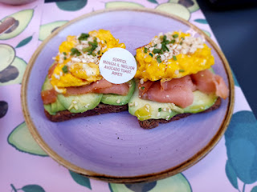

I also ordered an Italian hot chocolate, which is delightfully thick with mile-high whipped cream on top.

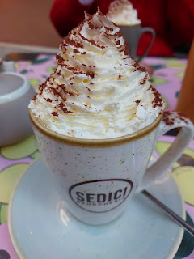

I'm finding more and more that you need a reservation for
lunch
now in Italy, especially at the higher rated establishments, such as this one. When we walked in, they asked us if we had a reservation, which we did not. They said that inside it was all booked up for lunch, but that we were welcome to eat outside at one of their little tables, so that's what we chose to do. It was really cold that day, but thankfully they had a large basket of fleece blankets that you could either sit on top of or wrap around you. We all grabbed one, and they DID help.

The food was delicious and the service was great, too. After we finished eating, we then went inside to pay. This is a customary procedure in Italy. Not always, but often. Sometimes they do bring a wireless credit card reader to your table and you can pay while still seated. But there is definitely a high level of trust, that you will in fact pay, and that you won't just get up and sneak off without paying. I think that as a whole, Europe is just classier in that regard. People aren't trying to sneak off, so the trust has long been established.

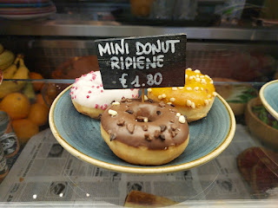

At the counter inside, while I waited for my turn to pay, I noted the cute little brunchy items for sale in the refrigerated glass cases.

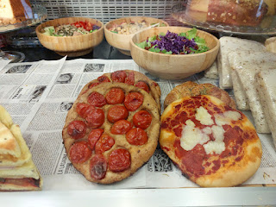

On the hunt for a bathroom before our class began, we found this public WC (which in Europe means "water closet", which also means bathroom, ha ha). We ended up being too chicken to actually use it though. Thankfully there was a bathroom at the KOKO Mosaico.

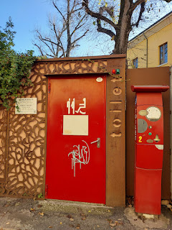

Ravenna, known world-wide for their mosaics, was the perfect place to take a class and learn the artistic process for ourselves. The sign outside KOKO Mosaico translates to: "City friendly to women" or "Women friendly city."

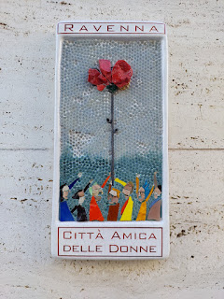

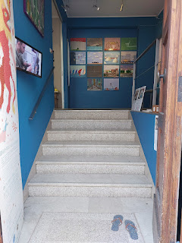

The table was all set and ready for us. We just needed to wait for one more attendee: Ita, an older lady from Ireland who was there on a girls trip with her sister and another friend. She was really fun and we enjoyed the afternoon working alongside her.

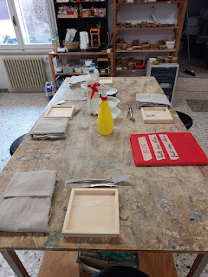

First, we received a tour of the studio, which was started by a husband and wife team who are passionate about creating mosaics. Arianna Gallo, who was born near Ravenna in 1976, graduated from the Mosaic Institute of Art 'Gino Severini' and from the School of Mosaic Restoration.

Her husband, Luca Barberini, was born in 1981 and also graduated from the Mosaic Institute of Art. He works mostly as an expressive artist but is also the business manager, while Arianna is an artist + teacher + marketing director. The mosaic works below are all made by Luca. (Click the photos to get a closer look at the fine details . . .)

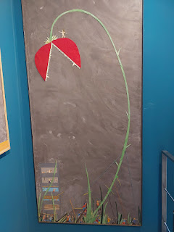

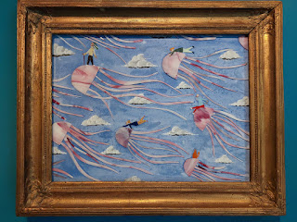

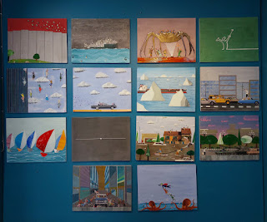

There is a beautiful gallery wall in the studio, with several of Luca's works. They all represent a scene from either an actual life event, or from a movie. Take this next one, for example: The day JFK was riding in the convertible during that fateful parade on the last day of his life.

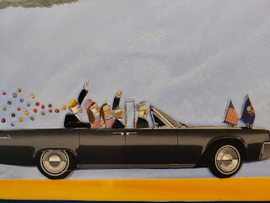

Other scenes on that gallery wall include: a boat full of immigrants trying to make it to shore, Tienanmen Square, the day of a major flood in Ravenna, and superheroes from popular movies. The giant spider represents a scene from the movie "Ghotstbusters". And the black square is what you used to see "back in the olden days" when you turned off your television, lol.

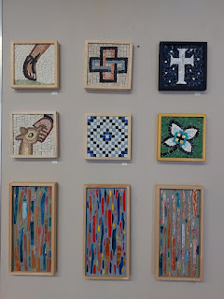

Other intricate works of art are on display around the studio . . .

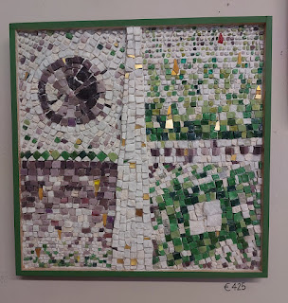

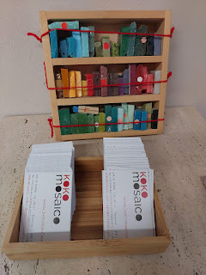

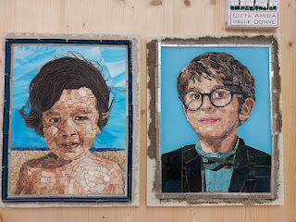

I couldn't believe it when I saw these faces up close . . . what patience it would take to recreate someone's face in tiny little pieces of glass or stone tile.

This is a current project they are working on for a commission . . .

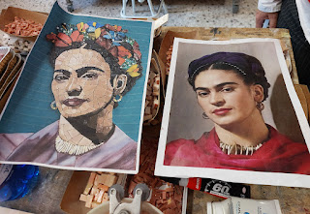

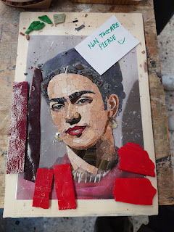

This next photo shows how they lay a piece of clear plastic over the photo to "map out" the process of laying down the tiles. Sort of like making a DIY jigsaw puzzle by hand.
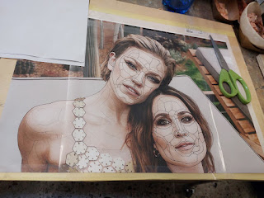

I really liked the colors of these finished works on the wall . . .

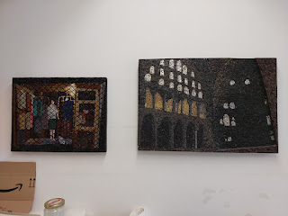

I got permission to take some videos of Ivana, the receptionist and our tour guide, when she taught us a great deal before we even began our class. In the interest of time, I'll just lump them all together and you can explore on your own.

Here is a link to all the photos and videos from our class in Ravenna:
https://photos.app.goo.gl/BRvR2aX6RFU55EF88

Dalia was our instructor. She is a cutie patootie. She is from Egypt and came over to attend the University in Ravenna and has lived there for the past 4 years. She was a lot of fun.

After we chose which tile we wanted to create, Dalia pulled out a corresponding "grid", or map, for us to begin our work.

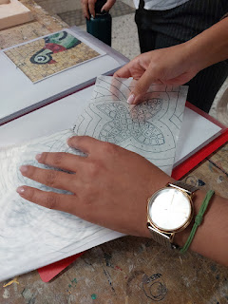

I chose to build this beautiful flower design. I love green, so it was a no brainer for me.

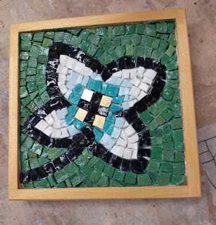

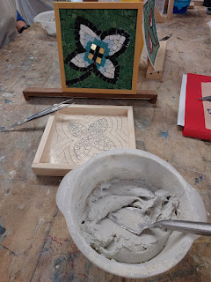

We mixed up a bowl of thinset cement, chose which colors of tiles we wanted, and then our 3 hours of work began.

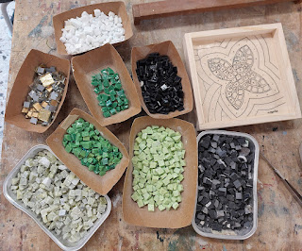

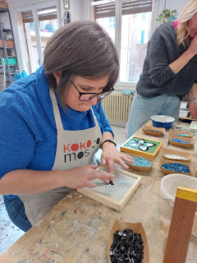

It was interesting to see how the wax paper has a sort of "stamp" or tattoo capability when you lay it down on the wet cement.

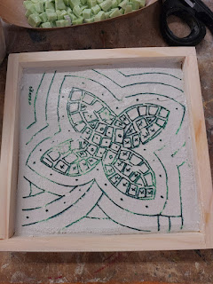

I began with the dark black tiles to frame the flower . . .

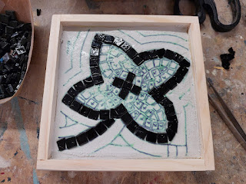

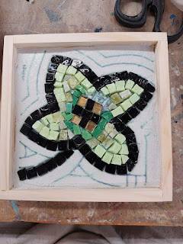

Then I filled in the other areas, a little at a time . . . I chose white as my background because I thought it would be more complimentary to the shades of green that I chose for the flower in the center.

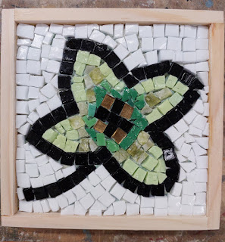

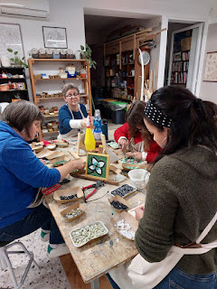

We chatted and laughed and enjoyed learning about each other as we worked side by side that afternoon. Ita's pigeon turned out so cute at the other end of the table . . .

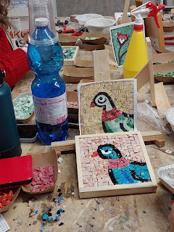

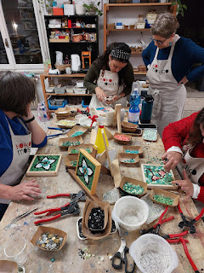

Left to right: Ita, Me, Marnie Parker, Rachel McGovern, and Dalia down in front.

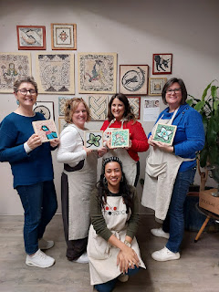

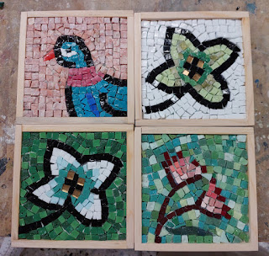

Dalia posted a reel on Instagram and she included pictures of us hard at work that day, including this one of me.

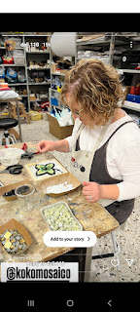

Other Happenings . . .

We forgot to take the supplies for a birthday gift to my grandson, Jonny (in heaven), when we traveled to Croatia recently. I had them on the kitchen table, and that's where they sat all weekend . . .

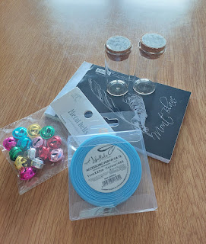

Shortly after we returned, we wrote our thoughts to him on slips of paper, letting him know how much we love him and are thinking of him on what would have been his 8th birthday. We sealed the notes inside two little glass vials with a cork topper. We glued the topper in place, for added measure.

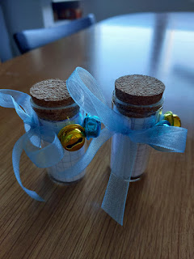

Then we walked over to the canal that's about 10 minutes from our home, where we could send them off to sea . . . (Scott looked on Google Maps to make sure it would work).

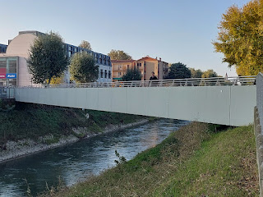

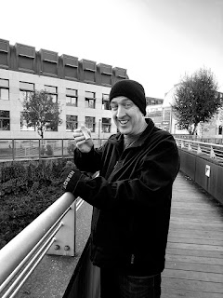

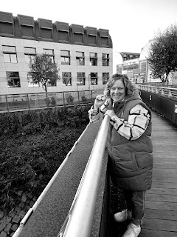

It was a beautiful moment . . . I felt of Jonny's beautiful spirit and I was comforted in knowing that he was aware of us. I very much look forward to meeting him in heaven someday. XOXO

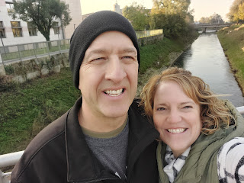

Video of Scott dropping his: (13 seconds)
https://photos.app.goo.gl/8zY5kQbMr2Qf3nYy8

Video of me dropping mine: (13 seconds)
https://photos.app.goo.gl/UjyLn6fbZr5LDLoT6

Incidentally, the canal where we chose to drop our Love Notes is adjacent to Via Bassano, a street named for Bassano del Grappa. With Bassanos on my family tree, it felt very appropriate to have done this here.

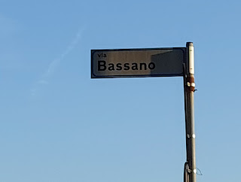

The New Job . . .

A few weeks ago, Scott came home and told me that he was interested in taking over his co-worker Emma's job at work. She is getting married soon and will be transferring over to England, where her fiance lives. He felt confident that he would be well-suited for the computer job.

My heart dropped when I realized this would mean staying on the other side of the world for a while longer. To be honest, I didn't think he was super serious about it at first, but maybe that's because I somehow hoped that this was the case. It turned out that he was
very
serious about it.

The job will be a government contractor job to support the US Army in their endeavors in Northern Italy. If you've ever seen a good CIA movie, essentially Scott will be the guy running the "Map". He will oversee a map that shows where every military personnel is located in Africa and what their mission is. He will have the power to let people "in" to update a person's status, and will have to encrypt and decrypt any access that is granted.

He told me that he would have to take a 30-hour course along with a $400 test to prove that he has the skills necessary for the job. He also told me that he had already gone through 5 hours of the course at work that same day! This let me know immediately just how serious he was in pursuing the job.

Everyone at work told him that he would be a great fit for the job, and that he would be foolish to not take it. Those who do the hiring are in the same office where Scott has worked for the past 2.5 years, and they are all good friends. They coached him a little bit during the process, including submitting his resume directly to them, instead of using the online portal, and when he brought it in, they suggested that he add a couple of things to it (qualifications that he did have, but neglected to list them on the resume).

While my mind reeled with the news those first few days, all I could think about was how many people would be either sad, disappointed, or let down if we didn't come home in the spring. Especially our children and grandchildren. We called each of our kids to see how they felt about the possibility, and they all gave their support and positive feedback.

Amber and I cried together on the phone, though, as we acknowledged the unexpected distance that we would be apart. We discussed a few ideas that brought peace to our hearts, including the idea of me coming up to Portland a little earlier for Christmas so we could spend more time together.

Jacob admitted that it didn't make a whole lot of difference to them whether we were in Idaho Falls or Italy, since we only see them about twice a year anyway.

Benson is wanting to transfer somewhere else with the Air Force, so he wouldn't be "alone" for long anyway. I was most worried about the idea of leaving him behind, since he wanted to be closer to family in the first place. But he gave his whole-hearted support of our plan, which made me cry because I was so happy to hear him say this.

Overall, I resorted to my usual technique of finding whatever work-arounds that I could in order to start adjusting to the idea of staying in Italy. What could the Pros be? What might the Cons be? How could I find a work-around to some of those Cons?

For the con of being so far away from family, here is the workaround:
I can still go visit them, I'll just need to be more strategic. I can fly to the US for a month or even longer if needed, making my way from family to family and spend some quality time with them. We can also bring them over to Italy for a visit. It will be harder for Jake and Hannah to travel with a small baby, but whenever they're ready, we will be ready to help get them here.

Scott will be allowed up to 30 days in the US each year. If he goes over the max, then he would likely lose his tax-exempt status for a US citizen working overseas. So we will have to be strategic with his travels, as well.

For the con of having an empty house, we think it will be okay. We have a good system already in place for the times that I have been gone for long periods. When I called our neighbor, Kim, to get her thoughts, she had nothing but 100% happiness and support for us. I was worried that she would be tired of keeping an eye on our house, but on the contrary she emphatically said that it was not a hardship at all. They are seriously the best neighbors in the world.

We will stay in the same house in Italy, which is a huge relief. Our landlord is happy to keep us on for another round. The biggest issue we will be facing is that we will need a ton of furniture. We've been using loaners from the military this whole time, so they will need to take everything back . . . this includes: our fridge, washer and dryer, living room furniture, wardrobe storage, Scott's office desk, our dining table, nightstands in the bedroom, etc. Two of the three beds are ours (we bought them), so we would just need to replace the one upstairs. Essentially, there's a lot we need to take care of in the coming months. But we will just take it one step at a time.

The process will essentially be this:
I will be in Idaho until probably late February or early March.
Scott will come back to the US in late January or early February to do his demobilization process at the end of a tour of duty. (Texas)
Then he will join me in Idaho. There will be a retirement ceremony at the National Guard, nothing fancy though, probably just part of a drill weekend.
We each need to get a visa through the US-Italian Consulate in San Francisco. It has to be in person. This is our assigned location for being a resident of Idaho.
Once we have our visa and passports back in our possession, we can book a flight to Italy and head out. We've heard that it typically takes a few days, maybe up to a week to get them back.
Start getting RE-settled in Italy, with furniture, etc.
It's a LOT of steps and moving parts, and I cannot wrap my head around all of the details. Right now, we're just focusing on getting back to the US for Thanksgiving and meeting our new granddaughter, Maisie. Oh - and Christmas . . . I did all of the Christmas shopping and organizing packages and sending them off before we left. (I'm typing this while in our hotel room in Vogar, Iceland.)

A few last items . . .

We drove up to Aviano recently to celebrate Avery's 3rd birthday. She is such a cutie! She has so much personality and it is always such a hoot to interact with her. XOXO

We came bearing gifts from our son, Benson, my Mom, and us.

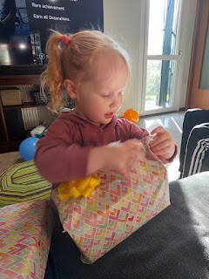

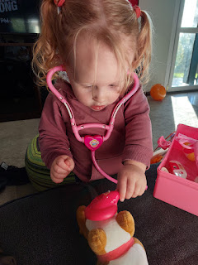

She absolutely LOVED the veterinary kit from Benson . . .

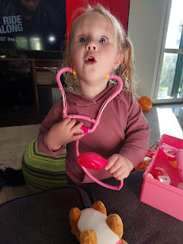

Video of Avery as she struggled to cut the toy tomato in half (*Her joy at the end!): (1 min, 2 sec)
https://photos.app.goo.gl/s46wgAoCvQqkB1Wn6

The only way we could convince her to go to the park was if she could bring her veterinary kit with her, too.

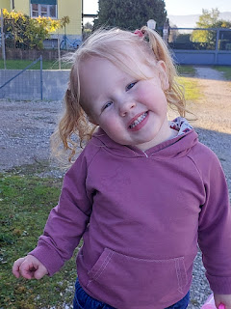

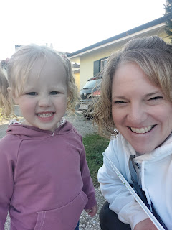

Scott, carrying Avery along with her little veterinary kit . . .

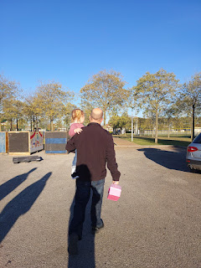

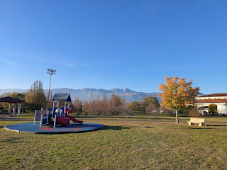

Several times, she just wanted to sit down and play with her new toy, checking the doggy's temperature, giving him a shot, etc.

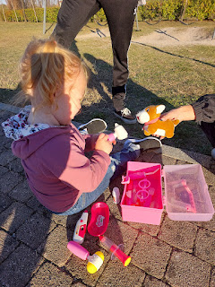

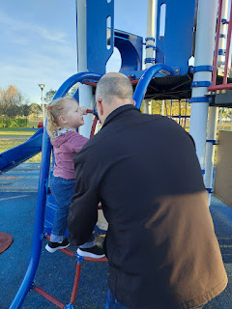

Scott, a.k.a. "Poppa", really enjoyed coaching Avery in her climbing endeavors . . .

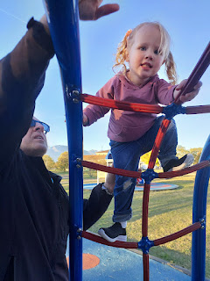

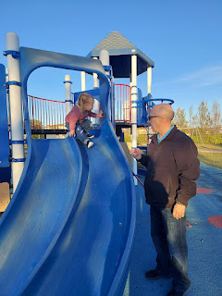

This was Avery's mood by the end of our playtime at the park . . .

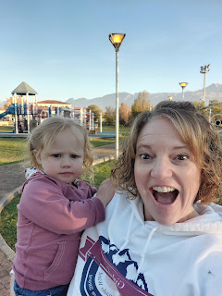

She was "hangry" and therefore she was more contrary to everything that we said, bless her adorably cranky heart. As we gave her hugs goodbye, she giggled as she gave me a pretend shot on my cheek.

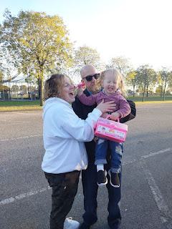

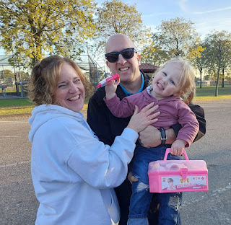

This was our first time going on the Aviano Air Force Base in all the times we've been up there. They used to have a really strict policy where you had to fill out paperwork weeks in advance for anyone that wanted to visit, even if they had a military ID card already. But finally, the rigamarol has eased up to where we can just go through the gate with our ID cards alone.

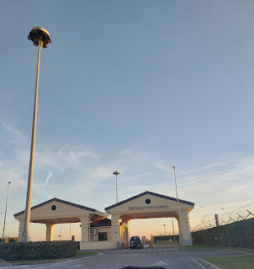

The drive home was calm and quiet after so much excitement and fun . . .

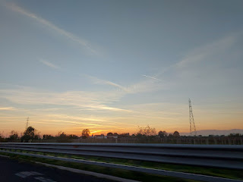

On a different day, I drove with my friend Rachel McGovern to Asolo to grab some pasta for a few Christmas gifts. But on the day we arrived, the shop was closed. Google said it was open, but it was not. There was a number on the door of the shop, so I sent a message to inquire about when they would be open. Not until the next morning was the reply . . .

So Rachel and I walked around for a few minutes before we made our way back to the car. It's such a cute town. She ended up going back 2 days later with a couple of ladies from our ward (I wasn't able to go), and she picked up all the pasta that I wanted to get but couldn't. What a good friend!

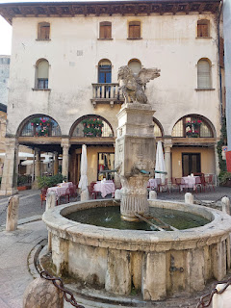

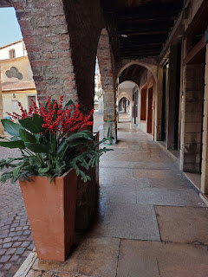

I just happened to look out the window one late afternoon and was shocked at the gorgeous cotton candy clouds in the sky. I ran up to the roof immediately and took several photos . . .

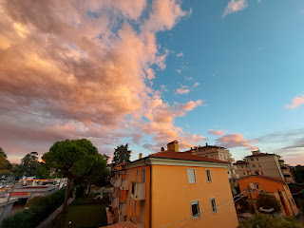

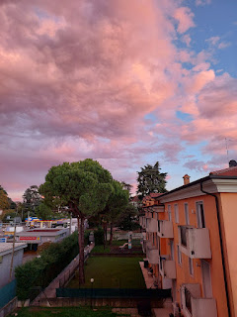

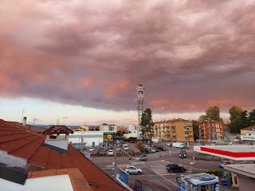

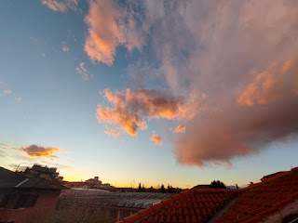

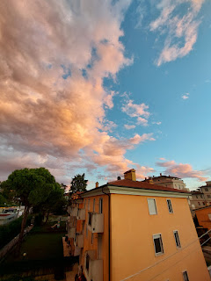

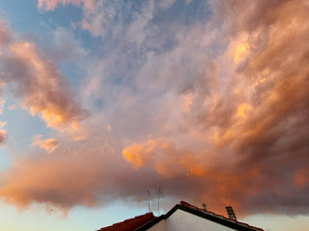

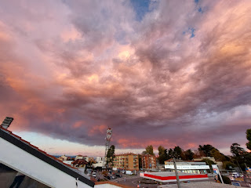

I had a nice video chat with Abdel down in Morocco (my Moroccan son). He is doing great! It was funny because while I was in a hoodie and a coat, he was in a tank top! It's their summer season right now, with temperatures around 33 degrees celsius (about 91/91 degreees F). Vicenza has been having temps in the upper 40's and low 50's for the high, and dipping down into the low 30's overnight.

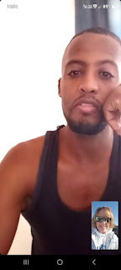

One of the last projects I cranked out before we left town was to make a big, soft blanket for our new granddaughter, Maisie. I bought a few pieces of fabric from the local craft shop and then, after cutting them, I pieced them all together for the top. Returning to the shop once the top was done, I found a really plush creamy white fabric for the underside. The biggest relief came when Scott was able to fit it into his suitcase . . . as mine was full to the brim!

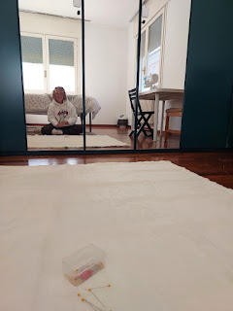

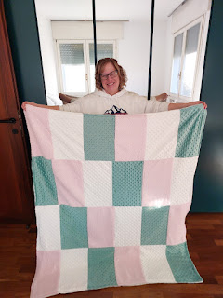

Scott and I walked into downtown Vicenza after I finished the blanket, because I had one last errand I needed to run before we left town. I really like a locally made face lotion, and with such sensitive skin, it's hard to find something that works well and doesn't cause my face to break out. I wanted one more bottle to take to Idaho with me for the winter.

Because it was a Saturday, there were street performers in several places and it was a delightful 30-minute walk each way.

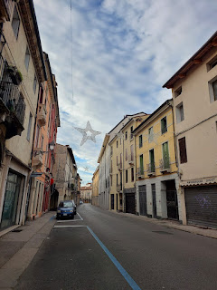

Video of a guy who could sing opera and was a former contestant on Germany's Got Talent: (47 sec)
https://photos.app.goo.gl/ieCK1e43vuG5YNCi6

And then there was this guy, playing a sort of xylophone instrument, with other percussion, too.

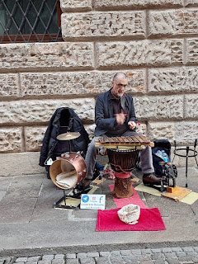

Video of him playing: (17 seconds)
https://photos.app.goo.gl/t2SSYZgjqitF6eMNA

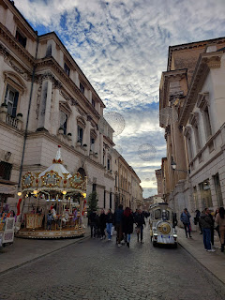

Persimmons are ripening all over Northern Italy right now . . .

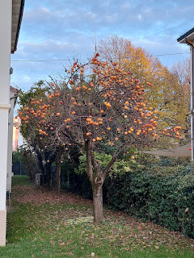

Another beautiful sunset over Vicenza . . .

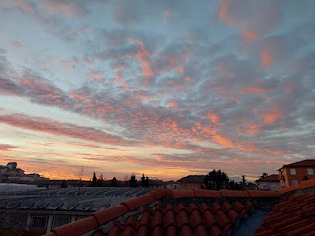

I made a new recipe for dinner recently that I want to share - it's basically like a zucchini lasagna loaf.

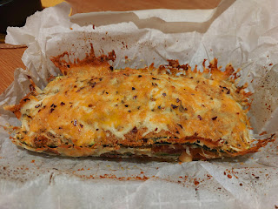

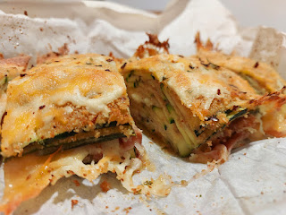

Here is the recipe:
https://hungryhappens.net/easy-zucchini-lasagna-loaf/

On my last night, our friends Kelly and Trevin Campbell invited several families over for dinner. I was tasked with making a dessert and it turned out so good! It's like a raspberry cheesecake, sort of. The bottom layer is a pretzel crust, the middle layer consists of cream cheese and cool whip, and the top has raspberries and raspberry jello.

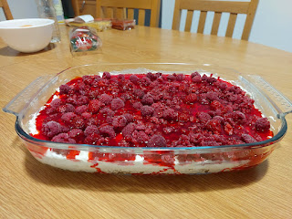

Here is the recipe:
https://www.allrecipes.com/recipe/16080/judys-strawberry-pretzel-salad/

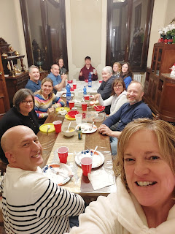

Above, clockwise starting with myself and Scott at the bottom:
Rachel McGovern, Angie and Chance Wilson (our new bishop), Ben McGovern, Sarah McGovern, Jacob McGovern, Addie Wilson, Emily McGovern, Kelly and Trevin Campbell.

The Campbells have a beautiful home that is just one section of what used to be a huge Italian villa. Other sections are rented out to other families, but wow, their place is incredibly beautiful.

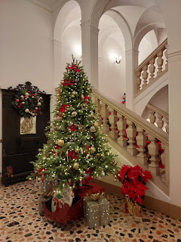

Right now, we are about to leave Iceland and fly to Minneapolis for Thanksgiving. Iceland has been AMAZING. I will need to come back here multiple times. I'll share more about that in my next post, after I get settled back home in Idaho Falls.

Happy Turkey Day!! I hope you find lots of things to be thankful for this year. The things I am most grateful for are: my husband, my family, the Gospel of Jesus Christ, and all of the hope that comes from knowing and following the Savior. I can't imagine a world without hope, without light, without a Savior, and no knowledge of or hope of anything beyond this life. Because of Him, I can get through this life, this year, this month, this week, this day, this hour, and this minute.

