Revenge of the Leprechaun & a Successful Flight
I made it to Italy!! All is well again in the world.

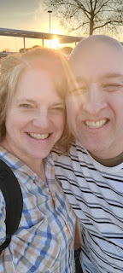

More on that in a minute . . .

First, I'll summarize the rest of the week.

Monday:
A first of many mornings that began at 6:00 a.m. The girls' school starts SO EARLY!!! Like ridiculously early . . . before 8:00 a.m. if you can believe that. If they were to ride the bus to school, they would have to get up even earlier, so to allow them some extra sleep, Amber drives them each morning instead. Amber and I would wake up at 6:00 to give ourselves a few minutes first, before going in to wake the girls up. At 6:15 it was time to turn on their light and start talking to them, rub their back, etc. to help them wake up. Once they're a little more alert, it's time to get dressed in their school uniform and then go to the bathroom. Amber and I would tag team for the rest. She would start making them breakfast, while I began brushing and fixing hair. The girls go from being asleep to being wide awake and cheerful pretty quickly, all things considered. They're kind of amazing.

By 7:00 we are in the car and driving to school. It's about a 15 minute drive to get there, especially when a million other parents are dropping their kids off at the same time. I think the reason why school starts so early is so that working parents have a chance to get their kids to school and then still get to work on time by 8:00. Most people work in Shreveport, which, from Stonewall, is a good 15-20 minute commute in the opposite direction.

First, we drop off Gwennie in the Pre-K zone at the lower elementary. A member of the school staff steps over to the car to open the back door and let Gwen out. Then we drive through the packed parking lot, past the middle school, past the high school, and over to the upper elementary school to get in line to drop off Abby. All of the Stonewall schools are on the same very large property. There are very specific instructions to drop off or pick up your child so that everyone knows the rules and the flow of traffic.

Abby hops out on her own and off she goes . . .

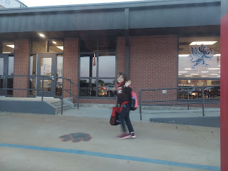

Then Amber and I drive back to her house as the sunrise is just beginning.

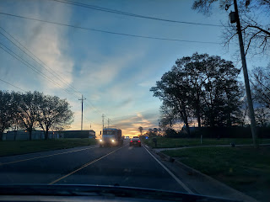

A note that Abby wrote in school recently:

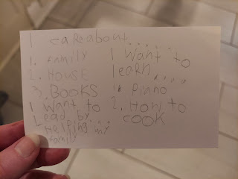

Weston wanted me to come in to see him at work again so we could do another eye exam. I rode with him into Shreveport after he had come home for lunch.

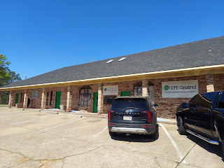

I got the royal treatment in his office, where his staff is super friendly and very efficient.

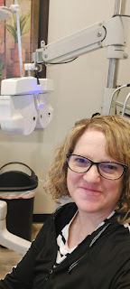

Sorry about the glare, but these are the glasses (below) that I chose for my new pair. I look a little like a buffoon in the photo, ha ha, but they really are cute on me and I really do like them. Jennifer was extremely helpful in whittling down my stack of about 20 pairs of frames down to one. They are building my prescription and I'll be back to Louisiana in 3 weeks (for Abby's baptism) and will pick them up then.

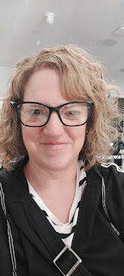

Amber made birria for dinner, which is basically a super slow-cooked beef that just falls apart and can be made into tacos or quesadillas. It's SO GOOD!!!

Below: Amber also made homemade tortillas with just oats and water. Place equal amounts of oats and water into the blender and blend until smooth. Then let it sit for about an hour. You can pour the batter out onto a griddle or into a nonstick pan to cook them into tortillas. They are kind of like a flatbread/crepe/pancake texture, but very yummy. We added mozzarella cheese, some birria shredded beef, and some chopped cilantro.



Fold up and continue cooking as a quesadilla until both sides are nice and golden.

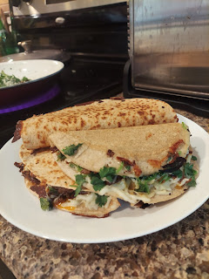

Tuesday:
Got up early for school again. Those girls are such champs every morning. :)

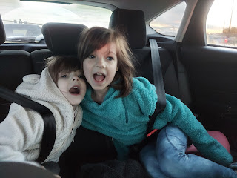

Another beautiful sunrise from the school parking lot . . .

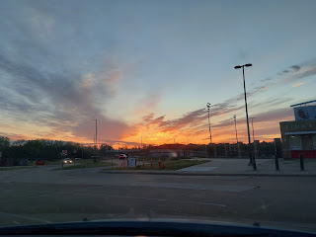

Amber was super tired that morning, so I sent her back to bed. I did some cleaning around the house, because that's what moms do for their child. I cleaned the girls' bathroom, and I swept and mopped some floors. I tidied up the kitchen a little bit and listened to some 80's music while I worked.

We went to pick up the girls after school in the hopes of saving an hour or so, since that's how long it normally takes for the bus to get them both home. However, by the time we got through Gwen's pick up line and then slowly worked through the line of cars to pick up Abby, it had taken us the full hour!! Sheesh! No wonder why Amber usually just lets the bus bring them home every day.

The whole point of picking them up was so we could go straight to a park and play for a while. It took us another 20 minutes to get into Shreveport to get to a really nice park by the river where there are ducks to feed, as well as plenty of playground equipment to climb on.

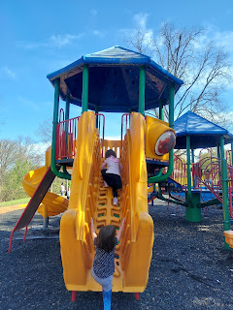

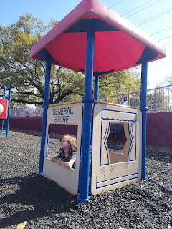

Abby enjoyed posing on every animal she could climb on, asking me to please take her picture. :)

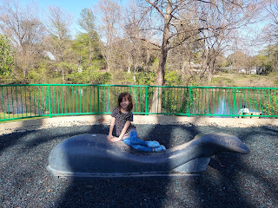

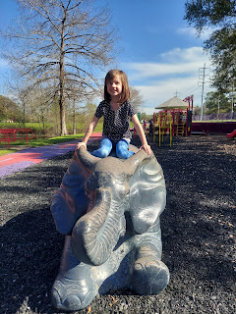

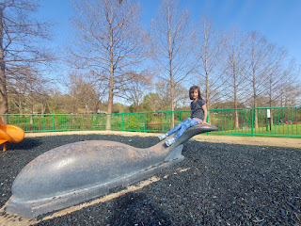

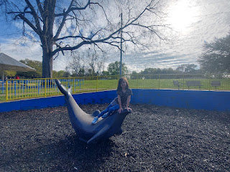

And we saw a sign at the park asking visitors to please NOT feed the ducks/geese with the usual bread items, since it has caused a decline in the health of the birds. Instead, they suggested that we feed them grapes or seeds, along with a few other suggestions. (I can't remember them all) We had some grapes on hand, so that's what we did. The grapes were quite large, so Amber thought it would be wise to bite them in half and toss half at a time to the ducks. Some were a bit shy and didn't even acknowledge the grape we had tossed to them, but some ran right over and gobbled it up.

Abby tossing a grape out to the ducks swimming in the river . . .

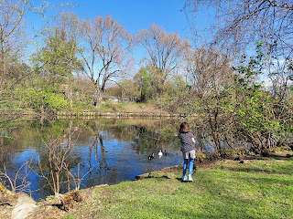

The ones on land seemed more excited to eat the grapes, for some reason.

Below: Amber, Abby and Gwen

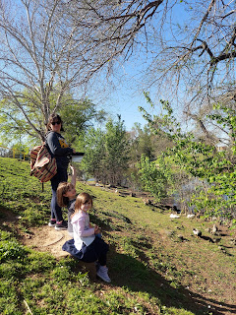

A huge white duck gracefully (and shyly) keeping her distance from us . . .



Abby was scared of climbing all the way up and over this arch the first time. After she got down, I suggested that next time she could turn around halfway (at the top). After a bit, she got brave enough to try one more time, and followed my suggestion from earlier. She was so proud of herself that she did it!

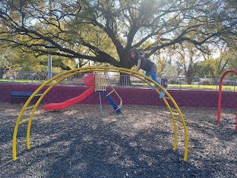

I think I've mentioned this before, but Amber has been working long hours as an illustrator for a card game called, "Dead Grandma". Some of the young men that grew up in our neighborhood in Idaho Falls have had this idea for many years, and they've been saving and investing money to bring their idea to life. They hired Amber to illustrate all the cards, the instructions, the cover of the box, and everything. They've been paying her handsomely for her hard work and efforts, too.

On Tuesday, she received the first prototype of the game in the mail. So we all sat down to play it together after dinner. Amber was very familiar with the rules, but we did need to refer to them several times as we learned how to navigate through the game.

I love how at the bottom of the box cover it says: She would have wanted you to have this. :)

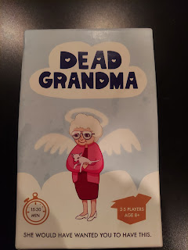

I really believe that this game has the potential to be the next "Exploding Kittens" game, which is already VERY popular (and super fun!). The premise of Dead Grandma is that Grandma has died and she has left behind several earthly possessions, which must now be divided amongst her descendants. It is meant to be lighthearted and silly, which it definitely is. We laughed over every action card that we drew. The brains behind the game are definitely very clever and creative!!

There are 3 categories of cards. The green stack = action cards. The pink stack = inheritance cards. And the purple card = the "disappointment card", which basically blocks an inheritance card.
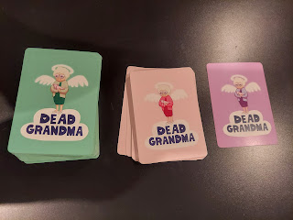

Here are just 3 of the inheritance cards. CLICK the photo to read more closely what each one says.

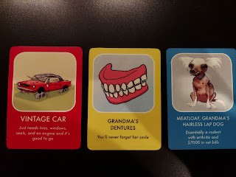

And these are some of the action cards. There are also several numbered cards, too, which you can use for bidding on the inheritance cards. There are other uses for the number cards, but this is just one way they are used.

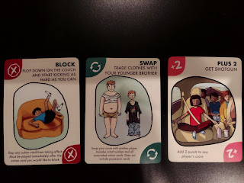

Amber did a great job teaching us the rules, and even Gwen was able to easily understand and play strategically. We all agreed that it's a really fun game, and we had a good time laughing while also being competitive.

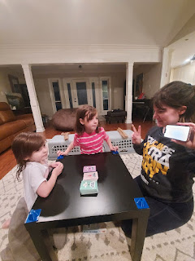

If you want to get involved with the Dead Grandma project on Kickstarter.com, you can go to this link:
https://www.kickstarter.com/projects/solderboys/dead-grandma-the-hilarious-new-card-game?ref=nav_search&result=project&term=dead%20grandma

Tuesday was also PI DAY - or should I say PIE DAY.

3-14 (or March 14th) is celebrated for being the first few numbers of PI, which is definitely a math nerd holiday. Since we are math nerds at our house, we celebrate it!

While Amber did some painting in her studio, I baked a pumpkin pie. It was tasty! I was a little worried because she didn't have any ground ginger for the pie filling, but she did have some ginger paste in a tube from the fridge. It worked just fine!

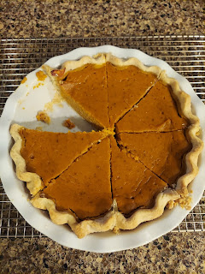

Wednesday:
It was pretty cold in the morning when it was time to take the girls to school. The temperature gauge said it was 39 degrees outside!! The girls got on their warm coats and off we went.

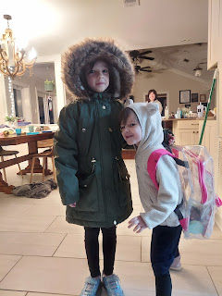

I had been decidedly ignoring my coat since I arrived in Texas and Louisiana, opting for my light sport jacket instead. But Wednesday morning, when I went for a long walk, I needed both the light jacket AND my coat!! It was very cold . . .

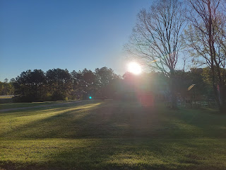

By the end of my 40 minute walk, I had shed the winter coat and tied it around my waist because I was plenty warmed up by then.

There have been 4 new houses built in recent months on Amber's street, with one more to be built this summer. The one next door is for sale and I wish so badly we could buy it and live in it. It is SO CUTE!! And it would allow us to be next door to Amber and her family!! How fun that would be!!

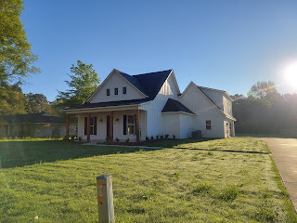

The new builds are all in a farmhouse style, which is my favorite. Here you can see the one for sale along with Amber and Weston's house next door. Amber's house is more of a ranch style home, with a flatter roof. When I asked about the pointy roofs down in the South, Amber explained that the newer homes tend to have the peaked roof because it's safer to withstand a tornado. It's harder for a tornado to grab hold of a pointy roof and try to rip it off, whereas a flat roof is more at risk . . .

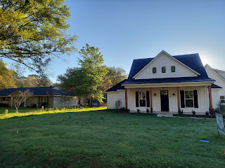

Even though it was very cold out, the sun was shining and the sky was blue, something that was missing back in Idaho. Well, let me clarify: Idaho wasn't missing being cold . . . but it was missing some blue sky and enough beaming sunshine days.

Amber and I tackled a big project that she had been wanting to get to for several months. She was eager to have my help, since I like to organize things. We completely re-did their whole pantry in just a few hours.

Here is the "before" . . . lots of things were split up or spread out instead of grouped together, and only a few shelves were grouped in a way that made sense.

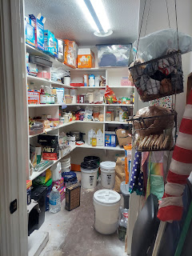

Here is what it looked like when we were all done. We moved some things out that really had no business being in there, which freed up a lot of space. I brought everything down so that things were more reachable. We organized things in a way that made good sense: canned goods were grouped together, such as beans and soups, while canned fruits had their own separate area. Baking items went together, such as flour, sugar, spices, etc. Paper goods were more easily reached by bringing them all down a shelf.

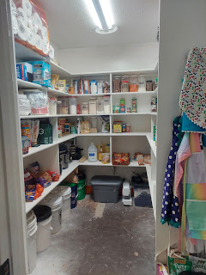

And I like to arrange the cans so that you can easily see how many you have. Soups for example: give each type of soup their own "lane". Stack them, or line them up in a single row, so you can see that you have 4 cans of tomato soup, or just 2 cans of chicken noodle soup. You will instantly see what you need to stock up on the next time you go to a store.

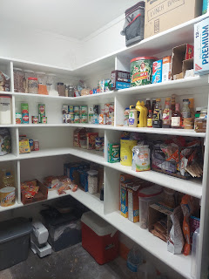

We cleared out the area on the left so that they can insert an extra fridge sometime in the near future. It was previously being used as a place to stash empty cardboard boxes. Abby and Gwen helped me break down the boxes and stack them all in a pile later that evening. The plan was to take them out to the "burn barrel" on Saturday and have a giant bonfire.

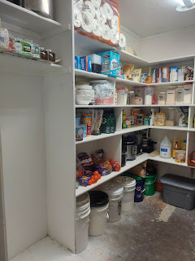

Their cat, Broski (pronounced broh-skee), is extremely intelligent. He knows how to open up the cat food bin and then go to town on it!

Video of Broski: (27 seconds) Gwen was pretty amused by his skills!
https://photos.app.goo.gl/SwsDFiBkS8tpvwri6

We took a little break to go into town and meet Weston at the office first (so he could get one more special scan of my eyeballs) and then go to lunch together.

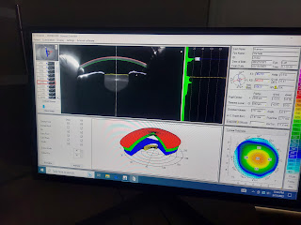

We ate at Torchy's Tacos and then Amber and I did a little bit of shopping together. I needed a few more lightweight shirts that were long enough to cover my bum while wearing a pair of comfortable leggings. I scored big at the TJ Maxx in Shreveport. I found 4 long button-down shirts that are lightweight and airy for warm & humid climates. Yay!

Then we went back and finished up the pantry.

Amber and Weston went on a little date after dinner, since I was there to take care of the girls. We ate a homemade broccoli and cheese soup for dinner, which Amber mostly prepared, while I just finished up the last step or two. I somehow convinced Gwen to eat 2 bites of her soup, after a whole lot of her not wanting to. Abby ate 3 bites without much encouragement. They also had a half sandwich and a clementine on the side so they didn't starve . . .

After dinner, Abby wanted to sing me a couple songs. Their school had taught them some really beautiful pieces: a Veteran's Day song that Abby wanted to share with Poppa (Scott), and a Thank You song for grandparents that they performed for a recent Grandparents Day at school.

Video of Abby singing for Scott: (3 min, 3 seconds)
https://photos.app.goo.gl/i3HrEEtDFEWDQPpPA

Video of Abby singing for me: (1 min, 59 seconds) *I was bawling as she sang, and I still get choked up just thinking about her singing this. She is such a sweetheart. XOXO
https://photos.app.goo.gl/8TGPMPNVi2p8q2gc8

We played more of Dead Grandma before it was time to get ready for bed. What a fun and laughter-filled riot we had!

Thursday:
I gave Abby her early birthday gift before she went off to school. We wanted a time when everyone could be there, including Weston.

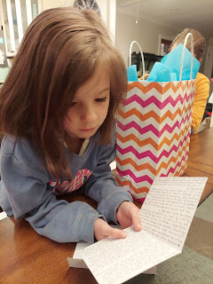

Here's what I wrote to her the night before:

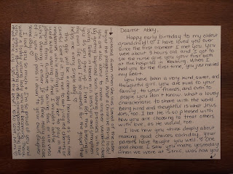

Video #1: Abby pulling the white dress out of the bag and saying, "WOW". (19 seconds)
https://photos.app.goo.gl/PPV6QrxkiBkw1vxs6

Video #2: Abby pulling out the pocket and trying to figure out what it says. (1 min, 3 seconds)
https://photos.app.goo.gl/b6EnWoR86CyZL5ex9

Video #3: Abby reading what I embroidered on the pocket. (45 seconds)
https://photos.app.goo.gl/PDLFoFhP3PTsrh4K9

I gave her a little bit more explanation about how we got the white handkerchief with Coy Harmon's initials on it, and then it all made more sense to her. She loved the dress a LOT and couldn't wait to try it on after school.

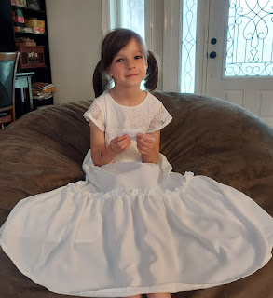

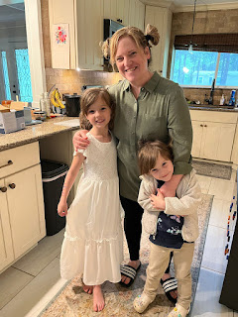

We went out to dinner that night at a place in Shreveport called Gibbons. It had a beautiful ambiance and felt fancy, without fancy prices that can break the bank. I ordered the salmon and it was really good!

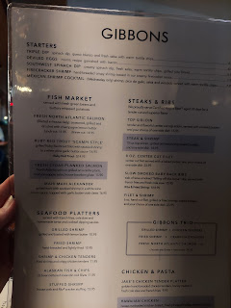

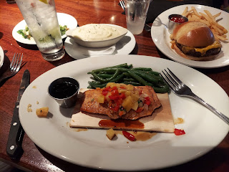

When we got home from the restaurant, and before the girls went to bed, we put together a quick leprechaun trap, since it was the night before St. Patrick's Day. (and we all know how leprechauns like to cause mischief . . .)

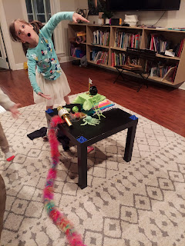

We found a plastic vase that could act as the trap. Amber fashioned a ladder out of pipe cleaners, while the girls collected various shiny things from around the house, since leprechauns like shiny gold, or sparkly glitter. They also found a rainbow colored scarf to help the leprechaun get from the floor up to the little table with the gold coins to entice him up the ladder.

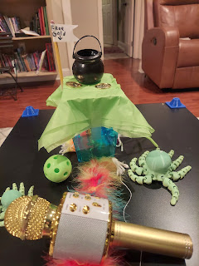

Inside the little black pot were a few shiny gold wrapped Rolo candies to further tempt him . . .

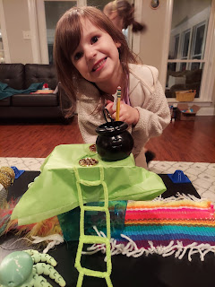

Abby made a little flag that said, "Free gold", pointing to the top of the trap door area. We had cut a slit in the tissue paper so when he climbed up to get the gold, he'd inevitably fall into the vase trap.

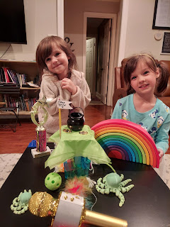

Once the girls were in bed, Amber got all gussied up to go outside and free up the water-logged ditch that runs along their driveway and the carport. The rain was coming down something fierce, with thunder and lightning to go with it. Southern rainstorms can dump a huge amount of rain in a short period of time, and if the ditch is full of dead leaves or other blockages, then everywhere gets flooded pretty fast.

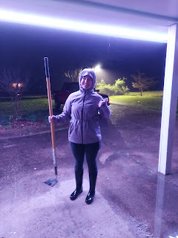

Most of the carport was already under water when she went outside, and the rain gutter was clogged so the rain just tumbled off the edge of the gutters in showers . . . Weston soon came out to work with her, and they both got 110% soaked.

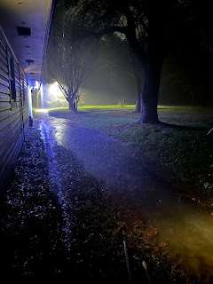

Weston dug out some blockages in the ditch and had to stop to empty out his knee-high boots 3 times in the process! By the time they were done, there was not a single part of their bodies that was dry, ha ha. Bless their little hearts.

Amber had already gone through the emergency preparedness checklist with me, since there was a tornado watch alert for the night. Not a tornado warning, just a watch. My instructions were that if and when I received the emergency alert on my phone, to grab a blanket and pillow and head for the bathroom in the mother-in-law suite. A bathroom is considered one of the safest places to take shelter during a tornado. It's generally an interior walled room, and has a tub or shower fixture, which provides a pretty solid anchoring that is more resistant to the tornado. The blanket is a good item to place over you while you take shelter, because if there is a window that could shatter, or other projectiles, the blanket can help protect you as a covering. The pillow is just to add a little comfort if you have to lay down on a hard surface.

Even though I woke up too many times to count during the night, there was never a tornado alert. I could hear the rain pouring down, and the thunder that was loud and sounded like a freight train roaring through, and maybe that's what kept waking me up. I have heard many people describe that a tornado sounds like a freight train roaring through, so maybe my brain was on high alert because of that . . .

Friday:
I woke up feeling a little disoriented because of such a poor night of sleep. When we went in to wake the girls up, they were feeling drowsy, too, until we said, "I wonder if we caught any leprechauns?"
That
got them wide awake, ha ha. They could hardly get dressed fast enough in order to run out to the living room to check . . .

What a mess!!

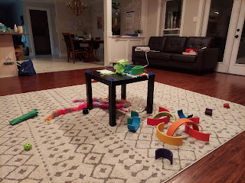

Inside the trap was this saucy little note:

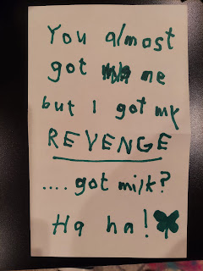

The leprechaun ate all the Rolos chocolate candy, left a snarky note, made a mess, colored the entire jug of milk in the fridge GREEN, and when Gwen went in the bathroom to go potty, she squealed out in surprise and called for us all to come and see . . . that the toilet water was all bright green as well!! What a mischievous little leprechaun . . . maybe they'll catch him next year.

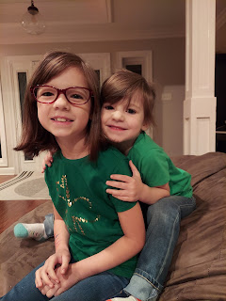

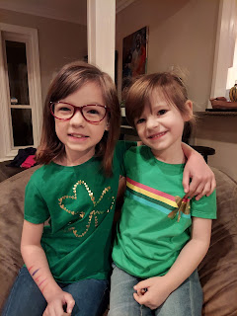

As we got to the school, I had each girl climb up into the front seat with me so I could give them a big hug goodbye, since I would be leaving while they were still at school that day. Surprisingly, they didn't even cry this time, probably because they love the daily routine of going to school. They hugged me and then hopped out and skipped off to class. XOXO

After eating a bowl of cereal, I climbed back into bed for an hour since I didn't get much sleep the night before. Then I showered and got ready to go into town with Amber to pick up my rental car. I got a one-way rental from Shreveport to the Dallas Airport. Unfortunately, the car they gave me stunk mightily of cigarette smoke. Even though I had the back windows down on the freeway back to Amber's house, my lungs were still burning from the effects of the tobacco.

Thankfully, Amber and Weston have something called an ozone machine. It can suck the impureties and stench out of the air in a matter of minutes!! We plugged this thing in and let it work its magic for about 40 minutes. Then we opened up all the car doors to let out the "collected" CO3. No more smell of smoke!! How incredible is that . . .

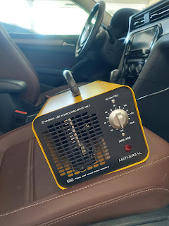

My 3.5 hour drive to Dallas was much more pleasant because of a small little ozone machine that I had never heard of before! Wow.

Weston bought it soon after they moved into this house because the mother-in-law suite stunk pretty heavily of cigarette smoke. The ozone machine saved the day then as well, because there is no hint of cigarette smoke whenever I stay there. Ingenius!

I had a pretty uneventful drive to Dallas, the traffic wasn't too bad, and I had some phone calls and music to keep me alert and entertained. Scott kept me company on WhatsApp for about an hour, and I chatted with both my Mom and also Jacob near the end.

I flew from Dallas to London in just under 9 hours, leaving at 8:00 p.m. Central Time and landing in London at 8:50 a.m. their time the next morning. I think I got some decent sleep during the flight, which was great. I am getting much better at being able to sleep while vertical, something I have never been able to do most of my life. Early on the flight, I watched a cute movie with Julia Roberts, called "My Best Friend's Wedding", something I hadn't seen in years. I really enjoyed it.

Saturday:
In the London Airport, I enjoyed hearing a British accent everywhere I went. You can take the worst words and say them in a British accent and suddenly they sound polite and heartwarming, LOL. Not that I heard any terrible words . . . I was just trying to make a point . . .

I found a closed gate where only a handful of people were sitting and then I curled up in a ball for a rest.

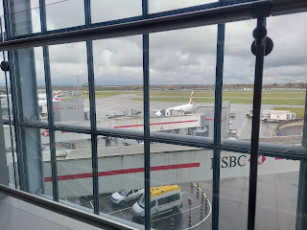

I used my backpack and my neck pillow as a prop for comfort. Not too bad, I'd say. I had a total layover of 3.5 hours there, but by the time we got through customs, I was down to 2.5 hours left. I set my alarm and conked out for a while.

My flight from London to Venice was a little late in taking off, but they must have corrected that in the air because I still landed on time. 'Twas a little bit rainy as we took off, but the sun soon came out - - very brightly.

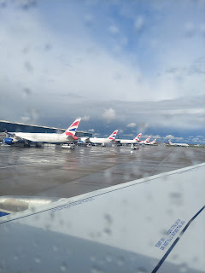



I loved the huge cloud formations . . .



I finally had a seat on the right side of the plane where I could see the Venice Lagoon from the air. All the other times I've been on the left side of the plane and could see the metropolitan Venice, or mainland Venice, which was pretty cool, but the lagoon is more cool.

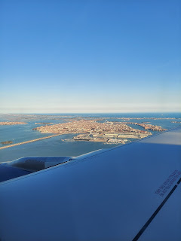

Scott was there to pick me up, which was fantastic! He's been working 12-14 hour days lately as they work their way through this "war" exercise, but he was able to turn things over to his colleagues and walk out early yesterday. He told them, "I'm going to pick up my wife. See you all later!"

A few days ago, Scott came out of work to drive home, only to discover that the battery in the new car was dead. He had left on an interior light for the entire day . . . he jump-started it to come pick me up, thinking that it would give the battery plenty of charge. But when we got out to the parking lot and tried to start it, . . . nope.

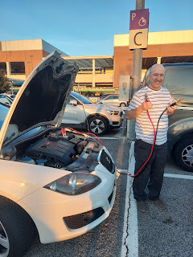

Scott found a nice man in the parking lot, who also happened to speak English, and was able to enlist his help by having the man provide a healthy car battery. THEN we were on our way home to Vicenza. :) It's always so nice when people are happy to help you out.

We made a simple dinner. I got 98% unpacked. And then we went straight to bed. Scott had to get up at 5:30 a.m. to go back to work again and he was definitely tired. But then so was I. Even though I caught lots of zzzzz's every chance I could get, I still went to sleep pretty easily last night. Funny story: I think I fell asleep around 9:45 or 10:00 pm. It felt like I had been sleeping for several hours when I woke up to go to the bathroom. I looked at the clock and it was only 11:30, ha ha. I was so disoriented that it felt like it had been MUCH longer . . .

Sunday:
Since I don't have my Italian driver's license renewed yet (the office opens up on Monday) and since the white car has a dead battery, and since my friend Marnie Parker was in Poland for the weekend, I decided to just catch the bus to church. It stops right across the street from us, in front of the Lidl grocery store and only costs $1.30 for a ride to wherever I need to go.

There is also a bus stop out in the parking lot behind our church building, so that is super convenient.

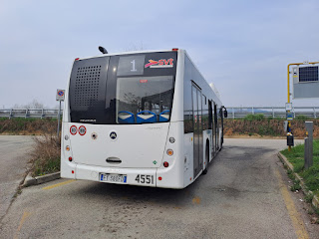



All of my friends came rushing to hug me all during church today. I felt so loved and missed. What a wonderful feeling! And my friend, Lasina, offered to give me a ride home afterwards, so that was nice.

Scott will be home around 7:00 p.m. tonight. If I can get this blog all proof-read soon, I'll still have enough daylight to go on a nice walk before he gets home.

Just a couple more quick things . . .

Jack got a HAIRCUT.

