Scottie is Home Again!
After 6 weeks of being deployed, Scott is back home again. Hooray! We have been enjoying the past few days here in Vicenza, hanging out, going for walks, and cooking meals together. How nice.
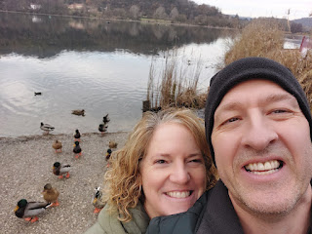

Monday, Dec. 4th:
I drove up to Pordenone to see Avery and Kylie. Pordenone (Por-deh-NOH-nay) is about 20 minutes east of Aviano, so it was a good meeting spot. I saw online that they had a nice Christmas Market and we thought it would be fun to walk around and see what they had. The Christmas Market wasn't that great (at all), but I had a delightful time with Miss Avery!!

She was super excited to see me again!! My heart just melts whenever she wants to run to me . . . Kylie had to hold her back for just a moment because I was standing behind her car and there were other cars driving by right behind me. That can be unnerving for a parent, ha ha.

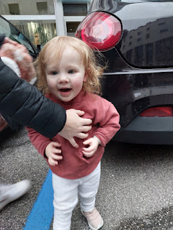

On our way down the street to the Christmas Market, we found a really cute Carousel. This was Avery's first carousel ride! She wasn't afraid at all. She rode on a zebra while I stood next to her and made sure she didn't slide off.

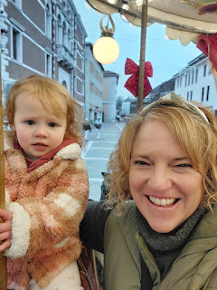

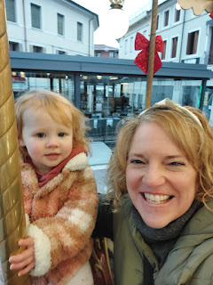

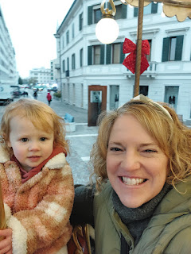

(It took a few tries to get a good selfie of the two of us . . .)

I got a better picture of the carousel later that evening.

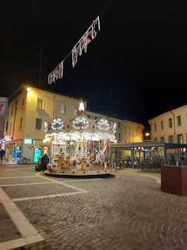

Just around the corner from the carousel was the Christmas Market. It looked very cute on first glance.

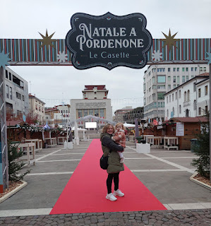

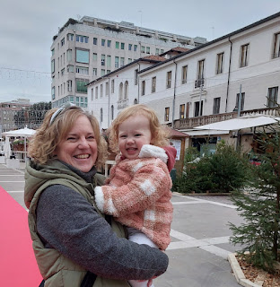

Avery had a lot of fun climbing on the bright red sleigh . . .

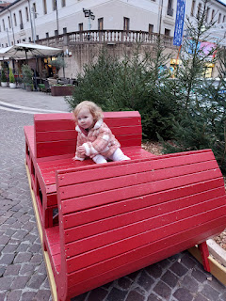

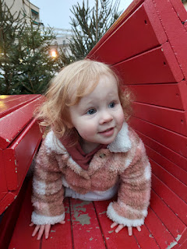

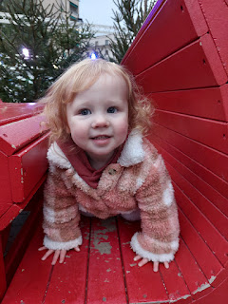

(This next photo is now the screensaver on my phone's home screen. XOXO)

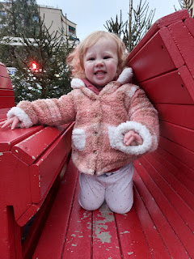

We let Avery take the lead to go check out the little Christmas booths.

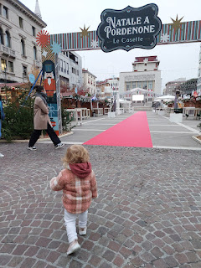

Video of Avery running as fast as she could down the lane of red carpet: (5 seconds)
https://photos.app.goo.gl/ohGP5HPmh99b2Xf58

Video of Avery laughing with me as she came towards me and then ran away: (14 seconds)
https://photos.app.goo.gl/chRRE4WPLrcVFFyD9

She wanted us to lift her up high so she could try to touch the Christmas ornaments hanging from the booth rooflines.

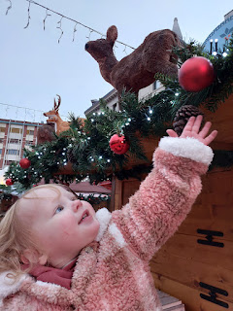

So, the Christmas Market was a wash for the most part. All the booths were closed until 5:00 and we had arrived at 3:00 p.m. There were 3 other booths open nearby, two of them were selling cheeses and salami, while one of them had some handmade crafts. I bought a set of crocheted tree ornaments and that was about all we could do.

What Avery REALLY wanted to do was to ice skate, ha ha. She was so excited to go out there and try to do what everyone else was doing. Kylie has been ice skating a few times before, but she wasn't really feeling up to skating this time. I have only been ice skating once before, so I was a little unsure as well. It's different when you're in a foreign country and there is a language barrier. Maybe back in Idaho we can take her to do something fun like this.

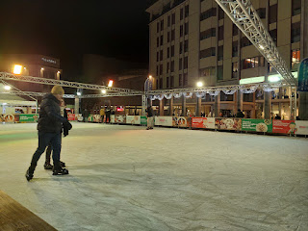

We let Avery run around for a while, until she started getting hungry. Then we walked back to where we parked, passing the carousel a second time. Avery wanted to ride it again, but she was also hungry. Such a dilemma!!

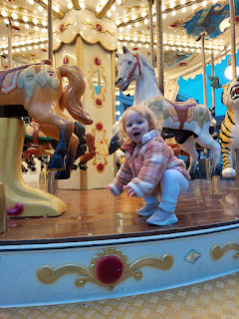

We drove over to the nearest McDonald's, since chicken nuggets are always a hit for Avery. After we filled up, Kylie drove me back to where my car was parked and then they drove home. I had a great time in the backseat with Avery while Kylie was driving. I didn't realize that Avery was so good at singing and doing the actions to songs like "Wheels on the Bus" and "Head, Shoulders, Knees and Toes." She also enjoyed when I sang "Five Little Monkeys" with her. She would shake her finger - "No more monkeys jumping on the bed!"

Video of Avery trying to keep up with "Head, Shoulders, Knees and Toes": (19 seconds)
https://photos.app.goo.gl/wKfJ1do4odTY1am58

Kylie said that Avery enjoys watching Miss Rachel, a children's show where they sing a lot of these kinds of songs. Super cute.

After they dropped me off, I walked back over to the Christmas Market area to see what was in those cute booths that had all been closed earlier. Well, they were just food and drink booths, mostly drinks. And mostly alcoholic drinks. Vin Brule is a really popular drink in all the Christmas Markets - all over Europe, really. It's a mulled wine. I don't drink alcohol, so I'm not interested, but apparently, it's a really big thing over here.

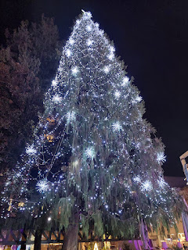

The decor was pretty, but the market itself was a pretty big letdown. Well, at least I got to see Avery. That was the most important thing. :)

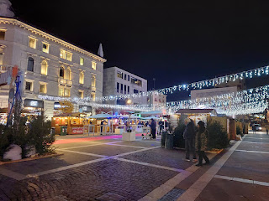

Tuesday, Dec. 5th:
I drove with my friend Rachel McGovern and her college-age daughter, Emily, over to Bussolengo to see Italy's largest indoor Christmas Market. Bussolengo is west of Verona and is about a one-hour drive from my house.

It was definitely huge! I think it's a very large landscape and nursery store when it's not the Christmas season.

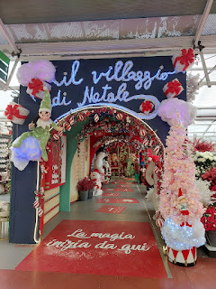

I am kind of obsessed with gnomes . . . I ended up buying four. If I had no limit on my budget, I would have bought several more . . .

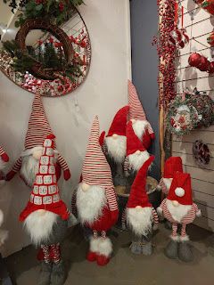

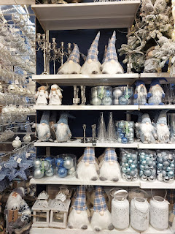

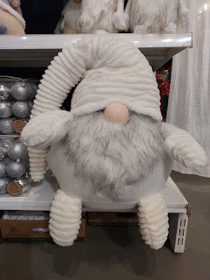

There were several themed areas that were really decked out and inviting and delightful.

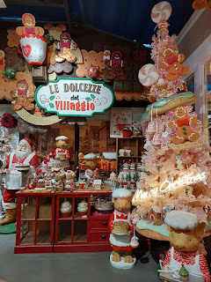

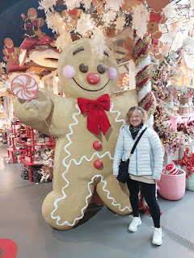

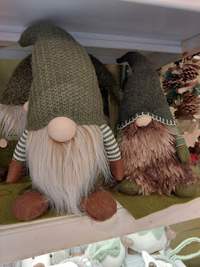

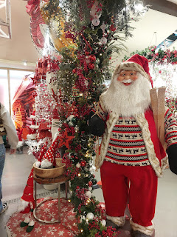

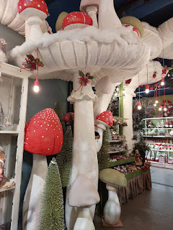

Near the end of the "trail" was a huge area with all things Nativity.

Video of the Nativity area: (10 seconds)
https://photos.app.goo.gl/LWPGSQuVNwFX9cbB8

In a glass case, there were several Nativity sets from around the world. Rachel got so excited to see one that represented Russia, because she spent some time there a few years ago, and she's been wanting one for a long time. She was a little worried that someone might see her choosing it and then assume that she approves of what Putin is doing to Ukraine. She was very happy to set it up once she got home, though.

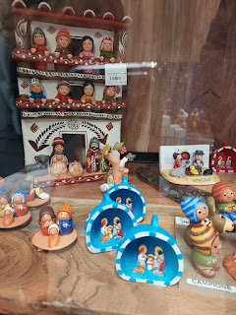

I saw a Nativity that represented Ukraine, and it spoke to me, so I ended up getting it.

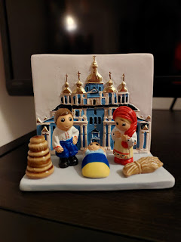

There were so many beautiful options, but I don't have a good way to get everything that I buy here home in 1.5 years. So, I just have to enjoy seeing them with my eyeballs.

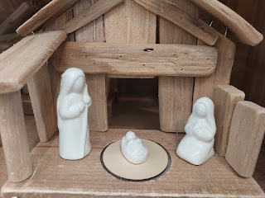

My cart mostly just ended up with gnomes, and a cute little stuffed animal for Jack . . .

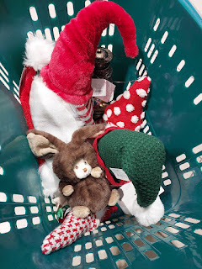

After we paid for our items, we tucked them into the trunk of the car and then we came back in to get some lunch. There is a large food court area, with cafeteria style service.

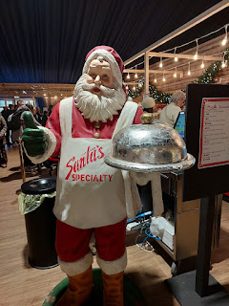

Mini charcuterie boards with local cheeses and meats, along with a wine-based jam . . . Emily chose this because it looked so good, and we had hoped that the dark "spread" was balsamic vinegar based. But it was not . . . so she just ate the items without the wine jam.

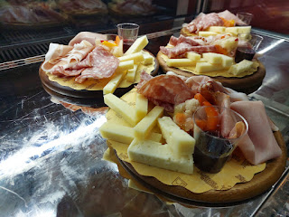

They had some festive pizza options, including "Pizza Klaus".

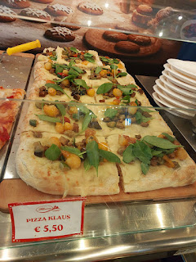

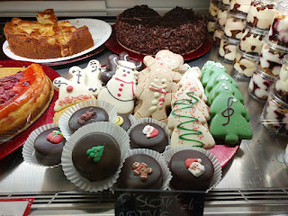

I chose: 3 Tyrolean dumplings (so good!!) with parmesan cheese on top, squash soup with lentils, a sliver of what I thought was raspberry cheesecake (but it ended up being a soggy jello cake), and a fun chocolate covered cookie.

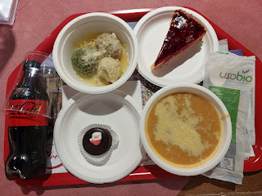

In the food court area, there were a variety of local crafty vendors, who not only had products to sell, but they also sat at their table working and demonstrating their craft. There was a man doing wood burning and a lady forming the cutest earrings. I took this one photo and then I saw a sign that said please no photos . . . oops. She had earrings with characters from Harry Potter, Frozen, etc. She had also made earrings that looked like sushi and other food items. Emily was beyond excited to get a set of sushi earrings. :)

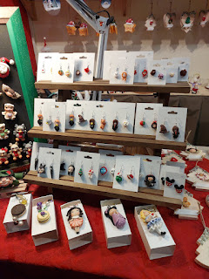

An adjacent shop had all kinds of treats and delectables for purchase. I chose a couple of chocolate treats for a lady that I "minister" to back in Idaho Falls. My "job" is to be her friend and to look in on her and do nice things for her throughout the year.

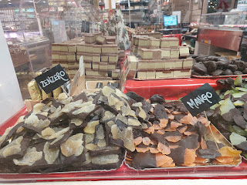

Outside, there is a Christmas Carnival area for the kids, with roller coaster rides among several others. It looked so fun! Sorry that this photo was taken through the fence . . .

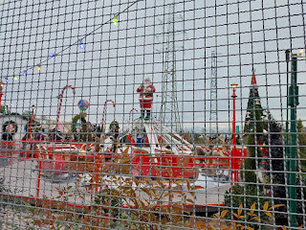

We had a great time and we marveled at how big this place was and all that they offered.

Later that evening I picked up Nell and the sister missionaries to drive out to Marnie's house for a Relief Society Christmas Dinner and Party.

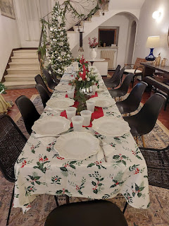

The dinner consisted of a Cafe Rio buffet - shredded pork and all the fixings. I brought a double batch of cilantro lime ranch to contribute. Nell, the missionaries, and I helped with some of the dinner prep before everyone else arrived. We chopped lettuce, tomatoes, avocados, helped cook the cilantro rice, set the tables, etc.

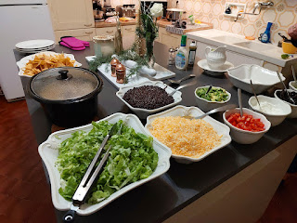

I made a shredded pork salad for my dinner, and it was delicious.

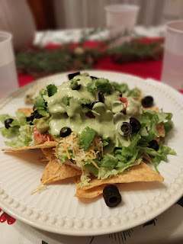

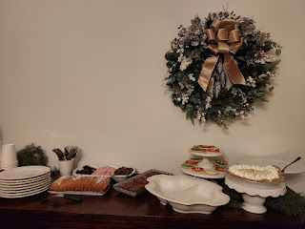

After dinner and dessert, we migrated into the living room. Sister Sherry Haines shared a spiritual thought about the shepherds in the fields when our Savior was born. The shepherds were likely uneducated and probably dirty and smelly from being out with the sheep around the clock for weeks at a time. They were lowly and yet I would like to think they were also humble. THESE are they whom the angels chose to visit to share the Good News. Why them? And then again, why not them? In the scriptures we read that they ran "with haste" to visit and honor the Christ Child. The angels did not come to the rich and the elite. They came to the dirty, the tired, and the uneducated shepherds. She generated a discussion about how we might compare ourselves to the shepherds. We might feel "less than" oftentimes, and like we are not good enough for important tasks or worthy to be a recipient of something miraculous. But we ARE!! It was a wonderful and thought-provoking message. Sherry is such an amazing person.

Next, we did a gift exchange. Last year it was a white elephant gift exchange, and somehow I got stuck on that plan again for this year. But, in fact, it was intended to be "My Favorite Things". Oops. I had wrapped a ceramic Christmas bowl with salad tongs (still in its original box) that a friend had given me last year to use in the white elephant gift exchange. Unfortunately, I was too sick last year to go, so I still had the bowl. I was excited to share my gift, but then everyone started sharing why they chose their items as their favorite things.

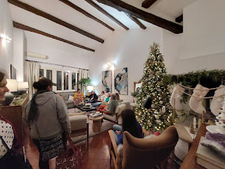

I scrambled to find something lame to say as to why I brought this Christmas bowl, when everyone else brought gifts of candles, a curling iron, favorite chocolates, favorite socks, a favorite cookbook, etc. Even though I felt dumb, everyone reassured me that it was a great idea and not to apologize for it.

Marnie Parker hosted this whole thing in her gorgeous home, with her usual kindness and generosity. She may have a house filled with magazine-worthy things, but she is so down-to-earth and humble. You can't help but love her with all your heart!

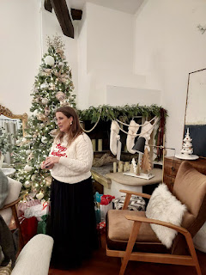

This was also an important day for my daughter, Amber. It was the eve of her big Christmas sale on her website, the culmination of weeks of painting elements of the Nativity story onto wooden rounds to be hung on someone's Christmas tree. She called me and showed me everything over a video call so that I could choose which one(s) I might want. She gave me first dibs!!

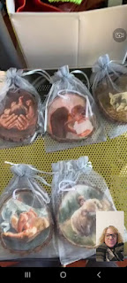

I had a hard time narrowing it down, but I got it down to three. We decided that she should go ahead and sell everything the following morning according to plan, but that she would also paint me 3 duplicates of the ones I chose and bring them to my house in a couple weeks. She will be driving out to Idaho for Christmas and I'm so excited to see them all again!! Her sale was very successful. She sold 16 out of 20.

There are still 4 ornaments available on her website:
www.amberwhitworth.com
Choose the category of "ornaments" to see what beauties she has created in the past month.

Wednesday, Dec. 6th:
I walked into downtown Vicenza to meet up with my dear friend, Sherry Haines, and our mutual friend, Nell Zeitzmann. Sherry has been overwhelmed with all the packing and organizing to prepare to go back to the U.S. at the end of their mission.

We wandered around the cute store, Flying Tiger Copenhagen, and walked around the piazza downtown. Sherry really wanted a hot chocolate, and she was shocked to hear that I have never had an ITALIAN hot chocolate. The cute little cafe that we chose is called La Triestina. It is on a side street near the main piazza in downtown Vicenza and is a very charming place.

Okay, so the Italian hot chocolate is actually pretty spectacular. What sets it apart from "regular" hot chocolate is the chocolate part. The Italian version is much thicker, and I've heard more than one person refer to it as pudding. Not all of them are that thick, but they do give you a spoon on the side. Mine was not that thick. It was more like a chocolate syrup underneath all the cream and whipped cream. It was amazing! It was a very fancy experience, one that I would very much like to repeat.

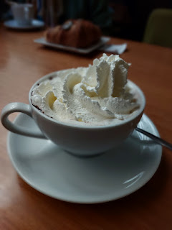

Me, Sherry, and Nell . . .

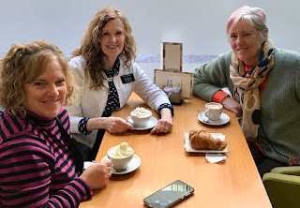

We walked Nell over closer to her home and then Sherry walked all the way home with me. It's about a 35-minute walk, but she wanted to visit with me some more. She asked me several questions about my childhood and my life experiences that made me who I am. She is someone that I refer to as a "builder-upper". She is always finding ways to compliment you and make you feel like a million bucks. She marveled at the experiences that I shared with her, commenting more than once that I am a miracle and that she has learned so much from ME. Wow. I would like to set the record straight that I am just an average person and that I have learned a great deal from HER. :)

I saw this on social media later that same afternoon. It seemed especially poignant after Sherry had talked about the special role of the shepherds the night before.

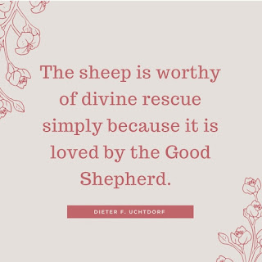

I taught another Family History Class that evening and it was probably the best one so far! We had about 10 people that participated and it was just SO FUN!! They were motivated and moved by some of the things I shared and taught. I showed everyone this sweet video that came out recently as part of the promotions leading up to the RootsTech Conference next February. It's a tear-jerker . . .

YouTube - "Your Story is More Important Than You Think" (7 min, 13 seconds)
https://youtu.be/cSfNA86DIUM?si=0wOyOA9NbCg8FJfr

We discussed a variety of ways to capture stories and memories of our living loved ones, especially since we are about to see some of them through the holidays.

I also taught them how valuable Newspapers.com has been in my research. I told them stories about my 2nd great grandfather, Thomas David Orr, who was pretty accident-prone. There were multiple newspaper articles about his horse and buggy crashes and details of the predicaments he somehow ended up in. Everyone thought it was so cool that the details were so specific. It was just a great night for the class, and I arrived home on a high.

We had kept a very close watch on Scott's flights during the day, because we were anticipating that they would likely be canceled. The flight from Cyprus to Munich had been canceled for 5 straight days in a row because of weather issues (snow and ice). Luckily for us, he squeaked through and made it to Germany just fine. There was another snowstorm coming into Munich about the same time his second flight was due to take off, so we felt extremely grateful when that flight took off on time, too.

I drove to the Venice Airport late that night to pick him up after 11:00 p.m. We got home at 12:30 a.m. and got ready for bed immediately, ha ha.

Thursday, Dec. 7th:
After sleeping in and having a relatively lazy morning, we worked on a few details to prepare for our trip to the Rome Temple the following day. We needed to print off some names to do ordinance work for, but when you don't have a printer, it's a series of steps to accomplish what would otherwise be a simple task. We had to save the info in Scott's Google drive, go to the library on base, sign up for a computer, log in and do all the required steps, and then finally print what we needed.

A huge celebration was already taking place that afternoon on base, gearing up for the big Tree Lighting Ceremony and concert that evening. Several booths were set up in the parking lot outside the library and the PX (Post Exchange), with children lined up in their cute little outfits to meet Santa and get a photo taken. As we slowly walked through, on our way back to the car, my good friend, Christine Swanson, ran over to hug me. I hadn't seen her in several weeks, so that was a small miracle that she spotted me in the crowd of people! She's been having a hard time with some health issues for many months now, sadly, and I am always worried about her. Scott took our photo in front of GIANT Santa, which was also next to the USO Booth where Christine was working. While the USO is an amazing program with activities and freebies and services for the servicemembers and their families, Christine's job is very demanding, and she doesn't get much time off to take care of herself. She'll even be working on Christmas Day! I'm hoping that after the holidays she can get a much-needed break.

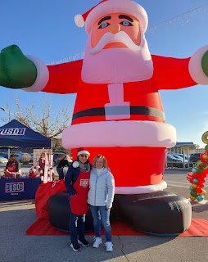

We went to bed extra early that night because we had to get up in the MIDDLE of the night to go the temple the following day . . .

Friday, Dec. 8th:
Even though my alarm was set for 3:00 a.m. (gross), I woke up at 2:45 a.m. (even grosser). We were out the door by 3:30 a.m. to meet with our friends at the Vicenza Est (east) parking lot by the freeway. I had encouraged Scott to bring a pillow in case he got tired, but he blew me off by saying, "I won't be tired. I wake up at 3:00 a.m. all the time because my brain has stuff to think about, ha ha."

Well, yep. He wasn't tired at all . . .

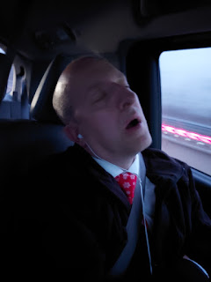

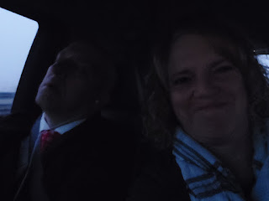

We were supposed to travel down to Rome with Sherry Haines, but she woke up very sick and felt like she was going to throw up. She drove into town with her husband, hoping that she would feel better by the time they got to the parking lot, but she didn't. With tears in her eyes, she sent us off without her, bless her heart.

The fog was as thick as split pea soup in several areas as we drove south, so Rachel McGovern, our driver, had to slow down quite a bit. It took us about 5 hours to get there, which really wasn't bad at all. Rachel is a very good driver and she got us to Rome and back safely. Katie Horner, our bishop's wife, also joined us. Marnie wasn't able to come due to some back problems and the anticipated long hours of sitting. So it was just the 4 of us.

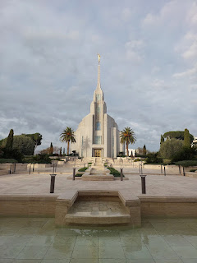

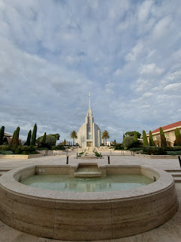

It was a wonderful temple session and was even more special than normal because there were a couple of ladies in front of us that were attending for the first time. They were from Romania! Thank goodness for headsets that can help everyone listen to the teachings in their native language. The movie about the Creation and Adam and Eve and other doctrines was presented in Italian. The closed-captioning on the screen was Romanian. And my headset was broadcasting into my ears in English. While it can be a lot for someone with ADHD to focus on what is actually being said, it can also be a catalyst for trying to pay attention more intently.

After the session was over, I found one of the ladies from Romania in the dressing room and I gave her a hug. I just felt like I needed to do that, so I did.

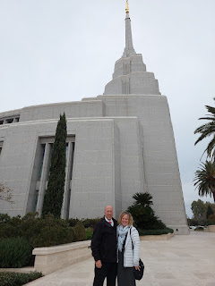

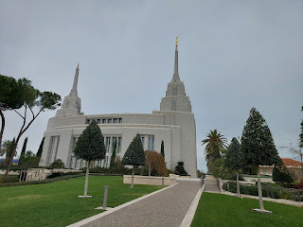

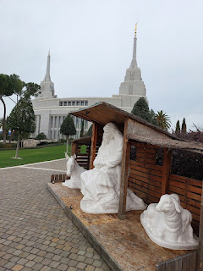

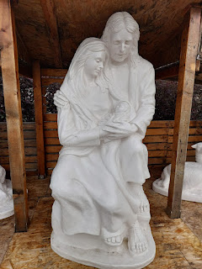

Funny story about this next photo: As we were preparing to take a selfie, my phone camera started doing a countdown of 3-2-1 and then CLICK all on its own, ha ha. So right as I was saying, "wait a minute, why is it . . .?" is when it took the photo. I especially love how Scott has a palm tree hairstyle.

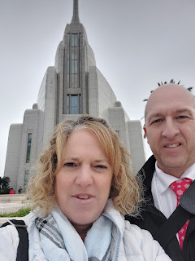

Much better . . .

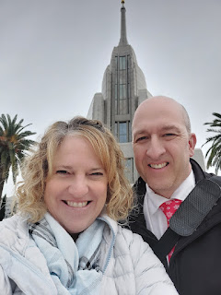

The Visitor Center was gorgeous with red poinsettias and Nativity scenes throughout.

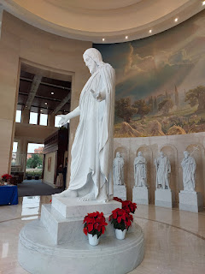

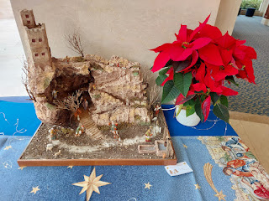

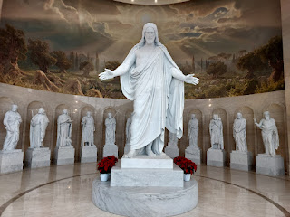

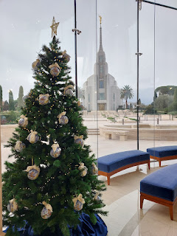

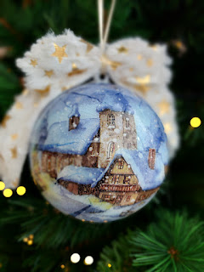

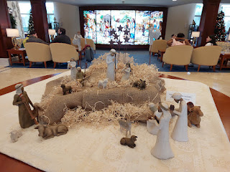

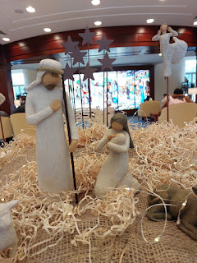

Then we began the long drive back up to Vicenza. It took a little longer to get home - a little over 5.5 hours - because there was a lot more traffic on the roads. There were some big Italian holidays going on around that same time, too. December 6th is St. Nicholas Day and December 8th is Immaculate Conception Day. It was also heading into a weekend, which caused even more gnarly traffic.

Some cool scenes on the drive home . . .

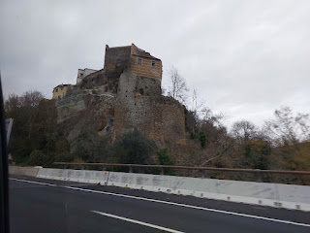

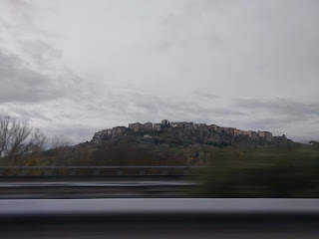

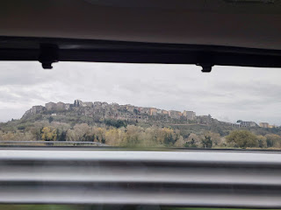

We ordered dinner through the Glovo app when we got home around dinner time. Glovo is similar to Door Dash, but the delivery guys typically use electric scooters and e-bikes to get around over here. We ordered kebab pitas and watched some TV before going to bed early again.

Saturday, Dec. 9th:
Scott and I worked together on his Christmas gift from me to him this year. Homemade applesauce. Last year, I found this large pot at the thrift store on base, so it helped to make this project a success. We borrowed a peeler/slicer/corer tool from Katie Horner and we were off to a great start.

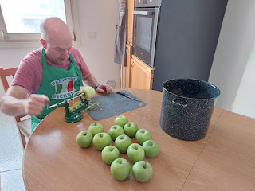

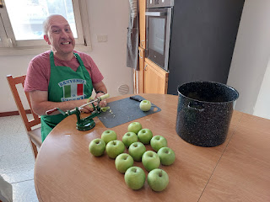

We mostly used Granny Smith apples because those were in the best shape in the Italian grocery store across the street from us. I have used the same recipe for years, one that my friend Julia Buell gave me several years ago.

It calls for about 18 medium tart apples, 1 cup of apple juice, 3/4 cup sugar, 2 Tbsp lemon juice, 1-2 cinnamon sticks, 1 tsp ground ginger, 1 tsp vanilla, 1/2 tsp nutmeg, 1/2 tsp mace, and 1/2 tsp cardamon. I could not find any mace here in Italy, even though I looked in several different stores. So I just addeda little extra nutmeg, since they are related. I also did not have any cardamon, so I just skipped that one.

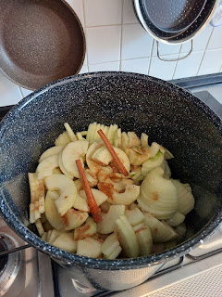

As it simmered for about 35 minutes on the stove, my whole house smelled AMAZING. I didn't even need to mash or puree any of it. It was perfectly cooked down with some occasional chunks. I didn't have a good way to heat up the jars and lids sufficiently with only having one large pot and no dishwasher, so when the lids didn't fully seal, we did an extra step by boiling the jars as you would in any traditional canning method. Now they are all sealed and ready for the winter months and for Scott to enjoy while I'm gone.

After we cleaned up the kitchen, we went for an afternoon walk around Lago di Fimon, about 20 minutes south of our house. This is the lake that I discovered for the first time when I was with Marnie's two daughters recently. We had hiked through the forest to get there that time.

There is a gravelly path all the way around the lake, a distance of about 4 km. We walked the whole way around and it was lovely. It was a very crisp day, but the sun was shining and that helped. It was about 42 degrees.

Lago di Fimon is a shallow lake, with a depth of only about 9 feet in the deepest parts. And yet, there is an abundance of waterfowl and even fishermen hoping to catch something.

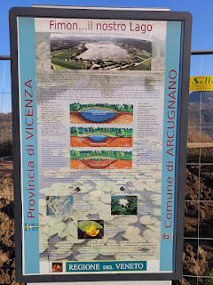

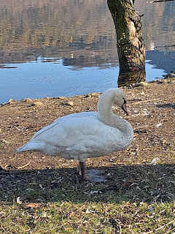

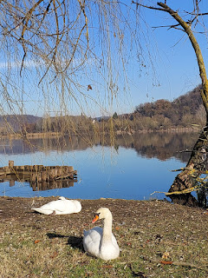

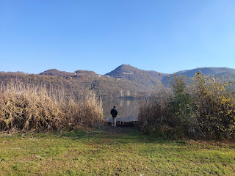

A group of Italian outdoorsmen hanging out on a Saturday afternoon. Guy Time.

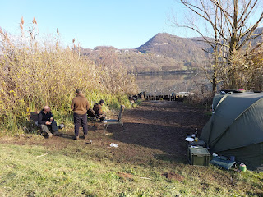

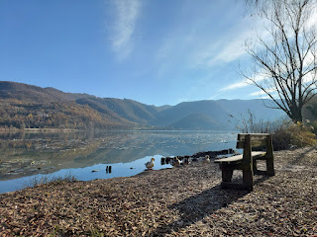

I loved seeing all the swans . . .

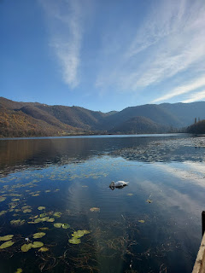

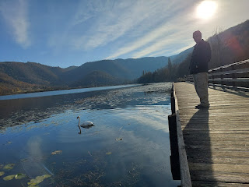

Some of these newfangled campers on top of an SUV are pretty cool. This one had a big solar panel on the front of it.

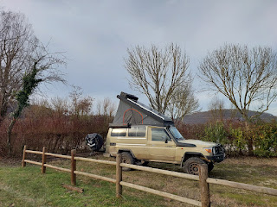

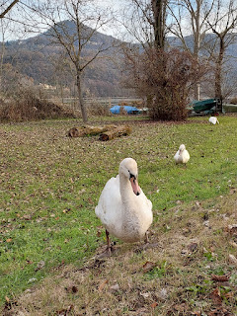

This guy hissed at me a couple of times, ha ha . . .

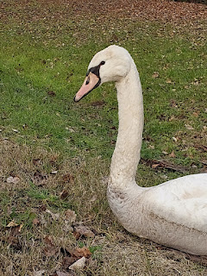

We plan to come back one more time before I leave so we can feed the ducks. We didn't have anything to offer them on Saturday, but they sure came running over to us!

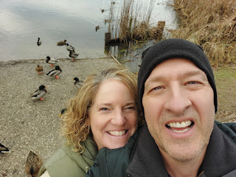

We squeezed in one more stop that I had been looking forward to sharing with Scott. I took him to the Museo del Risorgimento and the Parco Storico di Villa Guiccioli behind the museum. We wandered through the free museum first, viewing historical documents and memorabilia from when Napoleon invaded Vicenza in 1797, all the way through World War II. It was substantial and very interesting.

We did a short lap around the trails through the park behind the museum this time, because we had already walked around Lago di Fimon and we were getting tired. The trees were even more gorgeous than when I was there a couple weeks ago.

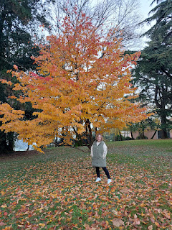

After we got home, we got a video call from Jack and his parents in Minneapolis. Jack was being super silly as we chatted. He was cracking me up!

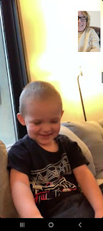

He has a new little toddler tent that will be his bed when he comes to Idaho and Utah in a little over a week. He loves to be zipped up inside with all of his animal buddies.

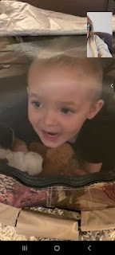

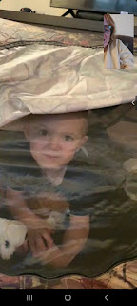

As he was eating a waffle for breakfast, I noticed that he seems to be getting taller and slenderer. He's probably having a growth spurt . . .

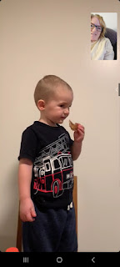

He was so hilarious as he made several different faces . . .

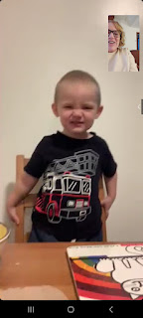

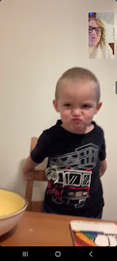

After we chatted with Jack, Jake and Hannah, we got a video call from Amber a short time later. She discovered that Whatsapp has a new feature - when you make a heart with your hands on a video call, red hearts start flowing out!! And when you do a thumbs up, it makes a thumbs up on the screen. Two thumbs made fireworks, too. How exciting!

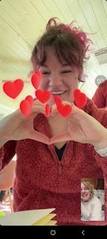

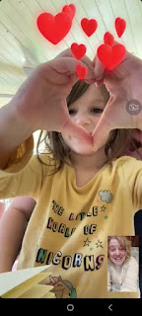

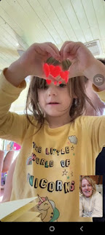

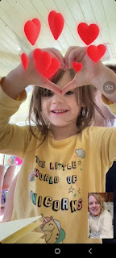

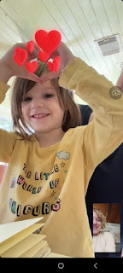

We couldn't get our Android phones to do it, and even though we searched on the internet for how to turn that feature on, we didn't have success. Amber has an iPhone, so maybe those of you with iPhones can give it a try and see if it works for you. Have fun!

I travel back to Idaho Falls on Friday, December 15th. I will be VERY SAD to leave Italy and Scott behind. It's getting harder and harder to leave him each time. I refer to it as "going to jail" when I go home (even though I love our home, our neighborhood, our friends, and seeing other family members). I refer to it as "getting out of jail" whenever I get to come back to Italy (even though I make sure to fill my time in the States with as many good things as I can). I am grateful for each 90-day period that I have. They each have their pros and cons. I am grateful this time that my kids and grandchildren will be there at my house through the holidays. That will make everything a little better . . .

