Shortest Blog Post Ever
Since my post from last week was so late in being published, it means that the rest of this week is very minimal as far as shareable content! ha ha
I'm going to make this as quick as possible tonight, because it's been a long day.
Gwen told me this week, "Hey Mimi. You are the best Mimi in the whole world." Say no more. That seriously made my whole day!! Here she is showing me her animal friends while I was talking to Amber on Wednesday.
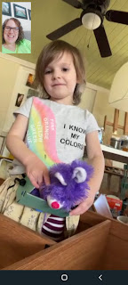

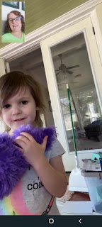



At one point, Gwen wanted to be up on Amber's shoulders. So Amber did what her father used to do when the kids were younger. If they said, "I want a piggy back ride!" He'd say, "Okay, hop on . . . " (while still walking). They had to figure it out themselves and make it happen.

Well, Gwen eventually figured out how to climb up and made it onto Amber's shoulders without any help from her mom. :) Oh, the exhilaration . . .





Jacob invited us all to to join a family video call that same evening. We got to watch Jack eat his dinner, while he watched us all on a cellphone screen and tried to figure out what we were all doing . . .





Shoving more broccoli into his mouth than he could actually hold. Eventually he began to let them all fall out . . . for about 3 minutes straight . . .



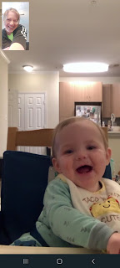

Jack has such an infectious grin, so here are some bonus Jack videos for your enjoyment.

#1: Jack eating a snack and shaking his head (18 seconds) (*This video has no sound*)
https://photos.app.goo.gl/CGWpUxGgwSbVxXPd9

#2: Jack eating a clothes hanger (22 seconds)
https://photos.app.goo.gl/uwawXhun7U6k1cko8

#3: Jack giggling with a full belly laugh while Jacob kept taking off his hat - which made his hair stand up super crazy each time (23 seconds)
https://photos.app.goo.gl/VxwnsJ5dKoDLk4mVA

He looks so sad in this next photo - maybe because he just woke up?

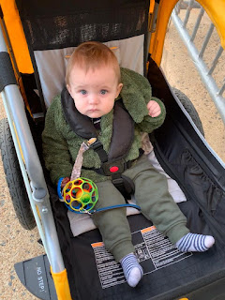

Babies are so precious when they're sleeping . . .

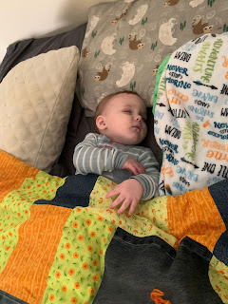

And here's Little Miss Avery - not sure whether to laugh or cry, ha ha. She is the cutest darndest little thing!!
(13 seconds)
https://photos.app.goo.gl/MjMGPT8AyJgPGZsy6

Abby recently discovered that she can turn a pineapple into a working phone!! (38 seconds) And she is so sweet and patient with her little sister, Gwen.
https://photos.app.goo.gl/HdNCabfid6iAMfBK8

And she also figured out how to imitate the dance of the Bird of Paradise: (10 seconds)
https://photos.app.goo.gl/pGCfmVgunh7EJnUKA

She's been studying exotic birds for several weeks in school. When they sent the video to us, we were asked to guess what animal she was imitating. I guessed the main bird character on the animated movie "Rio". Amber said, "You're super close!"

In Other News . . .

We chopped down our huge apricot tree on Thursday. It has been producing millions of apricots for several years, and unfortunately we planted it way too close to the front sidewalk. As the ripened apricots drop down to the ground, they always bruise on impact, and then quickly turn to fruit leather in the hot summer sun before I can get out there to collect them all (breaking my back in the process).

We decided it was time to get rid of it, even though it breaks my heart to chop down a tree. We still have our smaller apricot tree, and it can cross-pollinate with the peach tree. It has larger and better tasting fruit anyway.

Before we killed it:

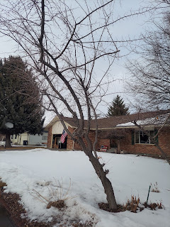

That tree was a stubborn one! It took quite a while to get it all taken care of. Scott had to resort to several different methods to get the thickest part of the trunk chopped down.

Video of Scott cutting down the first and largest section: (34 seconds)
https://photos.app.goo.gl/VN3G9ntq8N9VqNhm8

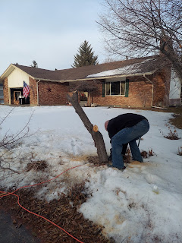

Video of Scott trying to get the last section of the trunk to go down: (He tried the chainsaw for a while, then resorted to chopping it with an axe)
(7 seconds)
https://photos.app.goo.gl/EHjZ6KKboJEs478K7

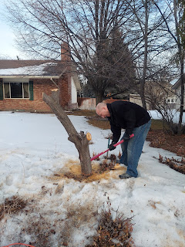

Scott climbing up on the trunk and trying to bounce it into submission: (19 seconds)
https://photos.app.goo.gl/caMuYmBjmXT3Teuk9

That technique eventually worked after much (and vigorous) bouncing.

We worked together to load up the truck and clean up for the evening. At least it was a warm 45 degrees outside for the project!

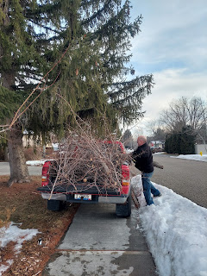

The next day we hauled everything to the dump. It feels good to not have to worry about picking up apricots for 3 hours a day for the entire month of July now . . .



After we chopped down the tree, I drove over to Community Care to get my throat looked at. It hurt so bad - but just on one side. It felt like my left tonsil was on fire and it really hurt to swallow. It took 3 tries for them to get a decent swab of the back of my angry throat, because I kept gagging. The test came back negative, but I was sure it was positive. My mouth tasted really nasty on Thursday in addition to the stinging sore throat. Also, every time I yawned it felt like someone was slicing open my throat with a knife.

The doctor was very accommodating and offered to give me a prescription for an antibiotic, since he was also left wondering if we had gotten a decent culture. I tell you what, after 24 hours on that antibiotic, I felt much better! I'm pretty sure I had strep throat, or at the very least, tonsillitis. I'm doing great now, even though it still hurts pretty bad when I yawn.

Today, Sunday, was a very busy day! Scott had army drill this weekend, so he left before sunrise to drive down to Pocatello. He has been busy turning in all his gear and getting things squared away to leave.

I got up at 7:00 a.m. and got ready for church. I was released from serving in my YW calling today, and it's definitely a bittersweet feeling. I feel relieved that now I'll have a big chunk of my brain to devote to other things, but I will also miss those girls and all the fun times. The silver lining for getting released is that we are planning a trip to the roller skating rink for our last big hoorah on Saturday. I'm super excited to have some fun with them one more time!

After church, I hurried home because our niece, Ashley, and her family were swinging through town after attending a funeral down in Utah. (They live up in Spokane, WA) I didn't get any pictures because it was a super short visit - only about 45 minutes. I got the kids all squared away downstairs in the grandchildren guest room with all the toys, while the grownups all sat down to visit about Europe and ask questions about their previous world travels. (Ashley and her husband David used to teach school in Qatar for 2 years a few years ago)

Then my young women showed up at 1:00 for our last class presidency meeting together. We discussed and planned for the next two months, ending our meeting around 2:30. The other YW leaders stayed a bit longer so we could help get all the new leader's questions answered. They left by 3:10 p.m. and that's when Scott and I kicked it into high gear.

We hurried to slice up a quart of strawberries and prep the ingredients for strawberry shortcake that we could take up to Rigby for dinner with his parents. Then we hustled up to Rigby, arriving just before 4:00.

We had a lovely evening with Phil and Coy, and while the last minute dinner preparations were being made, I took some cute photos of Scott sitting on the couch with his dad, talking about potential housing for his upcoming assignment in Italy.

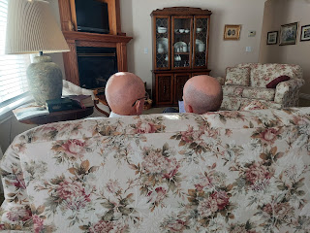

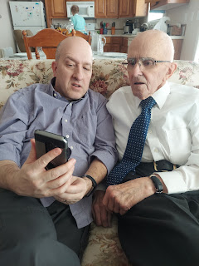

Dinner was delicious, as usual, and dessert turned out great as well. (Thanks Mom for making those yummy Bisquick shortcakes when we were younger!) I always remember them fondly and decided to recreate that nostalgic dessert tonight. It made me very happy. :)



Scott's dad offered to give him a father's blessing before he leaves this week. He is always so kind and thoughtful.

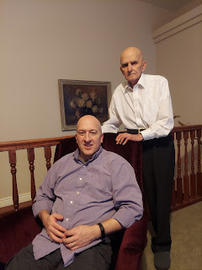

Sweet hugs . . .

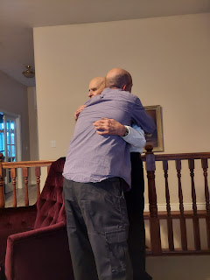

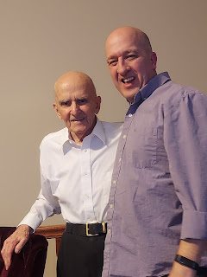

Final hugs for his mama, too. She will miss him terribly, as will I. But we will find ways to comfort each other in the coming months by getting together as often as we can.

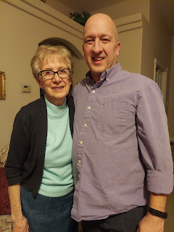

Scott leaves early Wednesday morning to head to El Paso, TX for some processing before flying over to Italy. We're not sure how long it will take in Texas, but we hope it will be quick and efficient so Scott can get over to Italy and start the process to find us a house.

I will still be here for a while. Sometime in April I will go over to meet up with him there. We're still working out those details . . . I just look forward to being WITH him. That's always a lot better than being on the other side of the world from each other. :)

