Soave Castle & Crespano del Grappa
Places mentioned in this blog post:
Soave, Italy
Bassano del Grappa, Italy
Campese, Italy
Crespano del Grappa, Italy
Vicenza, Italy

We have found some fun places to go on a date recently, that are also not too far away. We typically like to go somewhere together on Saturdays when Scott has the day off. Two of our most recent dates took us to the Soave Castle and also to the surrounding areas of Bassano del Grappa, in search of some family history sites.

Soave Castle:
With its beginnings going back to the 10th century, this large fortress has seen many feuds through the years, with ownership changing hands multiple times. In one of the inner courtyards, you can see some of the oldest remains, which include portions of a church that was dated in the early 10th century. But the castle as we see it today was rebuilt in the 14th century, with restorations and renovations being completed by 1379. Soave is approximately 35 minutes west of Vicenza.

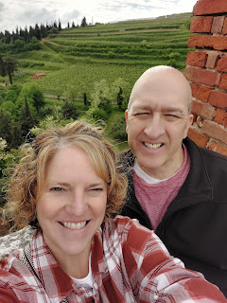

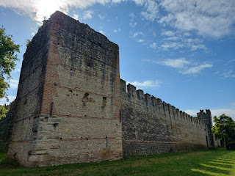

Video as Scott's drone took off outside the fortress wall: (15 seconds)
https://photos.app.goo.gl/RZiN7bQEj6KRLxXi8

To watch the drone footage that Scott made as he flew over the Soave Castle, click here: (3 min, 2 sec)
https://www.youtube.com/watch?v=P7pxVldgBr0&t=78s

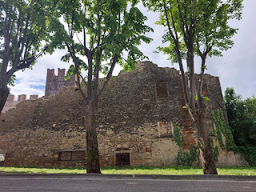

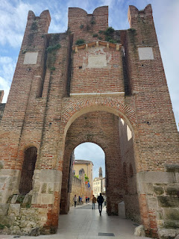

Below: A description of the entry arch that we came through, named Porta Aquila. The sign describes the history of the entrances and the fortress itself, mentioning that the surrounding walls were built in 1375. (click photo to enlarge and read)

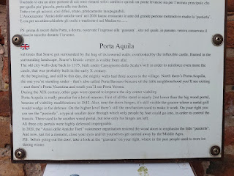

Note the two distinct sections on the ginormous door . . . I think this is what the sign above was talking about with the difference of 2 meters between the door and the street below.

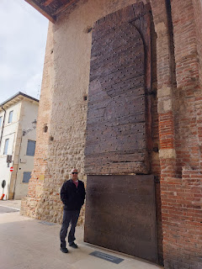

This next photo describes the "ice house", or La Giassara, as the Italians called it.

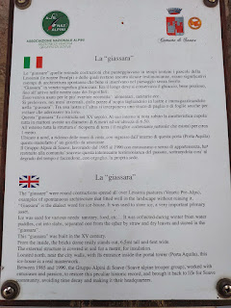

The entry to La Giassara . . .

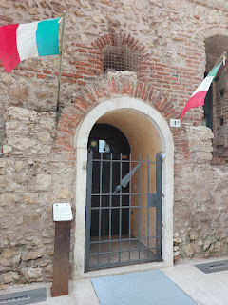

We hiked up 130 steps, give or take . . .

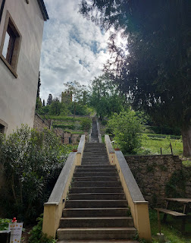

To walk up some steep pathways . . . with beautiful views, mind you . . .

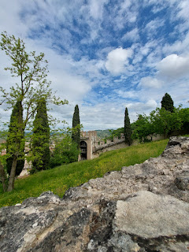

To walk up more steps and steep pathways . . .

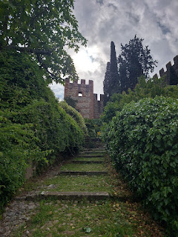

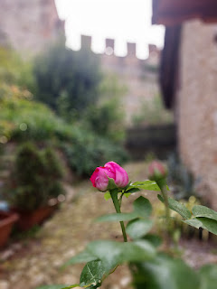

To get to the ticket office.

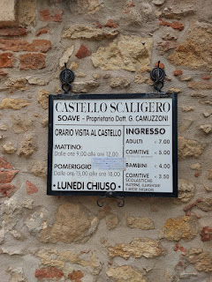

Then, after a few more stairs, we could enter the first courtyard . . .

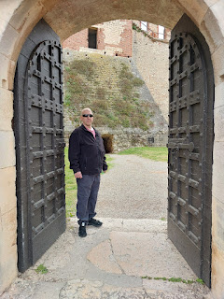

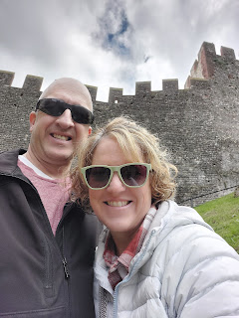

We enjoyed the ancient rooms, staged with furniture, armor, and weaponry.

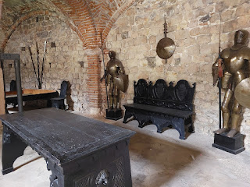

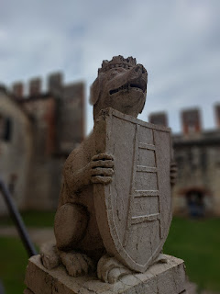

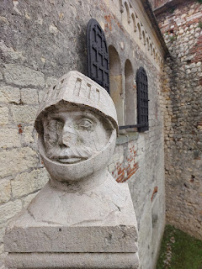

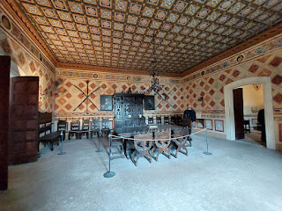

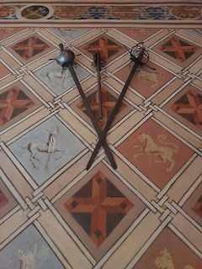

Views of the vineyards behind the Castle: (12 seconds)
https://photos.app.goo.gl/65ZpvZBiJy8oEVA97

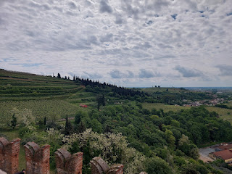

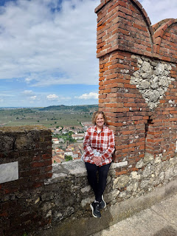

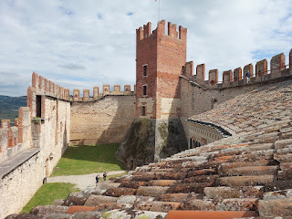

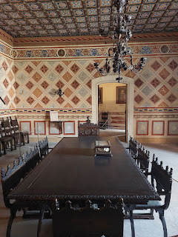

This website has a LOT of good information and history about Soave and the Castle:
https://www.amaronetours.it/verona_wine_regions/soave

**Depending on which browser you use (I use Chrome),
if the links I'm sharing are showing up in Italian
, you can click on the 3 little dots (the menu) in the upper right corner. Look down the list and if you see the option to
"Translate"
, choose that. I use it ALL THE TIME. :)

**If you don't see the option to translate, you can open a new tab and go to the
Google Translate
page. You can cut and paste whole paragraphs into Google Translate, choosing to go from Italian to English, of course.

I believe that the paintings below are 1) Taddea da Carrara, wife of Mastino della Scala II, and 2) Cansignorio. They lived in the Castle after conquering it in 1271. It changed hands again in 1338 but was reconquered again after much bloodshed. Why so much fighting? So yeah, it's a nice castle . . . maybe you could go and build your own?

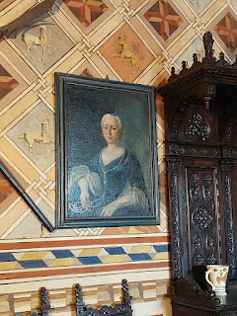

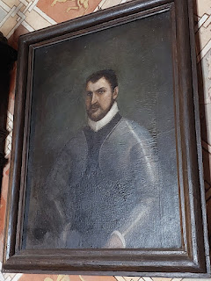

GINORMOUS keys . . . to the dungeon maybe? Or the "front door"?

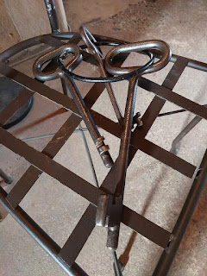

Some type of ledger, perhaps? Or a centuries-old guest book?

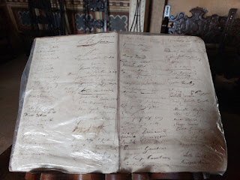

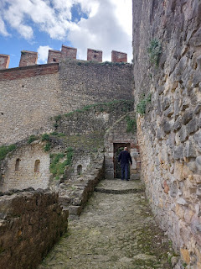

A map of Soave, showing the fortress walls that surround the "inner" town, versus the rest of the town situated outside the walls.

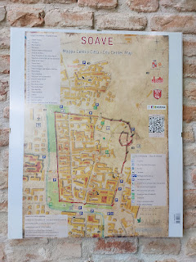

The castle was very interesting, even though there weren't enough signs and information posted about what we were seeing. I will be going here again in September, when my sister, Charmaine, comes to visit.

While we were in the area, we stopped by Frantoio Bonamini, my favorite place to get olive oil. I grabbed a few items to send to my mom and step-mom for Mother's Day. They had an interesting sign on the wall inside the shop that I hadn't noticed before. It explains some FAQ's, such as what is the difference between olive oil and extra virgin olive oil, what is "cold press", and what is "unfiltered" olive oil? (click on the photo to enlarge) It's in English. :)

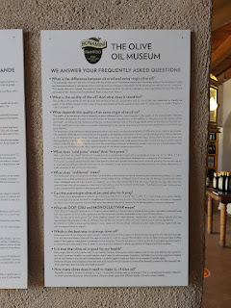

That evening, we made shrimp nachos for the missionaries and had a great visit with them. (Thanks, Mom, for the great recipe that I've used many times.)

Link here for the recipe:
https://photos.app.goo.gl/egc9VThPYrKB4gCc7

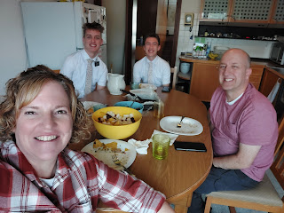

Bassano Ancestral Sites:

The first place we drove to was the Chiesa (Church) della Santa Croce in Campese, slightly north of Bassano del Grappa. The reason why we went there was because I came across a reference of Baptista Bassano and his father, Andrea de Crespano, with a connection to this same church. (more on that in a minute)

The Church of Santa Croce was built in 1477, with renovations taking place in 1488. Per Wikipedia (and Google Translate):

"The report of the bishop's visit in 1488 gives us precious information that allows us to go further back into the architectural history of the church and part of the monastery.

“That same day the bishop, having forded the Brenta, visited the monastery of Santa Croce di Campese [...] the place is large with many large buildings and (once) many monks lived there. The church has three apses facing east and had two others: one facing south, the other north, so that the building had a certain cross shape. These two apses (cubes) have been demolished and the walls, where there was the entrance to the apses, have been walled up. [...] The nave is long and large, but open to the winds and the numerous pigeons that nest on the roof cover the floor with excrement and feathers. There are three altars in the three apses, all consecrated; near the church there is an oratory (sacellum) with a consecrated altar, quite large, paved, where the monks celebrate the divine office. There is a garden enclosed by walls extending more or less for five square meters, a vegetable garden, another garden, courtyards. Then there is a cloister with the refectory, the wine cellar, the granary, the kitchen, then the guesthouse and the dormitory...
"Inside the church of Campese there are several valuable works. Among these we remember a fresco depicting the crucified Jesus with a donor (this donor appears to be a religious person), painted in 1517. The altarpiece is contemporary, the subject of which is the Madonna and Child surrounded by Saints Scholastica, Benedetto da Norcia, Rocco, Caterina d'Alessandria and Giuliano, work by
Jacopo da Bassano
."
In 1481, Andrea de Crespano (my 17th great grandfather), signed a lease for some farmland near Crespano del Grappa. The field(s) already had legumes, which was helpful because the Bassanos needed a place to graze a few cattle. Why? Because an important part of their instrument-making process involved the use of calf skins. I do not know exactly where they leased this land, but the distance between the church that they leased the land through and Crespano del Grappa is not very far. I started with the church because it had an exact address.

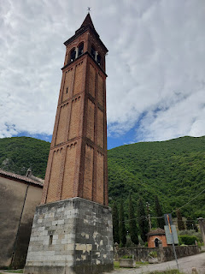

While Scott sent the drone up, I spent some time just wandering around the outside and taking photos, because the main doors were locked and I could not go inside.

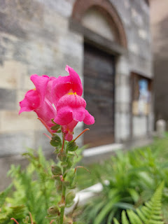

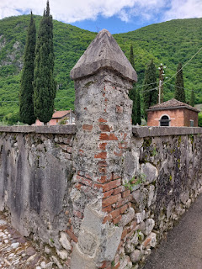

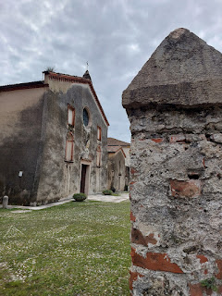

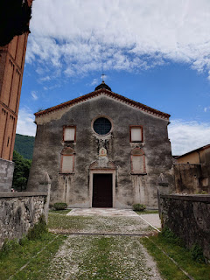

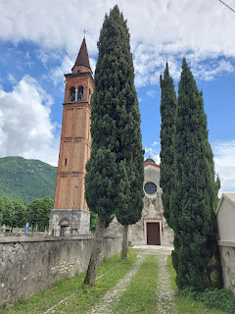

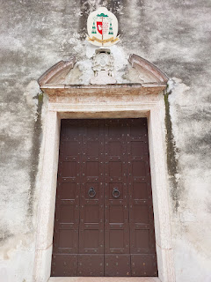

I was especially intrigued by these decorative carved rocks in the corner of the courtyard out front. I tried to use Google Translate to see what the one on the right says, but I could not get any answers. It might be in Latin, instead of Italian, but Google Translate still couldn't give me the answers I wanted.

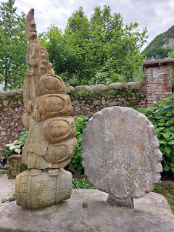

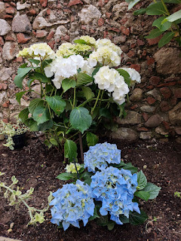

Almost immediately, I started noticing the use of this chunky cross, seen in places both inside and outside the church. (How did I get inside, you ask? You'll find out in just a minute . . .)

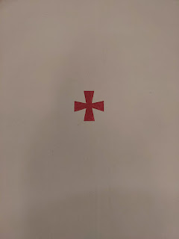

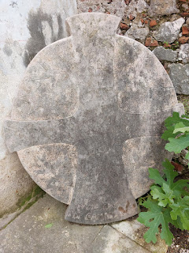

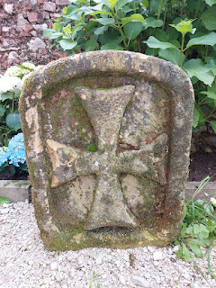

In the book I've been
meticulously
reading, "Shakespeare Exhumed: The Bassano Chronicles", the author (Dr. Peter Matthews) mentions the following:

"The de Bassan family were Knights of the Order of Santiago (in Spain). The Templar Knights of the Order of Santiago were much like the later Knights of the Order of Saint John of 1128 AD. However, the origin of the Order of Santiago dates back to 23 May 844 AD, whereby the Apostle of Santiago (St James) is said to have intervened in their favour against Muslim rule during the Battle of Clavijo amidst the reconquest of the Iberian Peninsula between 722 and 1492. (
*Note by Michele: In my original Ancestry DNA results - roughly 10 years ago - I had a category of DNA from the Iberian Peninsula!! It's basically Spain and Portugal, with a tiny bit of Southern France.
)

"The Order began out of a dream that King Ramiro 1st had of Saint James the Greater, one of the apostles of Jesus, upon a white horse leading them into battle against the Muslims. The next day (23 May 844), King Ramiro mounted a white horse just as Saint James had done so in his dream, and he won victoriously. Thus was the beginning of the 'real Templar knights' where Saint James was termed 'Santiago Matamoros' or
Saint James the Moor Slayer
and was recognized as the national patron saint.

"It should be noted that King Ramiro's royal flag of 844 AD was originally a red cross on a white background, exactly the same as the later adopted flag of the Order of Saint John of Jerusalem. Saint John was the younger brother of Saint James; both were sons of Zebedee. The red cross on a white background was not the original emblem of the Templar Knights of Jerusalem upon its inception in 1128. The squires wore black garments with a white cross, and the professed knights were required to wear white garments with a black cross to illustrate they had left behind their dark life for a white life."

Does this all sound like something out of the movie, "National Treasure"??!! The more I read, the more I'm hooked. It's an exhaustive number of historical facts along with my own family history that weaves in and out of these FASCINATING details, but I am having so much fun as I learn!

Also, do you recognize one of the crosses in the photo below? They are some of the crosses that are associated with the Templar Knights. I knew about the important crosses before I visited this special church and saw the red/white cross (on the bottom row of the photo) in and around the Church.

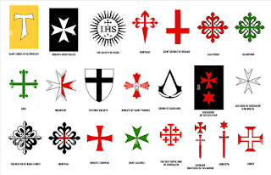

In this same book, Dr. Matthews also mentions things like:
There are symbolic markings in the All Hallows by the Tower Church (in London) that correspond with the symbolism of the Templar Knights of the Order of Santiago. This is the church were the Bassanos attended church after they settled in London and where some of them are buried.
There is a lot of evidence that the Bassanos were of Jewish origin, and it is very likely that they secretly practiced their religion down in the crypt of the All Hallows by the Tower Church. He lays out several masterful evidences of this. *Side note: The crypt is also the same exact room that made me cry the two times I visited, without knowing why I was getting all choked up.
On the Bassano Coat of Arms, the central feature is a Tree of Life.
He talks about the ancient Ark of the Covenant and the Urim and Thummim and how they relate to the Bassanos and their Jewish origins, how they also link to the Templar Knights, and how for centuries people have been searching for these sacred relics.
I wish I had more hours in the day to read and study, and study and read MORE, MORE, MORE!!

Okay, let's just calm down and take a deep cleansing breath. Back to the Church of Santa Croce in Campese, Italy . . .

More photos around the exterior . . . this plaque was clearly old because the inscription is unreadable . . .

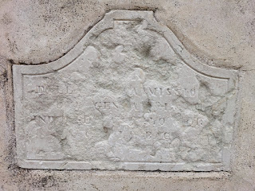

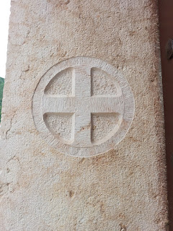

I walked through the two cemeteries that are adjacent to the church, but did not see any Bassano names. It was a longshot, but I had to try.

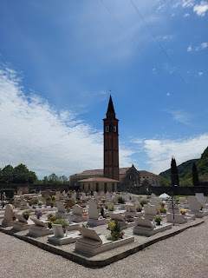

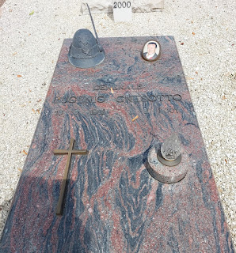

I wanted to know what this sign said, so I pulled up the Google Translate app on my phone, choosing the camera lens feature on the bottom right of my screen.

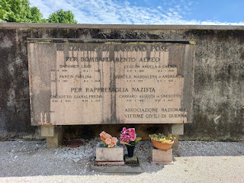

This is what it is able to do . . . (click photo to enlarge and read)

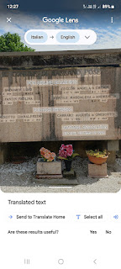

Sometimes I do a screenshot and save it for later, and sometimes I push "send to Translate Home". It changes everything to words only, without the photo in the background.

Scott wants to be tucked into something like this someday . . .

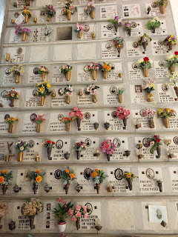

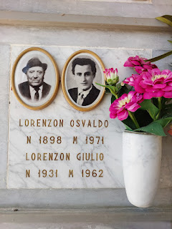

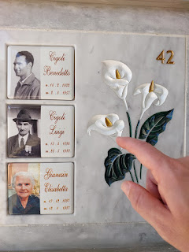

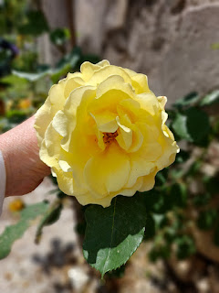

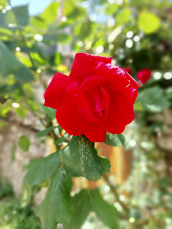

After Scott and I finished walking around the cemeteries, we were just about to wrap things up and walk over to the river nearby . . . and that's when we met some new friends. A man, who we later learned was named Alessandro, was at the door of the church and wanted to go inside, too. He spoke to me in Italian, and when I apologized for my need to speak English (mi dispiace, solo inglese), it turned out that he spoke English quite well!!

We discussed how we might could get access and he pointed to a sign next to the door with a phone number to call. We dialed the number, but didn't get any answer on the other end. However, within moments, a man appeared on the balcony above us and welcomed us to come in. Between Alessandro and his wife, Anneliese, they were able to translate much of what the rector shared with us (in Italian) during our tour.

YAY!!! We were going INSIDE!!!! The timing could not have been more perfect to run into Alessandro, since less than a minute later we would have been gone on our walk down to the river. Coincidence? I think not.

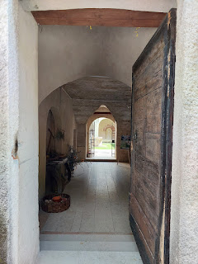

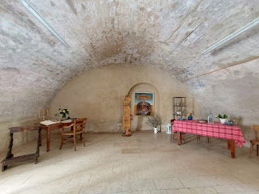

We had to be silent to walk through this room, but I wasn't sure why. Nobody explained . . . because of the need for silence.

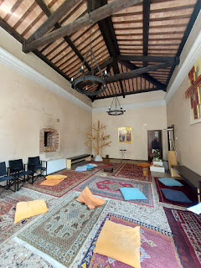

View from the back of the main chapel, looking toward the baptistry. Note the red cross on the wall.

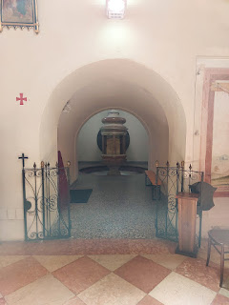

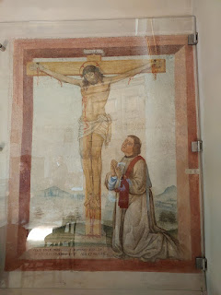

We had a brief discussion with Alessandro about our religious beliefs in the baptistry room. I shared that we believe that the age of 8 years old (and up) is a good age to understand what they will be committing to, and to be held accountable for their choices after baptism. We believe that babies are innocent and therefore need no baptism, plus they are not old enough to know and understand the ordinance that they are receiving. Alessandro was curious and interested and respectful.

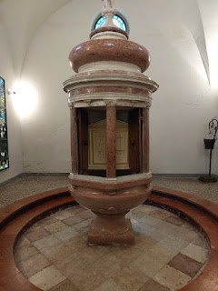

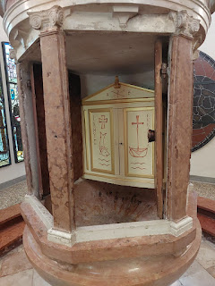

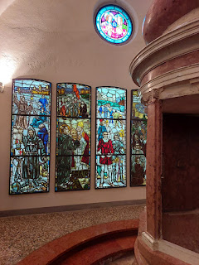

I absolutely loved the stained glass panels in the baptistry room.

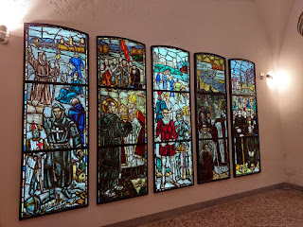

This is the main chapel . . . note the small arched openings to the left and right of the altar at the front.

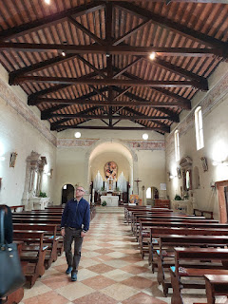

Video of the chapel: (14 seconds)
https://photos.app.goo.gl/xSiBMWhUh5ymsx6P7

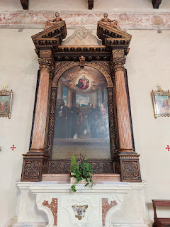

In the small arched room to the left of the main altar area there are some pretty amazing items. One of these is a memorial to Pontius de Melgueil, the original abbot of the Church of Santa Croce, who formed a monastery here in 1124 AD.

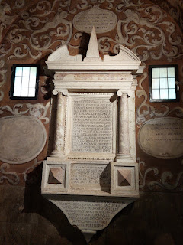

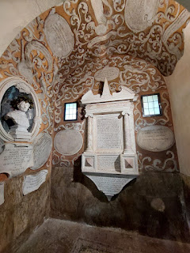

On the floor of that same small arched room . . . is a memorial to the macarone poet - and a colleague of the Bassano family, Teofilo Folengo, who was buried down there in 1544.

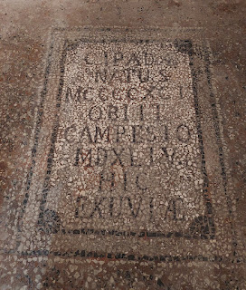

Outside the chapel and looking through the cloister (a covered walkway within a monastery) . . .

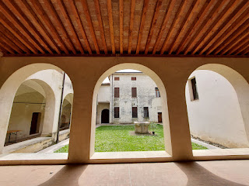

A memorial along one of the outer hallways, dedicated to Pontius de Melgueil, the original abbot. Note the cross on his chest . . . it was in the same chunky style as the other ones I had seen earlier.

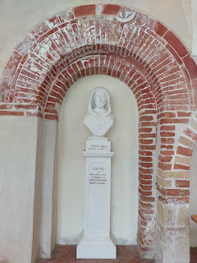

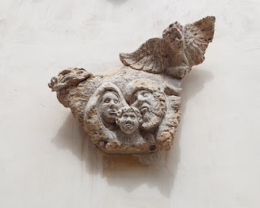

Another chunky cross above the doorway just before we exited . . .

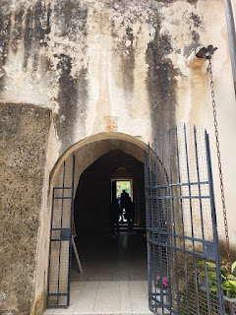

Scott and me, along with our new friends, Anneliese and Alessandro.

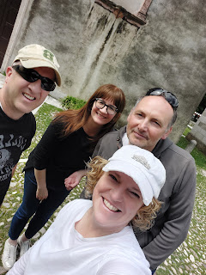

Alessandro texts me regularly to ask how we are doing. I messaged him today to clarify something we had seen in the church during our tour, something I could not remember the details of exactly. He was able to give me the information that I needed. They live in Bassano del Grappa, but he works in Vicenza and is familiar with the US Military bases in town. Maybe that's how he learned to speak English . . .

Shortly after our tour of the church, we parted ways. Scott and I walked across a long narrow bridge (thankfully with a pedestrian path) and found a trail down to the River Brenta a short distance later.

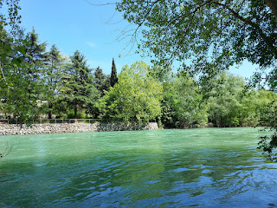

Video of the beautiful river and the calming waters lapping at my feet: (25 seconds)
https://photos.app.goo.gl/6tHHQpu3Fy4ArKhv7

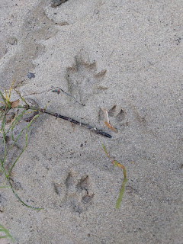

Video of a ducky floating by: (18 seconds)
https://photos.app.goo.gl/9Jpbq4QVxW6NVLVn6

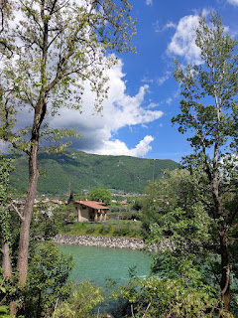

After some drone footage (link below), we walked back to where we parked next to the church.

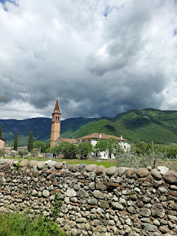

This sign in front of the church indicates the burial place of the famous macarone poet, Teofilo Folengo.

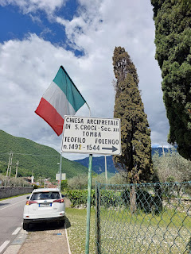

We were so lucky - and blessed, I feel - to have been able to go inside this old church. I'm so glad we took our time earlier as we wandered around the outside, which then led to the absolutely perfect timing for running into Alessandro and Anneliese, which then led to us getting access for a tour inside. Wow.

My short stature in comparison to the church . . .

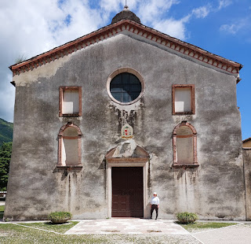

Next stop: Crespano del Grappa

Video as we pulled into the Piazza San Marco: (17 seconds)
https://photos.app.goo.gl/4LRYxsY3WXB8DMvZ7

In the Piazza San Marco is the Chiesa Parrocchiale di San Marco. Although there were older churches in the same location prior to this one, the current version was completed in 1762. The reason we visited Crespano was because my ancestor has the town as part of his name (!) and because we know he leased some farmland from this area.

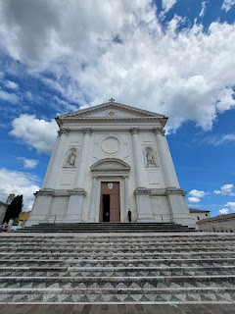

The interior was very beautiful and ornate . . .

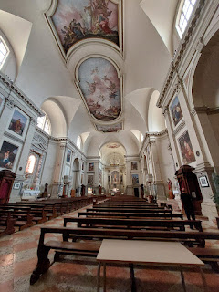

Video of the chapel: (24 seconds)
https://photos.app.goo.gl/veYHJSQGgpi2MrV66

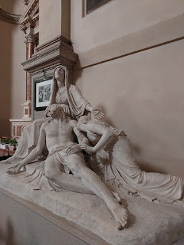

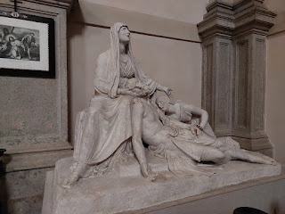

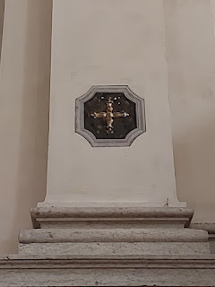

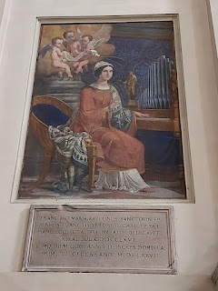

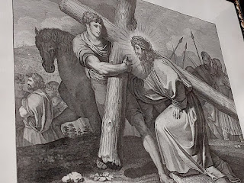

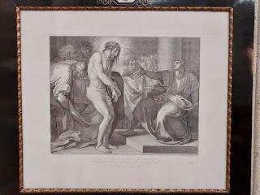

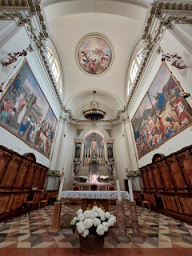

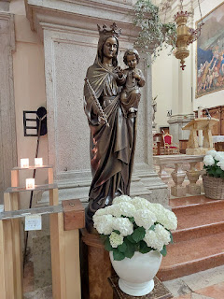

The flooring was original, and it felt pretty amazing to stand on it . . .

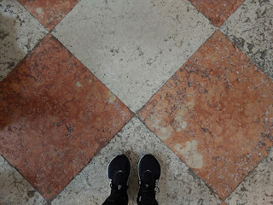

THIS flooring was not so amazing to stand on just a few minutes later, in a small restaurant bathroom in the piazza. Blech. I hate these bathroom experiences.

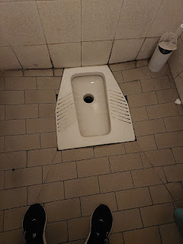

On the other side of the piazza is a very tall tower. It houses a museum dedicated to telling the story of the Great War during 1915-1918 and its effects on the Italians from this region. We did not go inside, but we did send the drone up again. The tower "towers" at a whopping 99 meters in height. The drone came a little too close for comfort as it flew a loop around the piazza, gathering some pretty cool footage. (*nervous laughter*) But everything turned out okay.

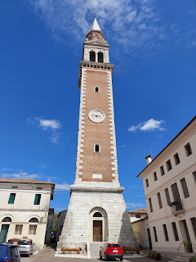

Next to the tower, on the left, were some beautifully crafted wooden benches. As we got close, though, there was a disturbing situation, and we could not get any closer.

Video of the benches: (21 seconds)
https://photos.app.goo.gl/n7RcP5ZBofgGQVuQ7

Behind the tower is a recreational sports complex, with tennis courts, etc. There is also a small courtyard with a very old building that is currently being rented out as apartments. Someone there sure has a fine skill in wood crafts to have built this very intricate birdhouse.

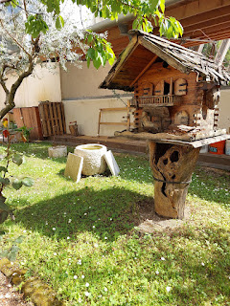

The very old building behind the tower . . . I'm always drawn to old structures, especially ones in the same centuries-old towns where my people used to live. I like to envision them living here themselves, or perhaps they were inhabited by friends of my ancestors.

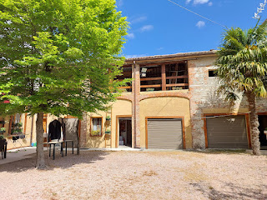

The same craftsman sculpted Jesus on the Cross out of a tree trunk. Wow. Just wow.

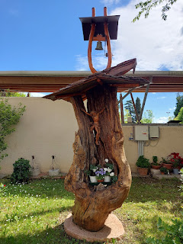

As we walked back across the piazza to our car, I noticed this sun dial high up on the outer walls of the church. Scott studied it for several minutes and was quite impressed. It was 2 p.m. on our phones and it was also 2 p.m. on the sun dial.

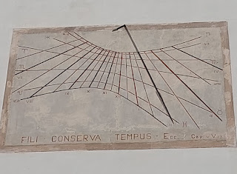

Just a boy and his drone . . . XOXO

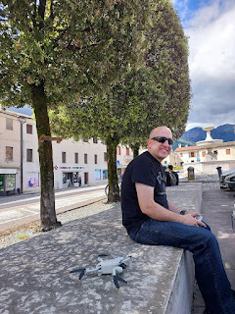

There was a nearby cemetery that I wanted to check out, so we drove less than 5 minutes from the piazza to make a visit.

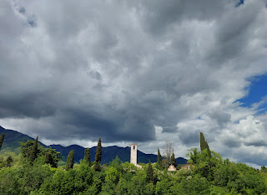

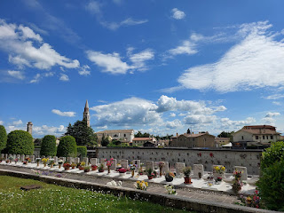

While Scott launched his drone one more time, I took a walk inside the cemetery. It was quite large, but I did not see any Bassano names.

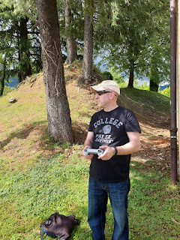

Link to the drone video
that Scott made from that day: (8 minutes, 9 seconds)
https://www.youtube.com/watch?v=9iAPNyWmZl8&t=359s

The last errand before we drove home, was to find a peaceful field of whatever size on the outskirts of Crespano del Grappa. I wanted to take a picture that I could remember my Bassanos with, one that could represent the fields that they leased for their cattle so they could make musical instruments out of the calf skins.

Note: I went paragliding off the Italian Alps back in October 2021. I launched off the top of Borso del Grappa, which is a mountain in between Bassano and Crespano del Grappa. It was an incredible experience to soar high above my ancestral homelands, and I hope to do it again this fall when my sister comes to visit.

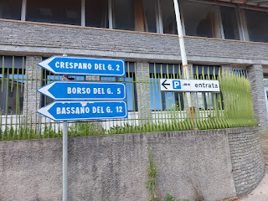

This is one of the fields that I liked on the outskirts of Crespano del Grappa.

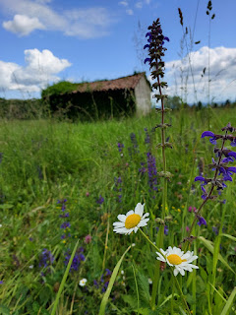

And this was the second field that I liked. I loved the scenic and moody clouds above the Alps, plus the barn and the other outbuildings. I could also smell the very distinct smell that cattle had been here recently. Yeah, you know that smell. :)

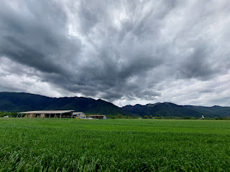

On the locality sign on the outskirts of Crespano del Grappa, I noticed that its "Sister City" in the U.S. is Folsom, CA!! I went there as a child, to Folsom Lake, on a family camping trip. I still remember wading out forever into the water of the lake and it was only up to my shins. What a small world that Crespano and Folsom are connected across the globe.

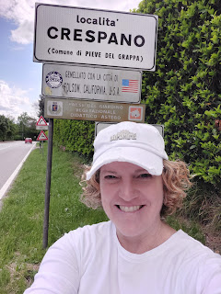

We made one last stop in Crespano before heading home for real this time. We needed a snack, so we made our way to a small grocery store called Maxi Market, near the same piazza where we parked earlier.

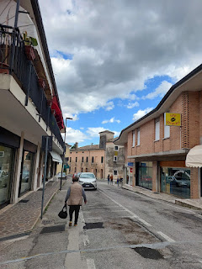

Below: Flyers in a storefront window, advertising various educational/musical/exercise opportunities for the locals. This town seems to be acutely aware of living a healthy lifestyle where they are so close to the mountains.

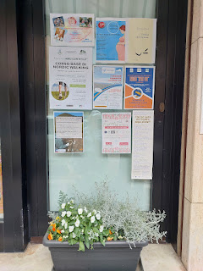

Remember the Tree of Life that is central to the Bassano Coat of Arms? How perfect that I saw these crafts for sale through a store window. I didn't go inside, but instead I just marveled.

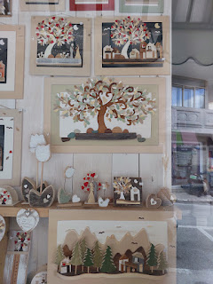

Inside the Maxi Market, I saw some yummy-looking nectarines right away. As I was choosing a few of them, all of a sudden, I felt tears welling up in my eyes. I had been to many places in the area, taking in all of the history and the churches and the cemeteries, etc. But the very moment I was choosing some fresh produce to eat, THAT'S when I felt connected to my ancestors. Long ago, they planted and cultivated their own food in this same area to feed their own families, and here I was - centuries later - selecting a nectarine to eat. In their hometown. What a powerful moment that was.

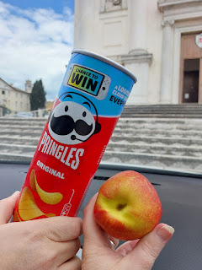

We drove home with happy hearts and happy tummies.

Updates on the rest of the family . . .

Jack has been taking swimming lessons lately and he loves being in the water!

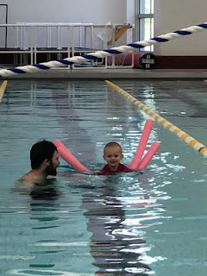

Hannah celebrated her birthday at the end of April, and she loves seafood about as much as I do. Jack is investigating her lobster tail, ha ha.

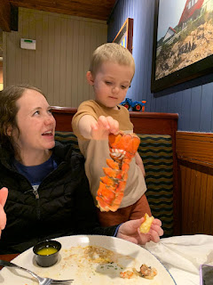

He's been to at least one MLB game in Minneapolis . . .

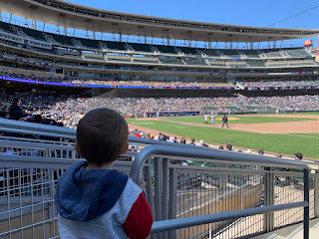

And Jake and Hannah are always in search of beautiful churches or buildings to visit in their area, too.

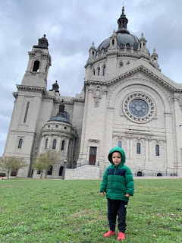

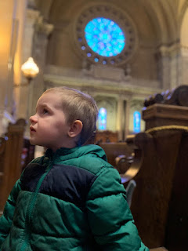

I got some cute pictures of Avery recently. Kylie took her to London to visit with her boyfriend's family that was also there. Kylie and Avery are now in the Tucson, Arizona area - Kylie will be staying with her friend, Rylee, and is looking for a job down there.

Avery - back at the house in Aviano, Italy before they left the country . . .

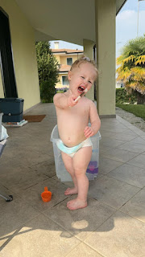

At the zoo in London . . .

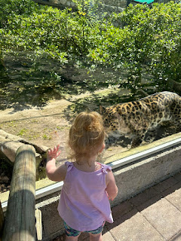

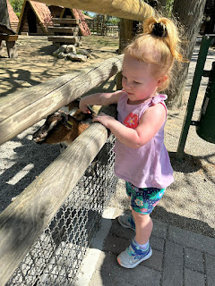

Meanwhile, down in Louisiana, Amber and Weston's house is officially on the market now.

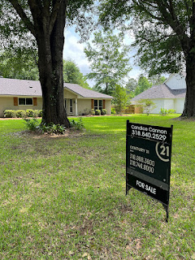

They are planning to head west at the end of May, vacating their home in Louisiana and taking a leap of faith to start a new job and to be closer to family. Weston will begin work at the beginning of June up in Portland, and Amber and the girls will hang out at my house in Idaho Falls until their house sells down south and they can move into a new house up in Oregon. YAY!!

