Southern Skates to Vicenza Ventures
What a week! I can't believe I was able to accomplish as much as I did in such a short span of time, even though I really did need just
one
more day before I left. Everything is going great so far here in Italy and the comment we make the most often is, "This doesn't feel crazy at all!" We are in awe of how normal everything feels, which then causes us to wonder if WE are the ones who are crazy, ha ha. But then we quickly realize that no, we are not crazy. We are just being richly blessed and that as long as we are together, it really doesn't matter what country we're in.
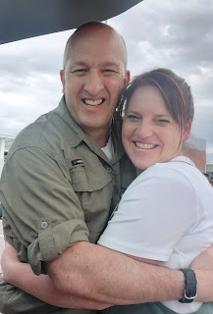

Monday:
Abby was on spring break, so she hung out with me for the day while Gwen went to preschool in the morning. We exercised together just like old times and did some laundry before going to pick up Gwennie. We all went through the car wash and then headed home to prepare for Amber and Weston's arrival mid-afternoon. We got a few things cleaned up and watched part of a movie while we waited.

It was a happy moment when they pulled into the driveway after being gone for 6 days. After lots of hugs and getting settled inside, we got to see all the photos they took while on their cruise to Costa Maya and Cozumel. They had a wonderful time, even though Weston was sick the first couple of days and Amber got sick the last couple of days (and had no voice when she got home).



After dinner, I took Abby on our much anticipated date to the skating rink in Shreveport. We had SO MUCH FUN!! It only cost $1.00 admission on a Monday night, and we both had our own skates. I rented a "helper" for Abby at an additional cost of $5, and it turned out to be worth every penny. It's made from PVC pipe with some wheels attached underneath and allows her to have something sturdy to hold onto until she gains a little more confidence.

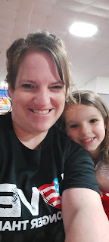

It was Christian music night, too, which was pretty fun. The crowds were smaller, as well, which was helpful to have more room out on the floor.

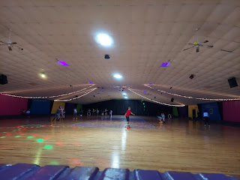

I was SO PROUD of Abby that night - she just skated around and around that rink and got better and better and better!!
Video #1: (14 seconds) A bit timid at first
https://photos.app.goo.gl/Yrk8NcmxjGbDGfAx5
Video #2: (33 seconds) Gaining some confidence
https://photos.app.goo.gl/jy2qxpGqAfQxkeph9

At one point, Abby wanted to know how to take it to the next level. I told her she needed to trust her feet. She wasn't sure what that meant, so I explained that just like she trusts her feet to walk and to run - that her feet know what to do and she trusts in that process - skating is very similar. As she goes from a walking motion to a gliding/running motion, she can trust that her feet know how to move in that same repetitive way and just let them do the work. She began trusting her feet enough to start letting go of the "helper".

Video #3: (28 seconds) Letting go and trusting her feet
https://photos.app.goo.gl/hNMBgX8wuEyKNmqv8

Video #4: 23 seconds) Getting all fancy now
https://photos.app.goo.gl/BoGK4nFoNivqWYED6

On our drive home, we were going the 45 mph speed limit down Bert Kouns Loop (in the dark) and all of a sudden there was a railroad crossing. But it wasn't just any RR crossing . . . it had a last minute uphill curveball that we didn't get any warning for at all . . . so up we went - - - hit the RR tracks, and then CAUGHT AIR before landing with a thud on the downhill side. After getting over the initial shock of it all, we started laughing and laughing about it. The funniest thing was when I said, "I hope you don't think I'm a crazy Grandma driver" and her response was, "I just hope I forget this whole thing ever happened!" LOL

When we got back to the house I showed her a clip from Dukes of Hazard and asked her if that looked like what we did. Her eyes got huge and she said, "That was EXACTLY what we did!!" I'm glad the car was okay and that we made it home alright. When I described that RR crossing to Amber and Weston, they knew EXACTLY what I was talking about. They also said that yes, there is no warning sign or anything to let you know to slow down beforehand . . .

Tuesday:
Abby and I decided to be Piggy Bun Twins for our last day as I packed up to go to the airport.

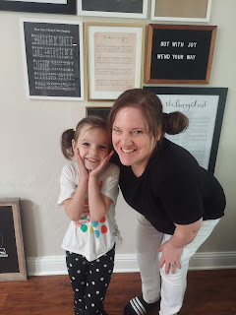

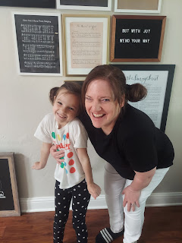

Amber woke up feeling like garbage still, so I felt bad about her needing to take me to the airport instead of her being able to just stay in bed and rest. It took her another 2-3 days to feel like she was in charge of her flu-croup-like sickness, instead of the other way around, poor thing. She insisted that she was fine enough to take me and that she could rest later.

It was hard to say goodbye to the girls, especially after the wonderful date night that Abby and I had at the skating rink, but thankfully we will just keep on skating and preparing for our next date in the near future!

I had a long day to get home, with stops in Houston, Denver, and finally into Idaho Falls at 10:00 p.m. that night. Barb Vance was kind enough to pick me up at that late hour and get me home quickly so I could hurry off to bed.

Amber also posted this hilarious quote on her Instagram feed.

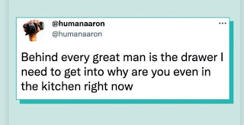

Wednesday:
I woke up EARLY and catapulted into my day because I knew I had a LOT to accomplish in only two days' time. I unpacked somewhat, got some (very minimal) groceries, Oh - and I woke up to this outside - - the high of the day was estimated to be about 29 degrees. Gross.

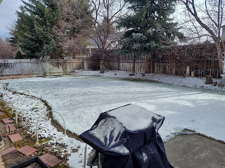

Meanwhile, Jack was enjoying all the beautiful tulips blooming in Washington D.C. What a lucky guy!

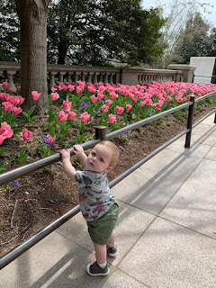

Hannah's mom, Michelle, has been out there in DC visiting them. One of their outings was to Old Town Alexandria, VA, which is just a few miles south of where Jacob and Hannah live. As a late birthday celebration, they all took Jack to a pizza parlor called "Bugsy's", since his nickname is Bug or Buggy.

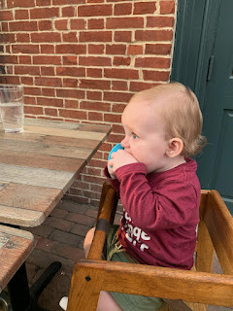

On my errands back home, I secured my International Driving Permit (for $20 at the AAA office), and I found some new (and very comfy) white tennis shoes. On my way into the store, I ran into my beautiful niece, Marissa, on her way out! I haven't seen her in forever! Not since I babysat her daughter, Azure, the first week of January and then got Covid, I believe. We hopped into her warm car and chatted for a while, getting all caught up before we parted ways.

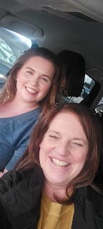

Wednesday and Thursday are really a blur in my mind at this point, as there was just so much to do in such a short amount of time! I had to get the house clean and ready to walk away from, including cleaning out the fridge and pantry and emptying all the garbages; I typed up a helpful list of where to find things for when company comes to stay in my house while I'm gone; I had to get our mail situation figured out (I ended up doing a temporary change of address); I had to figure out a couple of issues with the airline over the phone, etc. All I remember is just checking off things on my To-Do list all day long for 48 hours and then falling into bed exhausted both nights, ha ha.

Thursday:
More snow, more cold, and more hectic stuff to get done. I took a time-out mid-day to go to the temple one more time.

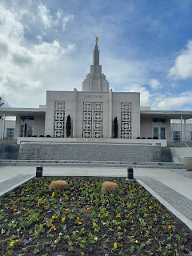

From there, I drove up to Rigby to visit my in-laws one more time before flying out. We went to Wendy's for a late lunch/early dinner. I had a spiritual question for them that had come up while I was in the temple, so we discussed it for a bit together. Coy read me some scriptures from the Doctrine & Covenants, section 138, trying to help me find an answer to my question about when do people in the Spirit World receive instruction and what kind of instruction do they get? I didn't get a specific answer to my specific question, but I felt at peace in knowing that I don't have to know all the answers right now.

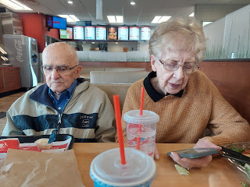

After a lovely meal together, I dropped them back off at their house and gave some final hugs. I know it seems extra sad right now to have to say goodbye, but I will be back very soon and we can hug again when I return. :)

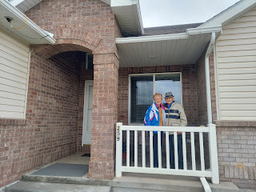

That evening, I hurried to finish packing and then get myself into bed. I had to forego some of the things on my to-do list, recognizing that I just couldn't do everything before I left this first time. Some things will just have to wait until I get home soon. For example, I really wanted to clear out my strawberry bed before I left, but the snowy & frigid weather said, "Nope! Not any time soon, lady!"

Friday:
My wonderful friend, Barb Vance, picked me up once again and dropped me off at the Idaho Falls Airport around 9:00 a.m. My trek to the other side of the world was beginning!

I had already said goodbye to my house, making sure I turned down the heat and locked everything up, and then I walked away.

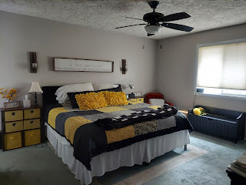

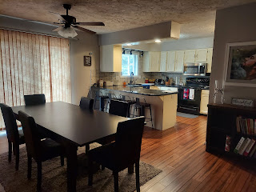

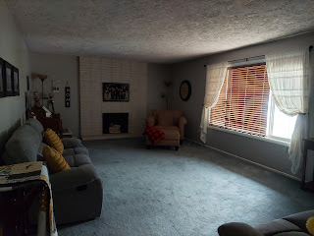

I flew from Idaho Falls to Denver, where I sat for 3 hours. I hung out in the USO for 2 of those hours in a comfy chair that also had a comfy ottoman for my legs to rest on. A lady was sleeping in a nearby chair with her boxer dog as a body pillow . . .

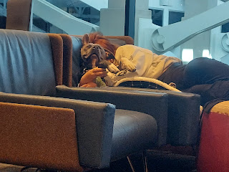

I grabbed a quick photo of myself in the bathroom mirror just outside the USO so that Scott would know what I was wearing when he came to pick me up. I found this super comfy "onesie" jumper through my neighbor, Kim Parkinson. When I went over to visit with her recently, she was wearing a dark grey one, and I said, "WHAT are you wearing?? It looks so amazing!!" She helped me find one for myself and I was in heaven the whole 24 hours of my traveling. It felt like I was in some of the best PJ's ever invented. (The brand is Free People, in case you're enraptured as much as I was.)

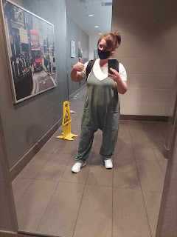

Then I flew from Denver to Frankfurt, Germany, where all the circus stuff happened. Details coming . . .

Saturday:
It was a 9.5 hour flight over the Atlantic Ocean, and when we landed, we had to get on a bus to get over to the terminal. Once we entered the terminal, they would only let a small group of people up the escalator at a time to head upstairs to the Customs area. I happened to be in the very back group of all the 250 passengers.

By the time we got upstairs, a lady was directing us to go up another escalator if our next flight was for any of the "A" gates, which mine was. (A52) Then, when we got up to the next level, a man wanted to know what gate we needed. When I told him A52, he said I needed to go back downstairs. Huh? But they just told us to go up here . . .

Before we could go back down, however, there was a lengthy delay to even go down a level. Apparently the customs area was backed up quite a bit and they couldn't send us down. I made friends with Russ and Cindy behind me, who also needed to get to gate A52 for the same flight to Venice. They were from Denver, Colorado and were super nice.

Just a few minutes into our wait, the same lady from downstairs who originally sent us all upstairs, came up to collect us (we had a group of less than 10) and take us on a lengthy hike across the airport. She was brusk and brief and just told us all to follow her. She set off at a very brisk pace, so we had to hustle to keep up with her. After about 7-8 minutes of speed-walking, I caught up enough to ask her where she was taking us. She hadn't even explained anything to us yet! Apparently, she was taking us to another customs area since the other one was so overloaded. It took us about 12-15 minutes to get there, and just as she anticipated, our wait was only about 5 minutes to get our passports stamped. Then we had to hoof it back across the terminal to get over to gate A52. Russ and Cindy and I stuck together and made it to our gate in about 15-18 minutes. I was sure sweaty by then! But wow, I got a good workout after that long flight . . . I mean, let's look on the bright side!

I originally had about 3 hours before my flight out of Frankfurt to Venice, but after all the chaos was done, I only had about 2 hours remaining. I found some food to eat, a bathroom to brush my teeth, and some comfy seating to lay down and close my eyes at my gate before boarding the final flight. I had closed my eyes for about 5 hours or so during the trans-Atlantic flight, but I'm not sure if I ever truly slept. I do know that I rested deeply and it certainly helped. But by this time I was feeling pretty trashed. When I laid down on the soft seats at my gate, I think I actually went unconscious for a bit . . .

Oh - and this was the dinner that they fed us on that long flight from the U.S. It was actually really good, I just couldn't eat it all because it was a lot of carbs. The main entree was chicken in a creamy sauce with spinach and tomatoes over some orzo pasta. There was also a tabouleh salad behind the entree. I didn't eat the multi-grain roll on the left because I wanted the mango sorbet in the red/yellow container on the right. Gotta watch those carbs! :)

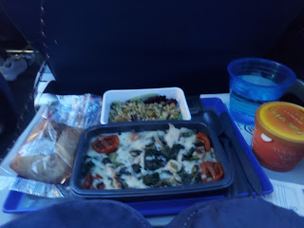

My last flight was pretty short, only about an hour and 20 minutes from Frankfurt to Venice. I closed my eyes and I do believe I slept for about 40 minutes or so. How delightful! As we started our descent, I woke up to have the sweetest conversation with the lady next to me. Turns out she's from Hagerstown, MD, right close to Scott's siblings in Harpers Ferry, WV. What a small world. She let me know that while I was sleeping, the flight attendant had come by offering small chocolates and she asked for an extra one for me, tucking it into my seat-back pocket for when I woke up. What a sweetie!

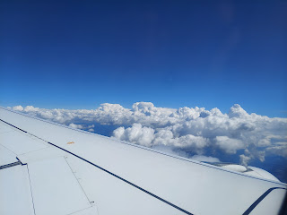

Possibly flying over Vicenza here . . .

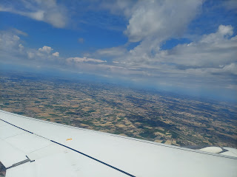

And finally we were over the top of beautiful Venice!!

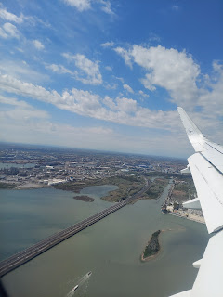

Scott drove his new car over to pick me up. He was just outside the baggage claim area and we were both super happy that both of my suitcases made it!! Most of all, it was just so good to be in his arms.

I was so impressed at Scott's excellent driving skills. He seemed extremely comfortable with his new stick-shift Suzuki Swift, navigating the dozens and dozens of roundabouts with ease, and I was not worried one little bit. I just sat back and took in the beautiful countryside on the drive to Vicenza.

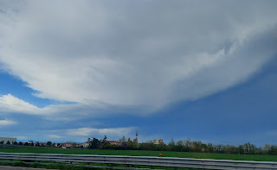

Here is the cute new car.

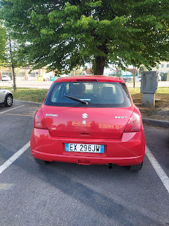

Finally we arrived within the city limits of Vicenza.

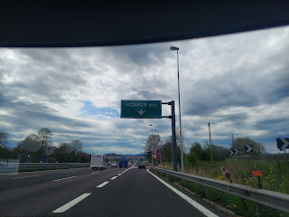

As soon as we got my stuff settled in the hotel room on base, we went for a walk. We went over to the nearby PX (similar to a Target) and food court so that I could get a bite to eat and see some of the shopping capabilities on the base. We also went to the Commissary to pick up a few groceries, and then walked back to our room.

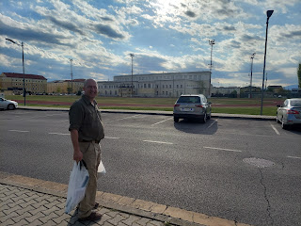

Scott patiently let me go to bed around 8:30 p.m. and I slept hard for somewhere around 9-10 hours. It was bliss.

Sunday:
As I prepared for church in the morning, I realized that my curling iron would not work over here. It was plugged in and the lights were on, but "no one was home". I just put my hair up into piggy buns again, and thankfully my bangs weren't too crazy for once and I just went "au naturale" to church.

It was about a 15 minute drive by car to get to church, as opposed to being double that if we had gone by bus.

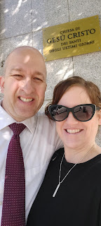

Church was AMAZING!! Everyone was so friendly and welcoming, and a member of the bishopric even invited me to say the opening prayer. The speakers were phenomenal and we really felt the Spirit from their heartfelt messages. The Sgt. Major spoke first, describing how he was "less than active" in the church for a long time, and then he met a pretty lady with Christlike attributes who helped him come back into the fold. That pretty lady, his wife, spoke next. She works in the field of psychology, something to do with the study of people's behaviors.

She shared a recent endeavor of hers with the congregation where she highlighted in red all the words that Christ actually spoke in the scriptures. What she learned was that not only was He a man of few words, but that He made sure that what He did say was meaningful and made maximum impact. She compared that to how she (for years) would get frustrated at her own husband, who was a man of few words, and she wished he would have more to say. But now she is recognizing that this is actually a beautiful quality in him, like that of the Savior. It was very enlightening to have this fresh perspective on how we see the Savior and how following His perfect example is literally something we can put into practice in our own lives.

There is also a lot of musical talent in this ward. No less than three musical numbers were performed throughout Sacrament meeting. First was the most beautiful flute/piano duet that I have ever heard, performed by Stacy (flute) and Dedra (piano), two cheery and friendly ladies that I got to know better at Dedra's home later in the day. Next, the Primary children came up and sang a song. There were about 10 children in all. And lastly, a father and his two daughters played a trio on 2 cellos and a violin. I love how some families choose to learn a musical talent together and then share it together, too! (I snuck a secretive photo while they played)

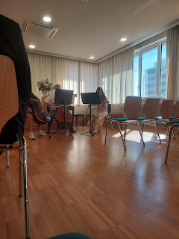

After Sunday School class let out, lots of people came over to introduce themselves to us, in addition to several others who spoke to us before and after Sacrament meeting. Phone numbers were exchanged and an invitation was even extended for us to come to Easter dinner with a group of families from the ward. We felt very loved and included. :)

We went on a scenic little drive after church, in order to go check our mail at the other base where Scott actually works. He took me up to the top of the parking garage so I could see the lay of the land without any obstructions. This is the view of the base looking out toward the Dolomites (pronounced doh-loh-mee-tes).

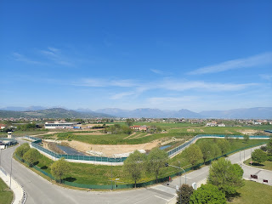

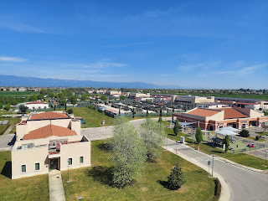

This is the building where Scott works during the week. On the front it says:
Operations Center, United States Army, Southern European Task Force, Africa

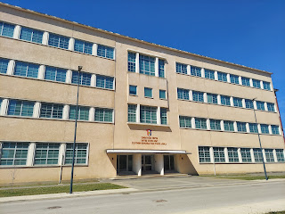

After we got back to the hotel, we changed shoes and went for a walk over to see our new house, about 1.3 miles from where we are currently staying. There wasn't much to see from the outside, but tomorrow evening we are setting up a time to have the realtor's office let us in one more time so I can get more of a feel for the space inside. I will be handling the move by myself since Scott will be gone to Germany for some training, and I need to know a LOT in order to figure out what kind of furnishings to look for in the meantime. I love that it is so close to grocery stores and restaurants, as well as having several bus stops nearby to get around.

There are the most beautiful trees lining the sidewalk just outside the gate for the main base, Camp Ederle. I don't know what they are, but they are in full bloom right now!

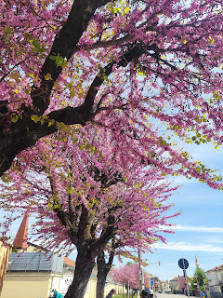

This is me just before we entered through the gate. We have to show our military ID every time we enter, even when we're on foot.

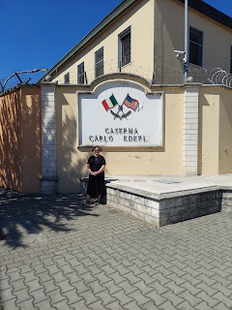

After a short rest period, we headed out to pick up Cody, a young servicemember without a car currently, and we all drove to Tom and Dedra's beautiful house out in the countryside near Vicenza. I felt bad that we didn't have any means to prepare something to contribute to the meal, but everyone cheerfully shared all that they had with us.

Let's see if I can at least remember all the names of the grownups: (from left to right)
Tom, Eric (resting on the head of a boy in front of him), Dedra, Erica, Cody, Stacy, Scott and me. Later, the sister missionaries joined us with a young mom from the ward named Joy and her darling baby, Rose.

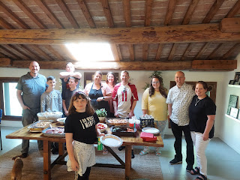

It was a beautiful meal with ham, funeral potatoes, rolls, roasted green beans, caramelized carrots, colorful fruit salad, and several delectable desserts. I chose the German chocolate cake, of course. :) Scott and I were able to learn a ton of helpful information from everyone: where to get furniture for the best price, where to get other furnishings and home decor, where to get groceries, etc. We even learned that the US equivalent to Home Depot here in Italy is called Leroy Merlin, ha ha.

The ladies also invited me to come exercise with them Monday morning, which I did. They go walking around the track next to our hotel on M-W-F mornings. They are so welcoming and friendly!

Before we left, the sister missionaries invited us each to share our favorite name that the Savior goes by, since He is known by many names (Savior, Redeemer, Shepherd, Light, Living Water, Counselor, Bread of Life, the Prince of Peace, etc.). It was a meaningful way to bring closure to our Easter Sunday worship and family time throughout the rest of the day.

We also got these cute photos of Abby and Gwen in Louisiana in their beautiful Easter dresses.

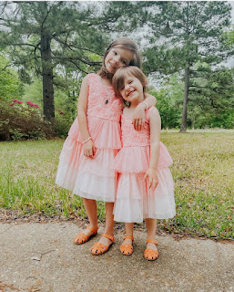

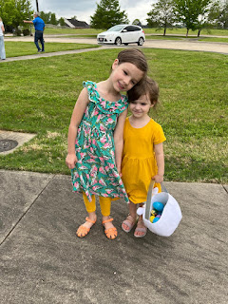

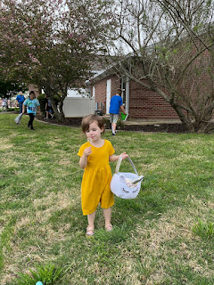

And here is a sweet photo on Easter Sunday of my mom sitting with her mom, my 100 year old Grandma Doris (soon to be 101).

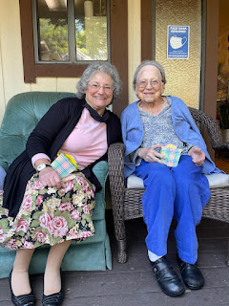

Monday:
Scott had one more day off during his 4-day weekend, so we tried to make the most of it by running some important errands and getting some things lined up for me to do while he'll be at work for the next few days.

After walking for an hour with the ladies in the morning, Scott and I took care of some business on base. One of our concerns is that in order for me to be able to drive his car, I have to have a special Italian driver's license. In order to get that license, I have to watch some videos (like a driver's ed class) and take the same 200-question test that he took recently. I need 85% to pass on that test. We got the paperwork taken care of and got me all set up online to begin this course while he's at work today (Tuesday).

A lot of Italian businesses are closed on Mondays, especially after a big holiday like Easter. So the places we wanted to check out in town weren't exactly open when we went on an explore. We decided to ride the bus together this time so I could practice learning how everything runs and how to use the app to pay for my ticket, etc. Scott has already figured it all out, so he was a good mentor in showing me what to do.

We found the home decor store "Happy Casa" that was highly recommended to us, but it was closed. We also found the Leroy Merlin store. Also closed. We did, however, find a furniture store that was open in the middle of a huge shopping area of town where NOTHING was open . . . so that was nice. We found a couch that we really like, but you have to put in your order and it takes 8 weeks to get it! Yikes . . . We saw another furniture store on the bus ride that had big signs in the window saying 80% off, so we'll be checking that out this week, too.

I didn't have much for breakfast, and all that walking was making me hungry. Unfortunately, the only restaurant that was open in this section of town - - - was Burger King. Really??!! Without any other options, I decided to just go in and find something small that sounded appealing. I was pleasantly surprised when my food arrived.

I ordered a chicken wrap and a side salad. The salad was preemie spinach with olive oil, bits of corn, a couple cherry tomatoes, and some salt and pepper. (I say preemie spinach because it was tiny and delicate, much smaller than baby spinach, ha ha) It was actually really good!

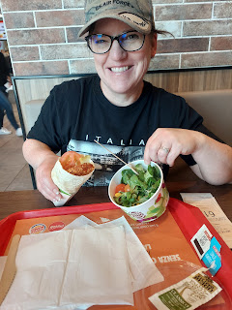

We had to show our vaccination card in order to sit down to eat inside the restaurant. Everyone over here still wears a mask everywhere indoors, and on public transportation you HAVE to wear a KN95 mask. It is mandatory.

As we were waiting at the bus stop, we got this cute video of Avery from Benson. They are making sounds back and forth. (37 seconds) It took a while to download because we were away from the Wi-Fi in our hotel, but it was worth the wait! :)

https://photos.app.goo.gl/a4tPh7rusgoFAQJd6

At the end of the day, we drove over to a nearby Shawarma restaurant that Scott had been wanting to try. (Shawarma is his favorite ever since he worked in Saudi Arabia for that year)

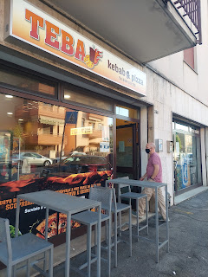

We got the #1 Kebab for me and the #3 Piadina for Scott.

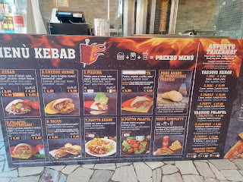

The chicken meat is on a rotating spindle and gets crisped up from the heaters surrounding it as it slowly spins. Every so often, the worker will come over and using a meat shaver, he'll shave off (or scrape) the crispy exterior, which falls into the tray at the bottom. It looks like pulled pork, or in this case, pulled chicken. It's very flavorful and juicy and wonderful.

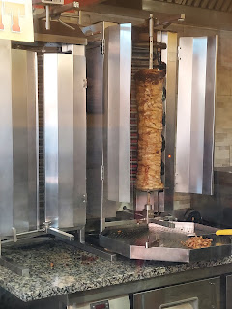

They have some fun items on the menu to choose from . . .

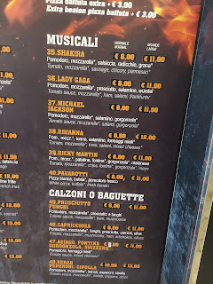

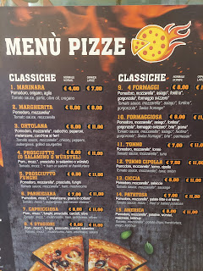

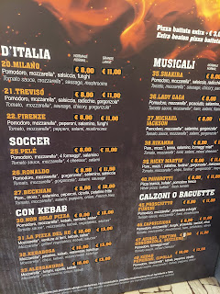

It's within walking distance of our new house, so we will probably come to eat here pretty often.

Last, but not least, here are a couple of cute photos of Jack that we got over the weekend.

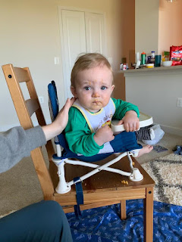

In this one (below), I think Jack is looking more and more like his papa Jacob.

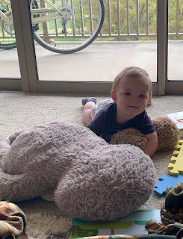

HAPPY EASTER!! I hope you had a wonderful weekend. I certainly did! I am so grateful for my Savior Jesus Christ who shows me the kindest and most perfect way to speak, act, and become. I hope to continue to learn from His perfect example and become more like Him in the process. I am also grateful that He is merciful and patient with me when I come up short. :)

