Tell People You Love 'Em
When someone pops into your mind when you least expect it, take a little time to reach out to that person. When that same person pops into your mind again, stop what you're doing and reach out to them right then. Life is short and the people we love won't always be around. Don't let those moments pass you by and then you end up regretting that you didn't do the thing that you felt prompted to do . . .

I got a text message on Thursday evening that my last grandparent on this earth, Grandma Lillian, was in the hospital up in Salem, Oregon. She had been admitted two days before with some sort of heart condition and the doctor was giving her about 48 hours to live at this point.

A few times over the past several weeks, I had the thought pop into my mind that I should give her a call. I also had the thought pop into my mind that I should send her a little note or a postcard in the mail because she loved receiving them. Well, I got distracted and didn't call. And I postponed sending her a note because I intended to call her instead . . . but then time ran out . . .

In the early hours of the morning, around 2:00 a.m. on March 14th, Pi Day, Grandma Lillian passed over into the loving arms of our Savior. I'm sure she was also surrounded by all of her loved ones in heaven and that it was a very joyous reunion. She is all done with the pain that she had endured for the past decade or so, with her degenerative disc disease. She is done with her heart issues, and never again will she get pneumonia and teeter on the brink of death. She is at peace now, and she can finally rest in the deepest and most beautiful way possible.

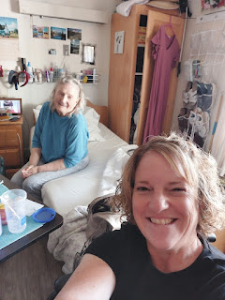

I shared my thoughts on Instagram and Facebook on Friday, about what I will miss most about her:

~ Trips to the coast and eating seafood next to the crashing waves (this photo was taken in 2017 near Depoe Bay, Oregon)

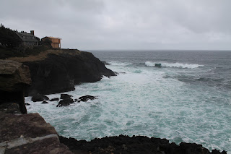

~ All the 1,000 trips to her favorite sushi restaurants.
~ Drives through rural Oregon on all the back roads that she knew so well.
~ Visiting antique shops and finding a little something that brought us joy.
~ Her French Onion soup with melted Havarti cheese on top.
~ Going through old photos and talking about the good old days.
~ Listening to her stories about Grandpa (Linton) and all of his family in Florida.
~ Hearing her laugh
~ Her positive attitude in spite of all her pain for so many years.
~ Her warm and strong embrace
~ Her kindness and listening ears as I "spilled the tea" too many times to count.

*One of our coastal outings was simply to go to lunch at an upscale restaurant in Depoe Bay - at Tidal Raves Seafood Grill, where they have the most amazing Seahawk Bread as an appetizer. While I sat there relishing in the incredible combination of flavors, Grandma was able to tell me exactly what was in it. I grabbed a piece of paper so I could write it all down and later try to recreate it at home with my family. Essentially the dish features a fresh baguette topped with smoked salmon, cream cheese, Havarti cheese, shrimp, and red onion. The recipe requires a little broiling at the end to create the melty cheese on top of everything else, but man . . . it is SO GOOD.

Here is the recipe that I scribbled out for the Seahawk Bread:
(*Note: The shallot salt and Parisien herbs are from the Penzey Spice Co., which Grandma also introduced me to.)

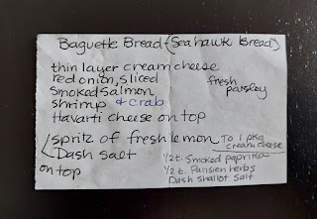

When I stayed with Grandma at her little apartment in West Salem, we would watch Hallmark movies together, go on drives to see what we could see, visit a quilting store or two to look at fabric, etc. But mostly we just talked. We could talk for hours and not get tired. Her apartment was the lower one at the far right end. Her gold Cadillac was parked outside and that's what we drove all over the place together. She even let me drive it a few times, when her back started getting worse.

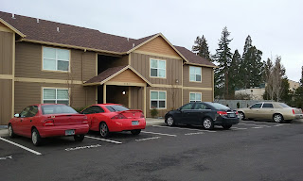

When she was feeling more able-bodied back in 2017, we drove over to the coast and visited one of the lighthouses. We also made it a point to stop and see a few of the historic covered bridges that are still around in Oregon.

Ritner Creek Bridge (1926)

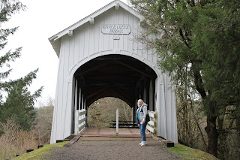

Harris Bridge (1929)

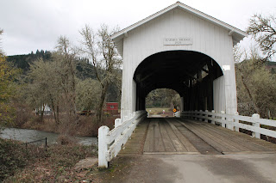

During one of my visits in January of 2019, she had a parakeet at the time, named Kiwi. Grandma coached me on how to convince him to eat a potato chip out of my hand, an obvious first for me, ha ha.

Video of this once in a lifetime event: (48 seconds)
https://photos.app.goo.gl/HGt6nbiUd9caX5ck8

I am forever grateful for the opportunity to have Grandma Lillian in my life. She taught me so many things, the biggest of which was how to keep your chin up and still smile and laugh in spite of the pain you might be going through.

One last thing . . . here is the recipe for Grandma Lillian's special oatmeal cookies that always seemed to be on hand. She wrote this in her own handwriting, adding that, "I've been making this cookie since 1949. My boys like eating the raw dough."

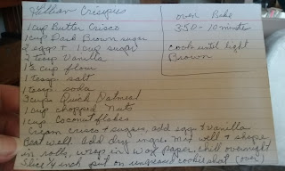

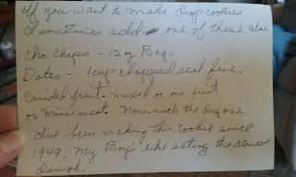

Last weekend, I drove over to Mountain Home to have a sleepover at Benson's house on the Air Force base. We went out to dinner with two of his buddies, Torres and Paies. Torres' wife wasn't able to make it because she wasn't feeling well, but hopefully next time I can meet her. She and Benson have an ongoing friendly competition when it comes to cooking. He recently made them some Indian Curry, which she had never had before (I think she's from Japan). This made her want to try making her own version of it, in the hopes of making it even better than his, ha ha.

Torres didn't want to be in the photo because he had just woken up from a nap, but he offered to take the photo of Paies (on the left), me, and my "baby" Benson.

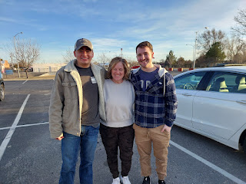

Benson has a great group of friends right now, and they are having such a good time. Every weekend, they have been getting together to play volleyball. They work on each other's cars together, they cook and BBQ together, in the summer time they go hiking or swimming together, and recently they went snowboarding together at Bogus Basin (near Boise). He feels like he has a real sense of community.

Torres has an engine lift and a couple weekends ago they got the old engine out of Benson's Audi. This weekend they were supposed to place the new engine in, so we'll see if it happened or not.

Benson's garage last weekend . . . (the new engine is sitting on top of the pallet on the left)

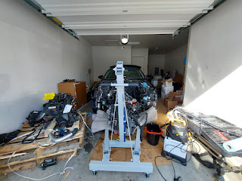

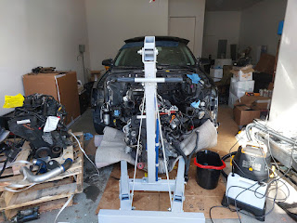

Benson and I went for a nice long walk that night with his dog, Daisy. I just loved the beautiful pathways that were all lit up (solar powered). They criss-crossed all over the neighborhoods and fields near his house. We talked and talked and talked for the hour-long walk. Daisy enjoyed the few times she could be off-leash and was free to explore next to us or to chase invisible bunny rabbits into the trees.

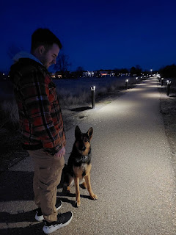

We watched a movie and went to bed suuuuper late, ha ha. I didn't sleep very well during the night, but thankfully I was able to sleep in and make up for it. By the time I woke up, it was 10:30 a.m.!! Whaaaat?? I haven't slept in that late since I was a teenager . . . In my defense, though, I went to sleep around 1:00 am, which was interrupted several times because Daisy was whining to be let out of her kennel to go potty (3x I think). When Benson opened her kennel down the hall from me, she was eager to get outside as fast as she could and was trying to run . . . but when the floors are made out of slick laminate, it sounded more like a herd of buffaloes as she tried to make each corner, slipping and sliding the whole way, LOL.

Benson apologized to me in the morning for all the disruptions. We think that because we took her on such a long walk so late in the evening, and then she was crazy thirsty by the time we got home, she ended up being sloshier than usual for the night.

I'm just glad I was able to sleep in so that I could be alert and capable enough to drive the 3.5 hours home a few hours later. We had the best time over roughly 24 hours. Benson is doing some really amazing things and he is such a giving and kind person. I'm really proud of him and I can't wait to see him again in about 10 days when Scott and I pass through on our way up to see Amber and her family in Portland.

I invited my nephew and his wife, Caleb and Bethanne Jackson, and their two little boys - Harrison and Everett, over to dinner one night. Bethanne is about 5 weeks away from her due date with a little GIRL.

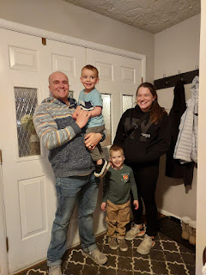

Harrison and Everett and I hung out in the playroom downstairs and had lots of fun with all the toys while Caleb and Bethanne offered to put the food away and load the dishwasher after dinner.

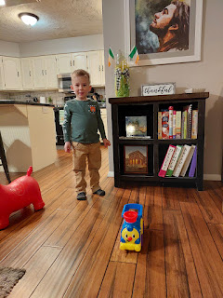

I've been busy making a couple of baby blankets recently, and it's been so much fun! I can show you the first one and the process that I went through, but I can't show you the second one (sorry Jasmine!) because the intended recipient (Jasmine) reads my blog and I don't want to spoil the surprise. I'll share some pictures of the second one later after she's received it in the mail.

Bethanne asked for the colors of blush pink, mauve, and sage green. I love this color palette!

This is what the top looked like before I evened up the outer edges and clipped the edges and rows . . .

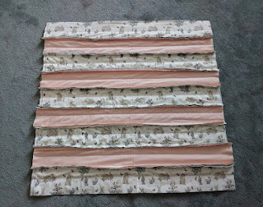

This is the back side . . .

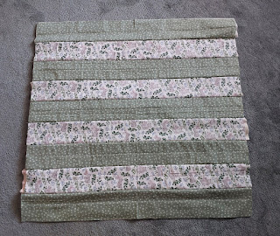

One evening, when I was feeling a little run down with swollen throat glands and some fatigue, I sat on my bed and started clipping all the edges of the blanket while I watched part of Moana 2. Moana is my favorite Disney movie, so I was eager to see the sequel. I haven't seen the last third of the movie yet, but I plan to watch the rest of it this week while I finish Jasmine's baby blanket. So far, the sequel is pretty good.

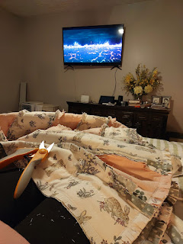

'Twas a messy job, but I just vacuumed everything up (including myself) afterwards . . .

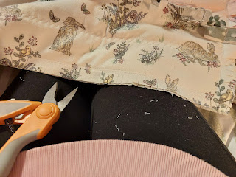

All finished with clipping the edges and the rows . . .

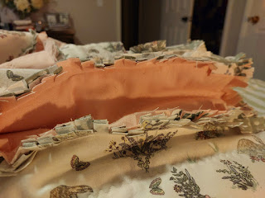

After a quick wash and a tumble in the dryer, this is the final product. It does make a lot of stringy mess in the lint trap, but it was totally worth it!

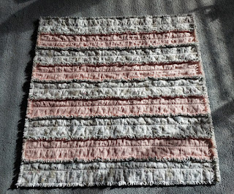

Because I tend to dabble in multiple things at once, I met my friend, ReNae Cunningham, over at the FamilySearch Center across town. She wanted to know how to digitize some slides, so I reserved two stations right next to each other. For two hours, she worked on her family slides while I scanned several strips of negatives that once belonged to my in-laws.

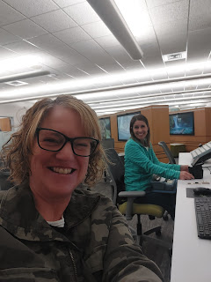

When I got to this photo on one of the negative strips, I was a little surprised. This is Scott's niece, Ashley, when she was a tiny baby. Well, Ashley just had a miracle baby of her own about 3 months ago and she looks just like her! Her baby's name is Charlotte, but they call her Lottie.

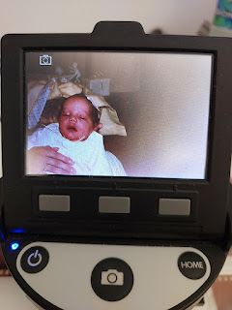

I sent the photo to Ashley when I got home, and she was surprised to see it. She couldn't believe the resemblance either, and she said this made her whole day. I love these kinds of surprises that pop up when I'm digitizing slides or negatives, ones that haven't been readily available to the whole family until now.

I helped my niece, Mari, clean her apartment one afternoon. She has been feeling a bit low and unmotivated recently, and it helped her immensely to have a buddy who enjoys cleaning. We cranked up the music and got to work! After the cleaning was done, we hung up a few decorations that she had been wanting to get to, but as you probably know, it's helpful for one person to hold the thing up against the wall while the other person stands back to scrutinize and find just the right spot. So that's what we did.

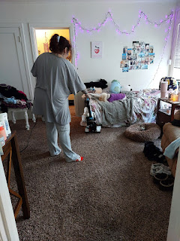

On a different day, we went out to dinner at Krung Thep Thai Cuisine in downtown Idaho Falls. The food was fabulous. I ordered my favorite crab rangoons (on the right), plus a big bowl of wonton soup. Mari ordered the calamari (on the left) and some Pad Thai with tofu.



While we waited for our food, she looked through all my photos of Grandma Doris in order to choose a few that she liked. The following day, I took her to Walgreens so she could get them all printed out for her photo album. She misses Grandma a lot, so she was happy to have some photos on hand that she can look at whenever she wants.

I went down to the temple in Pocatello one last time in the middle of the week. It has been windy and blustery up here for several days straight, with winds consistently around 25-35 mph and occasional gusts up to 40 mph. But inside the temple, it was quiet and calm and peaceful.

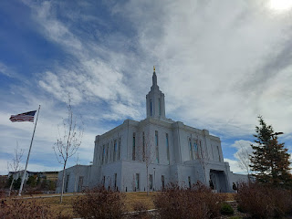

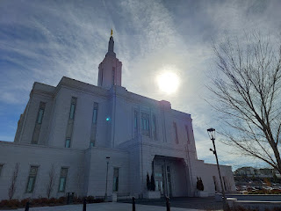

I have enjoyed my weekly trips down to Pocatello, but I am really looking forward to the Idaho Falls Temple re-opening this coming week. It's been closed for 6 weeks for some needed maintenance.

I also drove up to Rexburg recently to see my Italian friends, Sarah and Emily McGovern again. I took them out to dinner at Pizza Pie Cafe (Sarah's choice) where we had all-you-can-eat salad and pizza. Not that any of us ate THAT much, but still, at $11/person it was a great deal for dinner. Afterwards, I took them to Walmart to get some groceries before dropping them back off at their apartment.

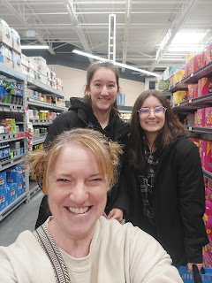

I met them in our church ward in Italy three years ago, and I am very good friends with their mom, Rachel. They have been attending BYU-Idaho this semester, but they leave next week for a special educational experience through DISNEY. Disney World has something called the Disney College Program, which I had never heard of before. You can apply to be a part of this program, which these girls did and were very lucky that they were both accepted. They will be gaining some college credits at the same time as working part-time for the theme park and having a blast! They'll be in the Orlando area until August.

Meanwhile, Scott made it to El Paso, Texas by late Thursday evening. This was also the same evening that I learned that Grandma Lillian wasn't doing so well. He has been struggling to stay awake until a decent hour before going to sleep. I keep telling him that he needs to stay up until at least 8:00 before getting ready for bed, and then the next night he should try for 8:15 or 8:30. But he keeps being naughty and ends up tucking himself into bed around 7:30 . . . what a guy. At this rate, he's never going to get to a good hour of waking up - a
NORMAL
hour of waking up . . .

He looked online to see if there was a Church of Jesus Christ of Latter-day Saints either on or close to Fort Bliss, and sure enough, there was. I suggested that he reach out to the Bishop (their info is online with the ward's meeting time and location) to see if someone could give him a ride to church. I found out afterwards today that he WALKED to church. A whopping 3.6 miles EACH WAY. It took him about an hour he said. By the time he got back to the barracks where he's staying, he said he had to take another shower, ha ha.

He could have asked someone for a ride, but he's a little anti-social sometimes . . . I'm proud of him though. I told him that this is a story for the grandkids! "I walked 3 1/2 miles to church UPHILL . . . and then I walked 3 1/2 miles back home again UPHILL . . . " LOL

He sent this photo to me once he got there. The plaque talks about how the very first ward, or congregation, in the entire state of Texas was formed here in El Paso in 1918. The members used to meet in each other's homes and later in the Odd Fellows Hall, until this building was later built in 1930. It's currently listed on the historic register of old buildings in Texas.

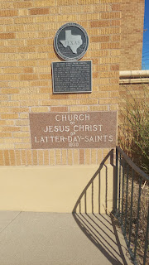

I found a photo online that shows the whole building - it's kind of reminiscent of the Alamo, isn't it . . . ?

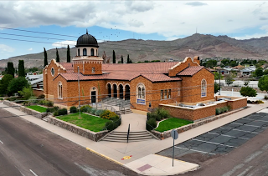

This is where Scott is staying for the next week.

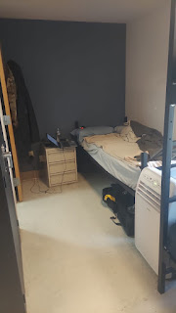

He's got a single bed, a fridge, a microwave, a bathroom, and that's about it. Cellphone reception is pretty bad, unfortunately. We have no problem with video calls every day when he's in Italy, but in Texas he has to put his phone up in the window to get the best service, and it still cuts out and has issues the entire time we are trying to talk. And we're not even using the video! We're just doing a regular phone call. This is AMERICA, dang it. We should be doing better than this.

Here is Miss Maisie, preparing a banquet fit for a king, I presume . . .

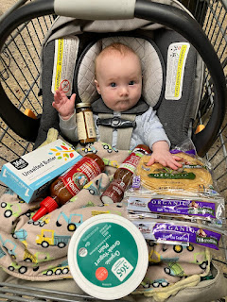

Jack was sick for a couple days last week, bless his little heart. He had a fever and some stuffiness and a cough. But he's all better now. Jacob was somewhat sick, too, but Hannah and Maisie didn't end up catching whatever it was.

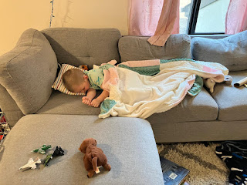

And lastly, Kylie shared a couple of photos of Avery with me today, along with a hilarious video.

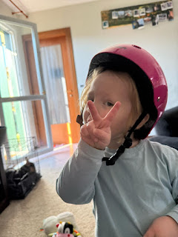

This girl is only 3 years old, but so full of personality!!

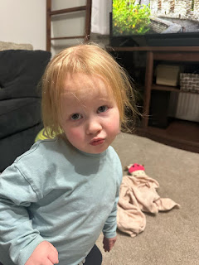

This is a video of Avery expressing how angry she is at her noodles over in the kitchen. It's a little long, but it's worth it. P.S. Kylie sometimes refers to Avery as Miss Sassypants.

Enjoy! (2 minutes, 16 seconds)
https://photos.app.goo.gl/vNCF2ZNHqgqwRQPs9

