The Family History Train
I don't know if I'll ever want to get off this family history train - - it's just the best train ever! It's interesting, intriguing, insightful, contemplative, peaceful, educational, uplifting, healing, comforting, and it expands my heart in ways that nothing else can provide. I have done more family history work in the past 2 months than I have in a really long time and it feels amazing.
I collaborated with numerous family members in CA and got new photos and information
I got our huge Rawles scrapbook digitized
I digitized 2100 slides from my childhood and shared them with family members
I've built most of the next Rawles Blog & Newsletter, with stories of our ancestors, to be sent out very soon hopefully
I've collaborated with Amber on our family history book project
I've kept up with my own "living history" through this personal blog of mine
And yesterday I added another special project to my growing list: a headstone rubbing. Per my daughter's request, I drove up to the Rexburg Cemetery and did a rubbing of Jonny's headstone for her. (Jonny was stillborn almost 6 years ago now)

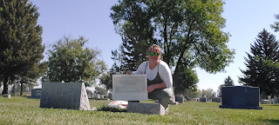

Amber wanted something she could put in a frame, so I knew I needed to do a good job on this. With her help, I was able to choose one of the many types of charcoal and some paper at Hobby Lobby. She suggested a charcoal stick would be good, and the paper needed to be thin enough to allow the texture to come through, but not too thin that it would tear or break down easily. We settled on a big sketch pad that was 70 lb weight for the paper thickness. It was one step thicker than newspaper print.

When I got to the cemetery, the caretaker was mowing right in the area where Jonny was buried, and when he saw where I was setting my supplies down, he quickly came back and asked if he could just finish that area real quick and then he'd be out of my way. I was grateful that he noticed my intentions and was so thoughtful about it.

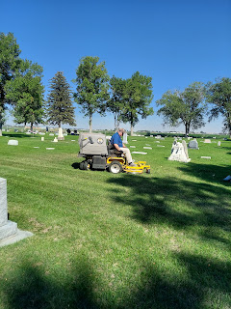

I used masking tape to secure the under side of the paper to the headstone and proceeded to rub my charcoal stick over the surface.

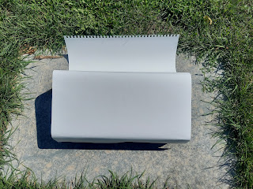

It came out looking quite dark even though I was using a very light touch, and the words were not coming through either. I called Amber on video so she could see my technique and how it wasn't turning out very well. She suggested that I could try a pencil or black crayon instead.

I went over to our friends' house (the Garners), since they just live 5 minutes away from the cemetery, and borrowed some sharpened pencils and a graphite stick to try.

Back to the cemetery I went. I tried the graphite stick first because it looked like the best option. Picture trying to get a headstone rubbing using a tiny pointed pencil tip vs a flat rectangular piece of graphite. Size-wise, I thought the graphite stick would be awesome. It worked better than the charcoal, but it still didn't pick up the words and details of the headstone.

When I tried the pencil and held it almost flush to the paper while capturing the details in each stroke, it came out much clearer! Hooray! And it was a good thing I borrowed 4 pencils from the Garners because I needed all 4 of them to get the job done. The only issue I had was that I couldn't seem to get enough definition for the date "10 Nov 2016" at the bottom. Thankfully, Amber thinks she can tinker with and enhance the date in Louisiana after I send the drawing to her. She'll clean up the edges, too and get it looking all ship-shape to go in a frame.

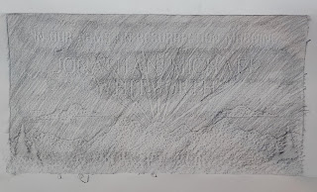

That was my first time doing a project like this and I really enjoyed it! It gives me one more reason to spend some time at the grave of my sweet grandson and to do a kind favor for my sweet daughter who doesn't live closeby. And I learned a lot about how to do this sort of thing. I'll do some additional research and see what others with more experience recommend so that I can do this again in the future.

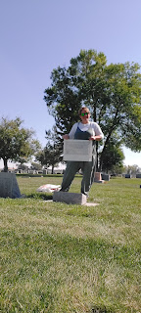

Another connection that I had with family history this week was when I cleared out my strawberry bed. I didn't just clear out the unwanted weeds this time, I literally dug up every single strawberry plant so that my strawberry patch is completely cleared out 100%.

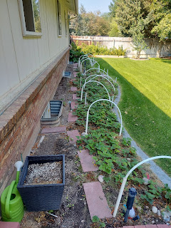

3.5 hours later . . .

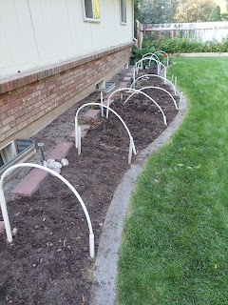

I knew I needed to do this at some point, so I figured now was the best time before I head back to Italy soon. I won't be here next spring to clear out the hundreds of plants from all the winter time yuck, and I won't be here to see that the weeds are taken care of either. This year there were a LOT more weeds to contend with since I was gone April-June . . . But the bigger issue is that the strawberries haven't been producing much fruit in the past 2 seasons, and that was a concern to me. If the huge garden bed is such a big job (and hassle) to take care of and then it's not producing very well, it seems like a lopsided predicament and I just don't want the headache anymore.

I planted 25 strawberry plants 16 years ago and have watched them evolve into over 300 plants over time. I have thinned them out, butched them down when production was wavering, and done a lot of research on how to care for them.

If I have mentioned this analogy before, I apologize. But here is the link to family history . . .

Strawberries consist of 3 generations.

The grandmas.
The daughters.
The granddaughters.

Take a look at this strawberry plant that I dug up.

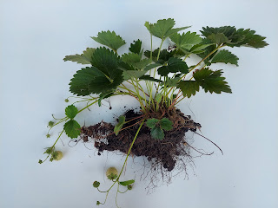

The grandmas look like little old brown cigars, ha ha. If you look closely, you'll see them on the left side of the dirt clod. They are always closeby, surrounding the plant, and providing nourishment to the daughters and granddaughters. While they might be retired and not as vibrant-looking, they are essential to the daughters being able to do their job.

The daughters are the producers. They are in full production mode with all the dark green leaves, flowering white blossoms, and eventual berries. Exhausting work, but how satisfying to be the ones producing those treasured red berries!

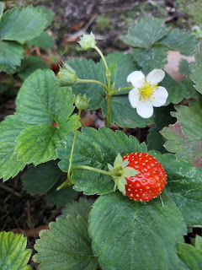

The granddaughters are the "runners". In the photo above (the one showing both the plant and the roots), you'll see some evidence of previous runners that I broke off at some point (on the right side of the dirt clod). They were probably getting into trouble and "running" toward places they shouldn't have been. These are the up-and-comers. They are giddy about spreading out and putting down roots to eventually become producers themselves.

Does this story sound familiar? Does it remind you of some of the Grandmas in your life, with their nurturing love and wisdom? (please don't try to contemplate if they look like little old brown cigars or not) How about the role of being a busy daughter or an energetic granddaughter?

As I dug up all of those plants, I felt so terrible!! I kept thinking, "You're a MURDERER!!" I felt like I was ripping up all of these families of women who had taken care of each other for the past 16 years . . . I was plucking them all up to just throw them away. I kept trying to justify my actions in my mind, telling myself, "You don't have time to take care of them anymore. It's okay." "They weren't producing much and they're getting tired anyway. So it's okay." Followed by,
"They're not real!! It's okay!!"

My mother-in-law used the phrase "inbreeding" to describe what happens with some strawberry plants after they grow together for so many years. They do, indeed, struggle with production issues if new plants are not introduced into the group. When Scott is all done in Italy, I will ask him to build me a smaller, square-shaped raised bed where I can start over with a new group of strawberry plants.

As I dug for hours, my thoughts were also thinking about how this all relates to family history. While the generations of strawberries were being broken up with a shovel in front of me, I realized that I am connected forever to my ancestors and also to my descendants. Something I cherish and am infinitely grateful for is my temple sealing. Heavenly Father and Heavenly Mother love us all so much and want us to be united and to have unbreakable family ties for eternity. Family is the most important thing of all. In a civil marriage, the pronunciation of the words "till death do you part" is just so heartwrenching to me. Most people BELIEVE in the idea of being together after the grave and living forever with your loved ones. We all WANT that beautiful blessing.

The covenants we make in the temple give us that beautiful blessing and it then becomes a reality. We are sealed together as husband and wife, as families . . . forever and ever . . . so long as we keep the commandments and try our best to follow Jesus Christ and His teachings. I am SO GRATEFUL that Scott and I were married and sealed for time and all eternity in the temple just over 30 years ago. I am grateful that we are a link in the eternal chain of our ancestors and this cannot be broken. It gives me confidence in my marriage, and that we are partners for the long haul - the ETERNAL haul. It gives me peace of mind that no matter what happens to us, should one of us unexpectedly die, we will be together once again in heaven and in the eternities.

While I am sorry that I broke up three generations of strawberry ladies, I know that it was for their own good and in my best interest as well. I will start over again in a couple years and I will take good care of them. :)

These were the last crop of strawberries that I gathered and they were oh so good. :)

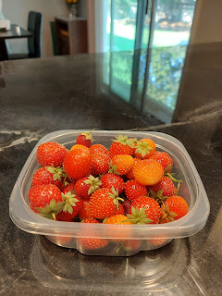

I was so grateful to be with my sisters down in San Diego. It was so nice to be cared for by my older sister, Charmaine. I was glad I could be there on her birthday, too. While she was at work, I worked on my blog and did some cleaning around the house for her. That was my birthday gift this year. Clean floors, clean laundry all washed and folded, and clean bathroom surfaces. When she found out, at first she was mortified. She thought that since I was a guest I should not be doing such things. But when I told her I was doing it as my gift to her, she settled right down and humbly accepted my offering.

I look forward to seeing her again in the near future. There are so many things I can't wait to explore and do with her in San Diego! I'll just be sure to pick a less busy weekend next time . . .

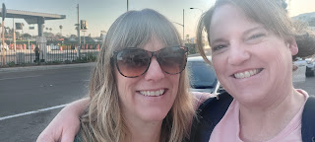

Yesterday (Sept. 10th) was my Grandma Lillian's 89th birthday. I called her and had a really nice visit with her on the phone for about 30 minutes. She is living in a care home now and said that her legs don't work much anymore. They swell up with water and are very uncomfortable each day, even though she's getting water pills. She's supposed to start physical therapy on Tuesday and is hoping that will help.

Bless her heart, she is always optimistic even when life tries to get her down. When I mentioned this to her, telling her how plucky and spunky she is, even with the difficulties she's facing, she responded with this nugget of wisdom:

"When things happen that you don't like, you just gotta dump them off the bridge and let the water carry them away."

Pretty solid advice. Just like Scott, who repeatedly encourages us to let the offensive things that happen to us go, like "water off a duck's back".

Speaking of Scott - he is still in Germany and is in the middle of their pretend war exercise. The cell reception is horrible at best and most days we don't get to talk at all. On good days, we can chat for about 10 minutes.

A colleague of his shared this link to what they are doing right now.

https://www.dvidshub.net/news/428880/saber-junction-22-begins-hohenfels-germany

Scott works with SETAF-AF - you'll see that reference in the middle of the article. He's enjoying what he's doing and is meeting people from all over Europe. He says the 173rd Airborne Brigade has the most difficult job and they are already exhausted. The training exercise is set up to be SO challenging that there is almost no chance of "winning", but the leaders know that in such circumstances a lot of important learning will inevitably take place and THAT is the underlying goal.

He should be back in Italy by September 20th. (ish)

A couple of final pictures to share and then I'm out.

Abby is really into acronyms lately. She has such a sharp mind and is always thinking and learning and is so smart!! She wrote this up yesterday:

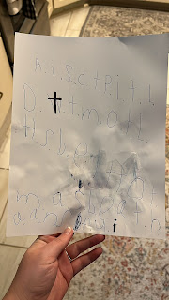

The translation: "And it shall come to pass in the last days, that the mountain of the Lord's house shall be established in the top of the mountains, and shall be exalted above the hills; and all nations shall flow unto it."

Wow. Just wow. I love that girl so much!!!

Finally:
This darling little doggy was in line next to me in Walmart on Friday. She just made me so happy. Maybe because she looked so happy and smiley. (and soft)



Have a good week everyone!

