The Next Chapter Has Begun
Welp . . . Scott left this week to begin the last phase of his military career. Everything is going swimmingly so far, thank goodness. Can you tell how he was feeling as he packed up? I wasn't quite sure.
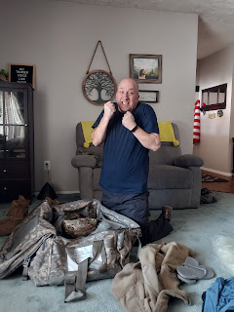

Monday:
Piles and piles everywhere . . . all needing to be organized and packed. His goal was to fit everything into 3 large pieces of luggage (a duffel, a rolling bag, and a garment bag).

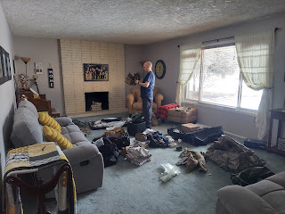

Success! It was a SNUG fit, and the zipper struggled to close on his army duffel bag, but thankfully it's a very strong zipper. The camo duffel weighed in at 65 lbs. by the time he was done.

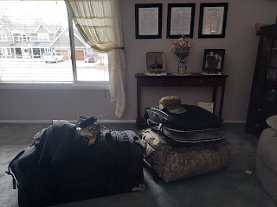

He did all of his packing on Monday, which turned out to be very helpful on Tuesday, since he was much more relaxed on his last day. I had been working on Jack's quiet book steadily on Monday and Tuesday, and since I was in the sewing frame of mind, Scott asked if I could sew on his CW3 rank to his hat.

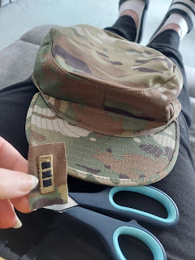

He instructed me that I would need to cut off some of the excess fabric around the edges, then fold all the edges behind the rank and sew it on. I accidentally trimmed the excess fabric down a little too much . . . which made it too difficult to sew on by hand. He ended up just doing it himself on the sewing machine . . . whoopsies . . . Good thing he's just as capable on the sewing machine as I am, if not better!

Tuesday:
We went to the gym together for the last time. I will miss the regular dates that we've had for the past several months. Later this week I went by myself and it felt really weird.



I hurried out into the snowy back yard to prune our little apple tree so I could stuff all the little branches into the dumpster before the garbage man came. It went from this:



To this:



We also went to Sizzler for lunch with Scott's parents. When Coy texted on Monday asking if they could take us out to lunch, I tried to downplay it by saying that they could just come for a visit and they didn't need to take us out and pay for a meal. She had the cutest reply: "Food is what people do as an excuse to get together." Ha ha, I couldn't argue with that! :)

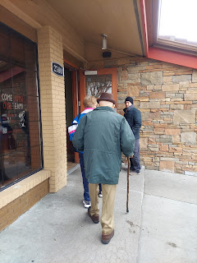

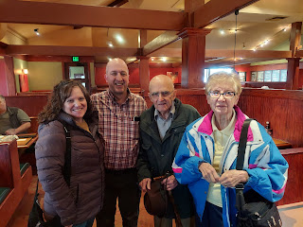

Our sweet neighbor, Maria, also brought us some of her fancy decorated strawberries in anticipation of St. Patrick's Day coming up. What a wonderful gift! We visited for a while and I shared more details with her of our upcoming plans.



Wednesday:
We both woke up well before our alarms were due to go off. Pretty spectacular. (?!!) Scott woke up at 4:00 a.m. and I woke up at 4:40 a.m. We were out the door by 5:15 a.m. and arrived at the Idaho Falls Airport by 5:30 a.m. It was about -2 degrees outside.

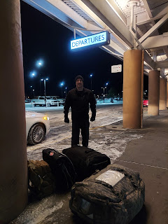



Honestly, I think this is the first time I didn't cry as I sent him off. I'm pretty sure it has to do with the fact that I get to share this lengthy deployment with him instead of spending a year (or more) by myself.

I drove home and tucked myself into bed since it was still dark outside. I tried to go back to sleep by laying there for at least a couple of hours, but wasn't able to actually sleep, even though it was nice and restful.

I worked on Jack's quiet book for most of the morning, took a lunch break, and then realized how tired I was again. I laid down and closed my eyes for an hour, trying to nap, but couldn't sleep this time either . . . what is wrong with me?? I was pretty tired the rest of the day, but also couldn't motivate myself to do much around the house either, so I silently declared Wednesday a "wash". And that's okay. Sometimes we just need a day like that.

Jack's simple car driving page . . .

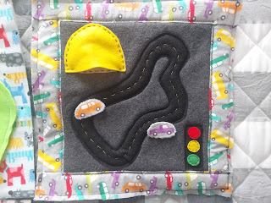

And a felt version of "Blockus", one of our favorite games because it uses geometry skills . . .

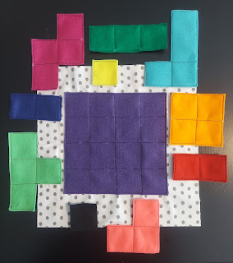

Thursday:
After arriving around lunchtime the day before (to Fort Bliss, Texas), Scott got all settled into his new room on base and went to bed early. On Thursday, he went to several classes and learned what his schedule will consist of for the next week or so. He doesn't fly over to Italy until Friday, March 18th. He has been most concerned about going to the military doctor on Monday, worrying that they might not let him go on this deployment if his cholesterol is too high. I quickly jumped in with reassurances, reminding him that he exercises regularly, eats well, and his cholesterol has been about the same for the past few years (always bad by the way) and yet they still let him go to Saudi Arabia . . . He acknowledged that that was a good point . . . still, he's crossing his fingers that he gets a good enough grade to go to Italy when he sees the Doc tomorrow.



I worked most of the day on Jack's quiet book again. :) These 2 pages will be for Jack's counting practice. I found a variety of fun little buttons for each number 1-10, and have spent about 3 days sewing all of them on.

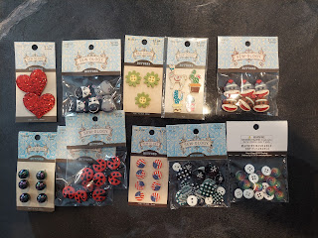

I did make a change to the buttons for #9 - which you'll see later on. Below, I've just laid out the buttons on top of each "flap" to see how well it might work.

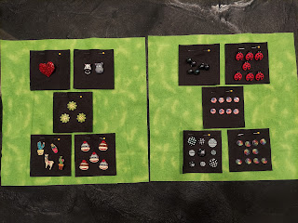

I also had a fun visit with Amber and the girls during the afternoon. Abby wanted to talk about school and some of the things she's been learning, so I also got to see her new backpack. It's CLEAR! When I asked her about that, she said it's so that if someone brings a knife (or other weapon) to school, it's easy to spot it inside of a CLEAR backpack. Sheesh. Our poor little kids these days . . .





Gwen was feeling mischievous (shocker, ha ha) and was wearing a tiara along with a colorful bandanna around her middle as a substitute for a shirt. She decided to climb up onto her top bunk and see what she could see out the window.









Amber and Weston recently bought me a plane ticket to come down to Louisiana in a couple weeks to babysit the girls while the grownups go on a cruise. Abby and I are excited to do some roller skating together, and hopefully Gwen will do alright at the rink, too . . . I'm very much looking forward to spending more time with them, though. And their weather will be much nicer for being outside than what we get during an Idaho spring. How fun!

Friday:
In between sewing on buttons and feeding myself occasionally, I got some things ready in order to send off our red truck down to Weston in Louisiana. He will be "adopting" our beloved red truck that has been in the family for YEARS. It's 28 years old now and yet it miraculously only has 110,000 miles on it. Wow! Weston needs a truck to do all kinds of things, including some yard work in the 2 acres surrounding their house. Plus, we need one less vehicle sitting around when we're both gone for long periods of time. So it's a win-win! And we know it will be in good hands because Weston is a tinkerer and loves fixing up his own vehicles. He is paying a vehicle shipping company to transport the truck down south. The $1800 is much, much cheaper than buying any sort of truck right now, even a used one.

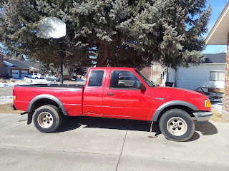

At one point during one of our multiple conversations that day, we both realized that I could throw a few items in the back seat area and send it down to Louisiana for "free". When the kids moved out last May, they weren't able to fit everything into those U-Haul containers, so there are still a few things sprinkled around the house and in the garage. After discussing what to send, I made sure that everything looked unobtrusive and didn't block any of the windows. Nothing breakable either. The guy that came to pick up the truck later didn't even notice . . .

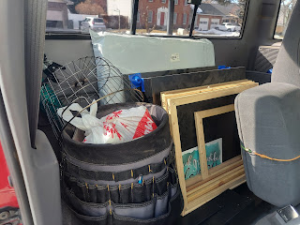

The transport guy lives in Florida, but drove all the way out to Oregon for a job, and now he's making his way back to Florida. He has a strong truck of his own to haul 3 vehicles at any given point. When he arrived he had to move the Bronco up to the middle spot to make room for our truck.

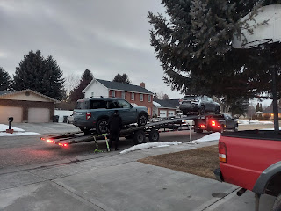

Video of him driving the truck up onto the ramp: (39 seconds)
https://photos.app.goo.gl/dSqZZuugFwWWvDfq6

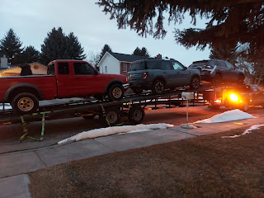

All ready for a long road trip now! Goodbye little red truck! You've been so good to us! (First, it belonged to Grandpa Harmon, then Scott, Benson used it for a couple years before entering the Air Force, and now it's moving on to our son-in-law and his family down South.

Saturday:
I woke up feeling a little bit dizzy, but was able to conquer it somehow and still go roller skating with the young women. This was our last big hurrah together, since I was recently released from serving with the YW12 class. We had a great time! There were 8 girls who were able to come, plus 3 adult leaders.

Front row (L to R): Billie (one of the new leaders and my neighbor 2 houses down), Kessli, Megan
Back row (L to R): Me, Charlotte (new), Harmony, Keeli, Linnea, Brielle, Lena, and Sophia

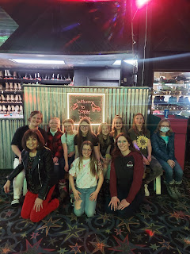

Brielle offered to do a video of me skating before we left: (36 seconds) (I'm in a black shirt/white pants)
https://photos.app.goo.gl/iyhH975o9F8C8x5d7

*She spliced together a few different segments as I skated around the rink during a "reverse skate". I need to ask her how she did that . . .

Right after I got home from skating my little heart out, I went out to get some groceries - which I was in desperate need of. I made a very simple menu plan to get me through the next week or so. I'll be making a crustless quiche (a favorite of ours), baked chicken thighs, and something with shrimp. The frozen bags of shrimp were on sale, so I got THREE bags!! I love shrimp so much - and they'll keep nicely in the freezer in between my cravings.

I finished sewing on all the rest of the buttons last night while watching a movie on Netflix. I've been on a WWII kick lately, watching several movies this past week that have to do with that time period.

First I watched Munich: The Edge of War. It had some historical facts sprinkled in with some creative liberties, but the premise was based on two old friends from Oxford who were now spies for their respective governments in trying to oust Adolf Hitler in 1938. One was from England and the other was from Germany.

Next, I watched Darkest Hour - picking up where the last movie left off with Neville Chamberlain as the PM of England, but this one was all about how Winston Churchill came into power as the new PM. He was definitely an odd duck, but after some rough spots early on in his service, he hit his stride and made some really great and rallying decisions, especially regarding Dunkirk.

For those of you not familiar with what happened at Dunkirk, here is my 2nd grade version: Dunkirk is a city on the beach near Normandy, France. Both the French and British military got cornered and surrounded there in 1940 and it was quite bleak. There were about 300,000-400,000 soldiers stuck there. They were needed desperately in other places, but they were running out of time and options to get them out of there somehow.

At one point in the movie (Darkest Hour), Churchill calls President Roosevelt in the U.S. and asks for about 40-50 naval ships. President Roosevelt is unable to help him because of whatever laws that were in place at that time, but instead he offers Churchill some interesting and creative advice to help him think "outside the box." That ended up sparking an amazing idea for Churchill to ask the civilians of England to lend their fishing boats and private yachts to rescue everyone in Dunkirk. It was easier to navigate smaller vessels back and forth across the English Channel than all the huge naval ships - which were getting pummeled with bombs and torpedoes by the way.

Which leads right into the third movie that I watched while sewing on all those buttons: Dunkirk. This is a much darker movie for sure. I watched it once before (at my son Jacob's urging), but didn't like it very much. But because I was in the zone last night and wanted to see the miracle at Dunkirk again, I decided to give it another chance. It is still very dark - in the sense that all seems hopeless and lost (for about 95% of the movie). But virtually every aspect of this movie was historically accurate, which made it all the more compelling. I love history - in case you didn't know that about me. Knowing that it was historically accurate made for a genuine nail biter, perhaps more so than if it were just fiction.

I'm not sure what to watch next, but I will do some research to see what some other possibilities might be. I'm especially interested in the WWII era right now. Maybe because of the obvious parallels one could draw from comparing Hitler to Putin . . . but maybe even more so because I have family members who served in that war and it gives me some insight into what they might have experienced.

At the end of the day, it was nice to connect with my sweetheart again.



Time for Grandbabies . . .

I got to see Avery in a video chat twice this week. She is super cute as always!





After Avery's nap, Kylie was hanging out in the nursery when their dog, Mocha, decided she wanted to be part of all the obvious fun.





I asked how Avery likes "tummy time", to which Kylie responded, "She hates it." I was hoping that by Avery seeing me on the phone screen and me trying to distract her, that maybe she could last longer than 15 seconds.



But nope, ha ha. She lasted maybe 10 seconds . . . bless her darlin' little heart!!



She is also getting to sample some new foods now. She apparently hates sweet potatoes, but in this video below, she is trying to assess how she feels about bananas . . .

Avery eating bananas: (57 seconds)
https://photos.app.goo.gl/oNvgk3L2pGbmsX3P8

Scott and I were impressed at how she kept her hands down at her side without needing them to be secured out of the way somehow, ha ha.

Meanwhile, Gwen has hair long enough for these darling piggy tails -

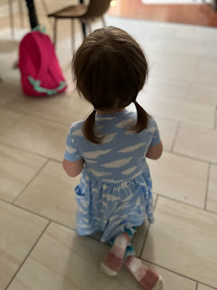

And . . . well, here she is from another view, ha ha -

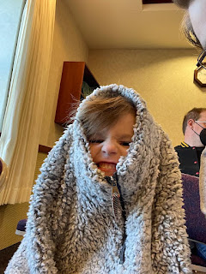

Can you find Gwen in this next photo?

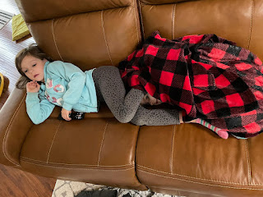

And here is Jack, learning about the world he lives in.

Video #1: Washers/dryers can also be drums (10 seconds)
https://photos.app.goo.gl/L68hE5T5CP41MgK36

Video #2: Blind cords require tippy toes in order to reach (34 seconds)
https://photos.app.goo.gl/yreAS1mcPeq3NEPZ7

He looks a little concerned about the mess he's in here . . .

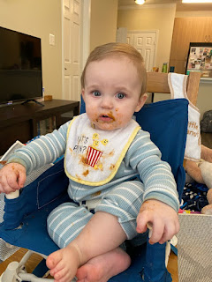

And this one just teaches us all that, try as we might, sometimes things just don't go according to plan.

