The Souk & Kasbah of Agadir
Agadir, Morocco is a much more laid back town than Marrakech. If you need to cross the street, cars will actually stop for you. There is a noticeable difference between the hustle and bustle of Marrakech versus the casualness and quietness of Agadir.

Agadir has a special resident: he is a very calm and friendly ostrich that I had the privilege of meeting.

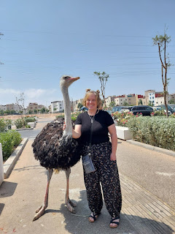

The ostrich and his owner, a young man, were outside the Souk market when my Moroccan son, Abdel (short for Abdellatif) recognized them. He told me that the owner had been orphaned at a young age and to this day he has no idea who his parents are. Abdel asked me if I had the equivalent of $1 in my coin purse and would I like to get my picture taken with the ostrich. Um, yes! He told me this was a respectful way to approach the bird and his owner, because the money would help the young man, too, and he relies on this sort of publicity in order to get by.

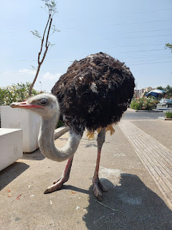

The ostrich was very soft as I stroked his neck and Abdel took a couple of photos for us. I also took a short video of the bird before we moved along. (9 seconds)
https://photos.app.goo.gl/Y7a7LKixf6A3iUZa6
We passed the Great Mosque of Agadir as we walked from my hotel all the way to the Souk, about a 40 minute walk.

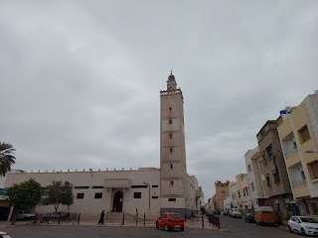

One of the entrances to the Souk . . .

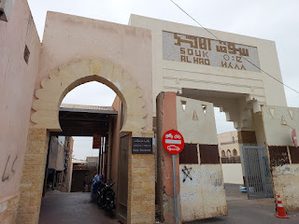

The Souk seemed like it covered a square mile . . . but it was all indoors, which made for cooler temperatures. It was quiet and calm, and no motorized vehicles were allowed, ha ha.

Video of one of the "intersections" in the Souk: (4 seconds)
https://photos.app.goo.gl/PaBJm9GSdZd6jqgFA
Another peek at the Agadir Souk: (5 seconds)
https://photos.app.goo.gl/WykTqoRjkqhhHfYL9

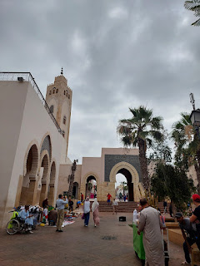

There is a beautiful courtyard outside the main Souk, with several food vendors that will make you some freshly squeezed orange juice, Moroccan tea, and a few other yummy options.

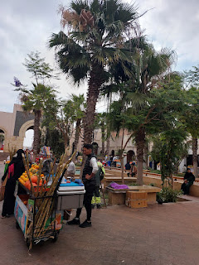

Italy has a reputation for quality leather products, but I was surprised to see so many options down in Morocco, too, and they all looked to be a good quality.

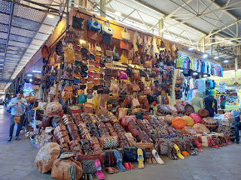

I bought Jacob and Hannah a popular type of dates in this shop. Abdel was my spokesman, asking some important questions to help me select something that didn't need refrigeration or to be eaten right away. I settled on a vacuum-sealed bag of traditional dates that came in a small box - all ready for shipping.

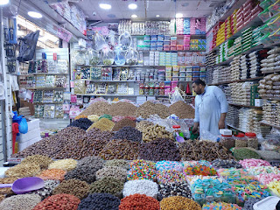

I wished so badly that I could bring home a tajine clay pot, but it was not even close to being practical. I just had to admire them and keep on walking.

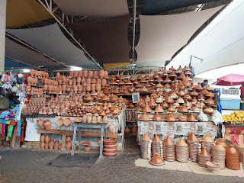

Here's a video that shows how the tajine meals are cooked in the clay pots: (5 seconds) I was lucky to find a friendly cook who saw that I wanted to make a video and he lifted the lid from one of the pots for me. :)
https://photos.app.goo.gl/fwCGd2yf5vA5DJMP8

"Spice Row", as I like to call it, with multiple spice shops spanning the length of the long path or "road: (10 seconds)
https://photos.app.goo.gl/tCzKJwWih8XB3gAC8

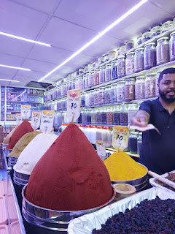

I bought a ready-made bag of maybe 8 or 9 spices, all separately packaged within the sealed bag and labeled. They included curry, cumin, sweet paprika, turmeric, and a few others. My plan is to divide them between myself and my children when I get home in a few weeks and when they will all come to visit. The whole lot cost me about $9.00, roughly $1.00 per bag of spice.

One of the workers offered to take our picture in the spice shop.

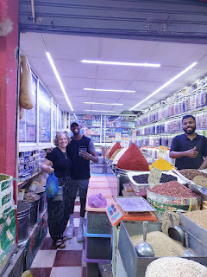

We passed several parakeets in a cage . . . I assume they were for sale.

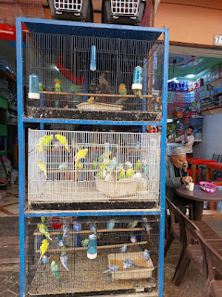

Many colors of olives and their respective olive oils . . .

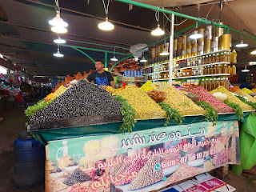

The last thing I needed to find was the argan oil products, so we left the Souk and headed out through this beautiful portal. This is where we found the ostrich and his owner sitting on the other side of the exit.

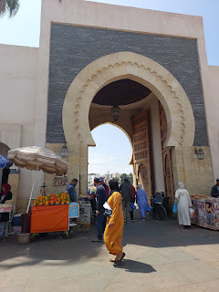

A short walk down the street brought us to a shop called Agadir Fabrica, shown in the center of the photo below. The argan oil store and laboratory are on the bottom floor. **They have the nicest bathroom of anywhere I saw in Morocco. :)

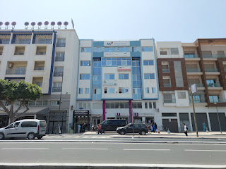

This is their showroom area with many categories of products that argan oil is beneficial for: psoriasis, eczema, dry hair, dry skin, high cholesterol, damaged skin, massage products, soaps, honey, etc. They even had a "peanut butter" or "almond butter" equivalent that is made from the argan nuts. We were able to try a sample of it and I was in love. They gave us samples of the honey and several skin care products to try. I was very impressed.

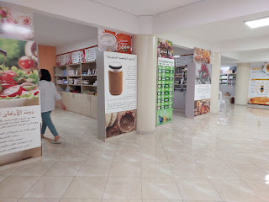

We had a reception area where we could sit on a couch and rest while they showed us a short video of how the argan oil is made - from tree to "shelf". They even brought us some bottled water and offered us a cup of Moroccan tea, which I politely declined. I think because I was so impressed with the whole experience AND their products, I ended up spending more than I intended to . . .

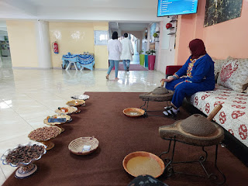

We took a taxi back to my hotel so I could drop off all the loot, and then we headed over to Abdel's house for a very special lunch with his family.

Video from the back seat of the taxi, listening to a lively conversation in Arabic between the driver and Abdel: (30 seconds)
https://photos.app.goo.gl/ATbkpofgHgXSkJ8u9

I felt so welcome in their home as soon as I arrived. They have a very large and elegant living room on the main floor, where guests can gather and visit. The windows were beautiful and the couch that wrapped around the entire room was very comfortable. I took off my shoes and sat down to wait a few minutes until I could meet Abdel's mother and sister.

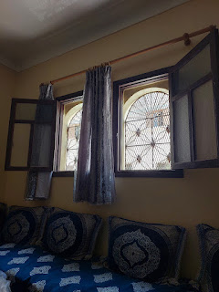

There is a set of stairs that goes up, but because of some renovations going on, I was encouraged to just stay downstairs. In the little alcove next to the stairs is a sink, and Abdel brought down a small plate with some liquid soap on it for me to wash my hands before our meal.

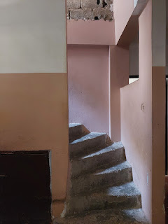

His mother and sister made a delicious lunch for us, consisting of tajine (taw-jheen) chicken with raisins, onions, honey, and spices (salt, pepper, ginger, cinnamon, and turmeric). They also made homemade fries and some kind of salsa salad on the side.

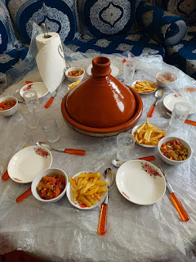

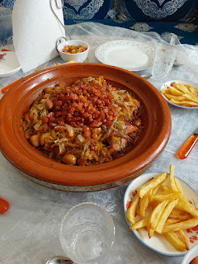

This time, I ate in the traditional manner, using bread (that Abdel's mother made) to grab bits of meat and toppings from the tajine dish. Eventually, I was encouraged to just scoop some from the main source and add it to my personal plate. Majida served me way more than my little stomach could finish off, but I gave it my best efforts. They fed my leftovers to the cat that hangs around outside, meowing loudly until they bring him something to eat.

Majida is Abdel's mother, and her name is pronounced more like Majhda. She is an amazing woman. She runs what I believe is a catering business, making meals and dishes for funerals, weddings, and other occasions.

Abdel's twin sister is named Latifa. She speaks really good English and was able to help translate during our conversation. She had her gall bladder removed recently and has had some health issues, but she is doing very well now. She is quiet, but very observant, and has a beautiful smile.

Abdel texted me the following day and said: "My sister and my mother, from the first moment they saw you when you entered the house, they admired you and loved you very much. They told me that you have a cheerful, bright face, and are acceptable. Anyone who sees you for the first time admires and loves you, and you enter directly into his heart and into his mind."

I responded with my thoughts about his family: (Keep in mind that I try to choose simple words that will convey easily to Abdel. For others, I might have used more flowery compliments.) "I noticed that your sister is very respectful and has a beautiful smile. I'm sure she has some fun stories of you as a little boy. And your mother has what we call a twinkle in her eyes. That means she smiles easily, but also it's like maybe she has a joke to tell but she keeps it a secret. She is a hard worker, but she is also very sweet as a grandmother. I can tell she is a very good woman."

He responded with: "Yes, all of this is true, as if you had been living with us for a long time."

Majida is an expert in pouring tea. It looks so fancy when she does it! She cheerfully let me take a video so I could share it with you. Notice her adorable smile . . . Also, she told me that it is a huge mistake if you accidentally pour even one drop of tea on the serving tray.

Video of Majida: (11 seconds)
https://photos.app.goo.gl/UMjfgMs69se2xiHbA

After our bellies were nice and full, we sat around and talked for a while, sharing photos of our families with each other. Abdel has an older sister who is married, and they have a son named Jad (pronounced more like Jhed). He is 5 years old. He was super shy at first, but after some consistent efforts on my part, I won him over. The older sister and her husband were both working that day, so Aunt Latifa and Grandma Majida were taking care of him.

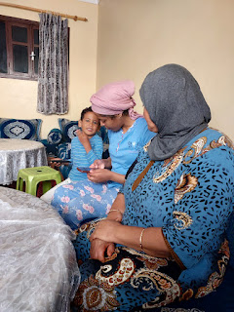

This was the most delicious chocolate cake I think I've ever had . . . it had something like a pudding on top in place of a frosting.

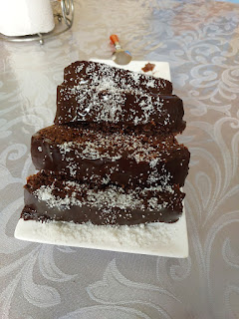

Jad is hilarious. He is super spunky but he's also very obsessed with watching endless videos on someone's phone. He liked to show me something he was watching every couple of minutes. At one point, he was explaining some details about the game he was playing. His voice is so cute!!

Watch him here: (21 seconds)
https://photos.app.goo.gl/qpkUe9x3ZK89QkLb8

Photos just before I left . . .

L to R: Jad, Majida, Me, Latifa, and Abdel

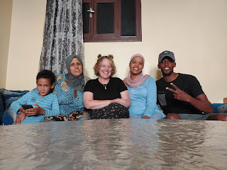

Interestingly, Majida and I are pretty much the same height. I might have a slight edge, though . . .

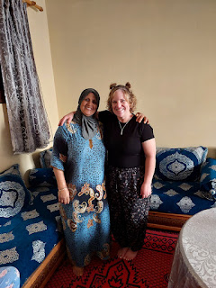

I was so honored to have been invited into their humble home, to share a meal with them, to swap photos of our family members, and to overcome language barriers. Majida had many questions about my religious beliefs, just like her son. She was really surprised to learn that I don't drink tea (unless it's herbal), coffee, or alcohol. It was really special to be able to share my thoughts and feelings with them and to testify of Jesus Christ and our purpose here on this earth.

Two days later, when Abdo and I got together next, the first questions out of his mouth were about some of the gospel doctrines that we had discussed in his home previously. This let me know that it was a positive experience and that they are still curious and wanted a little more information. I am so humbled as I have these unexpected missionary opportunities.

Abdel and I met up on the promenade to walk to the entrance of the cable car that takes you up to the Kasbah of Agadir Oufella. It was a 20 minute walk to meet him at the McDonald's and then another 20 minutes from there. The cable car place is called Danialand, and the parking lot was 98% empty, which was great for us.

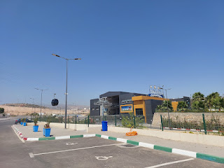

The tickets cost $9 for Abdel (as a Moroccan resident) and $12 for me. The cable cars are German-made (so very high quality) and they are comfortable and smooth. The entire ride takes less than 10 minutes.

*Note: 3 out of 3 times we went adventuring, we ended up looking like twins, LOL. A hilarious coincidence . . . and none of it was planned!
Marrakech: we both wore tan
Souk and lunch w/ his family: we both wore black
Kasbah: we both wore yellow

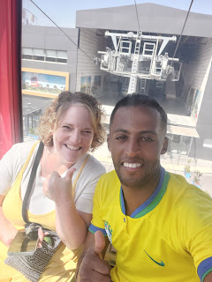

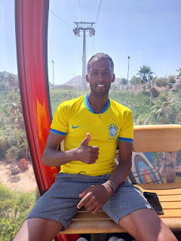

We shared our car with two ladies from RUSSIA, of all places. They were very nice.

Video of a portion of our ride up the mountain: (25 seconds)
https://photos.app.goo.gl/Q3agsgBpwgeWBQ4g9

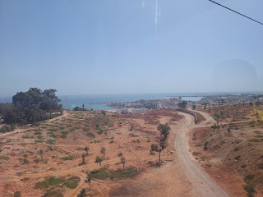

The marina district of Agadir is much larger than I previously thought. Two years ago, I walked over to the harbor, not realizing that it was only the "first" harbor if you're coming from the south along the beach. There are additional harbors and slips for personal boats and luxury yachts, as well as massive shipping vessels that bring supplies like petroleum and consumable foods from Portugal and other European ports.

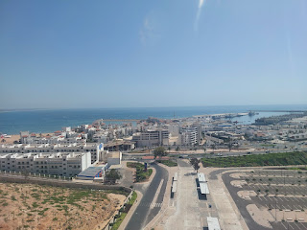

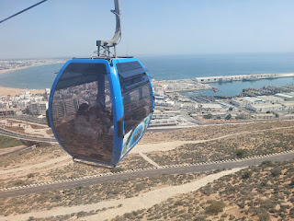

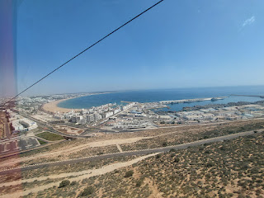

Almost there . . .

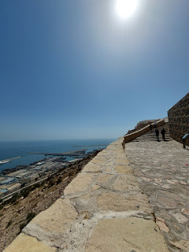

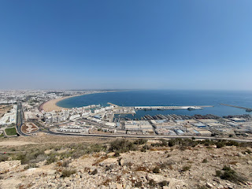

Video as we are coming to the end of the line: (12 seconds)
https://photos.app.goo.gl/i7dsn3Uvw2SQBYFJ7

Abdel . . . so proud of his beautiful city of Agadir . . .

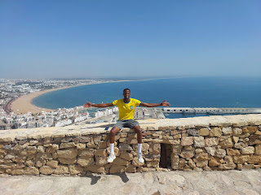

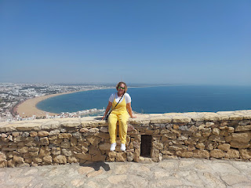

Me and Abdel . . .

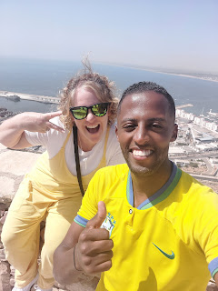

It was just a short walk from where the cable cars drop you off, and up a paved path to get to the Kasbah.

This sign explains the cemetery that was organized in 1913. I didn't see any headstones like what you see in the photos on the plaque, but that might be because they were out of view on the mountainside below us. (Enlarge photo by clicking on it)

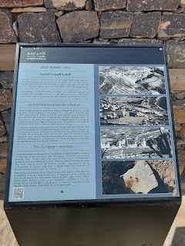

There is a large open area between the cable car building and the Kasbah. There are a handful of shops and vendor booths spread around the plaza, as well as some "animal encounters".

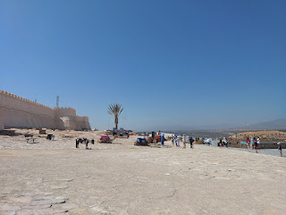

A mini pony for the children to sit on . . .

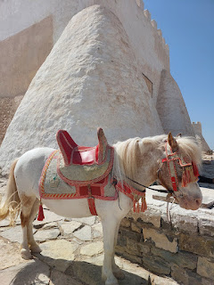

And camels for the adults . . . but they didn't appear to be available for rides. I saw a lady sitting on one of the camels, and the camel merely went from sitting to standing twice and then her "ride" was done. It was a photo opportunity, I suppose, just not a very good one. I chose to take my own photos for free.

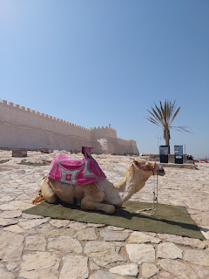

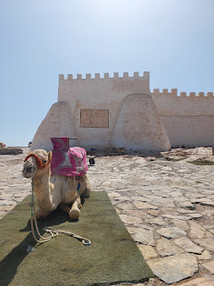

We walked along the side wall of the Kasbah to get to the main entrance. We learned that we needed an extra ticket to enter, but one of the guards happened to be Abdel's friend since childhood, so he let us in for free. It pays to have friends in high places. :)

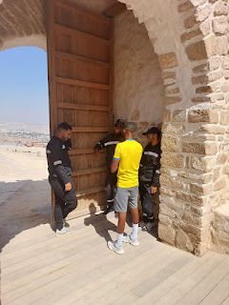

The Kasbah is a historical landmark in Agadir, and used to house the old city. It sits on a mountain that overlooks the current city, at an elevation of 236 meters (774 feet) above sea level. The earliest recorded settler was a Portuguese nobleman and his colony that occupied the lower area of the mountain, having built a wooden castle sometime around 1505. Later, the Sa'di sultan, Muhammed al Shaykh, built his own fortification higher than the Portuguese, and in 1541 his people attacked and took over the mountain.

There was a large earthquake in 1755 that primarily affected Lisbon, Portugal to the north, but it also destroyed cities to the south - even down in Morocco. Agadir was also affected, and so was the original Kasbah. I read about the Lisbon earthquake and - my goodness - it was quite a doozy. It was estimated that between 40,000 - 50,000 people lost their lives. The quake was rated at 7.7, with subsequent tsunamis and even fires that took out entire neighborhoods (because the tsunami waves came all the way ashore and infiltrated homes and churches who had lit candles for All Saints' Day, knocking them over - which then started the fires).

I know this is a digression, but the article about the 1755 Lisbon Earthquake was SO INTERESTING to read. It wreaked so much havoc - as far away as England - that it sparked a desire in the scientists of that time to figure out a way to understand and prevent future damage. Per Wikipedia: "As the first earthquake studied scientifically for its effects over a large area, it led to the birth of modern seismology and earthquake engineering."

The entire article can be found here:
https://en.wikipedia.org/wiki/1755_Lisbon_earthquake

The next big earthquake took place in 1960, essentially leveling the Kasbah high on the mountain. It has been rebuilt and renovated a few more times since then, even though most of it is just "ruins" now. I have mentioned the 1960 earthquake in recent blog posts, but I finally just read a more comprehensive summary of the trauma that Agadir went through. It is heartwrenching and so utterly tragic, but because I know Abdel and his family, and because his grandparents were there when it happened, it deserves some space here, as well. I can't even imagine how they found a way to recover . . .

Article about the 1960 Agadir Earthquake:
https://en.wikipedia.org/wiki/1960_Agadir_earthquake

Now - back to our "free" tour . . .

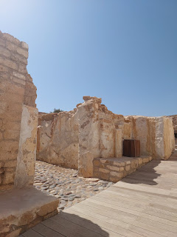

It was so epic to stand in this space . . . I will never forget it as long as I live.

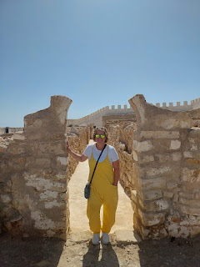

The ramparts were so cool . . .

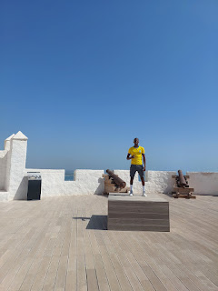

Information about the old cannons . . . (click photo to enlarge and read)

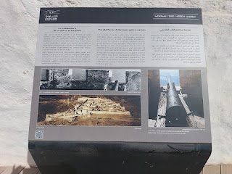

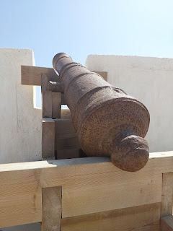

Abdel really liked the quality of photos that my cellphone camera can take, so he wanted lots of pictures taken of him that he could share with friends and family. After I took various photos of him in the places that he wanted, he insisted that I have my photo taken, too. So, that's why you're seeing lots of photos of us. You're welcome. LOL

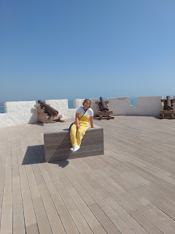

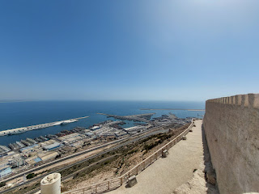

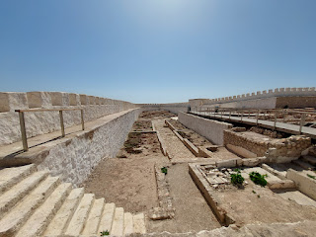

Below: You're looking at ancient toilets. Yep. Good old-fashioned squat-types. Abdel recognized them right away. You can see the place for parking your feet, if you look a little closer.

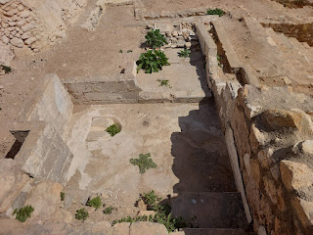

Below: a description of the Cafe Maure, a popular restaurant within the Kasbah before it was destroyed in the 1960 earthquake.

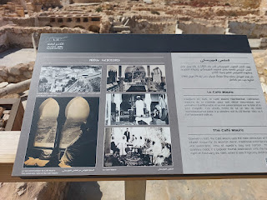

This next sign explains the open-air agora that was situated next to the Cafe Maure. An agora was a central gathering place where community interactions could take place. In the Kasbah, it was used for performances and traditional arts.

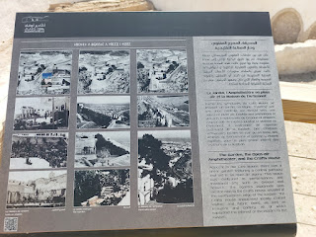

This was the area of the agora, with what appears to be a stage at the back.

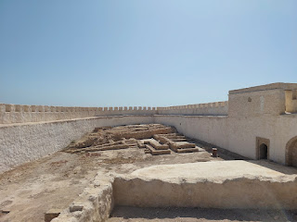

I really liked this next sign, mainly because of the photos. It shows the life that used to exist within these walls. (click photo to enlarge)

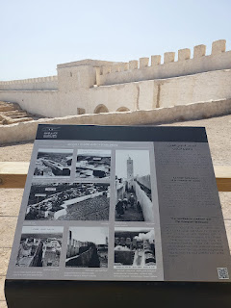

The next sign talks about the Mosque that used to be inside the Kasbah, serving both as a religious institution and a school for the children.

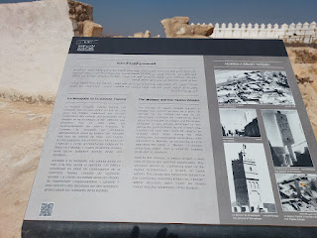

Abdel immediately recognized this important spot. He said that within a mosque, this is where a specified religious leader demonstrates what the attendees are supposed to do. He might bow down, or kneel, etc. as they pray or recite passages of scripture. Everyone is supposed to copy what he does.

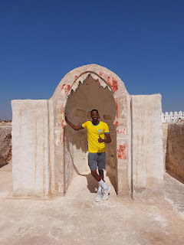

An artistic and old carving on display . . .

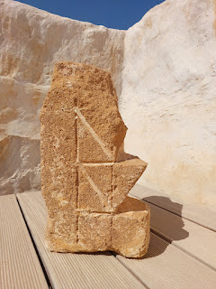

I cannot express how amazing it was to stand in this space . . . it was truly humbling.

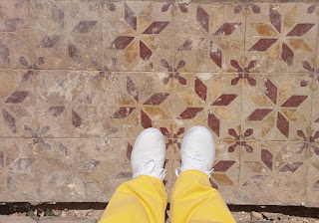

Next, we found the area where traditional hammams were given. The sign says: "Agadir Oufella boasted a hammam, a traditional steam bath, reserved to women during morning and to men during evening, where they performed ablutions to purify their bodies. This hammam, which first opened its doors in the winter of 1953, continued to operate until the fateful night of the 1960 earthquake."

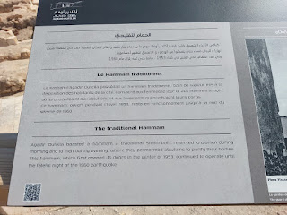

The hammam area, with beds for the scrubbing and cleansing of the body as part of the ablution process.

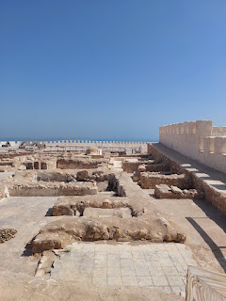

These tiny flowers within the Kasbah reminded me of my walks along the coastal paths of the Mendocino Coast of Northern California, a staple of my childhood.

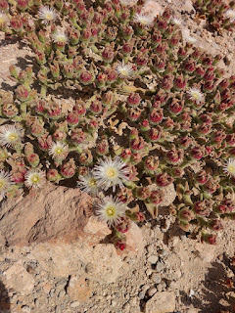

A staggering perspective of just how huge the Kasbah truly is . . . this is just one
portion
of one side.

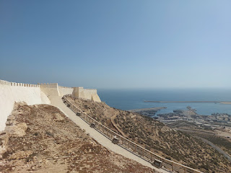

Looking out to sea . . . toward Portugal.

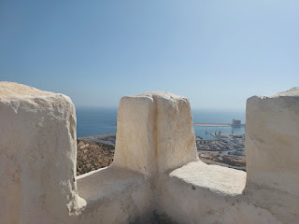

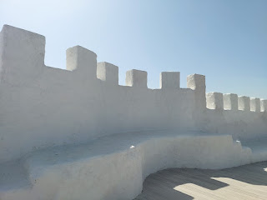

Covered up now with plexiglass, there were several communal wells placed in strategic areas within the Kasbah.

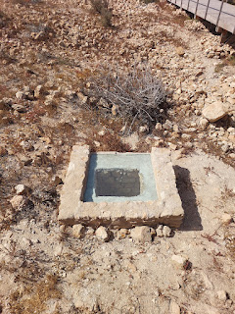

As we wandered along the footpaths and boardwalks of the fortress, we talked about religion once again. Abdel asked me if we pray in our temples. And he wanted to know if we have specific times that we pray. I told him that yes, we pray in our temples. I explained that we learn about God's Great Plan of Happiness in the temple, beginning with Jesus being chosen as our Savior and Satan being cast out of heaven. We learn about Adam and Eve in the Garden of Eden and their all-too-important choice to eat the symbolic "fruit" of knowledge. We make promises to God in the temple, and eventually we arrive in the Celestial Room, which symbolizes being in God's presence. It is there that I often like to sit in a chair and bow my head to pray silently. I might ask for help with something, or blessings for someone I care about.

I also told him that we can pray anytime, anywhere. There is no set time to pray, per se, except for mealtimes, when we ask for a blessing on our food. We talked about HOW to pray, and Abdel expressed frustration at some people that he knows, who practically demand things from God. We talked a lot about humility and I had to use Google Translate so that I could make sure he understood the word I was trying to convey. This is what he wrote to me in the app after he understood the meaning of humility:

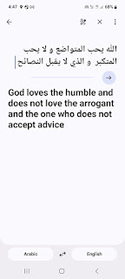

These experiences in Morocco felt life-changing for me. Not only as I absorbed the incredible history of their nation, with all of its colors, sights and sounds, but as I connected more deeply with my Moroccan son and his beautiful family. I cried when I hugged Abdel goodbye on the day before I left. I'll share more details about that in the next blog post, where I just have a little bit more to write about Agadir, and then I will catch up on all the other happenings within our family.

