Verona & Vicenza Christmas Markets
After several weeks of sickness, I was FINALLY well enough to get out and celebrate a little bit of the Christmas Season by the end of the week. It felt so amazing to walk around in the crisp, winter weather and take in some holiday sights and smells.

We spent most of Saturday in Verona, about 45 minutes west of our house. It's a large city (pop. 636,000) and is on the list of World Heritage sites for historical contributions and architecture. Verona is also known as "Little Rome" because of all of its Roman antiquities that have been preserved through the centuries.

A small portion of the few remaining arches still standing at the top of the Arena di Verona.

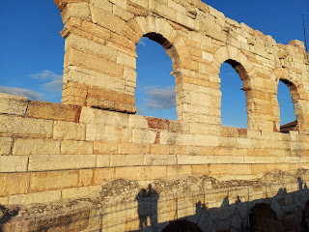

View overlooking Verona from the top of the Colosseum (Arena).

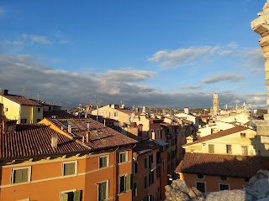

I'll just quickly summarize the first several days of the week: They were horrible.

Well, Monday, I felt better - and well enough, actually, to do some cleaning and laundry. I was still coughing, but my energy was starting to emerge again and that felt so wonderful. But then Tuesday, I got slammed with vertigo and nausea for 2.5 days, which sent me back to bed again. I couldn't eat anything because I was so nauseous all the time, and I lost 3 lbs. in those two days. Not the best way to lose weight, though, and I don't recommend it.

By Wednesday night, the dizziness had not let up, so I had Scott help me with what is called the Epley Maneuver. It's a series of head positions that you hold for about 60 seconds before moving on to the next position, and is a highly successful way to get crystals out of your ear canal that are potentially causing the vertigo. There are several helpful videos on YouTube and other articles online that can outline what it's all about. The maneuvers did help somewhat, and I was able to start eating again by Thursday afternoon.

Friday I was well enough to wash all the bedding, run a couple of errands and even make a pot of minestrone soup for dinner. It felt so amazing to be up and around once again!

So . . . since the Christmas season is about to wind down and I only have a week left here in Italy, our one good day to do something big was on Saturday. We had a wonderful time exploring Verona and visiting our very first Christmas Market.

Walking from the parking garage toward the Christmas Market area in Verona . . .

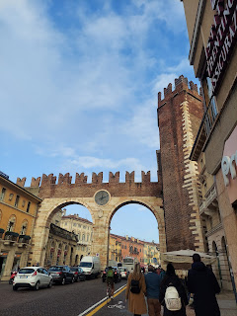

When we got to the first piazza with market stalls, they mostly consisted of: hats, scarves, leather wallets and purses, ceramics, and a few food vendors.

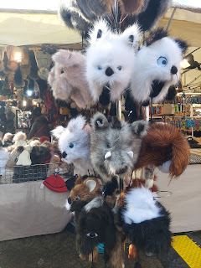

We continued on toward the second piazza, navigating through the narrow streets filled with shoppers shuffling along past dozens of trendy businesses, many of which you would typically find in a mall.

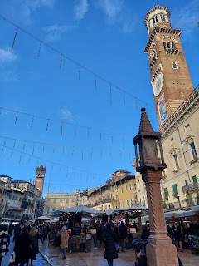

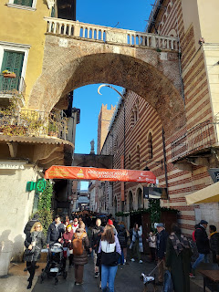

Soon, we arrived at the second piazza, Piazza dei Signori. There were more original crafts sold here, though I didn't see any handcrafted nativity sets, which was high on my list to find.

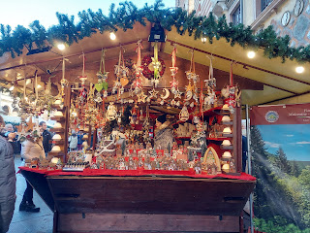

They did, however, have a few German booths with foods to sample. This food tent offered a choice of bratwursts or sausage burgers, with a side of sliced potatoes and/or sauer kraut.

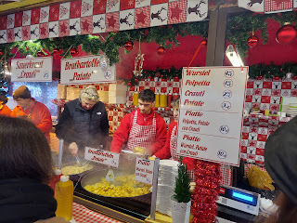

We chose to get a plate with the bratwurst, potatoes and kraut to share. It was so delicious and warmed our tummies very nicely.

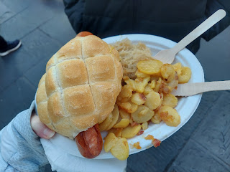

We stood underneath this giant Christmas tree to share our German meal together. :)

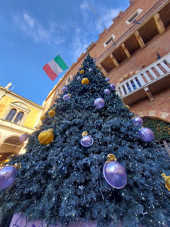

Another booth sold various types of sausage: truffle sausage, wild boar sausage, and donkey sausage to name a few. It didn't look very appealing to me . . .

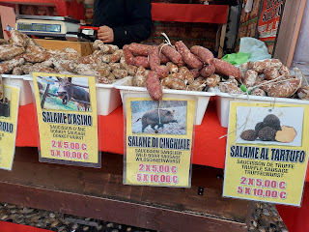

I was enthralled with the man in a nearby booth who was literally roasting chestnuts over an open fire. (*This next photo is from a booth in Vicenza later that night, but the process was the same in Verona)

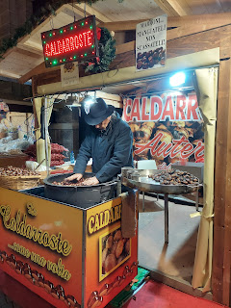

Video #1: The man roasting the chestnuts in Verona. He looked Eastern European to me, but said he was from Milan.

(22 seconds)
https://photos.app.goo.gl/HzexaatUkChxWaqq8

Video #2: He opened up a chestnut and showed me how it can be used as a hand-warmer, tossing it back and forth from hand to hand until it cools off enough to eat. It felt amazing, since I didn't have any gloves with me and my hands were pretty cold . . .

(6 seconds)
https://photos.app.goo.gl/Kvw12w8EoZv1YpZ49

We didn't see much else that we were interested in while visiting this piazza, so we decided to go on a walking explore of our own to see what we could see.

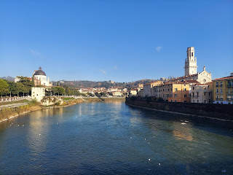

We walked along the wide Adige River . . . toward the castle that we could see off in the distance.

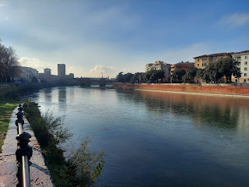

We would be walking out onto this bridge minutes later . . .

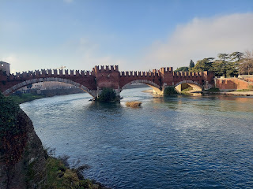

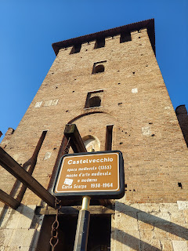

Castelvecchio was built in roughly 1355 AD.

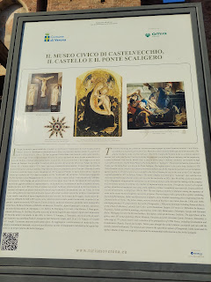

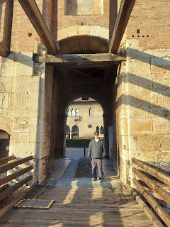

The courtyard inside the entrance . . . I
loved
the cow fountain . . .

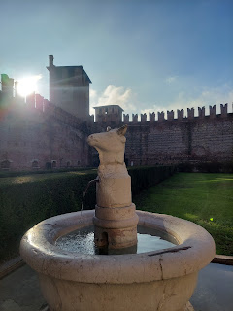

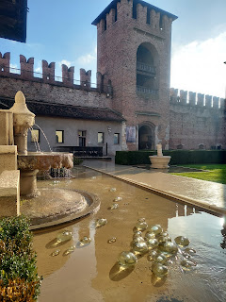

Walking out onto the bridge over the Adige River . . .

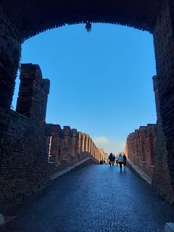

And up to a spot to look around and get a photo . . .

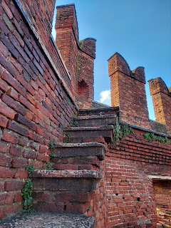

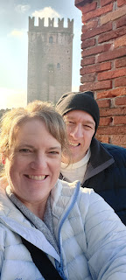

We found Santa getting some exercise as well . . .

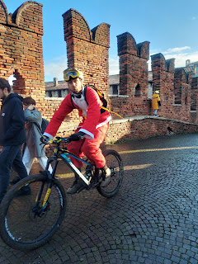

I really love ancient buildings. I always love to imagine what life would have been like so long ago. Like, what would these walls say if they could talk?

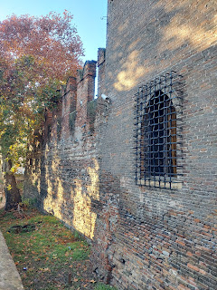

We made our way back to the first grouping of Christmas Market stalls that we saw earlier and decided to splurge and get a giant fritter with Nutella smeared inside. It was AMAZING.

Video of our fritter being prepared: (1 minute) *Enjoy all the lively Italian conversation going on.
https://photos.app.goo.gl/jCiGVbH2GZQo3neQA

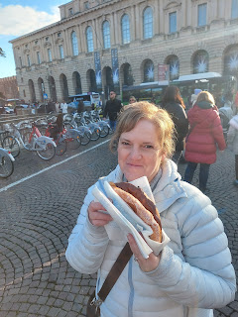

Next stop: to see a large collection of Nativity scenes in the building right behind me in the photo above. It was $8 admission for each of us. I really enjoyed seeing all the time and effort that some very talented individuals put into the making of the Presepi (Nativity).

There were representations from all over Italy - scenes from medieval Italian villages, to more modern-day Italian markets. Each Presepi showed the artist's interpretation of how would Baby Jesus be welcomed here, and how would he fit into this town?

Get ready for several photos . . .

Questions I pondered as I wandered:

What town is this? a fishing town perhaps, or a mountain village . . .
Where is Jesus?
Who is noticing the Lord of Lords, lying in a manger? Do the other figures know who he is?
Where is the light being emphasized in each scene?
Are people drawn to the King of Kings? Or are they too busy doing whatever they are doing?
How is Mary being portrayed?
What is the quiet message that the artist is trying to get me to notice? Something subtle perhaps . . .
Is there an underlying message here? Some symbolism?
How does this scene relate to me today?

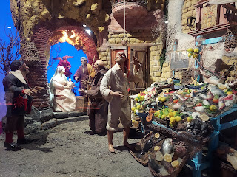

We especially loved this next scene - it's just a portion of the overall scene. But we loved how the angel is bent over and lovingly interacting with the baby. We think that the baby here is John the Baptist, based on the ages of the parents, possibly Zaccharias and his wife Sariah.

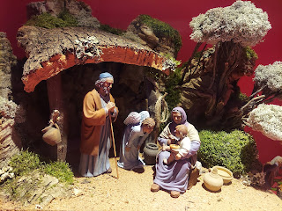

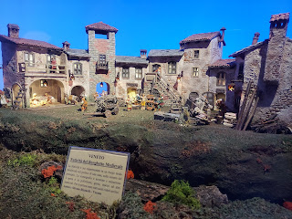

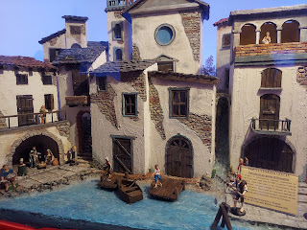

Video #1: Nativity scene (15 seconds) Lazio (Province where Rome is)
https://photos.app.goo.gl/DkSnSuNPynxzenCf6

Video #2: Nativity scene (52 seconds) Campania (Province where Naples is)
https://photos.app.goo.gl/4npXc773fwEbK9zE8

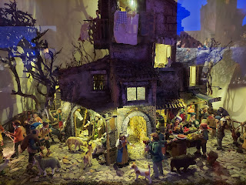

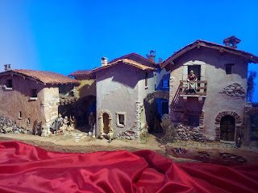

Croatia

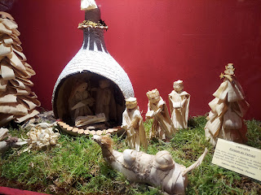

Japan

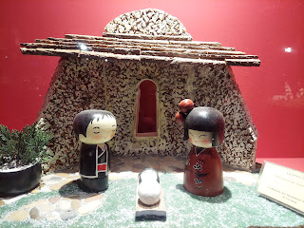

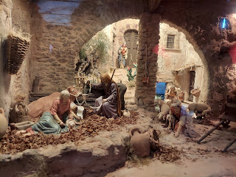

Video #3: A very LARGE Nativity scene from Sicily (34 seconds)
https://photos.app.goo.gl/xrFNHmC98qTg4GN46

Misc. nativities from some countries in Africa, and one from Russia . . .

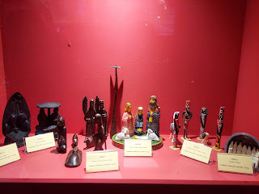

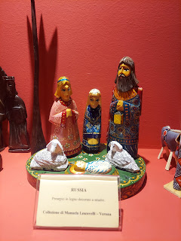

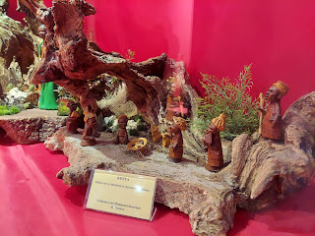

Mongolia

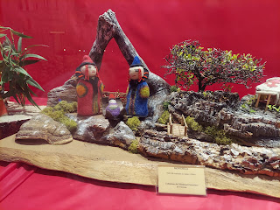

Jerusalem

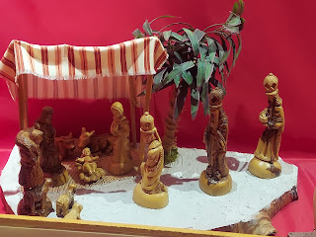

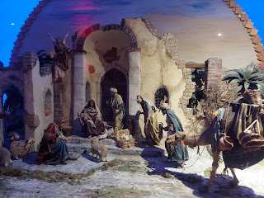

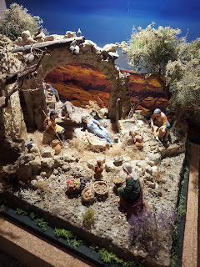

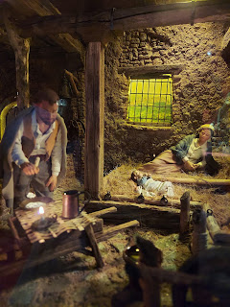

Belarus

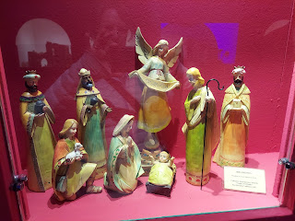

Philippines

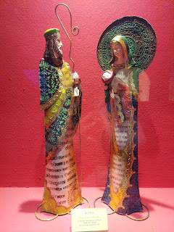

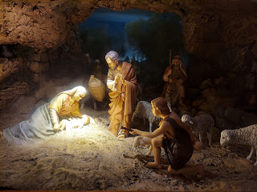

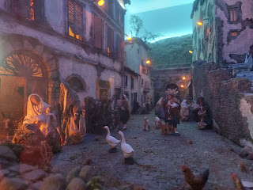

I hope you enjoyed the walk through the Presepi with me. Which one did you like the most, and why?

Next, we walked across the street and through the park to visit the Roman Colosseum. The Arena di Verona is the 8th largest in the world, and is the 4th largest in Italy. It pre-dates the Colosseum in Rome, which makes it pretty special. It's also more intact than the one down in Rome. The Arena was built in 30 AD.

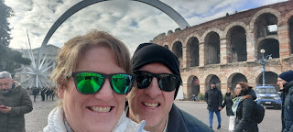

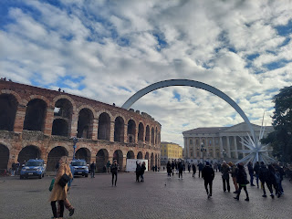

For $10 each, we could enter and walk around for as long as we wanted.

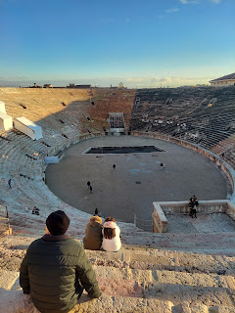

I just learned some interesting things about the Arena:

1. It will be the venue for the Closing Ceremony of the 2026 Winter Olympics. It can hold up to 22,000 people - although in ancient times they would pack in 30,000 spectators.
2. Numerous concerts have been held here over the years, including such artists as Bruce Springsteen, Whitney Houston, Duran Duran, Yanni, Pink Floyd, Rod Stewart, Sting, Paul McCartney, and many others. WOW. That would be a very cool experience to be a part of!!

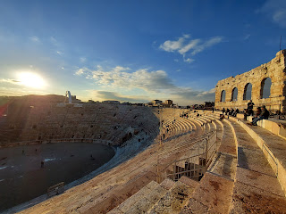

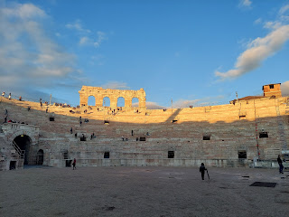

There are different tones on the seating throughout the Arena. We believe that a little at a time, they have been updating the stone, which would explain why one section is very dark black and the rest . . . not so much.

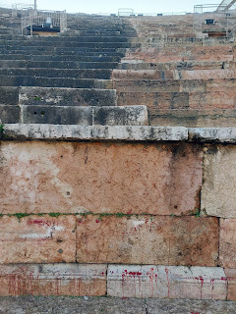

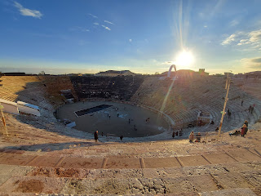

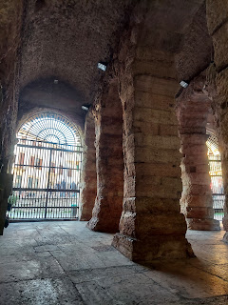

Once in a while I come upon a strange European bathroom, like this one underneath the Arena. Thankfully, I was able to use the handicapped stall next to this one and it had a normal toilet.

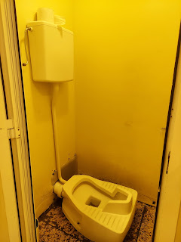

A little bit of explanation about the history of the Roman Arena. And it's even in English!

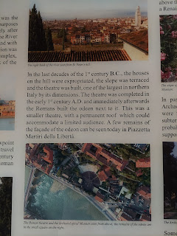

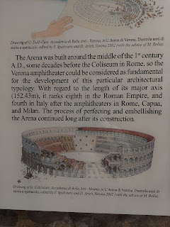

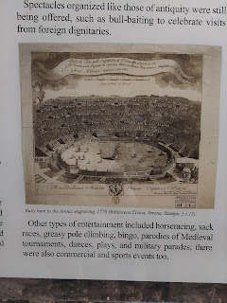

The two shadows in the photo below belong to Scott and me. XOXO
He was on the phone talking to his friend, Rich Garner, showing him the Roman Colosseum that was much closer than the one we toured with the Garners down in Rome.

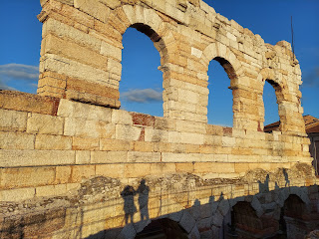

Once we finished basking in the sunshine at the Arena, we made our way back to where we parked our car, and began the short drive back to Vicenza. We wanted to visit the Christmas Market in downtown Vicenza before the day ended. We couldn't find any parking at all, though, so we drove home and rode the bus back across town instead, ha ha.

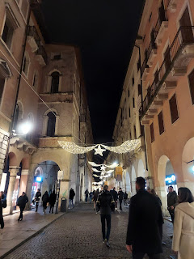

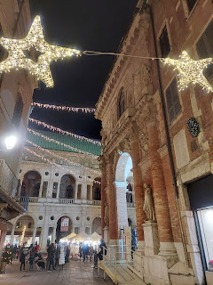

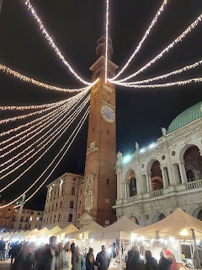

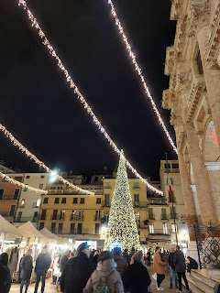

Video of the Piazza dei Signori of Vicenza: (16 seconds)
https://photos.app.goo.gl/g4P69x5xbsqV5Ufg8

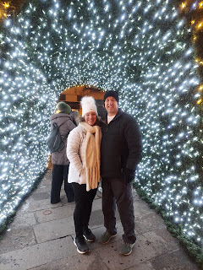

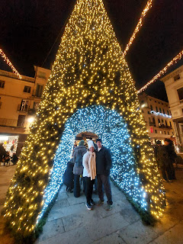

And hooray of all hoorays - I found something darling for Abby's Christmas gift at this booth in Vicenza.

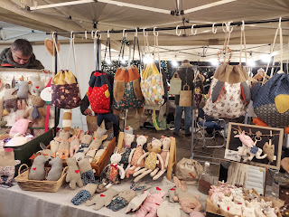

Someone spent some time crocheting all these tiny Christmas sweaters to decorate a storefront window.

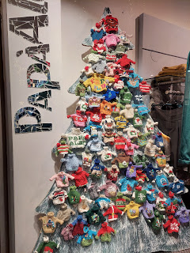

These olives are the largest I've ever seen in my entire life.

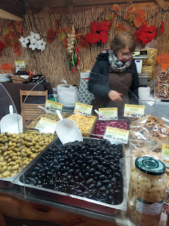

After struggling to find the right bus at the right bus stop, and getting on the wrong bus briefly, we finally made it home around 8:30 p.m. and heated up some leftover minestrone soup for dinner. It was a long day, but it was a wonderful day!

I didn't find most of the things that I had intended to find at the Christmas Markets, but I still came home happy. I'm immensely grateful that our health had improved enough to allow us to have at least one magical holiday adventure together. :)

Some miscellaneous photos from earlier in the week . . .

Scott stayed home from work on Monday to do some coughing with me. For a little while in the afternoon, we hung out in bed and played Name That Artist using Spotify. Scott likes to test my knowledge of musical artists from the 80's . . .

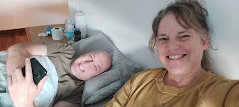

I loved this online photo of a very patriotic Christmas Tree.

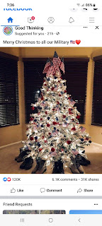

And this was the view from where I lay in bed for days, surviving by drinking Throat Coat tea with honey.

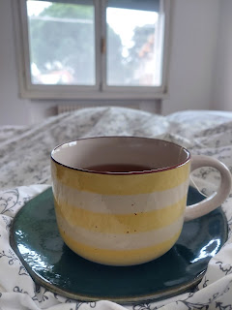

Thursday morning, Scott drove me to my hair appointment and dropped me off. I wore a mask, didn't cough very much, and the dizziness was a little better that day. My appointment took just over 3 hours . . . Scott came back to get me and then he drove me home to rest when it was all done. That is the definition of love.

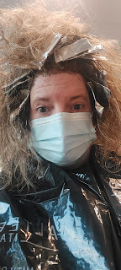

The beautiful floral arrangement at the hair salon.

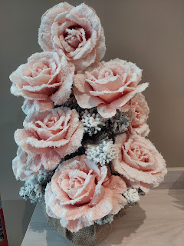

Time for Grandbabies . . .

Kylie sent me a cute photo of them cuddling together and the most darling video of Avery ever!!

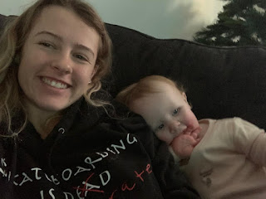

Video of Avery making faces at herself and then cracking up: (13 seconds)
https://photos.app.goo.gl/K15EAFzfjGyCmCAU7

We will be watching her for a few days this coming week and we are excited to spend some time with that little cutie patootie. :)

Jack has been busy doing yoga and looking very dapper as usual.

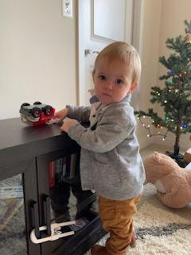

Video of Jack practicing his yoga poses: (15 seconds)
https://photos.app.goo.gl/97ejzdZuXKKShg1o7

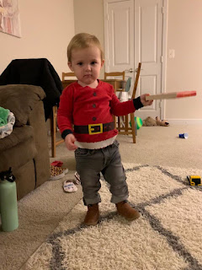

Jacob so enjoyed the memory of Grandma Harmon (Coy) making jam thumbprint cookies all throughout his childhood, that he decided to make some of his own to take to their ward Christmas party.

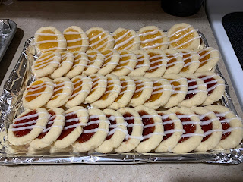

Lastly, here is Gwen enjoying some brownie batter remnants. :)

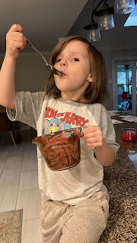

I will be hugging and squishing each of my grandchildren within the next week!! I can't wait!!!!!

