Welcome to Italy (again) & Swiss Heritage Sites
*Cities in this post:
Idaho Falls, Idaho, USA
Lake Maggiore, Italy
Aarburg, Switzerland
Neuendorf, Switzerland
Oberbuchsiten, Switzerland
Laupersdorf, Switzerland

I arrived safely in Italy on Wednesday (March 20th) and Scott was there to pick me up. My flights were all on time and nothing weird happened, ha ha. Well, I guess the one weird thing that happened was that I had all 3 seats in the middle section to myself, which meant that I could lay down during the night and try to get a little more sleep, which was nice. It wasn't perfect, but it was better than usual.

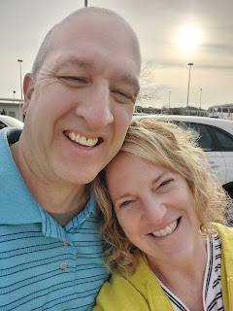

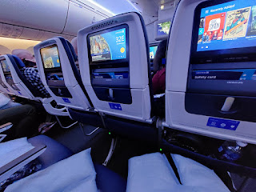

Before I left home, I had two enthusiastic helpers to assist with getting the house all tidied up after having had a house-full of company (and a puppy) for many days. Emily McGovern and Lauren Parker reached out to see if they could help me in any way before I left, which was so thoughtful of them. They came down from BYU-Idaho on Monday afternoon and after we visited for almost 2 hours first, we got down to business and did some cleaning. Emily cleaned the back door windows, where Daisy would jump up with her dirty paws and leave darling little puppy smears as a souvenir for me, ha ha. Once that was done, she also vacuumed most of the house, too. Meanwhile, Lauren meticulously cleaned two of my three bathrooms from top to bottom. I was so grateful!

I focused on cleaning my oven (something I haven't done in maybe 10 years??), as well as doing some additional packing and organizing.

Me, Lauren, and Emily . . .

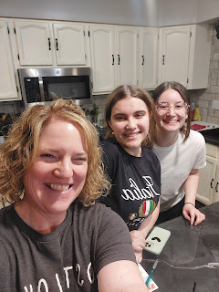

The oven door was particularly disgusting, and heaven forbid someone should ever need to peek through the glass window to keep an eye on whatever was baking . . . Benson had suggested I get some "Easy-Off" oven cleaner, something he had used in Italy. It worked really well. I sprayed it everywhere inside the oven, then closed the door and let it sit for a good long while. When I came back a couple hours later, I just had to wipe up the grunge with an old rag and voila! The only thing that didn't want to come off was the old foil that somehow became "one" with the bottom of the oven. I'll have to figure that part out later, I guess.

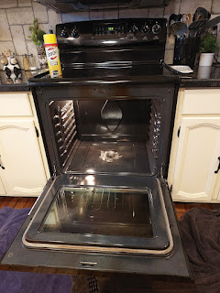

I was so happy that the glass window was shiny enough to see my reflection, though.

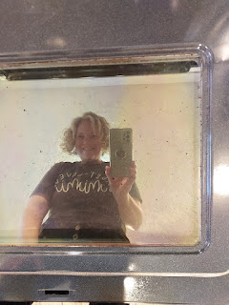

On Tuesday, March 19th, I took a final lap around the house, checking the inside and the outside before I left for another 90 days. The snow from Leap Day weekend was all but gone now.

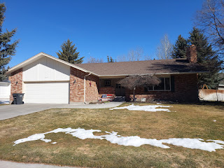

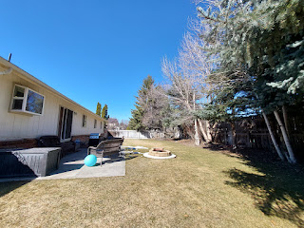

I flew from Idaho Falls to Denver, then had my long flight over to Munich (about 10 hours), and finally a short (1 hr) flight to Venice.

Idaho Falls from the air . . .

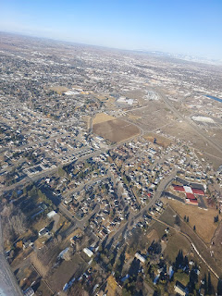

Star Valley, Wyoming area . . .

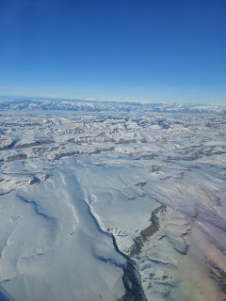

The sky was clear enough to see the Grand Tetons waaaay off in the distance . . .

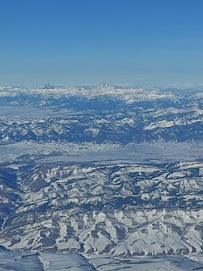

For my flight to Munich, I was pleasantly surprised to learn that the two seats next to me would be VACANT this time. No angry Russian lady to appease. Just lots of room to sprawl out and try to get a little better sleep later in the night.

Farm fields over Munich the following day . . .

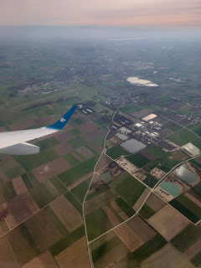

Then, on my last leg, we flew over the Alps near Innsbruck, Austria, coming down into Northern Italy. What a spectacular birds-eye view of the snowcapped mountains!

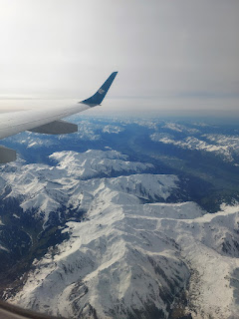

Video with Venice out in the Lagoon on my side of the plane: (7 seconds)
https://photos.app.goo.gl/pBHkQZATFTUv5rsf7

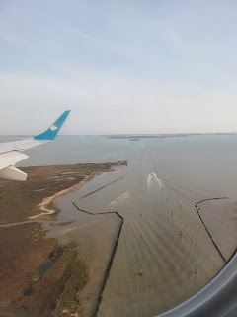

I arrived tired, but happy, into the arms of my BFF.

We left the very next day to drive up to Switzerland for the weekend. I had just enough time to sleep through the night, unpack a little bit, then repack (but in a much smaller amount), and then off we went! We had planned it out ahead of time so that we didn't drive the whole distance that first day, choosing to stop for the night at Lake Maggiore. It is a massive lake that shares its shorelines with both Italy and Switzerland. We had a very nice view from our room at Hotel Villa Ruscio, overlooking a portion of the lake.

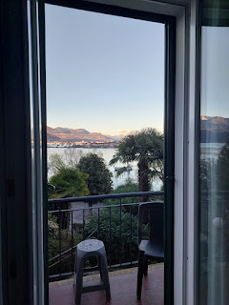

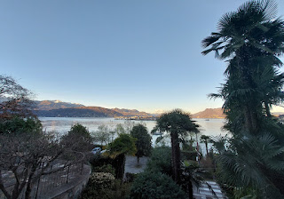

We walked into Baveno to find something for dinner. As we walked along the road that was next to the lake, we barely had enough room to walk single file next to the white line on the pavement . . . it was a little scary to be so close to the cars flying by, but what were we to do? We wanted to stretch our legs after the 3 hour drive and nobody had built a sidewalk for us until we got closer to town, so we marched on in single file.

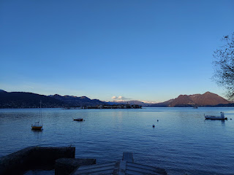

I wish I could have brought this rose home with me . . . it might just be the most beautiful rose I've ever seen.

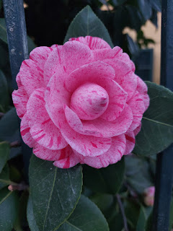

On the outskirts of Baveno, there were finally some paved walking paths for pedestrians, along with some gorgeous flowerbeds filled with spring bulbs in bloom.

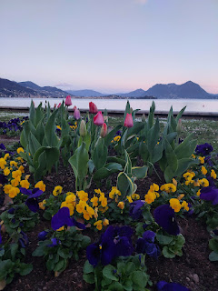

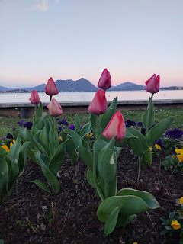

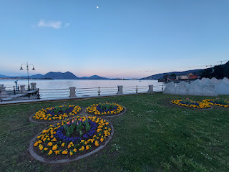

Views of the lake: (13 seconds)
https://photos.app.goo.gl/VBHmb1sqvghV1Bcu8

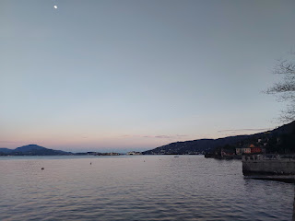

While we had hoped for something nicer to eat, we settled on sharing a pizza, since the nicer restaurants were too far away on foot. We found a deserted dining area next to the water and happily munched it all down.

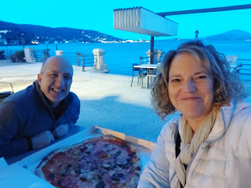

On the way back to our hotel, I was curious about this combined groomed hedge and memorial.

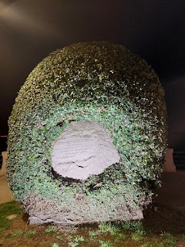

Using Google Translate and the camera within the app, I learned that the memorial read:
"Slaughtered by the German invader, Here fell for Italy of all Italians, Seventeen [of] our young people of Latin gentle blood. 21 June 1944."

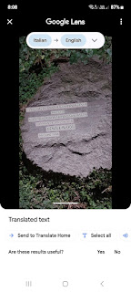

I found a detailed account of what happened in Baveno so close to the end of WWII on this website:
https://www.robertspublications.com/blog/the-murders-on-lake-maggiore-part-2-baveno

If you scroll past the descriptions of some famous visitors to Baveno (including Winston Churchill and Queen Victoria), about 1/3 of the way down you will find the story of the murders. The short version is that the German SS set up shop in Baveno at the Hotel Beau Rivage - which was RIGHT ACROSS THE STREET from where we ate our pizza and can be seen in the story that I provided a link to (immediately above). We literally sat under the awning shown in that photo across from the Hotel. Sorry - I started a sentence and then I digressed. The short story is that the German SS came to hunt down all of the Jewish Italians and either imprison them, kill them, or send them to Auschwitz. It's chilling to consider that such atrocities were happening in this charming little lakeside town 80 years ago. Why can't we just let people live their lives and stop trying to force everyone to look the same, think the same, and act the same?!! Let's allow people to be diverse and colorful and unique, as long as they are respectful of everyone else, too.

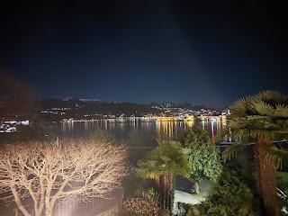

We carefully made our way back to the hotel (in between Baveno and Stresa) on that narrow stretch of road, only this time it was in the dark . . . thank goodness we lived to tell the story!

The following morning, after an uncomfortable sleep on an uncomfortable bed, we took our luggage out to the car across the street and then hiked back up for breakfast. There are lots of cute and tiny waterfalls in between the houses in Baveno, including this one at our hotel.

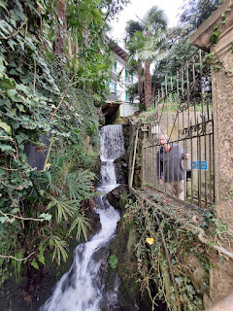

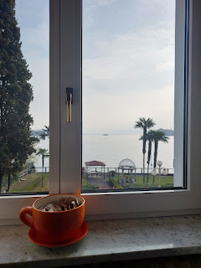

A couple of blooming flowers on our way out . . .

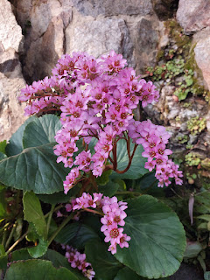

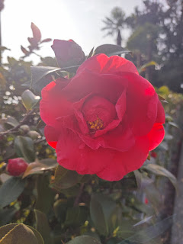

The first few minutes of our 3.5 hour drive were spent following the shores of Lake Maggiore. Right away, though, we noticed a worrisome sound underneath the car.

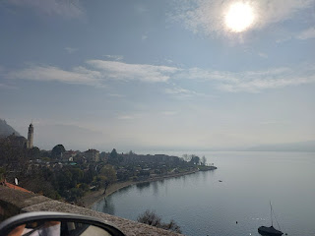

We pulled into a gas station to check it out, and thank goodness for my scary experience back in 2020 that Scott remembered and then applied to our current situation. In 2020, I was driving along some back country roads in Virginia (near Strasburg), which also included a stretch of gravel. In that case, the screeching and grinding sound I was experiencing at that time was because some bits of gravel got lodged in my brake pads or rotors. Each time I pushed the brake pedal, it sounded like a horrible death was occurring. Advice that came over the phone from Benson and Scott (who were in Italy and Saudi Arabia at the time), and also from a kind man who stopped to check on me, was this: Drive forward a little bit, then hit the brakes hard. Now drive backward, and hit the brakes hard again. The goal was to dislodge the little chunks of gravel, and it worked!

Along Lake Maggiore, Scott tried the same technique and the awful sound magically stopped. This was also right after we prayed and asked for help from God, so I'm sure that had something to do with it, too! With the problem solved, we went on our merry way and had no more issues with the car.

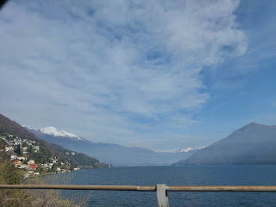

Near the northern end of Lake Maggiore, we crossed the border into Switzerland. There was merely a slowdown on the road, but no passport checks or cars being stopped. Switzerland is part of the Schengen Area, a group of countries in Europe that don't require a passport check as you cross from country to country. Within the Schengen Area, I am allowed to visit for up to 90 days. If I go outside the Schengen Area, then I am "off the clock" regarding my 90 days, but there will still be a passport check and a stamp made. Once I re-enter the Schengen Area, I am back "on the clock" and each day from that point on will count towards my maximum of 90.

For more info, click on this link, which includes a nice map on page 2:
https://home-affairs.ec.europa.eu/system/files_en?file=2020-09/schengen_brochure_dr3111126_en.pdf

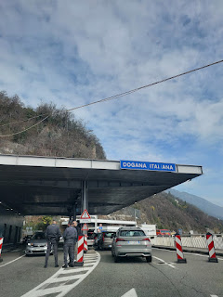

No more "Italia" . . . we were now in Switzerland . . .

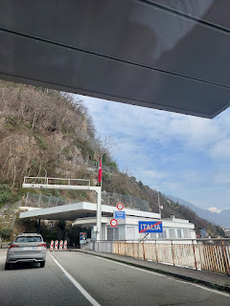

We passed by and in between many snow-capped Alps. We also went through several tunnels, right through the heart of some of these mountains. The longest tunnel was 17 kilometers long!!!

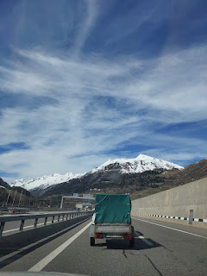

If you click on this next photo, I want you to zoom in so you can see just how massive the mountains are. Look for the Swiss houses on the hillside and note how tiny they are.

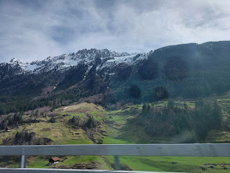

Another tunnel . . .

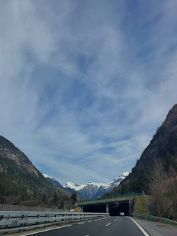

Hello dairy cows . . . thanks for your milk that makes such delicious cheeses and creamy chocolates!

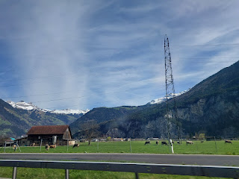

There's that silly word again . . . it means "exit". LOL

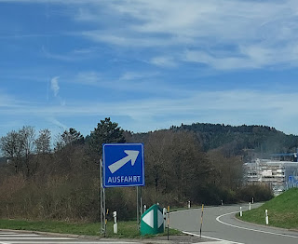

Coming into Aarburg, where our hotel was, we could see a giant castle situated above it from a long way off.

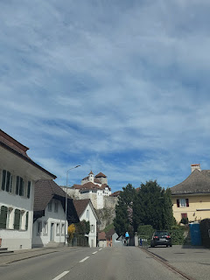

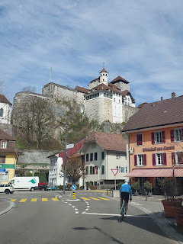

Breathe in the fresh and crisp Swiss spring air through our 4th floor window . . .

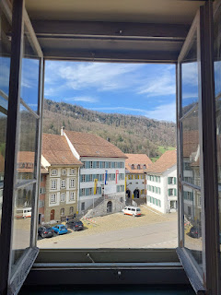

We stayed just long enough to haul our stuff up 51 stairs to the top floor of Gasthof Baren (Baren Guesthouse), use the bathroom, and then scurry off to see some nearby villages while the sun was shining and the weather was good. The next two days would be cloudy and much colder, with rain in the forecast.

First stop: Neuendorf
(about 13 minutes west of Aarburg)

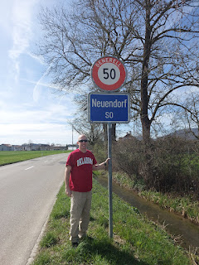

Records show that Scott's 2nd great grandmother, Johanna Barbara Gasser, was born here. One record said she was christened here, but another record said she was christened in nearby Oberbuchsiten. We went directly to the Catholic Church of Neuendorf, since the family was Catholic. Also, I would like to point out that the surname is pronounced GOSSER, which is a German pronunciation. The Swiss tend to speak what is known as Swiss-German.

Video pulling into Neuendorf: (19 seconds)
https://photos.app.goo.gl/Sf2uxrR5k6btyEXp6

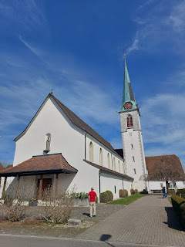

The Roman Catholic Church of Neuendorf was completed in 1886, but there was probably another one in the same place prior to that. Johanna Gasser was born in 1842.

I think I mentioned this a year or so ago, but I'll mention it again. Burial practices are different in Europe than what we are familiar with in the U.S. In Europe, the family essentially leases a plot for a period of time, like 10 or 30 years. When that time is up, the family can sign another "lease", but for an increased amount of money. If they cannot pay for Round Two, or if they do not choose to renew, they can at least reclaim the memorial (headstone). It can also be recycled for other purposes within the cemetery if left unclaimed and if it's still in good condition.

Bodies are often layered on top of another. Some countries allow the plot to be dug down deeper to allow for "newer" bodies on top. Some countries dig up the decomposed remains and place them into a communal ossuary. Many countries use cremation to cut down on space being used, especially if there's not a lot of space to work with. In Italy, cremated remains are kept in drawers that are all stacked up pretty high. Often, families are grouped together in alcoves or rooms, and most of the slots have a photo of the deceased on them. Because these are such common and cultural customs in the Eastern Hemisphere, none of these burial practices are considered to be troubling or inhumane or horrible over here.

Here are a few examples of what we found in Neuendorf at the church cemetery.

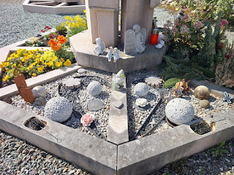

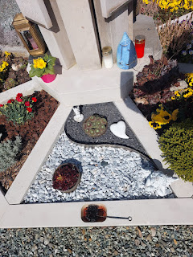

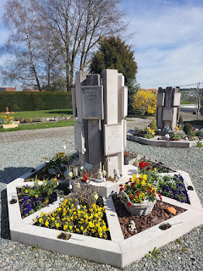

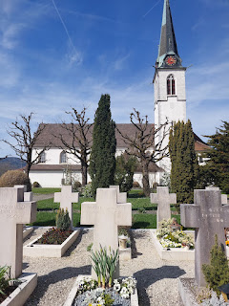

Small detour for a moment: Something we recently inherited from Phil and Coy (after their passing) was this beautiful table with a marble top. We were surprised to get it, especially when we were shown a little note that is tucked underneath the main top.

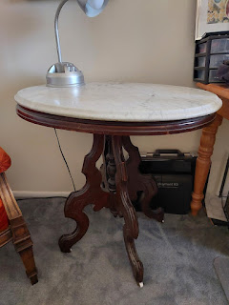

"Wedding Present to Johanna & Jonathan Hill. 1863."

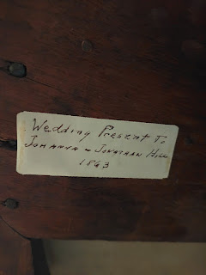

Well, this Johanna was none other than Johanna Gasser, who came from Switzerland!! Phil's mother, Helen Gordon Harmon, was Johanna's granddaughter. It had been passed down to her, and then to Phil, and then to us. Apparently, Coy had relayed to one of her daughters last year, "Give this to Michele (and Scott). If they don't want it, then make sure it stays in the family." What a special gift this is!! I thought it was especially timely because Scott and I were already making plans to visit Johanna's hometown in Switzerland.

Another view of the church in Neuendorf . . .

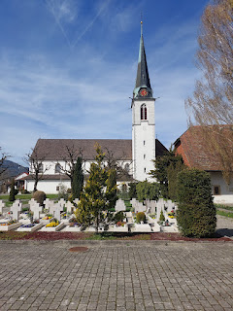

Related to the topic of burials, most headstones and memorials that you see now in the cemeteries are all within the last 100 years. I saw one or two where the person was born in 1899 +/-, but most memorials indicate that the person died in the late 1900s or early 2000s. We did not see any markers for people from the 1700s or 1800s. Probably because of the whole plot recycling program. Still, we saw a few Gassers and this one (Gassner) that could be a variation.

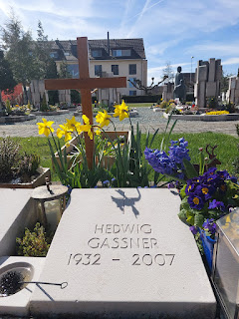

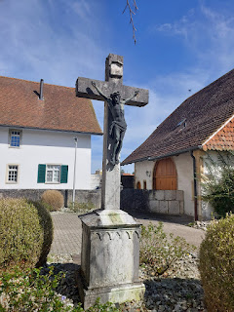

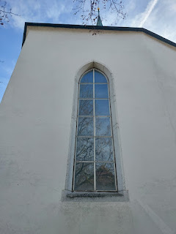

We went inside the church briefly, but didn't spend too long because we still had two more towns to visit.

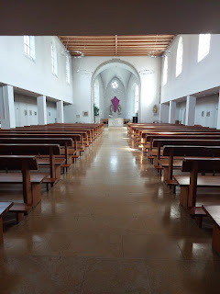

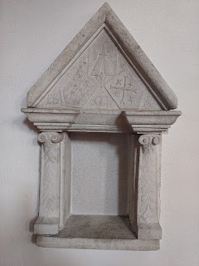

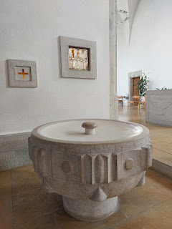

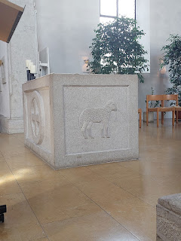

The organ was quite beautiful above and behind Scott.

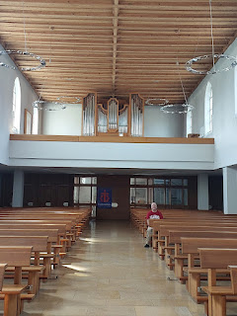

"Die Bibel" = The Bible.



We both marveled at these heavily pruned trees all in a row near the church. I'm not sure what they are called, though . . .

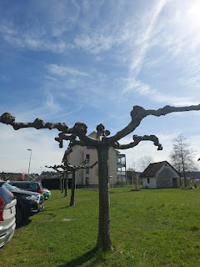

I stand corrected. ChatGPT is an amazing AI Encyclopedia!! I simply asked this question on my ChatGPT app: "What are the trees in Switzerland that are pruned substantially and don't bloom until summer?"

Instantly, the answer was: "The trees you are referring to are likely "plane trees" or "London planes". (Platanus x acerifolia) These trees are often pruned substantially during the winter months in Switzerland, and they typically don't bloom until summer. Pruning them in winter helps maintain their shape and health while avoiding damage to the tree."

I then looked for images of London Plane Trees and voila . . . ChatGPT was spot on. Amazing. (Specifically I found an image of what was called "Pollarded Plane Trees" and it looks just like what we saw.)

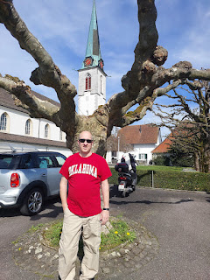

Second Stop: Oberbuchsiten
(Oh-berr-BOOK-sit-ten) About 13 minutes west of our hotel and less than 5 minutes north of Neuendorf.

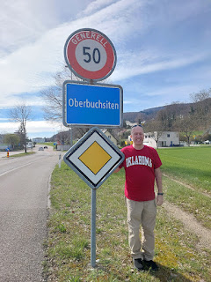

Welcome to Oberbuchsiten . . .

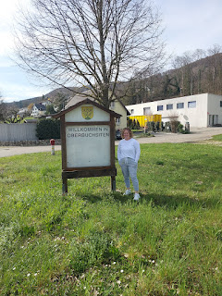

We headed straight for the church. Katholic Kirche Maria Himmelfahrt Oberbuchsiten.

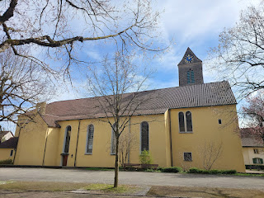

Video coming into town: (31 seconds)
https://photos.app.goo.gl/LnBKBnKPT79eH1Mq6

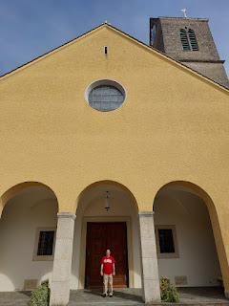

Video walking toward the church: (21 seconds)
https://photos.app.goo.gl/1uJkLN4EsPpN2ATY6

As we walked up to the front door of the church, I FELT something. I grabbed Scott's arm and said, "Do you feel anything?" He said, "Like what?" "Like this is the church where your family used to attend . . ." He hadn't noticed anything though. But I did.

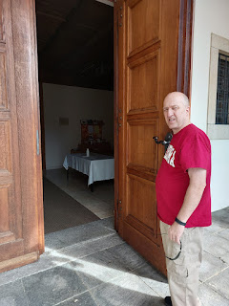

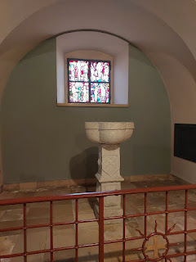

Just inside the foyer stands the old font, presumably where the christenings took place. The date on the front of the font says: 1728. Wow. This church was built between 1741 and 1743, so they must have incorporated the older font into the "new" church. It is possible that Johanna was christened in this font.

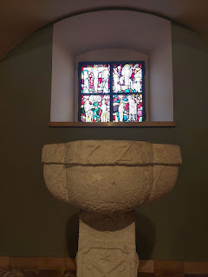

An older photo of the church, hanging on a wall within . . .

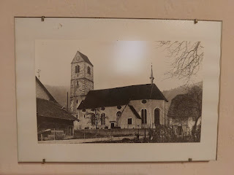

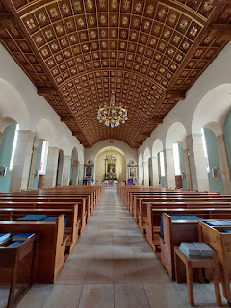

A collection of Swiss-German hymnals . . .

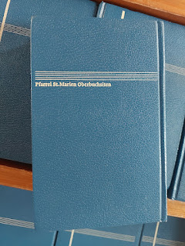

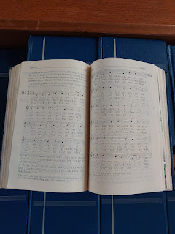

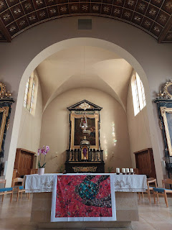

Looking back at this next photo later that same night, I got a little emotional. I was feeling a special connection to this church and chapel.

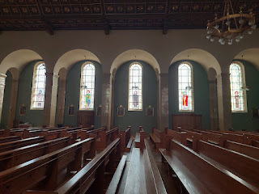

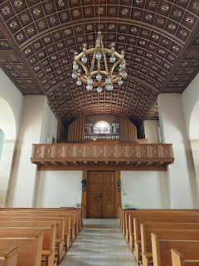

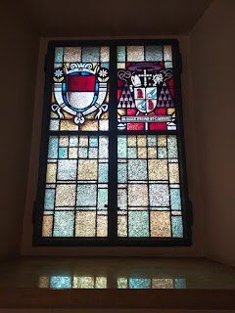

After taking a little longer inside this second church, we drove up into the hills above Oberbuchsiten. To be honest, at first we were following instructions from Google maps to get to a restaurant up there, but when we started off-roading and left the pavement behind, and then the gravel became dirt . . . that's when we abandoned our original plan, ha ha.

However, we used this opportunity to get some drone footage over the town of Oberbuchsiten. This is where Johanna's family lived at least back through 1740, which is as far as the line goes on FamilySearch.org at the time of this writing. (Specifically, her mother's line - Kolliker/Koelliker)

Drone video compilation of various locations in and around Oberbuchsiten: (1 min, 5 seconds)
https://photos.app.goo.gl/sV8oamZ4pDPHdMfD9
(*Note: no sound on the video)

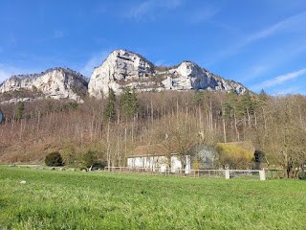

Third Stop: Laupersdorf
(About 19 minutes west of our hotel)

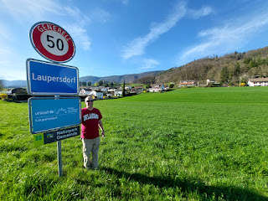

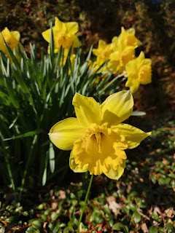

Johanna Gasser's father, Josef, was christened in Laupersdorf in 1816. Josef's father and grandfather (Friedrich and Johannes) were also from Laupersdorf, and possibly more generations before them. I just spent the past hour going down an exciting rabbit hole, scouring page after page of old Swiss church records (in Latin) with births from about 1773 through 1805 so far. I had to tear my eyes away, even though I found 12 new Gasser babies to add to FamilySearch!! Family history is the best!!! Finding babies and marriages and death records - this is my biggest passion in life besides my own family right now . . .

An interesting story about Josef Gasser is that he was recruited to work as a Swiss Guard at the Vatican down in Rome for about 3 years, from 1845 to 1848. There was a lot of turmoil in Italy during those years. Wars were going on everywhere as Napoleon and others sought for power, trampling all over the country to claim what they could. Even Vicenza was right in the thick of the devastation at that same time.

Swiss Guards were expected to be single and Catholic in order to qualify to work at the Vatican. There has been speculation that Josef Gasser and Anna Elisabetha Kolliker weren't actually married. But there is also evidence to support that they were, indeed, married. A document was sent from the Vatican when Josef died (close to Ferrara, Italy) to the local officials back in his hometown of Laupersdorf. It specified some instructions on how the surviving family members could lay claim to his pension. Why would they offer that privilege if he had supposedly been single? Further research is needed, and hopefully something will be discovered.

Three years after Josef Gasser died in Italy, his widow, "Elisabetha", remarried in 1851. Her second husband was named Christian Von Arb. In 1854/1855, the family immigrated to America. Scott and I were trying to figure out why they would have left this beautiful land behind, so we did some digging on the internet and with ChatGPT. ChatGPT is laser-focused on getting you the VERY SPECIFIC answers you are seeking, and thank goodness!!

We learned that there was a massive famine and an era of poverty between roughly 1850 and 1860 in this area of Switzerland. Maybe there was so much snow and it didn't melt fast enough to allow for a growing season. Maybe there were other factors, too. Either way, the poor families became destitute, and the rich families became poor (or poor-ER). That's when the newly formed Von Arb family decided that enough was enough and that it was time to start over elsewhere.

I looked to see how old Johanna Gasser would have been when they immigrated, and she was only about 8 or 9 years old. When I compared her age to my own granddaughter, Abby, who is that same age right now, I got a bit emotional as I considered a sweet and innocent young girl starving and not knowing where her next meal would come from. I'm glad they had enough money to get across the ocean, where they settled in Missouri for a long time. As Johanna got older, she took notice of Jonathan Hill who lived nearby to their own family's property. Or perhaps he took notice of HER. They eventually married and in time they ended up in the Covina area of Los Angeles. Their granddaughter, Helen Gordon, was born in Hollywood and married into the Harmon family in 1930. (Wesley LaVier Harmon, to be exact.) The Circle of Life. :)
This is the Reformierte Kirche of Laupersdorf . . . built in the 12th century, with a few updates since then. This is likely the church that the Gassers attended.

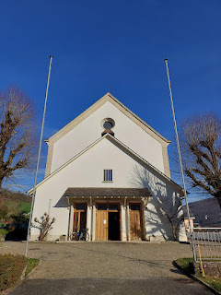

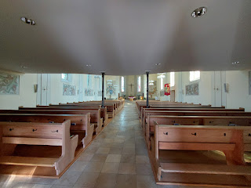

Flowers dotting the cemetery behind the church . . .

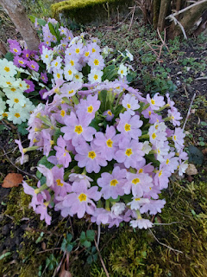

Ruth Schaad Gasser and Martin Schaad Gasser are buried here . . . probably cousins . . .

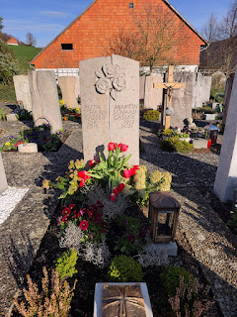

Helene Gasser-Maschmann, also probably a cousin . . .

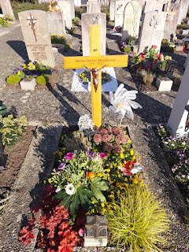

Hans Gasser-Brunner . . . probably a cousin as well. We saw SEVERAL Brunners in the Swiss cemetery and then I found just as many or more Brunners on FamilySearch this morning!

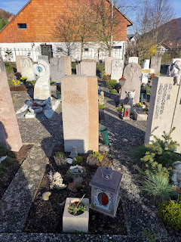

Rosa Gasser-Schaad . . . another probable cousin . . .

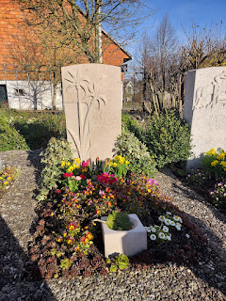

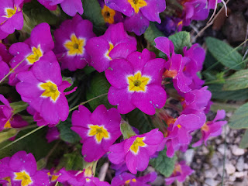

Kirche St. Martin in Laupersdorf (built in the 11th century) . . . with a cemetery behind it.

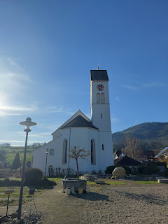

I just love the smaller memorials where family members plant a variety of flowers on top. They are so beautiful!

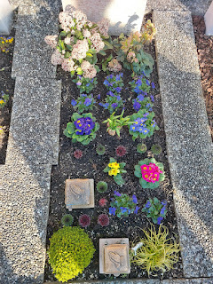

We didn't see any familiar family names in this cemetery though, so we turned our attention to the sheepies in the nearby meadow and walked over to pay them a visit.

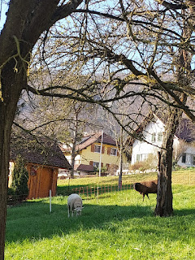

A small mob trotted over to check us out: (19 seconds)
https://photos.app.goo.gl/D3K8bsDTamtfMcxE7

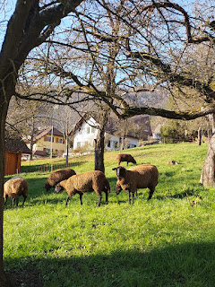

This stunning water fountain was across the street from the St. Martin Church, so I blurted out for Scott to pull over so I could get a picture, ha ha.

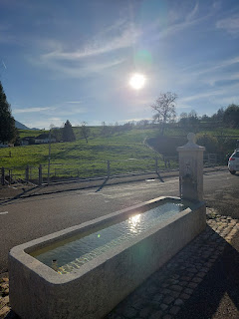

We drove a little bit through the countryside of Laupersdorf before heading back to Oberbuchsiten. We found a few more sheepies out in the pasture. You may recognize some of this lush farming area because there was a small portion that we included in the drone video that was shared above.

Video of the Baa-Baa-Black Sheep: (18 seconds)
https://photos.app.goo.gl/5AKuCr38WZ4cGdTx8

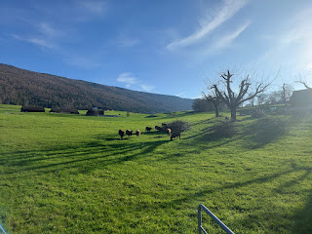

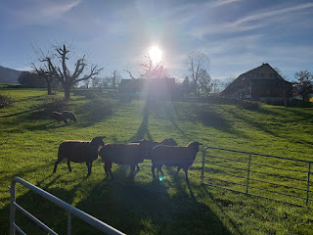

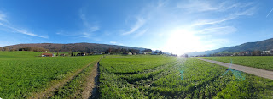

Fourth Stop: Oberbuchsiten Cemetery

We realized when we got to Laupersdorf that we had forgotten to find a cemetery back in Oberbuchsiten, so we back-tracked and found the "Friedhof" (cemetery) close to the church where I had felt that special connection earlier.

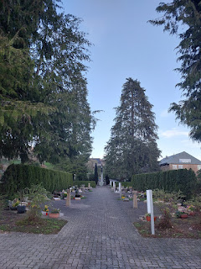

Kolliker/Koelliker is the surname of Johanna Gasser's mother. They were in the Oberbuchsiten area for at least one more generation back (Johanna's grandparents). That's where the branch of the tree ends on FamilySearch, so there is some work to be done to extend her line.

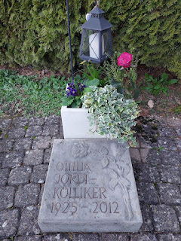

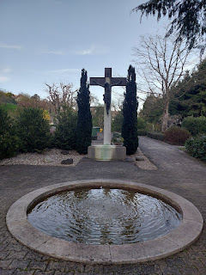

We enjoyed all of our cemetery visits on that sunny Friday afternoon. There was always a joyful outburst when we found a family name. :)

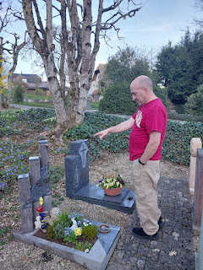

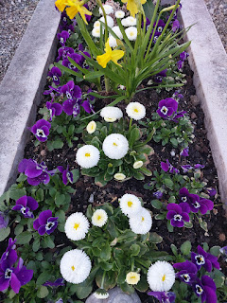

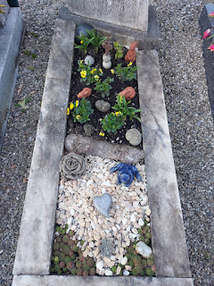

Martha Kolliker Philipona . . . a cousin I assume . . .

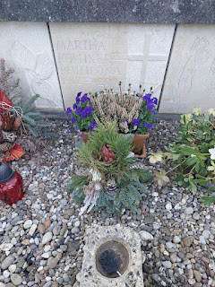

Irma Buttiker Kolliker . . . another cousin to discover . . .

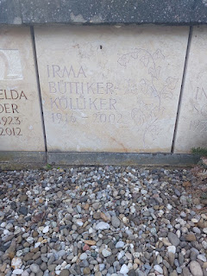

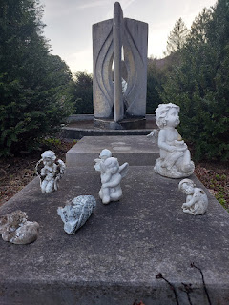

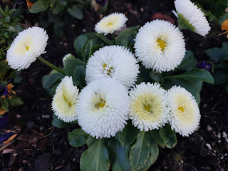

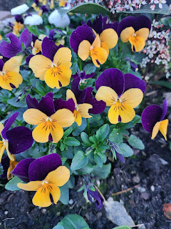

A family plot, or at least a shared plot, with two Kollikers and a Scheuermann that stood out to me on this memorial. I used to babysit for Terri Scheuermann back in Ukiah, CA. It's a very specific spelling, so it sure jumped out to me from this tiny town on the other side of the world!

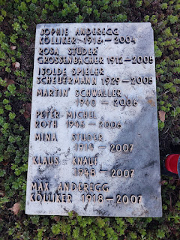

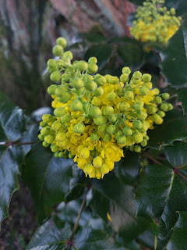

Pink magnolia trees were in bloom in many places around Switzerland. They are so exotic that it's hard to believe they can survive the harsh winters this far north . . .

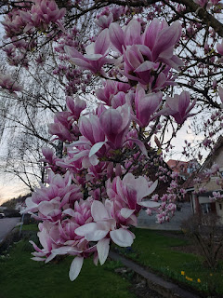

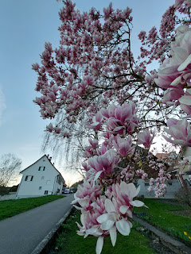

Final Stop:
Back to Aarburg to relax and wind down the day at our hotel underneath the castle.

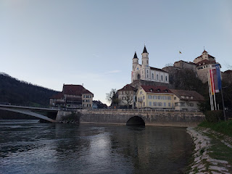

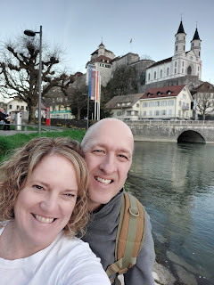

After getting a bite to eat at the shawarma place next to the hotel, we trekked up 110 stairs to the magnificent castle so we could see the stars in the night sky and the town below. (We may or may not have kissed up there . . . no one was around so it can't be proven either way . . .)

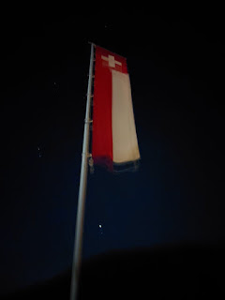

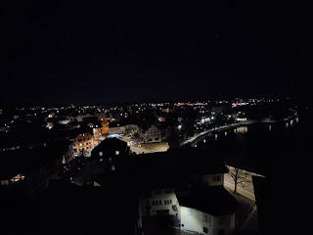

Upcoming blog post:
Our visit to the beautiful, historic and nostalgic city of Bern. Also the details of our detour over the border into Germany to do some family history recon for my cousin, Loreena Hester.

