What does the Bunny Say?
I'm sure you've heard of the song "What does the fox say?" If not, you can enjoy it here:
https://www.youtube.com/watch?v=m9OuOpVQFi0&ab_channel=WaqasKhan
I even have the children's book with the entire illustrated song. :)
What I would like to know is, "What does the bunny say?" I know they're capable of making little sounds, but what is it exactly? Is it a little squeak?? If anyone knows, please tell me . . .
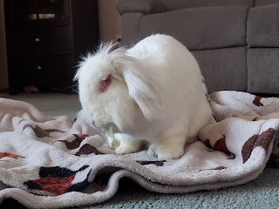
I was able to help one of Amber's friends on Friday by bunny-sitting all day. Lindsey was very concerned about her lop-ear bunny named Ouli (pronounced Ooh-lee) because she wasn't pooping. After 12 hours it was an actual emergency! Bunnies typically poop all day long as they hop around and nibble on stuff. If they can't poop or pass gas, it's a very critical situation. Lindsey looked on YouTube and found a couple videos on how to massage the bunny's tummy and help her stretch out to get things moving. She was finally able to get Ouli to take care of business early the next morning, but Lindsey didn't want to leave Ouli alone all day while she went to work. So that's where I came in.
Ouli came to hang out with me so I could keep an eye on her and make sure that A) she was eating enough, and B) she was pooping. :)
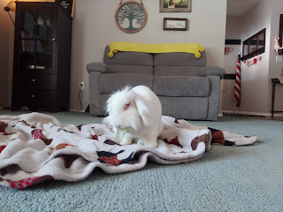
I'd say that Ouli did a great job at both for the entire day! Here are a few videos of me feeding her some lettuce, banana, and her personal favorite: cilantro. Oh - and Ouli is blind. She was born blind and has miraculously adapted and overcome throughout her life. What a champ!
Video #1: Lettuce (23 seconds)
https://photos.app.goo.gl/CpszP65xHReiQa8x6
Video #2: Banana (24 seconds)
https://photos.app.goo.gl/m8gXGAaBQzTPeeyM7
Video #3: Cilantro (22 seconds)
https://photos.app.goo.gl/5fWnZwkA1QtiRxqc6
We had a relaxing and calm day at home together. I worked on crafts, did some baking, and spent some time talking to friends on the phone.
Speaking of animals, I've been working on another page for Jacks' Quiet Book this week. It's been a little more labor intensive, so the progress is slow going. I'll show you what I've done so far - - -
First, I had to envision the vision. What animals should I create for this page? I can't do all of the possible farm animals, so I had to pick and choose. I chose a sheep, a horse, a cow, a pig, and a chicken. I made a paper barn template, and then started on some of the peripheral details, such as a picket fence, some grass, a mudhole for the pig, a trough for the cow and horse to eat from, and a tree. (They're not sewn on yet)
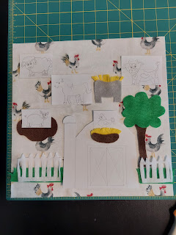

Then I made a little piggy and a hen, along with her nest. I used embroidery floss to stitch facial details onto each animal so far.

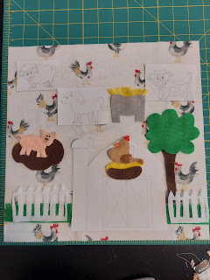

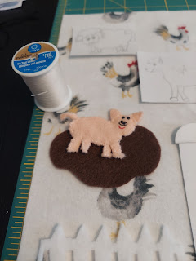

Next, I began the more difficult work of making the barn. Several times in the process, I have to stop and think through the next steps to make sure I will have a finished product that actually works! I knew I wanted the barn doors to open up and be a place where the animals could be stored when not in use. But that meant I needed more red felt behind the barn-front to act as the back wall of the barn interior. And if the chicken is supposed to nest in the loft of the barn, I needed to sew on all of her props before I could sew on the front of the barn.

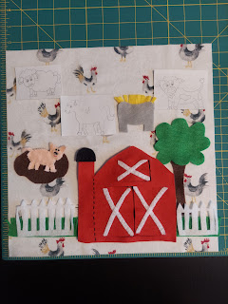

Details, details, details. It's coming along great so far! I haven't sewn the barn onto the page yet, because I'm still trying to make sure I'm not forgetting anything important . . .

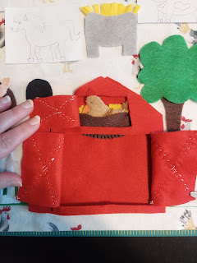

Here is the finished Texture Turtle page that I started last week.

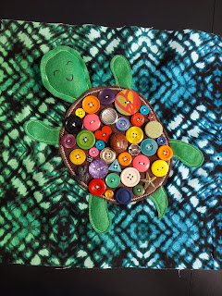

Let's talk about the frigid cold for a minute. As always, Idaho gets verrry cold in the winter. Temperatures this past week were no exception. On Thursday, it was NEGATIVE 6 degrees, but it said on the weather app: Feels like -15 degrees. BRRR!!!

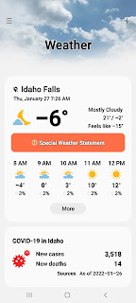

Dainty ice crystals formed on the outside of our bedroom window. I thought they looked like little snow fairies dancing and having a ball.

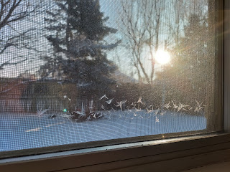

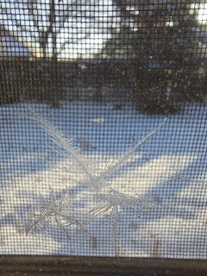

And on another morning, I enjoyed looking out the window as I exercised, promising myself that when I was done I would go outside and take some pictures. I put on my boots and some layers and went out into the yard to see what I could see.

Front yard:

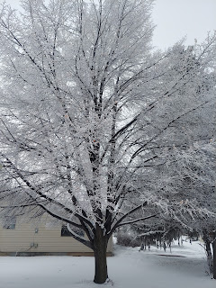

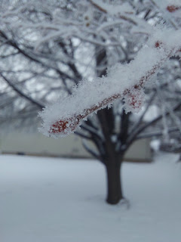

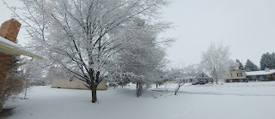

Heading around to the back, I paused at the wood pile. It was just so pretty!

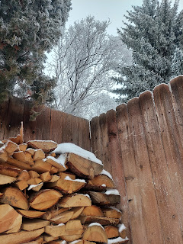

For this next shot, I tried a new technique that I saw on Tik Tok recently. If you want a good photo that involves vertical height and perspective, this is what you can try: turn the phone
upside down
and place it low to whatever it is you're trying to capture (the thing that's tall, like this tree for example). Choose the panorama setting. Then push the shutter button on your phone to start the panorama photo, while very slowly moving the phone upward in a straight line until you are satisfied you have captured the entire height of what you want in the photo. Then push the shutter button again, to stop the panorama process. Lastly, look at the photo you just took and admire the perspective and context that you just captured! WOW. I'm amazed that by turning the phone upside down this actually works!!

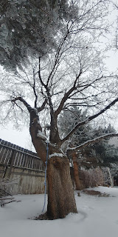

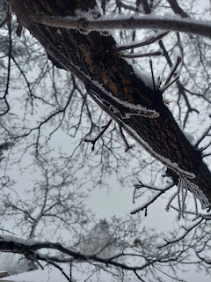

I loved the white frosty trees, branches, and even pine needles. And I'll just add that going outside after you've exercised is much more enjoyable because A) it feels good and helps you cool off, and B) you don't freeze as much as you would otherwise.

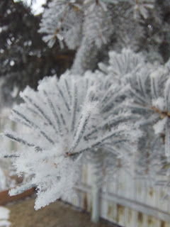

Here's Gwennie, meeting a cute and frozen friend named Olaf.

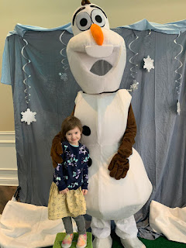

The baking that I have done this week has a lot to do with chocolate and a little to do with jalapenos. Sound enticing?

I made brownies from scratch one day, because I had run out of box mixes. And I was craving chocolate pretty intensely. I set it out on the porch to cool . . . because it's so cool to be a trendsetter, ha ha.

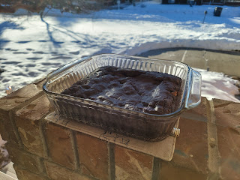

On a different day, I baked 3 loaves of jalapeno cheese bread. We gave one loaf to the Parkinsons across the street, one loaf to the Kloaks across the street, and we kept a loaf for ourselves. It was delicious!

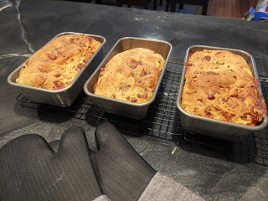

And on the day I had Ouli (on Friday), I baked a chocolate cake and decorated it the following morning. This was for a funeral luncheon for Ben Parkinson's grandpa, Mel Garcia, who passed away last weekend. Scott and I attended the funeral on Saturday and enjoyed hearing more about his wonderful life. Mel was born in Mexico, the youngest of 3 children. When he was just 1 year old, his mother passed away, leaving a one year old, a two year old, and a three year old. His father remarried in not too long of a time, and they did well for a little while. Eventually he lost both of his parents and the kids were farmed out to other family members. By the time he was 12, he had also lost his grandmother, whom he was living with at the time, along with his grandpa. Other family members took him in once again and helped him become the man that left such an incredible legacy for his children, grandchildren, and great grandchildren.

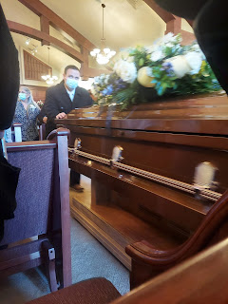

It taught me so incredibly much to hear about Mel's life. He had several traumatic things happen to him, but through it all, he found a thread of consistency, stability, love and peace. It was his family and extended family. It made me think about my life and the people that have provided a similar consistency, stability, and a sense of love and peace for me throughout my life. I am so grateful for all of the loving influences that I've had in my life.

I also hope that I am passing on that deep love and consistently being available and supportive to all of my family members. There's always room for improvement and I will always be trying harder.

Early in the week, I was able to connect with my friend Jasmine, whom I consider to be another daughter in our family. They had moved down to Salt Lake several months ago so her husband could be near his doctors down there for some treatments. We missed seeing her over Christmas, but when I found out they had moved back up here a couple weeks ago, I jumped at the chance to take her out to lunch and get all caught up. (I forgot to get a photo) We went to Jalisco's Mexican Restaurant and while we ate some tasty food, we shared everything that's been going on in our lives lately. She is such a tremendous human being and I am so privileged to be a part of her life. :)

I have also thoroughly enjoyed doing some family history for my cousin, Loreena Hester, this past week. We have been checking in with each other almost daily, sharing things that we have each found. Her focus has been looking through all the photos, letters, and scrapbooks that her parents left behind, gleaning details and important information to pass on to me regularly. My focus has been to find new family members to add to her limited knowledge of who her mother's German ancestors were. She really wants to find some cousins who are still living today that she can connect to, so that's what I'm trying hard to piece together for her.

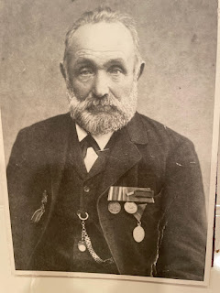

Photo above is Loreena's great grandfather, Lorenz Eichin, born in 1847 in Germany. I've been using Google Maps to pinpoint all the tiny little villages where the Eichin family lived, including the christening and marriage records. All of the places are surrounding Schopfheim, Germany, which is just over the border from Basel, Switzerland (down in the SW corner of Germany).

She has also dug up several photos that have my parents and grandparents in them!
Below: My great aunt Jane Rawles Carter, my dad's parents John Snider and Zola Rawles Snider, and my great aunt Mary Rawles Sappingfield.

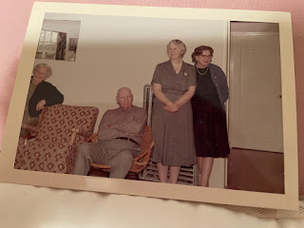

This next photo was taken at a Rawles Reunion, probably in the early 1980s. Pictured from the left to right are: Barbara Rawles McCulloch, Jeff Gillette, my dad John Snider, and my great aunt Mary Rawles Sappingfield.

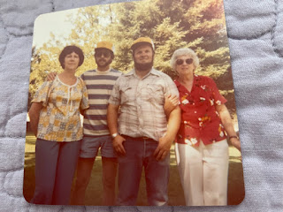

Speaking of family, Thursday was my mother-in-law's 89th birthday! Originally we had planned to drive up to Rigby when Scott got home and take Coy and Phil out to dinner. We thought Rexburg would be nice, since it was closer to go there than to drive south back to Idaho Falls. But then, it only ended up being about 18 degrees for the high - so Scott came up with a BRILLIANT plan. We called them mid-afternoon to have them pick something off the menu from Dixie's Diner here in Idaho Falls, and then we picked up the order and took it up to Rigby. We had dinner "in" at their home, where it was nice and cozy warm. We all appreciated not having to get dressed up to head out into the cold. Simply lovely. :)

We visited for a while after dinner before we had to dash home for a meeting that Scott had with the bishop. It was sure a treat to share the evening with such a wonderful birthday girl!
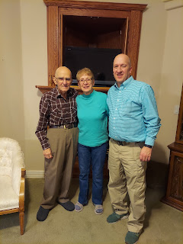

I think that the things I admire and enjoy most about Coy are: her quick wit and sense of humor, her hunger to understand everything (people, technology, family history, gospel principles, and even recipes), her consistent energy to be as productive as she can, her talented gifts in gardening/cooking/playing the piano & organ/organizing/sewing & quilting/etc., and her profound love for her children/grandchildren/great-grandchildren. She loves to sit down and read a book or two with a little one on her lap. And she's always thinking of ways to solve the world's problems - even if it means it's in the middle of the night, ha ha. She's quite a lady and I love her so much!

Scott and me just as we were getting ready to leave his parent's house:

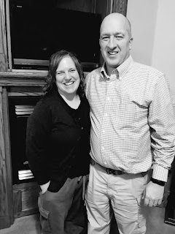

I have a few miscellaneous nuggets to mention here before I get to the best part of the blog: my grandbabies!!

1. Amber and I are making plans to go to NYC at the end of February to see her beautiful artwork on display there. She painted her own interpretation of Heavenly Mother, someone we don't often speak about, but that deep down we know logically exists. These 2 screenshots were off her Instagram account. (You can click on the photos to enlarge the wording and details.) I am so proud of her work and accomplishments! :)



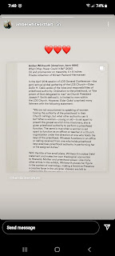

2. I did a little random research on places Scott and I could potentially visit while we're in Italy for the next couple of years. I was shocked at how cheap the flights are from Venice . . . I shared this small list of places with our kids in a text. Wow. Just wow. (*ROUND TRIP*)



3. When I blow dry my hair upside down, it gets really big. I thought it was hilarious enough one day to take a picture.



4. My brother, Michael, made a hilarious video a couple years ago. I stumbled upon it this morning and just had to re-share. He has been our go-to guy over the years to demonstrate how members of our family blow their nose. (3 min, 12 seconds)
https://photos.app.goo.gl/iYBGvi9WtwjFM2Lx9
Now for the Grand Finale of Grandchildren XOXO
I'll start with little
Avery Mae
this time. What a precious little girl she is!
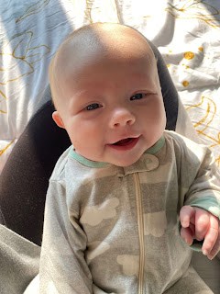

I just love this next photo SO MUCH!! It makes me smile as I wonder what she's thinking . . .

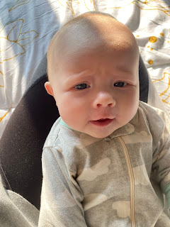
Next, a Video of her holding her head up so well! (26 seconds) She has SO MANY facial expressions, ha ha. She seems like she just has so much to say! Someday I'll get to meet her in person and hear all of her beautiful babbling.
https://photos.app.goo.gl/hEVfuFkBPbyL7JwJ7
And this sweet photo of Benson holding Avery. They look like they just woke up from a long winter's nap . . . :)
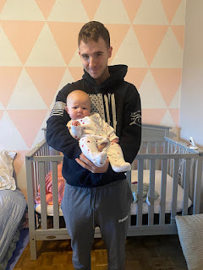
Jack:
This is my new favorite photo of him. Those lashes and that cute little button nose . . .
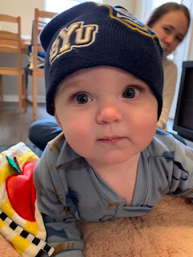

Jacob tells us that Jack gets giddy and silly and hysterical every night before bed. How fun!

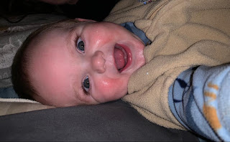

Video #1: (17 seconds) Hannah is singing to him across the room - maybe something she made up? Super cute! She's singing "Ride a boat, ride-ride-ride a boat!" "Thumbs up!" And he has his thumb up too! It's like he knew what to do before she even said it! Repetition, repetition, repetition.
https://photos.app.goo.gl/jBju758T1PKTXJNaA
Video #2: (25 seconds) Jack saying the sweetest things and what almost sounds like "hi" at the beginning.
https://photos.app.goo.gl/jHSc5Qu6G6DPwZ9t5
Video #3: (1 min, 2 sec) Jack chasing after a blue plastic cup in their new apartment. His new favorite toy.
https://photos.app.goo.gl/geXKaC9hASDcqa9C9
Video #4: (1 min, 1 sec) Jack loving on his giant toy sloth and Cosmo the BYU cougar while Jacob was secretly videoing. He narrowly missed hitting the floor with the back of his head when he tipped over . . . I'm glad he landed on the blanket instead!
https://photos.app.goo.gl/t4a1D41k7BAYZ4SL8
Video #5: (15 seconds) Jack appears to be heading toward Cosmo the Cougar, but detours all of a sudden to grab that plastic cup again LOL
https://photos.app.goo.gl/e2XFzQAsUCYh2sAZA
Video #6: (20 seconds) Jack thoroughly enjoying gnawing on a chicken drumstick. I gotta admit, it made me a little nervous - worrying that he might bite off something to choke on . . . but he is very serious about what he's doing and seems to be enjoying every savory slurp, ha ha.
https://photos.app.goo.gl/MncsYXqabx5jQvgo9
Abby & Gwen:
Abby got glowing remarks from her teacher this week. I'm so glad she loves school so much! :)
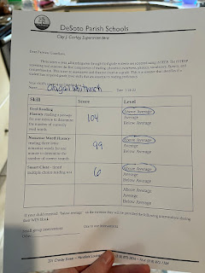

And Gwen, in her usual spunky style, said: "Don't touch this star. It will electri-die you."

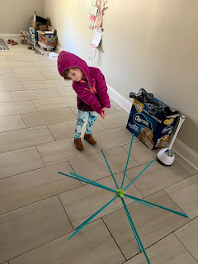

OHH, the little ones. How fun they are! How precious they are! I'm so glad they have such wonderful parents to raise them and love them and take care of them.

