When in Rome . . .
We had the privilege of attending a Rome Temple session on Saturday and not only was it a gorgeous drive down and back, but the temple was a unique and wonderful experience in and of itself.
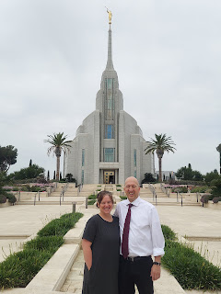

A close-up of one of the many vibrant flower beds nestled around the temple grounds.

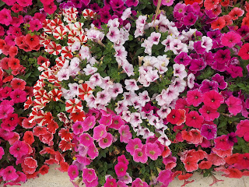

Friday began with Scott having to play dress up for work. He only had a half day, so that was nice.

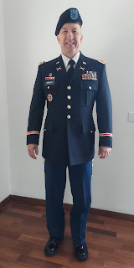

While he was schmoozing with all of his comrades in their fancy digs, I went to the Rosetto grocery store a few minutes away so that I could load up on some food storage items. Rosetto is a ginormous store and I knew I would be able to find a good selection there.

While this wouldn't be a good item for my
pantry
, I was impressed with these giant vats of pesto. I'll be back another day, however, to bring one of them home . . .

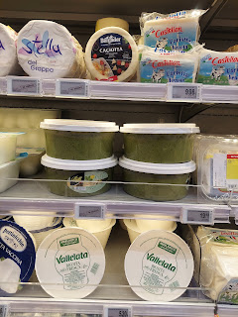

And I found some fun and colorful varieties of pasta that I added to my cart.

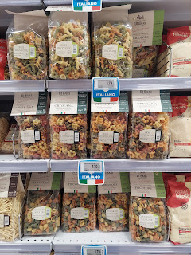

My focus was on building up our cupboards so they had more than 5 total items on any given day. I chose to buy some pastas, several bottles of passata (a thick tomato base in a glass bottle for 70 cents), 8 cans of local tuna, and several containers of shelf-stable milk. Of course, there were other items in my cart as well, but these were my main focus this time. With my cart full, I paid and headed to the exit. Grazie. Arrivederci. They always say that in all the stores! :)

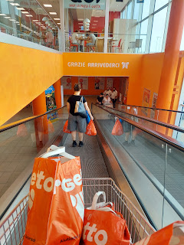

Once I got all the groceries put away and Scott was finished playing with the boys, we hopped into the car and headed south. The drive down to Rome takes about 5 hours, but it was beautiful and interesting the whole way.

MANY times we drove past castles, villas, and entire towns perched on top of a hill/cliff/mountain top. We aren't exactly sure how the people get up there, but wow . . . if I didn't have bugs on the window to contend with, or a guardrail constantly in my way, I could sell some amazing photography shots!

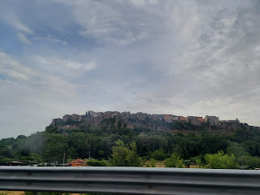

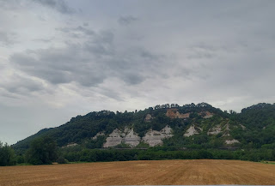

There were also miles and miles of farmland between Vicenza and Rome. At times, we wondered, are we back in Idaho and this is all just a dream?

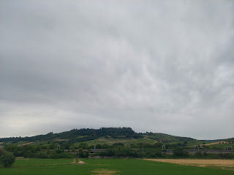

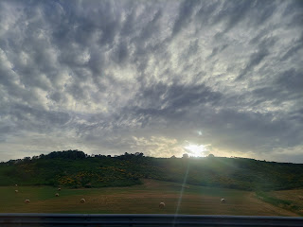

We arrived safely at our hotel around 7:30 p.m. We stayed on the northern outskirts of the city, since it was close to the temple. Another time we will explore the main city of Rome and all of the many touristy attractions.

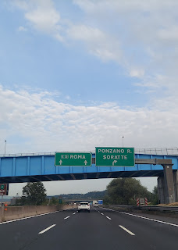

Saturday morning we checked out of the hotel and went in search of food. There was a grocery store not too far away, so we decided to go there. To our surprise, there was a little restaurant attached to the Conad grocery store. We each bought a half sandwich, since the rest of the choices were all pastries of one sort or another.

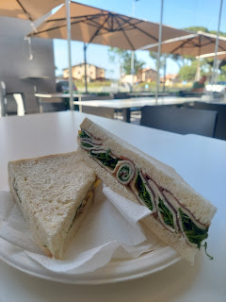

Scott went next door to buy us some bottled waters, but the Italian language got the best of us again. While it says "Naturale" - which is basically saying it's not sparkling water (disgusting, but common here), he didn't notice the word "effervescente". It tasted like
flat
sparkling water and was pretty gross, ha ha. We ended up going back in to find some BASIC and ORDINARY
natural
water.

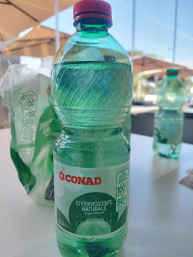

It was only a 10 minute drive to get to the temple. After several twists and turns, missed exits from roundabouts, and do-overs, we made it.

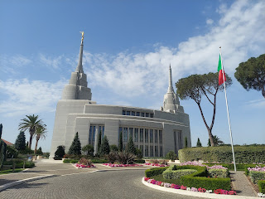

So many beautiful views around the temple grounds to take some photos . . .

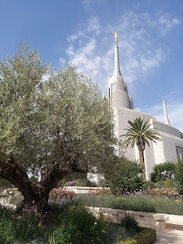

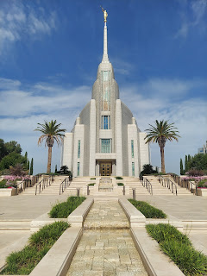

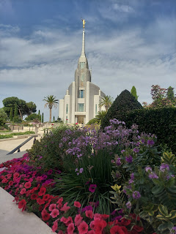

The sister missionaries greeted us inside the temple visitor center and were happy to answer any questions that we had. We were also free to wander on our own, of course, which we did.

This display shows where the makings of the temple originated from.

Stained glass: United States
Granite (for the exterior): Italy
Sapele wood (for trim work): Africa
Marble: Spain

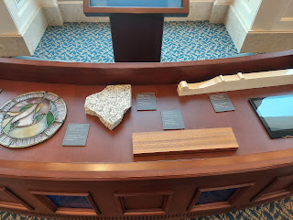

The most unique feature in the visitor center was this "house". The sister missionaries explained that when visitors come, many of them are not members of our church and want to know why we have a temple. This house is used to demonstrate that the Gospel and the covenants that we make are fluid and part of our every day life. We teach the gospel in our homes, we live the gospel in our homes, we talk about the temple in our homes, we love our families and want to be with them forever, etc. A very powerful way to tie everything together!

Inside the "home", there are photos of families (that are also members of the church here in Italy) hanging on the walls, as well as photos of the temple and of our Savior Jesus Christ.

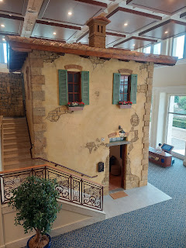

Scott - pointing toward Vicenza way up in the north . . .

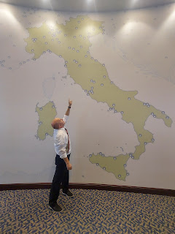

There is an exquisite marble statue of Jesus Christ in the front window of the visitor center. He looks out toward the temple, His Holy House.

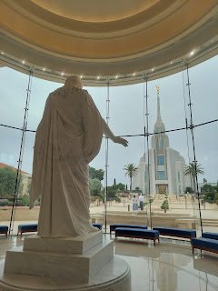

The Rome Temple Visitor Center is unique in that it includes all of the 12 apostles from when Christ was on the earth. Perhaps a nod to the many Catholics that have been so prominent in Italy over the centuries. The Catholic members pay homage to the "Saints" in many aspects of their faith.

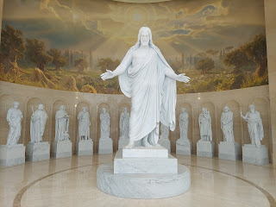

When the Rome Temple was dedicated back in 2019, our beloved Prophet, Russell M. Nelson and ALL of the current apostles were there together. They took a memorable photo in the very place where we also stood. I love the contrast and correlation between the Apostles of old and the Apostles of today.

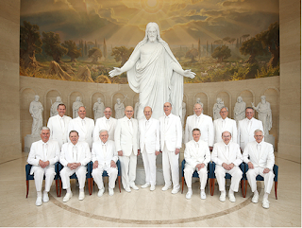

Scott is on the right in the photo below -

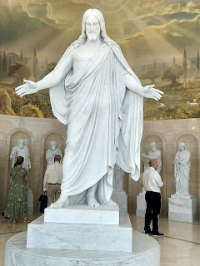

The sister missionaries were kind enough to take some photos of us before we left the visitor center

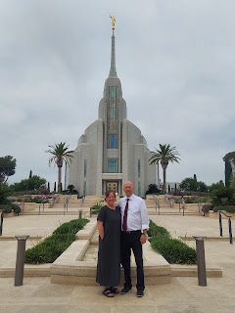

There is a large building off to Scott's left - not seen in the photo above. It's the Temple Patron Housing - sort of like a hotel, but at no cost to temple patrons. The only catch is that you have to actually LIVE in the temple district, and any additional guests have to be part of your immediate family. (Scott qualifies us because he resides in Vicenza and his church membership records are in Italy, too) We tried to set up a one night stay here, but they were fully booked when we called. This weekend we learned that there were a few BUSLOADS of temple attendees from Milan and I want to say Romania? But that might be too far away . . . I can't remember where the other busload came from. A tip I got from someone at church on Sunday is that if the housing is full next time, try to call them again about 1-2 days before we come down to Rome. Quite often, someone cancels at the last minute due to unforeseen circumstances, and we could then slip on in and stay just a few feet away from the temple. :)

There is also a small distribution center attached to the patron housing building, and I bought a couple of things inside the shop, including a couple of scripture-based coloring books for when Abby and Gwen come for a visit.

The temple session was much the same in Italy as it would be back in the U.S., with one big exception. We needed to use a device to help us understand what was being said. The main device looks like a remote control and hangs on a lanyard around your neck, with headphones that connect to it. I was able to choose English and adjust the volume. It was really amazing to hear the English and Italian going at the same time, although it required just a little bit more concentration on my part. Everyone was very helpful in the temple, and several American couples were serving in the temple as part of their missionary assignment. Having someone to talk to in English sure helped us a lot!

Once the temple session was finished, we left to go in search of food before heading north for our 5 hour drive home. I had access to a few more photos on this side of the freeway that I didn't have as we were coming down. Lots of hills and farmland again. It is all so truly beautiful!

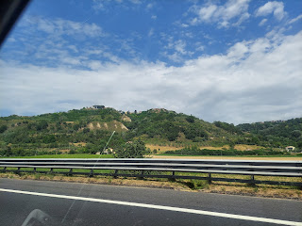

Sometimes there are sights like this that just take your breath away! You come around the corner and then BAM! You have to scramble to get the photo before the protective barrier wall impedes your view, something I encountered all too often.

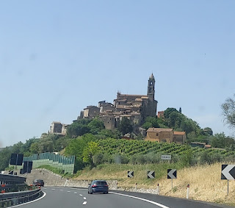

It was HOT. The temperature said it was 94 degrees - but that it felt like 98. Gross.

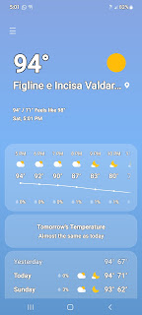

Something we noticed on the way down was all of the tunnels. We had no idea just how many there were, but vowed to count them on our way home the following day.

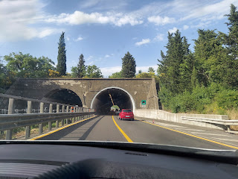

Turns out that there are 39 tunnels. Most of them are around Florence. And we especially enjoyed all the bright yellow flowers and shrubs along the highway between Florence and Rome.

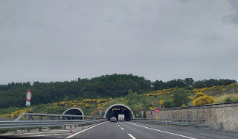

There are tolls to be a traveler on the main road. Soon after you get on the Autostrada (similar to what we know as the Interstate), you go through a toll booth checkpoint to pick up a ticket.

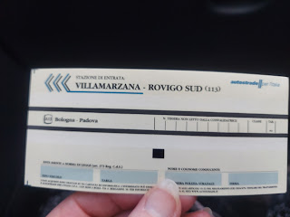

Occasionally you will encounter another toll booth checkpoint and that's when you pay for the segment you just drove. Sometimes it will be hours before you have to pay, while other times it may only be about 30 minutes from when you grabbed the initial ticket.

We paid $40 in tolls each way for a total of $80 to be on the fastest route. Additionally, since we had to book a hotel, that was another $80. And the gas was roughly $160. One trip to the temple was about $320. In Idaho Falls, it would have taken me about 10 minutes to get across town, and less than a dollar in gas. I was grateful to be in the House of the Lord, no matter what it cost or how long it took to get there. It was a special experience and brought me a great deal of peace and comfort just to be there.

As for the rest of the week . . .

Tuesday and Wednesday:
After our weekend trip to Lake Garda, I focused on getting caught up around the house, cleaning, doing laundry, making a menu plan for the week, getting groceries, etc.

The landlord sent a man over to fix our electric shutters in the guest room. They kept getting stuck as we tried to shut the blinds during the heat of the day. Over here they call them shutters, whereas I would call them blinds. They do a remarkable job of keeping the heat out. For example, when we left for Rome, we debated whether to leave the A/C on for 24 hours in our absence or not. I was in favor of leaving it on, Scott was not. Ultimately he won. I was quite surprised when we got home Saturday evening that the temperature was less than 80 degrees inside. We had left all the windows shut and all the blinds as well. Nice job, Italy!

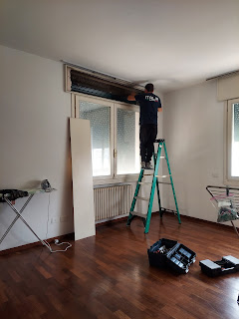

Thursday:
On my morning walk, I enjoyed seeing the progress of the corn fields and local gardens on my route.

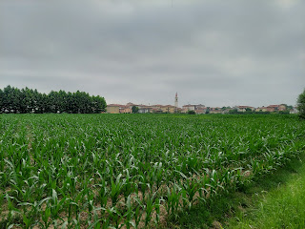

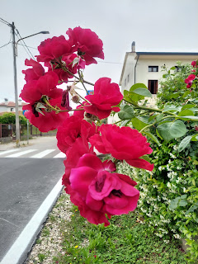

Wee little baby grapies are forming right now . . .

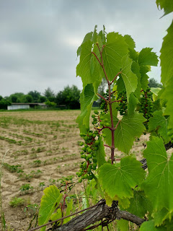

Someone in this house LOVES gardening. I can tell. :)

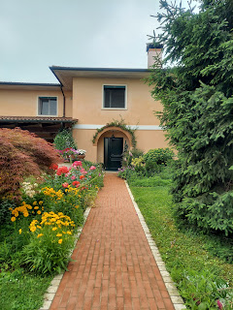

I took these next couple of photos to share with my sister, Charmaine, who is always curious about other people's gardening methods. They use the stick-pole method a lot in Italy. I see green beans growing up the poles, tomato plants, and other unidentifiable greenery.

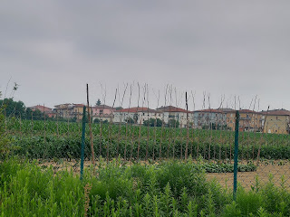

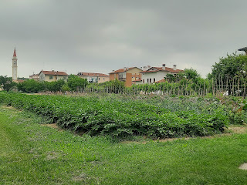

The vineyards here often remind me of my upbringing in Ukiah, CA.

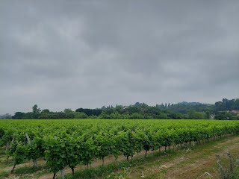

The "Flowers of Italy" photo album is still being updated if you care to take a peek:

https://photos.app.goo.gl/i4RGiVYYiVicd4Ln6

More gorgeous flowers on my way home - - these ones were next to a chain link fence in a gas station parking lot, almost like they were on accident. But they weren't.

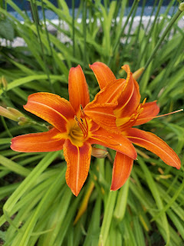

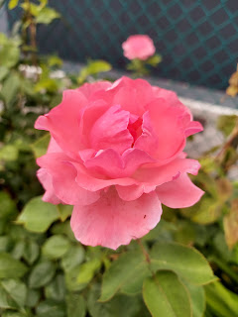

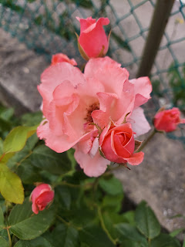

I had a good chat with my Dad that evening. I was sad to hear about all the troubles they are having with tenants and legal battles right now. There is a person living on part of their property causing trouble, and other tenants renting out one of the properties they own have not been paying rent for YEARS, so my Dad and Michelle are trying to figure out how to evict them during Covid regulation times. Not an easy task. I have been keeping them in my prayers and hope that they get some relief soon from all the stress.

During my video call, I took a few screenshots of my Dad. I always love the twinkle in his eye, and tried to capture that as we chatted.

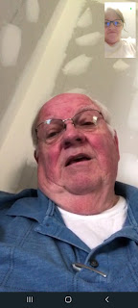

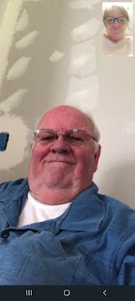

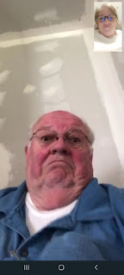

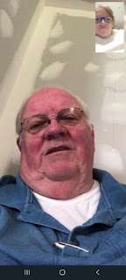

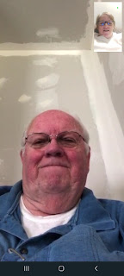

THERE it is . . .

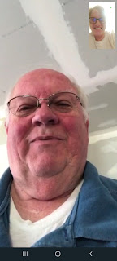

Time for Grandbabies . . .

Jack has been progressing in his walking abilities and is getting really good at it!

Video #1: Round trip from the window to the couch and back (28 seconds)
https://photos.app.goo.gl/CwVY7BdVgZCWSvdu6

Video #2: Tunneling (18 seconds)
https://photos.app.goo.gl/UzorHfwJvJZueWco6

Washington DC Temple Open House

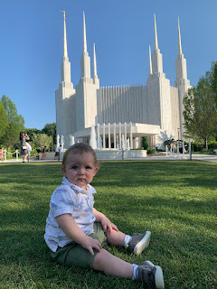

Cutest little squishy bum - -

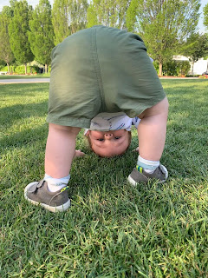

Glencarlyn Park - near their house. They rode their bikes over and then explored the creek and treehouse playground together.

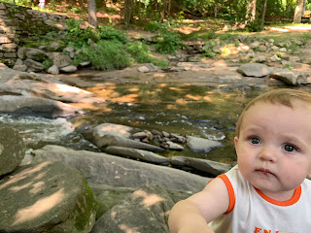

Abby is sharing below that they found Pizza Lunchables in the grocery store. Yum!

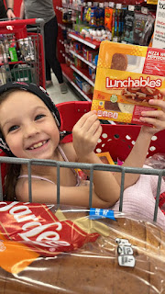

She and Gwen are enjoying the summer so far. They have been helping to care for the baby kittens, as well as getting into plenty of mischief. :)

Speaking of kittens, Kylie took in 3 baby kittens recently, whose mother had been killed by a car. Unfortunately, two of the babies didn't make it, but she has been feeding the remaining one every 2 hours and trying to keep it warm so its body temperature is more regulated. She is a diligent soul.

I tried to get a picture of the kitten when I went in to use their bathroom Sunday evening, but he was too busy nesting under all the cloth diapers that I'm sure felt so cozy and wonderful to him.

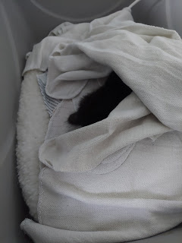

Avery was sure in a good mood while we were there! She was smiley, bright-eyed and bushy-tailed, and was happy to let us hold her for a long, long time. And she enjoyed sampling some of the food we brought with us for dinner.

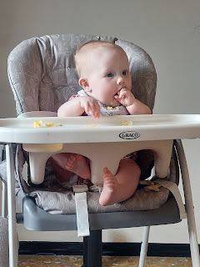

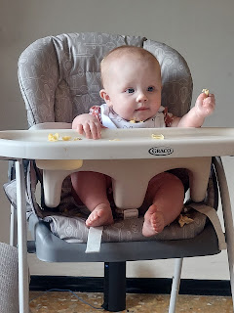

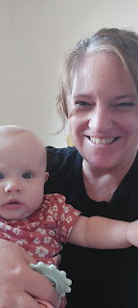

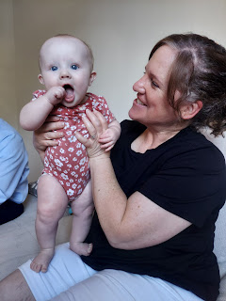

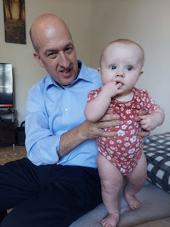

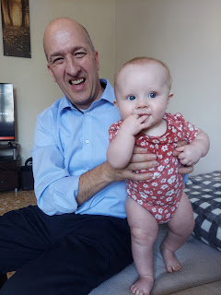

We made Lemon Chicken and homemade Macaroni & Cheese casserole, along with a green salad and some cookies for dessert. Scott helped me in the kitchen Sunday afternoon as we bustled around getting everything chopped, sauteed, shredded, and baked.

And he even washed all of the dishes for me, too. What a good husband. :)

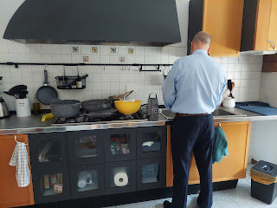

The food turned out great, even surviving the 90 minute commute up to Aviano. Thank you to whoever invented foil!

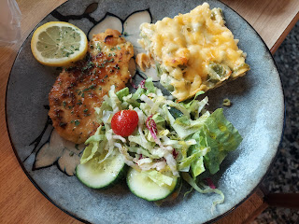

We had a lovely visit with Benson and Kylie. After dinner, we spritzed up with a decent layer of bug repellant and went outside to play a couple rounds of Skipbo (the card game) sitting around their patio table. It was fun to be able to play a game together, to hang out and laugh, and to be a little competitive too, ha ha.

On our drive home, we hit a classic Italian storm with all the wind and leaves blowing around, constant lightning, and then the heavy rain. Some people pulled off the highway and parked under an overpass with their hazard lights on, many others (like us) just trudged on, but at a slower rate of speed.

I drove us home this time, getting some freeway practice and learning how to set the cruise control in our Peugot, something very different from any car I've ever driven. Thankfully, Scott was very good at describing all the steps to me from the passenger seat. We made good time getting home and promptly got ready for bed.

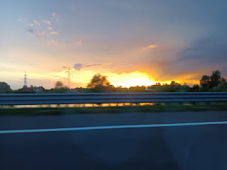

That was a BUSY weekend, but everything we did was wonderful. To the Rome Temple and back, to church and back, and to Aviano and back. :)

