Whitworths in Italy: Part Two
I am getting a big step closer to being caught up with all the stories and photos of our adventures from the month of October. In this post, I will share some of the day trips we took that were closer to home, as well as some of the quieter moments in between all the traveling.

One errand that almost didn't make it into our busy schedule was SHOPPING. I love the store KIABI here in Vicenza. I tell people it's like Old Navy and Gap had a baby in Italy, and they named her Kiabi. They have the cutest clothes, especially for children, and for fantasticly (sp?) cheap prices. We scored big on the day that we went, which was just before our trips to Florence and London.

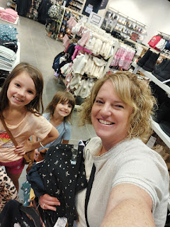

I took the girls to the children's section of the store, while Amber had a rare opportunity to shop for herself - BY HERSELF, ha ha. It helped me to just focus on one girl at a time, finding what we needed, and then moving on to the second one. We had immediate success finding some long-sleeved shirts and coordinating pants for Abby, not only because she has excellent taste, but she is also pretty easy to please.

Our objective was to find some warmer items for the very cold weather we would soon encounter in London. We noticed that we were lacking in long sleeves and layers up in colder Salzburg, so it was important to be more prepared for the next big trip.

Gwen was a little harder to please . . . The first shirt she picked out had some difficult colors to match and we couldn't find any pants to go with it. The shirt had an unusual brown/copper/mustard color, mixed with BRIGHT coral red and a bright royal blue. Yikes. Whenever I found something that could work, she didn't like it. And whenever she found something SHE liked, there was nothing in her size. It took us about 3x as long to finish up Gwen's list of necessities . . . but we did find a Harry Potter shirt on the clearance rack, so that was a celebratory win.

While we shopped and shopped and tried on clothes in the dressing room, Amber was having a great time and found several sweaters and cute items for herself. Hooray!

We also stopped at the Palladio Mall across the street, where, much to our surprise, there was a HUGE display of Star Wars posters, Lego creations, etc. to ooh and aah over. The Whitworths are huge Star Wars fans, in addition to Harry Potter and Lord of the Rings.

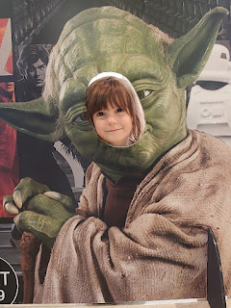

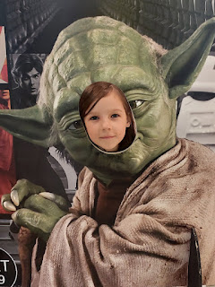

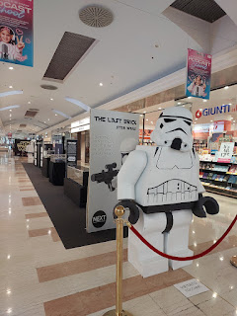

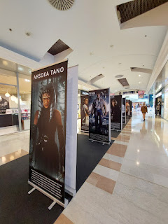

We got some gelato and found a place for the girls to play and get their wiggles out for a while. Later that evening, after dinner, we enjoyed a lovely sunset up on the roof.

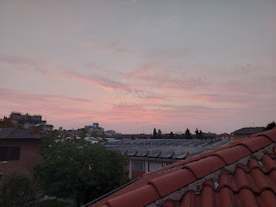

After we got back from Florence, Amber wrote the sweetest post on Instagram and Facebook where she described her experience. (click photo below to enlarge)

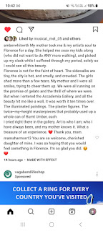

Gwen also drew the cutest picture of the two of us . . .

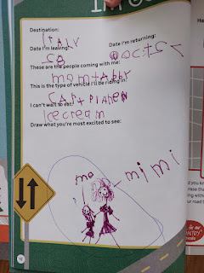

The night before we flew to London, I kept my promise to Abby to bake some chocolate chip cookies. It was pretty late at night, so we didn't bake all of the dough that night. We put the rest into the freezer for later, but we packed several baked cookies to take on the plane with us. We even brought a few to share with Weston, whom they hadn't seen in over 2 weeks.

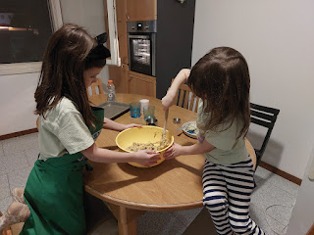

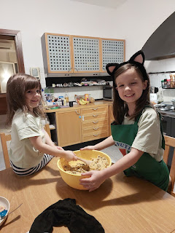

CITTADELLA:
When we got back from London, and after we took an entire day to catch up on sleep, we changed our plans that we had made weeks in advance, and instead took a day trip to Cittadella. (pronounced like CHEE-ta-DELL-la) It's only a 30 minute drive north from our house, but wow it was a special place.

We had no idea that we would be greeted by a giant pink squirrel next to where we parked. Maybe the squirrel knew how happy it would make Gwen because it was her birthday!!

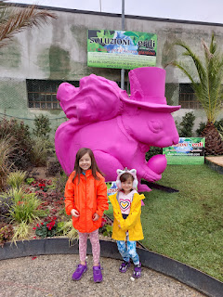

Cittadella is special because it has one of the coolest medieval walls surrounding the city and you can WALK ON IT.

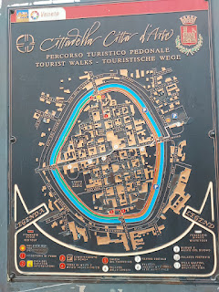

Per Wikipedia: The town was founded in 1220 by the Paduans (from Padova) to counterbalance the fortification of Castelfranco Veneto, 13 km to the east, in 1218 by the Trevisans (from Treviso). This was a time of war between the communes.

The walls are 46-52 feet in height, and approximately 6.9 feet thick. The surrounding wall of Cittadella is 4,793 feet in circumference and has a diameter of 1,480 feet. It was an absolute delight to climb up and walk the entire wall around the city.

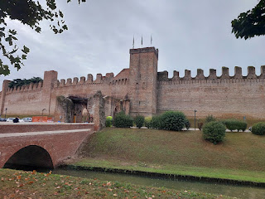

First we walked into the town itself and had to figure out where to access the walls. The city is beautiful and had a quietness about it for being in the middle of a weekday morning.

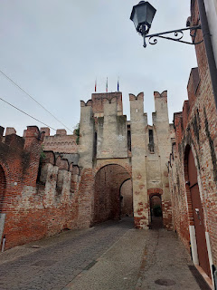

Italian porticos make any sidewalk feel like a special experience, especially when there are ancient frescoes over the arched covered walkways, too.

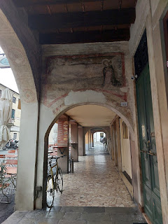

I enjoyed seeing all the posters around town for the up and coming graduating seniors. What a fun and novel idea!

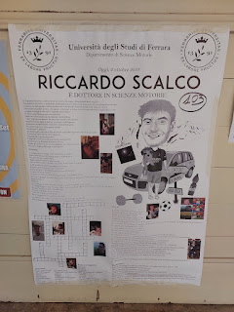

Video as we walked toward one of the medieval wall entrances: (14 seconds)
https://photos.app.goo.gl/axX7HcXzmUXC6iPd7

A description (in ENGLISH) about the House of the Captain of the Guards . . . (click to enlarge photo)

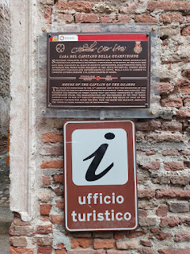

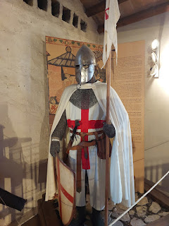

We paid a few euros each to enter, which was a small price to pay for all the history we were about to connect to. They did a very nice job explaining what we were seeing one floor up from the ticket counter, which also included historical and costumed figures and a description of their roles or jobs. Each station had something in English for us to read.

Video #1 of some of the costumed figures: (7 seconds)
https://photos.app.goo.gl/pRuTsux2mpNc9P4U7

Video #2 of the figures: (7 seconds)
https://photos.app.goo.gl/BwtYqrk1CMqd8d438

Google Translate for the photo below, which also explains Video #2 above:

"And Violante represents the power of the Bentivoglio. Elisabetta Aldobrandini, Pandolfo's mother, is the true architect of the Malatesta presence in Cittadella: her son owes her recognition and gratitude for the Venetian enfeoffment (?). The black clothes she wears recall her condition as a widow, but at the same time, the richness of the fabrics and the finesse of the decorations reaffirm her prestige and her high social status. Within the Malatesta family, her presence is a guarantee of political power and protection by the Republic of Venice. Elisabetta Aldobrandini is the essence of the Renaissance noblewoman."

Continued translation: "In this scene, while embroidering on a loom, she simultaneously supervises the servants' duties. Behind him is a dining table. Glass crockery and wooden plates were common in canteens. The metal cutlery and the painted and decorated ceramics underline the wealth and social level of the family. The guests who were welcomed into the house would have immediately understood, just by observing the table, the wealth and prestige of the hosts."

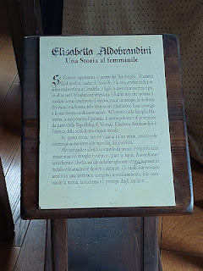

And, finally we went UP. Up to the top of the medieval wall . . .

Video of the first staircase to get us up to the walkway above: (10 seconds)
https://photos.app.goo.gl/qajGr71huckMMD2Z9

And wow . . . Behold the city of Cittadella: (12 seconds)
https://photos.app.goo.gl/mdjrsekE4ew8ZdHUA

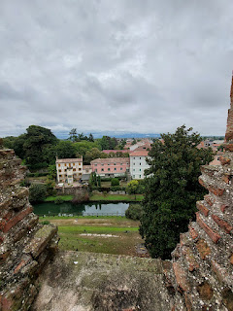

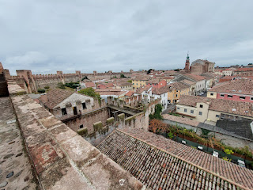

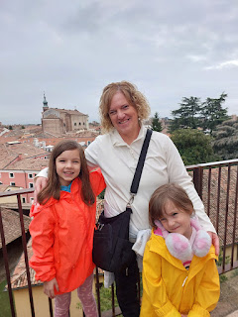

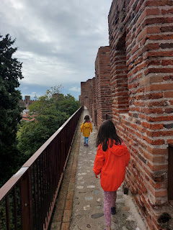

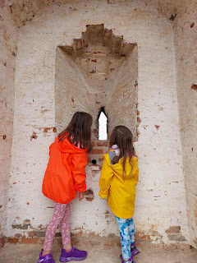

The girls enjoyed the many peepholes and slits for the guarded military maneuvers from long ago.

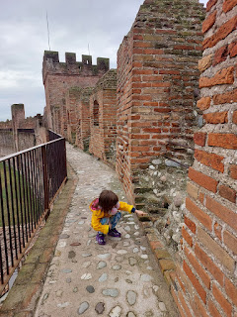

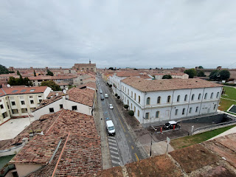

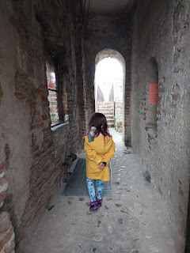

Video on top of the wall: (8 seconds)
https://photos.app.goo.gl/34jutPsGBcZhKbbr9

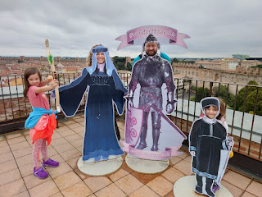

What kind of silliness is this . . .

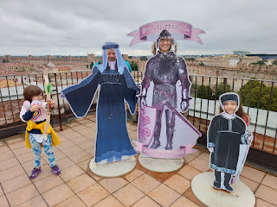

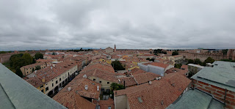

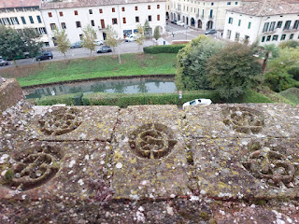

Gwen, laughing to the sky . . .

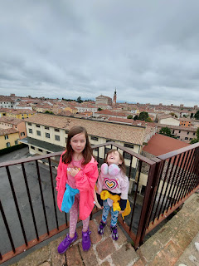

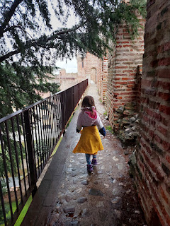

Oh, to be a kid and to have all that energy: (13 seconds)
https://photos.app.goo.gl/w76TwtmiZnH2odRR6

I laughed out loud when Gwen started walking this way: (4 seconds)
https://photos.app.goo.gl/oLJX3pKARaXirh3M7

A beautiful back yard as seen from above: (10 seconds)
https://photos.app.goo.gl/r4D7dnYfvKVdYVJU7

Video of some ancient weaponry in a mini-museum, halfway around the wall: (11 seconds)
https://photos.app.goo.gl/aguUt7kjQZ1UWNhdA

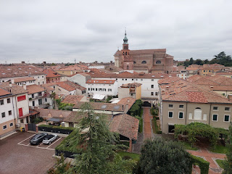

I was so, so grateful that they provided fascinating information in multiple languages. It was clear that they have had many visitors from many countries, and they have taken the time to provide us with a way to learn more about their beautiful city.

To read the next two photos, please click to enlarge each one.

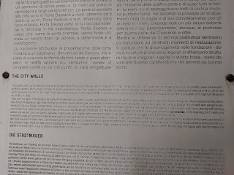

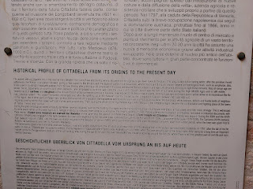

It took us a little over one hour to complete the loop around the medieval wall, plus a few extra minutes to visit the little museum halfway around and to choose a souvenir to take home. It only lightly sprinkled on us once or twice, but most of the time it was just cloudy and perfect.

On our way back toward Vicenza, we stopped for pizza at a little place that Amber found for us on Google maps. It was basically a pizza restaurant within a gas station, but they had a lovely little corner with books and toys where we could comfortably wait for our food to be prepared.

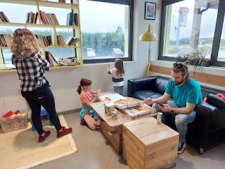

Romeo & Juliet Castles:
After lunch, we drove southwest to Montecchio Maggiore so Amber and Weston could visit the Romeo and Juliet Castles there. With it being an overcast and drizzly day, the fog and mist surrounding the castles created a mysterious, mystical and beautiful scene . . .

On top of the Romeo Castle, looking toward the Juliet Castle . . .

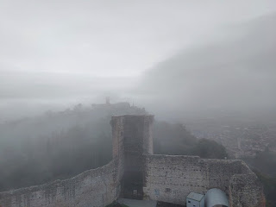

With each moment, the fog shifted ever so slightly.

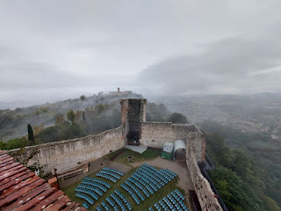

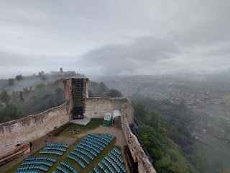

Video on top of the Romeo Castle: (14 seconds)
https://photos.app.goo.gl/NSNN6LYPxkuD9cWs8

I drove the car over to the Juliet Castle, while Amber and her family chose to walk the short distance between the two castles. Having the car closer to our end destination was a good idea in case it started pouring.

A pomegranate tree inside the courtyard of the Juliet Castle . . .

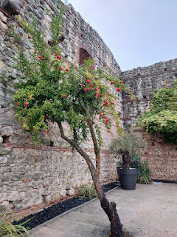

Abby thought everything looked so magical . . .

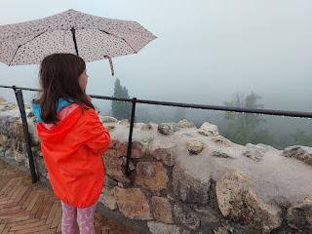

Weston, Gwen, Amber, and Abby at the Juliet Castle . . .

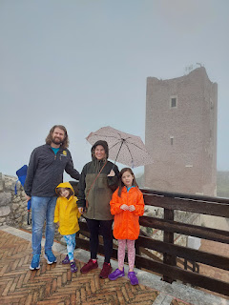

At the same time that Gwen was trying to catch raindrops with her tongue, she pointed at something indistinguishable in the distance . . .

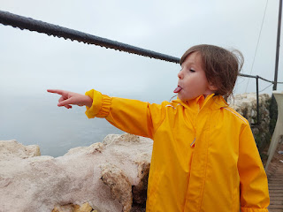

'Twas a fun day of adventure in the rain and fog, but we still had more celebrating to do. After all, it was Gwen's birthday!! After dinner, she got a phone call from Great Grandma Linda in CA, who sang happy birthday to her. And then it was time for her Pokemon cake and to open all her gifts.

Video of all of us singing happy birthday to her: (32 seconds)
https://photos.app.goo.gl/P3auEVdUkbWMQim58

Venice:
The following day, we hopped on the train and headed to Venice. The plan was for the girls and me to spend maybe a half day in Venice and then head home, while Amber and Weston stayed a while longer to have a date night together.

Fresh off the train at the Santa Lucia Station . . .

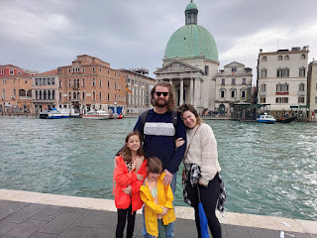

Video #1 of a "speedboat" in a Venice canal: (8 seconds)
https://photos.app.goo.gl/gkY29gJvq1LVEbwX8

Video #2 of another boat passing underneath the bridge we stood on: (7 seconds)
https://photos.app.goo.gl/5gcGWjAp3oTu4aPn6

Lunch consisted of a tasty seafood soup for Amber, and a variety of carbolicious and simple Italian dishes for the rest of us.

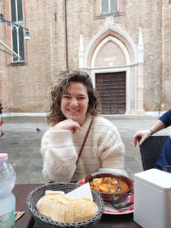

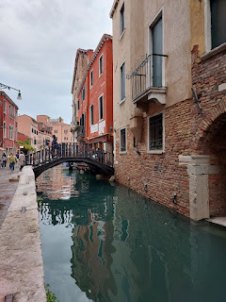

As we passed an art studio and shop, Amber was getting all sorts of inspired ideas for when she would eventually get home . . .

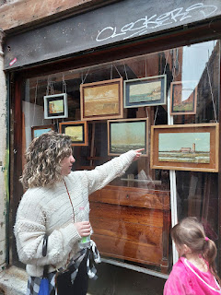

Just a little peek into this art shop . . .

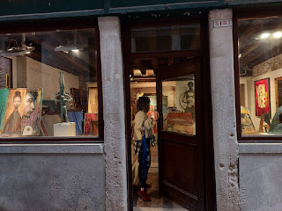

We visited the Leonardo da Vinci Museum in Venice, something I had been looking forward to for some time. It had excellent reviews, many of which said that it was fun for children and grownups alike.

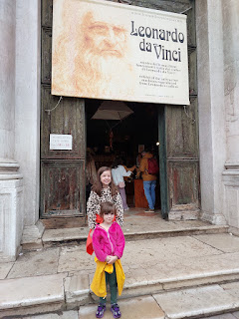

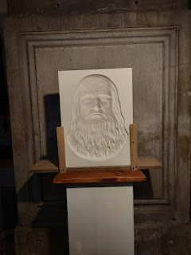

Leonardo da Vinci was a man of many talents: he was an architect, an engineer, an artist (both as a painter and a sculptor), and a scientist. *For those of you who don't get a thrill out of learning how things work, feel free to skip past this Da Vinci Museum section and look for the pictures of Abby and Gwen wearing their new Venetian masks below.

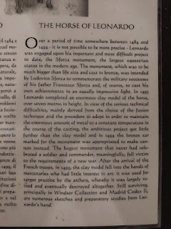

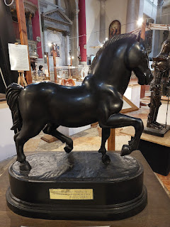

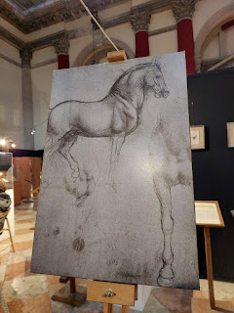

Video of Abby tinkering with one of his inventions: (8 seconds)
https://photos.app.goo.gl/XFZ6TzaRJLPQV6TW8

Video of Gwen trying to figure out how the locking mechanism works: (6 seconds)
https://photos.app.goo.gl/re4Krxnu9cSfxz6x7

For each of these explanative signs, you can click on the photo to enlarge and read them. (*Dad: I thought of you and Scott when I was in this museum. I wish both of you could have been there! You would have had so much fun!)

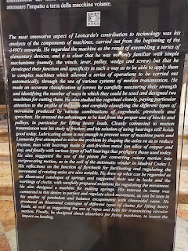

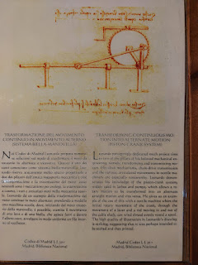

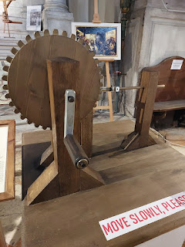

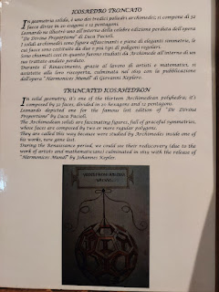

Right down Scott's alley . . . A truncated icosahedron. But of course, ha ha.

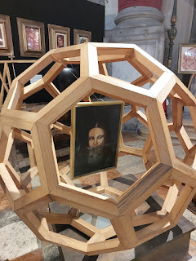

Another short video of Abby trying out one of Da Vinci's inventions: (8 seconds)
https://photos.app.goo.gl/VpbCqWBEZg27hVDz5

A timeline of the life of Leonardo da Vinci . . . (sorry it's in Italian)

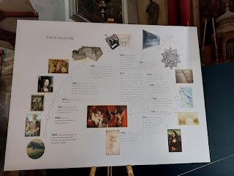

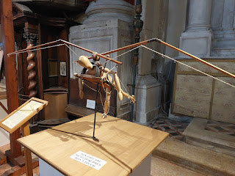

A flying machine with an explanation below:

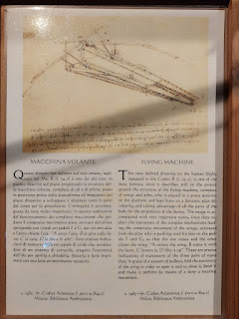

A background into Da Vinci's art and thoughtful processes with everything he created . . .

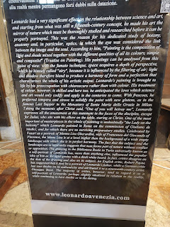

Video of Abby hefting a heavy sack using the trusty old pulley system: (7 seconds)
https://photos.app.goo.gl/PLTnsTs6jutF13SYA

Handwriting by the hand of Da Vinci himself, in what appears to be 1515, four years before he died.

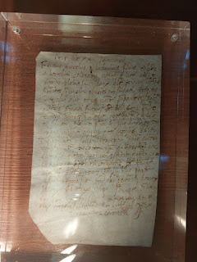

Another artful sculpture that he made . . .

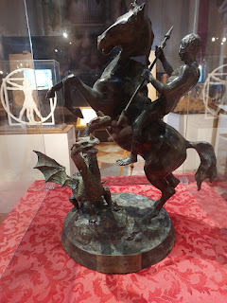

Video of the mirror closet, which Gwen clearly enjoyed: (8 seconds)
https://photos.app.goo.gl/y2P6cBMghi915fw8A

Gwen trying out the pulley system and discovering that each bag had a different weight: (22 seconds)
https://photos.app.goo.gl/K3t9QkeUFyUa5mzeA

So, after we got our fill of science and engineering and art, we got some gelato next door and then we parted ways. Amber and Weston went on a little explore of their choosing and I headed in the direction of the train station with the girls.

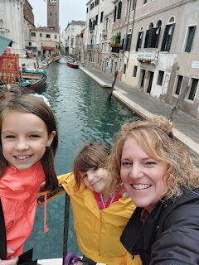

I had promised them we could get a souvenir somewhere along our way and told them to keep their eyes peeled for something that looked amazing to them. This is what we ended up with. :)

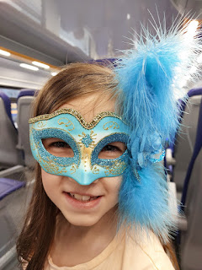

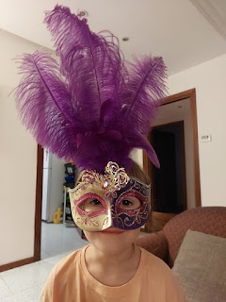

I ended up mailing their gorgeous Venetian masks to Louisiana after they left, along with a few other things, so that they could be properly wrapped and protected en route.

Scott enjoyed some silly time with the girls that evening before they went to bed: (8 seconds)
https://photos.app.goo.gl/SNj4SPfs9rYcJ3ST6

Meanwhile, Amber and Weston wandered around and visited St. Mark's Square, bought some locally crafted rings together, and visited a few more art shops before they headed home.

Monte Berico:
We woke up excited because we thought it was finally a Saturday where Scott could join us on a field trip!! But he ended up having some church responsibilities (to set up and fill a baptismal font, plus he needed to oversee the baptism later that afternoon) so he wasn't able to join us for more than a minute or two. After a good breakfast, we walked up to Monte Berico together while Scott drove up to the parking lot and met us up there. It was a lovely morning with one of the last warm days of the season for Northern Italy . . .

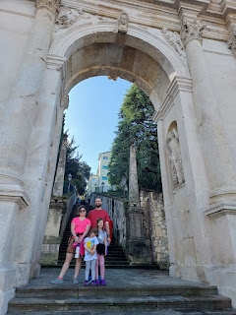

Goodness, it was so bright up there . . .

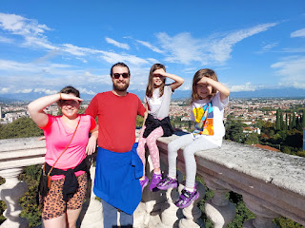

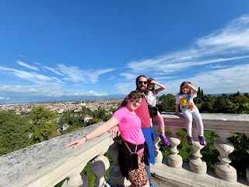

We filled some of the afternoon by playing games together. :)

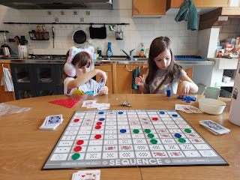

Scott ended up being gone for a lot longer than any of us anticipated, but we tried to have a good attitude about it. When he finally did get home, he had a bad headache and he was pretty tired. Even though I was looking forward to him joining us for the Chocolate Festival that evening, I made sure he knew that I loved him no matter what and that it was okay for him to stay home and rest. It was a good thing he did stay home, because things ramped up at work that night and he had to go to the base early the next morning for urgent matters to attend to. (This was in the first few days after the Hamas bombed Israel.)

We didn't know about any of this urgency while the rest of us hopped on the bus and went downtown for the amazing annual Chocolate Festival in Vicenza.

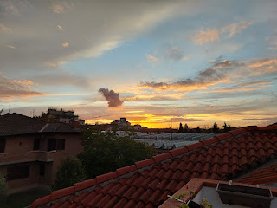

Dozens of booths lined the huge piazza downtown, with several VERY fancy creations of white, milk, or dark chocolate.

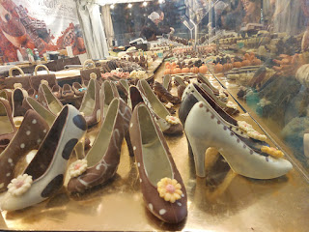

Teeth? Really? ha ha . . .

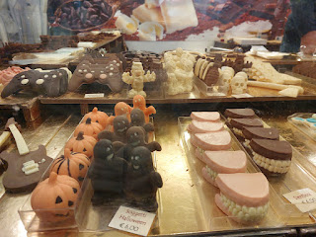

Tools made out of chocolate (sorry for the poor photo - they were behind glass which caused a glare).

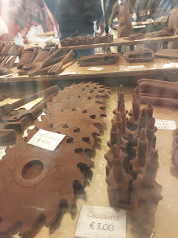

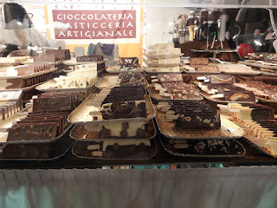

Video #1 of some darling chocolate animal creations: (5 seconds)
https://photos.app.goo.gl/v2abrZ5tVWxJeEQz7

Video #2 of a booth we bought a few things from: (10 seconds)
https://photos.app.goo.gl/4QLSZSSLiWpBmoEeA

We bought some cannoli, a couple of macaroons, and a couple pieces of chocolate. I really wanted some of the chocolate dipped fruits, but they wanted too much for them (by weight). We only had a limited amount of cash with us, and we didn't want to go hunt down an ATM to get more cash just so we could indulge even more in buying additional chocolate. But then, is there even such a thing as having too much chocolate?

We kept good track of our time to get back on a bus before the 90 minutes ran out on our tickets. I think we left after just 45 minutes or so. When we got home, that's when Scott told us he had to report to work early in the morning and that I would need to deliver his talk in church for him. I was supposed to speak WITH him, but now I would not only be giving my talk, but his as well. I promised to do my best in his absence.

We figured out the details for getting Weston to the Venice Airport in the morning, opting to put him on the train so he could check in with RyanAir a little sooner than our original plan. Originally, I was going to drive him to the airport as soon as Sacrament meeting finished, but now that Scott was at work and we only had the one car, it was getting too complicated. Plus, we learned an important lesson on our recent fight from London to Venice on RyanAir, and Weston did NOT want anything to go wrong this time.

He made it to the airport just fine, and flew to London on RyanAir without a hitch to spend one night before flying back to the U.S. the next morning on a much better airline.

The two talks I gave in church also went just fine. I spoke about family history and how it helps us in our own quest for salvation, as well as helping our deceased family members, too. We begin by connecting to them in learning all that we can about them, and then we perform saving ordinances for them, if needed. They have the option to choose for themselves whether they accept those ordinances or not (in heaven).

Scott's talk was centered on the Addiction Recovery Program that is sponsored by the Church of Jesus Christ of Latter-day Saints, similar to the AA 12-Step Program. Our stake over here is starting a local chapter to help families who are struggling with any type of addiction. Our assigned speaking topic for Sunday was Salvation, which is essentially what we need to do in this life to make it back into God's presence and to live with Him forever. The Addiction Recovery Program helps us conquer the things that are holding us back, to allow us to better follow Jesus Christ and become more like Him. And that, in turn, helps us prepare to be comfortable in God's presence and to be worthy to live with Him.

After I finished my talk, I sat down and took a few sips of water while we sang a "Rest Hymn" midway through the meeting. Then I stood back up and read what Scott had prepared as his talk. What a day, haha.

In Primary, the children sang a welcome song for Abby, Gwen, and Amber, who were visiting.

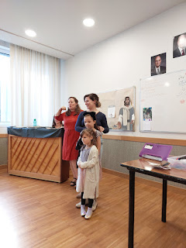

Video of the welcome song: (34 seconds)
https://photos.app.goo.gl/ZJSA5kt7ZiGmnzhr7

Chioggia:
We took advantage of the ONE sunny day during the last week of October by driving one hour to Chioggia (kee-YOH-jah) so we could enjoy the beach. We got a late start, so by the time we got there it was lunchtime. I made sure to order my favorite mussels, which I then shared with Amber. She enjoyed learning how to use the shell as a spoon. :)

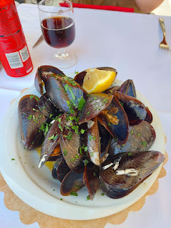

I learned something important on this third visit to Chioggia: on Mondays, there are no boat tours . . . how sad. So we didn't get to ride around the canals and harbors for an hour. We did a little walking around instead and then we drove across the bridge to Sottomarina to hit the beach.

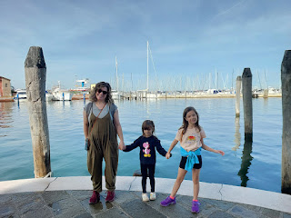

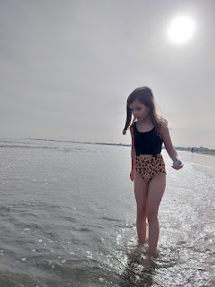

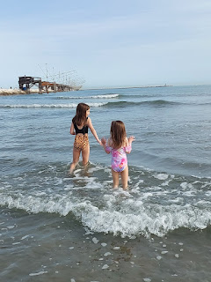

At first, the water felt a little cold. But the longer you were in it, the temperature felt nice and warm and comfortable.

Video of the girls playing a wave-jumping game: (10 seconds)
https://photos.app.goo.gl/qTSdUHPE3sHp4fkb7

There were several older locals out on the beach collecting clams in various ways. Some were walking on the wet sand with a scooper or a grabber, as seen in the photo below. They had little netted bags to place each clam into after they scooped it up.

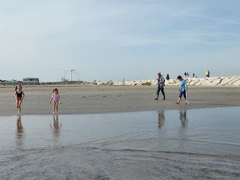

Video of another lady in galoshes, rinsing off her decent score of clams: (10 seconds)
https://photos.app.goo.gl/EcGmSsD6z18GVan97

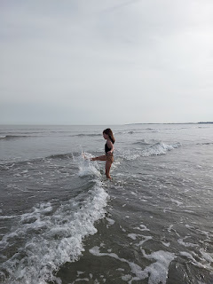

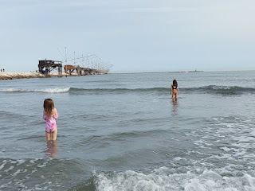

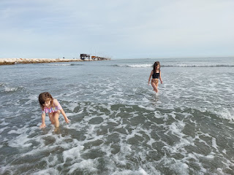

The water is shallow for a long ways out, which is so nice for young children. I made sure to stay close to them, though. Amber was resting, sketching, and even painting a couple scenes with her mini-watercolor kit on our nearby picnic blanket. She wasn't feeling that great during her last few days in Italy: sore throat, stuffy face, runny nose, etc. Poor thing . . . we had played pretty hard, though, so it wasn't a big surprise.

Meanwhile, the girls had such a wonderful time splashing around in the Adriatic Sea.

Video of Gwen and Abby (Gwen runs away shouting Big Wave, Big Wave): (17 seconds)
https://photos.app.goo.gl/W2pyzZXajLjGZYtDA

Abby was fearless, wading out further and further to face bigger waves: (20 seconds)
https://photos.app.goo.gl/FHwSbvmhA2Qa7HP18

She finally found a wave to crazily run away from: (10 seconds)
https://photos.app.goo.gl/gW3E2oqZar8zkTWGA

There was a darling little puppy tentatively chasing the water: (15 seconds)
https://photos.app.goo.gl/UtuKrcxWDpRbKEVY6

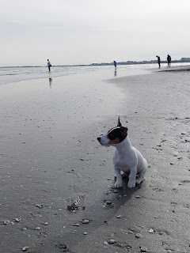

The girls shifted their play to digging in the muddy and wet sand . . .

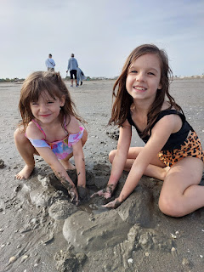

A little Italian family was walking by and their one-ish year old daughter wanted to come do whatever Abby and Gwen were doing . . .

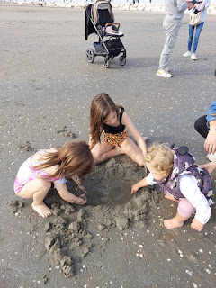

Thankfully they left before seeing what the girls did next, ha ha . . . MUD MERMAIDS!!

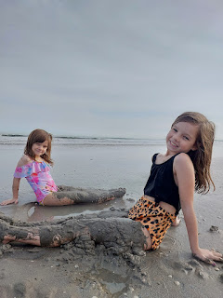

Once they got all rinsed off, we spent a few minutes gathering seashells before we left the beach. The tide was out pretty far, and there was a HUGE treasure trove of shells to forage through. (Further below in this post I will share closeups of some of the unique ones that we brought home.)

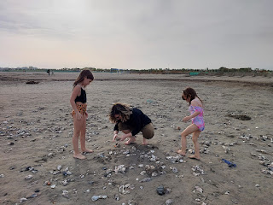

We "had to" do a quick run through the playground on the way back to the car . . .

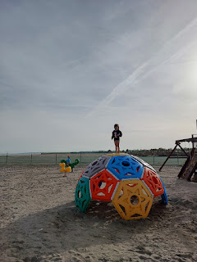

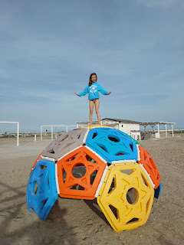

What an amazingly beautiful day!! I'm so glad we got to enjoy this outing before the rains settled back in.

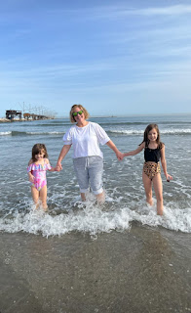

Olive Oil Tour:
Even though Amber still wasn't feeling too hot, we loaded her up with some hot tea, Advil and a decongestant so we could keep our appointment with Bonamini for a tour of their olive oil facility. It's located near Soave, about 45 minutes west of Vicenza. It's a family-owned business and their granddaughter, Rebecca, speaks English really well as the tour guide.

It was rainy outside, but sweet Gwen wanted to keep up with Rebecca: (4 seconds)
https://photos.app.goo.gl/U9i8T9Fd9tJrhD2Q9

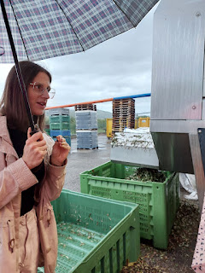

Amber and the girls enjoyed seeing how the olives are cleaned, squished, and how the olive oil is separated from the water using centrifugal force.

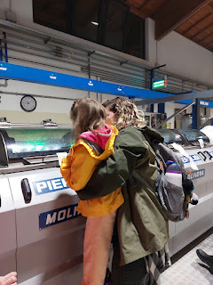

Video of the beautiful oil pouring out after the water has been separated: (10 seconds)
https://photos.app.goo.gl/AsiSfE2mznFuc6FQ6

Rebecca talked to us about how they used to use huge cement wheels to press the olives in the "olden days", squishing the pulp out. It wasn't a perfect process when they used large animals to walk around in circles, making the wheel work and turn continuously, and also pooping as they went along. Nowadays, the process is very clean and sterile, and no animals are involved, ha ha.

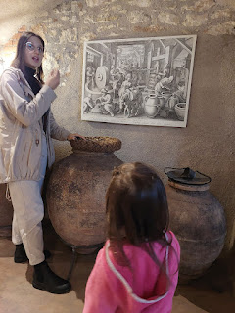

Rebecca had a lovely table set up for us to test taste some of their best oils. She also had some plain bread (which Gwen gobbled right up), and a few other samples with olive pate and pesto on them. Yum!!

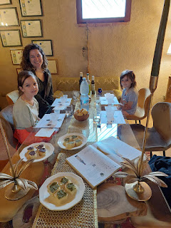

Video of the samples you can try before buying - oils, vinegars, etc.: (14 seconds)
https://photos.app.goo.gl/PWWsypnDVtT92DPp7

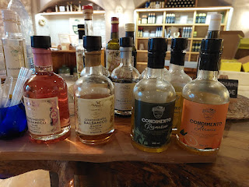

Video of the Showroom, with all of the older methods of making olive oil: (12 seconds)
https://photos.app.goo.gl/e1DhMWSg3pLktBsX9

Video of all the recent awards Bonamini has received for their olive oils: (16 seconds)
https://photos.app.goo.gl/Mn6BD8g8R83XZK2z8

Flos-Olei is like an atlas of approximately 500 olive oil farms that have been reviewed and ranked according to excellence. Their book is published each year in 3 languages: Italian-English, Italian-Spanish, and Italian-Chinese. The farms up for review are located on 5 continents and consist of 56 countries in all. I didn't know this until recently, but Spain produces the most olive oil in the world, not Italy!

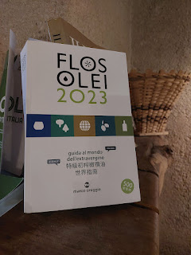

We each purchased a few things before driving home to rest and relax for a bit.

Later that afternoon, we cleaned, sorted and prepared some seashells to ship back to the U.S., because Amber wants to make a seashell wind-chime, like one that we saw at a souvenir stand in Chioggia.

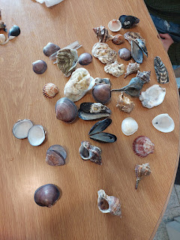

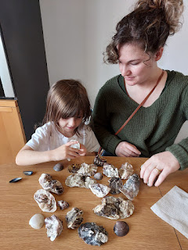

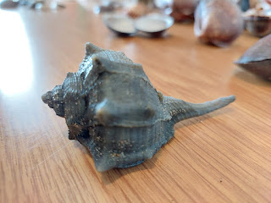

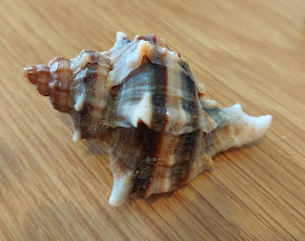

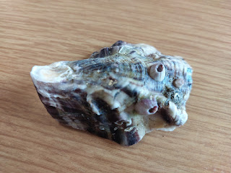

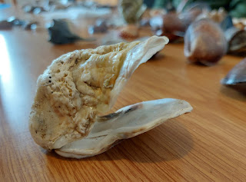

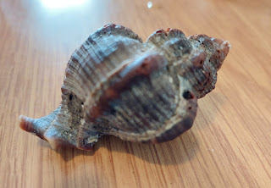

The following day we mailed her package of shells home to Louisiana, making sure that we lovingly wrapped them up and added lots of bubble wrap to ensure their safety. :)

We visited the library on base one more time and had lunch in the food court at the PX. (Post Exchange) Abby and I had fallen in love with a vendor booth in the food court area the week before, so we (well, me) decided to buy something there. I kind of have a thing for gnomes . . .

These are the two I chose to purchase.

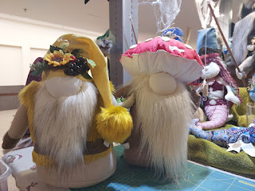

This one is for me . . .

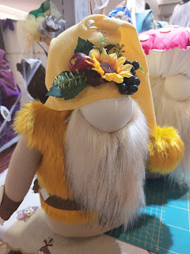

And this one is for my neighbor Kim, back in Idaho Falls. She, too, is obsessed with gnomes. We are always on the hunt for cute holiday gnomes - for Valentine's, St. Patrick's, Easter, Fall, Christmas, etc. I thought this would make a nice Christmas gift for her.

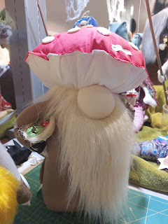

The lady that owns the booth told me that she makes each one to be unique, she never makes duplicates. She also carefully wrapped up each one in a clear cellophane bag and added a decorative ribbon at the top. They do that a lot here in Italy - making whatever your purchase is (whether small or large) feel a lot more special.

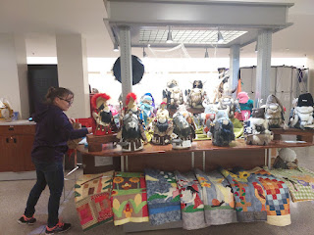

When we got home, the girls dug into their last big stash of library books in Italy and they read and read and read . . .

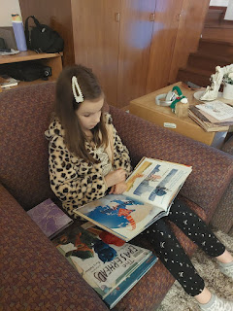

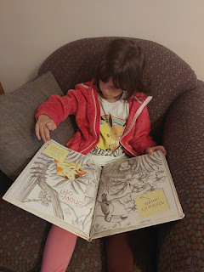

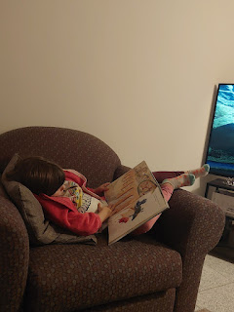

On Amber's LAST DAY, we had arranged for her to have a floral arranging lesson from my friend, Marnie Parker. First, we rode the bus downtown to pick out some flowers at the Farmers Market.

Abby had her heart set on these pompom mums, but they were pretty expensive per bundle.

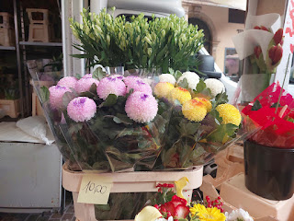

I let the girls choose some cheaper and brightly dyed daisies instead. They selected some bright pink and bright turquoise bundles and were very happy.

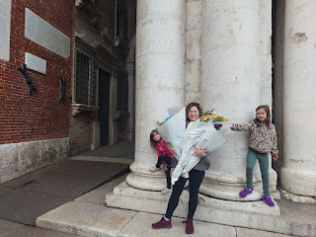

Loaded with flowers, we rode the bus home and then drove south to Marnie's house. She was a professional florist back in the States, and now she enjoys putting together centerpieces and other arrangements for a variety of events here in Italy.

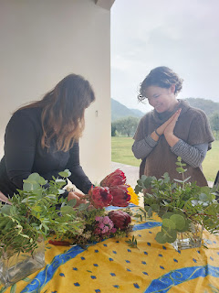

She taught Amber how to weave the stems one at a time as you place them into the vase, tucking them into each other from different angles. This not only helps each new stem to stay put as you build up a strong foundation underneath, but it also allows you to lift out the entire arrangement to change out the water regularly.

Short video of Amber weaving in some greenery to start: (6 seconds)
https://photos.app.goo.gl/kCpHjxihvWDjCsUP7

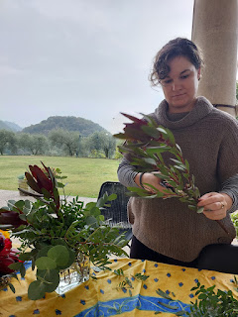

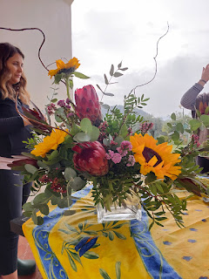

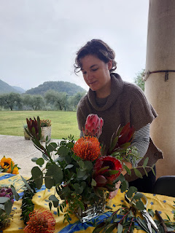

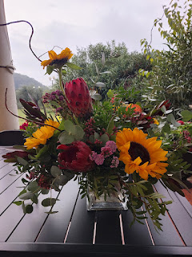

Everything turned out so beautiful!!

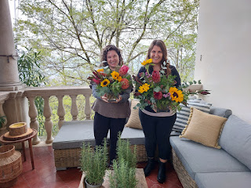

Marnie had also thoughtfully dug out her daughters' old collection of Littlest Pet Shop, with hundreds of tiny little pets and toys to keep the girls busy while we sat on the porch to work on vases of flowers. She is an amazing friend!!

Their hilltop estate is so dreamy . . . you can see for miles and miles . . .

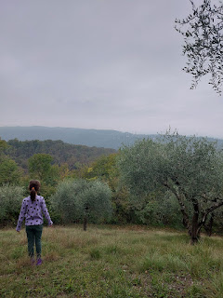

So the deal was: I bought the flowers, Amber arranged them, and then I got to keep them when Amber left. Not bad . . . :)

We walked over to the InterSpar grocery store one last time so Amber could get a few items to bring home to share with friends. She had a clever idea to have the girls take turns carrying the grocery bag for a total of 3 minutes each. Abby was a champ and made it for the entire 3 minutes, even though she was struggling at the end.

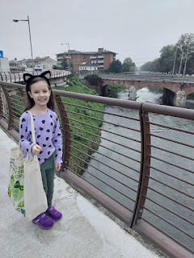

When it was Gwen's turn, it was quickly aborted because 1) the bag hung down to the ground with her shorter height, and 2) she instantly rejected the plan because of how heavy it was. It was an interesting way to teach the girls gratitude for what their family members do for them on a regular basis. And to realize that we can all do hard things!!

Last hugs for Poppa before he went to bed . . .

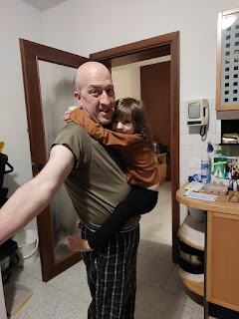

And that brings me to the worst words of this whole post: THEY LEFT THE FOLLOWING MORNING. Boo hoo.

We got up at 3:00 a.m. to be out the door by 3:45. Scott was already working from 2 a.m. to 2 p.m. all week (due to the war in Israel), so things were already a little out of whack around the house. We wisely had the girls go to sleep in the outfit they would wear for their flight home, which made it a lot easier to wake them up and get them out the door in the middle of the night.

I drove everyone to the Venice Airport, parked, and then accompanied them through the long line to check in their bags. And then it was time to say goodbye . . .

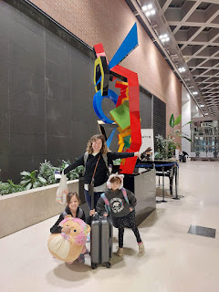

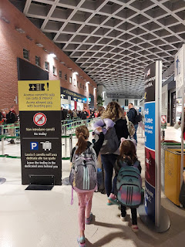

Goodbye my loves. Ciao. Arrivederci. Buona giornata. XOXOXO

