Graduation Time, Dr. Whitworth, and Happy Mother's Day!
Happy Mother's Day!!
The sun is shining this morning, the skies are blue, and I am super happy to celebrate the influential mothers in my life!
To my mother that gave birth to me:
Linda Norman Snider Dake
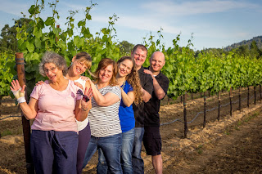

Thank you for teaching me to love nature, sunsets, waterfalls, and beautiful cloud formations in the sky. Thank you for all the poems you have written for me with all your clever words and phrases. Thank you for teaching me how to cook, how to wash dishes, how to clean the house and how to do it well. Thank you for all the times you have listened as I have cried to you, shared my joys with you, and shared my spiritual experiences with you. I love you!

To my step-mom
Michelle Muller Snider
:

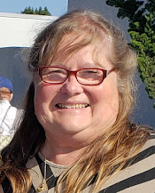

Thank you for showing me how to be clever and creative when life throws a curve ball your way. Thank you for being such a hard worker and never giving up when things get hard. Thank you for showing me what unconditional love looks like, especially when it comes to family. Your devotion to family is remarkable and so passionate. Thank you for being such a champion of my spiritual journey in life, you are always so supportive and encouraging as I share my experiences with you. And thank you a million times for loving my Dad as much as you do. :) I love you!

To my mother-in-law
Coy Michie Harmon
:

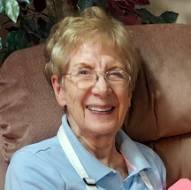

Thank you for giving me your wonderful son, Scott!! Thank you for your wisdom and frugality, teaching me how to live smarter and better throughout the years of raising our family. Thank you for your quick wit and great sense of humor! If we can't laugh about the hard stuff, then life is just miserable and dark. Thank you for your strong testimony of the gospel of Jesus Christ. You have led the way by example for your posterity through your discipleship. Thank you for teaching me how to bake delicious bread and how to preserve food through canning and dehydrating, something I really wanted to learn how to do. Thank you for helping me countless times through the years when I was in a pickle and needed help with this or that. And thank you for teaching me how to garden, coming from a master gardener yourself. And most of all, thank you for being so encouraging as I have worked on my family history all these years. We definitely have a common love for finding and learning about our ancestors!

HAPPY MOTHER'S DAY TO YOU ALL!! XOXOXO
Next is a
HUGE congratulations
to my son-in-law, Dr. Weston Whitworth, for all his perseverance, hard work, blood, sweat and tears for the past 8 years as he has devoted himself to becoming an optometrist!
He graduated in San Antonio a few days ago, with his wife, Amber, and his parents there to cheer and yell for him from the stadium.

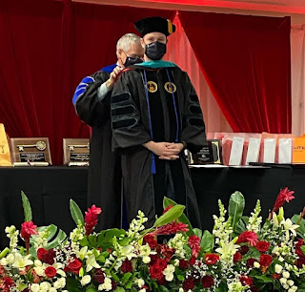

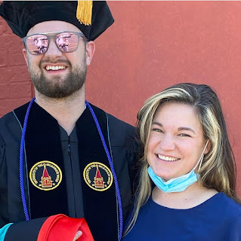

Wowza!

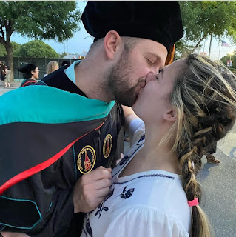

Dr. Whitworth and his overjoyed parents: Mike & Kathy Whitworth

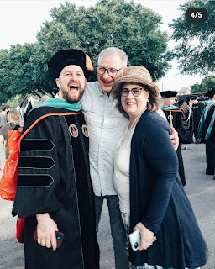

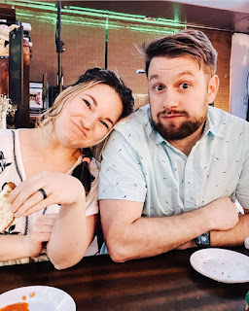

After all the festivities, they all went out to pizza together to celebrate. They were dehydrated and tired after several hours of being in the hot Texas sun (pushing 90 degrees). And Weston was dressed in all that fancy graduation attire, too!

As for the other family graduates . . .

Jacob and Hannah both graduated from BYU with a bachelor's degree this past week! Jacob got his degree in Economics, with a minor in Statistics, and Hannah received her degree in Special Education.

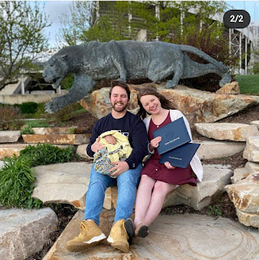

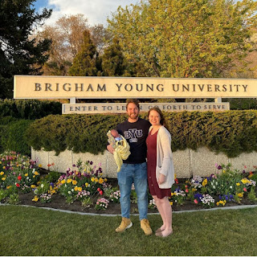

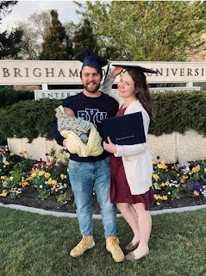

Jacob wrote the sweetest thing ever on social media regarding all the blessings in his life recently.

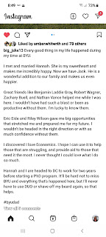

Hannah's sentiments were very similar on Facebook. They are truly being blessed as a family lately, and they are so happy! We are so happy FOR them!!

They also found an apartment in Washington DC and will be preparing to move across the country in just a few weeks.

In other news . . .

Monday:
Scott and I took the girls for a walk after dinner, admiring all the flowers coming into bloom around the neighborhood.

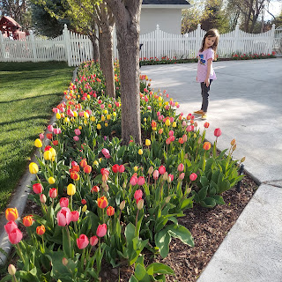

Tuesday:
I had a lovely video call with Kylie over in Italy. I can't remember if I already mentioned this in last week's post, but they are just having ONE baby. So that's somewhat of a relief! It would be hard to have twins on the other side of the world. Anyway, she is doing alright. Her allergies are in full swing right now as everything is blooming over there, too. And the medications that her Dr. prescribed to help with nausea and vomiting aren't working quite as well lately. She says that she gets sick pretty much every morning now, and sometimes every evening, too. Poor thing. What we women have to go through to bring a sweet little baby into this world! :)

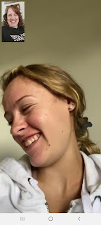

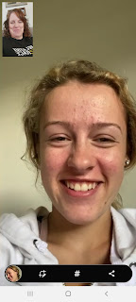

The day was sunny and beautiful, so for lunch, the girls had a little picnic out in the back yard.

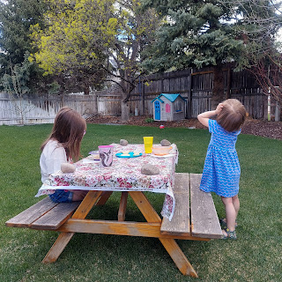

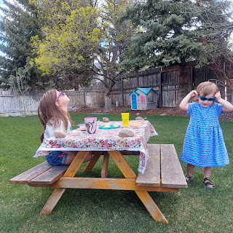

And as I took Abby on a quick errand in my car, John Denver's "Take Me Home, Country Roads" started playing on the radio. We had just been practicing the words the day before, as I studied the West Virginia travel guide that I had recently ordered. (Scott and I are looking into the possibility of retiring there in a few years.) Anyway, Abby, having practiced the song with me the day before, started belting out the words with all her heart and soul! She loves that song! What a cutie.

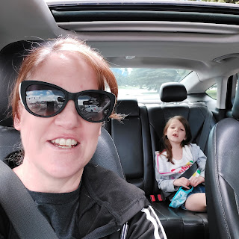

And this was one of the daily photos that we got of Jack. XOXO

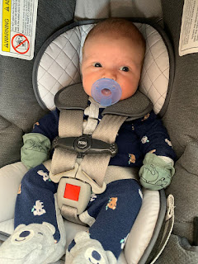

Wednesday:
After a frenzied morning of packing and organizing some last minute stuff, I drove Amber across town to the I.F. Airport to catch her flight down to San Antonio for Weston's graduation. Only actually we arrived 5 minutes too late for her to check her bag in!! So she ended up having to reschedule for the next morning. Thankfully they had room for her to fly on the next morning's flight, because that was the start of 2 important days of graduation festivities!

I had already taken this cute picture of her and driven away, only to return a few minutes later to pick her up. She was quite deflated about the whole thing, but she also knew that in a few hours it wouldn't even matter.

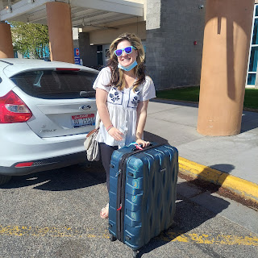

We also got this cute video of Jack. He looks like he is trying to smile - his eyes have a little twinkle in them!

Click here to watch: (13 seconds)
https://photos.app.goo.gl/6XW5NrQeYudBknJv8

And I did a screenshot during the video to capture this beautiful face.

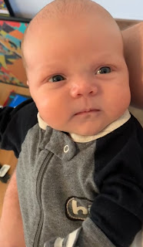

That evening, we took the girls down to the Snake River (part of Freeman Park) to run around for a bit. We also met up with my niece, Natalie, and her fiancé Chance, so they could say their goodbyes before Amber leaves for Louisiana.

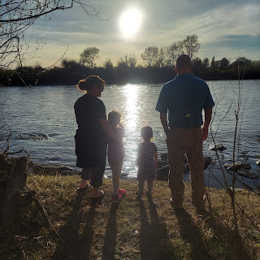

Gwen had a hard time leaving the sand and rocks behind.

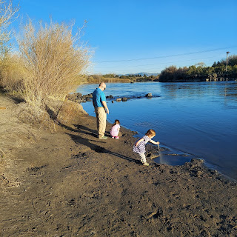

Gwen, Abby, and Papi.

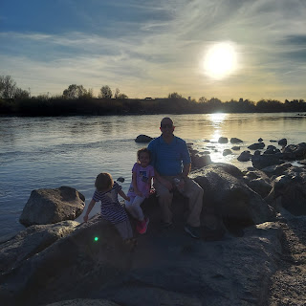

Abby, Amber and Gwen

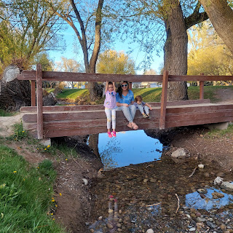

And Abby got cold when we first started walking. So she borrowed Papi's sweatshirt and we "held hands" with her, ha ha.

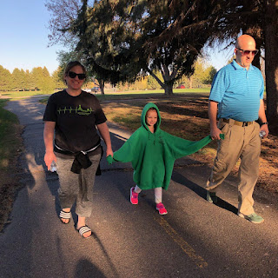

Thursday:
Another picnic day. I love spring days when the sun is shining and the wind is at its minimum. Those are precious and priceless days around here.

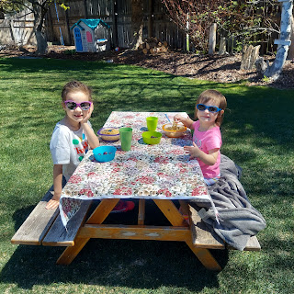

Amber also successfully got on her plane early that morning and arrived in San Antonio around noon. Weston was there to pick her up, and his parents flew in a couple hours later.

Meanwhile, we enjoyed eating ice cream cones on the front porch.

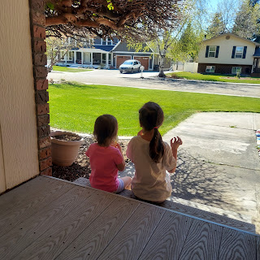

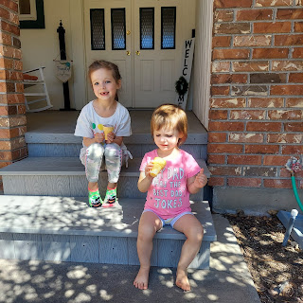

Abby's friend Anna Blatter came over to play for a bit. Funny thing happened: for the SECOND time, Anna and Abby were playing and Abby got bumped in the mouth and LOST A TOOTH! ha ha.

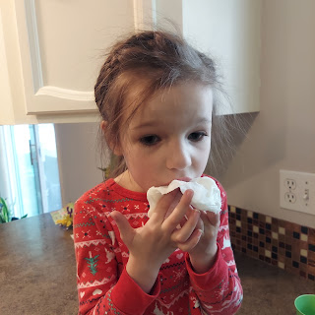

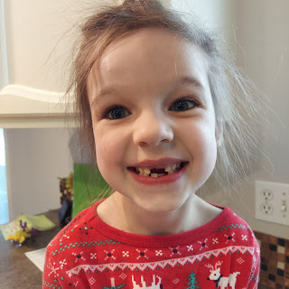

This time it was because I was trying to get a picture of the two girls in the hammock swing out back before Abby moves away. Anna felt so bad! But Abby did great, coming in to rinse her mouth out and get the bleeding stopped. This was her 5th tooth to come out, if I'm counting correctly. It was already loose, so it didn't need much coaxing.

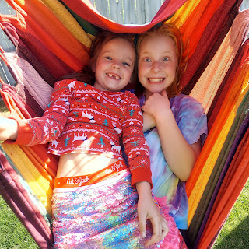

We made sure to tuck her tooth under her pillow that night and the Tooth Fairy was able to successfully pay her a visit before the morning came.

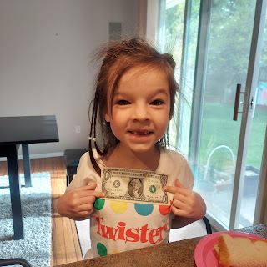

Also on Thursday, Scott and I took the girls back to Freeman Park to play on a playground there that we didn't have time to explore the night before. They had fun climbing all over the jungle gym equipment, and running up and down the hill.

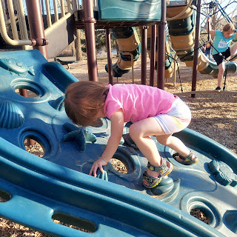

Poor Papi. He was worn out from being a little under the weather for a few days - scratchy throat mostly.

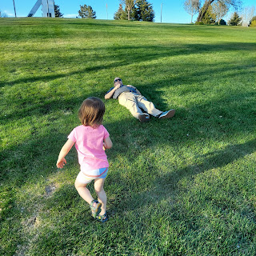

Meanwhile, down in San Antonio. Weston received his graduation gift from Amber. She has been working tirelessly for weeks and weeks to get a photo of everyone's eye, and then she painted each person's eye to make a beautiful wall hanging for Weston's new office in Shreveport.

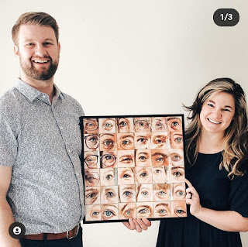

He LOVES it!!

See if there are any eyes you can recognize before looking at the cheat sheet below.



Harmons:
Top row - Grandpa Philip Harmon, Grandma Coy Harmon, and Benson
Middle row - Me, Scott, and Kylie
Bottom row: Jacob and Hannah

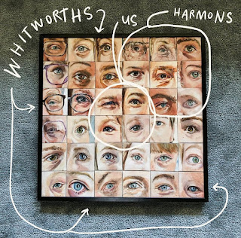

Amber ran out of time to get anybody else painted, but she does plan to expand her gift after things settle down a little bit in Louisiana. She wants to add other grandparents, little Jack, as well as recreating the eyes of some deceased relatives. What a labor of LOVE!! Wow.

We also got this cute video and photo of Jack for the day.

Video: (20 seconds)
https://photos.app.goo.gl/V3UMzsDShCjkVnD1A

And here he is SMILING!!

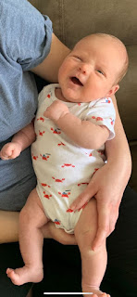

Friday:
Gwen was digging her cute pigtails. We sent pictures to Amber and Weston down in Texas to start the day. This was also the morning that Abby got her gift from the Tooth Fairy.

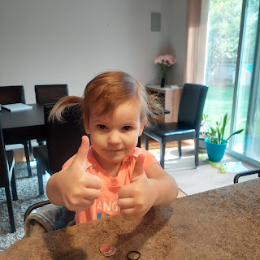

After a whole lot of running around doing errands and stuff, we ended the day by going roller skating at our local skating rink. We already had plans to take my young women's class for our bi-monthly activity, so I left Gwen home with Papi while I took Abby with me to go have some fun!!

Abby did AMAZING!! Much better than when I took them for the first time down in San Antonio last year. Abby has been practicing with her new roller skates around the house, up until we packed them up and shipped them off to Louisiana, that is. She was very confident in just taking her time going around the rink as she held on to the railing.

Click to see her shuffling right along: (30 seconds)
https://photos.app.goo.gl/kZAn3ZLrYJhCbARA9

Here are all the girls taking a snack break.

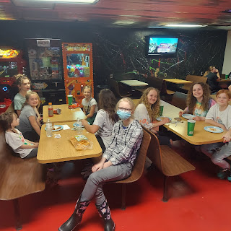

After helping her for the first little bit, Abby was content to do her own thing by going around the rink while holding on, and she cheered me on to just go and do some skating of my own. I would do a lap, then stop to check in. She always cheerfully assured me that she was doing great! So off I would go to do another lap.

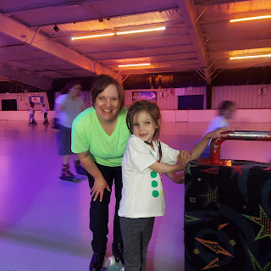

I had one of the young women take a short video of me. I bought myself some roller skates recently, too, and I am so glad I did! They are super fun and really comfy! And they light up when I skate, so that's super cool.

Click here: (18 seconds)
https://photos.app.goo.gl/SKMWQfF7LWrxBTkf7

And here is one of the daily photos we received of our sweet baby Jack. I just love this one so much! He looks ready to drift off into dreamland.

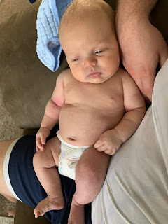

Saturday:
I hurriedly tried to pack in the last items on my to-do list that didn't get done while Amber was in Texas. I tell you what, I have a new respect for her as a young mother of two VERY energetic girls. I think they sense the excitement and stress that's leading up to the move and the anticipated reunion with their Daddy, but they don't quite know how to process it and behave appropriately. They just have a ton of energy and they've been bickering quite a bit more than usual.

I had some ambitious plans to accomplish while Amber was gone, but it seemed like nothing was getting checked off my list! It seemed like all I did was referee and entertain and clean up and feed and put them to bed at the end of the day. And then do the dishes, clean up some more, and go to bed myself!

I was out of time to get my things done before Amber landed at 1:00 p.m. on Saturday, so I had to resort to being creative in helping Gwen to be self-entertained.

I got out some little pom-poms and while she named them all and made them into her little family of pom-poms, I added a new level to her play. I told her that this blue basket was their swimming pool and this other one could be whatever she wanted it to be. This kept her entertained for a little bit . . .

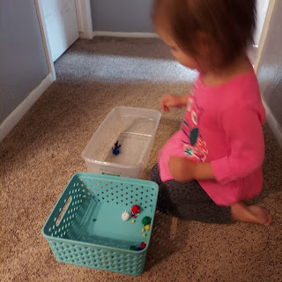

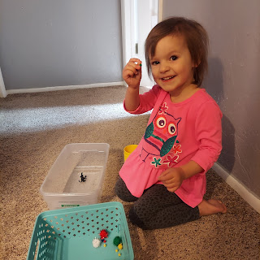

Our final task before Amber's return was to make their mother's day gifts for her. Having purchased the white flower pots on Friday, we were ready to assemble! With pipe cleaners and pom poms, we hot glued "I (heart) U" on each one, with the girls choosing their colors. Abby built both of the pipe cleaner hearts and I was very impressed with her skills!

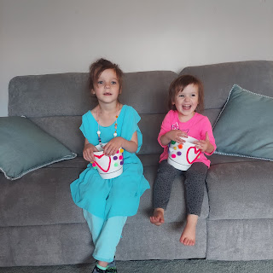

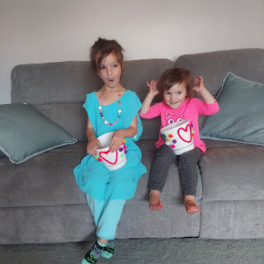

And this sweet boy. Need I say more? (This is my new home screen photo on my phone)

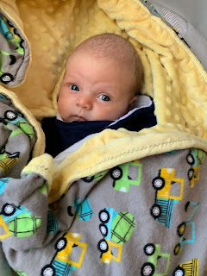

Sunday:
I got a phone call from Benson in Italy!! Hooray! It's been WEEKS - maybe even a month - since I last talked to him!!

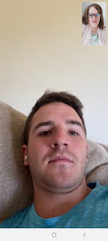



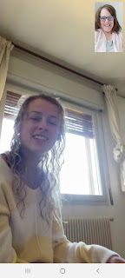

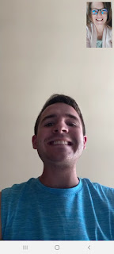

He's doing great. He had just finished mowing their lawn, and they were preparing to go out to dinner together at an Indian restaurant for Mother's Day. Kylie had just gotten out of the shower and was excited to go eat. It was so great to visit with them for a while. I'm glad they are doing well. :)

We got a few more pictures of Jack today (Sunday).

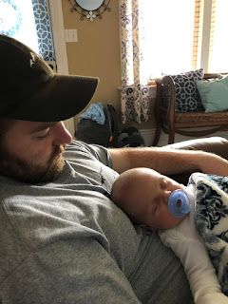

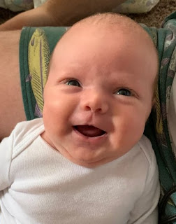

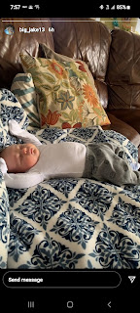

And this was from earlier in the week. A sweet mother and baby photo of Hannah and Jack.

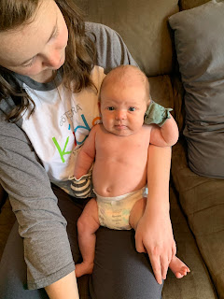

Tonight, we went to visit Scott's parents in Rigby so that Amber and the girls could say goodbye.

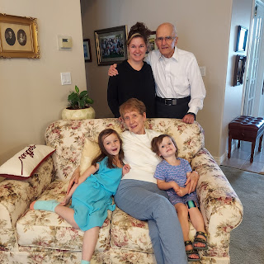

Goodbyes are always bittersweet. Especially in this case. A lot of people have been asking me how I'm handling the fact that they are moving so far away. My best answer is that my happiness for them far outweighs the sadness I will feel as we separate. They have long awaited this reunion and this chapter of their life, and they deserve to be together, not separated. It's like when your children leave the nest. You want them to leave, but then you miss them. So they come back for a visit or for a time. And then they leave. They will come and they will go, but they will always be in my heart.

We hit the road tomorrow morning bright and early, and we will arrive in Stonewall, Louisiana on Thursday. Wish us luck!!

