How's Ya Mama an' Them?
"How's ya mama an' them?" is a common phrase down in Louisiana. It basically means, "How is your mother and your family?" They also like to call everyone "baby" as a term of endearment. :) Any way you want to slice it up, Louisiana is a wonderful place and our daughter, Amber and her little family, are excited to dig in and get to know the area down there.
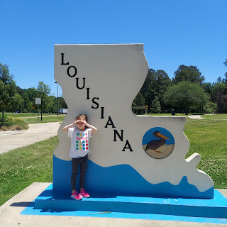

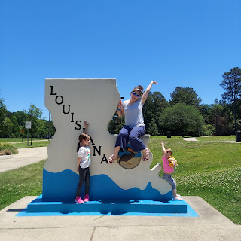

Monday:
In the morning we left bright and early to begin our drive across the country to Louisiana. It took us 3 1/2 days and we did great!! The girls were amazing the entire time! We only had maybe one meltdown the whole week and that was somewhere in New Mexico if I remember correctly, at our hotel in Tucumcari for the night. The girls were just soooo tired, so it was to be expected. But other than that, we sailed along and made it safely to Stonewall, Louisiana on Thursday.

Scott said goodbye to Abby and Gwen Sunday evening before they went to bed. Here they all are, hugging one last time, amidst all the packing going on around his feet. He typically leaves early in the mornings for school, so there wouldn't have been a good opportunity to say goodbye at 6:45 a.m.

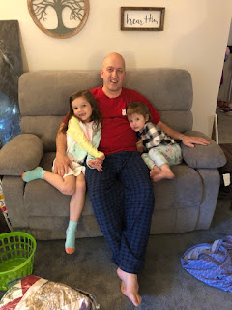

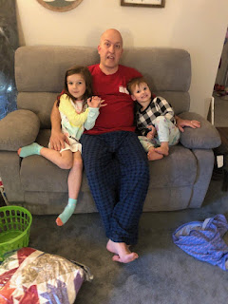

Gwen was enthralled with her new pop-it toy. It ended up being the easiest form of entertainment (besides a movie screen) on the drive. It is made of silicone and is soft. You just push in all the little bubbles and then flip it over and do it all over again, pushing them the other way. With each push, there is a satisfying and subtle popping sound that it makes. It's meant to be a fidget toy for those who have trouble sitting still or have trouble focusing.

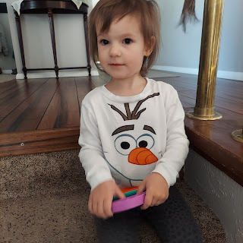

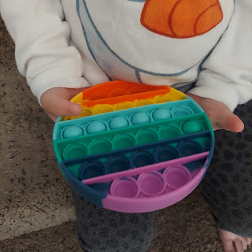

The girls were outfitted with a travel lap desk to organize all their objects of entertainment. They loved their desks the whole way to their new home! Abby's desk had a built-in white board to doodle on, and for Gwen - I bought her a small (but separate) white board so she wouldn't feel left out. Each desk had a strap that buckled around the back of each girl to hold it in place as we bumped along. And they were between $25-30/each on Amazon. A very worthwhile purchase!!

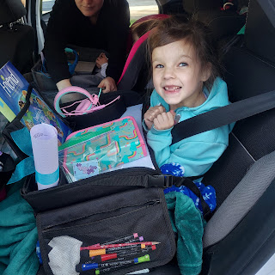

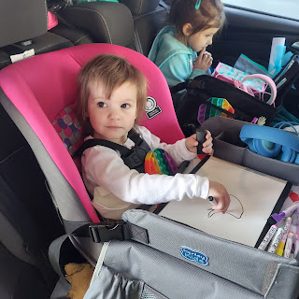

First big stop: a visit to our little Jack down in Provo, Utah. Amber got to hold him and feed him for the first time. She was in heaven!

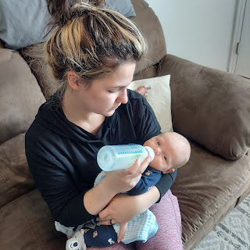

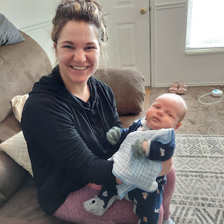

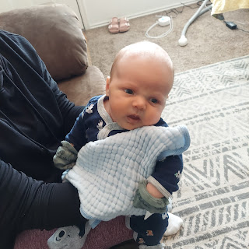

She also demonstrated how to properly wear a baby in a Solly wrap . . . (Solly is the brand)

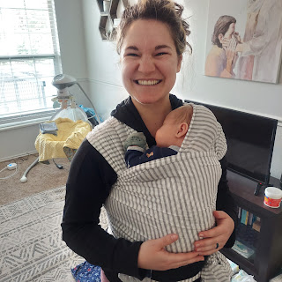

Amber also helped Jacob to comfortably wear his little son as he drew various states on the white board for Abby and Gwen to guess which state it was.

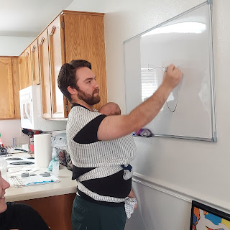

She also helped Hannah to get set up so she could confidently wear her baby, too. Amber has instructed many a new mom on how to properly wear a baby. It is so comfy and soothing for both parent and baby to do this, allowing the parent to have both hands free to fold laundry, wash dishes, or whatever else they would like to do.

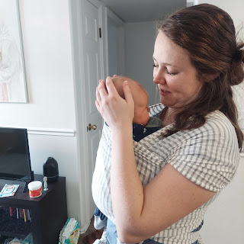

While I didn't get outfitted with the baby wrap, I DID enjoy holding Jack again. He is so snuggly and perfect! XOXOXO

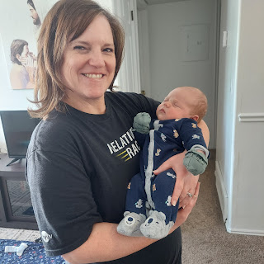

Abby and Gwen lovingly took turns holding little baby Jack, too. They were completely in love and full of adoration for their little cousin.

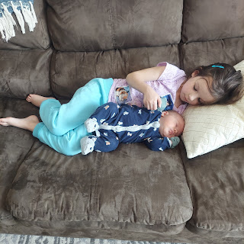

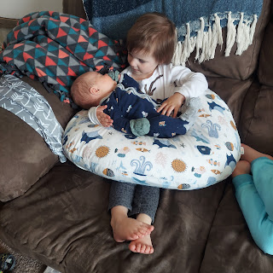

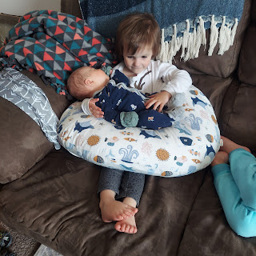

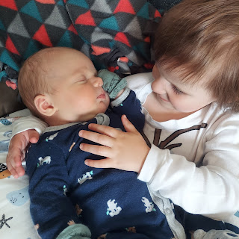

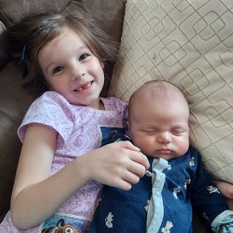

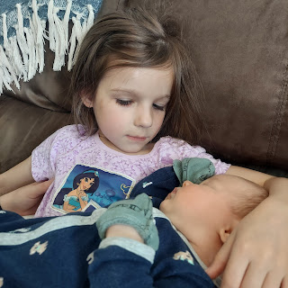

Our original plan was to spend an hour with them, have lunch, hold Jack as much as possible, and then be on our way. But we didn't want to leave!! We ended up staying for 2 hours! But it was worth every second.

We arrived safely at our hotel in Monticello, Utah later that evening and spent a little time in the pool and hot tub before retiring for the night.

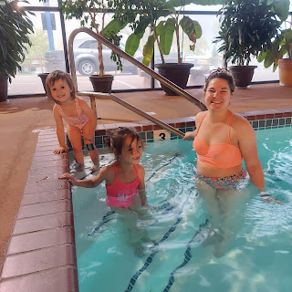

Tuesday:
We drove from Monticello, UT to Tucumcari, New Mexico. For a little while, the scenery was quite beautiful. And then . . . well, . . . it is New Mexico . . .

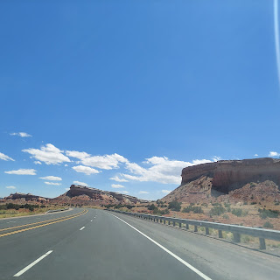

The girls were happily entertained by watching movies and eating snacks.

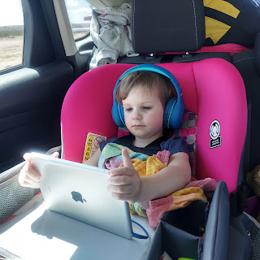

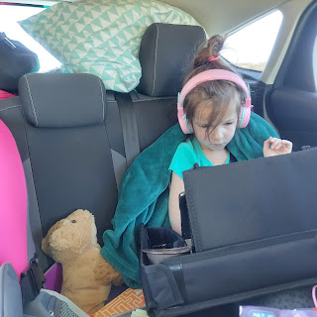

And eventually, we ended up at our hotel in Tucumcari, NM. Not the greatest town, I might add. But it was an ideal location for stopping after an 8 hour drive. The hotel was "meh", but our dinner was great at a place there called, "Pow Wow Lizard Lounge". I had some delicious smoked & grilled trout that filled me up to the brim! I told Amber, "You might need to roll me out of here . . ."

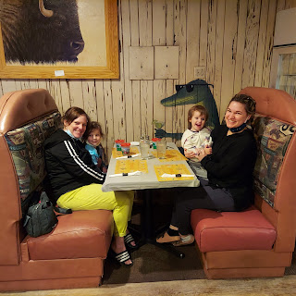

Wednesday:
We drove from Tucumcari to Fort Worth, Texas. Abby got creative with her gummy bears and her white board during the drive. She also took her own pictures with my camera.

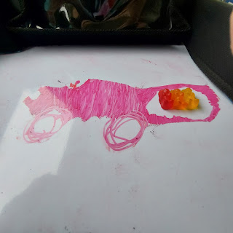

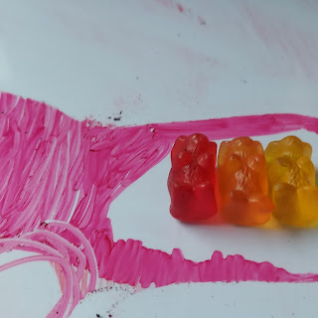

For lunch, we stopped at the CUTEST place in Memphis, Texas: The Rock Inn Cafe.

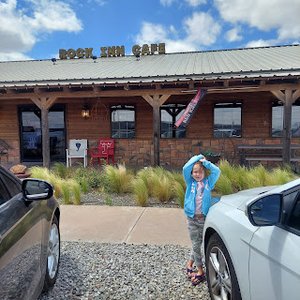

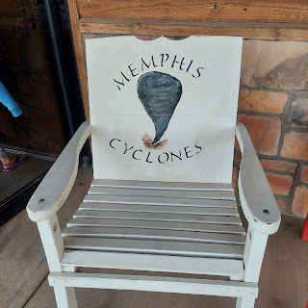

It was the real deal in there!

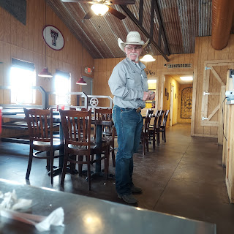

Abby ordered a PB&J with chips, Gwen ordered mini corn dogs with chips, plus they shared a giant chocolate milk.

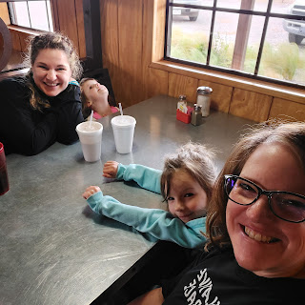

I don't remember what Amber's meal was called, but it was essentially chicken fried steak in a sandwich with Texas toast and all the fixins.

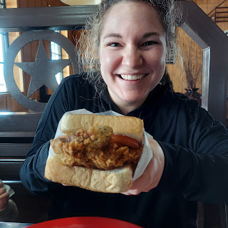

I ordered the steak salad and it was delicious!!

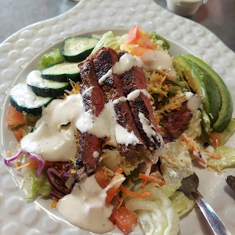

FINALLY, after our third long day of driving, we got to Fort Worth.

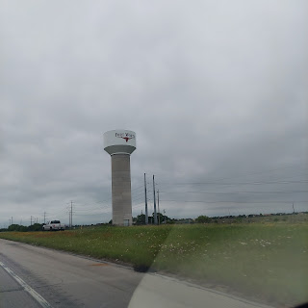

We opted for an AirBnb for this night, because I wanted a place close to the Fort Worth Water Gardens. I didn't really consider beforehand that by choosing a place DOWNTOWN that it might not be the best neighborhood to stay in. I looked at location (proximity to our chosen place of interest), price, and the fact that the host was a Super Host (meaning that he has excellent ratings and has been doing this for a little while). Buuut, . . . Raymond, the host, didn't do such a great job with this one. It was a new listing for him, but he had good reviews for his other properties. We were actually the first ones to stay at this location and man, it needed a lot of help. Raymond was a great communicator and encouraged me to let him know if something was missing or lacking so that he could fix it up for the next guests. So I gave him a lengthy list the following day in a private message, which he gratefully received and was very gracious about the whole thing.

It was in a very run down neighborhood, even though this little house was pretty cute. It was a "flip" for sure. In other words, someone did their best to fix it up so it could be sold, rented, etc. But whoever did the work didn't exactly know what they were doing. The whole house smelled of pets, . . . and pet poop. It wasn't 100% clean, although it was "pretty" clean. There were several other issues, but I won't go into that here.

Suffice it to say that the girls were super happy to have a large space to run around in and that was the best part of the whole night. We ordered pizza and watched part of a movie before turning in. :) I wasn't exactly SCARED to be in that house, but we didn't want to go outside much or open the blinds, ha ha.

Thursday:
We got up early and headed out to find breakfast. Once it was in our hungry little hands, we drove a few more blocks so that we could eat it picnic-style at the Fort Worth Water Gardens.

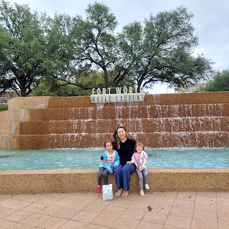

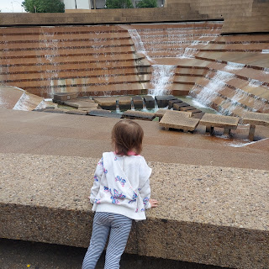

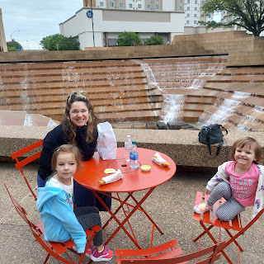

There's a giant stepping stone path down to the bottom of the falls, which we did in shifts so that we could take pictures. Abby and I went first.

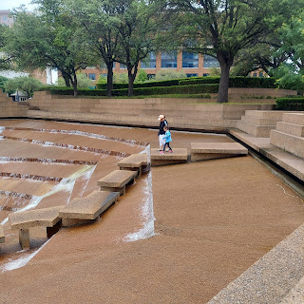

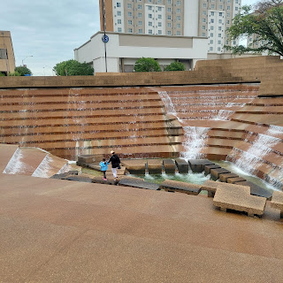

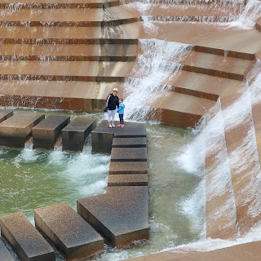

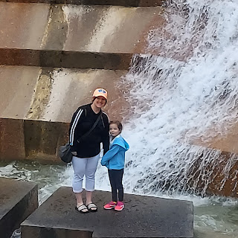

Then it was Amber and Gwen's turn.

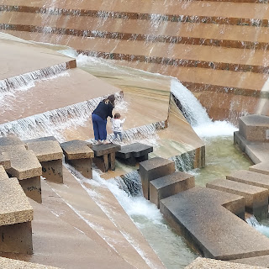

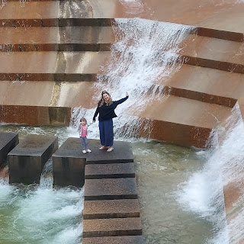

Next, the girls wanted to climb the mountain near the waterfalls.

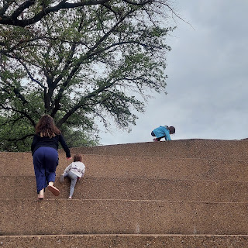

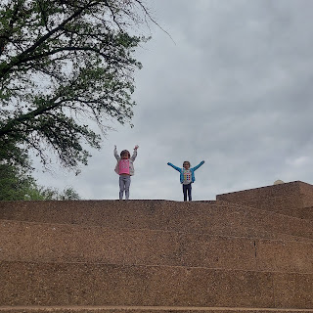

This next panoramic shot makes it look like the skyscraper is tipping over, ha ha. But it's really not.

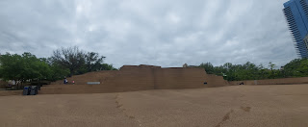

Short video of the girls hopping down the other side of the "Mountain". (18 seconds)
https://photos.app.goo.gl/Rtf7y4Ybyg72xVcFA

Moving along, we found another water marvel, which included a VERY tall wall, with water cascading down it, adjacent to a large reflecting pool.

Click to watch a series of each of us trying to send water over the edge and down the ginormous wall:

Gwen - (19 seconds)
https://photos.app.goo.gl/nim8Zdx8twDEURn8A

Abby - (14 seconds)
https://photos.app.goo.gl/tRRABsW9bhSwE3jT9

Amber - (14 seconds)
https://photos.app.goo.gl/vHAPp3wXHx8w312G7

It was all in fun trying to recreate the time when Benson was there with me 2 years ago doing the same exact thing.

Click to watch Benson: (14 seconds)
https://photos.app.goo.gl/qd9VXRNAKu35cMXj8

The beautiful reflecting pool at the bottom of the stairs is so peaceful and beautiful.

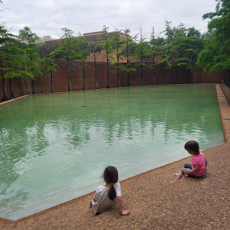

And here is a short video of the girls enjoying the cascading water coming down the wall and then Amber pointing out the interesting tree roots. (17 seconds)
https://photos.app.goo.gl/hUjy12VnLFujTwgt7

Soon after, we loaded back into the car and started our shortest drive of the entire week - just 3.5 hours to Stonewall, Louisiana!

Along the way, we stopped at Bucc-ees - a gas station of your dreams!! It all started in Texas, but there are a few other locations in Alabama and Florida. Weston had HIGHLY recommended that we stop at one. It's like a shopping mall + grocery store + gas station all in one. SUPER clean and sparkly. I could have spent a good hour there at least . . .

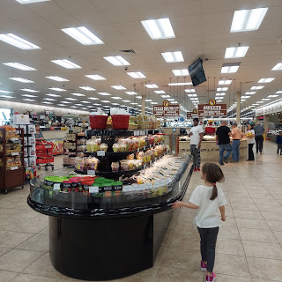

Even the hallways leading to the bathroom were gorgeous and clean, with lots of artwork to bedazzle you.

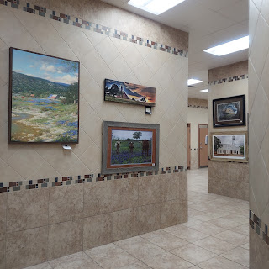

And Bucky the Beaver was available for purchase as well.

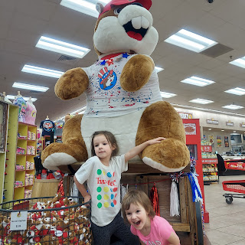

And just like that, in the blink of an eye, we crossed the border and stopped to take some pictures at the Louisiana Welcome Center

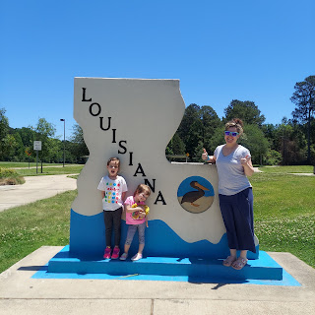

And then, just a few miles later, we had our LAST mile to go!

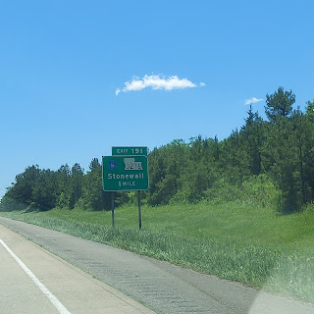

Here is a video of the drive from the freeway exit to Amber and Weston's new house. They live super close to the exit (maybe 1/4 mile), but it's tucked away in a very forested neighborhood that is extremely quiet. There are only about 15-20 houses on the 3 streets. Their neighborhood is basically a "W". They live on the left-most street of the "W".

Video of us pulling up to the house: (41 seconds)
https://photos.app.goo.gl/VonK7djmdPHZfQwk7

As we arrived, Weston was there to scoop up the girls and squeeze them tight. Within a few minutes, we were all launching into work mode, though. Turns out, the seller did not have the house cleaned AT ALL. The renters had moved out about 2 months ago, leaving everything pretty filthy. And the seller never got it professionally cleaned up. The hardwood floors had not been swept or mopped. The cupboards and drawers had not been cleaned whatsoever. I was pretty tweaked that it was so dirty. That meant that we couldn't even unpack anything until we got the whole house clean first!

Amber and I dropped the girls off at the Judd's house (friends of theirs from Optometry School in San Antonio and Dr. Judd works with Weston in Shreveport now) so that they could have a play date while the adults rolled up their sleeves and got to work. Amber and I loaded up 2 full carts full of stuff from Walmart (pillows, paper products, laundry baskets, etc.) and then took it all back to the house.

I got to work cleaning the kitchen from top to bottom as best as I could, while Amber and Weston took care of multiple matters.

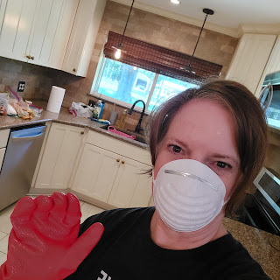

I wore a mask because they discovered cockroach feces in 2 cupboards under the sink area that needed to be excavated. While I did not do any excavating, I was still cleaning up yucky things and I didn't want to breathe any of that. The kitchen itself is GORGEOUS! Especially after it got cleaned up! They also got a new stove delivered yesterday, something the seller agreed to take care of.

We all fell into bed exhausted that night.

Friday:
Amber and Weston had some big errands to run, namely to look for a washer/dryer and a couch and a living room chair. So I took the girls on a walk around the new neighborhood to see what we could see. We walked almost the entire "W". The girls walked for some of the time, and other times they enjoyed riding in the little red wagon.

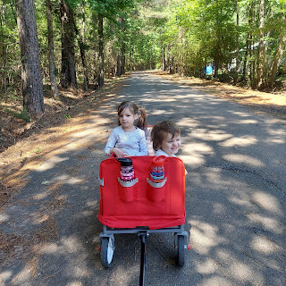

Then it was back to work again. Amber worked on cleaning the girls' bathroom, Weston tackled the master bathroom, and I continued cleaning in the kitchen.

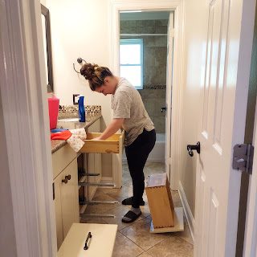

The girls happily emptied out their dress up bin of clothes, which they hadn't seen in a while because it was shipped in the U-Haul containers a long time ago.

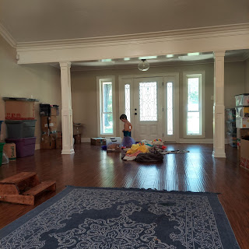

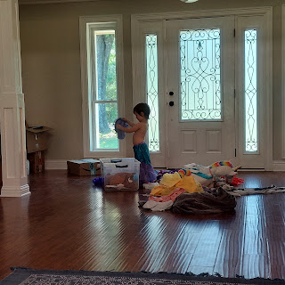

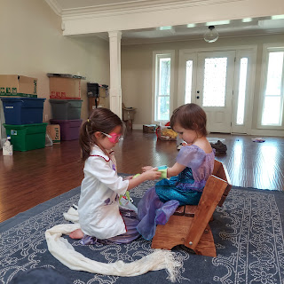

I captured this cute video of Abby playing Doctor with Gwen as her patient. Turn up the sound because it's just so cute! (1 minute long)

https://photos.app.goo.gl/DKCJM6tYMXN3UPTh7

You'll hear Dr. Abby saying things like:
And now, I need to take your temperature.
Oh dear, you're feeling sad!
Now, I'm going to check your eyes. Follow the light.
Now, a shot!
Gwen: "Will it hurt?"
Abby - Oh gosh! I forgot the band-aid!
It's okay. It will only hurt for a moment. Then it will be feeling better.

A little while later, A & W headed out again for some important errands. So the girls and I headed back outside to hang out for a while. We all spritzed ourselves with bug spray first. Otherwise we might have been eaten alive . . . that's what happens in the south.

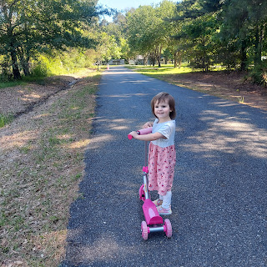

As we headed left from their driveway, we heard an insistent meowing in the grassy field next door. It was a youngish kitten, trying to figure out how to get over to where we were. Once he figured it out, he made instant friends with Abby. He has a turquoise collar around his neck, with a little jingle bell attached to it. But I don't know how to tell if it's a boy or a girl, ha ha.

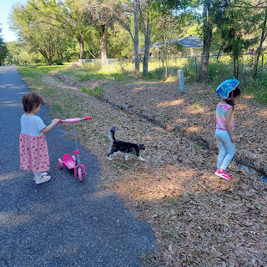

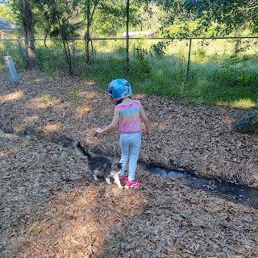

He hung out with us for the rest of the afternoon, even coming back to the house and exploring amongst the lilies.

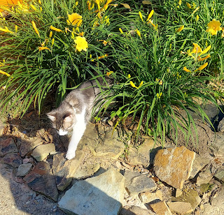

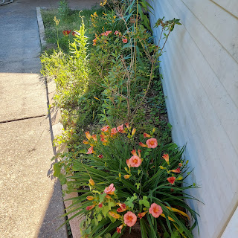

Abby figured out how to jump across the drainage ditch, with the kitty following her back and forth as well. That ditch-jumping challenge immediately became her new favorite thing to do outside.

Her very 1st attempt: (11 seconds) "Did you SEE THAT?!!"
https://photos.app.goo.gl/uifvXruXFYSXrhgf9

And then coming back across toward me: (9 seconds)
https://photos.app.goo.gl/h63VrsQBBTwFUJmh7

You'll hear Gwen excitedly announcing, "My turn! My turn!" Which is when I promptly stopped videoing so that I could set her straight. She did not need to try to jump across the muddy ditch at 3 years old, but I told her when she was older she could try it. She didn't fight me on that, surprisingly.

Saturday:
I got up at 4 a.m. to be ready to leave by 4:30 a.m. Amber drove me to the Shreveport Regional Airport and I began a very long day of making my way home.

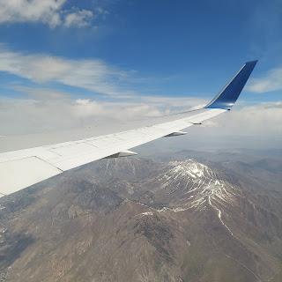

(The mountains just east of Salt Lake City)

One of my layovers was in Salt Lake City for 5 hours. I arranged for Jacob and Hannah to pick me up so that we could hang out together with little baby Jack downtown for the afternoon. We picked up some Asian Fusion lunch, found a shady spot behind the Conference Center to eat, and had a lovely picnic together.

Team work to get Jack's bib all tucked under his chin so he could drink his bottle.

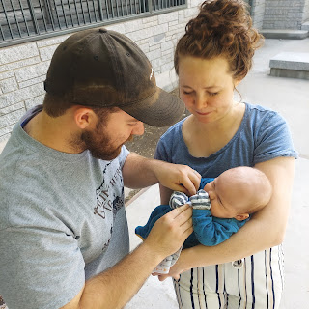

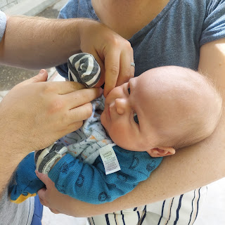

I got to be the lucky Grandma to burp him. Hannah pumped out in the car, while Jacob finished eating his lunch.

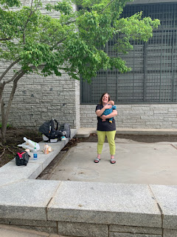

Then, we went for a walk to check out all the massive construction going on at Temple Square just around the corner. It is unbelievable how in depth the work is! They are trying to update the Temple in a major way, since it was built in the late 1800's. The renovation is expected to take about 5 years!!

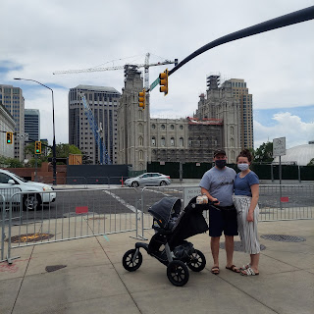

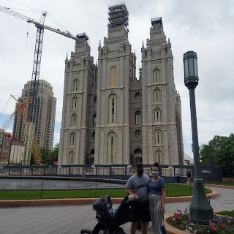

Through a plastic viewing window, we were able to see the progress being made. One of the things they are doing is to make it earthquake-proof by essentially adding shocks to the structure. An engineering miracle it will be!

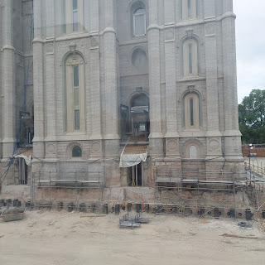

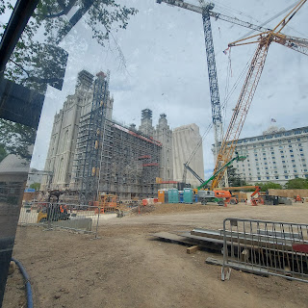

Jack enjoyed the blooming flowers. Sort of . . . he mostly just slept. :)

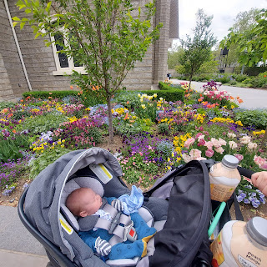

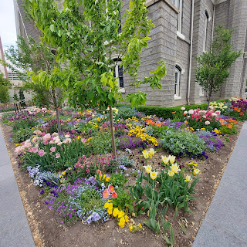

After our stroll, I hopped on my last flight from SLC up to Idaho Falls, where Scott was there to pick me up!

I had mixed feelings upon arriving home. There were remnants everywhere of grandchildren and my wonderful daughter, Amber. But the house is also strangely empty in décor, especially on the walls! I made room for all of Amber's creativity this past year by tucking a lot of my things away, and then she took all of her artwork with her to Louisiana. So now I need to figure out how to redecorate my house again.

I miss those 3 girls. I even cried a little last night. But overall, I know that their happiness to be all together as a family is the best thing of all. And I am super excited to be empty nesters with my husband once again. We haven't had the house to ourselves for almost 2 years now.

We have so many plans to begin on!! First I want to clean my house and spruce it up. Then we are going to prepare to re-do our kitchen countertops. I want to dig into family history again - in a BIG WAY. And I want to make more quilts. :) And it's also yard work season . . .

AND . . . I'll be starting a new job soon - just 2 days a week. A friend of our family owns Miracle Ear in Idaho Falls and Rexburg. They need some front desk help on Tuesdays and Fridays to answer phones and schedule appointments. They know that I have a busy few months coming up, and they are willing to work with my crazy life, so that's nice! I'm looking forward to having a little extra spending money, too. They sought me out and want me to start whenever I'm ready. I think I'll begin next week after I get my house in order somewhat.

Before I finish up, here are some pics and clips of Jack. Because he's worth everyone's time. :)

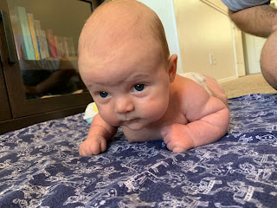

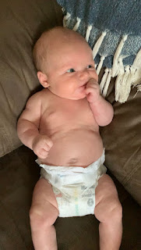

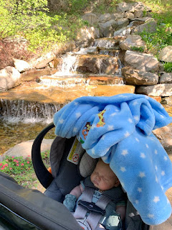

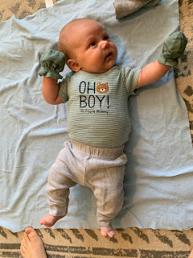

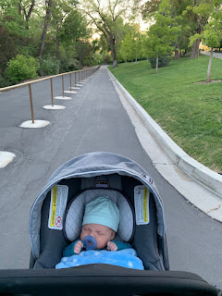

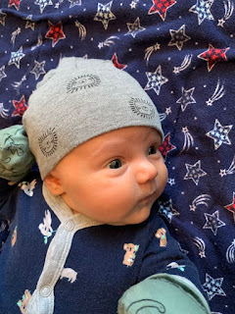

Video of him peeping: (11 seconds)
https://photos.app.goo.gl/5Wsp8cfFTKx5gQo69

Video of him very wide awake: (15 seconds)
https://photos.app.goo.gl/zxgKp55TH682yp4u7

(I'm not sure what the background sound is, but it might be Hannah pumping . . . LOL)

