100 Years, 245 Years - and Counting
Last week my blog was so full of our travels that I neglected to mention a very historic milestone in our family: Grandma Doris turned 100 years old!!!!!! Her birthday was on Saturday, June 26th and those in the family who could be in attendance made it a very special day for her.
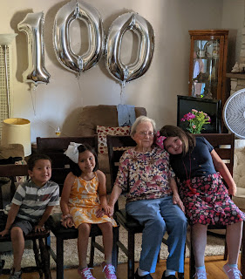

Above:
Grandma Doris is flanked by her great grandchildren Blake, Lily, and Emily (children of my brother Ryan Snider).

Below:
My brother Ryan is hugging Grandma. Such a sweet photo!!

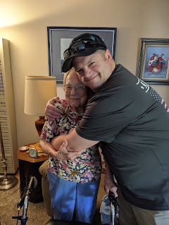

They had quite the catered feast for her birthday lunch! It included: Tuna poke' appetizer, Caesar salad, green goddess salad, grilled shrimp/grilled chicken with taco fixings on the side, and pizzas (fungi forage, pepperoni, 3 pigs and cheese).

In addition, family members provided homemade lemon cheesecake, watermelon & other fruits, apple pie, and bubbly for a toast. Below, my mom is helping Grandma choose what to eat. What a feast!!

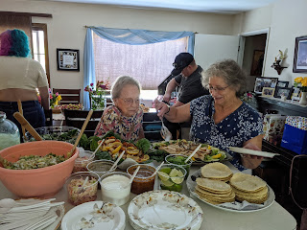

Grandma Doris and her only daughter, my mother, Linda

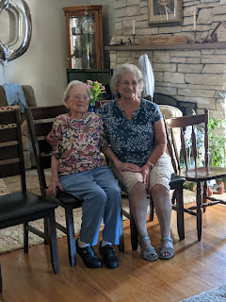

Here they are looking at some of the many birthday cards together.

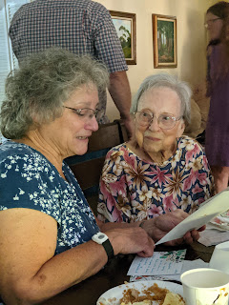

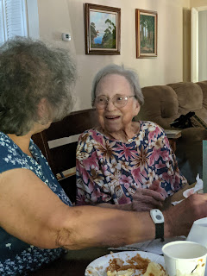

Grandma always takes her time to read (and later to re-read) written notes and letters from friends and family. She definitely cherishes any written words, and I think it helps her to remember details and important information better. My mom took great care to choose and lay out photo albums from Grandma's life and her travels for the company to peruse. I hear that Grandma really loved reminiscing as she looked through them.

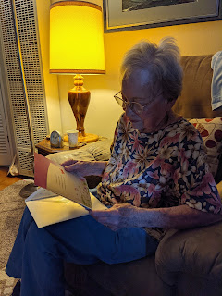

Here is the entire group that attended the birthday party: (minus Mari & Ana Fernandez who were there, but not included in this photo)

Back row: Cindy Norman, Rick Norman, Lynette Bower, Zina Bower, Nick Bower, and Karen Snider
Middle row: Ryan Snider, Charmaine Snider, Grandma Doris Day, Linda Snider Dake, Lela Norman
Front row: Lily Snider, Blake Snider, and Emily Snider

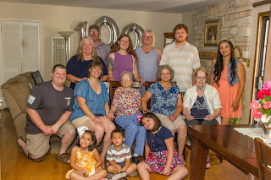

What a special milestone for Grandma!! Our son, Jacob, has been her #1 cheerleader for the past few years, encouraging her to make it to 100 and to achieve something that no one else in our family has every achieved thus far. Well, she did it! I know through my mom's updates that Grandma really enjoyed the love and attention that she received for her birthday and that this will be a memorable day for her into the eternities.

As for our past week . . .

Monday:
We flew all the way home from Washington DC and made it home late Monday night. Even though we are fully vaccinated, the airports still require everyone to wear a mask for the entire time you are there (and on the plane). I'm sure it would be way too difficult for the staff to police who has been vaccinated and who has not.

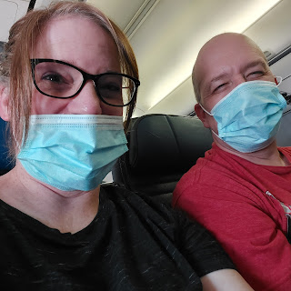

I love having TSA pre-check. ($80 for 5 years) I don't have to take off my shoes going through security, I don't have to remove my laptop - or anything - from my backpack, and the line looks like this pretty much everywhere I go. :)

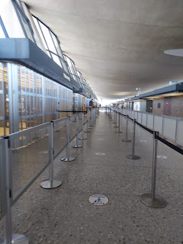

As much as we miss all the fun on the east coast, it was sure nice to come home to Idaho.

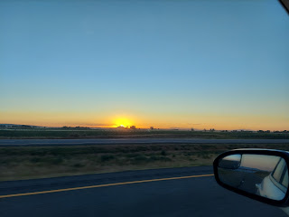

We received this precious and hilarious picture of Gwen during one of our vacation days on the east coast. Amber shared that the girls have been doing swimming lessons lately, and sometimes they get water in/on themselves in unexpected ways.

Amber wrote in our family group text: "They're learning to kick and put their faces under the water. Abby snorts water once per lesson. Gwen randomly trips and goes fully under the water once per lesson."

And in this photo below (that is now our family meme), she writes: "Gwen, sulking after she accidentally dunked herself."

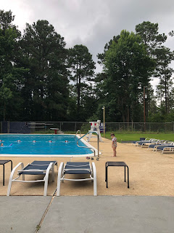

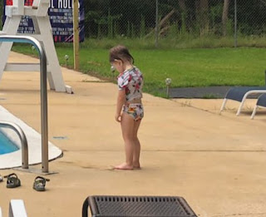

Now, whenever we feel deflated or depressed about an upcoming meeting, a chore we don't want to do, etc., we do the Gwen pose. We sure love that girl! She is as spunky and spicy and fun as they come! :)

Amber also shared the highlights of one of Gwen's recent prayers:
Help daddy at school
Help Abby be smart
Help mommy to eat
Help me not to cry
Please make me breakfast
In the name of Jesus Christ, amen.

Amber has had some internal issues as of late and just got the results back from her EverlyWell food sensitivity test. She has high reactivity to cow's milk, and moderate reactivity to egg whites. She also reported a mild reactivity to several other foods, including chicken, egg yolk, lobster, prawn, rye, wheat, eggplant, etc. She basically has to be careful with anything that has the word egg in it, ha ha. She's already eliminated dairy and a few other things from her diet, trying to see if her headaches, fatigue, sore joints, dizziness and digestive issues will calm down. Then she will carefully reintroduce a few foods, one at a time, to see how her body reacts. There are a few that she really wants to be able to handle, such as wheat, gluten and yogurt. Allergies to foods are sprinkled throughout my family, more on my side than Scott's. But I'm sorry that Amber is struggling and hasn't been feeling well. I hope things improve soon!

Amber also shared this cute picture of Abby - they put together a Tomte to guard their home, as part of an educational kit that Abby gets monthly. She got an Atlas crate with activities and has been learning about the country of Sweden for June. It's all through a cute company called KiwiCo that they've been using for a couple years now.

Here's the link:
https://www.kiwico.com/atlas

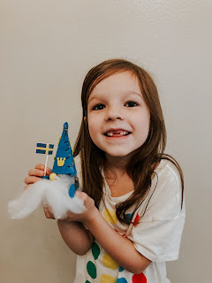

Tuesday:
We woke up to this. A very empty fridge because we got in so late after being gone for 2 1/2 weeks.

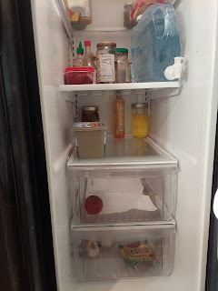

We made a very long list of chores to get caught up on around the house and yard, including getting some groceries, and then we got to work!

I also talked to Kylie in Italy, helping her figure out a few specifics for getting her Visa taken care of when she comes later this month for a visit. There are SO many details to navigate through, neither of us has any experience with Visas, and it's hard to make phone calls from Italy to the U.S. for any additional clarification. So I helped her out some, and now we think she's all set to get it taken care of efficiently while she's here. Yay!

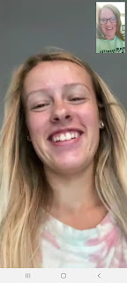

She goes in to get an ultrasound this week - which will also provide a spoiler opportunity on learning their baby's gender. Next month is when we all get to find out the gender - when everyone can be in one place all together here in Idaho Falls. I'm leaning towards them having a little boy . . . :)

Also, our microwave died! Scott went to make some popcorn in the microwave, and 4 minutes in, nothing had happened and the popcorn was still cold. He dismantled it and we found some lovely old green wallpaper behind it - the same green wallpaper that we removed throughout the rest of the kitchen several years ago, but the microwave was hiding this little remnant, ha ha.

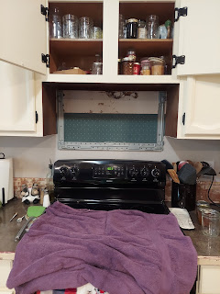

After quite a bit of research, Scott found the best deal at Lowe's on the
last day
of a huge sale. He even tried Facebook Marketplace but didn't see anything he liked.

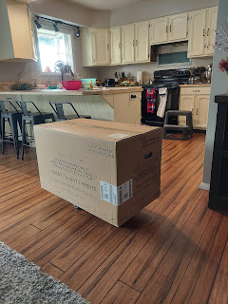

And voila! Here's the new microwave! I love it! It's very powerful and cooks popcorn much faster than our old one. So that's nice.

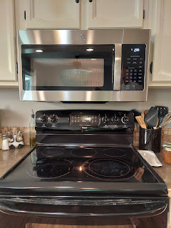

Wednesday:
Amber sent these adorable photos of the girls. She said that these are some very personality-appropriate pictures to add to the ward directory on LDS Tools.

Abby -
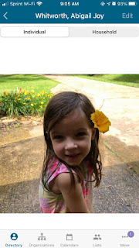

And Gwen -

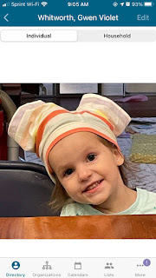

I spent a good portion of the day organizing the rooms downstairs, including the girls' old room. Scott set up the old bunkbed, but in a new location. I turned the previous bed area into a little play area instead.

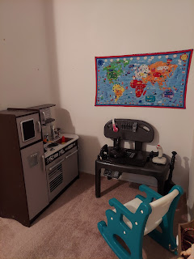

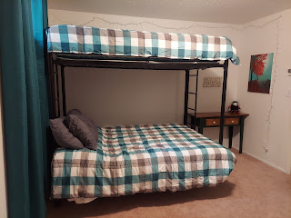

Thursday:
More cleaning and rearranging, pulling weeds, etc. Our neighbors came over with their family to pick all of our ripened strawberries, which saved me from having to add that to my ever-growing to-do list. I chose to bake the next round of monthly cupcakes in the evening, so that the house had time to cool off overnight.

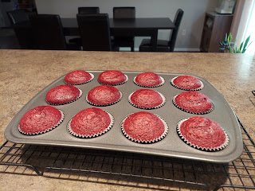

Later that evening, Scott and I tried out different combinations of mattresses and memory foam mattress toppers together for the upstairs guest room. Sort of like Goldilocks and the Three Bears. We finally settled on this arrangement, and then because it was so late, I decided to wait until the next morning to clean up our mess. :)

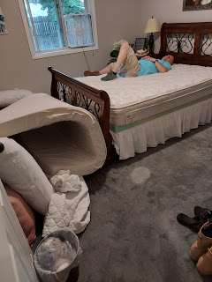

We also got to enjoy our first night of seeing the new 4th of July decorations that we hung up earlier in the day. The neighbors told us how much they loved seeing our new flag display hanging on the brick wall of our porch, too. I had ordered it last summer, but didn't get to use it until now.

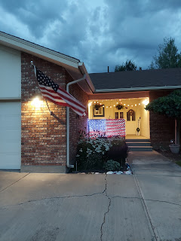

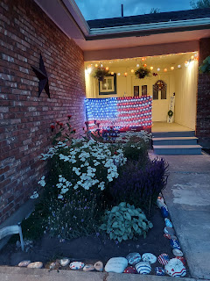

Friday:
I worked on decorating the cupcakes for evening deliveries.

Using red melting wafers, I dipped marshmallows to look like firecrackers.

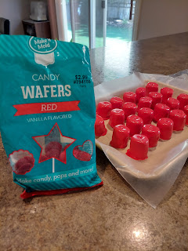

The website I was using suggested to use a toothpick and a spoon to coat the marshmallows. That technique worked really well.

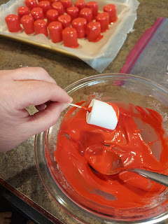

Scott cut up some black licorice Nibs so I could insert them into the dipped marshmallows to look like a wick.

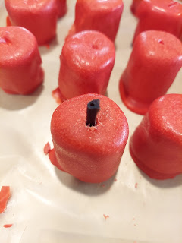

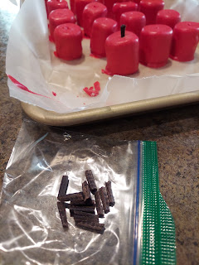

The red velvet cupcakes were frosted, sprinkled, and made ready for the firecracker toppers.

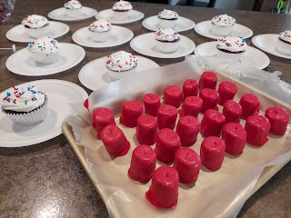

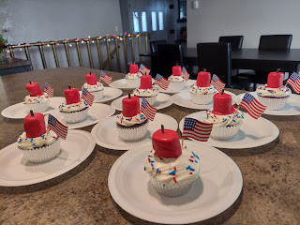

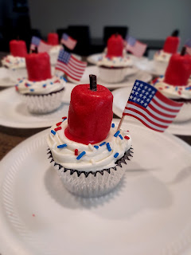

Here's the website I used:
https://www.ohnuts.com/blog/firecracker-cupcakes-for-the-fourth-of-july/

I was also keeping tabs on my sister Charmaine and (her significant other) Scott's progress from CA to Idaho in his own personal plane. They made excellent time and landed a little early in Rigby, Idaho at a small airport, mostly used by crop-dusters.

We hurried up to Rigby and got to the airport just in time to see them land.

Click here to watch the landing: (1 minute)
https://photos.app.goo.gl/v3proSJZVEfGKijv5

After we checked in at the airport office and got instructions on where to tie down, Scott taxied his plane over to the south end of the airport, where my Scott and I were waiting with our air-conditioned car.

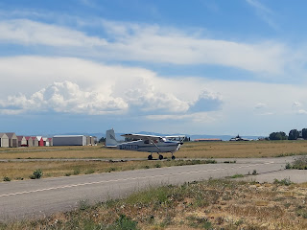

Yes, his plane does have A/C, but we were all hot from hanging out on the tarmac in 90-something degree heat. The plane is small enough that he can just push it and man-handle it into the parking spot. My Scott helped him a little bit, too. (My Scott is in the yellow shirt, Scott Perkins is in the blue shirt)

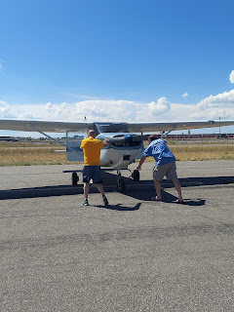

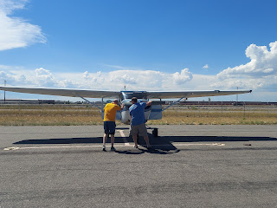

All was soon tied down, so we collected their luggage and left the airport.

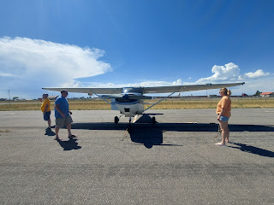

We stopped off to say hello to Scott's parents, since their house was just 5 minutes away in Rigby. We stayed for just a short visit, before heading to Idaho Falls to settle in.

I'm so glad they made it safely! They had to maneuver around some stormy pockets of weather that they could see on their radar, as well as a fire near Twin Falls, Idaho. I learned that whatever the driving time is for a car, you can pretty much chop that in half for how long it would take in a small airplane. In this case, it's about a 13-14 hour drive from Ukiah, CA to Idaho Falls, ID, but they made it in just over 6 hours. That included a refuel stop in Battle Mountain, Nevada. Charmaine told me it takes about 20 minutes to descend, 20 minutes to refuel, and then 20 minutes to get back up to altitude.

They enjoyed seeing the greenery of Idaho after all the brown that Nevada had to offer.

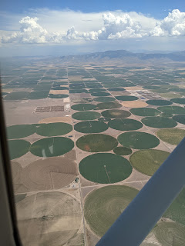

Saturday:
We got up early to head to the local Independence Day Parade by 9:00 a.m. We haven't gone in a few years, having gone religiously every year when our kids were growing up. It didn't disappoint - especially after there were no festivities for the 4th of July in 2020. We found a great spot under the shade of a huge oak tree, and had a great time together!!

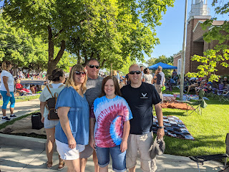

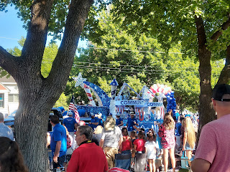

Our very own Idaho Governor, Brad Little, came over from Boise to be the Grand Marshall of our parade! He's in the backseat of this cute old car, wearing a hat.

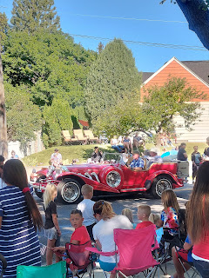

Idahoan Potato added an interesting float . . . and some of their employees were handing out (and even flinging out) packets of instant potato mixes to the crowd of onlookers!! LOL

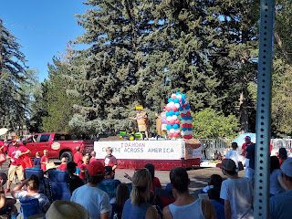

And we learned something new and exciting! There is a new naval submarine, named the USS Idaho, due to be commissioned in 2023. We got to meet the crew that will be running the sub! Scott looked up some additional info on his phone while we were at the parade, and learned that this new submarine has the potential to stay submerged underwater for 3 months!! Holy Cow!!

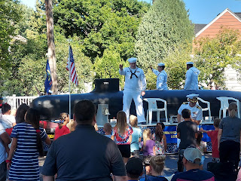

Near the end of the 90 minute parade, local fire trucks came through and sprayed water on the crowds. While the elderly and babies might not have enjoyed it very much, the children and teenagers loved it! The temperatures were quite warm, so I bet it felt good. You did have plenty of warning though, because you could see what was happening to the people to your right way down the street. And if you didn't want to get soaked, you could hurry and pack up your chairs and get out of the way, ha ha.

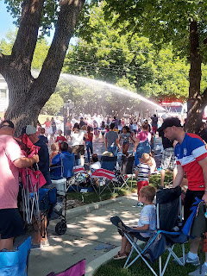

I took a couple videos of the fun with the fire trucks.

Video #1: (21 seconds) (*You can hear Charmaine saying OH MY GOSH, and Scott cracking up)
https://photos.app.goo.gl/yQGZS1WCxDzRivcdA

Video #2: (16 seconds)
https://photos.app.goo.gl/ZpTRPakRxbttEWM68

After the parade, we came home and had some lunch. I took Charmaine and Scott out on a joy ride around town, while my Scott took a little afternoon nap.

Around 4:00, we had Phil and Coy over for dinner, eating grilled bruschetta chicken, cole slaw, potato salad, corn salad, fresh fruit, and corn on the cob. It was lovely to visit with all of us together, and for them to get to know my sister and her Scott better.

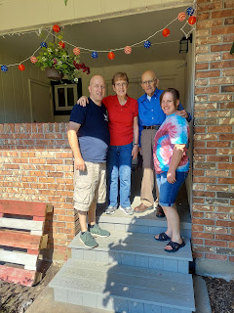

Once dinner was all cleaned up, we put our feet up in the cooler temps of the family room downstairs to watch a little TV and just relax for a bit. Eventually, we got ourselves out the door to find a spot for viewing the fireworks. Known as the "Greatest Fireworks Show West of the Mississippi", our expectations were high for what we were about to take part in. It turned out to be every bit amazing!!

We found our new favorite spot along the Snake River for viewing. Even as I type this, I hope I'm not giving our secret spot away . . . but basically we were directly across the river from the launching pad!!

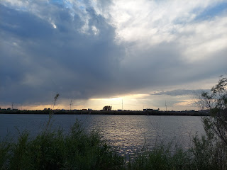

We got there early enough to get a great spot and even go for a nice walk while we waited.

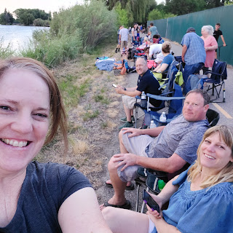

Eventually the sun began to set and we enjoyed the beautiful views.

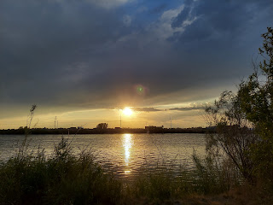

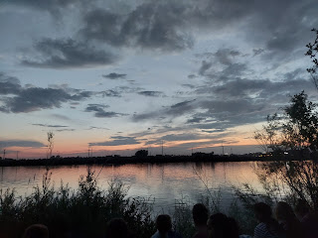

A local businessman, Frank Vandersloot, started a wellness company, called Melaleuca, several years ago. It's an international company that sells things like essential oils, shampoo, soaps, vitamins and supplements, and even household cleaning products that are made with natural ingredients. He is a multi-millionaire and loves to be generous and give back to the community. The biggest thing he does every year is to put on the Melaleuca Freedom Celebration - which includes the huge fireworks show. I've seen in recent years that shell-for-shell, our fireworks show uses more shells than what they use in the Boston Harbor!! That's pretty amazing.

You can read more here about how cool Idaho Falls is for 4th of July festivities:
https://www.eastidahonews.com/2021/06/preparations-underway-for-largest-melaleuca-freedom-celebration-in-history-featuring-fireworks-made-in-the-usa/

Here are some of the highlights from our incredible vantage point last night.

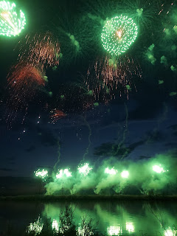

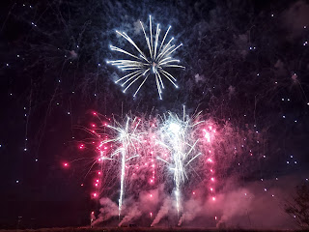

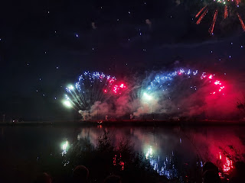

And yes, there was a brief little fire on the banks of the river across from us, but the fire department quickly arrived on the scene and effectively distinguished the flames.



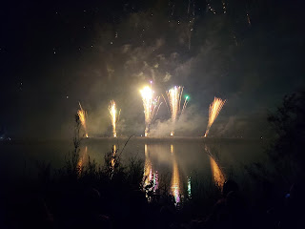



Here are a couple of my favorite videos that I took:

Video #1: (11 seconds)
https://photos.app.goo.gl/4EJgtUGXE9mEQL8f8

Video #2: (20 seconds)
https://photos.app.goo.gl/oHsexhnenD7vdvkG7

Video #3: (16 seconds)
https://photos.app.goo.gl/wbS2hY86eA6HXGBz5

Video #4: (24 seconds)
https://photos.app.goo.gl/BUogg2r2MM98x26u8

Video #5: (10 seconds) A portion of the Grand Finale
https://photos.app.goo.gl/HevGX2gheN8BGLPC6

All in all, the entire show lasted close to 40 minutes long! The only disappointing thing was that we didn't have access to the musical program that is always synchronized with the fireworks!! Nobody around us had a radio either. I guess radios are a thing of the past . . . we couldn't get the radio app to work on our phones either because the bandwidth was so overloaded from the crowds of people in the area using their cellphones. But WOW. What an amazing show!!

It was a little confusing trying to get home from where we parked, with the first responders directing traffic and making some streets into a one-way to better allocate the traffic jams. But I think we got home in roughly 30 minutes, even though we were only about 4 miles from our house.

What made the fireworks show extra special, is that my sister Charmaine and her man Scott have been setting up pyrotechnics for fireworks shows around CA for about 10 years now, in places like Edwards AFB and Bakersfield. Scott has a background as a firefighter, an arson investigator, and now works as a consultant down in San Diego advising power companies how to avoid starting accidental fires from the power lines or grids.

Scott and Charmaine thoroughly enjoyed the Melaleuca Freedom Celebration last night - and I heard Scott say as we were packing up our camp chairs, "That is THE best fireworks show I have EVER seen!"

Sunday:
Happy 245th Birthday America! I love our great country and the freedoms that we enjoy! I love being able to be me, to be with my family, to be comfortable and have opportunities to be happy, and I love our amazing military with all its servicemembers past, present, and future! I love the United States of America and I hope we continue to learn how to live better, love better, and take care of each other better. God Bless the USA!!

And the United States is a much better place now that we have Jack in it. 💗

