The View From the Hill Looks Great
It's official! It happened. I'm 50 years old now, and officially Over the Hill.
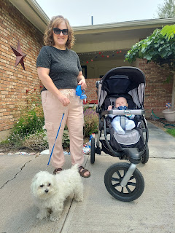
(Photo above is me as I'm getting ready to take a borrowed grandson - Jack - and a borrowed doggy, Sophie, on a neighborhood stroll)
I can honestly say that I feel more comfortable in my 50 year old mind and body, than I have in earlier decades. Though I am still working on several things as far as mindset and attitude go, I feel like I have come a long way in who I ultimately want to become. My capacity to love unconditionally is more natural and authentic than what it was in past decades, and my ability to sincerely listen has improved substantially as well. I am an earnest student of listening to the Holy Ghost, which has helped me to become better than what I would have been otherwise. The Holy Ghost teaches me what to do in every situation and circumstance that I am in: He prompts me to reach out to someone in need, which allows me to become less self-centered; He gives me a nudge to be more humble, more charitable, and more repentant on a regular basis, which reminds me that I am nothing without Jesus Christ and my Heavenly Parents; and He ministers to me by comforting me when I am feeling down or forgotten, which in turn shows me a loving example of how to then minister to others.
I love this journey that I'm on. And I love the people that are in my family and in my circle of friends. Without them, life would most certainly be miserable and sad.
Monday:
Jack figured out how to giggle!! First, it happened with Jacob after church last Sunday. Jacob was changing his diaper and coughed at one point. Jack thought it was absolutely hilarious! I couldn't get a good video then, but I was able to get a little snippet the following day. I have to be sneaky so he doesn't see me with my phone to record him, otherwise he just gets distracted and forgets what he was doing, ha ha.
Video of Hannah helping Jack to giggle about giggling: (22 seconds)
https://photos.app.goo.gl/WyMcXnwEKs72PQWZ8
I "house-sat" for Amber's friend, Lyndsey, for a couple of hours. She had to work all day, but had also just moved into a new apartment and the internet company was scheduled to come hook up their internet. My job was simply to just be there between 10 a.m. and noon, for whenever the technician arrived. I brought my nail polish supplies and painted my toenails while I waited. Then, while they dried, I watched a few YouTube videos of Strasbourg, France as part of the planning for my trip next month. It was a very relaxing couple of hours! Sigh, I wish all acts of service could be so relaxing . . .
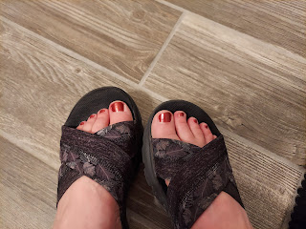
For dinner that night, Jacob made homemade tortillas for our pork tacos. I had never seen this method of prepping the tortilla dough, so I recorded what he was doing.
Pressing the tortillas first, then rolling them out (19 seconds)
https://photos.app.goo.gl/ANptGL4k2fKE8H3G8
The pork tacos were amazing, by the way! :)
Tuesday:
I took Scott to work early in the morning so I could have the car for the day (we loaned the truck to Kylie for a couple of days). The sun was bright red from all the smoke moseying up to Eastern Idaho from the fires in Northern CA.
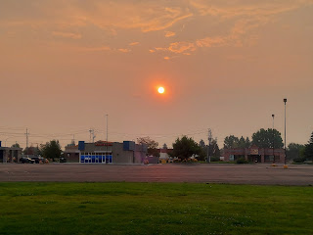

Our young women class activity for the week was to go on a picnic together at Freeman Park. I had the girls place their fast food order ahead of time so I could just run and pick everything up (to save time and not cut into precious time during the activity itself). Their food choices were: Panda Express or Wendy's. Most of them chose Panda and were super excited about it!

We met at my house, along with two other adult drivers, and then we all drove to the Park together. We ate lunch and played a couple rounds of Twister, before going on an explore to the creek area nearby.

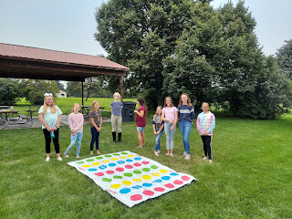

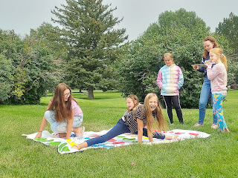

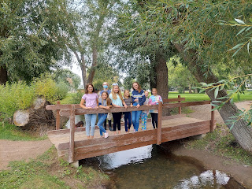

One girl came very prepared with galoshes, which allowed her to wade across the creek very efficiently!

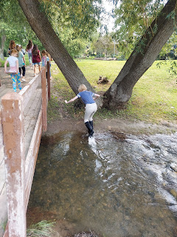

And right as it was time to pack up and head home, one of the girls got all tangled up - literally - in the rope of a tree swing. The girls had been spinning her around and around, and while her hair was flying out into the air, amid all the laughter and fun, it began to get entangled with the rope. (The swing consisted of a rope with a circular seat at the base, meant more for spinning than for swinging) It took some serious detangling skills from our young women's president to get her out of that gnarly mess!! Soon all was well, and we dropped the girls off happily at their homes.

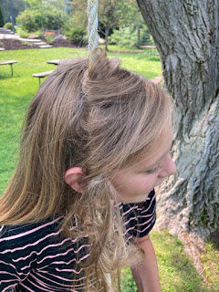

Later that evening, Sophie arrived again for a few days to spend with us. Her owners had to drive up to Washington for a family funeral. We are always happy to take her in with us. :)



Wednesday:
During one of Jacob's work breaks, he brought Jack upstairs to play and hang out for a bit. Jack has been learning how to roll from his back to his tummy, but he hasn't quite figured out how to roll from tummy to back yet. Usually it's the opposite, I think. Ha ha When his parents lay him down on his back for a nap or bedtime lately, he usually rolls onto his tummy to sleep. Tummy sleeping is pretty comfy.

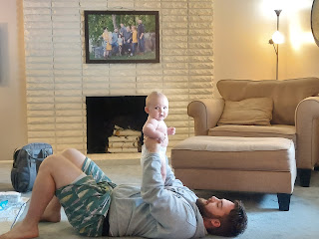

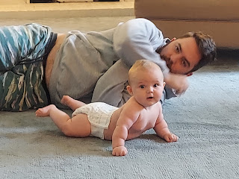

Jacob is helping him to practice rolling from tummy to back.

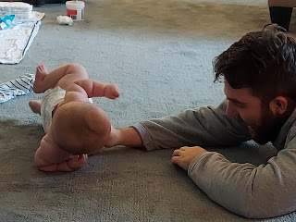

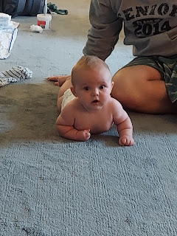

Later in the afternoon, we just hung out on the back patio. Good times. :)

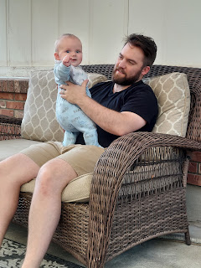

I've been doing a great deal of research for my trip coming up. This is a map of all of the small towns I have found that our Schnapp/Schnepp family used to live in near Strasbourg, France. They lived there in the late 1600's and early 1700's before they immigrated to Philadelphia and then, soon after, settled in the Shenandoah Valley of Virginia, USA. I need to do a bit more research to narrow down which of those tiny towns I should make the effort to visit, since I won't have time to see them
all
.

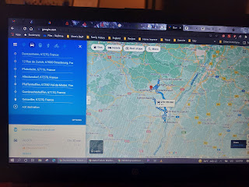

Scott also started school! On this first day back, it was just the freshmen who were in attendance. That way, they had a day to get acclimated by themselves without so many other students there at the same time. Scott reported at dinner time that it was a great day and he was very happy to be back in the classroom with his students again.

Thursday:
I went shopping in the morning to find a new white temple dress. I had success at Deseret Book across town!! I found this beautiful and comfy dress - in a petite size, so it didn't need any hemming - for only $43. Perfect! The reason that I needed a new dress is because my previous one, that I've had for several years, has a lengthy zipper in the back, and it's just getting too hard to get it zipped up by myself. I don't want to throw my shoulder out from trying to zip up in the temple, ha ha. New Dress = NO ZIPPER!!



Later that afternoon, Jacob and Hannah drove me across town to the temple and dropped me off. Our friends, the Beutlers, invited us to join them for a session with their son, Nathan, who will be heading out on a mission very soon. Scott wasn't able to come, since the time of the assigned session was before he gets done with school, so I went by myself.

I rode in the back seat with Jack. He was sleepy, and very, very stoic. :)



Views of the temple as I went in.



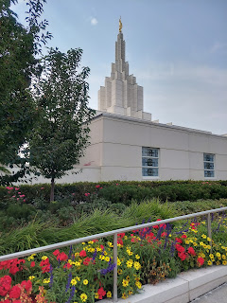

Views of the temple as I came out.

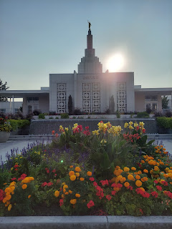

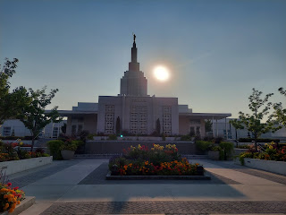

It was beautiful in every regard. I sat with some dear friends of mine, it was peaceful and comforting to be in the session, and it was so special to see Nathan with his parents in the Celestial Room of the temple, hugging and feeling so incredibly happy to be together. He will make a wonderful missionary.

Friday:
Happy 50th Birthday to me!! I got up early so I could go to the DMV and get my new Star Card driver's license. I had been talking to Jacob the night before, and something he said made me realize all of a sudden that my license would be expiring the next day! Yikes!

It was a pretty un-stressful trip to the DMV, for once, ha ha. I walked in, took a number, sat down to read my book until it was my turn, and then 45 minutes later I was walking out to the car with my new temporary license in hand.

Here I am, waiting for my turn to be called.

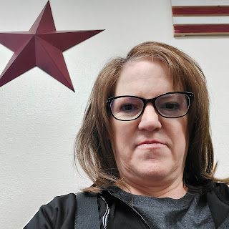

I loved the signs hanging by the clerk's desk when I went back to take care of my paperwork. The first one is pretty easy to read, but the second one - not so much. I will help you - - -

It says: Everyone brings joy to this office . . . Some when they enter, others when they leave.

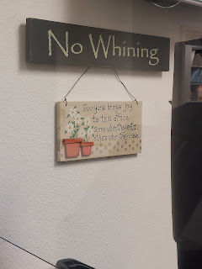

I received a multitude of gifts, cards in the mail, phone calls, drop-bys, and well wishes all day long. I don't think I've ever been so spoiled, ha ha. My dad and step-mom, Michelle, even sent me this beautiful floral arrangement, that now sits happily on my kitchen table.

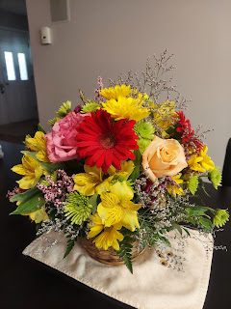

And my mom sent me a list of 50 things she loves about me! WOW!! :)

One of the young women in my class, along with her mother who is the young women's president, brought me a cupcake and sang me 2 versions of Happy Birthday at the front door! They thought it was only fitting to bring me a cupcake, since I bring them a cupcake every month. :)

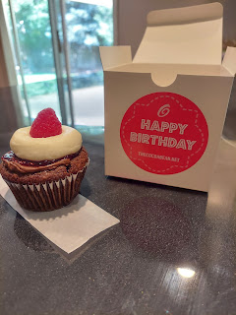

For dinner, the five of us walked to a nearby restaurant, Dixie's Diner. Hannah and Jacob had a good time chatting together in front of us, while I was happier than a camel on hump day
to just be walking along holding Scott's hand. :)

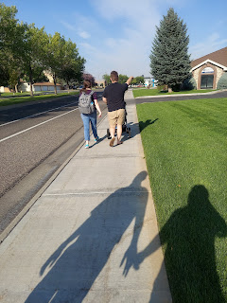

Jack seemed extraordinarily short at the dinner table. Or is it just me?

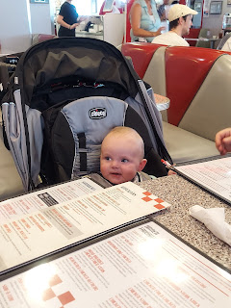

After we ate our yummy food, Jack had fun playing peek-a-boo with his momma.

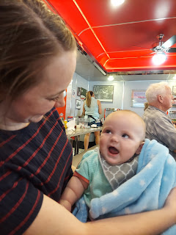

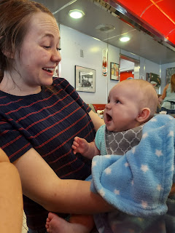

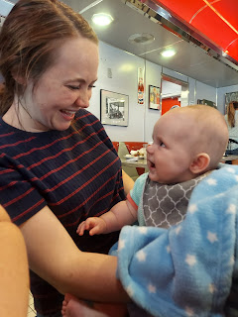

Click to watch him in action playing peek-a-boo: (10 seconds)
https://photos.app.goo.gl/6FcurerxXDREfV638

Jacob had baked something delicious while I was at the temple the day before, but when I got home and noted how amazing the house smelled, there was no trace of what had been baked!! Apparently it was a surprise for my birthday, ha ha.

Turns out he made several homemade ice cream cookie sandwiches! He baked a giant cookie sheet sized cookie, then added ice cream (my favorite is Death by Chocolate, but he also made some with a vanilla variety). He cut it all up into small portions and wrapped each one in freezer paper.

It was very fun! Tasty and crunchy on the outside, and verrry sweet. I couldn't eat my entire portion in one sitting . . . but it was just as tasty the next day when I polished the rest off. What a nice son to make a birthday dessert for me! :)

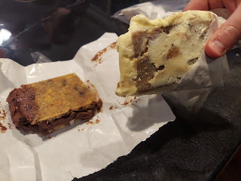

Saturday:
Benson and Kylie arrived to hang out with us for the day. Yay!! Jacob went all out by making homemade wings to feed his brother Benson (and the rest of us as well). He knew that Benson loves chicken wings, so he got several types of hot sauce and made some additional sauces from scratch so that we could have varying degrees of flavor and spiciness. They were all fantastic!! Sauces included: Parmesan Garlic, Lemon Pepper, Louisiana Hot Sauce, Marie Sharp's Habanero Sauce, and Secret Aardvark Habanero Sauce.

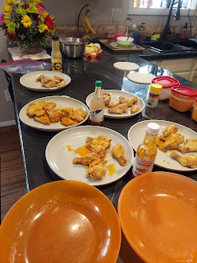



He put several at a time on separate plates, adjacent to its matching bottle of sauce so we could identify each classification before choosing as wisely as possible. I VERY bravely chose to go in reverse this time: hottest to mildest. They were all fantastic! The spice factor was definitely toned down by the fact that it was mixed in with melted butter, and trust me, it helped! The only one that made me cough for a second and grab my cup of milk was the Secret Aardvark chicken wing. Jacob was visibly proud of me. :)

After our tummies were sufficiently full, and after we plated a round of Exploding Kittens (a card game), we loaded up and drove up to Green Canyon Hot Springs for some swimming fun. There were several issues on the drive up that slowed us down to the point that it took us twice as long to get there than it should have. A road closure on Hwy 20 rerouted us to Ririe, and then back to Hwy 20 near Rexburg. Then, there was a series of construction stops between Rexburg and Green Canyon. Scott and I sat in the truck waiting at the front of the lineup for 20 minutes in one spot, and another 15 minutes or more in the second spot. Meanwhile, the kids - who were all in the other car together - took a backroad route (that involved a gravel road, ha ha) and beat us there by about 30 minutes. Punks. J/K

All of our grudges were forgotten by the time we got in the nice warm water. We hung out together for about 2 hours, just talking and visiting while we relaxed in either the indoor pool or the outdoor pool.

Hannah and Jack

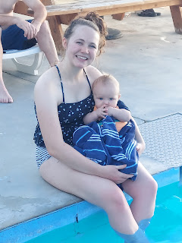

The outdoor hot tub pool - L to R: Kylie sitting on the edge, Benson, Jacob and Hannah. Scott was there too, but was not in this photo.

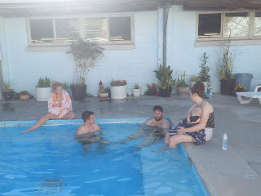

Soon, it was time to get dressed and head back to Idaho Falls.

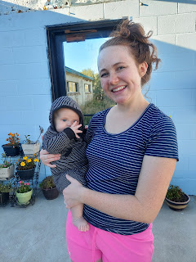



We got all cleaned up and headed out to a couple of wedding receptions for some friends in the ward. Benson did not bring anything fancy to wear when he came up for the weekend, because he didn't know about the plan to go reception hopping. To be honest, I didn't think he would want to go! But he did, and that made my heart happy. There are so many people that love and miss that kid, and there's just not enough time in these very short weekends to see all of the people. Going to a wedding reception or two meant that lots of people could hug him in each convenient location at a time.

This is our former Bishop, and still our friend and neighbor, Erik Larsen.

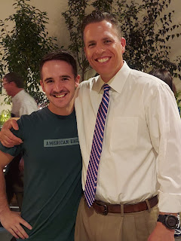

Benson's friend that he grew up with, Tanner Cunningham

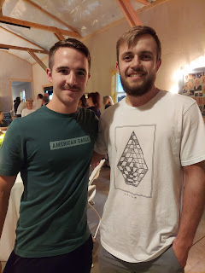

And here's Benson's former Sunday School teacher, Larkin Beauchaut (pronounced Bo-shay) - who ALWAYS asks about Benson every time I see him. Larkin was so happy to see him - almost as happy as watching his daughter get married that same day, ha ha.

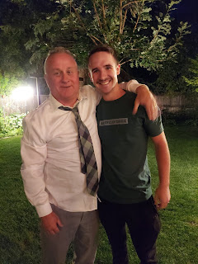

It was a great night! And a fun double date. Scott and I drove in the car, while Benson and Kylie met us there in the truck. We caravanned over to the second reception before parting ways for the evening around 9:30 p.m.

I'm so glad the kids got to ride in the car together to Green Canyon, and spend that time talking and laughing. I'm so glad that we get to see Benson and Kylie during the time that they are here in the U.S. Each time they walk through the front door, it's just magical. I love it. I love my kids so much and it's been so wonderful to have them in the area for these past few weeks.

Sunday:
Today was a mixed feelings day. Church was outstanding - the talks were all so amazing and I took a lot of notes. But lurking in the background was the knowledge that after church, our kids would be leaving us. (sniff sniff)

Benson and Kylie graciously agreed to take Jacob, Hannah and Jack down to Salt Lake with them, so that Scott and I wouldn't have to make an extra trip. Jacob and Hannah will now have their last few days to spend with her side of the family before they fly back to Washington DC next weekend. We will miss them a LOT! They were wonderful house guests. They cleaned up after themselves, they cooked several meals, they gave us time with JACK, and they like to play games (i.e. pickleball and a variety of card games).

Knowing that they would be leaving us, I took some precious pictures of Jack after church. But
nothing
was as cute as the photos Scott took of Jack hanging out in the office with him before church.

Before church




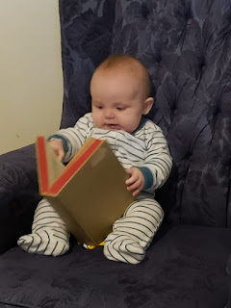

After church

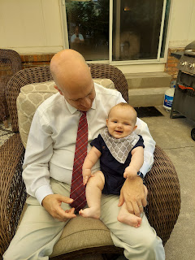

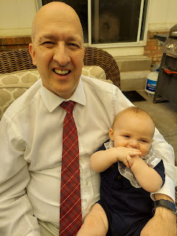

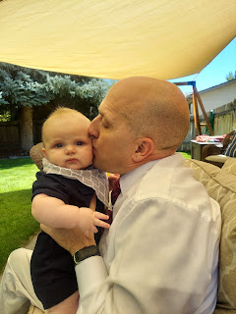

After a bottle, Jack fell asleep on my chest. Best therapy for the soul.

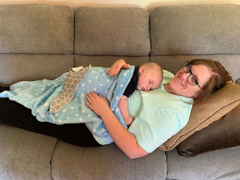

And then it was time to say goodbye . . .

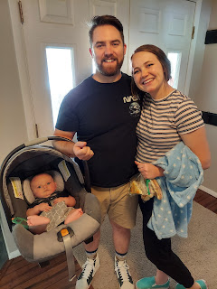

The trunk was full to the brim!!

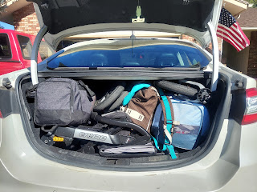

Jack, having just woken up from that comfy nap on my chest, was rudely transferred to his car seat. He didn't quite know what to think about that.

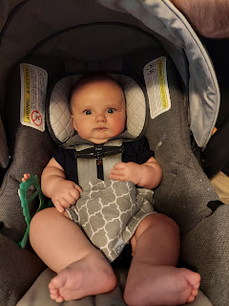

Thankfully, I will be able to see them in DC in a few weeks, just prior to when I fly over to Italy. I am holding on to that with very tight fists so I don't cry . . . as much . . .

