A Wedding, A Sharpshooter, and A Real Peach of a Guy
Holy moly! What a fantastic and memorable weekend in Denver!! Where do I even begin???
How about with this priceless moment right here.
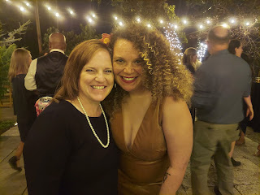

Chelsea and Garret are officially married now! Four of us flew in from 3 states and had a whirlwind of a humdinger of a fantastic time together. Scott and I came from Idaho, Amber from Louisiana, and my mom from California. Garret's parents were counting up how many states were represented at the wedding. Total: 11 states, including Massachusetts, Virginia, Pennsylvania, Louisiana, Idaho, and CA.

Here are approximately 100 photos to share. Try to keep up.

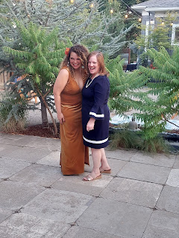

Oh Chelsea, with her luscious yet interfering hair, ha ha

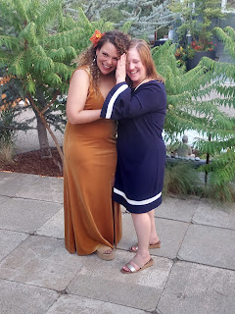

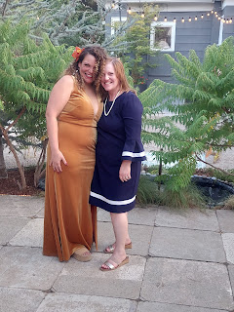

Lots and lots of emotional and tender hugs were given.

Doug (her birth father) and Chelsea

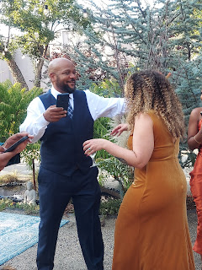

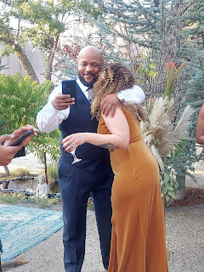

Chelsea and Amber

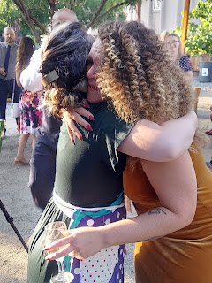

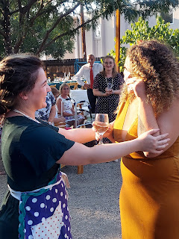

Chelsea and Grandma Linda (my mom)

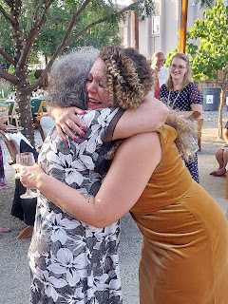

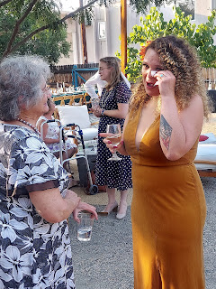

We had all met before, more than once, but it was still so special for Chelsea to see everyone she cares about all in one place - all at the same time!

Chelsea and Grandma Linda visiting during the dinner

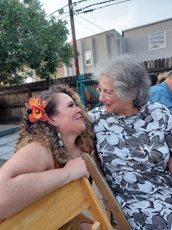

Chelsea and her mom, Paula

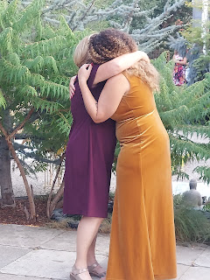

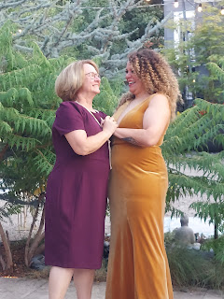

Doug and Chelsea

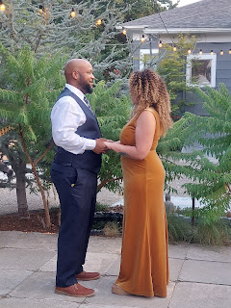

Dinner was so beautifully decorated and arranged. Fresh florals from the Garden Center where the wedding and reception were held made it oh-so-fancy.

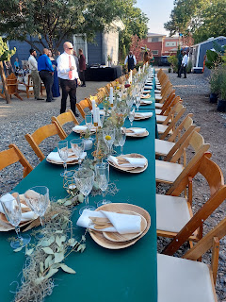

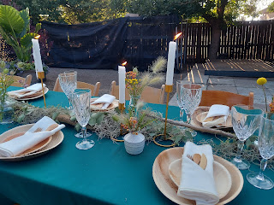

Puerto Rican food for dinner. I don't even remember all the names of the foods I chose to eat, but they were all so amazing!!

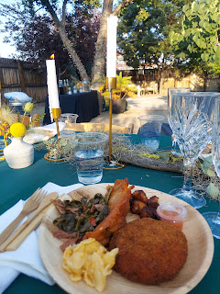

This big "patty" was a vegan alternative, but I chose it because it looked so awesome! It's made up of baked sweet potato with onions and peppers inside a fried cornmeal exterior. Delicious!

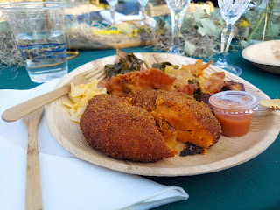

After dinner, it was time for "formal" photos. The photo session was actually supposed to take place before dinner, but everyone was really behind schedule, so after dinner it was! It worked out just great.

Here are the bride and groom with all the siblings on Chelsea's side.
From the left: Chelsea's two brothers that she grew up with (also adopted) - Kelvin and Bowen, then Chelsea and Garret, Amber, Niani (pronounced Nee-yawn-ee), Shamari, and Ashanti. The last 3 all belong to Doug. :)

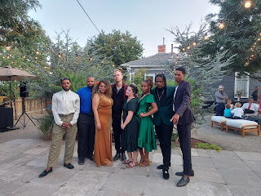

Paula (Chelsea's mom), Garret, and Chelsea

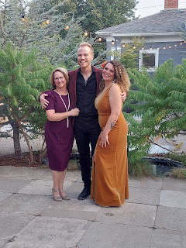

Time-out: When the photographer called for all the Jacksons to come on over for family photos, this is how they "danced" on over. SO. GREAT. They are just so much fun in everything they do!

Video of Doug's whole family sashaying over: (12 seconds)
https://photos.app.goo.gl/HQvGQALMCBHD5rsi7

Below: (L to R) Jamel (Doug's uncle?), Niani Jackson, Ashanti Jackson, Doug Jackson, Chelsea, Garret, Doug's dad (can't remember his name!), Doug's niece, Doug's nephew Clint (?), and Shamari Jackson

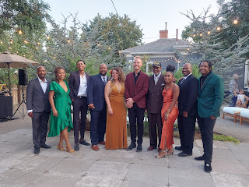

They were seriously the life of the party. Everyone single one of them was joyful, friendly, respectful, kind and fun. They all got along wonderfully, and you could just feel the love they all have for each other. That's a beautiful thing.

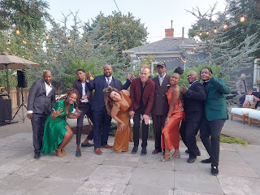

Doug, along with the googly-eyed couple

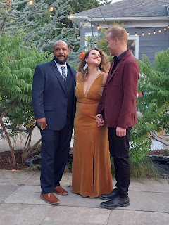

Meanwhile, Amber set up a little spot with her painting supplies so she could prepare the background on the soon-to-be "live" painting canvas. She worked HARD, like for several hours, to crank out the most beautiful gift for her half-sister, Chelsea, and for Garret.

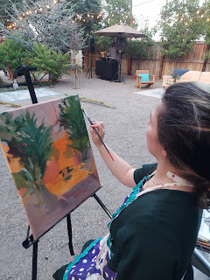

A short video of Amber, in the "zone" and painting away while background music played: (17 seconds)
https://photos.app.goo.gl/pTbmSX1G6VSVY4DP9

This was the ambiance just prior to the wedding ceremony. So beautiful and relaxed.
Video: (14 seconds)
https://photos.app.goo.gl/qomDcCPzS3sZYDAs5

Soon, the ceremony began. Bill, best friend of the bride and groom, officiated. He did a wonderful job, taking it very seriously and giving a very heartfelt speech before marrying them.

Chelsea's two brothers walked her down the aisle in a very festive way: (29 seconds)
https://photos.app.goo.gl/ZWyZQrJEDyEeFN777

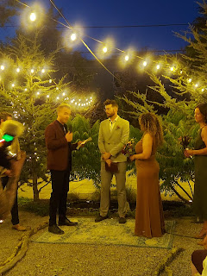

Garret gave a beautiful speech as he read his vows to Chelsea. I didn't capture all of what he said, but I got most of it.

Video #1 of Garret: (1 min, 3 sec)
https://photos.app.goo.gl/j88VfrnGF5KUMFTx7

Video #2 of Garret: (1 min, 42 sec)
https://photos.app.goo.gl/SZEmh7daHxwr42JB8

Then Chelsea shared her vows to Garret: (2 min, 36 sec)
https://photos.app.goo.gl/iQh5yiKbWiTLBLv39

And then, they were married!! Hooray!!

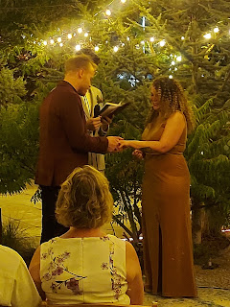

They jammed down the aisle together as husband and wife. Literally! ha ha
Video: (15 seconds)
https://photos.app.goo.gl/FCaMHbcECQ7hy4Gn9

Meanwhile, Amber had taken a reference photo during the ceremony to work from, and she just kept going, and going, and going! What a champ. She painted prior to the ceremony, during the ceremony, and for another hour or so after the ceremony.

Here is a video of her signing her name at the bottom when she was all done. (25 seconds)
https://photos.app.goo.gl/3HSNtZRq7rr7QJ6x6

Everyone kept coming over to see her progress all evening (including Garret's mom below), and they were all so intrigued and impressed and awestruck by her talent.

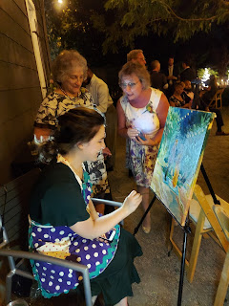

When needed, Scott, my mom, and I each took turns holding up her special painting lights so she could keep on going as it got dark outside.

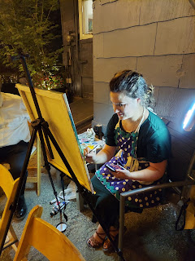

Finally, it was all done. Wow. Just wow.

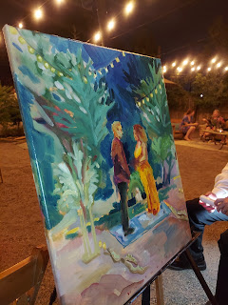

A forever keepsake.

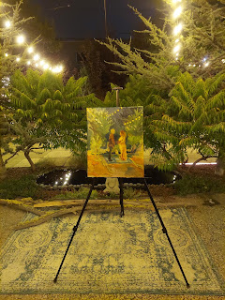

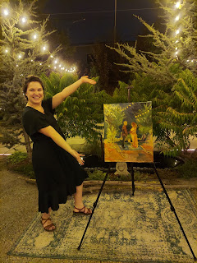

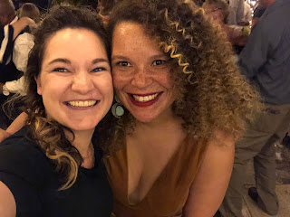

The rest of the evening we did some dancing out on the dance floor, hosted by a hired DJ, and took some breaks by visiting with those not on the dance floor. :)

Scott captured a moment where Doug's dad was encouraging me, my mom, and Amber on the dance floor during one of the songs: (11 seconds)
https://photos.app.goo.gl/V5MAZuyVgCEYQU2y7

It was so much fun!! Scott thought very highly of Doug, calling him "fantastic" and "such a great guy". Doug also made it a point to come right up to meet us when we arrived, and gave Scott a big hug. And later, at the end of the night, as we were saying our goodbyes, Doug asked where Scott was so he could say goodbye to him. He even left the dance floor just to come find him and give him one last hug. It was really special that everyone got along so well, and that there were no hard feelings or animosity whatsoever. It was all just so happy and lighthearted and wonderful. I will cherish the memories from the weekend for a very long time to come!!

As for the rest of the week . . .

Monday:
Scott and I took Benson across Idaho Falls, out into the barren wilderness, so we could all shoot Scott's Keltec Sub 2000 rifle. Benson hasn't had the opportunity to shoot a gun in quite some time, since Italy prohibits firearms (owning or personal use).

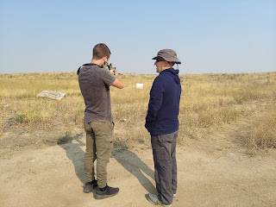

Benson and Scott - going to check the target that was set up in the distance . . .

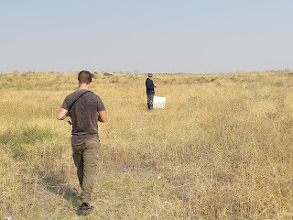

Nice job bud! Nice clustering.

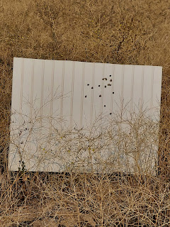

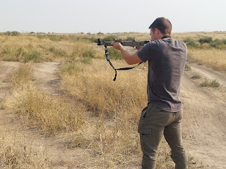

I even took a turn at one point.

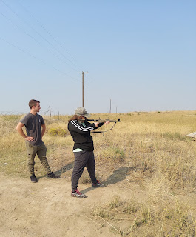

Video of Benson shooting: (5 seconds)
https://photos.app.goo.gl/TJzMWkYVFBygnMDq7

Video of me shooting: (9 seconds)
https://photos.app.goo.gl/fAMTs4MrdEMMgmdN7

I'm a lot slower to pull the trigger each time . . . ha ha

After we were done shooting in the desert, we drove Benson back across town to meet up with his in-laws so they could drive down to Utah. Kylie was heading down to fly back to Italy the following day, and Benson had a few more days of training down in Utah.

Goodbyes are always so hard. I love that baby son of mine.

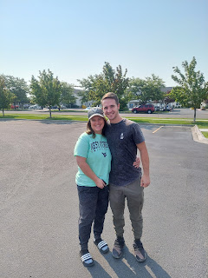

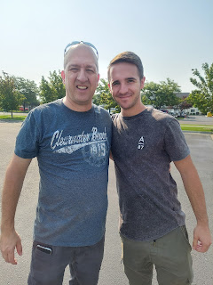

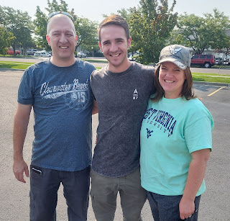

Later that evening, Scott and I rented some electric scooters and motored around the Snake River Greenbelt for an hour or so. Even though the rental ended up being a rip-off, as far as price goes, we still had fun enjoying the lovely evening together.

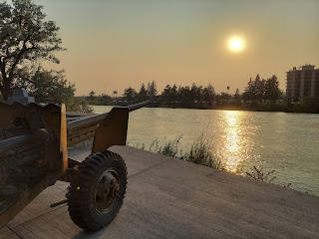

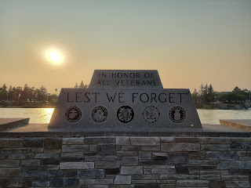

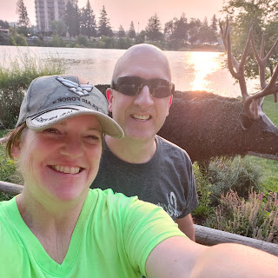

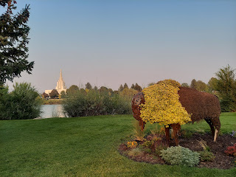







And we got this darling photo of Jack, holding a new stuffed puppy from his great-aunt Sharon. Jacob and Hannah had just arrived at Sharon and Thom's home in West Virginia to house-sit while they went on a short trip.

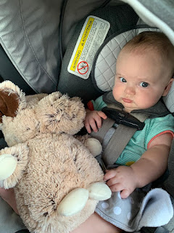

Jack has really enjoyed the new bouncy entertainment center that his parents bought for him.

Video #1 in the bouncy seat: (16 seconds)
https://photos.app.goo.gl/JajA8QhSkm85Uoa8A

Video #2 in the bouncy seat: (12 seconds)
https://photos.app.goo.gl/6gE9A5XDyD9fpix28

Video #3 in the bouncy seat: (25 seconds)

https://photos.app.goo.gl/K8tciHLCpdnAecjF8

Tuesday:
After work, Scott picked all the peaches off our tree. What a peachy guy!

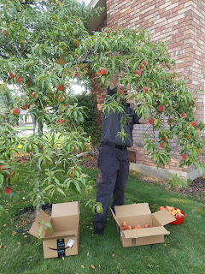

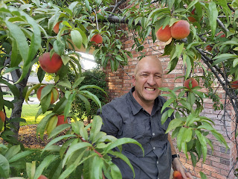

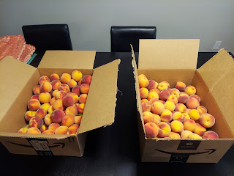

At the same time, I was setting up for our young women's activity. The girls painted their air-drying clay creations from last week. Some of their clay creations had broken in one place or another, which was no surprise to me. I am not a big fan of the air-drying clay. It might have just been the brand that I bought, but overall I was not impressed.

But the girls had fun hanging out and painting together. We listened to music, and I invited them to put in song requests and then I'd find it on Pandora for them. I hadn't heard one of the songs before, but I loved it so much that I downloaded it on my phone. It's a Taylor Swift song, called "Lover". Super cute.

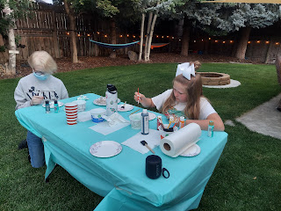

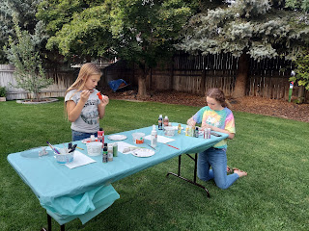

I told the girls that they could choose a rock out of my strawberry garden to paint if they wanted to. Several of them did just that.

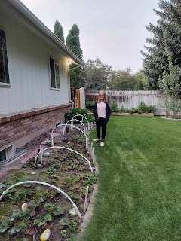

After they finished painting, we had ice cream cones for a treat, and then they played a few rounds of hide-and-seek, since it was dark by then. It was hard to kick them out and send them home because they were having so much fun. ("Pleeeease, Sister Harmon, can we just play one more round?") But parents were starting to text me at 8:45 pm asking if their daughter was on their way home yet . . . so I had to be the bad guy and send them packing. :)

I also heard back from Kylie that she made it safely back to Italy. What a relief!

Wednesday:
I went to visit a dear friend who has been through a lot this year, and I didn't even know it. When her father passed away from pancreatic cancer last year, a correlation was made between his type of cancer and that of his two sisters who had also passed away recently from breast cancer. The children were all encouraged to do some genetic testing to see if they had a similar cancer risk. Her two brothers' test results were encouraging, showing nothing worrisome. But while she and her sister waited for their results, her sister was diagnosed with breast cancer and began treatment immediately. When my friend's results came back, saying that she was at risk for breast cancer, ovarian cancer, melanoma, and cervical cancer, she was definitely spooked. She decided to do some risk-reduction surgeries, beginning with a hysterectomy in January. Later in the summer, she did a double mastectomy, removing the possibility of breast cancer from her body. And now, she is in the woes of hormone crashes, with problems left and right, including insomnia, anxiety, depression, and a slew of other symptoms.

We went on a walk, and then sat on her front porch to talk some more, spending about 3 hours in all. I was disturbed that she has been suffering so much, without much hope of any remedies. When you're at risk for so many cancers, you can't just hop on the estrogen train and start popping pills. I offered to do some research for her, to see if I could find any leads on an essential oil that could be both promising and safe.

The one essential oil that seems to be the most promising is Thyme. In several studies, it not only proved itself as a cancer killer (causing the cancer cells to commit suicide basically), but it also worked effectively to ease estrogen-related issues, including insomnia. I sent her and her husband, our former bishop, links to all the best articles I could find. They are going to take the information to her oncologist and hopefully get his approval for her to try the thyme essential oil. I hope he gives his permission! I am sad that she has suffered for so long, without enough support being offered from the medical community. It just goes to show that doing research on your own, and being your own best advocate is an important part of your self-care.

I sent this quote by C.S. Lewis to my friend, hoping to cheer her up and cheer her on.



Later that evening, Scott's brother, Gordon, and his wife, Pam, came over to help us can some peaches. That's love.

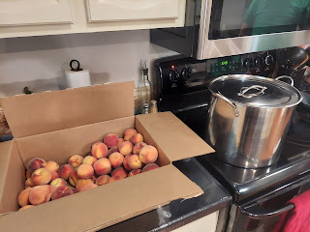

Between Gordon and I, we blanched the peaches in boiling water for about 60 seconds, then ladled them into an ice-cold water bath. That process helps the peels to come off really easily, which was my job. Then I passed them on to Gordon, who cut each peach in half, pitted it, then plopped it into the ascorbic acid solution (to preserve the bright coloring).

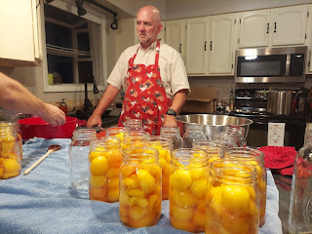

Scott was on the other side of the counter, straining the peaches out of the solution and placing them oh-so-carefully into each jar in several beautiful layers. Lastly, I made some light syrup to fill up the jars the rest of the way.

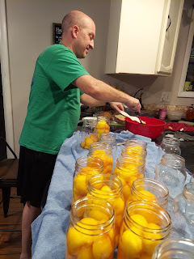

Pam was working on a crocheted quilt for her granddaughter, Azure, but was cheering us on from the dining room table and took this cute photo of us working in the kitchen.

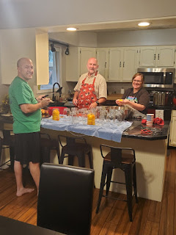

Scott and Gordon visited on the back patio while they supervised the peaches simmering in the boiling water-bath canner that we set up on our Camp Chef Stove outside. We could hear them laughing as they listened to a few Dry Bar Comedy sketches. In all, we canned 11 quart jars of peaches that night. Beautiful!! The rest of the
fresh
peaches are slowly, but methodically, being devoured by us on a daily basis. Such a chore, but somebody needs to do it . . .

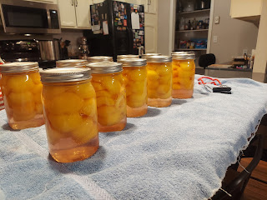

This is the book I like to use.

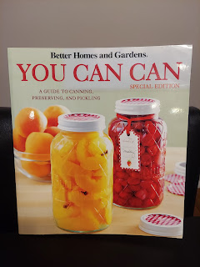

Thursday:
While Scott was at school all day, I was trying to do several loads of laundry, finish packing, clean some areas around the house, and get things ready to leave town for a few days.

As soon as he was done teaching, I drove over to pick him up from the high school, and we left immediately to head down to Salt Lake City.

We ate a tasty Mexican dinner near our AirBnb in North Salt Lake.

Scott ordered Carne Asada Fries.

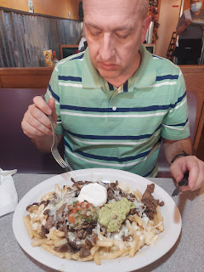

I ordered a Fajita Quesadilla with mushrooms. Everything was delicious!

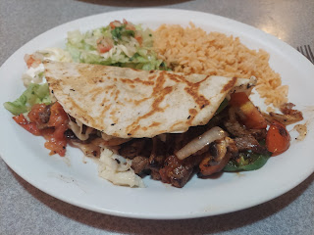

With full tummies, we went to back to our AirBnB and settled in for the night. Neither of us slept really well, even though the bed was amazing. For me, I know it was because we had to get up super early to get to the airport. That always messes with my brain and I can't fully relax. I woke up to my alarm at 5:15 a.m., only to realize that I had been dreaming about all kinds of things relating to being late, or forgetting important things, etc.

Friday:
The day was a complete whirlwind. From getting up at 5 a.m., to flying to Denver, to standing in line for 2 hours to get our rental car . . .

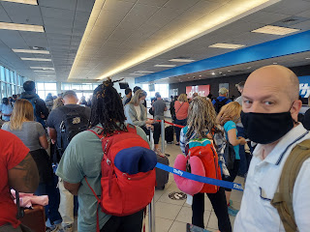

. . . To running to Hobby Lobby to pick up some painting supplies for Amber, finally getting some brunch in our bellies at noon (no breakfast because of our early travels), to thankfully getting checked in early at our hotel where I could lay down for an hour before hopping in the shower . . . to getting 100% ready for a wedding in 35 minutes . . . to hurrying over to the Denver Airport again to pick up Amber and my mom and then letting them freshen up quickly at the hotel . . . and then hustling across town just as the dreaded rush hour began . . . to arriving at the wedding venue . . . to this.

This
was what made everything worthwhile.

Every minute of anxious sleep lost, every neck muscle tensed up and stressed out, every slow-down on the traffic-jammed roads across Denver . . . it was worth every little bit. :)

