AAAAAAAAAAGGHHHHHHHH!!!!!
That's how I feel right about now, with only 2 days left until I fly out! I'm in crunch time and need to focus, but more and more things keep popping up and landing on my to-do list. This morning, Scott came in and held up this photo of Jack (on his phone), and asked, "How does this make you feel?"
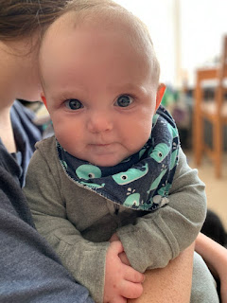
Well, much better, actually. Much calmer. And now I have a smile on my face. What a sweetheart he is.
Monday:
Jacob and Hannah got moved into their new apartment in Arlington, VA. When Jacob sent us this photo in the family group chat, Amber immediately responded with, "How did he escape?" ha ha ha

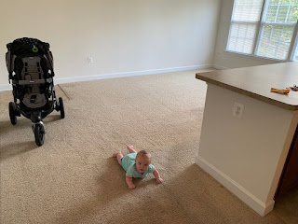
Mid-day, I got a text from one of the moms in my young women's class regarding her daughter, Keeli. There was a terrible accident earlier that morning involving her school bus and a pick-up truck. It didn't go so well for the driver of the pick-up truck: he
died
. The bus ended up on its side, and Keeli, along with 3 other girls, all ended up at the hospital with moderate injuries. Keeli broke her right collarbone and her left elbow. Another girl broke a collarbone as well. Yikes!
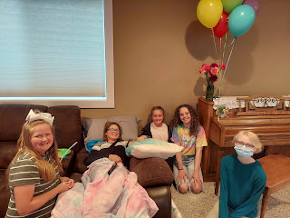

I rounded up as many girls as I could fit into my car after school to go visit her. We picked up her favorite blizzard from Dairy Queen, and during our short visit we let her know that we love her and are praying for her. She is such a sweet girl, always ready with a smile, even though she was clearly not in the best of shape with her arms all propped up. She was supposed to participate in her middle school volleyball game that night, and softball tryouts were also scheduled for that same night. Unfortunately, she will have to sit out the rest of the season now.

Here is the news article regarding the crash:
https://www.eastidahonews.com/2021/09/update-investigators-identify-man-killed-in-bus-pickup-crash/

Tuesday:
At the end of a busy day of errands and chores, Scott and I drove up to Rigby to have dinner with his parents and with his brother, Gordon, wife Pam, and their daughter Marissa - with two little ones now.

I got to hold the new baby, Rayma. She felt as light as a feather compared to my recent experience with holding Jack the Tank. :) (Azure was waving a butter knife around a little crazily in the background, but I was super fast and then I got out of the danger zone muy rapido.)

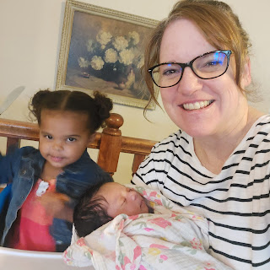

While Azure waited patiently for the pizzas to finish baking in the oven, we kept her occupied for a few minutes by showing her how to put olives on her fingers.

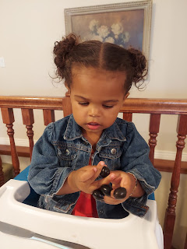

Gordon and Pam sure make wonderful grandparents. But then, I don't know of any grandparents who don't relish their role to just love, love, love - without any stress-filled responsibilities. :)

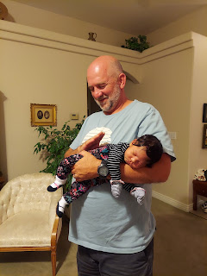

Here is Rayma's great grandmother, Coy, holding her. How precious! And that newborn head of hair!

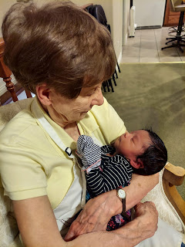

And speaking of babies, we had a little scare when Kylie messaged me from Italy to let us know she was in the hospital!! She was having regular contractions and her cervix was 50% effaced. She is only 30 weeks into her pregnancy, so that was a concern!

After about 4 days in the local hospital over there, after multiple kinds of tests to determine why she was going into labor so early, and after only getting about an hour of sleep per day in her hospital room (other patients shared the room, as well as 2 newborns), we still don't have a good reason why she went into labor. She received steroids through an IV to stop the contractions, as well as shots each day to help the baby's lungs to mature faster (just in case).

Benson was able to get permission to fly home early from his training in Las Vegas, and through the Red Cross he got a flight back to Italy and arrived home by Friday. Sadly, he arrived just after visiting hours were over at the hospital, so he had to wait until the next morning to see his wife. Thankfully, she was able to demonstrate that she wasn't having contractions anymore after they stopped the IV steroids, and was discharged in time to be home for the weekend. I haven't heard much from either of my Italian kids these past few days, but I just hope that no news is good news. They are certainly in our prayers! She is on bed rest now until further notice . . .

Wednesday:
Amber shared these darling photos of Gwen out on a forest walk with a new friend. Amber was markedly impressed with all of the fall foliage already showing up down in the south.

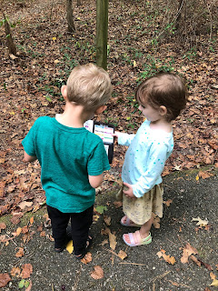

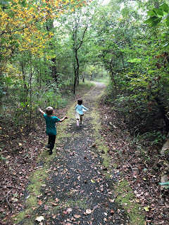

I worked for two days on several pairs of pants. First, for my favorite pair of jeans, I shortened the length, slimmed the lower pant-leg, and then frayed the bottom hem. I watched a YouTube video on how to do the fraying after I saw a young lady wearing a pair of frayed jeans in the store. I thought they were just so darn cute! A straight pin helps to loosen the weave of the pants so you can pull out the strings pretty easily.

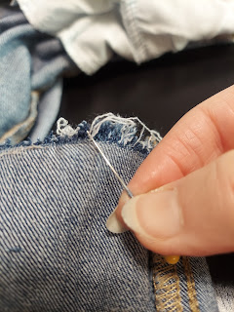

Here is the finished product.

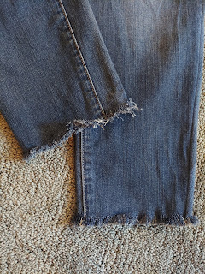

I also slimmed the pant legs for these 3 pairs of pants, and hemmed them to accommodate my shorter stature. Now I have plenty of pants to take to Europe that are interchangeable as well as comfortable. :)

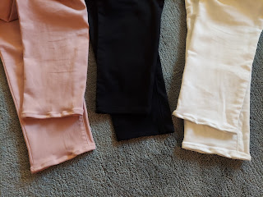

While I was sewing, cupcakes were baking in the oven. This time: homemade vanilla cupcakes. Once they were cooled enough, I frosted them and prepared to use some colored fondant for the first time to make the decorations.

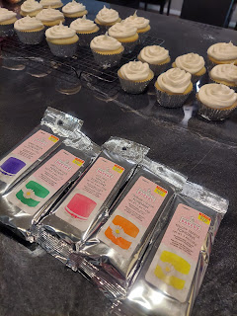

After watching a couple YouTube videos, I began rolling out the fondant, one color at a time, and just a tiny little bit at a time. Apparently, powdered sugar works well for rolling out fondant. (NOT FLOUR.) I copied this idea off the internet by the way. I am not that creative on my own. :)

Click here to see the website that I used:
https://myheavenlyrecipes.com/crayon-cupcakes/

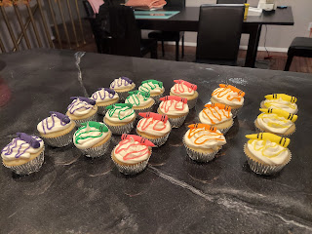

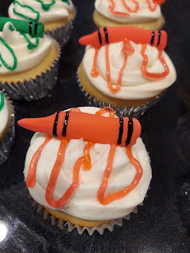

I attached this uplifting quote and then they were ready for delivery!

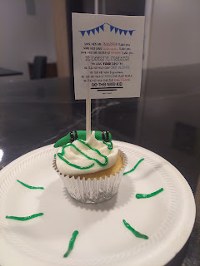

It says:
Some kids are smarter than you.
Some kids have cooler clothes than you.
Some kids are better at sports than you.
IT DOESN'T MATTER!
You have YOUR thing too.
Be the kid who can get along.
Be the kid who is generous.
Be the kid who is happy for other people.
Be the kid who does the right thing.
Be the Nice Kid.
We got this cuter-than-cute picture of Jack during the day. It's always a treat when we get to see him again, even if it's just through modern technology.
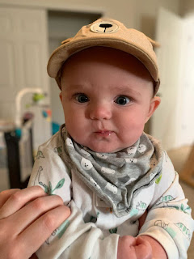

And Amber shared this with us regarding Abby and her love of math.

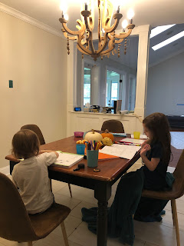
"Her favorite subject is math. I had her doing reading homework (learning words such as: and, in, look, like, etc) and she said, "Can I do some REAL homework now?" She's 2 weeks ahead in her math workbook."
Thursday:
Jacob shared this photo of Jack hanging out with him while he worked online for the day.
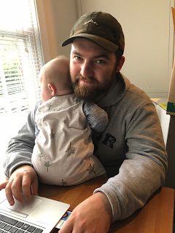

I continued whittling away at my long list of "to-do's". I also went to the chiropractor to get an adjustment because my neck and shoulders were so tight that it was getting uncomfortable . . .

Later that evening, I went to a Young Women Leadership training meeting at the church. It was time well spent. :)

Friday:
I worked on gathering several things to pack for my trip, ran errands, and worked around the house. Friday evening, Scott and I went on a date: we had dinner at Smitty's Restaurant and then we went to the Idaho Falls Temple.

Scott - making silly faces during dinner

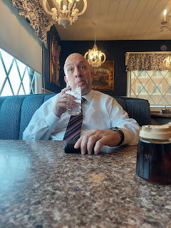

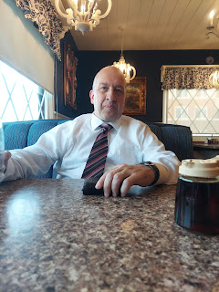

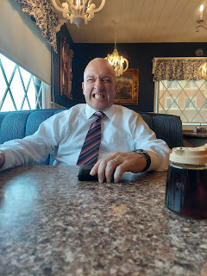

Admiring the waterfall in front of the temple, and the beautiful flowers

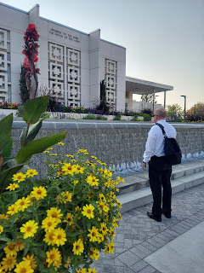

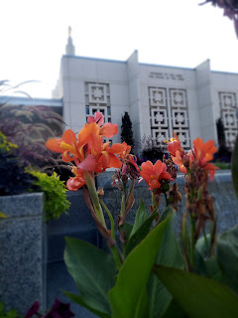



Short video of the waterfall fountain in front: (14 seconds)

https://photos.app.goo.gl/iRe2c4ZXb2zcko4m6

It was wonderful to be in the temple together. The sealing ordinances we participated in reminded me on how I can be a better wife and mother, and I am motivated to do better. :)
Saturday:
Scott went up to Rigby in the morning, while I did some cleaning and organizing at home for my upcoming trip. He installed a sturdy new handrail for his parents so when they go in or out of the garage and into the house, they can do it safely. What a good son. :)
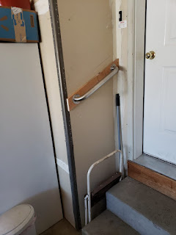

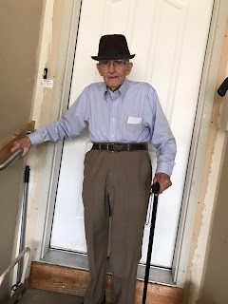

I made some soup during the lunch hour since I knew I wouldn't have time later that day. I made a huge pot of Coconut Curry Chicken Soup.



To make it low-carb, I omitted the Japanese noodles.



It was super yummy!



At 2:30, we met up with all the youth to drive down to Pocatello for the Temple Open House. This was the first day of the several-weeks-long open house. We had a great experience!

We went online to get free tickets a while ago, but it turned out we didn't even need them. Nobody asked to see our tickets, and it didn't have any effect on our travel or the tour itself. We parked at the assigned building at 3:40 p.m. and then boarded a bus to be shuttled over to the temple a few miles away. There were 36 of us that traveled down together for the tour.

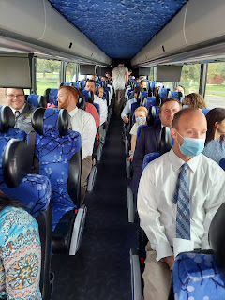

Here are all the youth in front of the temple before our tour.

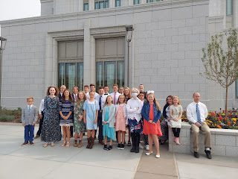

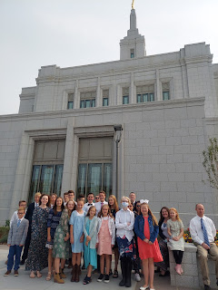

Even though the day was quite windy and dusty, the temple was a quiet and peaceful haven from the world outside. The paintings were exquisite on the walls throughout, the stained glass windows were beautiful, and the girls loved the majestic chandeliers hanging in a few of the ordinance rooms, especially the huge chandelier in the Celestial Room.

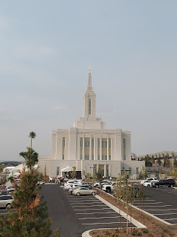

The tour didn't take very long - maybe 30-40 minutes. Then we just waited for a bus to come over to pick us up and take us back to where we parked our cars. After a 45 minute drive north to Idaho Falls, we stopped briefly at the church so the youth could all get a cookie that the Bishop provided for them, and then Scott and I headed back to our house for a little bit. (Before the next big thing)

Lastly . . . Scott and I participated as chaperones at the Skyline HS Homecoming Dance from 8-11 p.m. What a change that was from being in a quiet, peaceful temple in the afternoon, to a loud and dark dance floor that night! ha ha

I had the inspiration to suggest that we bring ear plugs to wear to the dance. Turned out to be a great idea! We could still hear everything: the boom, boom, boom of the songs pulsing through our bones, and we could even hear what the students were saying when they came up to ask us a question. The beauty of ear plugs is that it MUTES everything so it's not so loud and obnoxious. What a blessing those ear plugs were! :)

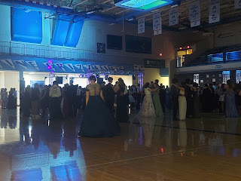

Short video of the kids early on in the evening: (25 seconds)
https://photos.app.goo.gl/iG9NjDmY5hit79G27

Short video of the kids later in the evening: (18 seconds)
https://photos.app.goo.gl/4zwVzXdE9sQF7NRcA

If I had had more energy last night, I would have done some serious dancing. But I was feeling a little rundown, and therefore I tried to just stay in my chair in order to rest as much as I could. I did tap my toes all night though! :)

Funny story: (well, not so funny actually) Some students at Skyline HS did some shenanigans earlier in the week by disabling certain fixtures in many of the bathrooms, one bathroom at a time during the day.

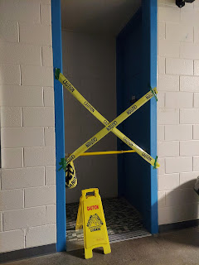

Apparently it was so they could post what they did on Tik Tok. (!) Little by little, bathrooms became off limits to everyone because of the damages. The bathroom right across the hall from Scott's classroom was disabled because the students pulled the entire bathroom sink down from the wall! In another bathroom, they broke the pipe underneath the sink. Oh, teenagers . . . It will take a while to get the bathrooms up and running again, but not without some new security in the hallways from now on I'm sure . . .

Jack still loves his exercise bouncer. Here he is from today (Sunday): (18 seconds)
https://photos.app.goo.gl/pmpCLTcZz84kMdqV9

Here are the final two photos from the week. See if you can come up with a catchy caption for them.





