Hard Work Pays Off
Benson and I have put in a LOT of elbow grease this week, and things have been getting fixed and/or replaced around the house, one big thing at a time. We have also enjoyed some quality time with Miss Avery.

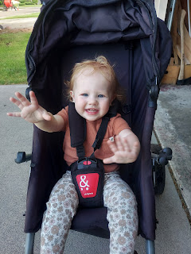

Just look at those curls . . .

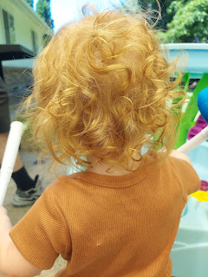

Monday, July 10th:
Avery came to spend the day with us while her other grandparents were at work. She rotated around with a variety of activities when it wasn't nap time. She seems to really enjoy music and likes to sit at the piano with a longer than usual attention span.

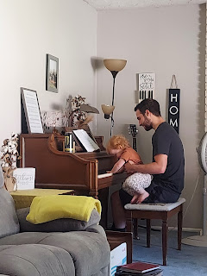

She is still enjoying the water table on the back patio. We didn't fill it up quite as full this time, so she didn't dump all the water down her tummy, ha ha.

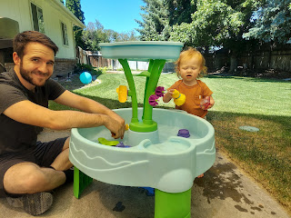

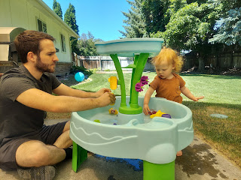

Benson is really enjoying being a dad, and is taking breaks often from working on his car to come play with Avery. Playing in some refreshing water on a hot day is also very relaxing . . .

Tuesday, July 11th:
I worked a good chunk of the day preparing a flyer to send out to my extended Rawles family. Some of my elder cousins (in their 80's and 90's) have requested more than once that they would love to have a get-together of some sort to...well...get together. I designed the flyer, and then got a few opinions from 3 family members (Dad, Amber, and Scott) before launching it. There are about 90+ cousins that I oversee in my duties as Secretary and Historian of the Rawles Family. Unfortunately, I only have email addresses for about 50 of the 90+, which means that I have to print out and fold 40 flyers, then address all the envelopes and put labels and stamps on them to go in the SNAIL MAIL. That took most of the afternoon, but I finally I got everything taken care of just before dinner time.

Scott says I should mention in my next snail mail that these mailings will be coming to a close soon, and that if people want to stay in the loop, they need to provide me with an email address. Right now I am paying for all the envelopes, all the stamps and labels, and doing all the printing myself. I don't mind it too much, but with the price of stamps consistently going up, pretty soon it's gonna be $1.00 per stamp!!

In the middle of the day, I went out to lunch with two of my friends from church, ReNae and Hulan.

L to R: Me, Hulan Swapp (from Mongolia) and ReNae Cunningham.

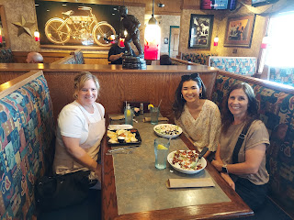

We have enjoyed a circle of friendship for the past couple of years while Hulan has lived in our ward boundaries (at church). She recently graduated with a degree in Math Education and has landed her first teaching job at a local high school. She will be moving out of our ward in the near future as she looks for a new home with a yard and better opportunities for her two young daughters. We will miss seeing her regularly at church, but we are excited for her future. She is an amazing person and a wonderful mother.

Shortly after I got all the flyers mailed out, I got home just in time to be picked up by Stephen Blatter and his son, Brad, so that we could go pick up the new water heater. When I went to Lowe's the night before, I was disappointed with two things: 1) It would not be delivered for free (which is what the young man told me last Friday night), because it was not considered to be a "large appliance". (??) Apparently, a large appliance is a fridge, washer/dryer, or an oven. 2) This item did not qualify for a military discount, either. Darn.

So, thank goodness for the Blatters, who came to my rescue once again to help get the water heater into the garage for a few days. Benson helped get it out of the truck once we got it home.

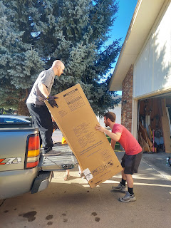

Wednesday, July 12th:
We had Avery all day again, which was fabulous. She is always such a hoot!! We took her downstairs to hang out with us and play in the Grandchildren Guest Room while Benson put the bunk bed back together. At one point, he had a few bolts in his teeth as he worked his magic with the new ratcheting drill he bought (for the car). Avery was very concerned that he had those big black bolts sticking out of his mouth . . .

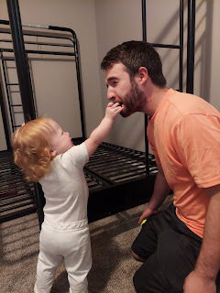

She kept engaging him in her play, even as he worked. She brought him several squishy and colorful balls, and when he started attempting to juggle, she lost it. She was cracking up hysterically and it was so funny that I captured several videos.

Video #1: (11 seconds)
https://photos.app.goo.gl/9iumebg1NpryeZSx8

Video #2: (21 seconds)
https://photos.app.goo.gl/vuYpB5hEqdTaFwfc8

Video #3: (15 seconds)
https://photos.app.goo.gl/BgMNyn6Dq79SUEDZ7

Video #4: (19 seconds)
https://photos.app.goo.gl/6pPeG9ozGg98ZU139

She slept hard for her nap, and when we got worried she might be sleeping too late in the day, I went down to wake her up. She was so cute, all curled up in a ball with her bum up in the air.

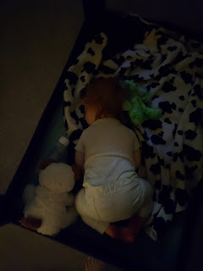

I tried taking another photo using the flash . . . she never even budged. I rubbed and gently scratched her back for a long time before she started to stir and eventually wake up.

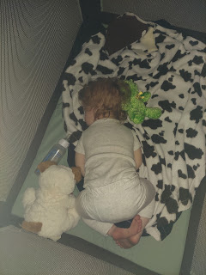

I was finally able to take Benson out to dinner, something I had been wanting to do for several days since he put in all those man-hours to install our garage door opener last week. There was always something in our way of going out . . . usually it was that we were both too tired . . . But this time we actually made it. He chose Jalisco's Mexican Restaurant, one of my favorites. They serve large portions and it's always so good. I especially love having leftovers for lunch the next day. I ordered a combination of carne asada and buttery shrimp with mushrooms. It was wonderful.

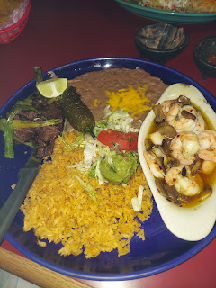

Thursday, July 13th:
I drove up to Rigby early in the morning so that I could spend some time with my father-in-law while Bev had to attend to some business down in Pocatello for a few hours. The goal was for me to take him on a drive and perhaps get some lunch on the way back. But halfway to Mesa Falls (an amazing set of Upper and Lower waterfalls near Ashton, Idaho), his back started bothering him and he asked me to turn around and head back to the house. So we drove home and arrived shortly after Bev had returned back home as well. She had already started on an apple pie and was just putting it into the oven for Dad. How thoughtful.

He needs lots and lots of naps these days . . .

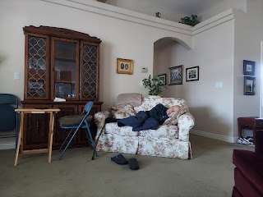

On my way home to Idaho Falls, I chatted with Scott, who was happily eating some peaches out of a giant bowl.

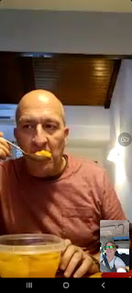

Once I got home and had some lunch, I changed into yardwork clothes and went outside to pull a bunch of weeds. A little while into my work, I saw a Citizens Watch patrol car pull up across the street. I figured they had come to finally respond to the form I filled out online last week regarding my next door neighbor, Ellen. I walked over to visit with the female officer, who was very nice. We spoke at length as I shared several details and concerns with her for about 30 minutes. This is what Ellen's front walkway looks like right now . . . lots of bags of rotting garbage mixed with several other bags of miscellaneous odds and ends. I hope that something can be done to both help my neighbor, Ellen, and also to protect our neighborhood from the hazards of living next to a hoarder.

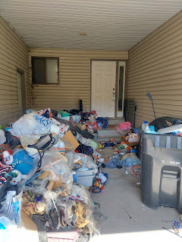

In the evening, after a full afternoon of pulling weeds, I changed my clothes once again - this time into a dress - so that I could visit the temple. I have been missing the blessings from my usual habit of attending the temple weekly, so I decided it was high time to carve out some time to go.

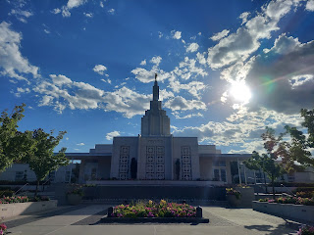

I spent about an hour inside and it was so reassuring to be there. I paid close attention to the words of counsel that were given as I did some initiatory work, and the biggest thing I came away with was how grateful I am for my husband. I am grateful to be married, to have him as my best friend and my eternal companion. I look forward to all the great things we will do in our future. :)

The flowers were so beautiful on my way back to the car.

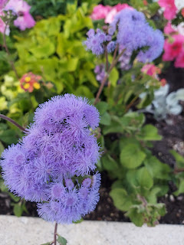

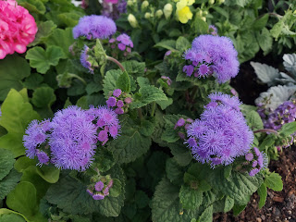

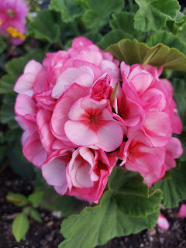

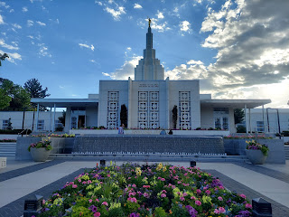

Friday, July 14th:
We got the new water heater installed!! Yay!! Stephen Blatter and his dad, Don Blatter (our backyard neighbor) brought several tools, along with some patience and skills. They arrived around 9:30 in the morning and Avery arrived shortly thereafter to spend a few days with us. It was a little hectic with so much going on at the same time, but they were all wonderful things!

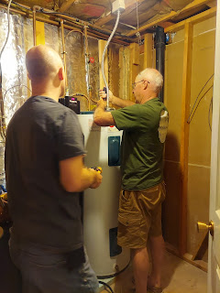

Here is our fancy new water heater - it even has a cool feature that allows us to change the water temperature using an app on our phone. So if we're in Italy, we can turn it up or down if company comes to stay at our house while we're gone.

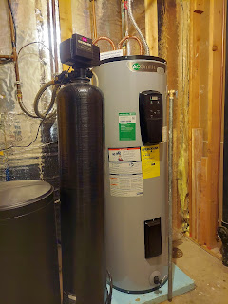

I took Avery across the street to see our neighbor Kim, and while we chatted, Avery was entertained by watching, following, and petting their two cats on the front porch.

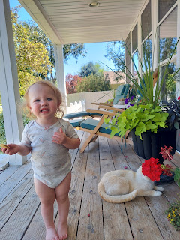

Mimi is their male white cat (above) and Garfield is the orange tabby (below).

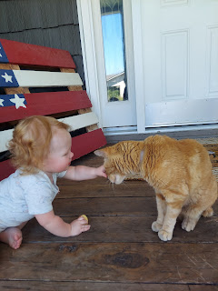

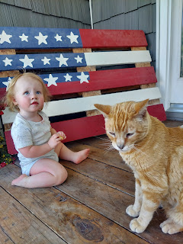

As she waited for dinner, I put her in the highchair near me in the kitchen. She was such a ham while she played with a straw . . . One of my favorite things about Avery is her infectious giggle.

Video of Avery: (22 seconds)
https://photos.app.goo.gl/PCMbf8yhdMVEPxuZ7

After her bath and before bedtime, I took Avery with me on a walk to the Paramount Movie Theater. It's slightly less than a mile from our house. I wanted to get a gift certificate to give to Stephen Blatter and his family as a token of my appreciation for his help with the water heater. It was hot out and I got pretty sweaty as I trudged along, but we got a nice gift for the Blatters, so it was worth the effort and she enjoyed seeing all the sights on the way.

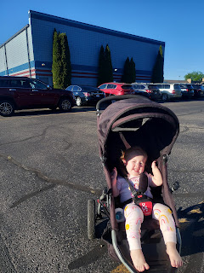

Saturday, July 15th:
I took Avery on a few errands with me mid-morning. We went to the bank, paid the rest of the bill for the new carpet, and went to the grocery store. She did great that whole time! I packed some snacks and a sippy cup full of cold water and she was so incredibly chill everywhere we went. As soon as we got home, however, she let it all out, ha ha.

She was hardly able to eat any lunch because she was pretty tired by that point, so I just tucked her in for a nap. While she was sleeping, Jacob, Hannah, and Jack arrived. She was a little thrown off when she woke up, but she switched gears quickly to All Smiles! :)

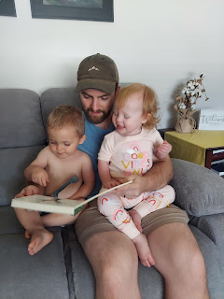

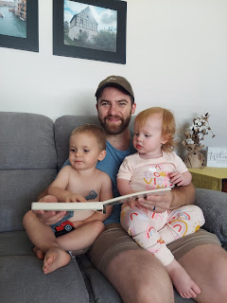

We took Jack and Avery in strollers over to the Andersons house nearby so we could borrow an extra Pack & Play for Jack to sleep in. It was hot out, but luckily it wasn't too far.

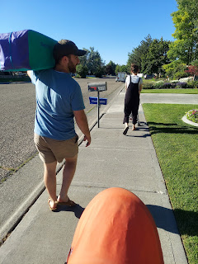

Avery and Hannah were so cute, chatting about eyes and noses and stuff. :)

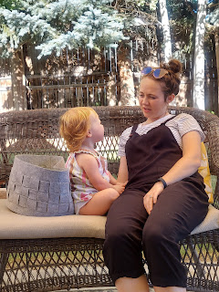

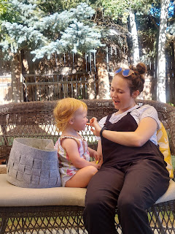

Avery was a little shy about swinging by herself, so Jacob did what most uncles do . . .

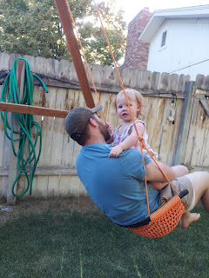

Jack kept asking for "High?" "High?" whenever it was his turn. :)

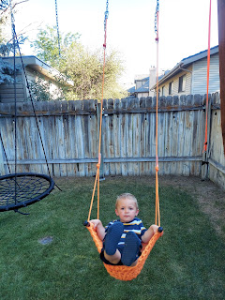

In the evening, we were out front, visiting with the Parkinsons again, when Mimi the cat came over to say hello. The two little ones had so much fun following him around!

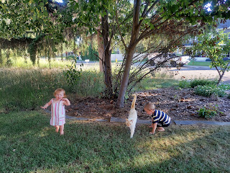

Video of Jack offering Mimi a long piece of grass from Ellen's jungle next door: (38 seconds)
https://photos.app.goo.gl/s1m2gSdYtsdm7MJ96

Avery was a little leery of all the textures in the grass, but at the same time, she wanted to be a part of the action! Bless her cute little heart . . .

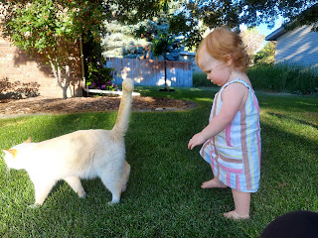

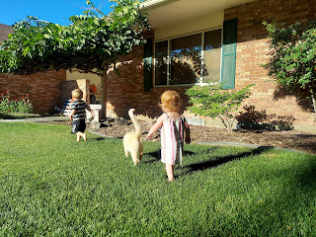

When Mimi wandered into the garden bed by my front porch, Jack trudged right in after him with no concern whatsoever for anything poky on his bare feet, ha ha.

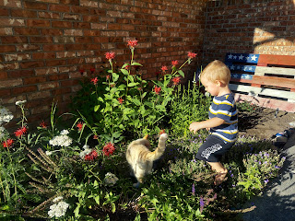

Avery definitely wanted to follow Mimi, but those darn textures . . . ha ha

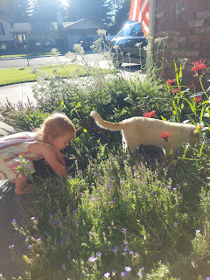

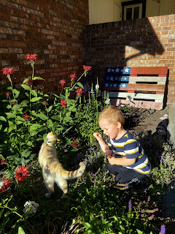

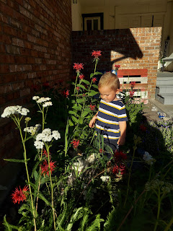

Video of Uncle Jake galloping around with Avery on his shoulders: (10 seconds)
https://photos.app.goo.gl/4jk98xR71q8KYNR3A

Video of Jacob leading Jack and Avery back & forth down the hall with lots of giggles: (27 seconds)
https://photos.app.goo.gl/6LnNLzotb3XSb5rP7
After some evening ice cream (once the kids were in bed), we sat on the front porch chatting for a long time. It was also an opportunity for Benson to take a break from working under the hood of the car, which he appreciated. At one point, I asked the boys to pose for a picture, and this was the look they each gave me . . . (bunch of pills)

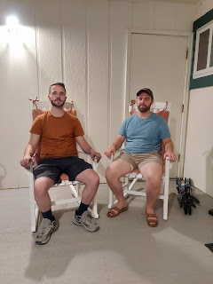

Sunday, July 16th:
Between 10:30 p.m. Saturday night and 1:30 a.m. Sunday morning, Benson worked tirelessly to put everything back into his Audi that he had steadily been removing for days so he could access (and remove) the intake manifold and fuel rail to inspect/replace parts/and clean everything.

Rewind: He had come into my room the night before and woken me up in the wee hours to show me the intake manifold that he had FINALLY gotten out, holding it up like Simba in the Lion King, LOL. He was so proud of himself, so naturally I was, too! It had been 4 days of taking one thing out after another just to get access, only to find yet another obstacle in his way. I told him many times this week that I was in awe of his patience, his diligence, and his ability to stay on this task for so long. I would have given up long ago . . .

Then, within those 3 magical hours Saturday night, he was skilled and deft enough to get everything back in and hooked up. I couldn't believe it when he came in to wake me up so he could announce, "It's all done!" WOW. He is amazing.

He was so full of adrenaline at that point, plus he had way too much caffeine in his system, so it took him quite a while to wind down and go to sleep.

The rest of us went to church Sunday morning, even though we were hoping that Benson might have joined us. The odds weren't great since he didn't go to sleep until after 3:00 a.m. We still love him, though.

Below: Jacob giving snacks to Avery, while Hannah and Jack were listening to the speaker.

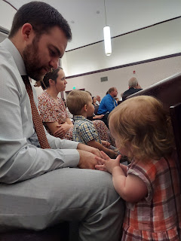

After church and after naptime, we drove up to Rigby to have supper with Grandpa Phil and Aunt Bev. She made a tasty beef stew and homemade rolls, being mindful of Dad not being able to chew things very well. The babies thoroughly enjoyed those warm rolls . . .

Bev put Jack to work watering some flowers in the front yard, since he likes to have a job to do.

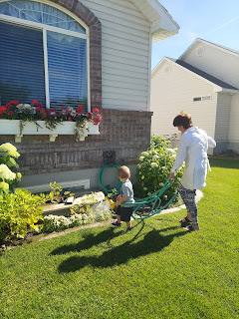

Hannah had to keep a tight grip on the sprayer so he didn't water all of us, plus the entire neighborhood.

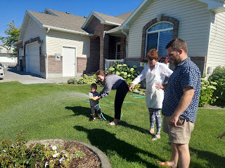

Avery enjoyed touching each of the pinwheels spinning in the breeze, tokens of kindness that had been lovingly placed weeks ago by the Primary children during Coy's final days.

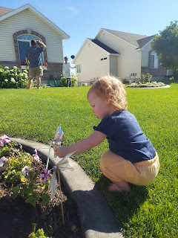

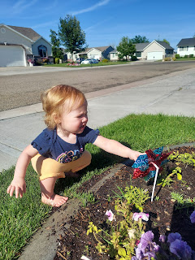

And speaking of Coy, as I watched the little ones playing in the water fountain in the back yard, I couldn't help but think about how much Coy would have enjoyed watching them as well. That was one thing that brought her a great deal of happiness, was to let her grandchildren and great-grandchildren play in the water that bubbled out from the big rock and made the babies squeal with joy. I got a bit emotional as I shared my thoughts out loud . . . Then again, maybe she was actually there with us already . . .

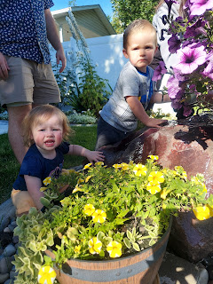

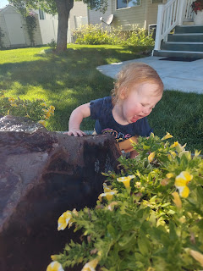

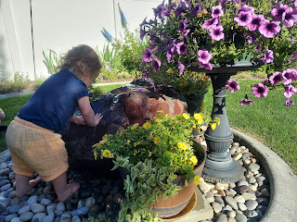

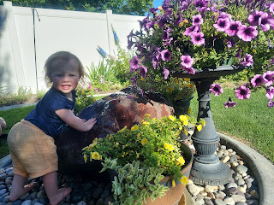

Video of Jack getting fancy: using his fingers to plug up the hole so that water would spew everywhere. (such a BOY) You'll hear his sounds effects, while simultaneously Jacob was removing Jack's clothes as quickly as he could. (8 seconds)
https://photos.app.goo.gl/Y9vCUyH2Rfo1gQcr5

It was so beautiful to see my kids and their kids hanging out together by the fountain.

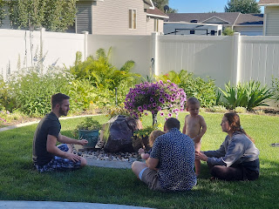

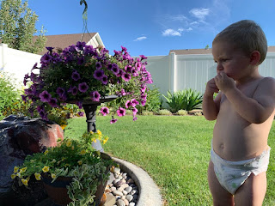

Avery was so sweet saying goodbye to Great Aunt Bevy.

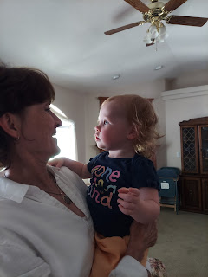

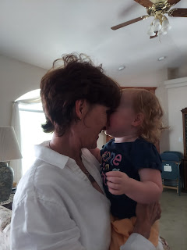

She was a little squirrelly, though, when I wanted a photo of Benson and Avery with Grandpa . . .

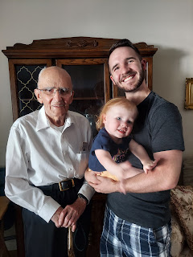

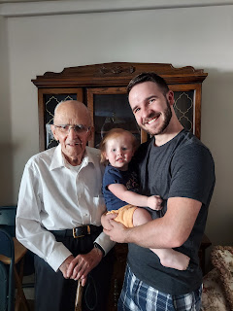

When we got back to my house, the kids just ran and ran and played and played. I got some hilarious videos of some of the fun.

Video #1: Jacob getting "pummeled" in a wrestling match with Avery. (27 seconds)
https://photos.app.goo.gl/acyLsrWDuXyqpG5j9

Video #2: Jacob giving airplane rides to any takers. (1 min, 10 seconds)
https://photos.app.goo.gl/vJ51TidfcXEcpNcr8

Video #3: Jack and Avery running and giggling together (40 seconds)
https://photos.app.goo.gl/4A8arB7n96F1Gbfh6

Video #4: Jack learning how to cut an orange before he went to bed. (57 seconds)
https://photos.app.goo.gl/TWR74XgwDoLu5uK8A

Video #5: Jack cutting a banana and being so proud of himself. (1 min, 3 seconds)
https://photos.app.goo.gl/HBc2fHVPqg6knfJx6

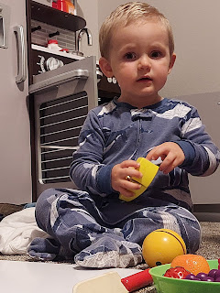

Monday, July 17th:
We only had the morning to spend with Jake, Hannah and Jack, because they needed to head south around 1:00 and drive to Spanish Fork, Utah. Hannah has 3 sisters as well as her mom and step-dad down in Utah, so she was very excited to see everyone!

Hannah and I entertained the little ones for the most part, since Jacob was working remotely for the morning and Benson was working on his car. We played in the back yard for a bit and then took the kiddos on a walk around the neighborhood.

The swing was still wet from the sprinklers, but we just placed a bath towel underneath Jack and he was happy to swing for what seemed like hours. Foxy enjoyed the relaxing time with Jack, too.

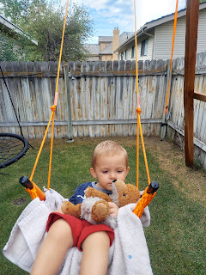

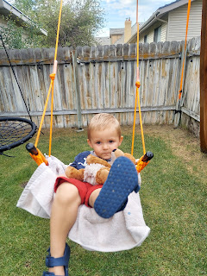

Avery wasn't too sure about swinging by herself, but I was proud of her for trying. :)

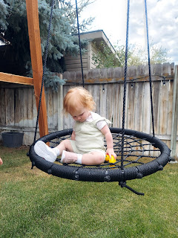

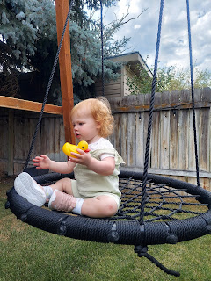

One of the reasons I wanted to go on a walk was because THIS was just around the corner from our house and I knew Jack would LOVE an opportunity to see one up close. He is always so fascinated with large equipment, wanting to hear how each one works and what they are currently doing. This one was just resting, though.

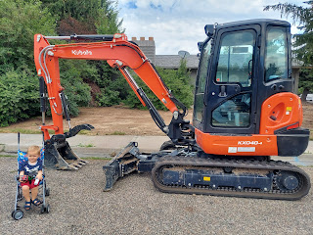

When it was time to say goodbye, Avery was very sweet and full of love. She kept wanting to give Jack kisses over and over . . . I grabbed a quick video of them because this is definitely something to cherish for years to come.

Video of Avery kissing Jack goodbye: (18 seconds)
https://photos.app.goo.gl/5Zss4ZZMHhuqwgDU9

Jack has been taught well how to mimic and repeat words and phrases. But now he has found a way to skip to the end somehow . . . watch this video and see what I mean.

Video of Jack as he's getting buckled into the car: (24 seconds) *The camera did a weird twitching thing - - I'm not sure why, but I'm so sorry!
https://photos.app.goo.gl/pHucsxof68Whgd4C8

A short time after they left, I began cleaning up in the kitchen and found this thoughtful piece of modern art that Jack left for me on the table. XOXO

He is the best.

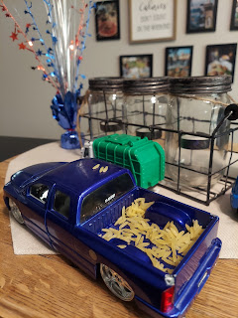

A few final photos that Hannah took of Jack and me . . .

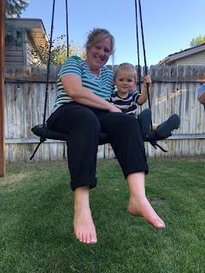

This next one was not staged - it was as authentic as you can get, ha ha. Jack was excited to swing his toy golf club but his mom was asking him to say "cheese" at the same time. Any slight movement made me jump, even though I was pretty clear of his swing area for the most part . . .

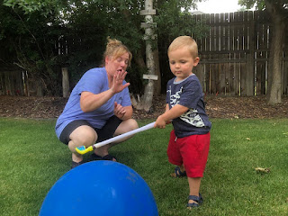

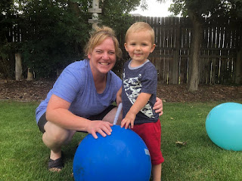

We had SO MUCH FUN over the weekend with everyone there!! It was truly a delight to see Jack and Avery play and giggle and run around together. Sure, there was chaos and mess happening everywhere, but it was overshadowed by all the fun and laughter. I will treasure these past few days for years to come.

Right now, I am getting ready for a big road trip to Oregon and California, so the next post will be from somewhere along the way . . . I'm excited to see family and friends very soon!! XOXO

