Time With Grandma in Salem
Thank goodness my car is so comfy because I have spent a lot of time riding in it lately. The best hack I've figured out when I'm on a long drive is to turn the seat warmer on low (to help my lower back stay happy) at the same time as having the A/C turned up. It's a nice combination. :)

Wednesday, July 19th:
After I finished all my packing, I helped Benson make a huge bowl of guacamole before I drove away. I found out the next day that his dinner consisted solely of chips and guacamole that first night, ha ha. I made good time getting to Meridian (adjacent to Boise) and squeezed in a little bit of shopping before arriving at Mike and Carol's house for the evening (Scott's oldest sister and her husband). Whenever I go to Boise, which isn't very often, I always love shopping at the Town Square Mall. I always seem to have good success in finding clothes there that fit me well and that are complimentary and cute.

This is the welcome mat at Mike and Carol's house. I gotta get me one of these . . .

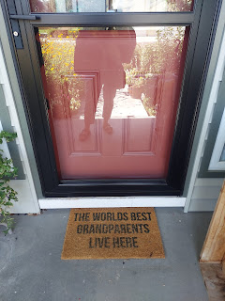

We ordered some protein bowls from Qdoba and watched a couple episodes of The Monarchy (a super informative documentary about the history of the Monarchy in England and Wales, and relations with Scotland and France). It was a relaxing evening and we visited quite a bit, too, even though we watched two shows before hitting the hay. I always feel so welcome at their home.

Thursday, July 20th:
I woke up at 5:13 a.m. instead of 6:00 a.m. when my alarm was intended to get me out of bed . . . not the best way to start such a long day, but oh well. I was out the door at 7:00 a.m. and on my way to Oregon.

Life got a lot more beautiful when I saddled up to the Columbia River and could see it off to my right as I drove west on the interstate.

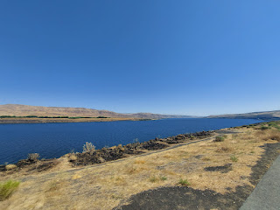

I felt a "pull" to go across the river to Goldendale, Washington again. It feels like a pilgrimage to me to spend a few extra minutes to visit the cemetery where my 2nd great grandmother, Ellen Lambert Baugh Pollan, is buried. Goldendale is only 10 miles out of my way and is a cute small town.

This is a view of the Columbia River from high above on the Washington side once I crossed the bridge.

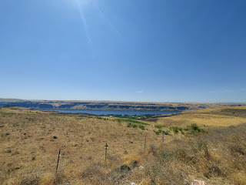

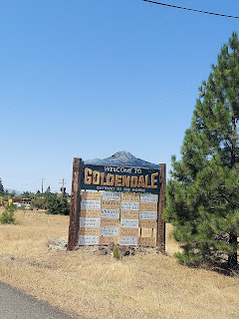

While I ate my lunch in a local diner, I hopped on Ancestry.com and FamilySearch.org to see if there were any clues to an old family residence in Goldendale. First, I found a death certificate for one of Ellen's sons named George Pollan. It lists his cause of death, but it's a little hard to discern what it says, even if you do click the photo to enlarge it. I was grateful for the added family connection shown on the document, because it lists Elnora Lambert as his mother.

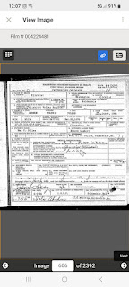

Then, I found a census record for George Pollan that showed his address back in 1940 in Goldendale.
There are some important contextual clues that you can find if you take the time to look closely at the ACTUAL IMAGE on the internet. (versus a list of indexed info that is only partially typed up for you)

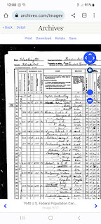

The clues that I wanted in the image above are the streets. In the far left column, the streets are listed, but they are abbreviated in a way that I don't know what the street name is for George Pollan (shown below).

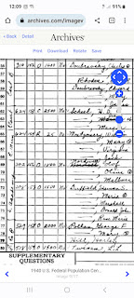

I decided to pull up Google Maps to look for one of the streets that was fully spelled out,
S. Academy
. I could also see E. Main, E. Court, and an "E. B" on the image above. When I cross-referenced this with Google Maps, I could see that a strong possibility for George's street was East Burgen.

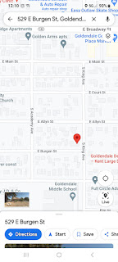

Next, I looked at the column on the census record to see what the house number was: 529. As I started typing in 529 E Burgen St, Google Maps showed me right where it was. And it was the only 529 on any of the nearby streets. Yay! Now I knew where I could take a little drive to see a house where a distant relative used to live in 1940.

Here is the house where George used to live: 529 E. Burgen Street in Goldendale, Washington.

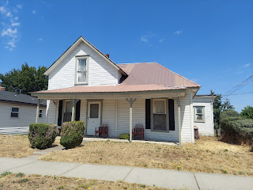

It made me so happy to see it in person! How do I know it was the original house? Well, in this case, it's the architectural style of the 1940's period that convinced me. Other times, I choose to look up an address on Google or Zillow and it tells me the year it was built and what it's worth today.

I made a stop at the grocery store to pick up some fresh flowers, and then it was off to the cemetery. It took me a minute to find Ellen's memorial again, but here's a helpful tip I just learned recently that saved me some time: I typed "Pollan" into my Google Photos using the search option, and I found a photo that I took the last time I was at the cemetery. It had some clues in the background of the photo that helped me triangulate where to go. The photo from last year also had the word "Pollan" as part of the headstone, which is what made it searchable!

I placed the flowers and stood back to admire . . .

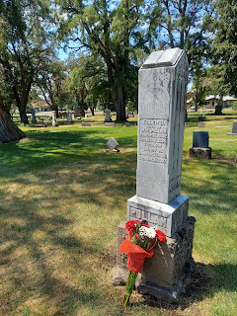

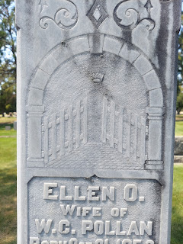

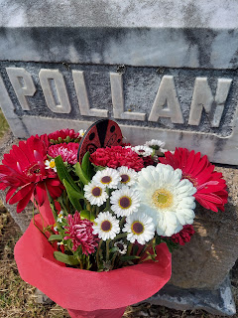

I spent several minutes in front of her headstone, just thinking and feeling and connecting with Ellen.

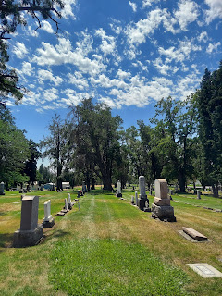

I paused on the way out of town for a quick photo of Mt. Hood off in the distance. It still has some snow near the top.

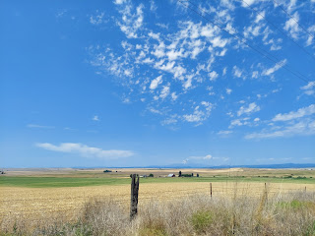

Back down to the bridge again to get across to Oregon . . .

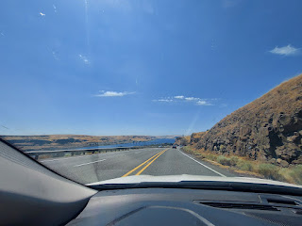

I was looking forward to stopping at Multnomah Falls and kept a sharp eye out for the freeway exit. The waterfall is so close to the freeway, and it's hard to believe that something so beautiful could be that close.

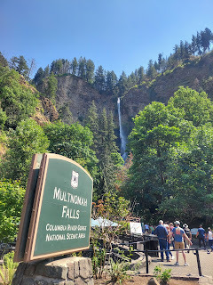

It was a fantastic way to get out of the car for a little bit. The trail up to the upper bridge was just 0.2 miles from where I stood in the next photo.

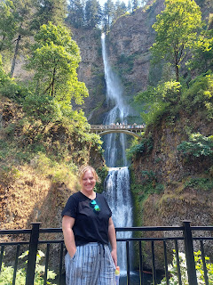

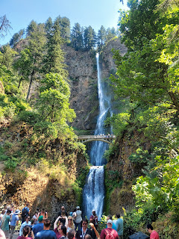

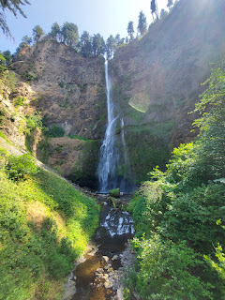

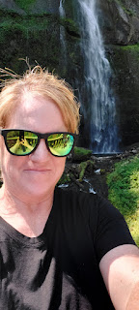

Video #1 of Multnomah Falls: (10 seconds)
https://photos.app.goo.gl/ddgwmMWg1F3HpQ1r8

Video #2 of Multnomah Falls: (14 seconds) You can see the freeway from the waterfall!
https://photos.app.goo.gl/MXPMQZdHriSrhvCN6

This guy wanted to share the beauty of the waterfalls with his three little doggies in the wagon . . .

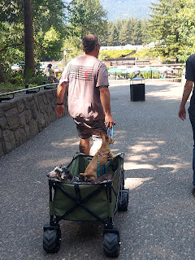

I was grateful that I had that chance to get out of the car, because I was about to get stuck in traffic for the next 90 minutes or so. Blech. Stop. Go. Stop. Go. I thought it would never end. I arrived around 5 p.m. just exhausted. What a long day . . . it all started when I woke up at 5:13 a.m.

Friday, July 21st:
For the first time in FOREVER, I took myself for a nice long walk. About an hour to be exact. I love the hills in the neighborhood where my Uncle Mike and Aunt Suzy live in Salem, Oregon. It makes for an excellent exercise session. I also love the wooded neighborhoods and the homes that are tucked in amongst all the trees.

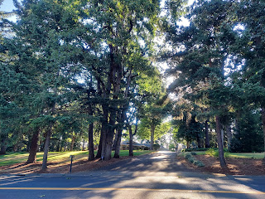

After my walk, shower and breakfast, I went outside with Suzy to gather a few flowers from her yard to take over to Grandma Lillian.

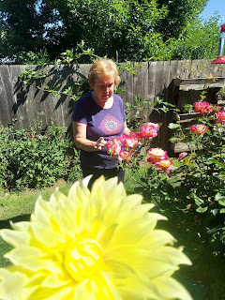

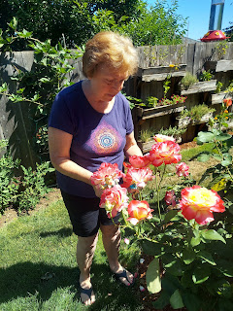

Grandma was so happy to see me! I was only there for about 10 minutes when she learned that her Dr. appointment was much earlier than she had previously thought. She had to be ready in about 5 minutes, which was pretty rushed for an almost 90 year old lady. But she pulled it off.

We got permission for me to ride in the transport van with her to go see the doctor. How fun!

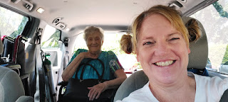

She had a good checkup and was able to figure out a better solution for her pain management, which was very reassuring to Grandma.

I also learned that Grandma's roommate, Alice, is a very talented needlework artiste. She hand-embroiders folksy and cute designs onto white tea towels. Grandma has been buying a few from her, at $10 each. I jumped in to buy two for myself. Here's Alice holding one of the towels that I bought from her.

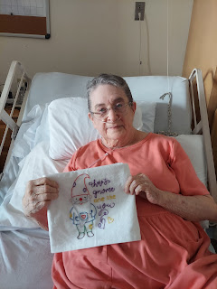

I had an assignment from Uncle Mike to replenish Grandma's bird feeders and get them back up into the tree outside her window. He makes a fresh batch of hummingbird sugar-water regularly and then it just needs to be poured inside the Texas-shaped feeder and hung up.

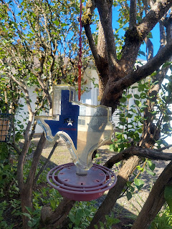

I loaded up the other feeders, too, and she would give me a thumbs up from inside the window with each thing that I did.

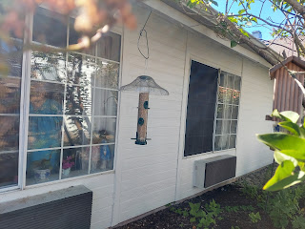

I got home to Mike & Suzy's house around 6:00 p.m. and they took me over to a nearby food truck plaza, with approximately 12-15 options to choose from.

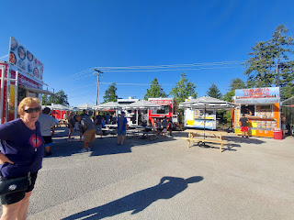

I had a big (and very late) lunch with Grandma and Alice around 3:00 so I wasn't very hungry. I just chose a little empanada with mozzarella, basil, and tomato inside.

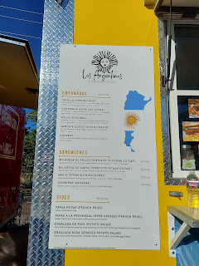

It was super yummy!

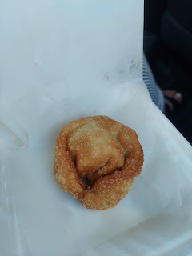

I also got a chocolate covered piece of cheesecake with coconut sprinkled on the outside. It was pretty good, but I think I would have fared better by getting a chocolate dipped banana instead. It seemed a bit much to coat the cheesecake, plus the coating kept breaking off and making a mess.

It was a great first full day in Salem, Oregon!

Saturday, July 22nd:
I went on another long walk first thing in the morning, the same hills and dales as the day before, but in reverse. This time, I was walking mostly uphill instead of mostly downhill.

I made it over to see Grandma later in the morning and she wanted to go on a field trip to Walmart. She thought she would be okay walking along pushing a cart, but within just a couple minutes we had to find her a chair to sit down. I had her wheelchair out in the trunk of my car, but I decided to bring her a motorized cart instead (from the store entrance) and see how she did with that. She was a bit nervous and scared at first, but she gained more confidence as she cruised around the store. I acted as a "scout" to make sure she was clear to pull out into the main aisle, and to also find her a good route to places that might be a bit tight.

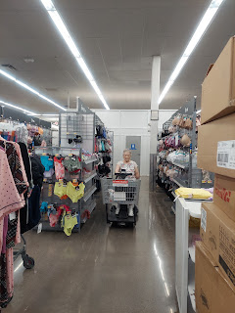

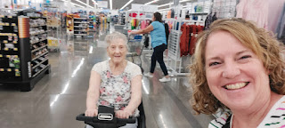

We spent quite a while in Walmart, but it allowed her plenty of time to browse and shop and choose a few things for herself that she doesn't usually have the opportunity to do. We picked up some lunch in the drive-thru at Arby's and took it back to her care home. I helped her sort through all of her clothes, separating out all of her winter clothes and leaving a nice selection of summer clothes behind. The winter stuff will end up in her storage unit until the temperature drops in the fall.

It was a productive day overall, and I decided to let Grandma have some much-needed rest, so I left around 4:00. I had also given her another back massage, which she appreciated so much, so now it was time to allow her some space to close her eyes and not have to "entertain" me.

I had driven past the Capitol Building several times without stopping, but on my way back to Mike & Suzy's, I made it a point to stop and explore. It was hot out (low 90's), but the park adjacent to the Capitol Building had lots of shade and park benches. They do a wonderful job keeping all the gardens healthy and vibrant, and I enjoyed walking around taking a few pictures.

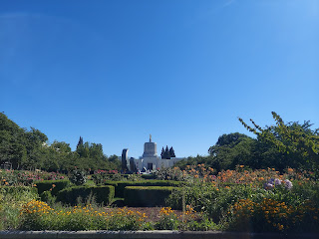

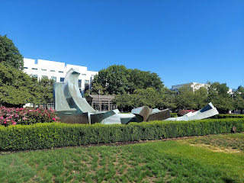

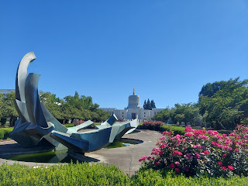

There was a bit of construction outside the Capitol Building, but the fountains hide most of the eyesores.

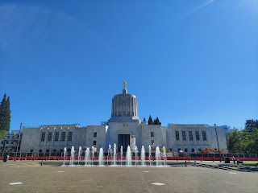

If I had more time, and if it weren't closed because of the weekend, I would love to go inside and walk around. Maybe next time . . .

Final photos of me with Aunt Suzy . . . and Piper the cat . . . (can you tell she was not happy?)

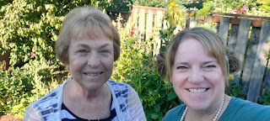

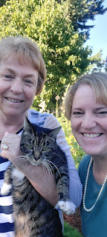

Next up: Drive down into California and spend a couple weeks visiting and helping family members with a variety of tasks. I can't wait to see everyone!!

