How The Rome Temple Changed My Life
At the end of October, I had the most incredible experience as I spent several days at the Rome Italy Temple. The nature of the trip was for ladies within our Venice Stake to be able to attend the temple together as Relief Society "sisters". A notice was sent out by email while I was in Idaho Falls back in August, inviting us to go down to the temple from October 27-30. We would have the option to stay next door in the temple patron housing, as long as we contacted them well in advance to secure a spot. I did that immediately!! I knew right away that this was definitely something I wanted to be a part of.

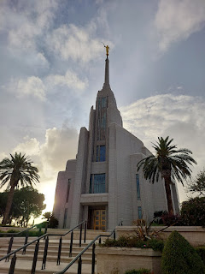

As late October crept closer, two of my dear friends asked if they could ride down with me. We ended up being the only three people to go from our military ward. It would not be an easy feat for many of the mothers to leave their kids behind for almost a full week of school and extracurricular activities, while their husbands are also busy at work on the base, so I completely understand why they couldn't join us.

But I was free to go. And miraculously, we secured our new car just a few days before the big trip, so now I had a new - and much more reliable - car to drive us all down. In addition, I knew Heavenly Father was hearing my sincere pleadings in my prayers as I asked for continued health and blessings. Scott had been sick for almost 3 weeks. In place of picking up his cooties, Heavenly Father gave me a giant cold sore on my lip instead. I was "happy" to have it, especially if it meant I was healthy and capable enough to go to the temple.

The two friends who traveled with me were Terry Sim and Addie Mae Pyne. Terry is serving as a senior missionary here in Vicenza as part of a military relations mission. She is the same friend who accompanied me to all the thrift stores recently. :) Addie Mae has been a sweet friend to me for a couple years now. I first met her when we went on some outings with the "Wednesdays in Italy" ladies group, up until the group fizzled out a little over a year ago. Wednesdays became an early-release day for the school kids, which made it too short of a day to go on our adventurous field trips. We are in the process of aiming to start back up again in January - on Thursdays instead. Also, Addie Mae's husband, John Pyne, teaches seminary with my husband when the world is still dark outside every morning.

Monday, October 27th:
We left Vicenza around 10:00 a.m. with a 5 hour drive ahead of us. We made good time, stopping just once for a bathroom break at one of the rest areas along the way. In Italy, as well as in other countries throughout Europe, the rest stops are not just a bathroom with a vending machine like we see in America. Instead you will find a gas station, a restaurant, and a schnazzy store with the fanciest and most beautiful trinkets and gift options (such as pastel colored pasta, posh jars of pesto, and ginormous chocolate bars). At the rest area where we stopped, there was a McDonald's restaurant, so that's what I grabbed for lunch.

We arrived at the temple around 3:00 p.m., which was perfect because that's when we could also check into our room. We weren't sure if we would all end up in the same room or not, but after asking the man at the desk, he was very accommodating and made sure that we did end up together. If you're a married couple or a family, you will likely get a different type of room. But when you're "single", you get a BUNK BED!!

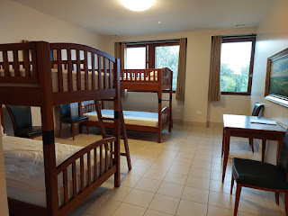

I figured that Sister Sim would want a bottom bunk, and I wasn't sure what Addie Mae would prefer, so I offered to take a top bunk . . . I chose to sleep on the top bunk closest to the window. The front desk gives you a little stack of linens per person, and then you can make your own bed. You receive two flat sheets, a pillowcase, a bath towel, a hand towel, and a wash cloth.

Everything is so organized here. In our little dorm room, everyone had a place marked just for them. When you check in, you are assigned a room with an A/B/C/D to go with your room number. There are four spacious wardrobe lockers in the room, labeled A, B, C, and D, each with a lock to secure your belongings, if needed. Even the bathroom drawers are labeled A, B, C, and D, so you know exactly where you can stash your toiletries or whatever you want.

After we settled in and assembled our beds, we walked next door to see the temple. YAY!!

Terry, Me, and Addie Mae . . .

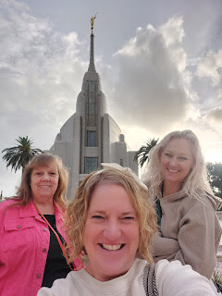

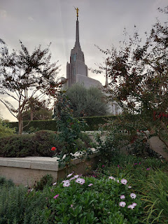

We drove to the nearest grocery store, a Lidl, where we found some items to feed ourselves for the next few days. I grabbed two marinated salmon fillets, salad fixings, some fruit, and a couple varieties of dark chocolate. In the temple patron housing building, there is a kitchen and a large cafeteria area for dining. Each person has an assigned shelf "cubby" in the large, industrial-sized fridges, and everyone has a pantry cupboard for any dry goods, which also locks.

The kitchen has multiple microwave ovens, regular sized ovens, induction stoves, dishwashers, sinks, and all the plates/bowls/pots and pans you could ever possibly need. There are cupboards marked and stocked with cleaning supplies, and everyone is expected to clean up after themselves - both in the kitchen and also at the table where you sat to eat.

There are also labeled recycling bins for any aspect of your waste. I observed many families and couples preparing their meals that week, and I loved what I saw. (More on that in a minute)

When it was time to cook up our dinner, and while the oven was preheating, I popped outside to take another photo of the temple as dusk was fast approaching. The moon was barely becoming visible above the middle section of the temple . . .

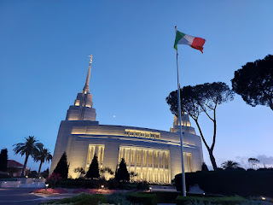

This is just one scene that I sneakily captured of an older couple sitting down to eat . . .

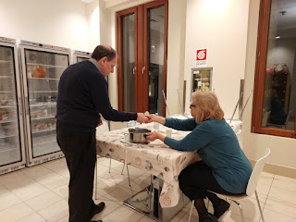

They brought their own tablecloth to dress the table (in typical Italian fashion). Also - you can see some of the large fridges behind them, where each guest had their own half-shelf area with a divider in between.

Over the course of the next few days, here were some of my observations:
Families tended to cook their meals from scratch, some were more elaborate, but all were made with healthy ingredients.
Everyone had a job within each family: I saw a grandpa coring several zucchini, removing the seeds and scraping the fleshy parts out so that the zucchini could be chopped and added to the rest of the ensemble. I saw teenagers manning the stove, cooking up some pasta for dinner, and cooking up a large pan of scrambled eggs for breakfast. I saw younger children cleaning and setting their table, skipping and humming as they went back and forth.
Everyone was respectful and very mindful of cleaning up their dishes, the countertops, the sinks, wiping down their table with cleaning spray, sweeping the kitchen floor, etc.
It was all very homey and beautiful, and my heart felt warm and fuzzy.

We met a family from Slovenia who had traveled with multiple generations together. Grandparents, children, and grandchildren had all come to worship in the House of the Lord. They have one week in the fall where the children are out of school, and they chose to come to the TEMPLE. What a powerful example of what it means to focus on things that matter eternally - more than anything else. I'm sure there were sacrifices made in order for them to travel such a great distance, taking time off work, etc. But they will be so blessed for their efforts.

Terri and I spent a fair amount of time outside after dinner, while Addie Mae checked in with her family over the phone.

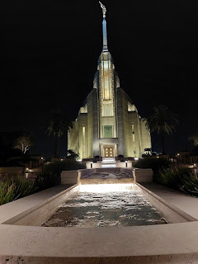

Video of the comforting sounds of the water trickling down from the temple entrance: (10 seconds)
https://photos.app.goo.gl/EsMfrFiAppmrRu1PA

Terri had never been in the Visitor Center before, so we walked over there next.

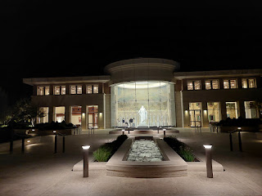

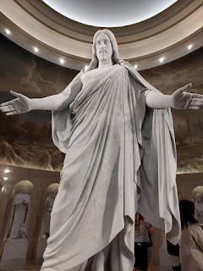

We read about the missionary efforts in Italy and how The Church of Jesus Christ of Latter-day Saints evolved here.

As per the sign below: "In 1980, the first Church meetinghouse in Italy was completed in Pisa. In 1981, the Milan Stake (similar to a diocese) was created and led by local Church members. Today, Latter-day Saint congregations in Italy are scattered throughout all Italy.

"As the Church has grown, it has received more recognition and respect. In 2012, with President Giorgio Napolitano's signing, The Church of Jesus Christ of Latter-day Saints obtained full official acknowledgment on the Italian territory.

"Pisa, 1977. President John Grinceri (the first from the right) breaks ground for the first meetinghouse in Italy for the Church.

"Pisa, June 1980. Completed meetinghouse."

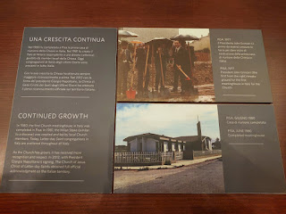

Standing next to the Christus statue was a good way to end our first day.

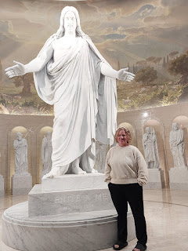

Tuesday, October 28th:
We had each booked our own temple appointments before the trip. I was the first to make an itinerary, and both Terri and Addie Mae followed my lead and chose similar temple sessions, too.

On this day, my schedule was as follows:

9:00 Endowment session
1:30 Endowment session
4:00 Sealing session

Before entering the temple around 8:30 in the morning, I noticed an old olive tree in the courtyard that I hadn't really paid much attention to before. What caught my eye was the black olives that had randomly dropped down to the ground below. Olive trees have been incorporated into many parables and teaching opportunities through thousands of years.

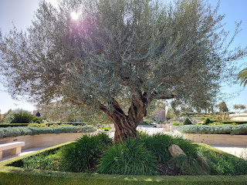

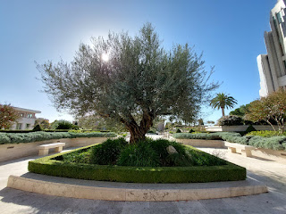

Olive trees have also been an essential source of food, lamp oil, medicine, annointing oil, sacrificial oil, and wood for furniture. Olive trees and their branches are considered symbols for peace and reconciliation.

I read on this website (
https://www.gotquestions.org/olive-tree-Bible.html
) that just as olives are beaten and crushed to produce olive oil, Jesus Christ was beaten and crushed on the cross. Gethsemane, where Jesus prayed mightily in our behalf, as part of His Atoning Sacrifice, is a place known for its ancient olive trees. The name Gethsemane means "olive press".

Just a little something to ponder . . .

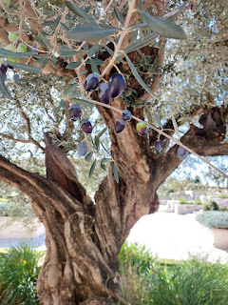

Time to enter the temple . . .

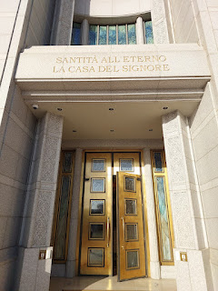

I change into my white temple dress each time I visit the temple. Everyone who enters the temple comes inside in their everyday clothes, but we change into our white temple clothes first thing. The men wear a white shirt, white pants, and a white tie. The ladies wear a white dress that is typically full-length. Something I love about everyone being dressed in white is that we are immediately equalized. We are all children of a loving Heavenly Father and we are all equal in His eyes.

In the Rome Temple, it is a little harder to concentrate during the instructional film of the endowment session because A) the language is in Italian, and B) the volume is usually quite loud. I had my headset on and tuned to the appropriate channel for English, but I had to turn it up louder to match the volume coming through the speakers.

I had to intensely focus in order to hear the words as I was taught several eternal gospel principles, beginning with the creation of the world. It was difficult, but still meaningful.

After the session was over, and after I had finished a comfortable lunch break in the cafeteria next door, I entered the temple again for another endowment session at 1:30.

As the session began, and all throughout the next hour or so, I marveled when I realized that I didn't have to concentrate nearly as hard this time. The loud Italian words that attempted to fill the room from the speakers did not overpower my ability to hear the translated words floating into my ears through my headset. It was as if the Italian words were muted a bit, blurred, and even faded into the background of my brain. I didn't have to earnestly struggle anymore to hear the word of the Lord. Everything felt very comfortable and natural, as though the ONLY thing I could hear were the words gently piping through the foam ear cushions and into my brain. IN ENGLISH. It was quite remarkable.

This made me think of how we tend to struggle every day to hear the Lord's voice. The world is loud, with a variety of voices in multiple languages all vying for our attention. Peers, social media, music in all its forms, demands at work, and the needs of our own family members all compete for our attention and our focus. It takes WORK just to listen through all of the daily noise in order to hear what God is trying to tell us.

Maybe He wants us to do something differently. Maybe He wants us to help a certain person. Maybe He wants us to remember something important. Or maybe He just wants to remind us how much He loves us.

If we don't put in the effort to HEAR HIM, then His voice will easily be drowned out by everything else that is blaring through earth's speakers. We need to make a concentrated effort to listen for HIS voice above everything else.

Realizing this precious truth was just the beginning of my change of heart . . .

Both Addie Mae and Terri joined me for the 4:00 sealing session, as our final contribution of the day. As members of The Church of Jesus Christ of Latter-day Saints, we believe that families are at the heart of everything God has created for us. He wants us to be united as families for eternity, where death does not separate us, but where we can be bound together forever. This sealing ordinance can only take place in the temple, His Holy House. We have the honor and privilege of acting as proxies for our deceased ancestors by being sealed as family members in their behalf, one of the most special and most sacred ordinances in the temple.

Two very short reads:

To find out more about what it means to be sealed as a family, visit here:
https://www.churchofjesuschrist.org/temples/what-happens-in-a-temple-sealing?lang=eng

And to see a picture of a sealing room and to learn a little more, visit here:
https://www.churchofjesuschrist.org/study/manual/families-and-temples/what-is-the-temple-sealing?lang=eng

The sealer in the Rome Temple, a man who had been set apart and ordained to this calling, spoke very limited English. For the most part, he performed the sealings in Italian. We had a laminated card to read the English translation during the ceremony. He also switched over to practicing his English a few times, which was so sweet.

As we walked out of the temple an hour or so later, the sun was setting and everything was so peaceful.

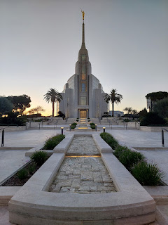

This was the first time I had ever spent more than just the typical 2 hours in the temple. And I was starting to understand just how special it was to be here for a much longer time frame. Instead of the temple just being a temporary place of refuge from the craziness and chaos of our daily life, it now felt like HOME.

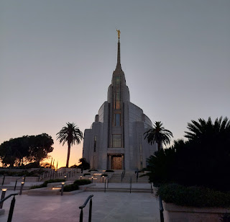

Addie Mae was hoping to connect with a missionary couple who are friends with her mother back in Arizona, so we stopped over at the Visitor Center before heading back up to our room to change clothes. Each temple throughout the world typically has a Visitor Center. This is a place where people who are not of our faith can learn more and ask questions of the missionaries who serve here. It is also a place where family members can hang out and relax in between temple sessions, especially kids and teens as they wait for their parents to finish. There is usually a room with faith-filled movie options, too.

On display in the Visitor Center was a circular table filled with Books of Mormon in a multitude of different languages from around the world. We believe that the Bible is a book of holy scripture, as long as it is translated correctly. And we also believe that the Book of Mormon is a book of holy scripture meant for our day.

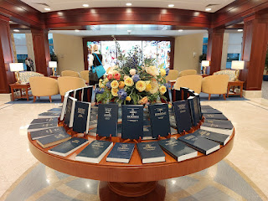

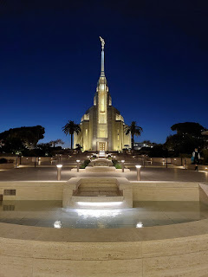

Terri and I cooked up a second round of salmon fillets for dinner, while Addie Mae heated up some of the soup she had brought in a cooler from home. We joined up with the other ladies who had traveled down to the temple from the Venice Italy Stake. We had the BEST TIME getting to know them!! There were ladies from Pordenone, Trieste, and Venice - all Italian-speaking, of course. But a couple of them were pretty good at speaking English, thank goodness!

The Venice Stake consists of 8 wards and 3 branches (much smaller congregations).
Wards: Bologna, Mestre (Venice), Padova, Pordenone, Pordenone Military, Trieste, Vicenza, and Vicenza Military.
Branches: Ferrara, Gorizia, and Udine.

All but the two military wards are Italian-speaking. So when we have stake conference, it's in Italian. When there is a large youth activity, such as Girls Camp, it's primarily in Italian.

I met Chiara (kee-AW-ruh), a larger-than-life personality from Trieste, which is up close to the Slovenia border. As we commented on how nice it was to gather the Italian ladies
with
the English ladies at the temple, Chiara told me how she used to serve as a Girls Camp leader for a number of years in our stake. She didn't like how the Italian girls would congregate separately from the English-speaking girls. She wanted a way to bring everyone together, so she asked a couple of the American girls to teach her some of their favorite girls camp songs. One of those songs was: Boom-Chicka-Boom. She not only used this to help bring all the girls together with a fun song at camp, but she started singing it at our table in the cafeteria, too, ha ha. I was the only one who responded and sang it with her, but we had a great little bonding moment. :)

L to R: Chiara is in the glasses wearing white, ______, Maria, several ladies whose names have escaped me, Lolly (in yellow), another Maria, then Addie Mae, Terri, and Me.

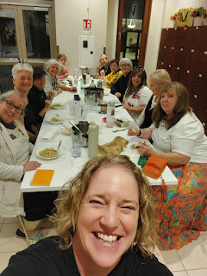

A couple of the ladies made a big pot of tea for everyone to share, with multiple tea bags hanging over the side of the pot. I took a short video snippet for an upcoming Instagram video because I felt like it captured the moment so perfectly.

Video snippet: (3 seconds)
https://photos.app.goo.gl/ve97nBWTEcjkMBVs7

It was so nice to get to know everyone around the table. One of the ladies served a mission in England a long time ago, so she knew English really well. Another lady was blind, but another lady from her ward helped her everywhere she needed to go - from their room upstairs into the elevator, down the hall to the kitchen, outside and across the courtyard to the temple, getting dressed in the temple, etc. It was such a sweet thing to watch. One of the ladies, Maria, had a tramautic brain injury a while ago. She was super conversational with each of us, even though we didn't always understand her. She would speak with a mix of Italian and Romansch (Romania), with an occasional word in English.

I'll tell you about Lolly in a minute . . .

Partway through the table conversation, I got a text from my sister-in-law Pam back in West Virginia, saying that she was available for a phone call. I had reached out to her earlier that day because she was in my thoughts. I hadn't spoken to her directly yet since we found out that she had terminal brain cancer back in September . . .

I excused myself so that I could call Pam privately and then I headed outside where I could stand and see the temple during our phone visit.

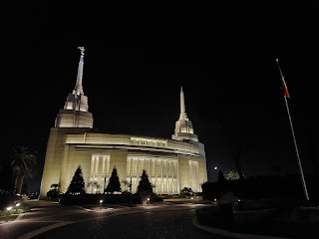

We talked about all kinds of things, and I just let Pam take the lead on whatever she wanted to talk about. I also learned more details about what she was going through. As of a month ago, she had just started both chemo and radiation. She was a little over one week into Round One of both treatments as part of the process for qualifying for a cancer study that she had been accepted to. This study will potentially prolong her life and they will also pay for all the medications. She just needs to have completed one round of chemo + radiation prior to beginning the study.

She told me that the chemo was going alright so far, although she was expected to start losing her hair a couple days after our phone call. She has since shaved it all off. The radiation was much more difficult for her, mainly because she suffers from claustrophobia.

I didn't know this, but with radiation, you are fitted with a face mask of sorts that they anchor down to the bed securely so that you don't move at all during the procedure. She was so afraid of doing this, that she had delayed the treatment for a few days until her oncologist told her that she needed to start immediately or else she would be expediting her DEATH. He basically said that every day that she delayed the radiation was a day that the cancer would find new opportunities to grow and multiply. They needed to kill it when it was at its weakest point after the tumor had been removed.

He had offered to prescribe something to help her to calm down for the treatment, but she had resisted until he emphatically convinced her to get the ball rolling. She now takes the prescribed pill (lorazapam I think it is) to help her relax and not panic, and then she gets all strapped in for the radiation which lasts roughly 8 minutes. She told me it was about 4 minutes too long, but she was powering through as best as she could.

She has been taking a separate pill each day for the chemotherapy, seven days a week. The radiation therapy is 5 days a week, with Saturdays and Sundays off. The entire round for both treatments is supposed to last between 6-8 weeks and she is due to finish up either the first or second week of December.

We talked about her family and how they are handling everything. I expressed my love for her and how I would love to be able to do something to help her. We brainstormed a few ideas, and then settled on me coming out there to stay with her for a little bit in January. She wants me to help her organize some photos and things like that so that her kids and grandkids will have a place to connect with her long after she is gone.

She felt silly at one point in our phone call, joking about a few random things. I just followed suit - whatever her lead was, I was right there, too. She thanked me at one point, telling me how nice it was to be free to say whatever was on her mind without any fear of offending (i.e. her immediate family). She said that sometimes she just needs to let off some steam, and that she's been told things like, "Mom! You shouldn't joke about something like that!" or "Mom! That's not okay to say out loud."

She told me she needs an outlet from time to time - to just be "inappropriate", ha ha. I told her she had a safe place with me in that regard. If she needed to cry, I would cry with her. If she needed to rant, I would graciously listen. If she needed to be inappropriate, I could also be inappropriate with her. :)

It was getting late in Italy and I was ready to go to bed, so I was the one who made the move to end our conversation. All in all, we talked for 1.5 hours!! I think she really needed that. And so did I. I pray for her every day and I am looking forward to spending time with her in January, helping her in whatever ways she needs.

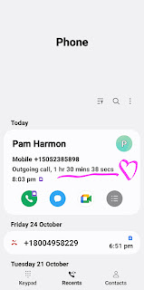

Wednesday, October 29th:
After a good night of sleep in my bunky-bunk, I was ready to enter the temple again. I started the day in the baptistry area of the temple. This is where we can be baptized on behalf of deceased ancestors. We act as a proxy for each individual (those who did not have the opportunity to be baptized while alive), and then they are free to accept or reject the ordinance in heaven. No one is ever forced to comply with the "offering" that we perform in their behalf. They are always free to choose.

I looked for a photo of the baptistry inside the Rome Temple, and I came across this article. This was written around the time of the Open House in 2019, when anyone could come and walk through the temple before it was officially dedicated. The article has
several photos
of the interior of the Rome Temple, so enjoy!

Article here: (including a 9 minute video tour of both the inside and outside of the temple)
https://www.ldsliving.com/see-first-official-photos-inside-the-rome-italy-temple/s/90088#:~:text=Original%20paintings%20hang%20in%20all,that%20join%20families%20together%20forever.

The weather was perfect for the last week of October - mid to upper 60's. My favorite kind of weather.

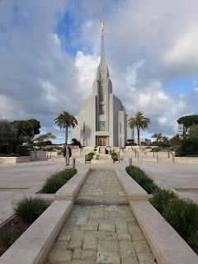

The beautiful spirit of the Lord's house continued as I waited in the baptistry for my turn. There was a family from the Sicily area that I had a chance to visit with earlier that morning. The dad was from the U.S. and the mother was from Italy. They spent a few years living in the U.S. and they just recently moved back to Italy so she could be closer to her side of the family. They had a teenage son, maybe 17 or 18 years old, and a teenage daughter, maybe 15 or 16 years old. I'm not sure what they did for work in the U.S., but in southern Italy the mother works at the front desk of a hotel and the father is not currently working. They seemed like they were doing pretty well for themselves with just living off one income.

In the baptismal font in the temple, this father and son duo traded off helping to baptize several patrons who had come that morning. It was the sweetest thing to watch the son baptize his own father, and then his younger sister. He would pause regularly to make sure she was okay as she wiped the chlorinated water from her eyes and face. I could tell that they were all very close as a family and that they treated each other with kindness and respect.

I was baptized for 6 of my ancestors and then I quickly showered (basically just a rinse-off) and got dressed in my white temple dress. I love that the temple provides a zippered jumpsuit for those coming to perform vicarious baptisms. It sure makes everything run more smoothly and efficiently.

After a shortened session of initiatory work (there were just so many ladies who were waiting to do this - and they had to shorten my six names down to four), I was eventually able to change back into my own church dress and head back up to our dorm room to shower for realsies.

View of the patron housing looking down from the second floor . . .

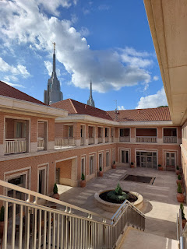

As I ate my simple lunch - a peanut butter/nutella sandwich that I had brought with me, I had a few minutes to contemplate the sweet spirit of yet another day at the temple and what I was feeling. I felt full of gratitude for this experience. I was filled almost to the brim with the love of our Father in Heaven. I felt calm. My perspective had widened and I felt like I had a deeper understanding of eternity and what truly matters most. I felt empowered - almost as if I could truly conquer anything that came my way. I felt enriched - knowing that the temple ordinances were not only for my ancestors, but the words, the instruction, the promises, and the feelings were also for ME.

What I was just starting to realize was that by being in the temple for MORE HOURS at a time, I felt more blessed and more filled than I had ever been before. Attending the temple for a 90-minute session is great, don't get me wrong. But because of this special experience of being AT and IN the temple for multiple sessions and multiple days, I don't know if I can ever go back to just "one session".

I think this is my new plan going forward: Be intentional about being in the temple for longer. Maybe half of a day, or perhaps a full day. And since temples are so far away from Vicenza, I think it would be lovely to stay overnight and continue with more time in the temple the following day. I know that we will be filled more completely by doing this and that we will be blessed beyond our comprehension.

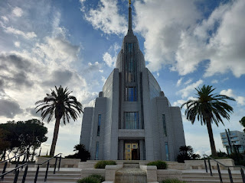

I attended one final endowment session with both Terri and Addie Mae. I was sad that things were coming to a close . . .

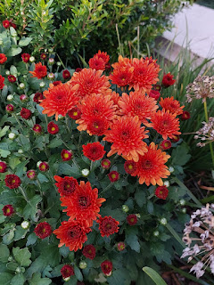

These cooler weather flowers were healthy and happy all around the temple campus . . .

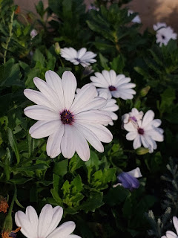

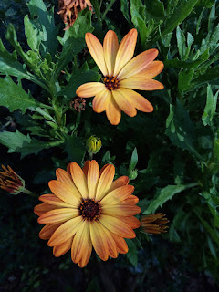

The Rome Temple is extremely close to both a huge shopping mall and IKEA. It was more convenient to visit the IKEA here, rather than driving to Padova - which is about a 40 minute drive from Vicenza. I needed something very specific, and a couple other items as well. I can't say what they were because they are part of a series of Christmas gifts for my family and extended family, but I will say that I found what I was looking for pretty quickly. :)

We had planned to grab something to eat after our trip to IKEA, but since Terri is gluten-intolerant, we had to choose carefully where to go. After filtering the list of restaurant possibilities for places that offered gluten-free items, I saw one that looked promising. Terri gave the thumbs up and then we piled into my car in the underground parking at IKEA to head over to the mall next door.

It was a bit of a spaghetti maze to get from IKEA to the mall, with all sorts of roundabouts, lane split-offs, and exits. We (I) mistakenly took the wrong one and we ended up back at IKEA again, ha ha. It added an additional 8 minutes to our drive time as we made the second attempt. When we finally found parking as close to the restaurant as we could (Terri has trouble walking long distances - she's had both knees replaced), and as we came up the escalator, we saw that we were only like 200 feet from where we parked underneath IKEA just a few minutes earlier!!!! We could have just WALKED from there and saved ourselves almost 20 minutes of driving around through all the spaghetti loops . . . lol.

Take a look at this map . . . The temple is down in the lower right, and IKEA and the Mall are super close, but look at all the roads to get from one to the other. It's a crazy series of one-way lanes that lead all over the place, even though everything is so close, ha ha.

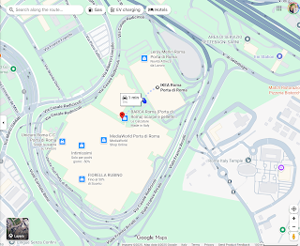

Anyhoo . . . the restaurant that we had chosen (because it said on Google that they had gluten-free options) did not pan out. All they had for gluten-free was a small pita that goes with a charcuterie platter. Thank goodness a McDonald's was next door in the mall, so that's where we went. And just so we're clear: McDonald's is a huge step above the ones in America. I wouldn't want to eat here every day, but in a pinch, I'll do McDonald's in Europe. NEVER in America.

We grabbed our food and hurried back over to the temple patron housing because there was a special evening planned with all of the Relief Society ladies from our stake. First they wanted to do a song practice, and then we would be performing the song for the Temple President and have a little meeting with him. We didn't have any time to eat our food because it took so long to get from IKEA to the Mall, sadly. So we tucked it into the kitchen and hurried over to the Visitor Center next door.

We met in a conference room within the Visitor Center and we all sat in a huge circle.

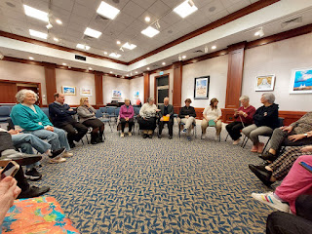

Chiara is animatedly talking about something next to the temple president . . .

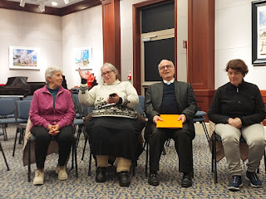

We sang the song, "How Firm a Foundation" for him and of course (!) we sang it in Italian! It was really lovely. He spoke to us about how wonderful we are and how, as God's daughters, we have a special mission to bring the Light of Christ to the world. He had us break out into groups and we had to use the Gospel Library App to find answers to some questions relating to the parable of the Ten Virgins. He wanted us to specifically find pertinent topics in the General Conference section and then appoint a spokesperson for our group.

We were so blessed to have Nicole Southworth with us on this trip. She is a recently returned missionary from the Vicenza (Italian) Ward and speaks almost flawless English. She sat behind Addie Mae, Terri, and me and quietly translated everything that the temple president (and anyone else) said. If it weren't for her, we would have been so lost!

After 40 minutes or so, the temple president needed to leave. But the ladies from the Venice Stake wanted to have a testimony meeting before we parted ways. It was so amazing. It felt like the last night of Girls Camp, but in a much more mature and reverent way. Nicole translated everyone's beautiful testimonies for the three of us, including translating in reverse when I wanted to share some of my own thoughts and feelings to the group.

The last lady to share her testimony was Lolly. I didn't even know her name at this point, but we shared an incredible bond from that night on. She told the group how much the temple and the gospel of Jesus Christ means to her. Her husband passed away about 14 years ago, and she told us how she still feels his closeness every single day. When she goes to the temple, she feels like he is there. When she lays down in bed at night, she feels like he is there. She even tells him, "Hi," and he tells her "Hi" back. It was the sweetest thing ever. She testified that life continues after death and how grateful she is to be sealed to her husband through the ordinances in the temple.

After the testimony meeting, I went over to hug her. We didn't speak the same language, but we connected through the spirit of God. She cried on my shoulder and I cried on hers. Nicole came over to help translate, letting me know that Lolly was trying to say thank you to me for what I shared in my testimony. It must have meant a great deal to her because she cried a lot. She cupped my face in her hands and then kissed each of my cheeks. It was one of the most precious things I've ever been a part of.

After hugs were exchanged and teary faces were haphazardly tidied up, it was announced that a group photo was needed. Great - I always have the reddest face on the planet when I cry . . . But I agreed nonetheless. First we took a photo in front of a stained glass panel that encompasses every single one of the parables that Jesus shared when He was on the earth.

I'm in the long black dress, and Nicole is kneeling down in front with her mother. Lolly is two people over to my left, with a dark blue jacket and a purple purse.

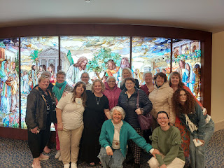

Then we migrated into the other room of the Visitor Center where the Christus stands in front of all the early Apostles . . .

I am on the far right . . . and Lolly is two ladies over to my right (in front of Jesus).

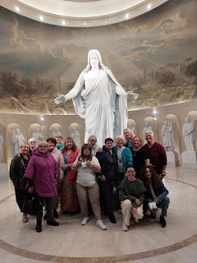

Wow. What a way to wrap up four incredible days.

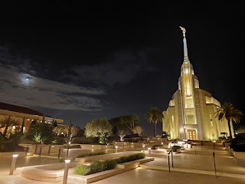

Later that evening, I was finally able to eat my cold McDonald's dinner (after 9:00 p.m.) and it was delicious. I didn't even care.

Some of the other ladies from our stake wandered into the kitchen area for a snack or to make some tea before bed. That's when I spotted Lolly again. She came over and hugged me tightly again, kissing my cheeks and holding me close. I asked Nicole to come help translate for us again, which she happily did.

I was able to find a way for us to communicate on our own going forward. We found her on Facebook and we also exchanged our phone numbers and sent a test message on WhatsApp. She has been texting me every day since, sending me cute and cheesy photos of things like a puppy holding a pink rose in his mouth with the caption "Per te...buongiorno." Which means, "For you...good morning." She is in her 80's. What a sweetie. XOXO

I blacked out her identifying information on Facebook, but you can see a photo of her and her husband.

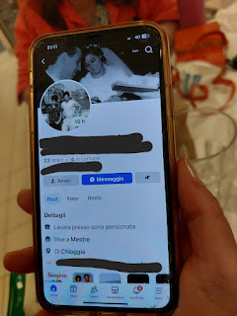

Thursday, October 30th
: We cleaned up our room, took our linens down the hallway to send down the laundry chute, vacuumed, and then went down to the kitchen to make our last breakfast.

We said a few more goodbyes, took one last photo, and then we were off . . .

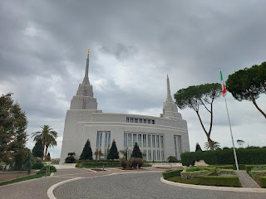

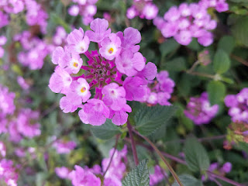

We got home to Vicenza a little after 2:00 p.m. on the day before Halloween.

But I can still remember sitting in that endowment session at roughly 2:00 p.m. on Tuesday, October 28th. That's when I felt my change of heart take place. That's when I knew that I wanted to be in the temple longer and more often. That's when I could hear the voice of the Lord over any other noise that was trying to penetrate my soul - good or bad. That's when I gained a sure knowledge of how and where and why it's so important to be able to hear God's voice in my life.

I am forever changed for the better.

