A Day in Bern & Detective Work in Germany
*Cities listed in this post:
Bern, Switzerland
Solothurn, Switzerland
Aarau, Switzerland
Eichen, Germany
Schopfheim, Germany
Wieslet, Germany
Vicenza, Italy

Continuing on from my last post and recounting our weekend in Switzerland: We drove about 45 minutes SW from Aarburg to attend the Bern Temple last Saturday morning (March 23rd). The Bern Switzerland Temple was built in 1955 and was the first temple to be built in Europe for the Church of Jesus Christ of Latter-day Saints. It is a smaller temple and has very simple landscaping on the temple grounds, but it is still very beautiful.

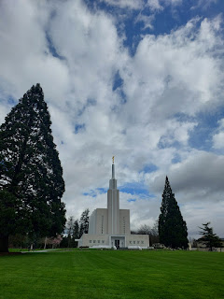

It was extremely cold that morning, with a brisk wind to boot.

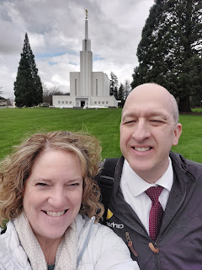

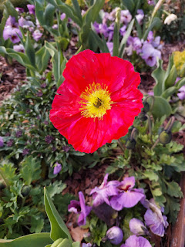

We stopped at a nearby shopping mall to find some breakfast before we arrived at the temple. German pretzels are just SO GOOD. I find them to be worth all the carbs, ha ha.

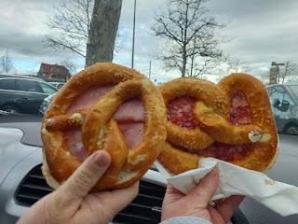

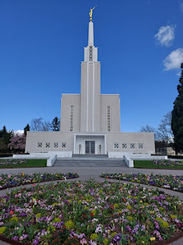

The temple session was wonderful, as usual. During the instructional video, Scott and I wore a little headset with English translations piping into our ears, which was very helpful. I learned from the girl next to me that the Bern Temple typically plays the video in either German, French, or Italian, because those are the 3 countries that surround Switzerland and are therefore the most prominent languages spoken there. The closed captioning was in what appeared to be Italian, even though what we heard through the speakers came out as French. I had to concentrate and focus in order to distinguish the English words being spoken into my ears.

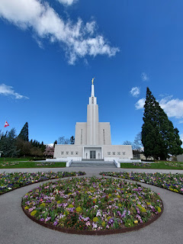

Adjacent to the temple sits a building for temple patrons and is called "Patron Housing". You can stay overnight there, similar to a hotel, but it is free. We used the bathrooms downstairs to change into more comfortable clothes for going into the downtown area of Bern, and then we took a short walk through the woods behind the temple.

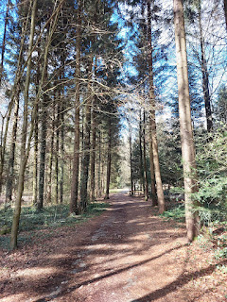

There was a beautiful clearing with a firepit just a few paces down the trail, which I assume is for youth group gatherings and maybe for holding a testimony meeting.

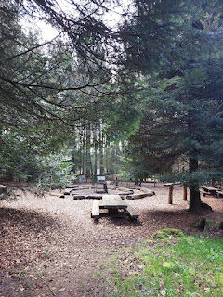

We were lucky to get a parking spot near Bern's Old Town and the Bear Pit. Unfortunately, we didn't see any bears because they hadn't come out from their hibernation period yet. So we ended up just walking through the area a little more briskly - - especially because it was FRIGID that day. If the wind hadn't been blowing, it would have been fine . . .

What the Bear Pit looked like in 1857 . . .

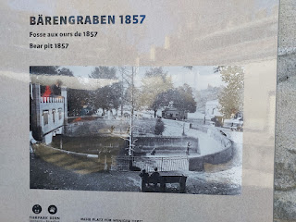

And what it looks like today . . .

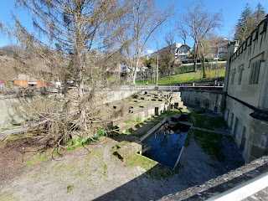

A little history of Bern's bear pits and how they came to be: But first, Bern is pronounced more like you're saying the word "bear" with an "n" at the end.

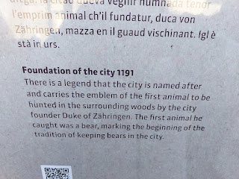

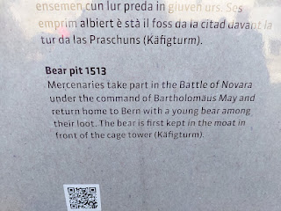

Me with my ginormous winter coat on . . .

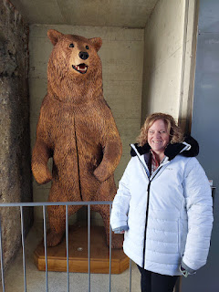

The bear habitat has been extended in recent years to include several more acres along the Aare River. What a spectacular view they get to have . . .

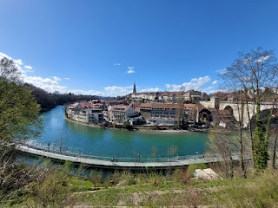

This next photo has an explanation (and a visual) of how much weight the bears lose during their long winter's nap. (click photo to enlarge)

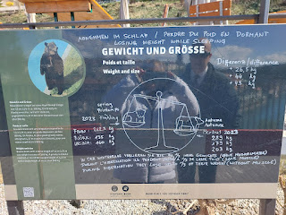

These steep stairs took us down closer to the river, where we could also wander along and see the occasional bear dens that were tucked into the hillside.

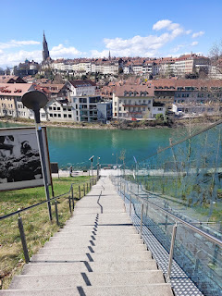

The sun felt amazing, even though it was such a cold day outside.

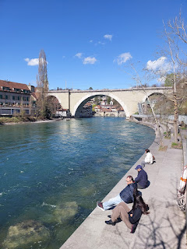

We were still close enough to where we parked our car at this point, so I swapped my huge, fat winter coat for a lesser layer. All that walking, along with the hefty stairs, made my core temperature go up, ha ha.

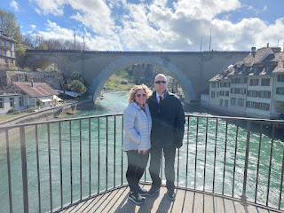

We crossed the Aare River and began a little explore in the Old Town area of Bern. It was so charming! The buildings and the architecture, the history and the unique features all made it really special.

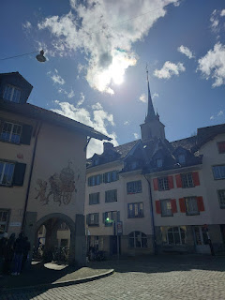

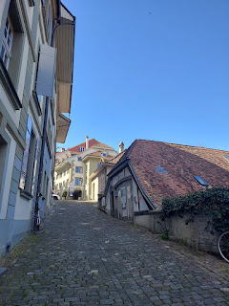

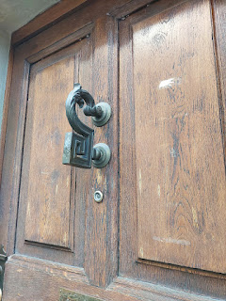

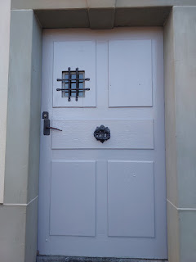

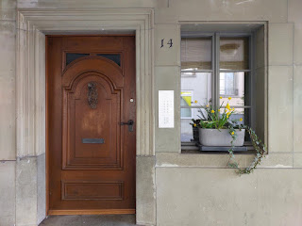

Again, that silly German word that means "exit" . . . but Scott took it to a whole new level. LOL

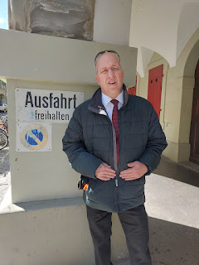

Below: That's me on top of some tall steps, overlooking the water fountain below. We both thought it was curious that there was a set of steps going up there, so I decided to climb up for a photo.

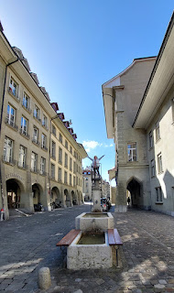

When I came down the stairs, I noticed this plaque on the building to the right. It says:

"The judiciously positioned present-day fountain was erected around 1820 below the Staatskanzlei (state chancellery), in the place of an older fountain. The longitudinal trough is supplied by a square fountain column in the shape of a pedestal, supporting a short column stump. In 1992, Bernese artist Carolo Edoardo Lischetti created something of a Speaker's Corner with steep steps leading up to the podium on the column stump. Anyone could now emulate the famous figure fountain and try their hand as a fountain figure."

Ha ha, well that's pretty much what I had just done.

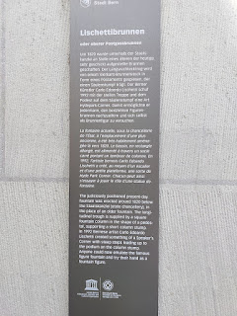

The Church of St. Peter and Paul, a Christian Catholic Church, whose doors first opened in 1864.

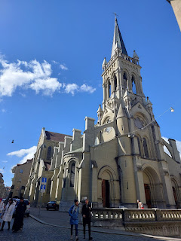

A little bit more info about the church . . .

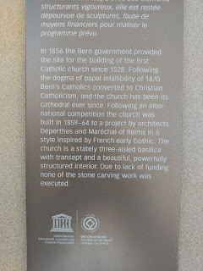

Now there's a super handsome guy, adding to the intrigue of this old church . . .

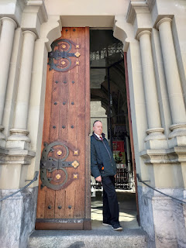

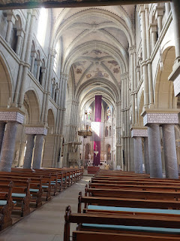

I was touched by a note that someone had written in the guestbook inside the church: (click photo to enlarge)

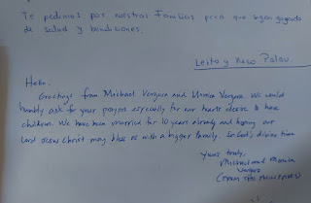

Making our way up the main street of Old Town . . .

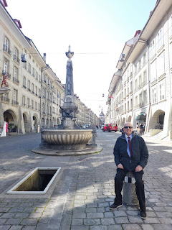

We found our way over to this: the enormous Bern Minster. Construction began in 1421 but did not finish until hundreds of years later, in 1893. It took 150 years just to complete the basic construction, not taking into account the detail work, the artistry and the embellishments both inside and out. Wow.

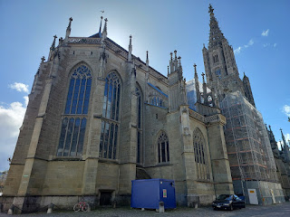

Here is a link to a little more information about the Bern Minster:
https://www.bern.com/en/detail/the-bern-minster

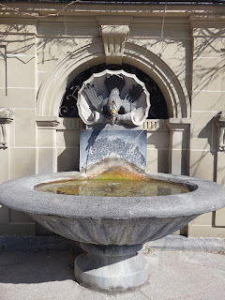

We walked around to the backside of the church where there is a large garden, lined with more of those London Plane Trees and several benches for sitting, all of which overlook the river below.

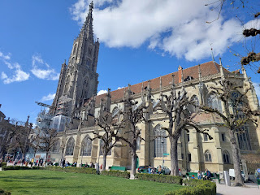

The Aare River "below" the Bern Minster . . .

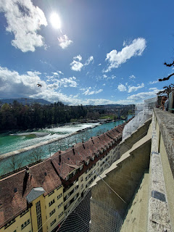

After we finished walking around the outside, we paid a few dollars to walk up 310 steps to the top of the church tower.

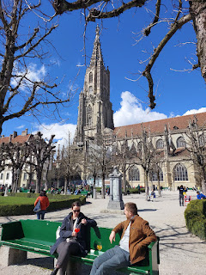

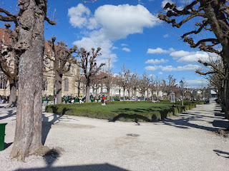

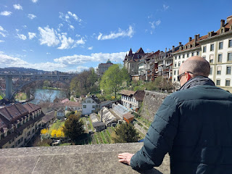

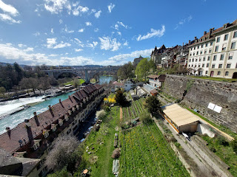

Inside the church, they had some interesting explanations about the interior and the exterior and how they came to be. If you click on the photos, you can enlarge the words to read. I apologize, but the first photo didn't turn out that well.

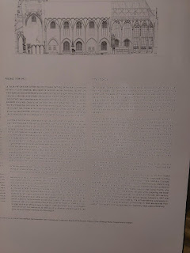

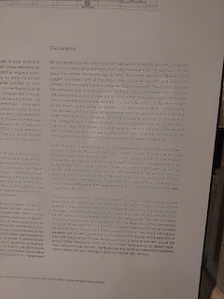

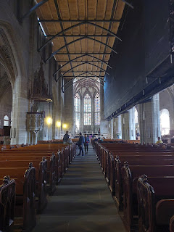

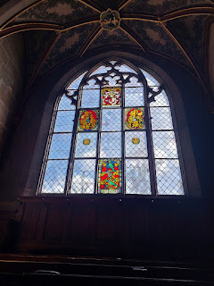

The detail work in every nook and cranny was crafted with a great deal of care.

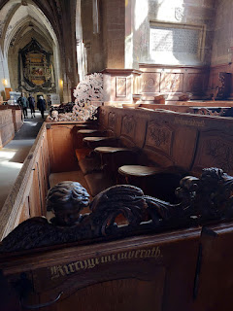

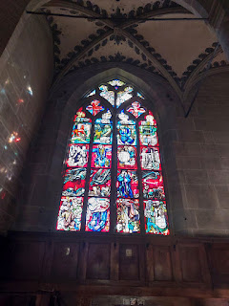

On our way up to the top of the tower, the steps were small and tightly formed. It was a never-ending spiral staircase that could cause some dizziness if you didn't stop to take a few breaks along the way. We passed three separate centuries-old bells, and we were grateful that they weren't chiming at the time. Surely we would have lost some of our hearing . . .

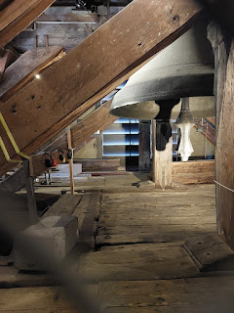

Views from the lookout terrace above . . .

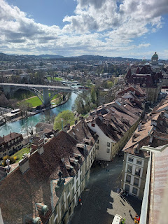

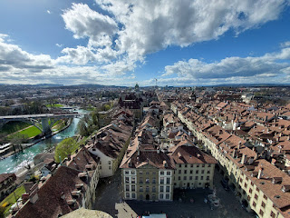

This was the main architect for the tower: Erhart Kung. He died before the tower was completed, though.

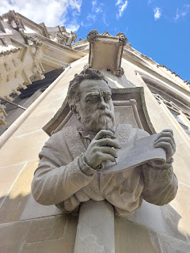

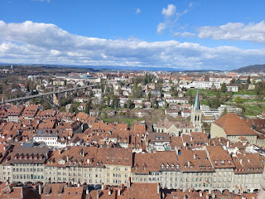

Video #1 of Bern below: (13 seconds) **Note: it was WINDY so turn your sound DOWN.
https://photos.app.goo.gl/ogwCEPVbEwXdoNik7

Video #2 views from the opposite side of the tower: (15 seconds)
https://photos.app.goo.gl/1gNbrXfivAKUi4YF7

Video #3 shows a marching band that we had heard coming down the street while we were up above in the tower. They stopped to play for a bit in front of the church entrance. I ALWAYS love a good drumline!! (52 seconds)
https://photos.app.goo.gl/yfx6NthWdN8pJwGs7

Video #4 shows the band marching away down the street as we exited the church. I noted that there were a few people holding signs, indicating a protest of some sort, and everyone wore the colors of Ukraine (blue and yellow). (36 seconds)
https://photos.app.goo.gl/g61x76iEDzcnLnYFA

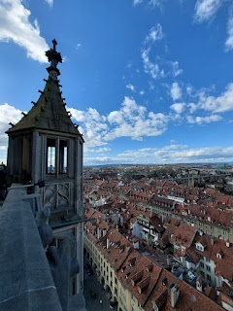

On Wikipedia, it states that there are 344 steps up to the top viewing platform. On our way down, I counted 310, but I guess I was wrong . . .

https://en.wikipedia.org/wiki/Bern_Minster

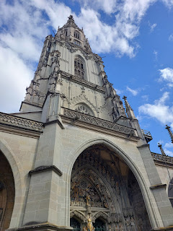

Behind my left knee, it felt a little tweaked by the time we got down to the bottom of the stairs. We bought a couple of cute children's books and some postcards in the gift shop and then found a chair outside for me to sit down on. I massaged my knee for a few minutes and then it felt much better. If you add in the 100+ steps from the night before, when we climbed up to the castle behind our hotel in Aarburg, plus every time we went up to our room on the 4th floor (it was 51 steps each way), it's no wonder my knee was a little upset after the Bern Minster Tower! But everything is fine now, thank goodness.

Next, we found a little cheese shop to try some samples of Emmental and Gouda. You can't ask for Swiss Cheese here, ha ha. It's all Swiss!! What we call Swiss cheese in America, they call Emmental over in Switzerland. And apparently, Italy is their #1 customer, at least according to the owner of this shop. After trying several variations of cheese, we bought a little portion each of two kinds of Emmental.

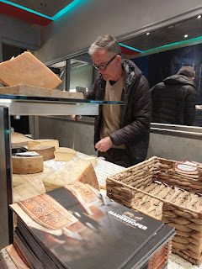

This is the name of the cheese shop . . .

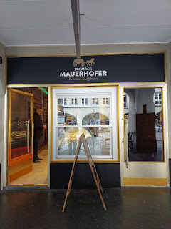

A couple stores beyond the cheese shop is the Einstein Souvenir store. We didn't buy anything, but it was fun to look.

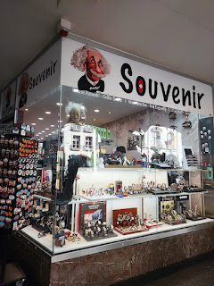

Our goal, instead, was to find a late lunch or at least a hearty snack to tide us over until dinner. We decided to stop at the Einstein Cafe, where we ordered their antipasti platter to share. ($25)

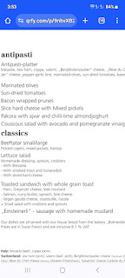

It may not look like much, but it was very filling.

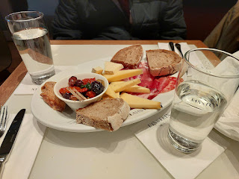

The Einstein Cafe is on the ground level of the Einstein Haus (seen below). Albert Einstein lived here with his wife from 1902 to 1909. Per ChatGPT: He worked as a patent examiner at the Swiss Patent Office during this time while also developing his revolutionary theories in physics.

THIS is where he developed his Theory of Relativity!

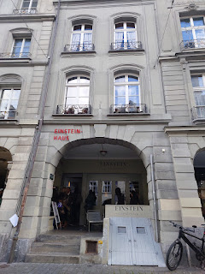

Something interesting in Old Town is how they make use of the underground building space, turning the "cellars" into more shops for passersby.

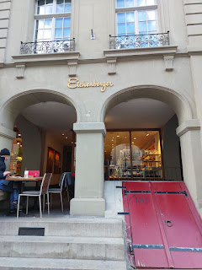

When the shops below are open for business, they open the doors and set out signs or stylish mannequins to draw more people downstairs.

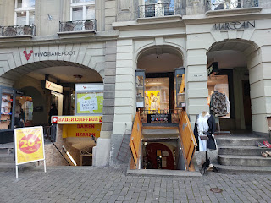

The Zytglogge (Clock Tower) is a central figure in Old Town. We purposely stayed extra long on top of the Bern Minster Tower because we could see the Zytglogge really well from there. We knew that at the top of the hour, something magical would happen. Dancing figures were supposed to come out, including a rooster, a jester, a parade of bears, and Chronos (the God of Time). I had my camera poised and ready for several minutes leading up to and then a little beyond the 4:00 hour, but NOTHING HAPPENED!! I was so disappointed.

This is what it looks like from ground level . . .

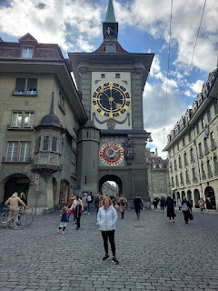

Here is a link with more information about the Zytglogge:
https://www.bern.com/en/detail/clock-tower-zytglogge

I loved the detail work on this impressive door as we walked back to our car. There are scenes depicted from Jesus' life, including when He washed the feet of His disciples, and when He saved Peter as he (Peter) doubted his ability to walk on the water.

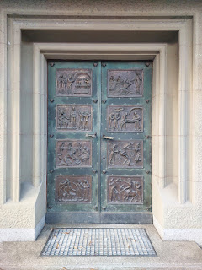

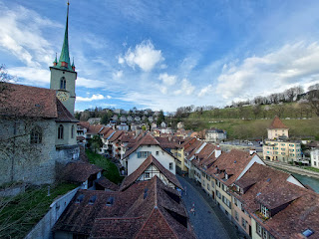

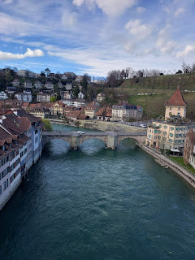

We absolutely loved Bern and we do plan to go back. We noted that it takes 5 hours to drive down to the Rome Italy Temple, and that it takes 5.5 hours to drive to the Bern Switzerland Temple. Our vote is for going to the Bern Temple from here on out because of these factors:
It costs less money to get to the Bern Temple. We paid $50 for a vignette associated with our license plate to drive on Swiss roads for a FULL YEAR. In contrast, it costs about $80 in tolls EACH TIME we drive to the Rome Temple.
It is easier to get into the temple patron housing in Bern than it is in Rome. It is free to stay there.
Bern is decidedly safer for tourists than Rome is. In Rome, we were squished into public train cars like sardines, while two girls were rooting around to try to get Scott's wallet out of his pocket. One of his work colleagues also had his wallet AND passport stolen last year in Rome. Bern has less tourists per year, which is nice, and is one factor in making Bern a very safe city to visit.
Bern has such natural beauty all around to explore. The air is clean and fresh and everything just feels gorgeous and inviting. Rome is dirty and crowded, and everything you want to visit means having to navigate through crowds and swarms of people. Blech.
Bern is also close to family history sites on both Scott's side of the tree and mine. That alone makes Bern more deserving of our future temple trips. So, with all of those reasons laid out, we will definitely be back in the near future.
Goodbye, beautiful Bern. We will see you soon . . .

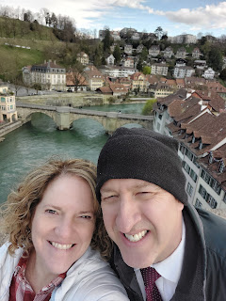

Next stop: Solothurn, Switzerland

We didn't have any specific information on what to do or where to look in Solothurn for places relating to Scott's ancestors, so we chose to aim for the oldest church in town. The clues we had for Solothurn included references to Solothurn as a place of birth, marriage, or death. The information on FamilySearch did not specify if this meant the CITY of Solothurn or the CANTON of Solothurn (which also houses the city of Solothurn).

A canton is a district or section of Switzerland. There are 26 cantons in total. Not all cantons speak the same language: some are French, some are Italian, and some are German. There are even a couple of cantons that speak Romansh (Romanian).

We also had the photo of the old family home in Switzerland, with the wording on the back simply stating something along the lines of: Gasser family home in Solothurn, Switzerland.

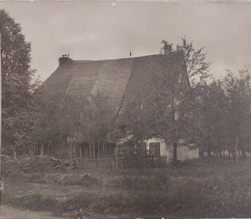

Not wanting to leave any stone unturned, we decided to check out the city of Solothurn, which is about halfway between Bern and Aarburg. We parked near the Cathedral of Saint Ursus, built in 1773.

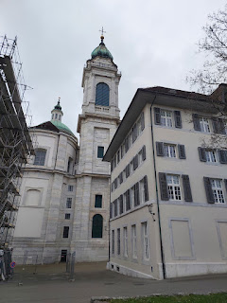

Can you see Scott waving to you underneath the arched entry?

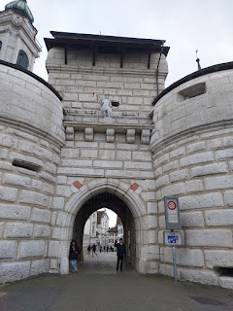

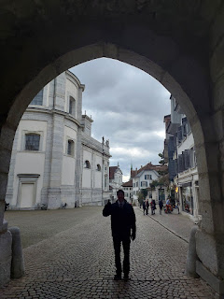

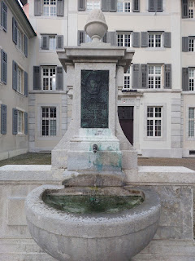

My first excited gasp was when I saw these old, peaked rooftops near the church, similar to the photo of the old family home. These roofs were more pointy, though. But still, they were definitely OLD, with bits of moss growing on the shingles.

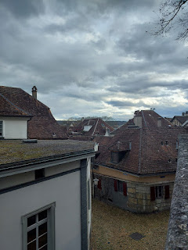

A memorial outside the Cathedral of St. Ursus . . .

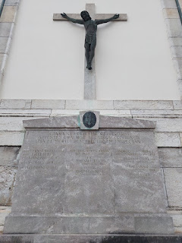

I didn't know this until putting this blog together, but apparently the city of Solothurn has had a long history and association with the number 11. Check out this link to learn more: (It's a very short couple of paragraphs)

https://www.myswitzerland.com/en-us/experiences/solothurn-city-cathedral-of-st-ursus/

Had I known this earlier, I would have looked harder for the 11 altars and 11 clocks inside the Cathedral!

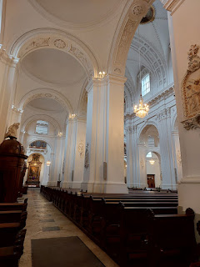

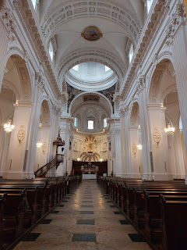

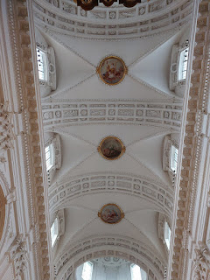

It was one of the more exquisite cathedrals that we visited in Switzerland. Scott noticed that in some sections of the chapel flooring, it looked very old and therefore ORIGINAL. :)

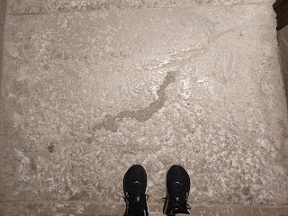

A couple of BEAUTIFUL paintings of Jesus . . .

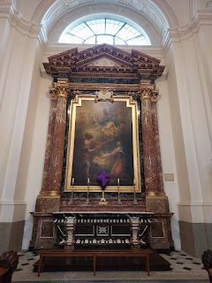

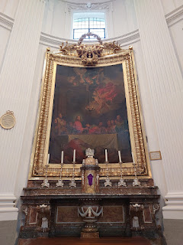

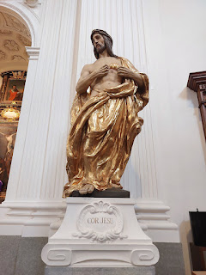

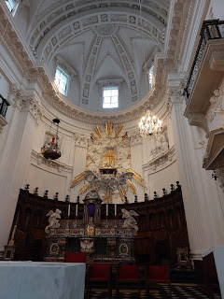

Many times I have seen memorial stones incorporated into the floors of a church's main chapel, especially throughout England. There were a couple of these in the Cathedral of St. Ursus, as well.

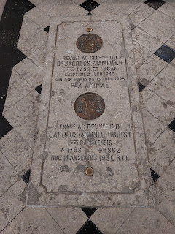

A ring of tenderly lit candles at the front of the chapel, probably in memory of a loved one . . .

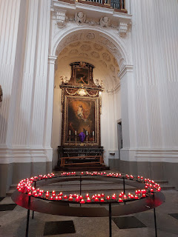

Looking up . . .

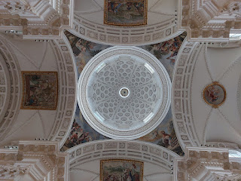

And looking down . . .

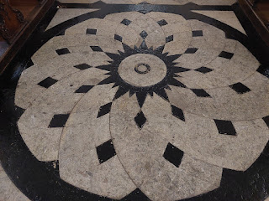

Accomplished carpentry work leading up a spiral staircase to a pulpit . . .

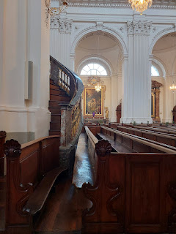

Looking up the cobblestone street from the front steps of the Cathedral . . .

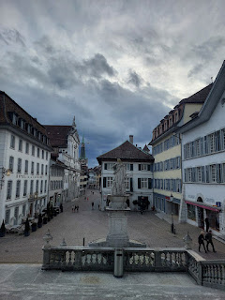

We slowly strolled up the street for a bit, until we got to the old clock of Solothurn. How fascinating it was! I am not so much into astronomy, but my sister Charmaine is, my cousin Valorie definitely is, and my mom used to be into it many years ago. This clock is not just about astronomy, though. It shows the phases of both the sun and the moon, too.

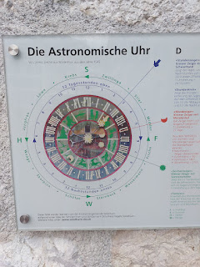

Visual aid (above) and English explanation (below). (*Click photos to enlarge)

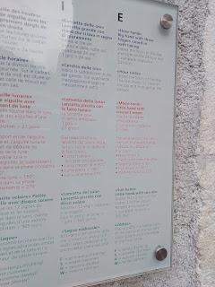

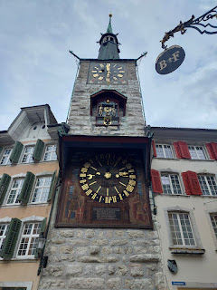

Scott studied the makings of this old clock for several minutes. It was built in 1545 and has been in continous operation ever since.

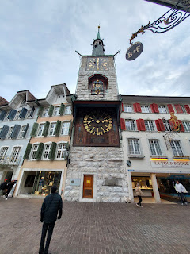

A very interesting paragraph about the clock can be found here: (It's a super short read!)
https://schweizmobil.ch/en/place-of-interest-498-solothurn-clock-tower

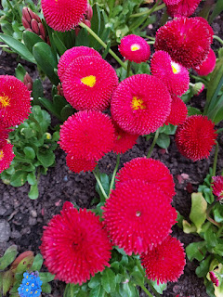

One of Solothurn's 11 fountains . . .

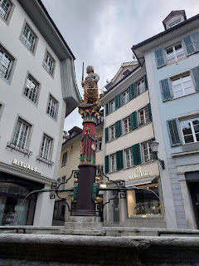

Yes, the fat-n-fluffy coat was back in play again because it was SO COLD!!

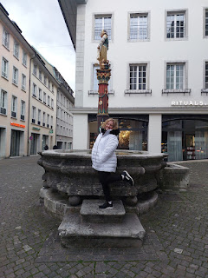

A front view of the Cathedral of St. Ursus from the street with all the shops . . .

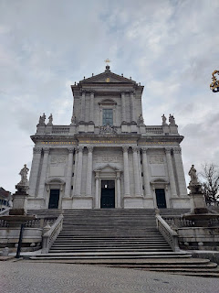

Around the corner from the cathedral were some interesting buildings. I wondered what this one was used for a few hundred years ago . . . That's Scott standing in front of it below.

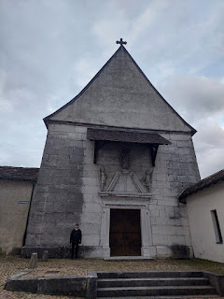

You can barely see Scott standing next to this dark building below . . . because he looks so tiny!

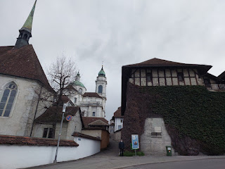

Another London Plane Tree . . .

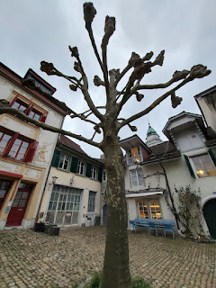

Skinny and tall buildings that I assume were people's homes . . .

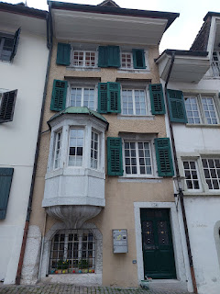

And then we saw this . . .

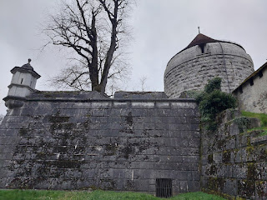

It was starting to rain at this point, so I snapped a quick photo and then we RAN all the way back to the car as it started pouring down on us, ha ha. Later that evening I finally found this place on Google maps so I could pin it for a future visit: it's known as the Ramparts of Riedholz.

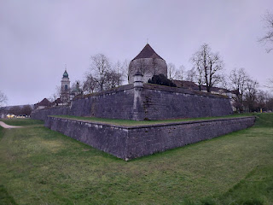

On the Solothurn city website, it says this: (
https://www.solothurn-city.ch/en/attractions/riedholz-redoubt-62b2cf8008
)

"
In 1667, Solothurn began building a redoubt fortification system, beginning with the Riedholz Redoubt. The fortifications were built in response to the many wars of the 17th century. It is noteworthy that Solothurn built a complete set of fortifications with a bastion system, something that was otherwise done only in large cities such as Zurich and Geneva. The enormous construction was surrounded by a trench that was 30–50 m wide and 5 m deep. Without ever having been used to defend the city, the redoubts were deconstructed between 1835 and 1905 for economic, urban planning and transport reasons. The St. Ursus Bastion with the Riedholz Tower and the Krummturm Redoubt with the tower of the same name were preserved as valuable reminders of the original arrangement of redoubts."

The same website also adds more info about the circular tower structure behind the massive wall:

"The Riedholzturm is the northern cornerstone of the city of Solothurn and, together with the redoubt, forms the only remaining part of the former full bastion. The Riedholzturm is the second tower on this site. Its predecessor, the Nydeckturm, served among other things as a powder magazine. As a result of a lightning strike in 1546, the stored powder exploded and so did the buildings. Today's tower was subsequently built at the highest point of Solothurn's old town. It is the only remaining baroque full bastion with moat in the whole of Switzerland."

They also mention that the Riedholzturm is a remnant of 11 redoubts that once protected Solothurn. There's that number 11 again!! How interesting.

Since it was already so cold and then the rains started pouring down on us, that was our cue to call it a day and head back to the hotel in Aarburg. I ordered some tomato soup with cream on top for a late dinner in the hotel restaurant and let it warm up my soul. :)

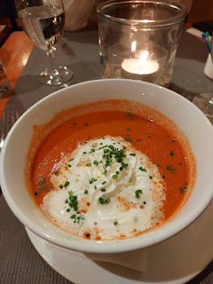

The following morning, Sunday (March 24th), we drove about 25 minutes NE to go to church in Aarau. When I try to pronounce "Aarau", it comes out sounding like a flirty tiger growl, LOL.

The meetinghouse was an actual church instead of a converted office building, which we've often seen in this half of the world. The chapel was very simple, but the people here were very friendly. Before the meeting began, we had been approached many times and were warmly welcomed.

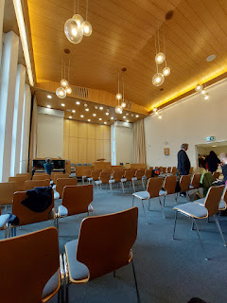

One lady went the extra mile to secure us each a headset so we could hear the meeting in English. She told us to set it to station 5 for English, and then we could hear the announcements and the talks perfectly through the little speaker that hooks over one ear.

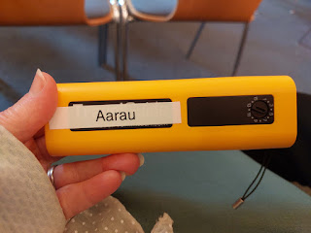

Scott had his Google Translate app running at the same time, and I thought it was hilarious to see the attempted translations it would post on his phone screen. It (the app) was horrible at trying to listen to the speakers across the room and then translate it into sentences of what it thought they were saying. I remember one sentence having something to do with a trampoline, when in fact nothing of the sort was said! But the man quietly translating for us through our headsets did a great job.

I loved singing in German again. I always love having an opportunity to connect to my German heritage through music. I recorded one verse of us singing "Come Follow Me" with the congregation.

Video here: (39 seconds)
https://photos.app.goo.gl/BRQLiNvgyXgtTavq5

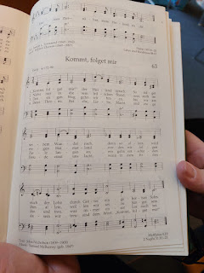

I learned something important while listening to everyone singing confidently around me. In German, if the word has an "ei" in it - like the word "Heiland" in the first line of the hymn above - you pronounce the SECOND vowel sound, while the first vowel is silent. In this case Heiland would be pronounced HY-land, with a long "i" sound.

If the order of the two vowels are flipped (to "ie"), the second vowel sound is still emphasized, but this time it's a long "e" sound. Take the word "diesem" at the beginning of verse 2. It should be pronounced DEEsem. When I whispered my discovery to Scott, he said, "Ohhh. Well that helps a lot!"

In Relief Society class, the instructor had a very meticulous and well prepared presentation on her phone, which was connected to the TV screen. She would advance her presentation one slide at a time and then generate some good discussion relating to it. From time to time, I would hurry and type what was on the screen into my Google Translate app so at least I could know what they were discussing in German. Like this series of questions below . . .

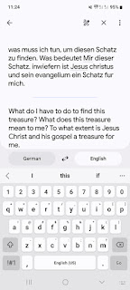

I really like this next invitation that the instructor gave us . . .

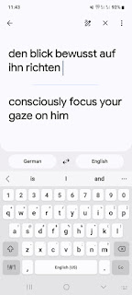

On my way to the Relief Society class earlier, another member of the ward came over to introduce herself to me. She told me her name is Astrid and then shared that she works as a chiropractor. She actually came to Idaho Falls last year to attend a medical conference for chiropractors! What a small world we live in. She spoke perfect English so I made sure to sit by her in class. One of the times I was using Google Translate during the discussion, she leaned over to correct something. The app had mis-translated a phrase (I can't remember what the words were now) but she wanted me to know that the word being used in class was "covenants". Google Translate had used a lesser word but she felt it was important to emphasize the correct word. I was grateful that she was aware of me trying to understand things and that she leaned over to assist.

After church, I changed into more comfortable clothes for our next adventure and then off we went. We found a grocery store to pick up a few things for lunch and some snacks for the drive before we left Aarau and headed north.

This is the border crossing from Switzerland into Germany. The border changed halfway across the bridge over the Rhine River. Scott panicked when he saw me take a photo because he was worried the Germans would be upset about it and maybe throw me in jail or something. I think he's watched a few too many WWII movies about the Nazis . . .

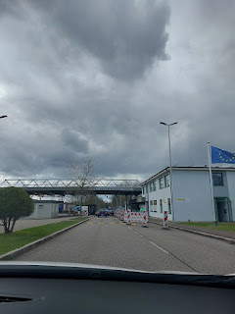

We drove from Aarau up to Schopfheim, Germany, which is almost directly north, a distance of about 48 minutes (45 km). I had noted some time ago that Schopfheim wasn't very far from where we would be staying, so I offered to visit and document the area for my cousin, Loreena Hester.

Her mother was Dora Eichin. Loreena's Grandpa Eichin (Ernest Frederick Eichin) was born in Schopfheim in 1881 and later immigrated to the U.S. in 1901. *Note: His WWI draft record says he was born in Wieslet, a tiny little town slightly north of Schopfheim. He settled in Westport, CA and eventually in the Santa Rosa area. He died in 1961.

Ernest's father, Lorenz, was a very handsome man. Loreena shared this photo with me of her great-grandfather. He was born in 1847 (probably in Wieslet, near Schopfheim) and died at the age of 71 in 1918 in Schopfheim.

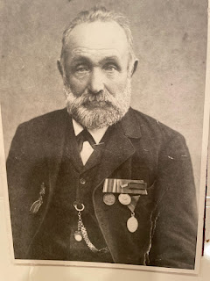

Loreena and I have gotten very close in recent years as we have collaborated together in family history efforts with our Rawles Family. I also spent the night at her house in Petaluma, CA a couple summers ago and we had the best time! I learned a great deal from her in how she displays and shares her family's heritage throughout her home. She is the sweetest person I think I've ever met. She reminds me of Faye Marvin, a character on the movie, "What About Bob?" Faye plays the wife of Dr. Leo Marvin (played by Richard Dreyfuss), who is trying to help "fix" Bob (played by Bill Murray). Bob has dozens of fears and anxieties in life. It is a fun little comedy and is one of our all-time most quoted movies in the Harmon household.

It was a no-brainer to me about whether to drive an extra hour into Germany or not. Loreena told me on a phone call before I left the U.S., "This was always a trip I wanted to take, but I don't think I will be able to go after all. You can be my feet. And you can be my eyes. I will see my ancestral homelands through YOU."

With that in mind, I created a Google photo album of pictures and videos for Loreena and all of her extended family. I made brief notes on many of the photos so they could know what they were looking at. It was a really lovely experience, and I wouldn't mind doing this more often for people, to be honest!

If you would like to see some charming towns and beautiful countryside in this SW corner of Germany near Basel, feel free to click on this link below:

https://photos.app.goo.gl/wecohRZtaUCSqeSj9

The towns we visited were:
Eichen, a tiny hamlet on the outskirts of Schopfheim. I thought it was intriguing that there was a town with a similar spelling of Loreena's family name of Eichin.
Schopfheim
Wieslet, about 12 minutes slightly NW of Schopfeim, where Ernest Eichin said he was born. He was also married in this darling town before immigrating to the U.S.
After we got back to our hotel in Aarburg, Scott and I attempted a video call to say hello to Jack. He was tired, though, and just wanted to finish watching an Easter video before his looming nap. I can smell a meltdown a mile away, so in order to preserve his dignity (and that of his parents), we offered to try again a different day. Bless his almost-3-year-old heart. XOXO

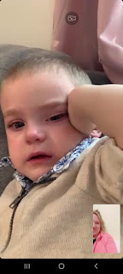

Jacob called us back a little later, after Jack was all tucked in for a cozy nap. They are all doing great in Minneapolis, he said. Jake and Hannah are plugging away in school, and Hannah is feeling great with her pregnancy. They have an appointment today (April 1st) to see how the baby is doing with an ultrasound, and we are all excited to find out if it's a boy or a girl!! I feel like it's a girl . . . and so does Hannah. So we'll see if we are right.

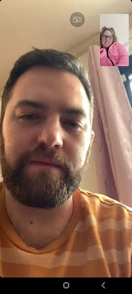

On Monday morning (March 25th), we checked out of our hotel and drove the 5 hours back to Vicenza. We passed several freshly whitened mountain tops, and noticed that with the windy day, the snow could be seen blowing around on the tippy-tops! (click photo to enlarge)

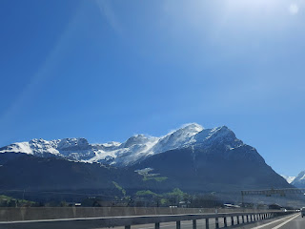

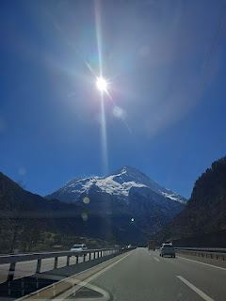

We have always wanted to eat while seated over the freeway in one of the many AutoGrill restaurants throughout Italy. We finally did it!

(photo credit:
https://www.travelwithmeredith.com/post/why-you-must-experience-an-autogrill-in-italy
)

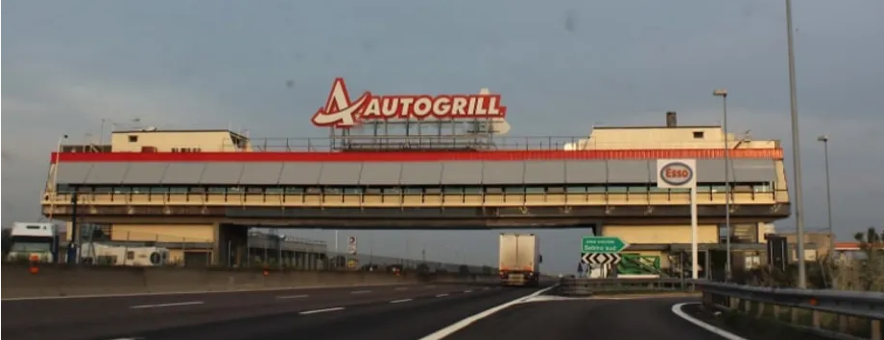

You simply pull over at the AutoGrill rest area and park your car. In the downstairs level of the restaurant, it's a convenience store, similar to what you might find in a truck stop in the U.S. They had clean bathrooms - and for FREE, too! If you want to access the restaurant, just go up the stairs or elevator and there it is. It was cafeteria style, with a couple of different food lines. You grab a tray and then let the server know what you want, then pay for it all before you go find a table.

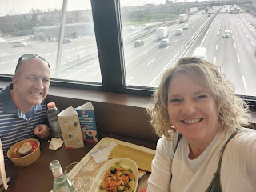

I chose a delicious and very tender chicken with a creamy mushroom sauce, and a medley of vegetables on the side. Scott ate a shawarma salad that we had bought earlier that morning at a grocery store.

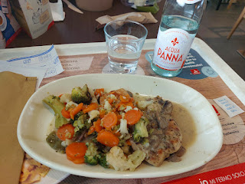

After we returned home to Vicenza, I've been getting more settled in over the last week. I've been catching up on some cleaning around the house, since most of it hadn't been touched since I left in December. I had a meaningful 2-hour lunch with my friend, Christine Swanson, while she was kinda-sorta working at the USO. We talked about a lot of things and I'm so grateful to get to know her each time we visit.

At Scott's request, I also helped proofread his talk for Easter Sunday. He shared the podium with a counselor from the bishopric in the Italian Ward, and they would trade off reading sections of the talk. Scott would read a paragraph in English, and then the other man would read the same paragraph but with the Italian translation provided. Scott used ChatGPT to translate his talk, and the Italian man asked him afterwards, "The translation was spot on - did you use ChatGPT?"

It was a great message and he did a wonderful job delivering it.

Here is a link to the talk:
https://docs.google.com/document/d/1-8-SIqaSOg-4ysw_kgbRZWSLcVX5UDu8/edit?usp=sharing&ouid=109847307616181621361&rtpof=true&sd=true

Amber's artwork made it into the Church of Jesus Christ of Latter-day Saints Easter collection!! She worked so hard on this and I am immensely proud of her. She has a lot going on this year, but I know she will find a way to still squeeze in a painting here and there.



And what a beautiful family photo for Easter Sunday . . . XOXO

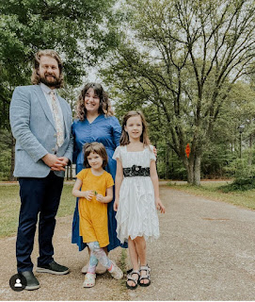

Side note: Amber told me over the phone that a couple days ago, Gwen decided to give her bangs a "trim". Yikes. Amber had to do some damage control and ended up chopping Gwen's hair off quite a bit to balance out the extreme "trim" in front. I think it turned out pretty cute in the end, though. :)

I haven't heard from Benson in a couple weeks. I assume he's okay because he usually is. But he tends to go into "hermit mode" from time to time, and I think he's in one of those right now. We were also hoping to connect with Kylie and Avery over Easter weekend, but they already had a full schedule, so hopefully we can get together soon.

Even though it's been raining almost every single day in Vicenza, the water levels have gone down substantially since all the flooding happened at the end of February, when Sott was in England. We've been taking walks together on most days and we were standing on a bridge talking about the flooding when I took this photo.

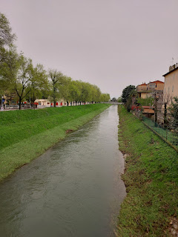

The day before Easter, I had a video call with President Nate Hunsaker, a member of my stake presidency back home in Idaho Falls. He arranged the "meeting" since I was not there to meet with him in person.

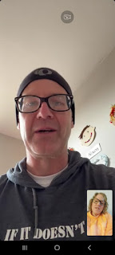

He asked me if I would be willing to serve as a Stake Temple & Family History committee member, to which I responded, "YES!!" I've served as a ward committee member for many years, helping individuals and groups learn how to "do" their family history. Even though I'm not 100% sure yet what I'd be doing on the stake level, I do know that part of my responsibility is to teach and train the ward consultants, and to probably be involved in some leadership training meetings once or twice a year. I think I will also be expected to go around and meet with the wards in our stake occasionally, helping to light a fire underneath them and helping them to grab hold of something they can feel comfortable doing on their family tree. I am always happy to help other people have a positive experience with family history!

I've been a little under the weather for a few days, but thankfully nothing too serious. I started Easter weekend with a sore throat and enlarged tonsils, and on Saturday I stayed in bed most of the day just resting and watching a few shows. I feel better for the most part now, but all of the rain and stormy weather has been doing a number on my head. When the barometric pressure drops, I get a pressure headache and my head feels dizzy and full of brain fog. Essential oils help somewhat, and caffeine does, too. But I'm finding more and more lately that the every-other-day-or-so
half can
of Coke Zero tends to carry over into the next day and might be GIVING me some low-to-medium headaches. So I am wanting to back away from caffeine right now and instead, lean on my essential oils, ibuprofen, and some fresh air on a walk whenever possible.

On a final note: Look at the SIZE of this red pepper that we saw in the Lidl last week. Scott is the one holding it. My goodness!!

