Alpini Rally & Misc Italian Adventures
Places mentioned in this blog post:
Vicenza, Italy
Nove, Italy
Agadir, Morocco

I am currently in Morocco and I'm enjoying a nice and relaxing Sabbath day. I am worn out from yesterday's long and sweaty travels, so today, my goal is to catch up on life but also prepare for a busy week ahead.

During Mother's Day weekend, Vicenza more than doubled in population. With approximately 330,000 residents already in the metropolitan area, it is staggering to consider an additional 400,000 people coming to town for a few days. But that's exactly what happened just one week ago.

Who are the Alpini? Essentially they are the special forces of the mountains, the mountain rangers, if you will. They are an elite military force, primarily serving in Northern Italy, and have been doing so since 1872. They are also the oldest active mountain infantry in the world!

For the past 95 years, the National Alpini Association has been organizing a Rally to honor and celebrate the oldest surviving Alpini in Italy. The Rally changes location from year to year, and it was Vicenza's honor and privilege to host the festivities for the first time in 20 years. Alpini members, current and former, come in buses, cars, motorcycles, and RV's from wherever they are currently living. They bring their families, too, which is what drives up the number of attendees.

Vicenza went all out with flags, ribbons, and other festive decorations to welcome all of the Alpini and their families.

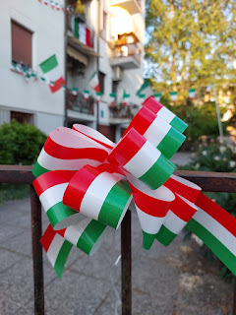

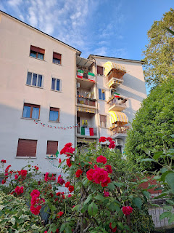

There were even some large tiered planters placed at the base of the stairs going up to Monte Berico, filled with bright red and white geraniums and their dark green leaves, all symbolizing the colors of the Italian flag.

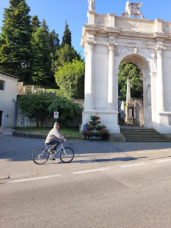

Sunset from our roof on Friday evening, heading into Mother's Day Weekend.

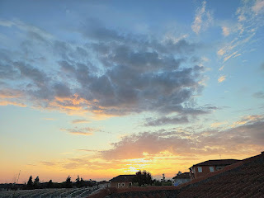

The following morning, we got up early to go on a little explore, while the city was still waking up. We walked over toward Monte Berico to launch the drone (about 30 minutes each way). We wanted to see the heart of Vicenza and what the setup was for the Alpini Rally. On our way there, we saw numerous encampments everywhere. If there was a unique place to set up tents and RV's, then that's exactly what they did. We saw little "tent cities" in the grassy center of some roundabouts, parking lots had been converted into RV parks, and even the old abandoned school that is next door to our apartment building had a few RV's and tents that popped up for the weekend. I guess it's who you know . . .

The city had organized most of the encampments, though. We saw signs in many places that indicated which Alpini unit was being welcomed at which location. They had port-a-potties and makeshift outdoor showers for the men, along with several covered picnic tables and BBQ grills ready to go. One of the most convenient things in Europe, especially Italy, is that you are always very close to a grocery store, a pharmacy, restaurants, and other necessities. So no matter where these encampments were set up, they were close to whatever else they may have needed.

At mid-day, we walked over to Parco Querini (about 35 minutes each way) because we saw on the schedule that skydivers would be landing in the park. This is also the park that we affectionately call, "The Bunny Park".

There were jeeps and trucks full of Alpini with their signature dark green hats and black feathers sticking out, cheerfully singing as they rode along.

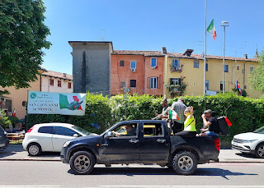

Many, however, were on foot like us. We blended into the swarms and swarms of Alpini, their families, and local Italians on the toasty and sunny walk to the park.

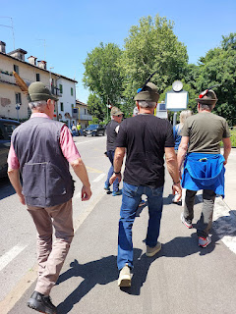

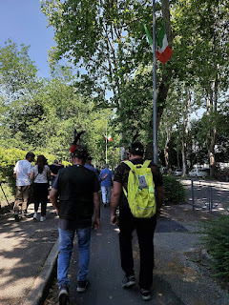

It was a good thing we arrived when we did, because there were THOUSANDS and THOUSANDS of Italians gathering around the perimeter of the "landing zone". We found ourselves a great spot up next to the ropes and then we stood for about 20 minutes in the hot sun to wait for the "show". We had hats on and water in our backpacks, so we were just fine.

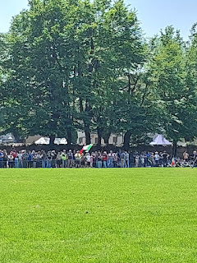

A man stood with a smoking flare next to the giant red "X" in the grass, to indicate the spot where the skydivers would soon aim to land.

Video of the guy with the flare: (4 seconds)
https://photos.app.goo.gl/ejD1aBUwDvxyg9C6A

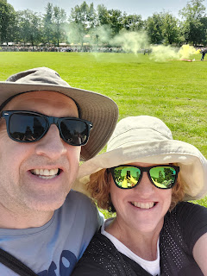

Right on time, at 1300 hours, the skydivers began their descent, in small groupings.

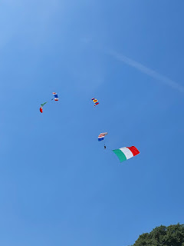

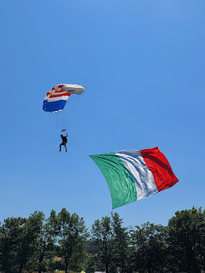

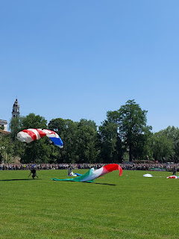

There were many styles in how they stuck - or didn't stick - the landings. See for yourself . . .

Video #1 of a skydiver coming in to land: (17 seconds)
https://photos.app.goo.gl/EkHEFZhk5vP5mLCk6

Video #2 of another landing: (10 seconds)
https://photos.app.goo.gl/Uu4PZ8zF96bu3KCF6

Video #3 of another landing: (12 seconds)
https://photos.app.goo.gl/VR61gRSKbHjYS4WL6

Video #4 of another landing: (9 seconds)
https://photos.app.goo.gl/kXi8892vMfiEeXJv8

Video #5 of another landing: (11 seconds)
https://photos.app.goo.gl/hikm5MAfQeggHGa37

Video #6 of a double landing: (21 seconds)
https://photos.app.goo.gl/jjBDSvpQtodhEaUBA

Video of the excited crowds around us: (10 seconds)
https://photos.app.goo.gl/xxJ7eunYtpUBFC2H9

We thought the skydiving was over, so we started walking home . . .

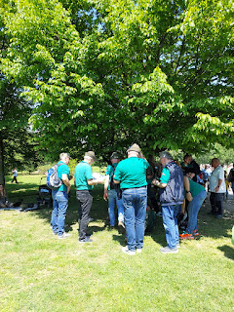

But as we walked home, we saw more rounds of skydivers floating down from the sky to land in the park behind us. But we weren't sad. We got a good piece of the action already, and it was quite warm outside, so we just kept going. It was fun to see how festive the streets were in the different sections of Vicenza.

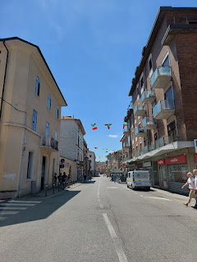

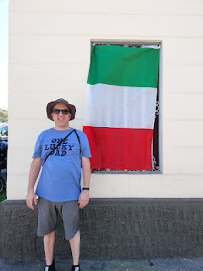

We rested - indoors - for the rest of the afternoon. I worked on my blog and Scott worked on a computer project. Then, once again, we headed out for one last excursion around 5:00 p.m. Another 30 minute walk (each way) brought us downtown, near the Olympic Theater.

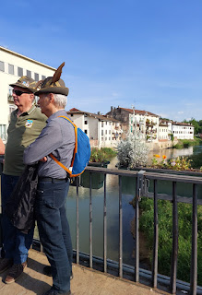

We passed a giddy group of Alpini, some musicians, and other spectators as we got closer to the Theater.

Video of the celebratory bunch: (16 seconds)
https://photos.app.goo.gl/k8vfeHvWAe74D9Po9

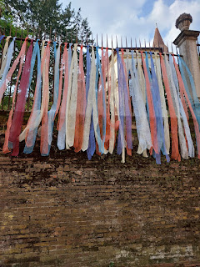

I'm not sure what these ribbons were for, since they were in pastel colors, but they lined the upper gardens adjacent to the Chiesa della Santa Corona. We found a spot here to wait for the parade that was due to come through any minute.

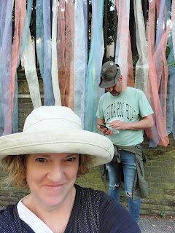

Crowds and crowds of people were heading into downtown Vicenza . . . but the parade would be coming from the opposite direction . . .

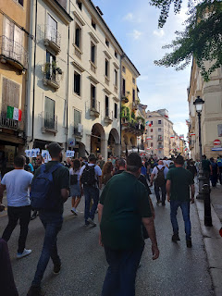

The first marching band that came through had to squeeze through the crowds: (40 seconds)
https://photos.app.goo.gl/YN8EPETSoPgwaSwx7

The police came through next, insisting that people back up and get off the road: (33 seconds)
https://photos.app.goo.gl/X8PDfpf1zAv92JM26

And then the PARADE arrived!!

Video here: (1 minute, 53 seconds)
https://photos.app.goo.gl/AhHbeapyBtR1evxr8

I got a little teary-eyed when I saw all those old Alpini men marching through. How precious!

And at about 1 minute, 10 seconds in, there were a couple of Italian officers dressed in black - and HIGHLY decorated. They did not crack a smile - AT ALL. Very intimidating . . . ha ha.

We came, we enjoyed, and now it was time to head back home. It took a while to work our way through the packed throngs of people. But we got to see some band members up close . . .

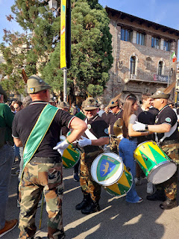

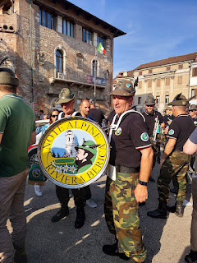

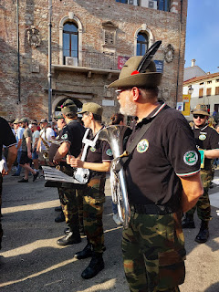

We passed by that same group of accordion players and dancing participants, still partying pretty hard!
Video: (20 seconds)

https://photos.app.goo.gl/gwEDvBiTuECQFvnR6

And closer to home, another jeep flew by - full of Alpinis. Everyone liked to honk to show their appreciation if there was a vehicle packed with the Alpini. We heard the honking all weekend long, ha ha.
Video: (5 seconds)
https://photos.app.goo.gl/vLPZMaXgAFLGoZDEA

Scott bought me a t-shirt to commemorate the special occasion. It was so cool to be there for the festivities, even though everyone had been warning us to leave town for the weekend. I'm glad we stayed.

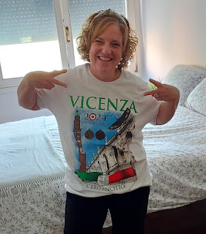

Other happenings . . .

I went to the PX on base a few days earlier, and was delighted to run into Olga - who is from Amsterdam. I told her I had just visited Amsterdam. She was selling some Dutch cheeses and offered me some free samples. Yes, please!

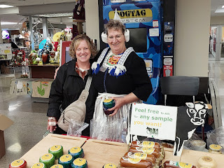

I was captivated by the Baby Gouda Coconut cheese wheel. It was mild and sweet. Very delicate. She told me it's best served with fruit or dipped in chocolate. Come again? Cheese dipped in chocolate??? Yes, she repeated. Okay, Olga. I'll take your word for it, AND I'll buy some of your cheese. :)

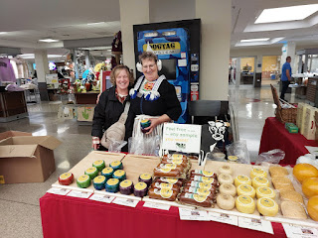

Following her instructions, the delicate treat turned out to be quite interesting. She told me to take a couple of my favorite chocolate candy bars, whatever type, and melt them. Dip small cubes of the cheese into the chocolate, and then place them on some wax paper (or parchment paper) and refrigerate to allow them to set up. I went one step further and sprinkled some kosher salt on top. I liked that addition very much.

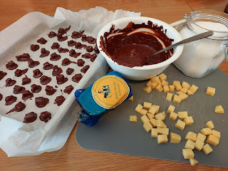

We ended up serving the chocolate-dipped cheese with our Mother's Day Lunch for all the missionaries. They came over to watch church on Zoom with us (because of the Alpini Rally, church had been canceled "in person"). Scott did a great job on the technology so that our ward members, who were scattered all over the area, could watch a speaker and a couple of pre-recorded musical numbers. The elders (missionaries) administered the ordinance of the Sacrament for us in our living room.

For lunch, we served pulled pork, a tomato/cucumber/red onion/corn salad, fruit salad, and pumpkin chocolate chip cookies. Afterwards, we played the "Dead Grandma" game. They loved it so much and said that they liked it better than the "Exploding Kittens" game. What a compliment to Amber and the crew who designed the game!

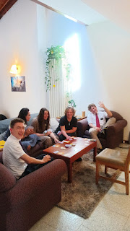

I sent off a couple of packages to our children and their families around that same time. I was so tickled to find these darling dresses for our future granddaughter, due in September.

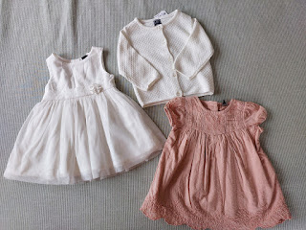

We also had a Ward Party the week before Mother's Day. We assembled at the Spiritual Life Center on base where pizza was served, along with all the side dishes that everyone else brought. We put together a veggie platter with a ranch dip on the side.

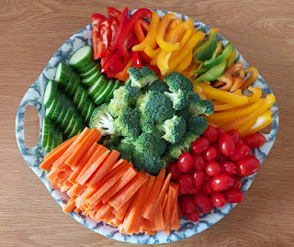

Scott and I practically fought over holding sweet little Piper, the Matekal's baby that was born just before Christmas. I think we're just a little bit excited about having another grandbaby in the near future . . .

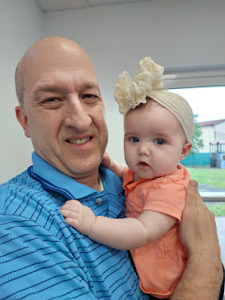

At the end of the evening, Scott ran these two boys up and down the hallway too many times to count, ha ha. Their parents were busy sweeping and cleaning things up after the dinner, so we were happy to entertain their kiddos.

Video of Scott with those two little giggling boys: (5 seconds)
https://photos.app.goo.gl/DugFqayzRzKFPXVB8

I've been hanging out with a new friend named Kelly Campbell. They moved in this past winter while I was in the U.S. We are both short, we have the same length of hair, we are both very chatty and friendly, and we are about the same age. We've gone on a few errands together, and sometimes we just hang out at each other's house.

She showed me this amazing new "find" of hers, once she knew we would be in Morocco. They are called eucalyptus crystals. Someone had bought them for her down in Morocco on a recent trip and she hasn't been able to find them anywhere since. They are very potent.

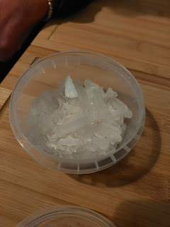

Her favorite way to use them is for a headache or stuffy sinuses. You break off a
teeny-tiny
piece of one of the small shards and place it into a mug. Pour some boiling water over it and prepare for the magic to happen. You will definitely need to close your eyes as you lean in over the powerful vapors, otherwise it may burn or irritate your eyes. The point is to just breathe the medicinal steam, and I am confident it would clear out even the stuffiest nose immediately! She made a cup of the "tea" so I could experience it for myself. Holy moly. That stuff is powerful! A tiny bit goes a LONG way.

She asked me to keep an eye out for some in Agadir this week, so I will definitely do that. I think I would like some for myself, too.

On another occasion, I joined up wtih Kelly and Nell to visit the Farmers Market downtown. It was a rainy Thursday morning, but that didn't stop us.

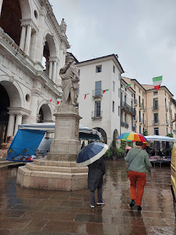

Kelly found some new clothes, I purchased some flowers, and then Nell took us to one of her favorite cafes in the downtown area. We ordered some Italian hot chocolate and then Kelly and I shared a pistachio cream-filled croissant, or brioche - as they call it in Italy.

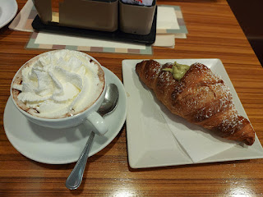

I made two floral arrangements out of the peonies, purple stattice and other fillers that I bought. One was for my next door neighbor, Zhanna, who had let me shower at her place a couple weeks ago when our hot water heater wasn't working. And the other one was for me. :) Zhanna was so happy that I gave her flowers, and for the next 3 days she sent me messages about how every time she walked past them they just made her so happy. She even sent me a photo when her peonies began to open up.

This was the vase I made for myself . . .

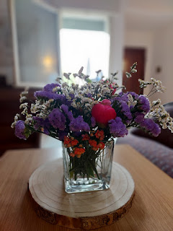

Another day, Kelly and I drove up to Dueville to visit the health food store and have some of their delicious lunch buffet. This time, I think my favorite item was the breaded zucchini "boat" - on the lower right of my plate.

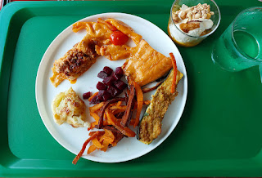

I've been scouting out flours and sugars around Vicenza for when my sister, Charmaine, and her partner Scott come to Italy in September. Her Scott is diabetic and has to be very careful with the types of flours and sugars he uses. I've been sending Charmaine lots of photos of what the stores have so that they can plan ahead. This was one of the sections of sugars and sugar substitutes that they had in the NaturaSi health food store.

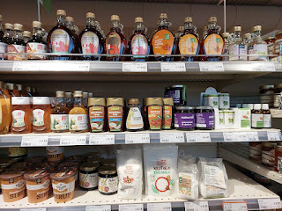

On that same day, Kelly and I drove over to Nove ("NOH-vay"), a little north of Vicenza. Nove is world-renowned for their ceramics. My friend, Lasina, who moved to Idaho Falls, asked me to do her a favor the next time I went to Nove. In one of the stores there, you can assemble lettered tiles that fit into an iron frame, and she wanted their last name and the year they got married. (Jensen - 2013) There was just one problem . . . they only had one "N", so I couldn't complete their last name!! The guy working there said they should have more letters in about 2 weeks, so I guess I'll be going back.

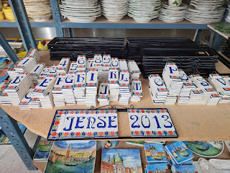

I found a better placement by removing the first "spacer" tile . . . but I still need to wait for that extra "N".

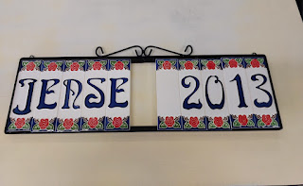

I liked these beautiful painted tiles with scenes from Vicenza . . .

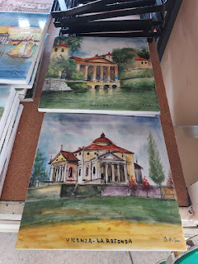

Next week, I'll have plenty of Moroccan adventures to share!! And hopefully they won't have anything to do with traveler's diarrhea . . . (like what I experienced two years ago - it was horrible!!).

