Christmas With All The Children
We were just missing two people for Christmas this season: Scott and Avery, who were both still in Italy. But the rest of us all congregated at my house and we had a Grand Ol' Time!!
Jacob, Hannah and Jack arrived first. They flew into Salt Lake City and then drove up to Idaho Falls in a rental car, arriving late at night on Tuesday, Dec. 19th. After a few minutes of visiting, we all went to bed because it was so late.

Wednesday, Dec. 20th:
We set up a fun little construction site for Jack to play with, one that I had recently ordered from Amazon. He was in heaven for the next several days. At one point, Jacob even brought in a supply of dry black beans from my pantry for the construction vehicles to scoop and pour.
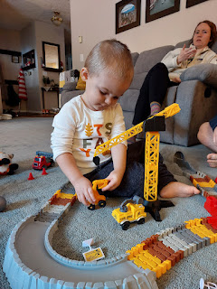

There was a small amount of snow on the ground outside, thankfully just enough to pull Jack in a sled around the yard.



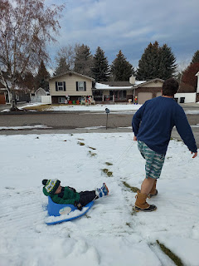

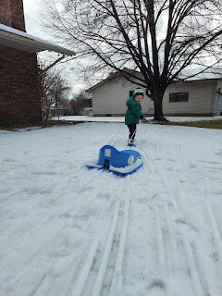

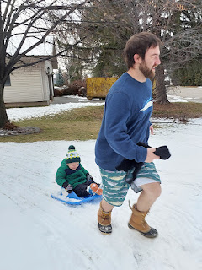

Video of Jacob running around in his pajama shorts, pulling Jack through the snow: (20 seconds)
https://photos.app.goo.gl/5frUEVozo4ds4qn98

Before we went back inside, Jack found a little spot to drive one of his construction vehicles in a patch of snow.

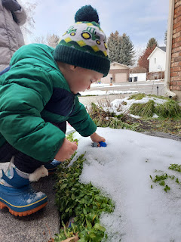

A little later, Jacob wanted to build a fire downstairs, but we hadn't built a fire yet this season. It requires one important step before lighting that first fire: taking off the chimney cap on top of the roof. The only problem is that the roof was mostly covered in icy snow . . .

Jacob used a snow shovel to scrape off the snow where he needed to exit the ladder (per my suggestion).

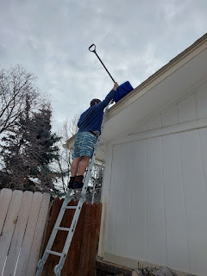

Then he crawled up to the tallest peak of the roof where the snow was actually melted and therefore provided a clear path over to the chimneys . . .

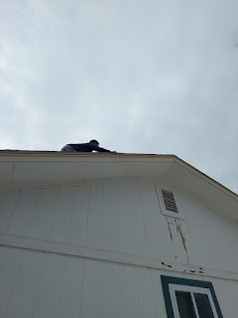

A careful walk across the skinny peak path with no snow . . .

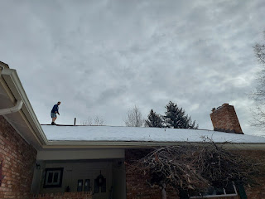

Eventual success . . . he got the cap off and also got himself safely down off the icy roof. Whew.

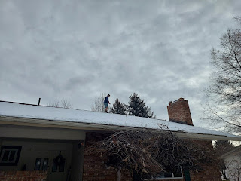

While Jacob built us a nice fire, Jack happily played with the new construction site for a while.

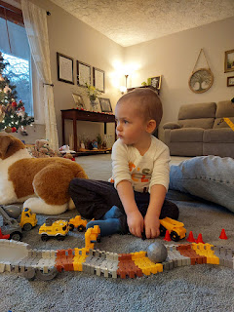

Video of Jack: (44 seconds) You'll hear him describing the "digger" and a "garbage truck".
https://photos.app.goo.gl/EpVuids7RUTaUjNm7

We took Jack for a walk around the block later in the afternoon to drop something off at the Vances. They weren't home, so we returned with our gift. But they stopped by later in the evening and we had a nice visit at my house.

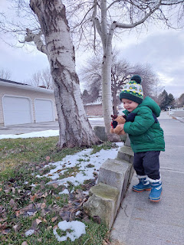

Jacob and Hannah have taught Jack to love books, and his attention span is quite impressive. He will ask for another book, and another book, and another . . .

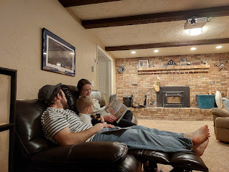

My mom had sent us some dehydrated persimmons and we all enjoyed sampling them throughout the week. They are long gone now . . . but Jack even enjoyed them. He called them "fireworks".

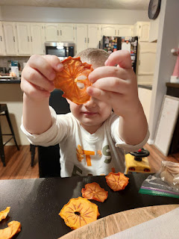

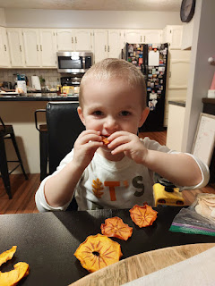

Thursday, Dec. 21st:
We drove up to Rigby to finally see Grandpa Phil, Scott's dad. I hadn't seen him yet since I flew in the previous Friday because I was sick for those first few days and didn't want to share any germs. It was so good to see him again, and Bev, too. She's been such an angel to stay there all these months and take care of him.

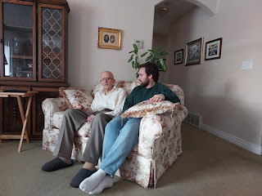

Jack carefully thumbed through a book, taking his time to look over each page.

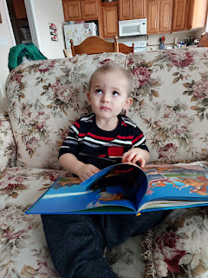

We didn't stay for too long, because Grandpa gets tired so easily.

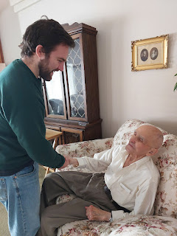

While Amber and the girls were in their final few hours of driving across the country, I made a batch of gingerbread dough (which had to sit in the fridge for a couple hours) and then I made the Samichlaus Bars in preparation for our upcoming Swiss Ancestor Night. Samichlaus Bars are made up of peanuts, coarsely chopped chocolate, and some orange zest and freshly squeezed orange juice. The story of Samichlaus comes from Switzerland. He was also known as St. Nicholas and lived during the late 2nd century and into the 3rd century. In current times, he arrives with his donkey from a nearby forest, along with his sidekick "Schmutzli". He brings peanuts, chocolate, and oranges to the children, but requests for them to recite poems to him before they receive their gifts. Schmutzli is there in fun, but has a slightly dark side, too. If the children have been reported as "naughty" by their parents, Schmutzli is there to silently swat them with tree branches to encourage them to do better in the year to come. No one actually gets hurt, and it's more of just a silly ritual.

Since we were making plans for a Swiss Ancestor Night, I was excited to make the Samichlaus Bars. Here is the recipe I used:
https://www.helvetickitchen.com/recipes/2016/12/2/samichlaus-bars
They ended up being Jacob's absolute favorite.

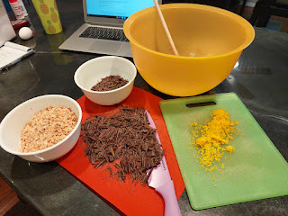

Right about the time that Amber, Abby and Gwen arrived, Kim Parkinson brought over a delightful gift basket with an Idaho-shaped charcuterie board and all the fixins. (Salami, cheese, grapes, crackers, and a cream cheese spread) The next day she also brought over the new Barbie DVD, to commemorate the date when she, Mady, and I all went to see it together at the theater in August. We are still eating all the cheese and salami, because it was such a huge supply, but it has filled several tummies with all the company we've had this past week. :)

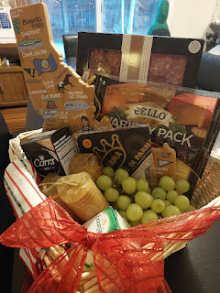

Amber drove to Idaho in their new (2021) Toyota Rav4 and it was a very comfy ride. They all did great and arrived tired, but happy. Abby read a Christmas story to Gwen while we got dinner ready.

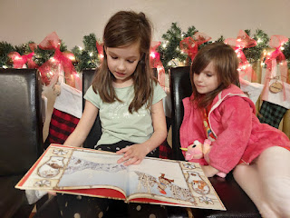

Friday, Dec. 22nd:
We went out to lunch at my favorite Mexican restaurant in town, Jalisco's. I am always excited for Mexican food whenever I come back from Italy (where there aren't any good Mexican restaurants). We made sure to order an entree for Benson, who would be arriving the following day.

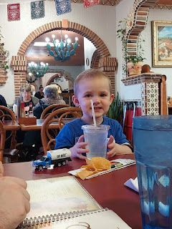

Abby and Gwen wanted to walk over to the "Pit" to see if there was enough snow for sledding there. I had my doubts, but it was good to get out for some fresh air and a little bit of exercise. It is only about a 5 minute walk to get there.

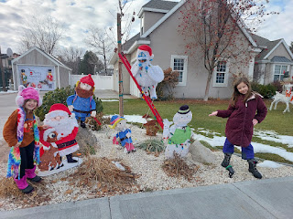

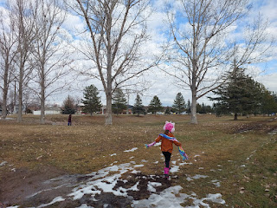

As expected, there wasn't enough snow for sledding, but the girls still had fun running around and making snow angels.

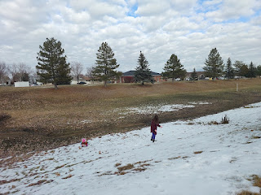



Video of Jack and his "Oh baby reindeer" Part 1: (37 seconds)
https://photos.app.goo.gl/i5Ac44pVKSPjo61HA

"Oh baby reindeer" Part 2: (44 seconds)
https://photos.app.goo.gl/eaH5PneWgnApKdPM8

I baked the Gingerbread Pines (tree-shaped cookies) that morning and let them cool while Amber took the girls to visit Weston's parents in Rigby. Meanwhile, Jacob and Hannah made a batch of Thumbprint Cookies for our Swiss Ancestor Night.

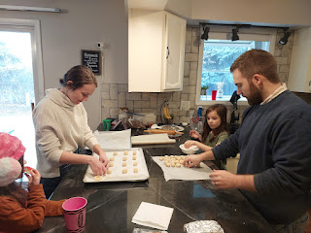

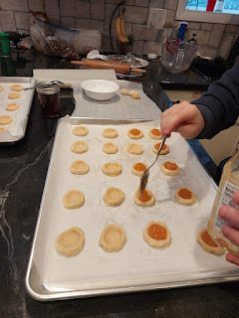

I had sent Hannah down to my food storage room to choose a few jams for the cookies, and she came back up with this jar.

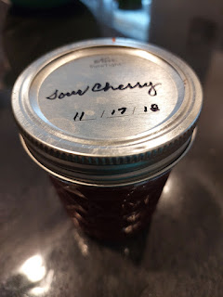

It instantly brought tears to my eyes as Hannah asked if it was okay to use this sour cherry jam. I got emotional because my mother-in-law, Coy, had made it for me a couple years ago. I was already missing her during this Christmas season, since it's our first one without her. So it felt like it was absolutely the right thing to do by incorporating "her" into our special meal.

Several family members helped to decorate the gingerbread cookies with royal icing for our dinner.

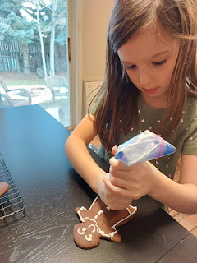

Abby (above) . . . and Hannah and Gwen (below) . . .

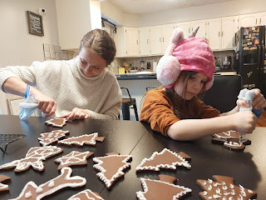

After an early dinner, we drove in two cars up to Menan (near Rigby) to visit a place called The Christmas River. It is a decked out trail through the woods filled with lights and several surprises along the way.

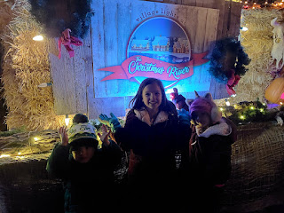

Carolers and small local bands would serenade us in different areas of the forest . . .

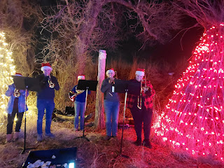

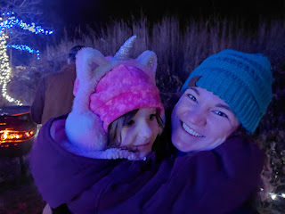

Olaf and Elsa!! Gwen went running over to them, while Abby shyly hung back with Amber and me.

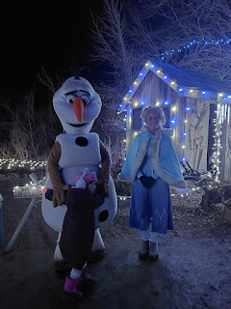

Gwen, Amber and Abby . . .

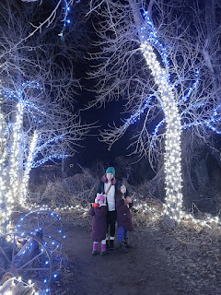

Old shells of cars from decades past were now decorated with festive lights . . .

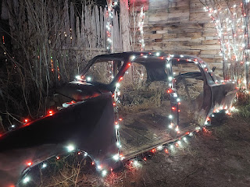

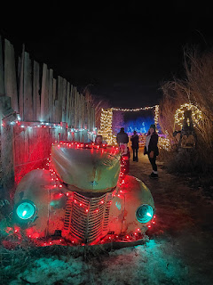

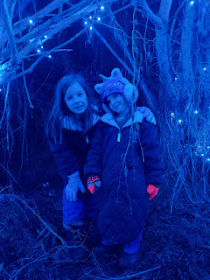

The girls were able to meet with Santa halfway through the forest. Gwen was excited to discuss her wish list with him, while Abby didn't feel the need to this time.

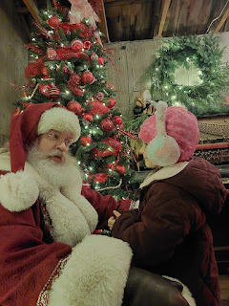

An old John Deere tractor was aglow with green lights on the other side of the cabin where Santa met with the children and visitors. I thought it looked pretty cool.

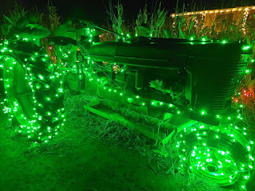

The last big stop was the Grinch's house. For both Santa's cabin and the Grinch, there was a "bypass" for those who wanted to skip those stops. We chose to do both, even though we knew that the Grinch was not going to be the "nice" version. The sign outside even said: "The Grinch is Naughty", with an arrow pointing the way to the "bypass".

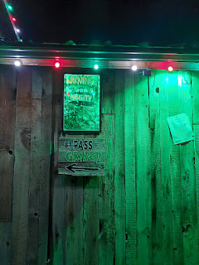

Mr. Grinch walked past us outside while I was on the phone with Jacob. We had been separated earlier when the girls wanted to see Elsa and Olaf, but Jack just wanted to run and run and run. Mr. Grinch snarled at me, saying something snarky - but I can't remember what he said now. I responded by saying, "Your breath sure smells like onions." (which it did) He shot back, "Well, did you bring me an onion?" I replied, "Nope!" and kept on walking. LOL

There was a large group gathered inside the cabin, and then suddenly Mr. Grinch popped in through a side door and jumped up on the stage to be in the spotlight.

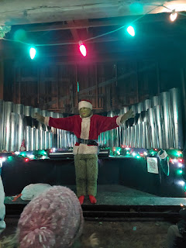

Video of Mr. Grinch playing a song on his blow-torch pipe organ: (17 seconds)
https://photos.app.goo.gl/1xuF3fJXZqKKCwwb6

It was a lovely evening, and not too cold, with so many twinkling and magical lights everywhere. I can see how this is a place that families like to return to year after year. I, myself, would like to go again.

Video of following Gwen Part 1: (6 seconds)
https://photos.app.goo.gl/6AtvCBhN3WPPJm878

Following Gwen Part 2: (6 seconds)
https://photos.app.goo.gl/39Afa1QMHwANV65y9

Following Gwen Part 3: (10 seconds)
https://photos.app.goo.gl/SCWoAba9pj9sYvdLA

Saturday, Dec. 23rd:
We paced the day with a mixture of relaxing, cleaning, and prep work for our Swiss Ancestor Night. We finished decorating the rest of the Gingerbread Pines cookies, tidied the house, set the table, and made the main dishes.
The recipe for the Gingerbread Pines can be found here:
https://www.helvetickitchen.com/recipes/2016/12/24/gingerbread-pines

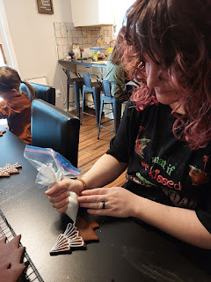

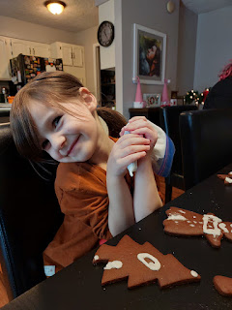

My mom sent me her tried-and-true recipe for Cheese Fondue, something she made many times for us when we were growing up. I bought a mixture of Swiss cheese and Gruyere cheese for the job. Many recipes for cheese fondue call for sherry or another form of alcohol, but my mom found that chicken broth makes a great alternative, so that's what I chose to do as well.

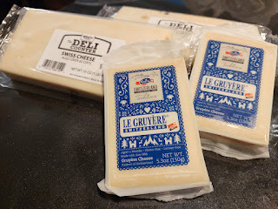

The finished assortment of Gingerbread Pines, Thumbprint Cookies, and Samichlaus Bars.

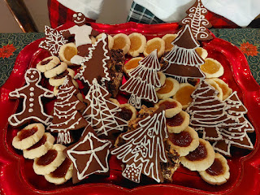

The set table, with placecards made by Abby. :)

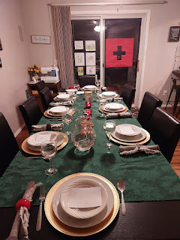

Short video of the main dish - Nidwaldner Bohneneintopf (Beef Stew): (3 seconds)
https://photos.app.goo.gl/PZNaC6F6qtoi9TUD6

Recipe is found here:
https://www.helvetickitchen.com/recipes/nidwaldner-bohnentopf

The stew turned out so delicious!! The two things that made it so special were: 1) the Herbs de Provence, a combination of 11 or 12 herbs, including thyme, sage, lavender, and tarragon. It made the kitchen smell so amazing! 2) The recipe said to simmer the meat and veggies for one hour, but we cut up the chuck roast into very small bite-sized pieces and then we simmered it for 3 hours before adding the vegetables in. This made the meat very tender and flavorful.

Scott's sister, Bev, offered to make some Spaetzle - which is like a dumpling noodle. She added a layer of carmelized noodles on top, which expanded the flavors quite a bit. This was a dish that Coy made many times during their childhood. You put a scoop of the Spaetzle and onions into your bowl, and then ladle the stew over the top. Wow. Simply stunning.

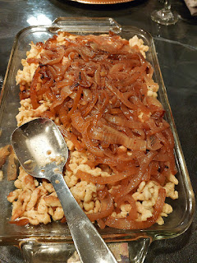

Meanwhile, the fondue turned out great, too. I was most nervous about this dish, since I knew it needed constant attention during the cooking process and I didn't want it to be a flop. The smell and flavor of it sure took me back to my childhood in the best way possible. I apologized to my kids that I had never made this for them up until now . . .

Short video of Amber and Weston trying the fondue: (3 seconds)
https://photos.app.goo.gl/RWakfc3M6yUekoM58

Keep in mind that many of these very short videos are so short because I usually put them into a "reel" for Instagram and Facebook. They are not long and informative, but they are intended to be part of a collaboration.

The dinner was wonderful, the food was wonderful, the stories were wonderful, and the company was wonderful. Benson arrived about 20 minutes before dinner was served - and we were so grateful. The roads were icy and yucky - at least in Eastern Idaho, so it took him longer than usual to get home.

Dad (Phil) has a sweet tooth, which we were able to take care of with our platter of traditional Swiss cookies. XOXO

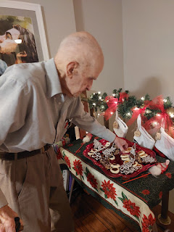

Scott prepared a video on YouTube to explain the Harmon connection to Switzerland. He gave a nice little tutorial on how to use FamilySearch to see where your people are from. The video is approximately 5 minutes long, if you'd like to watch it.

YouTube link:
https://www.youtube.com/watch?v=VeWjQD7HZDw

After Dad and Bev left to go home, we switched gears to Christmas Games Mode. This was what I had been dreaming of for several weeks and I knew everyone was also excited to play the games. The first game we set up was Bounce the Ball, but it ended up being more like Roll the Ball. The object was to get the ping pong ball to land on one of the plates at the opposite end of the table.

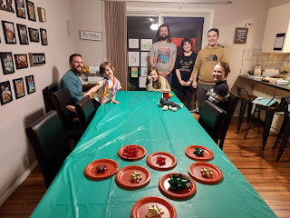

Each plate had a number on it. If the ball landed on plate #4, then you get prize bag #4. The SPECIAL prize was plate #1 at the far end. If you could get the ball to land on that one, then the prize was a gold gift box with $20 inside. Many of the gift bags also had cash in them, but in smaller amounts. I also got several $2 bills at the bank, which ended up being a big hit.

Video of Benson sticking the landing: (3 seconds)
https://photos.app.goo.gl/zWtYvh6Wm8nBwqLo9

Abby giving it an "A" for effort: (14 seconds)
https://photos.app.goo.gl/z1HWCrBRJ2nMmACE7

Second Game:
Roll the ping pong ball into the cup at the end of the table.

Jack just chucking the ping pong ball across the room: (3 seconds)
https://photos.app.goo.gl/PT4PZhPhpPbA5vKD8

After a couple tries, Amber nails it: (4 seconds)
https://photos.app.goo.gl/MmafSRtE3d9gnpXz7

Third Game:
Hershey's Kisses Shuffleboard.

Hannah was a pro. Each time she stepped up for her turn, she did great! (3 seconds)
https://photos.app.goo.gl/339hLbuZTwmkLBmr9

The prizes consisted of random items that I had picked up in Cyprus, Austria, and Italy (food items, trinkets, cute coin purses, and candies/chocolates). After three games, we decided to call it a night. While I was cleaning up the last round of mess in the kitchen - washing dishes and running the dishwasher - Abby came upstairs because she couldn't sleep. She could hear the running water and rustling where I was working directly above her room . . . I offered a few options to help her go to sleep, but the best idea was for her to just sleep in my king sized bed. Within two minutes of tucking her in, she was out cold. :)

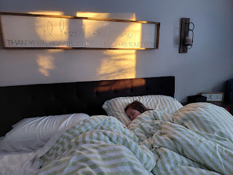

Sunday, Dec. 24th:
We went to church together in the morning, with the exception of Benson, who still wasn't quite ready to attend, and that's okay. I thoroughly enjoyed all the musical numbers by the choir and other smaller groups. I felt the spirit very strongly in my heart, and I felt the love of our Savior and the beautiful gift of His birth. Amber helped the choir by heading up there to sing with them through the whole program. Several people thanked her afterwards, some even saying, "I knew as soon as I saw you walk up there that everything was gonna be amazing." She really does have an exceptionally beautiful singing voice.

After church, we had a quiet afternoon with a few family members napping and others that simply found something quiet to do. Amber and her family drove up to Rigby to spend Christmas Eve with Weston's family. Benson and I locked ourselves in my bedroom to wrap several gifts that needed attention. We had Abby be the "runner" by collecting any wrapped gifts that we sat outside the bedroom door and then placing them under the tree. We had to lock the door halfway through because Abby's curiosity was getting to be too much, ha ha.

Before Jack's bedtime, his parents read him the scripture story of Jesus' birth from Luke 2 in the New Testament.

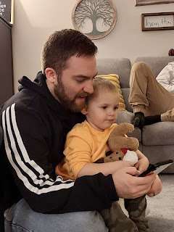

Hannah did a great job working with the "actors" while Jacob read the story. The crocheted Nativity figures that my sister, Melanie, made for me a few years ago came in really handy. They were perfect for Jack to hold and to help him understand the story.

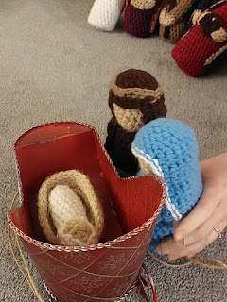

I also had a small bottle of Frankincense essential oil that we let him sniff when we talked about the gifts that the Wise Men brought to Jesus. His silly reaction made us all laugh. "Smell-eeey!"

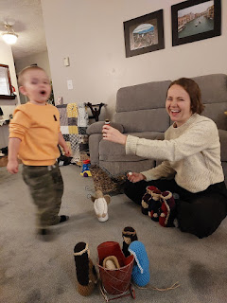

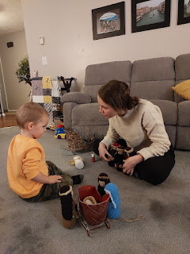

After the kids were all tucked into bed, the grownups played a couple more Christmas games. I had recently bought Christmas Family Feud and Christmas Scattergories from the Etsy website for a few dollars each. I downloaded the games and then printed them out for all of us. We had a lot of fun!!

Around 11:00 p.m. I put together our traditional Breakfast Casserole in the crockpot that we have made every Christmas Eve for several years. The casserole was ready to start cooking around midnight and then I finally went to bed.

Monday, Dec. 25th:
I woke up way too early to go pick up Scott's Dad in Rigby and bring him to our house for the day. I only got about 5.5 hours of sleep, but I knew this was important. Bev had been invited to spend Christmas Day with a friend at their cabin in Island Park (up near Yellowstone), and she had asked me in advance if I could help care for Dad so she could go. Caregivers NEED breaks, and I was happy to help make that happen for her.

Dad was very confused over the phone before I drove up to get him, saying first that he had already eaten and would be just fine to stay home all day, and then he told me he hadn't eaten yet. It took a few minutes of explanation and me being persistent to convince him that this was the plan (something that Bev had reviewed with him several times a day for weeks now). I headed off to collect him at 7:30 a.m. just as the sun was coming up.



Within moments of our arrival back to Idaho Falls, we got to have a video call with Avery back in Italy. Benson initiated the call that Kylie and I had arranged a few minutes before, and Avery was SUPER happy to see her daddy again. She hadn't seen him in a long time . . . He had several minutes with her first and then he passed the phone around so the rest of us could wish her a Merry Christmas, too.

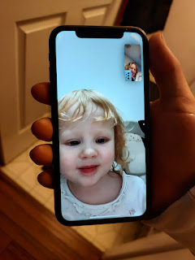

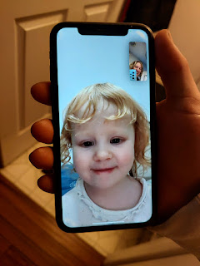

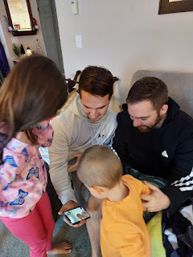

We gathered in the living room to have family prayer together before we ate the Breakfast Casserole in the dining room. I asked Phil to offer the prayer, and it was so moving and sweet that I felt like we needed to have a group photo immediately afterwards. I'm sure Coy was there, too, perhaps even planting the idea that we should take that special photo.

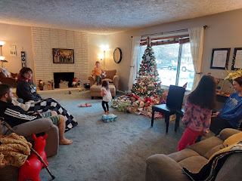

Back row on the couch: (L to R) Hannah with Jack, Grandpa Phil, Jacob
Front row on the floor: (L to R) Benson, Me, Gwen, Abby, Amber, Weston

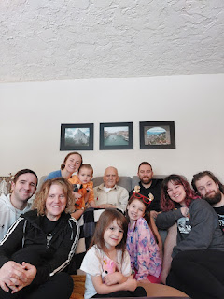

The breakfast casserole turned out amazing and the kids all oohed and aahed over this being their favorite holiday tradition ever. It's made of layers of hash browns, sausage, bacon, and cheese, with a dozen eggs + milk and a few seasonings poured over the top.

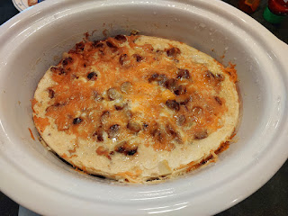

Grandpa Phil needed several naps during the day, and I helped him get all tucked in on my bed each time.

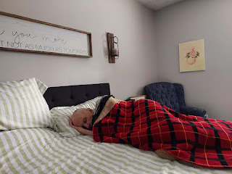

One of Abby's favorite gifts was a children's rhyming dictionary that my mom sent to her. She loves to read and also to write - both stories and poems. Phil is a retired English professor (he taught literature and Shakespeare) so he was especially interested in her new book, too. It was sweet to see them thumbing through the pages together, something they did for a good half an hour.

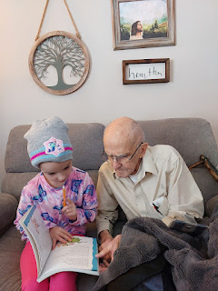

Video of Phil reading a list of rhyming words with Abby: (26 seconds)
https://photos.app.goo.gl/vH8U9mZAd2dZXJKPA

Soon after lunch, Jacob and his family packed up to head down to Scipio, Utah so they could visit with Hannah's family for their second week of vacation. It was hard to let them go . . . we had a lot of fun with little Jack, and it was so nice for those two brothers to spend some quality time together, too.

Jacob, Benson, and Jack . . .

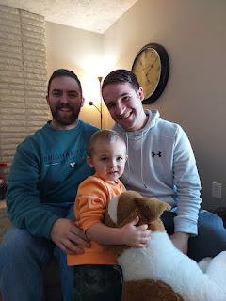

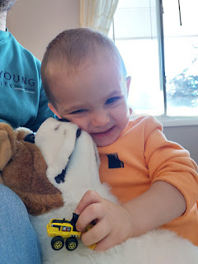

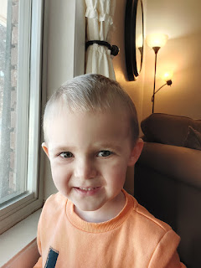



Hannah had me get in there for one of the photos, too. I hadn't showered or put any make-up on . . . but she convinced me to do it anyway . . . ha ha

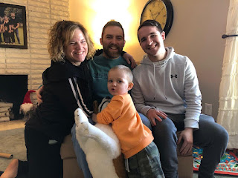

I received a couple of photos from Chelsea and Garret in Colorado, along with a sweet text message for Christmas Day.

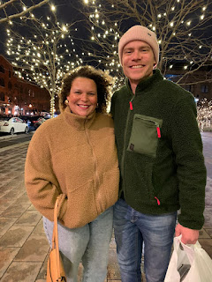

Chelsea and her mom, Paula, over the holidays . . .

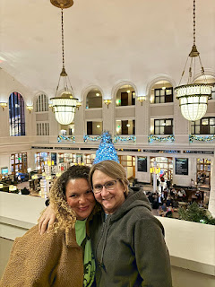

Meanwhile, Scott picked up both the Elders and the Sisters (missionaries) and drove them up to Marnie and Kevin Parker's home for Christmas dinner and a fun evening together. They sent me this photo . . .

Back row: (L to R) Marnie Parker, Elder Perego, Kaden Parker, Elder _____ (I can't remember his last name), and Scott.
Front row: (L to R) Sister ____, Ava Parker, Sister ____ (both of them are new and I only met them once before I left), Lauren Parker, Kevin Parker, Olivia Parker (red shirt).

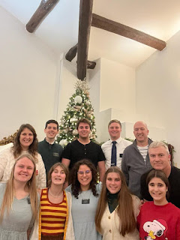

Merry Christmas and Happy New Year!! I hope that the things that have been stressful, troublesome, frustrating, scary, or depressing from 2023 will be smoothed over, lessened, worked out, and that the peace of our loving Savior can lift your spirit and help you with whatever you might be going through.

