Dolomites, Ducks, and a Doctor Emergency
This week went by so fast, even though it was the slowest week I've had in a long time. Slow is a good thing, as long as it is temporary. If the slow pace lasts too long, then I lose momentum and end up in a slump that gets hard to break free of. I prefer busy . . . with a slow day here and there to reset.

Last Monday, Labor Day:
We woke up to the most beautiful sunrise through our open window in Santa Maddalena, Italy. It might have been even more spectacular if we had woken up a few minutes sooner . . . but you get what you get and you don't throw a fit. :)

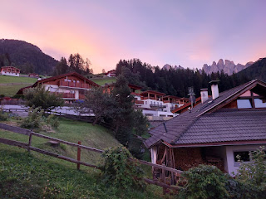

After a hearty breakfast downstairs, we began our 3 hour drive south to get home. I had researched several options where we could break up the drive and enjoy something interesting along the way, but sadly, most things were closed on a Monday. We ended up settling for something slightly off our intended route, and started on our way.

We saw several castles, some of which were nestled up in the mountains, some were next to the highway, and some were in an interesting or even a precarious place. (click on photos to enlarge)

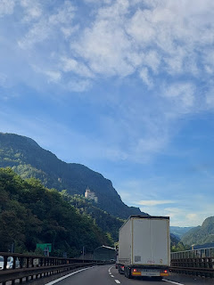

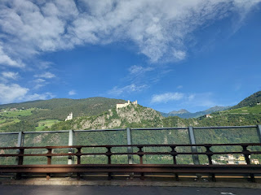

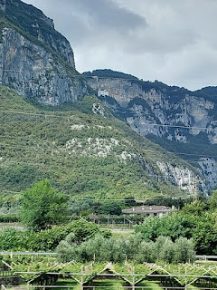

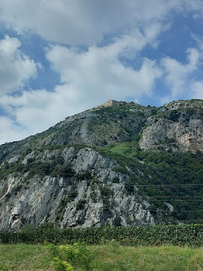

I was very impressed by the terraced communities, situated on those huge hillsides, and wondered how they get back up to their houses in the winter months after a grocery run . . .

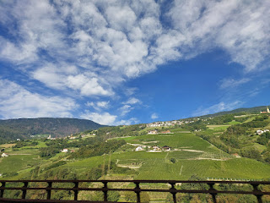

The place we veered off course to see did not end up being that impressive. It might have been because
everything
was less amazing after being up in the Dolomites and now we were "spoiled". But, in my opinion, the description on the internet made it sound like a lot more than it actually turned out to be.

The destination was Lake Toblino, just west of Trento. I read that you could walk around the lake and that there was a castle on a little peninsula that made for some great photos. Awesome! Let's go see it! I had researched a bit further to learn how long the trail was around the lake: 2.3 miles. Perfect.

We followed Google's directions and didn't fully trust where it suggested that we turn off at the lake, so we kept going. We ended up in a little village moments later, and found an Information Office where we could ask a few questions. The young lady inside said that the only walking trail along the lake was on the west side, where we were, and that it was back where we had already passed. We had to hunt in the little village to find a bathroom for several minutes, before finally finding one in an underground parking garage. Blech, this bathroom had not seen any cleaning supplies in a while . . .

We reverted back to where Google had originally tried to direct us, and pulled into this all-of-a-sudden turnout from the very busy road, to then slam on the breaks so we could gauge if we could fit through the entry arch or not. We did fit, but only after we turned the car's side mirrors in, ha ha.

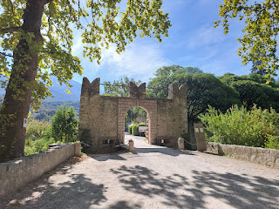

There was a very small parking area that was filling up rather quickly because it was close to lunch time. The castle turned out to be a restaurant!

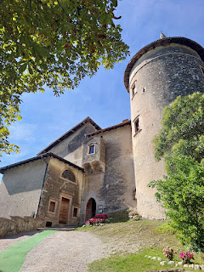

We hopped on the walking trail around the west side of the lake, as prescribed, but didn't go far before turning around and heading back in the other direction. You couldn't even see the lake because of all the shrubs and bushes growing along the water's edge. But we did see this explanation of the history of the castle.

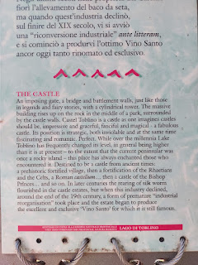

After turning around and heading the opposite way, back toward the village and the sketchy underground toilet, the views finally opened up a bit.

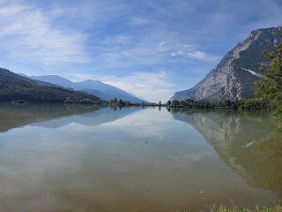

Another trail sign offered a deep and thoughtful poem to ponder. It may have lost some of its original intent as it was translated into English, though.

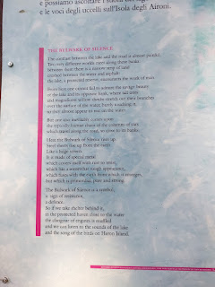

We hiked just far enough to find a view that gave some perspective looking back on the castle/restaurant and then we turned around to walk back to the car. While the views were pretty, they weren't overly spectacular. It was very hot out and we were sweaty and getting hungry. In actuality, the water was much more muted in color than the internet made it out to be. I suppose if you live in this area, it would grow on you. But I guess we must be Dolomites Snobs now, because it was just plain disappointing for us . . .

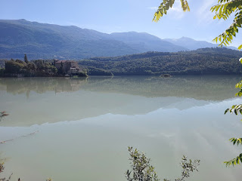

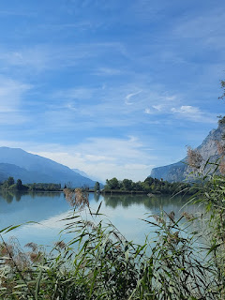

I remember years ago, we took our kids on a camping trip to Grand Teton National Park and then to the nearby Yellowstone National Park. We learned an important lesson: if you're going to visit both parks back to back, you should probably go to Yellowstone first and then the Tetons.

When we visited the Tetons first, it was pristinely beautiful and unbelievably gorgeous. It was quiet and peaceful, with lots of space between us and any other humans, whether in the campsite or on the roads or on the trails. When we moved on to Yellowstone next, it felt incredibly cramped, crowded, and busy. The beauty of what Yellowstone had to offer paled in comparison to the majesty of the Tetons. It even seemed downright ugly at first. But, over the course of a couple of days, it began to grow on us. We began to appreciate its rugged beauty. It was no Tetons, but it was beautiful in its own sort of way.

I compare this experience to us coming down from the Dolomites and being so disappointed at Lake Toblino. If we had never known the Dolomites, we would have appreciated this area a great deal more.

Next stop: Lake Garda. Scott had never been to Lazise on the southeast edge of Lake Garda before, but I had been there in May with Jake, Hannah, and Jack. The lake is delightfully situated within a stone's throw of a parking lot, and is easy to access from the freeway. It only took us about 5 minutes off our route back to Vicenza.

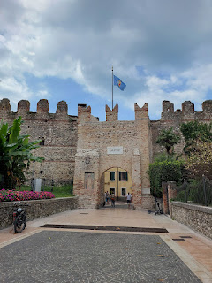

Once you go through this impressive arch of Lazise, it is less than a 5 minute walk to the water's edge.

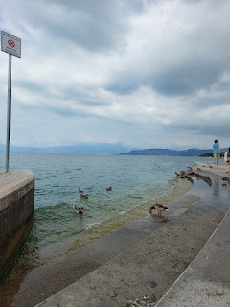

I got some gelato from the same place that was so kind to Jack earlier this spring, when he needed fresh milk as he was getting sleepy in the stroller. I will forever remember how, once they understood what Hannah needed the milk for, they jumped to attention and gave her the royal treatment. The man escorted Hannah all the way back to Jack with the cutest little tiny pitcher you've ever seen. He even provided them with a straw so Jack could slurp it all down successfully. Their attention to detail was incredible!

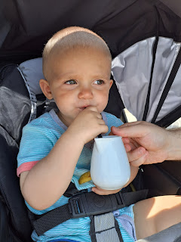

So yes, I will forever get my gelato at The Riviera in Lazise every time I go there.

We found a place to sit near the ducks, where we could watch the people walking by, and listen to the sound of the water lapping up onto the steps.

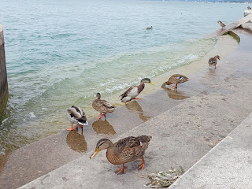

Video of the ducks nibbling at the algae on the lower steps: (19 seconds)
https://photos.app.goo.gl/Zb4PiaMpbRuuZk1Z7

Scott wanted to take his shoes and socks off to get in the water, and I warned him to be careful in case it was slippery. Man, it sure was! He had to hold on for dear life with any movement he made . . .

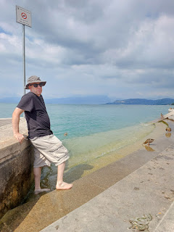

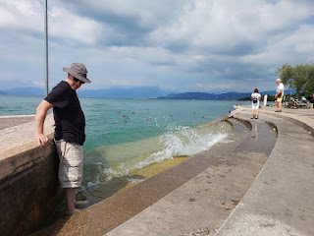

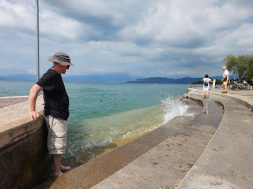

When the clouds blanketed the intensity of the afternoon sun, it was wonderful. But when the sun peeked out from time to time, yikes. It was blazing hot!! So we didn't stay too long . . .

On our way back to the car park, we briefly stepped inside the old church of Lazise. It was very beautiful and quiet in there.

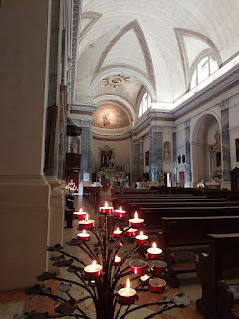

Below: one of the many beautiful alleys you can happily get lost in while visiting Lazise . . .

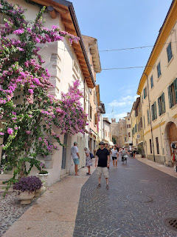

The rest of the week consisted of very little:
Catch up on sleep
Clean at least one area of the house each day
Spend 4-6 hours/day researching for our upcoming trip to London (with Amber & family)
Go to the gym each afternoon with Scott
Relax together each evening (Dinner + America's Got Talent)
We had a lovely date night on Saturday by going to dinner at a nearby Mexican restaurant, Hot Cactus Cafe. It was actually very good! Our only other experience in Vicenza - in eating Mexican food at a different restaurant - was disappointing last year. This time, I ordered shrimp fajitas with vegetables (zucchini, yellow squash, and bell peppers). Yum! I even ate more rice than I should have because it was so good . . .

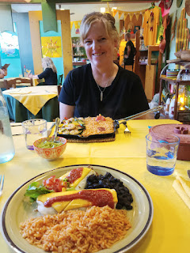

When we got home from the restaurant, I called my neighbor, Kim, to visit with her and see how things were going back in Idaho. She had all good things to report, which was very reassuring. My sister, Melanie, and her family will be arriving at my house soon to spend a few days in the area. Her daughter, Natalie, and Natalie's husband, Chance, live about 30 minutes away from Idaho Falls, and they haven't seen each other in a while. Kim will make sure that all is well for the crew across the street while I'm so far away. :)

My sweet neighbor, Kim . . .

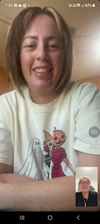

Jack has had some adventures this week! He went to the local zoo in Minneapolis, which is also free. (How awesome!)

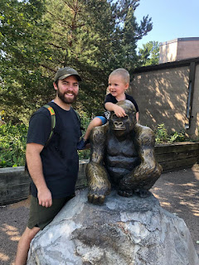

He rode on an exciting swing ride with Hannah . . .

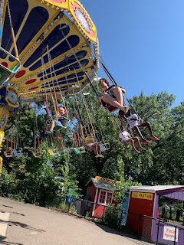

And the family went on a bike ride together . . .

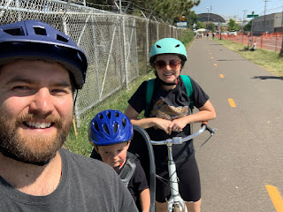

Jack also ended up in the ER one evening, because he got whacked in the head by a large swing at the park. There was a kid swinging back and forth, and Jack walked behind him and got knocked down to the ground. This was very reminiscent of when Jacob, his father, was about the same age . . .

We were at a school playground, and all of us were swinging on the swings. Amber was 4 and Jacob was 2. Jacob decided he was done swinging and hopped off while the rest of us were still going pretty high. He walked right in front of Amber and WHAM, down he went. I remember feeling like it was all happening in slow-motion as I saw Amber moving forward in her swing, heading right toward him. I was mid-swing, myself, and wasn't able to leap out to save him. I ran over as fast as I could and scooped him up into my arms...he was crying loudly, and then all of a sudden his eyes rolled back and he stopped crying, and went limp in my arms. Omigosh, I freaked out! We took Jacob to the ER and by the time all of his x-rays came back just fine, he had already charmed all the nurses and was all smiles.

Kind of like how Jack was all smiles while eating his popsicle at the hospital . . .

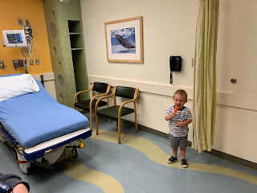

Thank goodness all is well. We had a short visit with him on a video chat the following day, where he tried to describe in his limited vocabulary what happened the day before. What a precious.

We chatted with him again tonight (Sunday). He was a two-year old whirlwind in the 30 minutes or so we talked to him (and his parents). He went from bouncing the basketball, to eating a container of cherry tomatoes, to drawing with chalk, to drawing with crayons, to eating peas, to playing more basketball, to rolling around on the floor, and lastly to playing with his toy car on the train tracks.

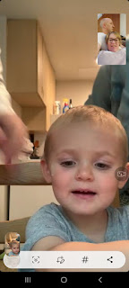

He was getting a little bonkers with the chalk, so his parents swapped it out for some crayons instead.

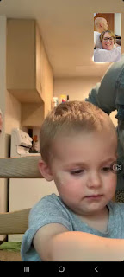

He fed me a few spoonfuls of peas through the phone, which was so tasty! ha ha

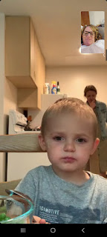

I was cracking up at the end of our phone call because it looked like he was giving kisses to his momma, when in fact, they informed me, he was trying to sweet talk her into letting him watch a show on the TV...

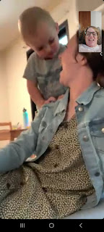

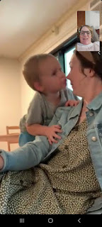

Jacob is keeping his head above water so far in his PhD program. He told us on the phone tonight that it is extremely difficult right now, because there is so much information coming at him, and then there are projects and homework on top of that. He spends about 12 hours in classes on campus each week, and another 30-35 hours doing homework and other related tasks. About 40-50 hours total each week.

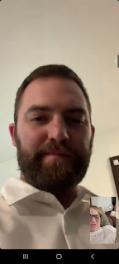

Hannah has begun a remote job for a few hours a week, and will be starting an additional job in a week or so. Both jobs are connected to her Master's program, helping to fulfil certain criteria for her degree. Jake and Hannah said that their schedules will mesh pretty well in caring for Jack, and that the only time they will need someone to watch him is 2 afternoons per week, and just during his nap. They are doing a lot right now, but it is all good stuff. I am so proud of all of them and I will definitely be keeping them in my prayers.

Meanwhile, down in Louisiana, Abby and Gwen have been enjoying the Science Museum on Fridays, as part of their homeschool curriculum. Amber is doing a great job at facilitating their education and I have no doubts that the girls will be successful in the coming year.
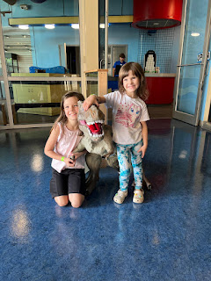

Right now, I am just counting down the days until they arrive here in Italy so the adventures can begin! We have been working hard on the month-long itinerary, collaborating often over phone calls and video chats. We will be incorporating in several activities around Northern Italy, as well as a 5 day trip to Salzburg, Austria and a 4 day trip to London. It will be wonderful and exhausting, but mostly just wonderful!!

After church today, we drove south to have lunch with the Parkers at their beautiful home just behind the church on this hill. They made barbecued chicken, roasted potatoes, a giant salad, and rolls. I brought some chocolate cake for dessert. We played games after the delicious meal and had such a fun afternoon.

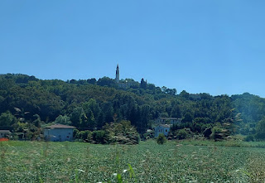

Me, Olivia (their youngest daughter), and Marnie Parker, just before we left to come home.

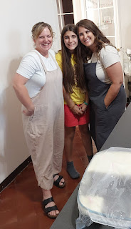

This is the cake that I made: Chocolate Banana Cake by Sister Michelle Craig, who used to serve in the General Young Women's Presidency for our church, until she was recently released from that calling. She had the best Instagram account and I loved following her for the past couple of years. She was always so upbeat and cheerful, and she often shared some great recipes and tutorials, too!

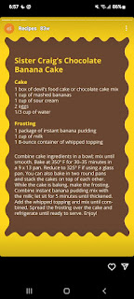

The cake turned out to be pretty amazing. So much so, that I'm gonna go get myself another piece before going to bed, ha ha . . . Thanks Sister Craig!!

