Family History Heals Hearts
I don't know how to begin to describe how wonderful it was to work on my Dad's slides for the past 10 days. It became my full-time job and was very tedious at times, and even wreaked a little bit of havoc on my neck/shoulders/lower back from sitting hunched over at the dining table for hours on end. BUT (and that's a BIG BUT) I was able to see my childhood through a new lens and it brought healing and peace to my soul.
Below: Grandma Lillian holding me and Grandpa Linton holding Charmaine (in San Angelo, Texas)
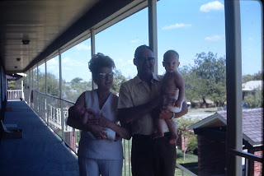

I loved seeing every single picture that included a visit to Grandma Zoe's house. I remember the layout of her home so well in my mind's eye, but seeing all the details again was wonderful. Below: Charmaine and me washing dishes in Grandma's sink.

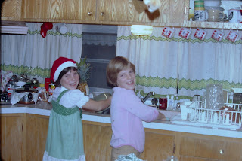

Another year, when I was younger, this is the same sink in the background but with different curtains. Pictured: me, Charmaine, and Mom

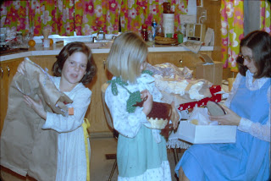

I had forgotten pretty much every gift I ever received for Christmasas a child, all except for this ballerina doll. She had a button or knob inside her tiara that, when pushed, would cause her to kick out a leg or do a spin. She was my favorite doll. :)

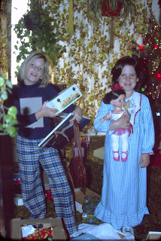

I loved seeing all the places that our parents took us. They took us to just about every state park or national park in California, including this trip to Yosemite where apparently we rode on some mules. We visited lakes, beaches, oceans, waterfalls, forests, trails with ginormous boulders, and took more than one road trip clear across the country.

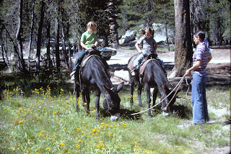

This next photo is a classic representation of our yearly trek over the curvy Boonville Road into Boonville to attend the annual Rawles Reunion. I absolutely loved seeing my cousins and playing with them! We would meet at the Boonville Fairgrounds where sometimes there were varieties of livestock (such as sheep) penned up for some 4-H events (separate from our reunion). I remember climbing on top of several huge stacks of hay that were stored there for the animals.

Below: My cousin Loreena's two oldest children on each end - Rodney on the far left and Cherie on the far right. In the middle from the left: my cousin Katie Gillette, Charmaine, and me. We always had a watermelon eating contest at the reunion, in addition to a seed-spitting contest. What fun we had!

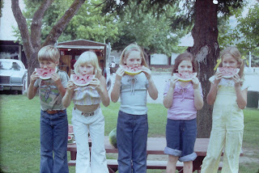

I'm pretty sure this next photo was taken down in Escondido, CA, near San Diego, where my Grandma Doris lived for several years. I remember flying for the first time by myself (at 11 years old) to spend a week or two with Grandma Doris in Escondido. She had a swimming pool in the trailer park and I would ride bikes around the park loop with another girl who was visiting her grandma at the same time. We were about the same age as I recall. That's also the summer that Grandma taught me how to embroider, patiently showing me each embroidery stitch and having me practice them on a pillowcase for embellishments.

Below: My mom taking me for a spin

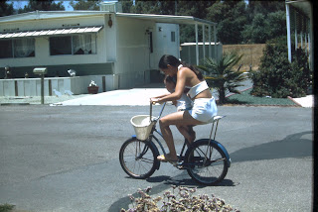

When I was around 16, we drove up to Albany, Oregon as a family so that my sister Charmaine and I could participate in our cousin Suzi's wedding ceremony. We served as the candlelighters. We camped on the way up north and had a good time. I enjoyed seeing my Aunt Juanita (Suzi's mother) and other family members who had gathered for the wedding.

Below: all 5 of us siblings - Ryan, Charmaine, Melanie, and me - holding baby Michael

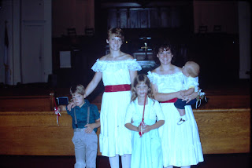

Me, Melanie, and Charmaine - at the base of a very large tree - I think it's a Sequoia, not a Redwood . . .

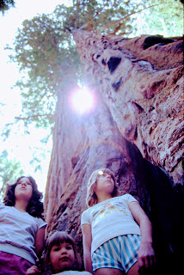

A very neat and tidy campsite was always kept. We also had good food to look forward to because my mom was an amazing cook, but I also remember my Dad being very capable as well, especially when it came to barbecuing.

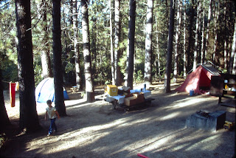

One of the things that surprised me and moved me to tears was seeing all the subjects my Dad chose to photograph. He could find beauty in the mundane and the unwanted, such as a dandelion.

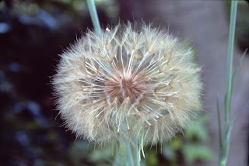

If something caught his eye anytime he was driving somewhere, he would stop to take a few pictures.

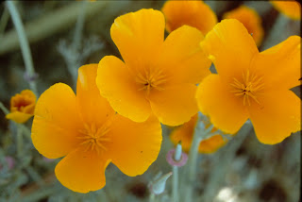

It showed me that he had a soft spot in his heart for so many things that he found beautiful. Whether it was a scene in nature . . .

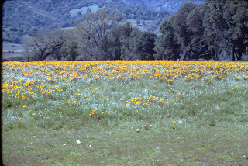

Or a close-up of Ryan's chubby little toes all covered in sand at the beach . . .

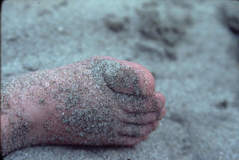

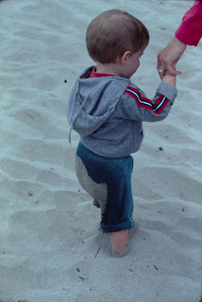

Or moments like this . . . (Charmaine and me feeding some deer in West Virginia, or possibly Maine)

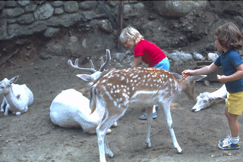

He caught other moments of Life as well, like me having a meltdown on the beach . . . possibly because a wave caught me by surprise or something.

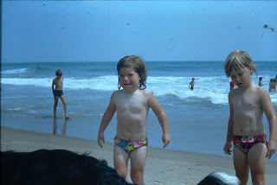

The thing I didn't expect, and that hit me all of a sudden several days into this project, was that I was getting to know my Dad in a much deeper and profound way through his photos. I came to recognize his eye for detail, choosing just the right scene for a picture with composition, lighting, and camera settings in mind. I see that same eye for detail in many other areas of his life as well, something that I think has served him well. I now know where my love of photography comes from, too!

I saw a softer side of my dad, through this photo journey. Because he noticed a single beautiful flower somewhere in the world, and because he chose to park the car and walk over to take a photo, and because he took the time to document our family's life, and because his slides have miraculously been preserved for 50+ years, I was able to see and feel and remember so much of my childhood.

I had two years of trauma that happened to me when I was 9 and 10 years old, and it completely overshadowed the rest of my childhood for the past 40 years. I had forgotten all the good times, the good memories, and the goodness that my parents had blessed me with - notwithstanding those two ugly years. This slide preservation project allowed me to see all the fun places we went, all the fun activities we did together, all the family gatherings we had, all of the love we had as a family, and all of the happiness that they gave me. Suddenly I found myself FEELING stuff deep down and then I had to process what I was feeling.

I mentioned it to Charmaine first in a phone call. It was on a day that I was just beginning to notice what I was feeling. Then the following day it continued to build and build in my heart until I was about to burst. I called my mom next, and just spilled everything out while sobbing and sobbing. I told her I was filled with so much gratitude for all the wonderful things they did for me as a child and that this project was such a gift to ME.

A short time later, I called my Dad and tried to express my thoughts and feelings to him as well. I tried to convey to him how I had a newfound appreciation for him as a person, as a photographer, and as my father. I cried even more while trying to express how my heart grew two sizes because of this project. It was so immensely healing for me to have this journey into my childhood. I always knew that family history has a power in it, including the power to heal hearts and relationships. I just didn't realize the extent of what it would do for ME. But I have a new respect for gathering information pertaining to my family tree, for finding photos of my people, and most especially for connecting to each of them.

I loved seeing a photo of me with my beloved piano teacher, Marguerite Keiffer. She was an amazing teacher, full of energy, pizzazz, and spunk. She knew how to get the best out of me and she did it with love and so much enthusiasm. I will always remember the loving influence she had on me during my childhood. I took lessons from second grade through eighth grade, when I decided I was tired of practicing and didn't want to commit to any more lessons. I regret quitting, though, because I could have benefitted from learning more piano theory.

Below: Mrs. Keiffer is next to me - I am in the white sweater and denim skirt on the far right.

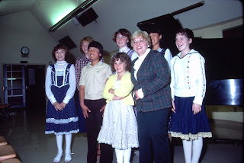

I love this photo of my dad, ha ha. Even though he's doing something that doesn't look very fun in the bathroom, he's just so young and handsome! This took place in the Philippines where he was stationed in 1968. He and my mom had just recently been married, and I think he went over there first to get all set up and then she joined him sometime later.

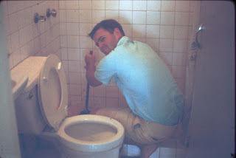

Here he is, also in the Philippines. They lived on the naval base near Subic Bay. He told me that he climbed up the coconut tree while in his dress socks and dress shoes (what was he thinking?) and then didn't quite know how to get down. He said the notches in the tree were razor sharp and he was worried about getting all cut up on the way down. Thankfully he got down okay and lived to tell the story!

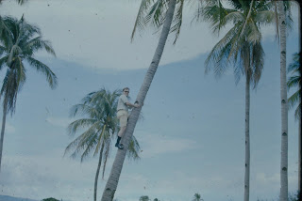

Did I mention that I digitized a total of
2100 slides
into viewable online photos?? I uploaded everything into Google Photos and then shared links with all of my siblings and parents. Everyone has been enjoying seeing all the pictures of so long ago. It will be a conversation starter for years to come! I'm SO GRATEFUL that I was able to work on this special project and it will forever bring joy to my soul as I reflect back upon it. :)

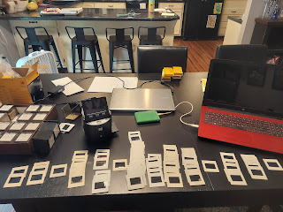

I made 62 new photo albums on Google Photos, but I will only share one of those albums in my blog, since this is a public blog.

Link to the photos from my own childhood: (There are many more photos of me, but this is a collection that my Dad had already sorted out from all the rest of the slides)
https://photos.app.goo.gl/twDqPrG397y8dwbR9

There's not much else to report from the week, since I spent countless hours on this project alone. But here are a few things I can share.

Last Sunday:
I drove up to Rigby to visit with Phil and Coy for a bit. We looked at some children's books together (ones that I bought for Abby and Gwen but hadn't shipped them yet) and had some good laughs.

Dad retired to his office near the end of my visit so that he could practice his German. He's been practicing German every single day for the past few weeks and I'm always so impressed with his discipline and ability to memorize things. I wish I had the knack for memorization like he does . . .

Video of him reciting German with the computer program: (21 seconds)
https://photos.app.goo.gl/8ef9W4UMXBqwfrNfA

Tuesday:
I received our favorite neighborhood dog, Sophie, to take care of for a few days. She's getting quite old, and doesn't run around like she used to. She has a limp for most of the day, but she is still very snuggly and sweet.

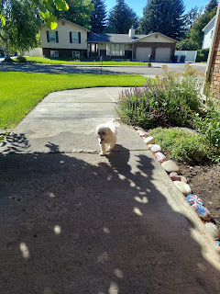

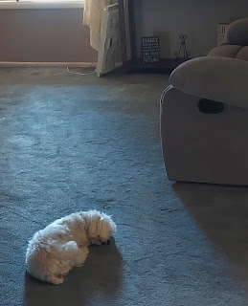

She is getting hard of hearing too, bless her heart. I don't have to tiptoe around so much when she's sleeping, which is nice, because usually she's
super
quick to hear if I walk down the hallway and then she jumps up to see what I'm doing. But this week, I could move about without her even noticing! One time, she was sleeping in her little soft pet bed, and I went over to pet her. As I gently touched her back, she almost hit the ceiling as she jumped with a start!! She hadn't heard me coming or crouch down or reach over . . . I felt really bad that I startled her to that extent!

Wednesday:
I snatched the ONE remaining apple off my tree in the back yard and sliced it up to try for the first time. I've had this tree for 3 years now and this is the first time anything has grown to maturity. The wind has knocked all the rest of the apples out of the tree in recent weeks, but I decided to grab this one and see what it tastes like.

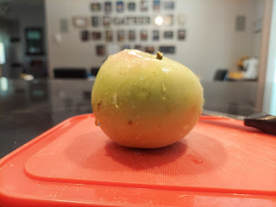

It tasted a little bit tart because it was probably a couple weeks premature, but it wasn't bad. I prefer a tart apple over a sweet apple any day! The apple variety is called Zestar, a combination of two types of apples (I can't remember which ones), and is supposed to taste like apple pie. Maybe next year it will . . . but it was still really good!

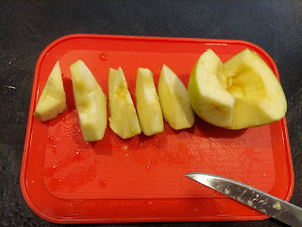

Friday:
Phil and Coy, along with our niece Vanessa and her husband Don, and their daughter, Taylor, came and scooped me up to take me out to an early birthday dinner. We chose to go to Sizzler because it was a great all around winner for our individual preferences. I ordered giant shrimp and sweet potatoes with a trip to the salad bar. It was wonderful! It was even more wonderful to visit with Don and Vanessa, whom I haven't seen a while, and to hear stories of their expanding family now that they are grandparents. :) It was a thoughtful treat for Dad to buy us all dinner and give us a place to hang out together and visit. :)

As they dropped me back off at the house, the rain started dumping from the skies above and I had to run fast to avoid getting drenched. Soon after I got inside, the rain turned to HAIL!!

Short video of the crazy storm: (I sent this to my kids and texted, "What in the hail . . .?) LOL
(22 seconds)
https://photos.app.goo.gl/ees6gpk6e7AKfZ1UA

Saturday:
I turned 51 years old! I spent most of the day on the phone, ha ha, and had some wonderful visits with family and friends. I also went out to lunch with my friend Jenn Anderson. We had a nice visit and I was able to share my recent family history project with her.

I also had a video chat with Jacob and his family, including Jack, who is just the cutest and most smiley toddler.

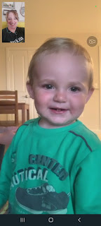

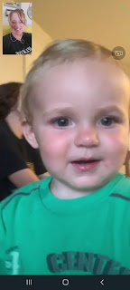

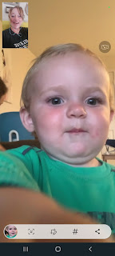

Near the end of our visit, he got into his pajamas and Hannah helped get his teeth brushed.

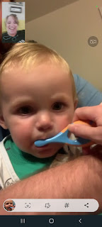

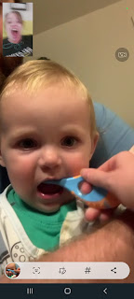

Right after that video call, I got another video call - this time from Louisiana! Abby had just gotten out of the bath and got the royal treatment with hair curlers. Super cute!

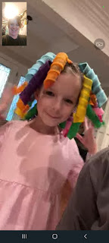

Gwen wanted me to see the rainbow on her forehead and the cat ears on top of her head, but mostly she was too busy to sit and have a conversation last night. :) So I talked to Amber mostly, which is always great!

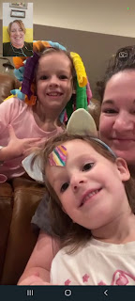

Earlier in the day, I chatted with Scott for a while. He asked me what I planned to do for my birthday, to which I answered, "I'm excited to clean the house!" He was surprised that I would want to clean, but I told him that it makes me happy to have a clean house. I haven't put much effort into cleaning for WEEKS because of my trip to CA and then working on the slides for the past 10 days. I wanted to be up and around instead of sitting in a chair, and I looked forward to cranking up some music and getting my house in order. It's therapeutic for me. :) He didn't quite get it . . . but that's okay.

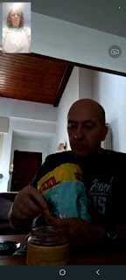

With some of the phone calls I was able to put in my ear buds and multi-task while chatting. I dusted while I talked to Charmaine, I swept and mopped the floors while I talked to my cousin Valorie, etc. It was great!

Over the weekend, my little nephew Jaxon, who lives up in Northern Idaho, got in a terrible 4-wheeler accident. He is my little brother Michael's son. I don't know the details of what happened to cause the accident, but Jaxon ended up in the hospital and spent the night Friday night while they determined the extent of his injuries.

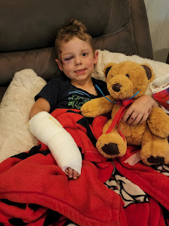

At first they thought he had fractured some bones in his face, but after a CT scan they learned that his bones were all okay, except for his right hand, which is broken. He is supposed to start school this week . . . but I think he might be home for a few more days instead. He is home now, but if you would like to add him to your prayers, please do! His name is Jaxon Snider. Bless his little heart! That looks so painful! I hope he heals quickly and is able to go to school and have a wonderful school year. He is a really smart boy so I'm sure he's itching to go as soon as he's able. He'll be in 2nd grade this year, the same as his cousin, Abby.

