Finding History in DC
I've been having a blast in Washington DC for the past few days, Jack being the highlight of course. We've been seeing the sights and eating yummy food and enjoying just hanging out together.
Jacob, Jack, and me in front of the Washington Memorial

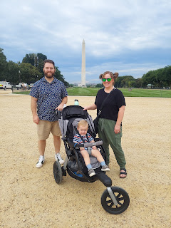

First, I had to finish up around my house back in Idaho and prepare to walk away for a season . . .

I mailed out all the Rawles Newsletters, about 45 heading out by snail mail and about 50 were emailed. It felt amazing to get all of that taken care of and checked off my to-do list.

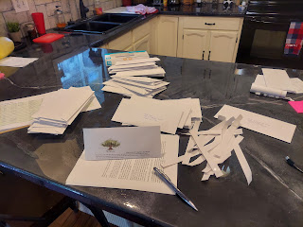

I visited Phil and Coy one last time before leaving, in which Dad gave me a priesthood blessing to help me get through the next few months. He blessed me to be in good health and to be a light and an influence for good with all those I come into contact with. What a wonderful blessing, and what a wonderful Papa!

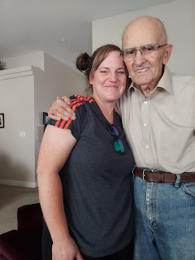

Coy's heart had been acting up again right before I left town, which leaves her feeling quite exhausted and drained. She reports that she is feeling better now though. GOOD!!

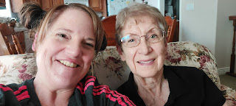

After cleaning the entire house, cleaning out the fridge and taking some food over to my neighbor, taking out the last of the garbage, and "closing up shop", my friend ReNae Cunningham came over to pick me up and take me to the Idaho Falls Airport with my 2 heavy suitcases.

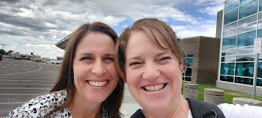

My larger suitcase came in at 50 lbs (yowza!) and the medium suitcase was 39 lbs. I'll be sure to transfer some items over to the smaller suitcase before leaving Washington DC, which should ensure a better weight distribution.

I didn't have any problems on my flight across the U.S., except that my tv screen on the seatback in front of me didn't work. I was left to play a couple games and read scriptures on my phone for the 3 hour flight from Denver to DC. Although I did close my eyes for a little bit, too . . .

Jacob picked me up at the airport and we got back to his place around 12:30 a.m. EST. I got ready for bed as fast as I could and was asleep just after 1:00 a.m.

The next morning, when Jack woke up and saw me for the first time, it didn't take him long before he gave me that signature huge grin of his. He has the ability to light up an entire room with his smile alone. :)

Later in the morning, we all drove to a nearby Metro station at the Pentagon City Mall.

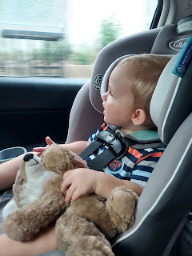

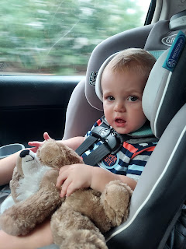

We parked the car there and then rode the Metro over to the National Mall area and then walked a few blocks away to visit the American History Museum.

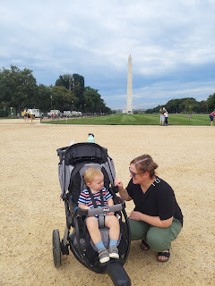

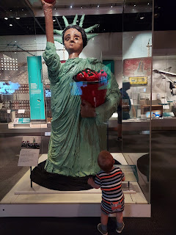

This is the original flag that flew over the Baltimore Harbor during the War of 1812 and the very flag that inspired Francis Scott Key to pen the words to our national anthem.

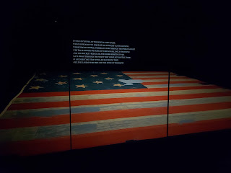

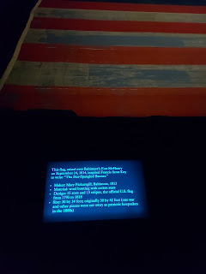

These are sewing instruments from that same time period that Mary Young Pickersgill may have used when she made the giant American flag.

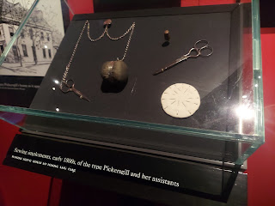

Jack vascillated between riding along in his stroller and getting out to walk and wander and explore.

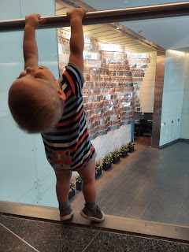

The gunboat, the Philadelphia, was built in 1776 during the Revolutionary War, but was sunk by a few British cannonballs as it sailed in Lake Champlain (along the NY-VT border). In 1935 they found it and raised it up to preserve it, and now it's on display in the Smithsonian Museum of American History.

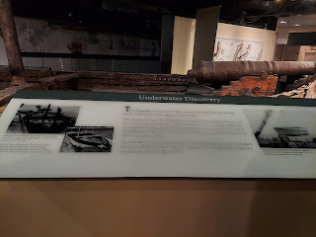

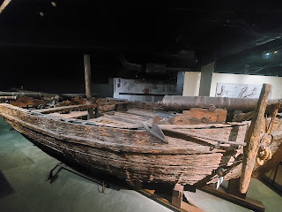

These are the epaulets that George Washington wore on his military uniform.

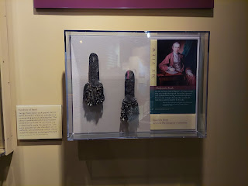

This was the top hat that Abraham Lincoln wore on the night he was assassinated, while he was attending a theatrical performance in Ford's Theatre.

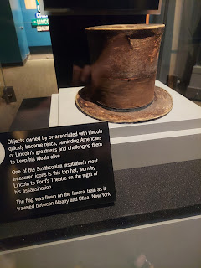

There are several different sections of the American History Museum. Sections with US history, cars, military, fancy outfits that First Ladies have worn over the years, and even a history of food! We didn't absorb this section really well because Jack was pretty much done with our museum experience at this point . . .

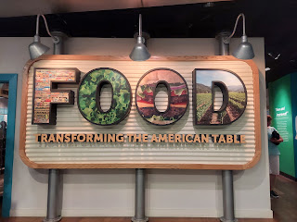

But we found a display of how "Jack in the Box" got its slogan. The box says on the side "Jack will speak to you . . ."

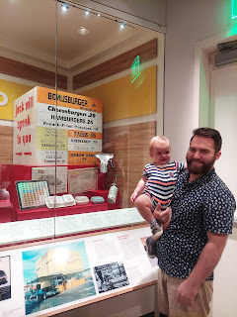

On our way back to the Metro station near the National Mall, we passed the Washington Monument on our right and the Capitol Building on our left.

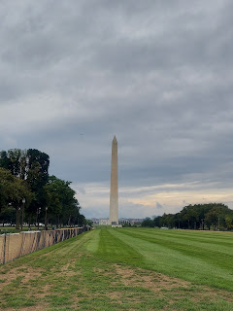

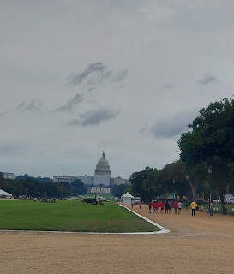

Jack fell asleep hard as we rode on the Metro back to the car.

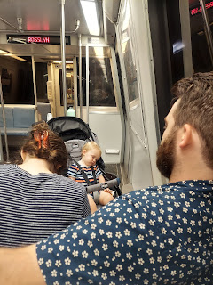

When we got home, he went down for a brief nap, but it was past his usual naptime. When he woke up, he was all out of sorts and unhappy. Hannah got out his "Bean Box" and set him in there. Within just a couple of minutes he perked right up and was happier!

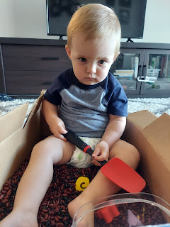

Video of Jack playing in the beans: (38 seconds) *I love all the variety of facial expressions that he makes in a matter of seconds.
https://photos.app.goo.gl/PbCpDCsvGhBcEFQ48

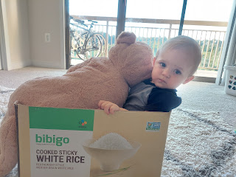

The weather has been so nice here! Upper 60's and a light breeze, mostly. Jack likes to play on the balcony, but he also likes to throw things off the balcony . . . and they live on the 12th (top) floor . . .

Video of Jack: (27 seconds)
https://photos.app.goo.gl/cj4aSPHDP5dvGn8SA

After dinner we went to a nearby park that they like to visit frequently. Jack really enjoys the rocking toys!

Video: (14 seconds)
https://photos.app.goo.gl/S5XoakHFmo2dEzgx9

There are all sorts of toys there for little kids to enjoy. Like this shopping cart.
(45 seconds)
https://photos.app.goo.gl/ZWkFUmxbJJdC43xk7

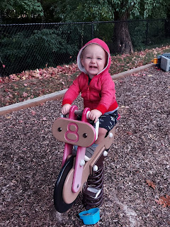

The following morning, Friday, I accompanied Jacob and Jack on a bike ride while Hannah ran 3 miles for part of her training toward her upcoming half-marathon. She's in her final days before the race, so this week hasn't been so intense as far as how far she runs each day. I got to ride on Hannah's bike and it was very comfortable.

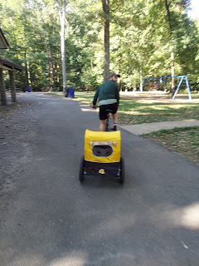

After our morning exercise, we went to visit Mt. Vernon, George Washington's personal estate. Jacob and Hannah have a membership to Mt. Vernon and have been thoroughly enjoying numerous visits this year.

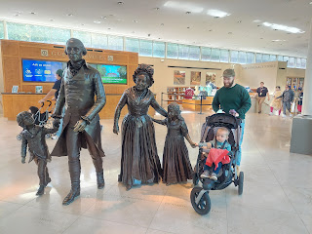

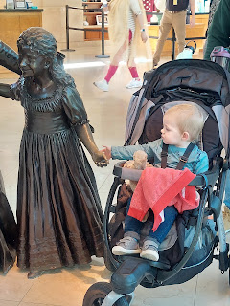

Here is a link to an album with all my photos from Mt. Vernon.

https://photos.app.goo.gl/GUbiR9CLbfosyLJQ6

We walked around George Washington's vast estate, through the forested trails, across wooden bridges, over to the circular barn, down to the dock, over to where he and his wife, Martha, are buried (although it was under renovations with a lot of scaffolding), we did a tour of their house, and finally we wandered through the museum that was attached to the gift shop at the end.

George was first and foremost a farmer. He loved farming and problem solving and figuring out new and creative ways to do things. One of the things he made was a circular barn with the intent of harvesting his wheat crops. He'd lay the wheat down on the floorboards of the main barn floor and then bring in mules and oxen to trample on the wheat. As they walked on it, the friction and weight of their hooves would dislodge the seeds, which would then fall through the floorboards to the room below to be gathered. He could mill the wheat into very fine flour and sell it to make a good profit.

Jack alternated with riding in the stroller and walking throughout the hours that we were at Mt. Vernon. He was a really good sport, as always. :)

I just love seeing the love that this family has for each other. Jack absolutely adores both of his parents and it is evident in every single moment of the day. Jacob and Hannah work as a close team to care for Jack, and they are very loving yet flexible parents, calm, cool and collected. They see the big picture of what needs to happen and are able to do what is needed for Jack's best interests. One example is that they feed him whatever they themselves are eating. Jack is learning to eat what is put in front of him, rather than feeding him baby food or something "special". Jacob made a chicken stir fry dinner the other night, and it had a little bit of heat to it. They served it up for Jack in his dinner bowl and he ate the chicken, the bell peppers, the carrots, and all the vegetables in the sauce except for the zucchini. He didn't like the zucchini and would spit it out, ha ha. But wow. I was seriously impressed.

Here are a few cute family moments at Mt. Vernon.
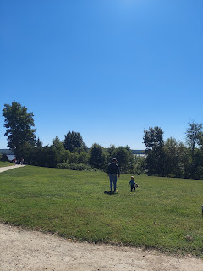

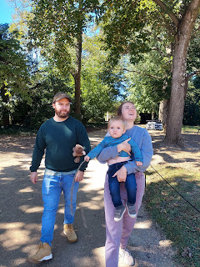

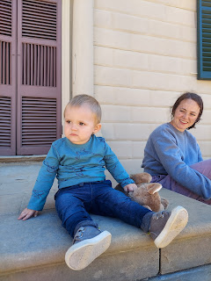

Something they mentioned on our tour of the mansion was that there are elements of decor that reflect George Washington's love of farming and hard work. On the ceiling panels and over several doorframes there were emblems of plowshares and farm tools.

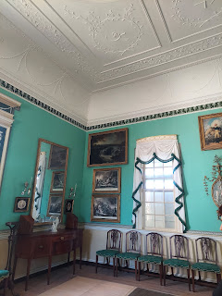

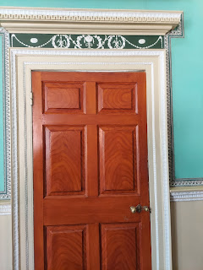

This is their original hand rail from the 1700s. I loved feeling of its strength as we went upstairs.

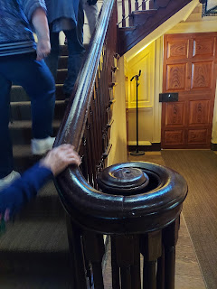

This was George and Martha's bedroom up until George died in 1799.

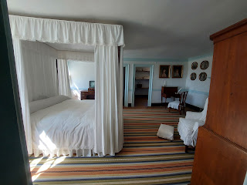

After George passed, as was customary in those days, Martha moved out of their bedroom into another room upstairs. This yellow room was the one she chose.

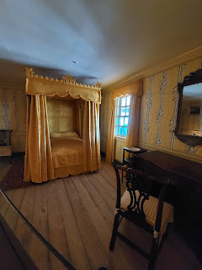

George also had misgivings about slavery, even though he owned a LOT of slaves. He went through a process of recognizance and wanted to change. (see below)

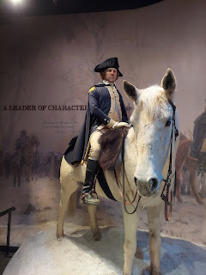

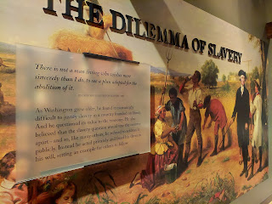

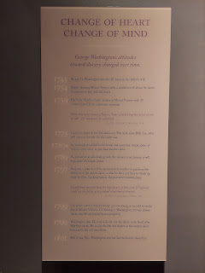

Earlier in the day, they had another Naturalization Ceremony at Mt. Vernon, but we did not attend. They were putting everything away by the time we finished touring the estate and walked over for our tour of the mansion.

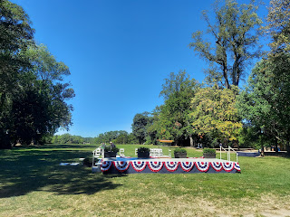

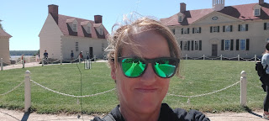

Saturday, we got up and headed out on another bike ride and a run for Hannah. This time she ran 11 miles! Jacob and I rode 6 miles together this time. He dropped me and Jack off at the park and then he went on ahead to catch up to Hannah who was out on the trail. He swapped out her water bottle and stayed with her for a little while before circling back to where I was with Jack. What a good husband!

Just a boy and a stick . . .

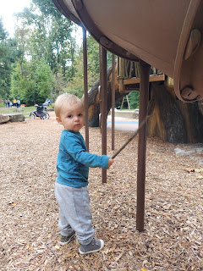

He gets really stoic when his parents are gone. He does have moments of smiles and happiness, but for the most part he is reserved and quiet. He really loves them a lot.

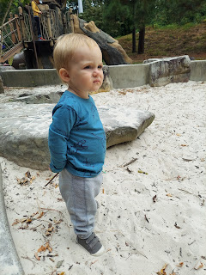

This is part of the trail that runs through Glencarlyn Park in Arlington, VA. Very woodsy and scenic. It's over 100 acres, too.

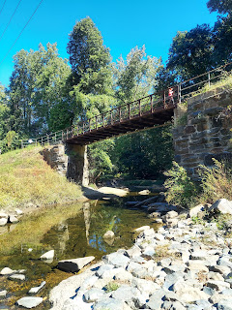

Later in the afternoon, Jacob and I went to visit the Basilica of the National Shrine of the Immaculate Conception. It's the largest Catholic cathedral in North America and is the 10th largest Catholic cathedral in the world. They have been here several times because it's so beautiful and it's also free to do a self-tour.

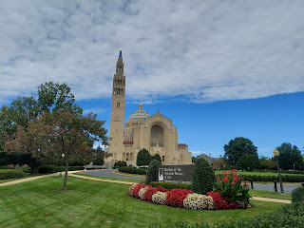

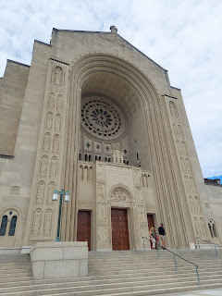

Inside, there was a Mass ceremony going on so we couldn't visit the main chapel, but we could go downstairs to see the crypt with all the mini-shrines and artistic renderings to honor Mary, the mother of Jesus.

I loved this quote on the wall.

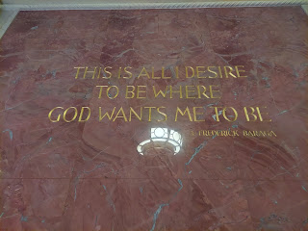

A tribute to Mother Theresa of Calcutta

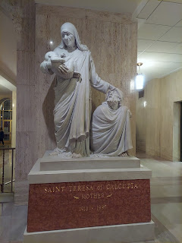

This was a very poignant story of La Vang and a Catholic group of parishioners in Vietnam (see below).

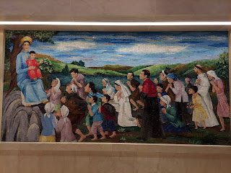

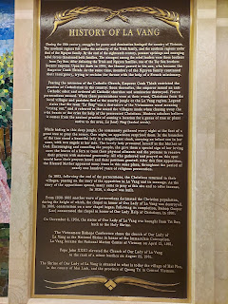

Jacob snuck this picture of me while I was reading the inscriptions in one area. I loved the lighting and the beautiful tributes to ancient apostles and leaders.

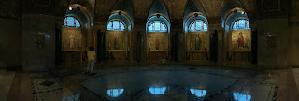

One thing that I noted was that there these massive columns all over in the cathedral. Each one was donated from a country somewhere in the world (Ireland, Italy, Greece, Norway, Lebanon, etc.) and each one had a "plea" or a prayerful phrase at the top. It might have been a plea for safety, for health, for loved ones, etc. Whatever that country felt was the most important thing they needed help with at the time.

But the one that came from Africa simply said: "He hath filled the hungry . . . with good things."

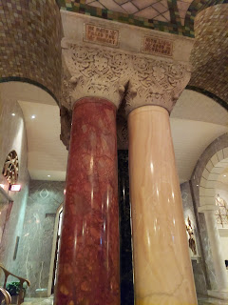

I thought how pertinent that would be - - to come from a place where hunger is also so prevalent.

There is also a VERY life-size cardboard cutout of the Pope. It can definitely catch you off guard . . .

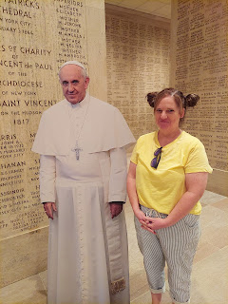

I really enjoyed our tour of the Basilica, especially since Scott and I will be touring the Vatican City Basilica and Sistine Chapel (next to Rome) in a week (with our friends, the Garners).

Jacob is an amazing chef, and I always appreciate whatever he cooks when I come to visit. On our way home from the Basilica, we stopped at a Mexican grocery store that he loves. He grabbed a big 4 pound slab of beef to make tacos on Monday.

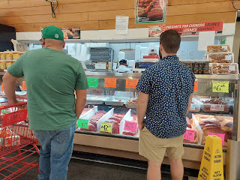

Saturday night, we went out to dinner in nearby Alexandria. We chose a Mexican restaurant named Los Tios (The Uncles) and not only was the food delicious, but the service was outstanding! They were so attentive and kind, in spite of Jack throwing food and straws on the floor, ha ha.

I ordered a shrimp dish with poblano peppers that was SO GOOD!!

As we walked back to the car, I couldn't resist getting yet another picture of Jacob and Jack. They are the bestest of buddies.

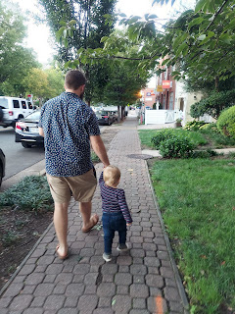

I had texted my Dad as we were heading to dinner, asking if he knew the address of where he and my mom used to live in Alexandria. He told me it was on Bashford Lane, which ended up only being one mile from our restaurant! We stopped by to check it out after we left the restaurant.

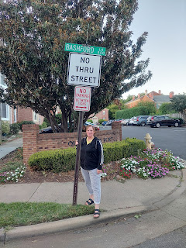

The views looking north from that street sign . . .

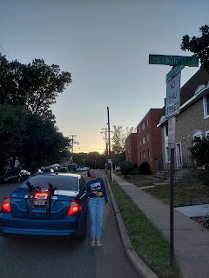

The views looking south from the street sign . . .

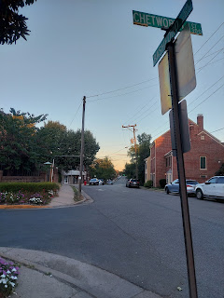

After the little family history detour, we stopped at a nearby park for Jack to unwind at the end of the day.

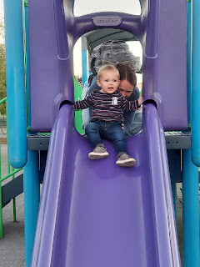

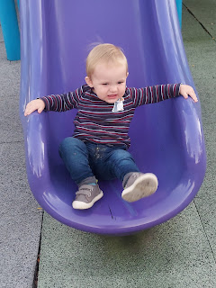

Just a casual "Jack in the Box" breakfast on Sunday morning.

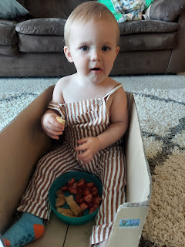

Those extra long curls in the back . . . that Jake and Hannah haven't brought themselves to trim yet . . .

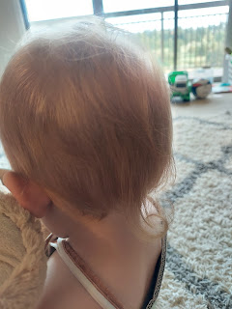

After church, we drove 1.5 hours over to Harpers Ferry to see Gordon and Pam (Scott's older brother and his wife). They made us a tasty lunch which included a bowtie pasta soup, green salad, and homemade bread. It was so nice to see them again - it's been several months.

There were lots of little ones that entertained us for hours!

Gordon and Pam's granddaughters, Azure and Rayma played really well with Jack.

Video of all the goings on: (25 seconds)
https://photos.app.goo.gl/Yz49ccojDg9wqrQq7

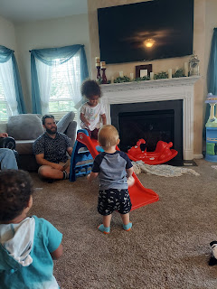

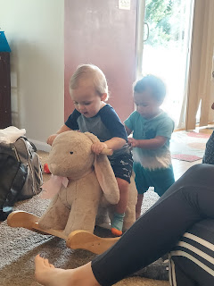

Video of the wee ones: (5 seconds)
https://photos.app.goo.gl/QmpcACY3ZHtRhfFk7

Follow-up video of why Gordon took off his belt: (3 seconds)
https://photos.app.goo.gl/LeTKzFhGgpr8y9f3A

And finally . . . the many cute faces of Jack on the drive back to Arlington - - -

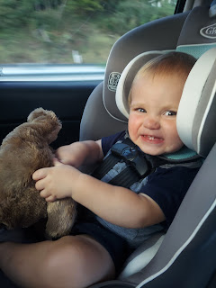

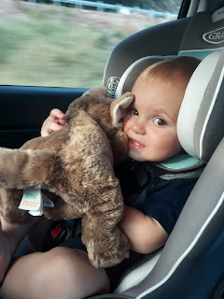

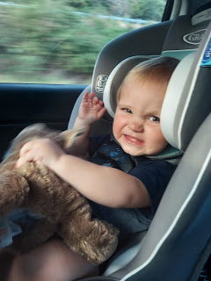

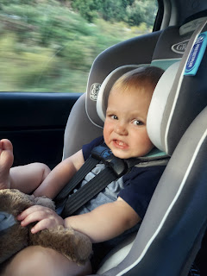

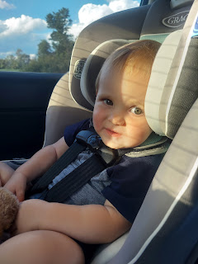

Sunset from the 12th floor . . .

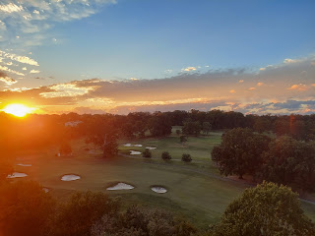

I will be reunited with my husband in 3 days!!! Hooray!!!

