Fingerprinted and Good to Go
It's been a relatively slow week and I am NOT complaining! I worked on some sewing projects, took care of a few organizational projects, planned and cooked our meals, visited Avery up in Aviano, and went on a few errands here and there. For the most part, I have just been the biggest homebody . . .

Friday, May 16th:
Scott drove me into downtown Vicenza after he got home from work so that I could pick up an item at the Tricot Cafe (a fabric/craft store). We used to visit the one across town when we lived over there, but this was a new location and I knew it would be tricky to find a parking place and navigate by myself on those narrow one-way streets. One wrong turn and then you're stuck, ha ha. He dropped me off as close as he could get without driving into a pedestrian zone, and then I walked a few more minutes from there.

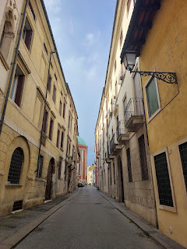

All I needed was one color of embroidery floss for Maisie's quiet book that I'm working on. I didn't have any dark brown to make the little chocolate chips for the cookies on her baking page. It took using Google Translate to communicate with the shop owner that I needed a MUCH smaller version (piccolo) of what I saw in the main portion of her store. She thought that I needed a tiny sewing needle or something, ha ha. But she ended up taking me into another part of the store - in the back - and that's where they have every color imaginable for embroidery floss! Yay! I purchased my one little item - for just over one euro, and then I made my way back to Scott. The store was sure cute, though.

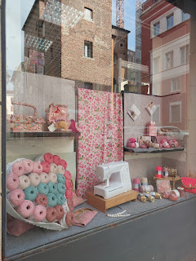

We took my little zippy red car over to the Ederle base where it got a nice car wash. We took care of a couple other errands on the base before heading home to eat dinner and relax for the evening.

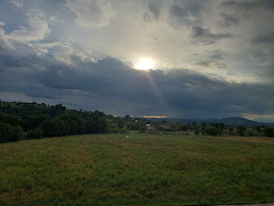

Saturday, May 17th:
We drove up to Aviano to see Avery one more time before they move up to Germany. Because they moved into the hotel on base, our route took us a different way. We passed through the Castello d'Aviano again - something we hadn't done for quite some time. It's always so hair-raising in a couple of spots because it's so narrow and you just hope that a car doesn't come around the corner . . .

Video #1 driving through: (12 seconds)
https://photos.app.goo.gl/BiVVFUgBGAbCr7xd8

Video #2 driving through: (14 seconds)
https://photos.app.goo.gl/EJWmo2Uez1ZbX74J9

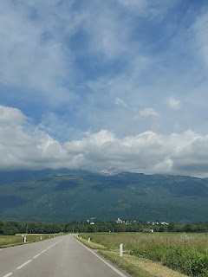

I haven't been to "downtown" Aviano in a really long time. I walked through there several times back in October 2021 when I came to visit Benson and Kylie, just before Avery was born.

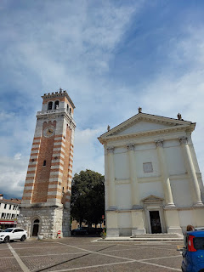

This time, however, I found a sign explaining the history of the large tower in the central piazza. (click photo to enlarge)

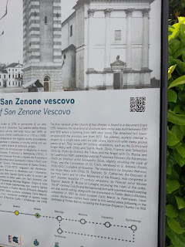

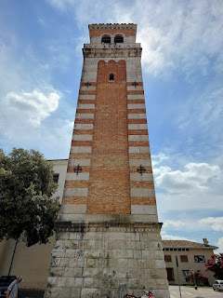

We got to the designated restaurant (Campanile) a few minutes ahead of Kylie, Miles, and Avery, so we found a table outside and began perusing the menu.

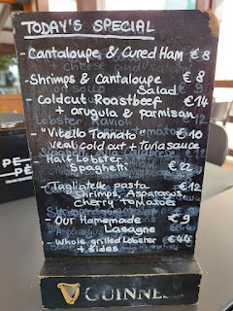

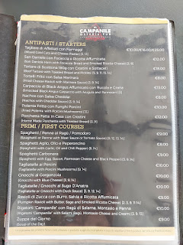

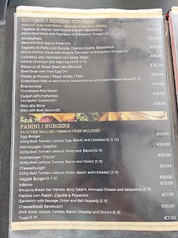

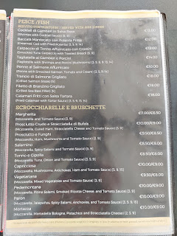

I was quite hungry, and I've been trying to gradually increase my daily protein intake, so I chose the cheesburger. There were several fancier options I was contemplating, but sometimes you just need a burger!

While we waited for our food, Avery entertained us nonstop, ha ha. Between several little mini "explores" around the piazza, she pretended to cook us some food. It was served in none other than the tiny plastic cap from the water bottle! We had to be very dainty to slurp the various entrees out of that little cap . . .

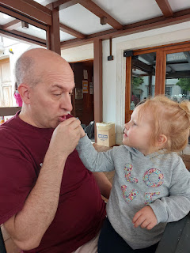

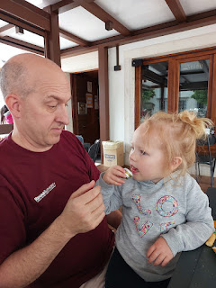

I had brought a hat for the day, fully intending to wear it. I even did a twisty pigtail braid sort of thing to wear underneath my hat. But on the drive up to Aviano I realized that this was a bad idea, because as soon as we arrived home later that afternoon, I would need to change my clothes and head to the church for a baptism. My hair would be an absolute disaster by that point, with "hat head" and the likes . . . So, between Scott and Avery, they wore my hat instead and I just ended up with a bad hair day and no way to hide it.

Avery wore my hat very well, though!!

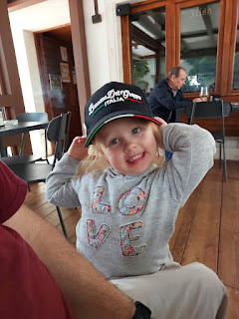

Video of Avery attempting to eat her very hot pasta: (9 seconds)
https://photos.app.goo.gl/k5SVwo7C22Uu3NnH9

**It didn't take her very long to figure out that she could slide one of the fork tines up into the length of a noodle and it would stay put until she could offload each one into her mouth. What a pro. :)

Miles bought a new BMW recently and we followed them to the base after lunch. I took a photo so Benson could see what they're driving these days. He was starstruck when he saw their new car . . .

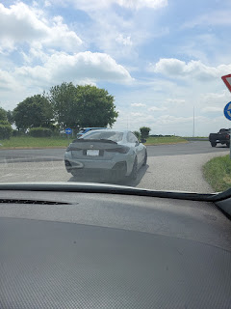

Aviano Air Base . . .

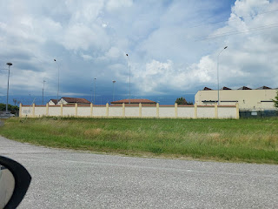

We took Avery to the huge park near their hotel. (Don't look too closely at my hair . . . )

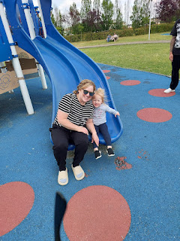

She insisted that I follow her up the steps, across the bridge, and down the dual slide. MANY TIMES. After maybe the 8th time, I was feeling a little winded because we had completed this loop back to back nonstop with no breaks. I breathlessly said to Avery, "Whew. I'm getting tired!" Her answer . . . "Nope."

She cracks me up!! In her mind, there was zero tolerance for anyone being tired. It was time to play and that's all there was to it.

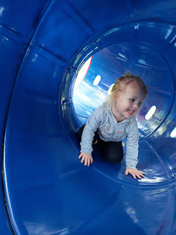

When it was time to say goodbye, Avery wasn't having any of that either. She clung to me desperately, crying and pleading for me not to go. It was heartbreaking!! Kylie told me that she does this most nights at bedtime, too. She loves being around people SO MUCH that she has a really hard time separating from them. I had to peel her fingers off of mine and then back up so they could close the car door - all while she was strapped into her carseat, howling in tears.

We have since made plans for me to come stay with them in Germany at the end of September. Miles wants to go to Oktoberfest - because it's GERMANY - and they need a babysitter. I'll fly up to Frankfurt and grab a rental car. They will be roughly 1.5 hours west of Frankfurt, once they get settled into a house to rent. My plan is to stay with them for the first few days, and then once they are home again, I'll take off on my own for some family history adventures. There are SO MANY places nearby that are connected to my ancestors. This year my goal was to focus on Germany, but it's been so busy that it's hardly even seemed possible. Kylie knew that Germany was my goal, so she reached out to help me take a step in that direction. I'm so glad she did! It will be a win-win all the way around.

The baptism that we attended back in Vicenza was for a lady named Florida. She is originally from Albania, but she moved to Italy several months ago as part of her separation from her husband back home. She has two teenage daughters and one son, also a teenager. It was while she was in Vicenza that she began meeting with the missionaries and started coming to church. She not only speaks Albanian, but she also speaks fluent English and Italian. She has been attending the Italian Ward on Sunday mornings, and then she slips into our meetings immediately afterward.

She has shared her testimony at least twice in the past few months of the Savior and the things she has been feeling so deeply in her heart. She is so genuine and sincere as she speaks, and also when she smiles and has interactions with everyone. I have really grown to love her in a very short amount of time.

We all sang "Love One Another" in Italian for one of the songs. It was so beautiful to hear everyone singing in their native language all around me.

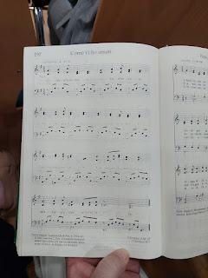

Another lady named Monica was also baptized on the same day, and probably because she only speaks Italian (and Florida is fluent in Italian), the whole program was also in Italian. A dear friend from our ward, John Pyne, is who Florida asked to baptize her. John works in the same office as Scott and he is one of those amazing people that knows everyone's name, makes each person feel like a million bucks, and is so genuine and also super smiley! His wife, Addie Mae is one of my dear friends, too, and their daughter Liberty is currently serving as a missionary in New Zealand.

I may have mentioned this before, but the Pynes named each of their children something very patriotic. Their oldest son is named Patriot. Then Liberty. They have a teenage son named Justice. And their youngest daughter is named America. She just turned 8 a few months ago.

An incredible part of Florida's story is this: She has kept in touch with her husband regularly, even though they have been separated. He comes to visit her and the girls once a month in Vicenza, too. Recently, when he came for a visit, she wanted to tell him that she intended to be baptized into the Church of Jesus Christ of Latter-day Saints, but she was worried he would be upset. When it finally came up in conversation, he was very receptive and kind, telling her that he could tell how much it meant to her and so he gave his support even though he knew nothing about this new religion.

She also told me privately a week before her baptism that she never knows when he will be coming to visit each month. Well, his visit for the month of May just "happened" to be on the weekend of her baptism. She had been praying that he could come and be a part of such a huge step in her life, and now it was coming true!

This is their whole family together, with her husband and the 3 children starting from the left. The missionaries are on the far right, with Florida in the beautiful coral striped outfit. What a special day for her! So many prayers were answered in her behalf and I'm grateful that we got to be a part of it.

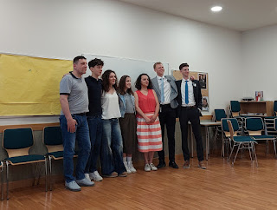

We stuck around for the refreshments afterwards, and we stayed a little longer after that as we waited for the missionaries to dismantle the baptismal font and clean everything up. Then we drove the missionaries across town to another engagement before heading home around 7:30 p.m.

As we drove home, two things happened.

1.) While sitting at a red light, we saw the weirdest car ever parked off to our left.

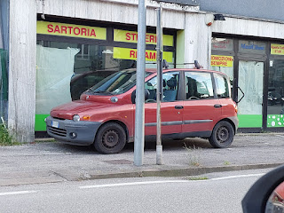

And 2.) I realized that I was supposed to call Chelsea at 7:00 p.m. and it was now almost 7:30!! I messaged her and apologized, letting her know we were almost home. We had never intended to be gone that long in the first place, but when help was needed, we volunteered for the job. Thankfully, Chelsea and Garret were just cleaning their house back in Denver and so it was no big deal to delay the call.

We ended up having a wonderful visit and got all caught up on what everyone is up to in each of our families. I'm hoping to go visit them next summer (2026) and spend a few days where we can do some hiking and a few other activities in their neck of the woods.

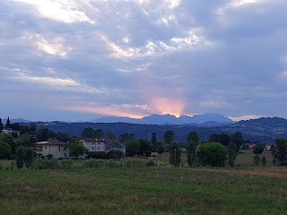

Sunday, May 18th:
Happy Birthday to my beautiful daughter, Amber!! She is now 31 years old!! Where has the time gone . . . wow. They were busy making homemade donuts when we called, but they were at a good resting spot at the time so that the dough could rise a little.

After church, we prepped a tasty meal to feed some of the young single soldiers.

Video of the taquitos, fruit salad, and cilantro rice, along with some of the other fixings: (11 seconds)
https://photos.app.goo.gl/tF3e2fMb91mgt9eo8

I told the boys it was an all-you-can-eat buffet and they happily obliged, finishing everything off except for the giant bowl of fruit.

One of the first things we noticed when we moved into this new place was the ping pong table down in the garage. Paddles and ping pong balls were also available, and the table legs even have wheels so you can move it wherever you want to play.

Morgan, seen below in the green hoodie, was the resident expert. He knew all the rules and patiently coached those of the rest of us who were pathetic, including me.

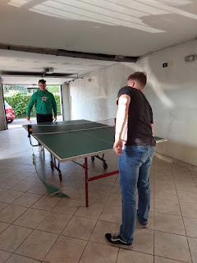

L to R: Braddock Olsen (Formerly Elder Olsen, who served in Vicenza last year but has since been released from his mission and now works for the military in Germany), Morgan Kethley (from Bossier City/Shreveport LA), Scott, Jace Wood (from Houston TX) Shayne Ramon (from Mapleton UT), and me in the front.

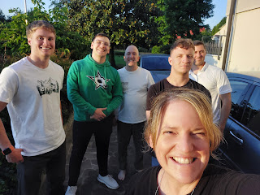

Monday, May 19th:
The sun was up and the temperature was the warmest it's been since I arrived here on May 1st - a toasty 80 degrees. I used the opportunity to lay out on the balcony and do a little suntanning. I like to listen to either some music or some general conference talks while I do 20-30 minutes on one side, then flip and do 20-30 more. And that's it for my tanning session for the day.

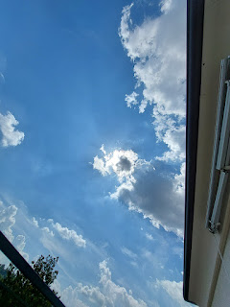

We are still getting a beautiful sunset every single evening . . . this one was a little more special because we rarely get to see the Dolomites off in the distance. They are usually enshrouded by clouds.

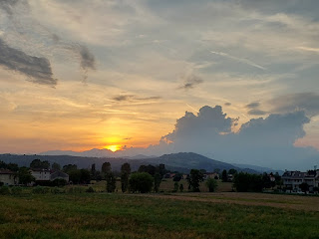

I've been frustrated that I haven't been able to lose any weight lately. Amber helped me start using a new app that she uses, called FoodVisor. Yes, I had to pay a little bit for it, but she has lost over 20 lbs from using it every day. It's basically a food tracker, but it only takes seconds to log each meal. I'm able to see how I'm doing each day with protein intake, carbs, fiber, fats, protein, and overall calories. I can add any exercise or activities that I've done throughout the day, too.

I saw that I was typically only eating around 900 calories per day. This is what felt comfortable to me, but apparently I'm not eating enough. Eating under 1,000 calories per day can backfire and cause metabolism to slow down drastically. Also, I was not eating nearly enough protein. To be honest, I just don't crave a whole lot of protein most of the day. What I do crave is fruits and vegetables, and sometimes cheese. But also, some nights - AFTER I've brushed my teeth and climbed into bed - I get hungry. Sometimes I ignore it, but sometimes I sneak into the kitchen and grab a string cheese or something simple to tide me over until the morning.

Anyway . . . I have increased my exercise over the past month since I arrived in Italy. I am doing strength training, Pilates, and I've even added the rowing machine and stair climber at the gym recently. We go on walks most nights - for about 45 minutes.

But no weight loss.

I was discussing all of this with Scott the other night before we went to sleep. He said, "Have you asked ChatGPT about it?" I hadn't, but I did right then.

This is a portion of the response that I got . . .

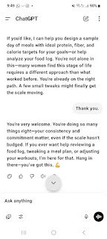

By the time I finished reading everything, I was in tears! I know some people are up in arms over AI and ChatGPT, but I find it to be oh so helpful. Plus, it said exactly what I needed to hear. I got validation for my efforts, and some encouragement. Thus, the tears.

Since then, I have made a few alterations to my plan:
~Make sure I'm aiming for 90 grams of protein per day. This will help increase my metabolism and will help my body as I'm trying to build more muscle.
~Drink more water. This will also increase my metabolism, among other benefits.
~Continue with strength training. I think I will go ahead and purchase some kettlebells that I can use at home on days that it's not convenient to go to the gym.
~Limit my overall calories. For the longest time, I was cutting back, but I didn't realize that I had cut back TOO MUCH. The FoodVisor app was encouraging me to aim for 1200-1400 calories per day, but I think that is too much for being in my 50's now. I think I would be okay with aiming for 1200 MAX, but 1100 feels more natural and realistic for me.

I'll report back on how things are going from time to time.

I'm also getting some feedback from a new doctor here in Vicenza. More on that below.

Tuesday, May 20th:
After going to bed in tears, I also woke up in tears . . . this time for something completely different. My dear friend from my childhood, Emily Fawson Flake, shared that her mother was in the final days of her life here on earth. It hit me pretty hard, considering that Janet Fawson was like an extra mom to me for many years. Every time I hung out with Emily, Janet was always so cheerful and kind, with a warm smile and an offer of something delicious that she had just baked. The pumpkin chocolate chip cookie recipe that I've used for DECADES was hers originally. She would make these (and other) cookies and bring them to share with our Sunday School class at church when she was our teacher.

Link to her recipe (with some alternate options that I created on the side:
https://photos.app.goo.gl/xwk93sibmvTosUBi7

A little over a year ago, Emily's sister Julia suggested that their mom would love to get a postcard from me from time to time. So I did! Emily reported back to me later that Janet was so happy to read about some of my travels. I'm glad I could bring her some measure of joy in the final year of her life, since she brought so much joy to my own life.

She ended up passing within a day or so. She is now reunited with her sweet husband in heaven, and no longer suffering from Parkinsons Disease. I'm happy for her, but I know she has left a big hole in the lives of her children and grandchildren.

Later that morning, I went to the other Tricot Cafe shop across town, the one closest to where we used to live, so that I could get some fabric. Sister Sim, the senior missionary who is in charge of making a community quilt, asked me to make a red/white/blue heart on a white square. This was after I told her my plan to make one for myself, ha ha. She loved the idea so much that she wanted a USA one for the quilt, too!

As I was perusing the fabric section, a lady came and stood by me and started talking to me in Italian.

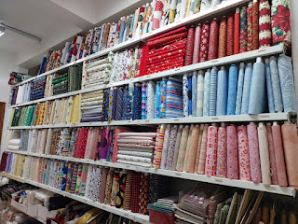

Very quickly she learned that I did not speak her language fluently, but then she didn't speak any English either. We used Google Translate on my phone to discern that she was curious if all these fabrics were for "patchwork quilting" and if I knew how to do that. I showed her a photo of the heart that I had already made, with the colors of the Italian flag, and how I wanted to make an American one. She wanted to know how did I learn how to quilt because she wanted to learn, too.

I showed her one of the tutorials I had watched on YouTube, and she said she would do some additional research. At one point, she spoke to me very quietly, but still in ITALIAN. I didn't know what she was trying to discreetly say, but when she spoke into my Google Translate app, it turned out that she wanted me to know that there is a cheaper place in a nearby town called Abano Terme. :)

We must have stood there "chatting" for about 20 minutes. My arms were filled with bolts of fabric, and she was filled with an immense curiosity about everything. She indicated that she wanted me to meet her at some fabric store in another town the following day. Not only did I feel that this was very "forward" of her, but I had to tell her I couldn't because Scott and I had an appointment to be fingerprinted for our visas that same day.

She still insisted on giving her personal information to me, so I gave her mine. I have no idea if our paths will ever cross again, though. At one point, the thought crossed my mind that if I were a missionary, I would be more comfortably fluent in her language and could visit with her more easily. Perhaps comfortably enough that I could have invited her to church . . .

Here is one of the bits of our conversation while using my app - she literally gave me all of her information!!



I've never had anyone be so forward before here in Italy. She is perhaps 8-10 years older than I am. Unusual, yes. Intriguing, also a yes.

On our evening walk, Scott and I trudged further out toward that distant village of Maddalene again. This time, we stopped briefly in the cemetery along the way. Scott wanted to test out using the Billion Graves app and to upload some photos and information to see if it all worked correctly. It did.

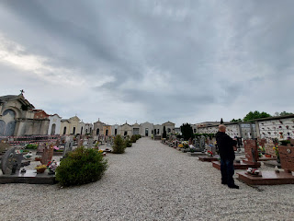

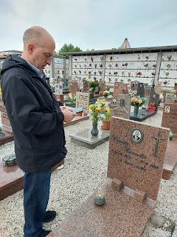

I still need to get my app up and running, because for whatever reason, it doesn't want to log in and let me get set up when we're away from wi-fi. Scott had the same problem earlier, too, but he remembered to get his account set up on his computer first, then log in with the app while still at home, and then it all worked just fine at the cemetery.

We continued on, and made our way toward the little church in the village of Maddalene . . .

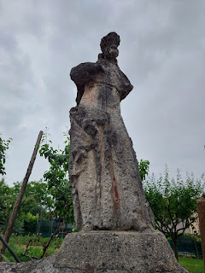

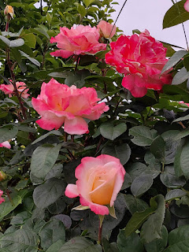

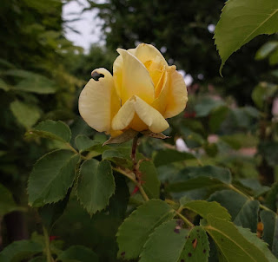

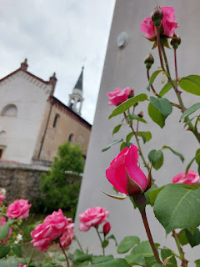

Someday I hope to have a balcony just as pretty as these ones . . .

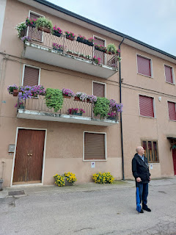

The church was closed and it looked like it hadn't been open in quite some time.

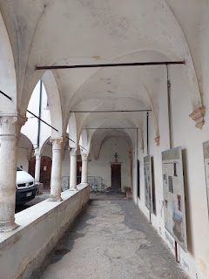

There was a row of signs in the exterior hallway that explained some of the history of this old church. The wording on each of them was a bit tedious, so I will skip to the most important highlights:

~ The Chiesa di Santa Maria Maddalena was built in 1437 by Girolimini friars.
~ During the Christmas season each year, there is an impressive display of Nativity scenes, both inside and outside of the church. There are additional displays in the nearby fields (by our house) and along nature paths that wind past a stream.
~ There is a beautiful painting inside the church that has been carefully restored. Experts are not certain when it was created, but the estimate is somewhere between the end of the 16th century up until the beginning of the 18th century. I hope to see it sometime soon, when I can figure out how to get inside the church.

The painting is entitled, "Noli me tangere", which means "Touch me not."

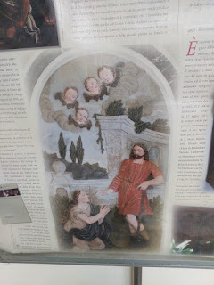

These were the only two doors I could see, although we did not walk around to the other side of the church. Approximately half of the original structure has been converted into small apartments, so we didn't want to trespass.

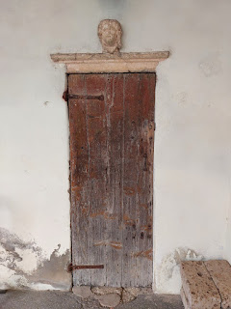

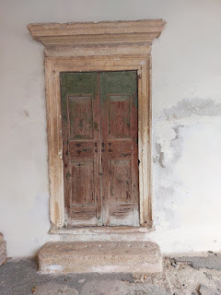

Since our visit, I've done a little bit more research and I'm hoping to find the entrance next time we walk out there.

Here is a link to the most information I could find - and it's not much! Maddalene is the tiniest little village ever - population is roughly 86.

https://app.wanderlog.com/place/details/7919125/chiesa-di-santa-maria-maddalena

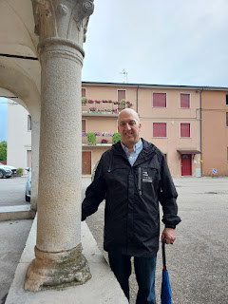

Continuing our walk, we passed by some artichoke plants . . .

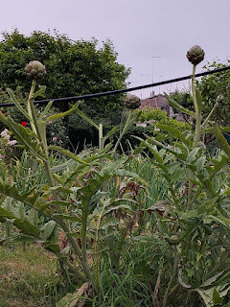

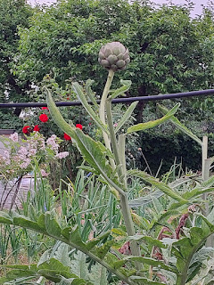

Old buildings that have been dressed up a little with present-day flowers . . .

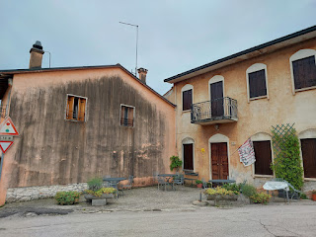

A whole passel of black cats on someone's front porch . . .

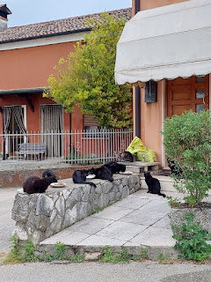

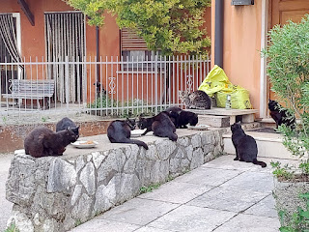

And some pretty roses, of course . . .

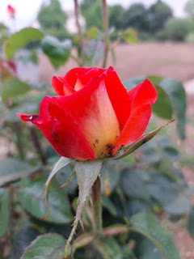

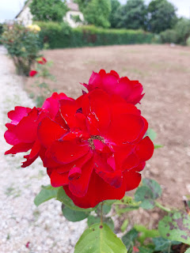

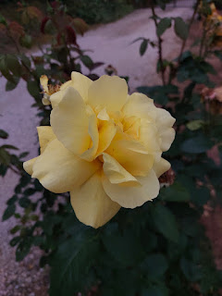

The one time we brought our umbrellas with us, it never rained at all, ha ha. But at least we were prepared!!

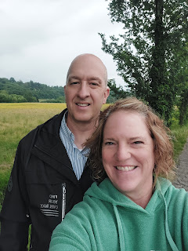

We walked past a large garden in a vastly large field. It was peaceful and beautiful, even with all the weeds everywhere. I made a point on a recent Instagram/Facebook video that my eyes were drawn to the 3 bright red poppies amongst all the weeds, something that is just part of my nature. I like to be an optimist. It's a lot more fun to live life that way!

Video of the 3 poppies: (9 seconds)
https://photos.app.goo.gl/3ge4uJLpHJ3icT9q7

Wednesday, May 21st:
I think this was the final step in our visa process, but we *at long last* got fingerprinted. Soon(ish), we should get a notification that our soggiorno visas are ready to be picked up on Ederle, the bigger base here in Vicenza.

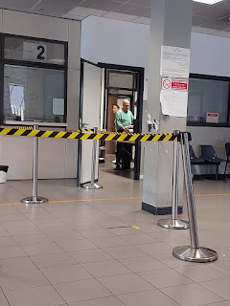

The small team of workers that did the fingerprinting for us were so friendly! When it was my turn, they opened the conversation by asking about Texas, since I was born there. They debated back and forth about whether it's called the Lone Star State or the Longhorn State, ha ha. I finally told them I wasn't 100% sure because I only lived there briefly as a new baby before we moved to Alaska. They were even more intrigued about the remoteness of Alaska, asking why did we move all the way up there? I told them about my father's Naval service and what his job was at the time on Adak, a tiny island that's part of the Aleutian Island chain. They bantered and joked and asked some good questions. All in all, I would say that was the funnest fingerprinting process I've ever had! (I've only been fingerprinted a couple of times - just to be clear . . .)

Once we got home, we washed, peeled, chopped, and cooked up several pounds of potatoes. Why? Because one of Scott's buddies at work, Elkima, was having a going-away party the following day and he signed up to bring a big pan of creamy mashed potatoes.

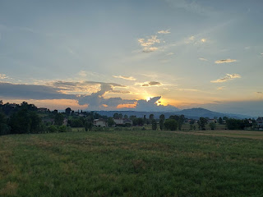

I also found out this same day that my dear friend, Jasmine, who is like another daughter to me, was having some serious health issues back in Arizona. She had just given birth to her first baby 6 days prior, but she had been in a great deal of pain in the final months of her pregnancy. They determined that the pain was stemming from her gallbladder, but they couldn't do any surgery until after the baby was born. She was already dealing with a high risk pregnancy and was staying at the Ronald McDonald House in Phoenix until the baby was born safely.

But now, six days after having a c-section, she was in the hospital again with excruciating pain. They diagnosed it as her gallbladder and made plans for another surgery! I went to bed with some worries, but I just kept praying over and over for her, as I had already been doing for days and weeks.

By the next day she let me know that the surgery had gone well and her pain was significantly improved. Hallelujah! That girl has been through more than most people in her short 24 years on this earth. I'm glad her husband, Brandon, was able to care for their newborn baby while she was in the hospital, even though it was taxing on him as well. Any extra prayers for them would still be appreciated, since she still has a long road of recovery ahead. Thank you in advance.

Thursday, May 22nd:
We woke up to some light flooding in a couple rooms from the sideways rain that poured in during the night. We mopped up the puddles and all was well.

The rain continued through most of the day: (9 seconds)
https://photos.app.goo.gl/Q76dgQXEQE32VAGf6

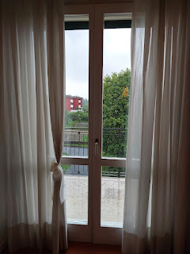

I drove to a massage appointment with Evelyn, the same lady I've gone to for the past few years in Vicenza. I used to be able to walk to her building, but now I have to drive because it's just too far away.

I picked up some groceries on the base and dropped off some items at the thrift store there, as well. It always feels so good to downsize and tidy things up.

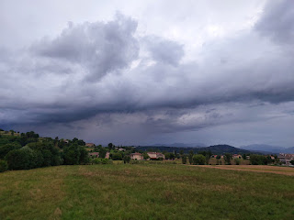

Things finally started to dry up by dinnertime . . .

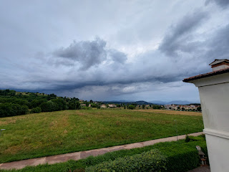

Friday, May 23rd:
I went to the first of what will be many upcoming doctor appointments. All I needed was to get an eye exam, but with our new insurance (Cigna), I have to see a primary physician first and then they will make the referral.

Dr. Nicoletta was very thorough. She had a great sense of humor, but was also very intensely focused on my entire health history. I'm starting to recognize that Italian doctors REALLY, REALLY want to figure things out. They might be a little over the top in their process, but then Western doctors seem to be the opposite - doing the bare minimum and then not really trying with all they possess to figure out what your health issues could be.

She spent about 20 minutes pecking out her report with no more than her two index fingers, LOL.
Also, when she said the word "uterus", it came out sounding like "hooterus". :) :) :) :)

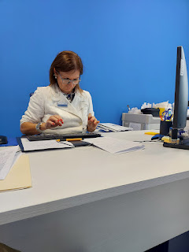

My appointment ended up lasting TWO HOURS. She wanted to look at all the potential puzzle pieces for my issues of: thyroid, weight gain, hormones, pre-diabetes, and most especially - the nagging problem in my larynx area that makes it hard to inhale and breathe comfortably.

I will have a whole slew of other appointments coming up - besides my original need for a new pair of eyeglasses, ha ha. She wants me to get an ultrasound on my throat - she's worried I may have an enlarged thyroid; an ultrasound on my abdomen to look for a loss of "villi" in my intestines which would be an indication of Celiac disease and which could also explain my inability to retain iron and other essential nutrients; I may end up having to get a colonoscopy (yay); a visit to the cardiologist to explain my extra "beat"; a visit to the endocrinologist to look at all of these puzzle pieces as well; labwork to test for Celiac disease and to check thyroid levels and a few other things; and finally - yes, a visit to the optometrist!!

The good news is that we are double-covered right now - - we have an extra 6 months on Scott's military insurance (TriCare) and we also have the new insurance, Cigna. I guess we'll see where all of this leads.

After I left the healthcare clinic, I drove to a new grocery store called Esselunga, one that my friend Sherry Haines had said was one of their favorites. It's a pretty big store, but it was a little hard to find things on my first visit. What I did find, however, was a great circular display with everything you could ever want or need for sushi. They have some already prepared sushi, but they also have many individual components so you can make your own if you want. What I brought home - and loved - was this little tray of sushi-grade salmon, chopped up and formed into a patty, with a few pieces of diced avocado on the side. I splashed a little bit of soy sauce on it and snarfed it up in a flash. It had lots of protein - and healthy protein is something I'm striving for.

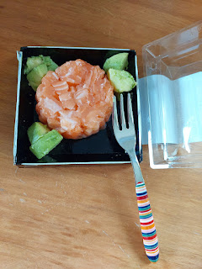

After work, Scott brought home some packages that finally arrived, including this beautiful Mother's Day gift from my children. They had put together some of their favorite photos - some with me, and some not - and made them into a collage photo frame. I absolutely LOVE IT!!

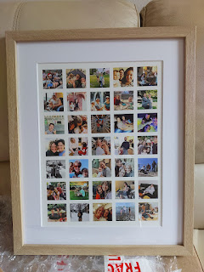

That evening, we had a Date Night by going to the movie theater on Ederle for the first time. We got to see the new Mission Impossible movie - and boy was it EPIC. We are huge fans of the series and we've been looking forward to this one coming out for several months!!

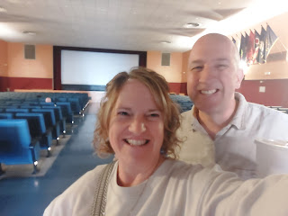

Something interesting about this movie theater is that when it came time to begin the movie (after all the new movie previews), the Star Spangled Banner began playing on the screen and everyone immediately stood up and put their hand over their heart. WOW!! We've never seen anything like that before!! That was pretty cool.

We took an extra photo to send to our kids before the lights dimmed . . . that was one of the best movies we've ever seen.

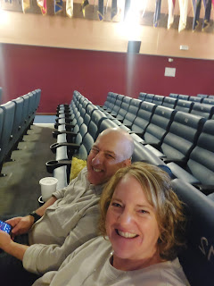

Saturday, May 24th:
We spent most of the day helping the Alejos (members in our church ward) move to a new house. Sheri Alejo is our Relief Society president, and she's also a teacher at the Vicenza Military High School. Her son is on the baseball team and they had traveled up to Germany for several days for what is called "Euros". Euros is a tournament of several sports where students from all the European military high schools compete against other military high schools. The geographical area is large enough that they've split it up into different divisions. Vicenza is in Division II. Sheri's son, Billy, competed against several other schools and ended up in 2nd place overall. Naples won the baseball division title, much to their dislike.

Anyway, they rode the bus all night long to arrive home at 8:00 a.m. Sheri barely had enough time to shower before several of us arrived to help get them moved. It was a long day for us, but it was all for a good cause.

Scott and Bishop Wilson worked really hard and did a great job. The missionaries helped, too, along with several other families.

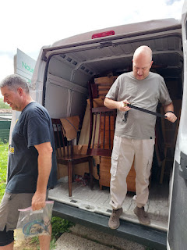

As Bishop Wilson and I dissambled their 72-inch plasma screen TV and carefully packed it into its original box for transport, he told me that he just found out Thursday night that he no longer has a job with DODEA.

DODEA stands for DoD (Dept of Defense) Education Academy. We have several teachers and administrators that live and work in Vicenza, including our good Bishop. For many years, he's been more of an administrator, serving as a principal mostly. But last year, he switched jobs. He started serving as a technology support, helping students with any problems they are having with their school-issued laptops, for example. He also assists the teachers with any tech issues they may encounter.

Well, with the recent overhaul by our new US President, the military has been asked to cut back a certain percentage of expenditures as well. Apparently, this now includes some of these "non-essential" jobs. So now, he's out of a job - and the students and staff will have more stress as they try to figure stuff out on their own.

His wife, Angela, who was our previous Relief Society president, is still teaching English for DODEA, but it won't be enough income for them to stay in their current home. They have much to figure out in the coming weeks. We'll be praying for them for sure.

The Alejo's house was sure interesting. The layout was spread out over 4 floors. I thought the shower upstairs was especially interesting.

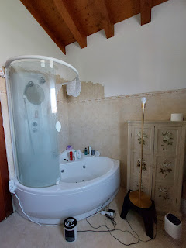

As we cleaned out their sports storage room, these doors became more visible. They are super solid and thick, and they look like they're hundreds of years old.

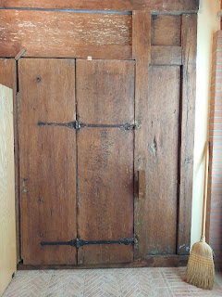

This was their kitchen with a large fireplace . . .

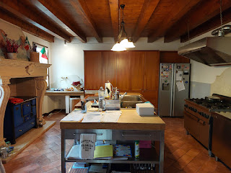

The biggest difference that I noticed between their old house and the new was the lighting. At the old place, everything was dark. Dark wood, very little natural light, etc. But the new house was filled with light. It was more contemporary and was even close to a creamery and several other cute shops, all within walking distance. They told us they were moving because it was just too expensive for utilities at the old house. It was not energy efficient at all and they were paying a fortune just to live there. While the new place is slightly smaller, it is very efficient (and modern!) and they anticipate being very happy there.

Hydrangeas are starting to come into bloom now!!! I am over the moon happy about this. My two favorite flowers in the whole world are hydrangeas and ranunculus.



Happy Memorial Day! I am so grateful for all the people who have served our country, and also for all of my loved ones who have passed on. XOXO

