From All White to All Green
It hardly feels real that everything is so green down in Louisiana . . . since all I've seen is white, sparkly white, dingy white, and powder white for the past 3 months. I'm still pinching myself to make sure this is not just a temporary dream!
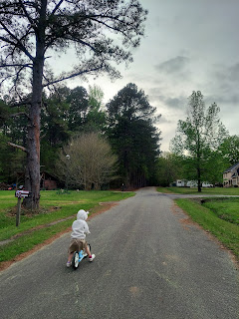

This afternoon (Sunday), I took Abby and Gwen for a walk around the neighborhood. Abby brought her backpack along so they could stash any treasures that they found along the way. We collected a variety of flowers, weeds, and some acorns.

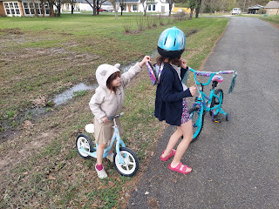

At one point, they noticed a big beautiful bush full of huge pink blooms (sorry - I forgot to get a picture), and asked if they could pick some. I told them we would need to ask the person who lived there first and get their permission. Abby informed me that Larry lived here and that he's the "spoon guy". He goes on long walks and whittles pieces of wood into wooden spoons, and everyone knows him. So we walked up to his front door and asked if it would be okay to pick a couple of flowers from that pink bush out front. He cheerfully said we could pick all the flowers we wanted! He even came out front to chat with us for a minute or two. He was very surprised that I was the grandma, laughing as he said, "You don't look old enough to be a grandma!"

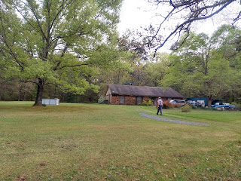

He was very friendly and shared that he was a great-grandpa, himself. I helped the girls pick a couple of flowers by straddling the ditchbank in order to reach them. And then off we went again. :)

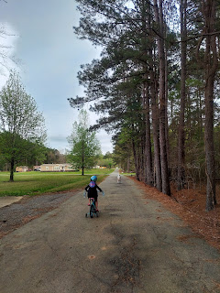

Just before I arrived in Louisiana on Friday, the weather had been crescendoing up into the upper 80's. But today was a pleasant mid-60's sort of day. Definitely my kind of day. I don't think I'm ready for the upper 80's just yet, after having sub-zero's through 20 degrees for the past 3 months . . .

Monday:
I spent one last day "in jail" just to be sure I didn't have any lingering Covid symptoms, but I felt great the whole day. I put that energy to good use by tieing up as many loose ends as I could around the house before the week disappeared. I made phone calls, paid a few bills, and did several light chores around the house.

Kylie and Avery also called me mid-morning and we had a fun visit. Avery was happy to smile at me while she chewed on the squishy bath toys that I had sent her recently.



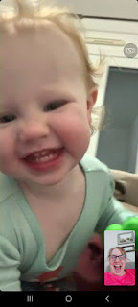

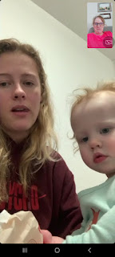

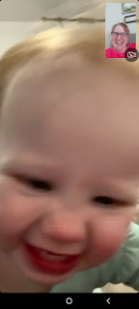

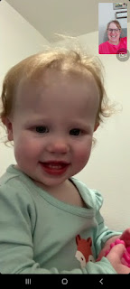

Near the end of the call, Avery was being so silly. She'd stick her bum up in the air and peek out from underneath. Kylie's hand would slowly creep over and then grab Avery's leg and tickle her or pull her over closer. I loved hearing Avery laugh and giggle, over and over and over.

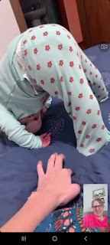

I put away all of my St. Patrick's decorations a little early (before the holiday even arrived), and then I set out some patriotic summer decor inside the house so it would be appropriate for when I return in the summer.

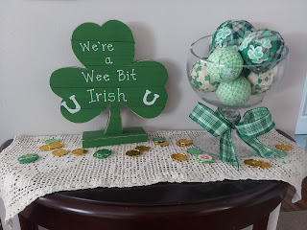

I sewed Abby's dress pocket back together, making sure to create a nice seam along the edges of the hanky first.

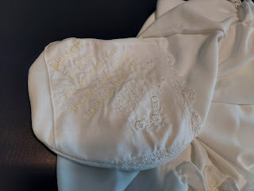

I'm planning to present the dress to her this week while I'm here in person, so I can share that moment with her. :)

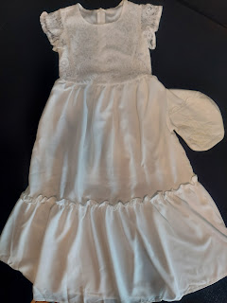

I cleaned out a few areas in my food storage room downstairs.

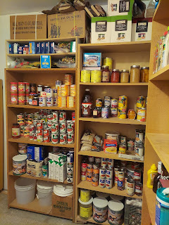

It seems that a mouse had a little bit of a party down there at some point, including sampling these bags of beans. Normally I don't have loose bags like this on my shelves, but in this case, I did.

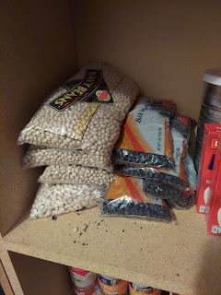

The party also ended this week for the "poor" mouse . . .

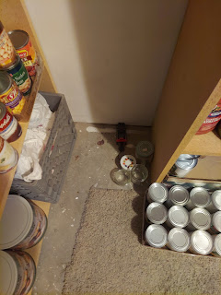

I was extremely disturbed to have to dispose of him, but there was no one else around to do it. It bothered me for the rest of the day.

I found a plastic storage container in a bedroom closet downstairs and used it to house the rest of the untouched bags of beans. They should last a lot longer now, since they'll be protected in the box.

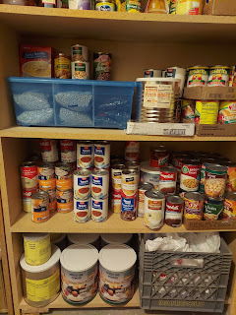

I also made a big pot of butternut squash soup. This time I added a sweet potato in addition to the squash, carrots, and red onion. I didn't remember to get a picture of the soup when it was finished, but trust me, it was delicious.

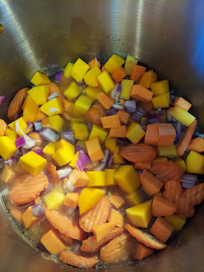

It felt so wonderfully good to do so many things after being sick for an entire week. None of what I did was overly stressful or energy-sapping. I made sure to pace myself, but to keep a good pace, nonetheless.

Tuesday:
I ran some errands in the morning and then went to visit Scott's parents in the afternoon. I brought them some of the abundant amount of soup that I had made the night before. Coy gave me some stain removal spray to try to get the fabric pencil lines off the pocket of Abby's white dress. I had drawn some lines with a yellow fabric pencil to guide my embroidery stitching, but now I couldn't get them to come out. The spray worked a little bit, but it wasn't 100% successful in removing the yellow lines. I guess I can just be thankful that I chose a light yellow instead of a bright or darker color instead!

Later in the afternoon, I went back over to the FamilySearch Center in Idaho Falls again, to scan one last round of photos from my Snider family. I had recently discovered several folders' worth of loose photos and I decided to make one final push of scanning before I left town.

I figured it would take me about 1.5 hours, but it took me 3 hours instead. What I didn't anticipate ahead of time is the amount of time it takes to sort all the different sizes of photos into stacks before feeding them into the scanner. You need to put "like" photos together, according to size and also according to orientation. (horizontal vs vertical) There were also several unusual sized photos that couldn't go through the scanner and had to be placed on the flatbed scanner, which takes a little more time to work with.

I worked quickly and efficiently, but it still took a long time. I worked through the dinner hour, telling myself that I should be done soon and that then I would feed myself. When I finally finished, it was very dark outside.

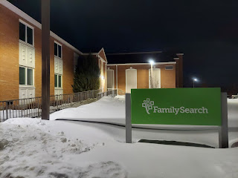

I love how when I walk out the doors of the FamilySearch Center, the temple is very visible nearby.

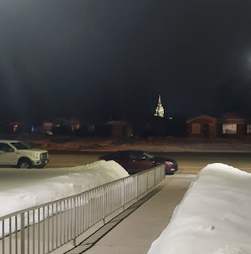

The photos that I scanned ranged from my early childhood, to my parents' wedding in 1967, to photos of my grandparents and great-grandparents before I was even born.

My sister, Charmaine, and me - with Santa Claus

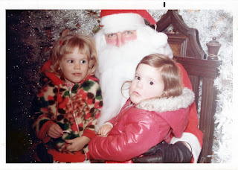

My parents on their wedding day (20 August 1967)

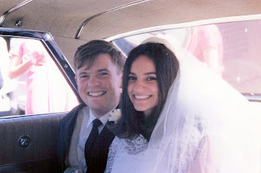

My dad's parents: Zola and John Snider

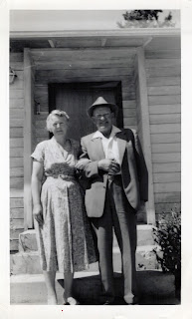

My dad's grandparents, father, aunts, and uncles
L to R: Vera, Ada, Ernest, William Alvin "Al" Snider, Sarah Jane Baugh Snider, John A. Snider (my grandpa), Maggie, and Mary.

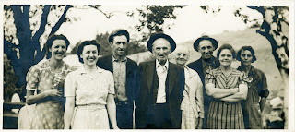

My cousin, Janis Nelson, sent me the photo above some years ago, along with this enlightening letter, shedding some entertaining light on the various personalities of my Grandpa John Abraham Snider's siblings and family.

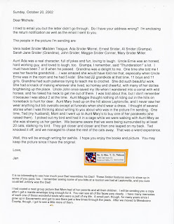

It was time well spent during the 3 hours of scanning, even though I was very HANGRY by the time I walked out to the car and drove home. I picked up something in the Taco Time drive through, and scurried home to eat it before getting ready for bed. It was 8:00 p.m. at this point.

No sooner had I put the first bite in my mouth, than the doorbell rang. It was the Vances, my dear friends, stopping by to bring me a gooey chocolate cookie and to wish me well as I would be leaving soon. How thoughtful! :)

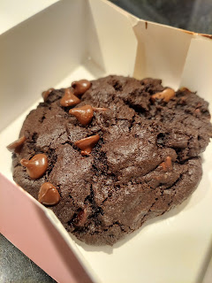

It took a really long time to unwind and quiet my brain to be able to go to sleep that night.

Wednesday:
I went to the temple one last time for the next little while. As soon as I walked up the sidewalk from where I parked the car, I choked up. I have come to love the temple in a deeper and more profound way than any other time of my life. I feel strength flowing into my soul when I attend, along with a sense of empowerment to help me deal with whatever comes my way. I feel a peace and contentment that I am loved, I am cherished, and I am being watched over.

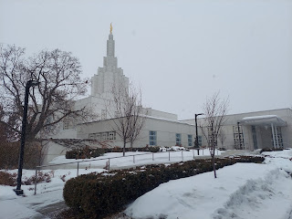

When I got home, I changed into working clothes so I could prune my fruit trees. I had to dig a trench from the back porch all the way out to the apple tree (aka the Jonny Tree).



I tried putting on my snowshoes first, but I couldn't get the one latch to cooperate and I was spending more time on that than if I just grabbed a shovel and cleared a path . . . so I gave up on the snowshoes and got to work. The blue cord in the photo below is from my earbuds...I had to unplug my phone so I could take a picture, and then I could go back to listening to my music while I worked.

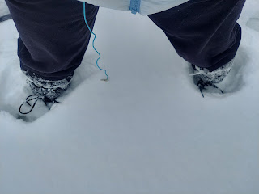

Path all cleared . . .

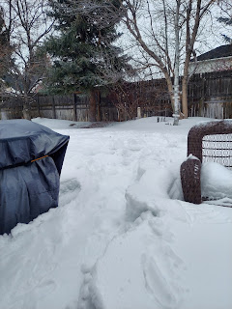

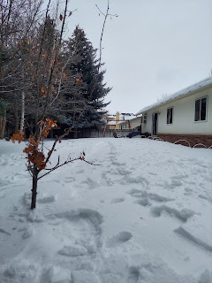

I pruned the apricot tree out front first, while I waited for Bishop Aaron McCracken to arrive. He owns Sunnyside Gardens in Idaho Falls, and I needed his advice before pruning the wonky apple tree.

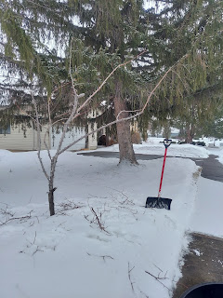

While I was working on the apricot tree, Kim Parkinson came across the street to visit with me. Their two dogs were barking loudly from inside their house, so she let them out to join us. They were so silly and energetic! Their BIG dog, Cleo, is a Great Dane. She will be 6 years old in a month, and is much more mellow than Hazel, their Doberman, who is roughly one year old.

Video of Hazel running around the yard, romping through the snow, while Kim calmly pets Cleo: (23 seconds)
https://photos.app.goo.gl/GLXv3kTKXMn9BVDF8

Video of Hazel and Cleo chasing each other around my yard: (18 seconds)
https://photos.app.goo.gl/Pv35vxERaJytpVmaA

When the Bishop eventually arrived, we got the apple tree pruned up real fast. Now it will have a much better shape to produce some apples this year. :)

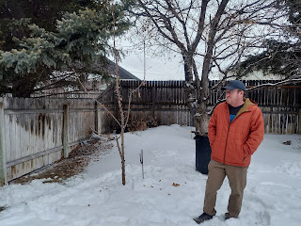

Next, I got the peach tree all pruned up and pretty.

From this . . .

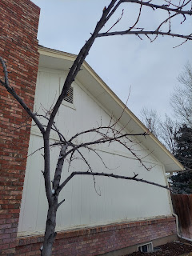

To this . . .

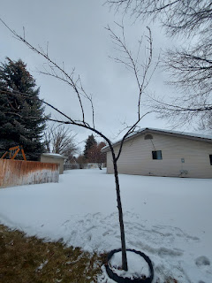

Last year, I didn't get any peaches! So I'm hoping that this year I will.

After dinner, my friend, Jen Anderson, picked me up so we could get a pedicure together. This was my second time. (The first time was last summer when a bunch of ladies all went together after girls camp.)

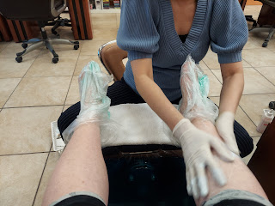

I was trying to go for a light salmon color, but this turned out to be a bit more orange, ha ha. It's still cute, but just unexpectedly bright . . .

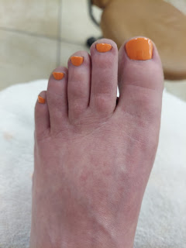

All ready for wearing sandals in Louisiana and Italy!

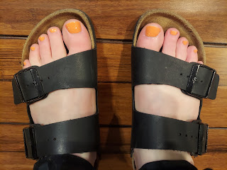

In between all the events of the day, I started making piles in my bedroom of what to pack. At the end of the day, I just moved all the piles off the bed so I could get in and go to sleep.

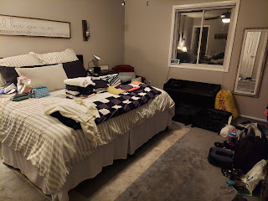

Thursday:
This was a run around like crazy day!! I needed to gas up the car, wash the car, mail something, clean the house a little, and PACK!! Right in the middle, I had my hair appointment, which lasted for 3.5 hours!! Usually it doesn't take that long, but this time it did. Tessa even got to talk to Scott on a video call while she worked on my hair. I got highlights and color and a great haircut before I leave the country. Then it was time to race home, get showered, and finish packing.

At the end of the afternoon, Coy and Phil came over to have a sleepover at my house. XOXO

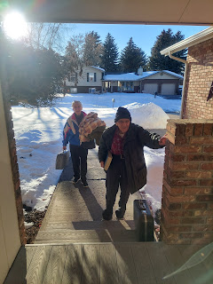

The reason for the sleepover was because Coy needed to have a procedure at the hospital quite early the following morning, and a storm was due to hit. They didn't want to have to drive in the dark when the roads would be potentially hazardous, which was very wise on their part. So they stayed the night with me, since I live within one minute of all three area hospitals.

We planned ahead of time to go out to eat because I knew that I wouldn't have any food to offer, since I would be leaving the following morning. However, within 5 minutes of their arrival, Dad was already changed into his pajamas and slippers, with a comfy robe over the top. So we decided to order something and just bring it back to the house instead. :)

We all went to bed early, since we had a super early start the next morning.

Friday:
True to form, we woke up to a deep and abundant snow, about 4 inches for the latest round. I woke up at 4:30 a.m. and once I was dressed and ready, I went out to shovel the snow one last time. Once I cleared the driveway, I brushed all the snow off Mom and Dad's car, and then shoveled again. :)

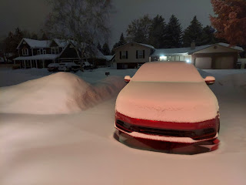

Before we all left the house, we knelt to pray together. What a blessing it is to be part of a family who lovingly and respectfully prays to our Father in Heaven every single day. Phil and Coy are such wonderful parents and I am so grateful for the time that we spend together.

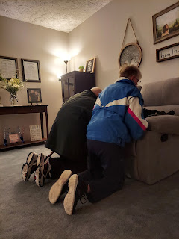

Unfortunately, Coy's procedure did not work and was not a success. She had been experiencing an elevated heart rate again, even though she has a pacemaker and is on heart medication to help as well. So her doctor recommended they do a cardio aversion, basically putting her to sleep so they could "shock" her heart and make it convert to a normal rhythm. But it didn't work. How disappointing! The doctor decided to up her medication instead and she is doing better now. How exhausting, though, to be so wiped out all the time because your heart rate is as high as someone in the middle of a vigorous workout . . . for days and days in a row . . . and at 90 years old . . .

Thankfully, they made it home safely to Rigby and settled back in while I was up in the air making my way down to Texas. My friend, Barb Vance, came to pick me up at 5:30 a.m. to drive me to the airport. We passed several snowplows clearing the roads as we drove across town.

I went from a landscape all in white . . .





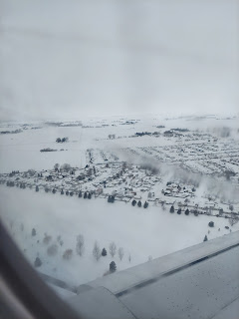

To a sunny blue sky and lush green landscape . . .

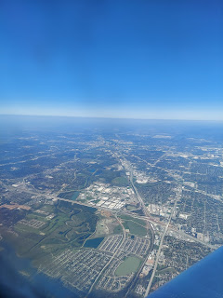

I'm always happy when I land in Texas, the state where I was born, and where patriotism always runs high.

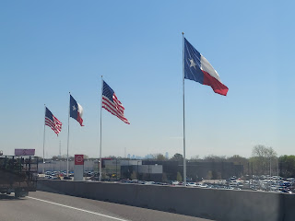

Amber picked me up from the Dallas Airport after finishing a session at the Dallas Temple earlier that morning. It's a 3+ hour drive each way, so when you go to Dallas, you try to fit everything in that you can while you're there!

We stopped at Buc-ees Travel Stop on the way home to Stonewall, Louisiana, because you ALWAYS stop at Buc-ees (pronounced "Buckees"). We grabbed some sandwiches to munch - for me (brisket) and for Amber (pulled pork). And now we're pretty much famous because we got a photo taken with Buc-ee the Beaver!

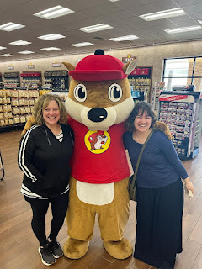

We hurried to get home because Abby and Gwen would be getting off the bus soon and we needed to be back in time for that. We made it with a little over 15 minutes to spare . . .

The girls were so happy to see me, which made me so happy, too!

A few minutes later, they put on their roller skates to do some living room laps. (22 seconds)
https://photos.app.goo.gl/GAvW6LHGnTqcAwTu6

After dinner, we watched Matilda the Musical together. I cried a lot, and laughed some, too. What a sweet and tender movie . . . the girls are VERY familiar with the songs and could sing along.

Video of Abby singing her little heart out during the last song: (30 seconds)
https://photos.app.goo.gl/qTyMJHuB7PeG1bTt7

Saturday:
I woke up earlier than I had planned to, LOL. I was wide awake at 6:48 a.m., which would be equivalent to 5:48 a.m. Idaho Time. I chatted with Scott while I was still in bed, and eventually Abby came out to see if I was up. I'm staying in the mother-in-law suite, which is connected to the main house by a carport. It has 2 bedrooms and a bathroom and a nice quiet space to call my own when I visit.

After breakfast, we went outside to do some yard projects. Amber and I worked on a compost enclosure, while Weston worked on several things, including cleaning out their vehicles and fixing up his many fish tanks throughout the house.

The girls also did some morning yoga . . . it's called Wizard of Oz Kid Yoga and it is super cute.

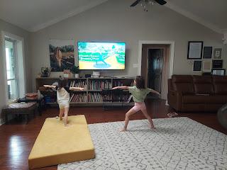

Video of Abby and Gwen doing their yoga: (36 seconds)
https://photos.app.goo.gl/SV8AjNp3zuZMPMR56

The many faces of Abby. XOXO

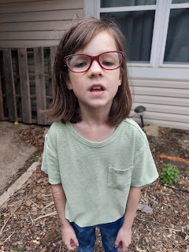

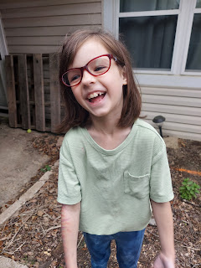

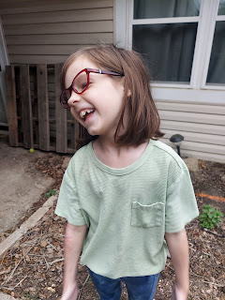

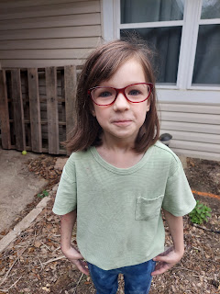

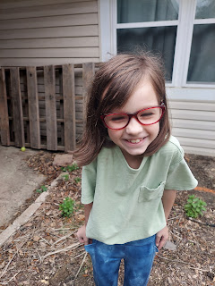

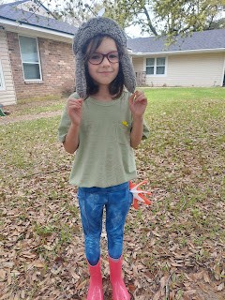

Amber and I built this together.

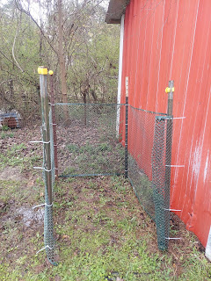

Right next to the barn at the back of their two acre property . . .

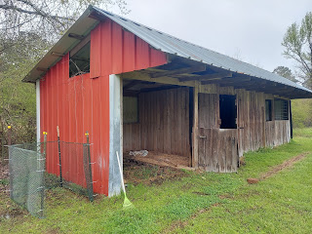

We added layers of old hay from inside the barn, some wet soil from the yard, and then a layer of biodegradable food items.

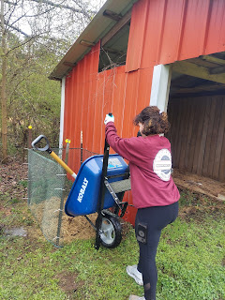

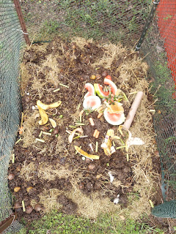

It's looking real, real good.

I loved seeing the emerging wildflowers next to an old burned up stump. Sort of a symbolic story of rising from the ashes . . .

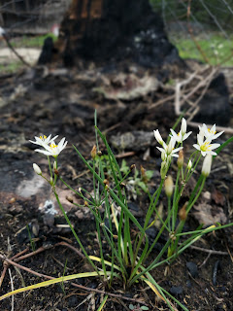

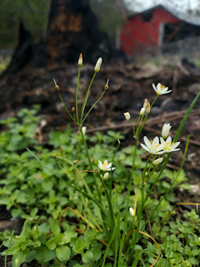

The many faces of Gwen . . .

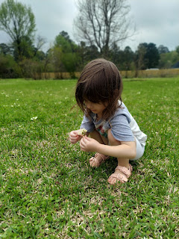

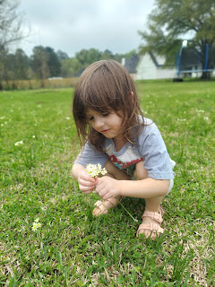

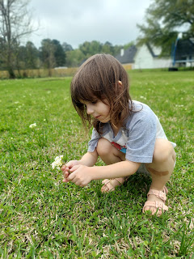

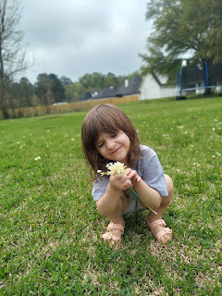

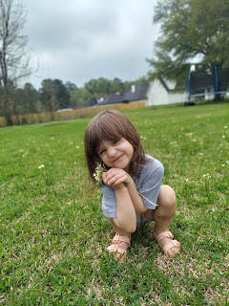

Including these cute ones of her eating some watermelon like her Uncle Benson always did.

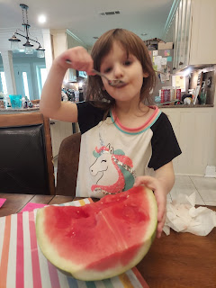

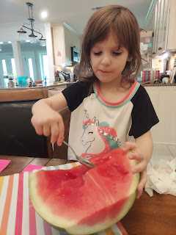

Once all the work was done, we went into town to get some groceries. I told the girls that I would help them find something in the produce section that they could take home to eat. The only criteria was that it needed to be a color of the rainbow.

Abby chose orange cuties, I chose green artichokes, and Gwen chose red raspberries. (*It looks like Gwen is missing some pants, but she has shorts on with a long t-shirt . . .)

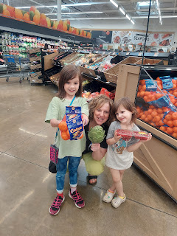

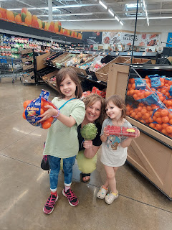

Amber made a tasty Greek chicken for dinner, with tzatziki sauce and a cucumber/tomato salad. The girls had a bath afterwards and I was able to put curlers in their hair while Amber worked on her talk for Sacrament meeting the next day.

XOXO I sure love those cuties!

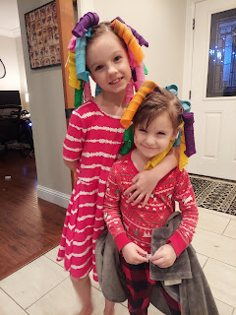

Sunday:
Church was at 9:00 a.m. and we only got there 5 minutes late, ha ha. We all felt as if the government had literally stolen an hour from our sleep cycles, something we would never get back . . .

Amber did a wonderful job on her talk, entitled: "Personal Conversion." Here is a link to the beautiful message she prepared.

https://docs.google.com/
document/d/12RMu3C-NdXBt9HH9_
yi2KJ1FScB4U2vYarjBs-5wLpA/
edit

Amber serves as a counselor in the Primary Presidency, so she went off to Primary after Sacrament meeting, while I went to Relief Society with the ladies. Our lesson was based on Elder Jeffrey Holland's recent general conference talk on why we don't focus on the cross as much as other Christian religions do. While we believe 100% in everything that happened on the cross, and the events that happened BEFORE the cross (when Jesus suffered in the Garden of Gethsemane), we choose to focus a lot on what happened AFTER the cross. He LIVES. We will all have the blessing of eternal life because He lives. Death is not the end.

I do think that while the cross is a symbol of Christ's Atonement, particularly when people wear a form of it, such as a necklace, I feel that it's like a double symbol. Not only is it a symbol of His Crucifixion, but Jesus Christ's death also represents His LOVE for each one of us (because He was willing to die for each and every one of us), and it makes sense to me that the majority of the Christian people in the world would want to wear something that is a symbol of that love. There is nothing wrong with that, not even a little bit. There is no rule or anything written (that I know of) that says we should not wear a cross. I think the reason for Elder Holland's message was that our church, The Church of Jesus Christ of Latter-day Saints, doesn't have any obvious or outward symbol of the cross in our buildings, on any literature, not even on our church-based websites. Some people have asked why that is, and often enough, apparently, that Elder Holland decided to talk about why.

Here is a link to his talk:

https://www.churchofjesuschrist.org/study/general-conference/2022/10/41holland?lang=eng

After church was all done, we stayed a while longer because one of Abby's friends, along with her friend's cousin, were both getting baptized. Lots of family and friends had come to participate in the sacred ordinance, and we were eager to share in the occasion as well. Amber led the music, and the girls' Grandpa and Grandma both gave short talks about baptism and the gift of the Holy Ghost. The girls were baptized by their fathers and were blessed to receive the Holy Ghost.

The families of the two little girls provided pizza, chips, fruit platters, and desserts for all those who came to witness the baptisms. We didn't leave to go home until after 1:00 p.m. but it was wonderful to be there and to see the love and closeness of the large extended family that were all there.

I laid down for a rest soon after we got home and that felt really nice. Later, I invited the girls to come on a walk with me around the neighborhood. They cheerfully agreed, and off we went. It was so nice to get some fresh air and move around a bit.

We also played Candyland together. They have a Disney Princess version that I haven't ever seen before and it was very cute.

It was nice to get into bed a little earlier Sunday night, due to the time change. I slept much better that night and woke up feeling great Monday morning. :)

Something I love about being in the South, is how polite and kind everyone is. They all seem to be aware of personal space, apologizing for needing to slip past you in the grocery store, etc. But the best part is when you go through the grocery store checkout, and the cashier says this to each customer: "Thank you! And have a blessed day! Be careful driving home . . ."

One more thing about Abby and Gwen . . . Amber has found a delightful app to teach the girls how to play the piano. They set up the i-Pad and it seems more like a game, but the girls LOVE IT!!

Here is a video of how it works: (23 seconds)
https://photos.app.goo.gl/atgGxVamdQ9CKnyW8

And we can't forget about Jack this week . . . .

Video of Jack pretending to eat a wooden hot dog: (44 seconds)
https://photos.app.goo.gl/Me6Vt3w9AZsJG4eu5

Video of Jack saying "Bye-bye" to the bus: (13 seconds)
https://photos.app.goo.gl/95CrYiMeXQpQ461SA

