Girls Just Wanna Have Fun
Welp, I made it through another Girls Camp! It's always so FUN, but EXHAUSTING, but FUN!!
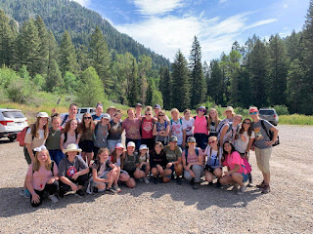

We had 26 girls, 10 adult women leaders, and 3 adult men leaders with us for the 3.5 days. We camped at what used to be a busy boy scout camp: Little Lemhi. In recent years, the Boy Scouts of America haven't been thriving very much, so the upkeep and care of Little Lemhi is now a bit understaffed. (more on that in a minute) We learned that they used to service 30,000 boy scouts during the summer season. Now they only have about 3,000 that come to use the camp.

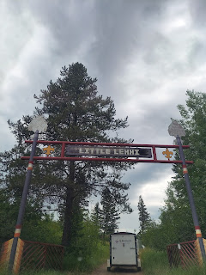

The location was BEAUTIFUL. There was no shortage of things to do there, and the girls all had a WONDERFUL time!!

On Monday and Tuesday, leading up to when we left for camp on Wednesday morning, I was putting in 15-16 hours a day getting the rest of the food from the stores and then getting things as prepped as I could ahead of time. All the groceries were filling up my guest room fast!!

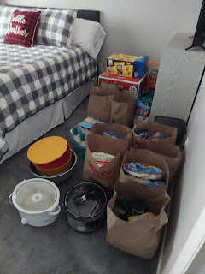

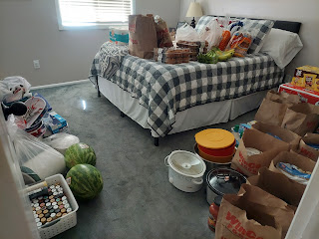

I baked all the gluten-free things for Emerson on Monday evening, which included: GF cornbread, GF chocolate chip cookies, and GF brownies. I didn't want her to feel like she couldn't have the same things the rest of us were eating . . . Little did I know that she would end up going home in the middle of the first night because she wasn't feeling well. (severe anxiety that she just couldn't recover from and it made her throw up) It's okay though. When her mom texted me up at camp to apologize that I went through so much effort and that it was all for nothing, I told her that our job was to minister to each and every girl and to let them know they are loved. I feel like that was accomplished for Emerson. She knew she was loved because of the effort we put in to include her, to care for her health concerns, and to bake for her.

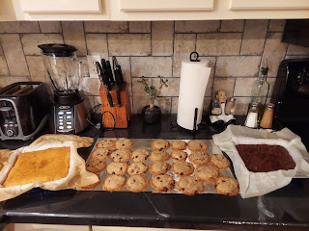

On Tuesday, I rushed around getting the final items (bread, bananas, etc.) that previously I didn't want to get too far in advance. I got myself packed and dropped off the bigger items over at Alishia Brown's house - one of the camp assistants. They have a cargo trailer and it was put into very good use to haul everyone's gear. (sleeping bags, cots, bedrolls, camp chairs, duffel bags, etc.)

That evening, the camp director, Michelle Going, and her husband, Lynn, came over to bring me the other cargo trailer for all the kitchen stuff. Our ward has owned this trailer for a number of years, and we've used it for girls camp many times, as well as for all of the boys' activities like scout camp and high adventure. I loaded a few things in, but had to wait until the morning to load in the rest of the food.

This is what the trailer looked like just before we closed it up to haul everything up to camp. Notice how neat and tidy everything was packed in. That was because Neal Cunningham, who has an engineer type of brain, was able to make it look real real good. We were all very skeptical that everything I had in the guest room would fit (in addition to all the extra dishes and several coolers) . . . but it did! Amazing.

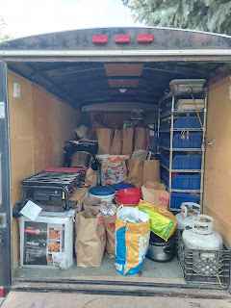

The drive over to Little Lemhi took just over an hour. It's located near the bottom of the Palisades Dam, a few minutes SE of Swan Valley, Idaho. Beautiful country.

It took us several hours to get camp all set up for 40 people. The girls worked together to get their tents set up and filled with their bedding and gear, while the leaders did the same with our own stuff.

Bishop McCracken worked HARD with Neal Cunningham (1st counselor in the bishopric) to hang up the two sun shades that I brought to provide some relief from the summer heat in our camp.

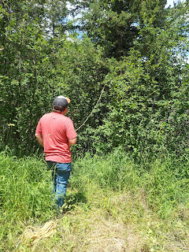

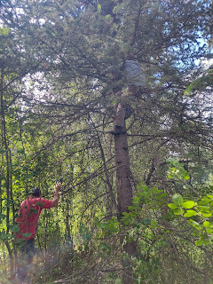

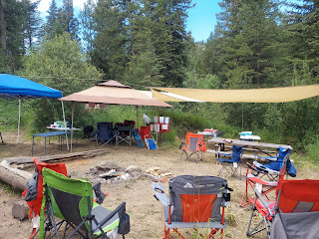

After all the hard work was done for the day, everyone headed down to the lake to cool off. What a beautiful setting!! On the other side of those mountains, off in the distance, is Jackson Hole, Wyoming.

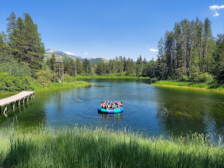

The girls loved jumping off the dock, hanging out on the giant trampoline float, and paddling around on some small water craft. The canoes, kayaks, and one paddle board were in a shed around the corner from the big wooden tower in the photo above.

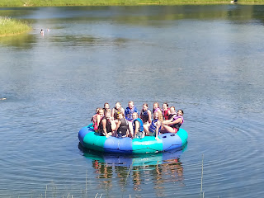

Here is a short video of the girls chanting, "Rebecca! Rebecca! Rebecca!" to get one of the leaders, Rebecca Eastman, to jump off the dock. (7 seconds)
https://photos.app.goo.gl/2vqQb8eXh7ULof6p8

For dinner that evening, we had to wait out our first thunderstorm before we could build a fire to roast our hot dogs. (we had a thunderstorm and a small amount of rain every day)

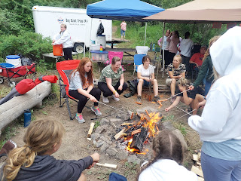

I was so impressed with Emerson, the girl who I baked all the gluten-free foods for. She has a phobia of thunder storms and was really freaked out. She was crying and trying not to go into a full-on panic attack, when I suggested we do something to keep her mind off of the fear. She wholeheartedly agreed, so I put her to work cutting up the watermelon for dinner. She put ear plugs into her ears, pulled her hood up and over her head and cinched it up really snug around her face to help muffle the sound of the thunder, and then dug in to cut up the melon. What an amazing way to work through and power through her fears!! I was very impressed.

After dinner, we stayed around the campfire for a while, just hanging out. We got a big kick out of Megan Smith's narration skills as she read a portion of a Patrick McManus book out loud. She was so talented in switching from a country-hick voice to a narration voice as she plowed through an entire chapter. Meanwhile, Jessie Larsen spent a long time braiding our YW president's hair. (Amanda Whipple)

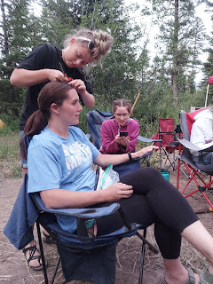

Short video of Megan reading out of the Patrick McManus book: (21 seconds)
https://photos.app.goo.gl/tYyqnxwwh4JPFZbj7

Every evening, we would have one of the older girls share a scripture and spiritual thought to generate a discussion around the campfire. It was always really though-provoking, and several girls would contribute to the discussion in a deep and profound way. I am constantly in awe of how mature these young women are and the extent of just how amazing their brains think about life.

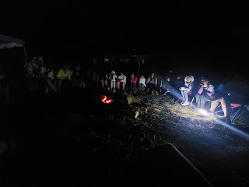

Thursday morning, as soon as breakfast was cleaned up, the girls all went up the trail with the rest of the leaders to do some outdoor activities for a few hours. They were able to rotate between 4 stations: archery, first aid, knife safety/whittling, and a shooting range! I saw some photos later (which I'll include below) of just how much fun they had! In the shooting range, they learned how to shoot BB guns and .22 long rifles. We had arranged for a couple people from our ward to come up to help with the guns, since they were certified. The camp hosts helped supervise in the shooting range, too, since they are both former military men, a father and son duo. The father retired as a Colonel in the Idaho National Guard (Kenyon Kofed), and his son, Sam Kofed was a chief warrant officer (Scott's rank) and flew a Blackhawk helicopter for his career. Even though it was a HOT day, the girls enjoyed all the activities. For the knife safety station, they whittled some pretty cool shapes out of bars of soap.

I ducked out of the late morning activities since I wanted to get my camp kitchen trailer more organized. It was driving me nuts. There were not enough shelves in the trailer, I didn't have enough tables outside, I couldn't find the things I needed half the time, and it was all very stressful.

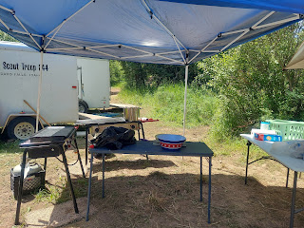

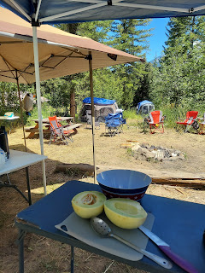

Once I got everything organized as best as I could, and cut up some melons for lunch, I sat down under a shade canopy to relax and enjoy the peace and quiet for a bit. I also called Scott, since I hadn't been able to talk to him very much for about 2 days. Amazingly, we had wonderful cellphone reception at the camp and I could even have VIDEO chats with him!! Fantastic.

After lunch was devoured and cleaned up, we all went down to the lake to cool off and have some fun for a couple of hours. I also got into my suit and enjoyed the refreshing water with the other girls. I did some canoeing and just floated around for a while in my life jacket. It was WONDERFUL!! The lake has a lot of plants and weeds growing up from the bottom, and some areas are pretty thick. I had on my swim shoes because I don't like feeling the stuff on the lake floor with my bare feet. But even though I had my shoes on, I was still a little creeped out from all the gunk below . . .

For dessert that evening, the camp director, also named Michelle, had asked me a few months ago if we could make s'mores in a cone. So we did! None of us had ever tried it before, so while the YW president led the girls in some unity-building games a short distance away from camp, the few remaining adult leaders decided to practice making them.

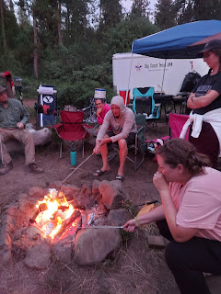

It's a good thing we did, too, because it was a little tricky to get the technique to work. The idea is to build your s'mores experience in a CONE instead of between 2 graham crackers. I bought waffle cones so we had more space to put the toppings inside. We learned through trial and error that this is the best way to do it:

1. Get a waffle cone.
2. Put a few toppings inside. Don't overload it.
3. Put the peanut butter down inside (if you choose to add PB) instead of on top or as a coating on the outside. It seems to act as a heat buffer and doesn't allow the other toppings to melt very well if it's on top or smeared on the outside of the cone.
4. Chocolate melts fast, so if you're using chocolate chips or mini M&M's, place them in the bottom or middle of the cone.
5. Place your mini marshmallows in last so they're on top. They had a hard time melting or getting gooey if they were anywhere else besides in the top section of the cone.
6. Wrap up your cone in a foil sheet. We found that it worked best if you wrapped it up in 2 foil sheets. The Bishop ended up burning his waffle cone.
7. Place it on some hot coals in the fire. Peter Vance had a great idea to use our roasting sticks to "hug" the cone while holding it over the coals. The Bishop placed his on the coals and left it there instead of holding it with the roasting stick. He may have left his on too long, since it burned, but it might have also burned because he laid it directly on the coals instead of holding it above the coals.
8. Be patient, but don't leave it over the heat too long either. I think the sweet spot was about 5-6 minutes over the coals. You can always take it off and check to see if the marshmallows are melted and then put it back on if they're not gooey enough.
9. I thought it was helpful to have small plates and plastic spoons handy for consuming the treat. I opened up my foil while it was on the plate and it gave me a nice surface for stability.
10. The peanut butter was EXCELLENT and was a nice contrast to the sweetness of the chocolate and marshmallows. Other toppings that would be good: chopped nuts, strawberries (either fresh or dehydrated), a mashup of leftover candy bars, coconut flakes, etc.

By the time the girls came back to work on their desserts, we were able to give them some great advice and they all had success! How cool is that. :)

While we were practicing making the s'mores in a cone, Scott called me from Italy. He wanted to show me where he was at the moment: on top of a mountain watching the sun come up. Wowza! How beautiful!

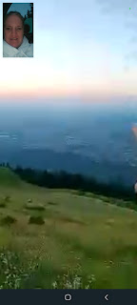

Below, he is pointing to where Vicenza is from where he was standing.

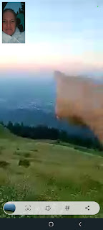

I was able to hold the phone so several of the other leaders could see what Scott was sharing with us, and we all oohed and aahed over the views. Scott wants to take me there this fall. :) Hubba hubba.

This shows the curvy switchbacks that he navigated to get to the top of the mountain. He drove all the way up to the top in his little red car.

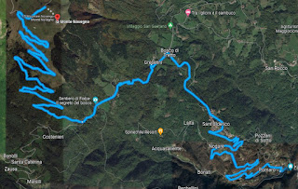

And here is a link to the photos he took on his early morning adventure:

https://photos.app.goo.gl/e4eERk46yKMZS94H8

We enjoyed another evening devotional around the campfire. The theme for our camp was Unity: Together We Are Strong. Each night, one of the older girls would share a scripture relating to unity ("If ye are not one, ye are not mine" for example) along with a thought or story relating to it. Again, the girls amazed me with their deep thoughts in the discussion afterwards.

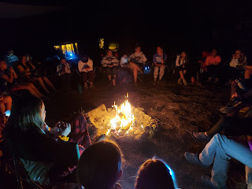

Friday morning, we hustled to get breakfast taken care of so we could head out by 9:00 to go on a nearby hike before the heat kicked in. (*Quick side story: 2 days before we left for camp, we were having a group texting chat with all of the women leaders. As we were checking in with what preparations we were taking care of, I mentioned that I was cooking 8 packages of bacon so I didn't have to deal with it up at camp. Lots of loving words and gratitude flowed in from the ladies and I responded by saying, "I love you, therefore I cook for you. That should be on a t-shirt, ha ha!!" They laughed and said, "Yeah, that would be a good one!" Well, on Wednesday morning when we gathered at the church before driving up to camp, the YW president calls me over in front of everyone and presents me with this apron that says, "I love you, therefore I cook for you." What a thoughtful thing to do in the TWO days before camp! Holy cow. :) I was in the middle of cooking French toast before our hike when Amanda took this photo of me.

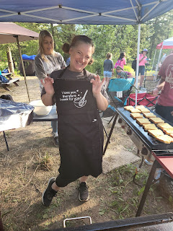

Back to Hike Day . . . We drove the girls about 15-20 minutes south and east to hike a portion of the Big Elk Creek trail. We hiked about 2.5 miles in, rested by the creek for a bit, and then trekked the 2.5 miles back out. It was a beautiful day and the views were even better.

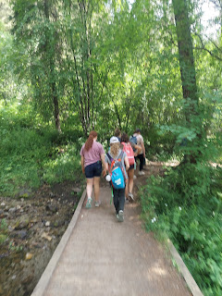

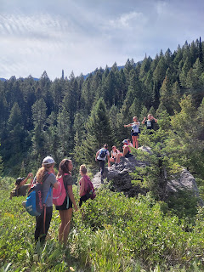

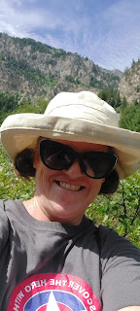

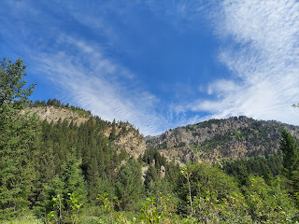

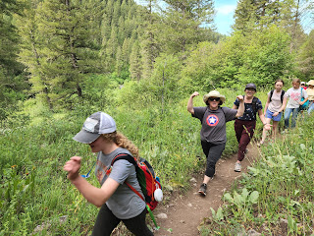

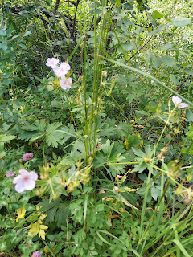

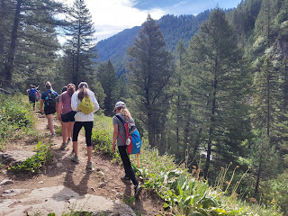

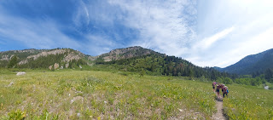

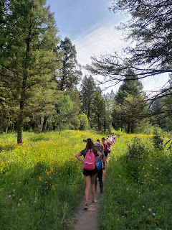

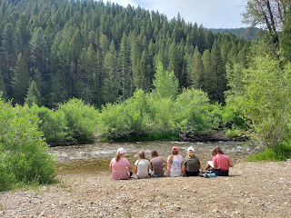

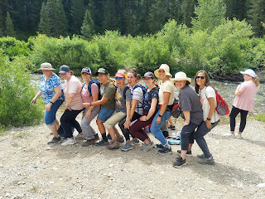

Here is a short video of us trying to get a photo of all of us together: (11 seconds)
https://photos.app.goo.gl/tf7AEgkY7FrVN3Ky7

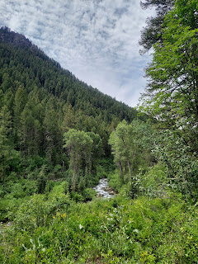

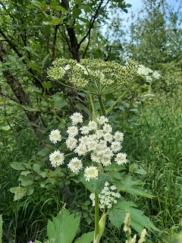

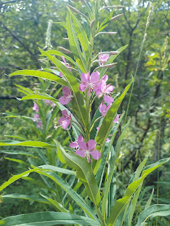

Below: this is known as a Dirt Tan, ha ha. You mix powder poofy dirt from the area around our camp along with 3 doses a day of bug repellant spray, and this is what you get.

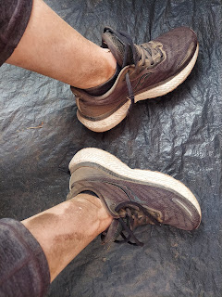

An assortment of videos that I took on our hike:

*Something I had not considered before was to bring along some music to listen to while hiking. Tatum and her cousin Karlie had a portable speaker along with a really fun playlist on their cellphone . . . I happened to be right behind Tatum and the speaker the whole 2.5 miles in and it was so fun!! Those of us in the group who were closest to the music were singing at the top of our lungs and it was so joyful! I don't feel like it detracted from the beauty of the hike because there were plenty of moments for me to take in the sights when I was too out of breath to sing, ha ha.

https://photos.app.goo.gl/VFanZGCN3udMd5YS6
(7 seconds)

https://photos.app.goo.gl/uH4MoBcyaPc7xQyT7
(12 seconds)

https://photos.app.goo.gl/WSKDYdsk1ydzrWGc8
(11 seconds)

https://photos.app.goo.gl/PfPH8RH2ux94XJ1a7
(11 seconds)

This last one was what we saw when we (as the middle group of hikers) got back down to the parking lot. The fastest group of girls and leaders were down in the parking lot dancing while they waited for everyone else to catch up . . .

https://photos.app.goo.gl/k49LMSMAX8yqt6oeA
(12 seconds)

It was wonderful to be in the fresh mountain air, dip our feet into the ice cold creek, sing and laugh together along the way, and that the hike was relatively short and sweet.

After a simple lunch of sandwiches and fruit back at camp, I snuck away to go take a SHOWER. Whaaat? What's a shower? ha ha

It was amazing to get somewhat clean for the first time in 48 hours. I say "somewhat" because: A) the floor in the bathroom isn't exactly what I would call clean; B) there are spiders and bugs all over the bathroom; and C) as soon as you're done you have to spray bug repellant all over you and then go out into the powdery poofy dirt again.

For dinner that night, thankfully I had several willing helpers to pull the whole thing off. The menu consisted of pulled pork (remember the 30 lbs that Megan and I cooked last week?), homemade macaroni and cheese casserole, cornbread, fresh veggies with homemade ranch dip, and cut up melons. Honestly, it was my favorite meal during girls camp!

We decided to focus our cooking efforts down in the lodge since we needed both the stove top and the oven, so about 5 of us ladies headed down the hill to spend the next 3 hours preparing dinner together.

Pause for a side story: this was probably the hardest thing for me (and just about everyone else too) as we camped at Little Lemhi. Hardly any scouts have come to use the facility in the past 3 years, and because of that there isn't much income coming in. If you don't have much revenue, you don't have much of a staff. If you don't have much of a staff, the whole place gets run down pretty quickly. And when the place gets run down, nature takes over . . . in the form of spiders and all kinds of bugs. Everywhere.

Whenever I would go down to the lodge/kitchen for meal items (they have a HUGE walk-in fridge and 2 large freezers), I had to first sterilize whatever space I would be working in. You are probably thinking, well, that's what I do at home, too. And you're right. But this was a whole new level of sterilizing just to be able to use a counter top surface. Let me paint a better picture for you . . .

The first morning I went down to get the food for breakfast, I couldn't even open the old wooden door from the outside to get in because it was covered in a spider web with a giant spider just hanging out where the door handle was. I had to find a stick first, then gather up the web, get rid of the spider, and THEN I could enter.

That same morning I discovered that one of the doors on the front porch side of the building hadn't been shut properly the night before. It was open . . . and someone(s) had gotten in and decided to have a party with our leftover chip bags from the night before. It was probably mice. They had also chewed into one of the bags of bowtie pasta, so I tossed that bag in the trash. They also chewed through the packaging of my double bag of tortillas from Sam's Club - intended for the breakfast that I came down to get supplies for. But they didn't nibble on the tortillas at all . . . so what to do? I decided to haul it up to camp anyway and get a second opinion. (Ultimately we decided that for that one package that had been compromised, we would throw each tortilla on the big Camp Chef griddle and get them nice and hot to kill any potential germies.)

There are mice droppings just about everywhere in the entire lodge, commissary and kitchen. There are spiders everywhere as well. In the kitchen, I reached down into the lower cupboard to get a giant pot for our mac & cheese noodles, and as I grabbed the pot and pulled it out, a huge hobo spider cowered in the back corner, not sure where to run or hide. GROSS!!!!!! Another leader took a picture of a huge spider just hanging out on the pepper shaker that was on the kitchen counter.

For anyone who came to help me in the kitchen, I told them: we will first WASH, then use, then wash again anything that we need. But before we could even do that, we had to get rid of any spiders in the sink or dangling above the sink in our face. And before I ever did anything AT ALL, I grabbed the clorox wipes and wiped down all the counters so that when we washed the dishes we could have a clean place to set them down.

The room would get hot and stuffy really fast, so inevitably we'd have to open up some doors for cross-ventilation. This would also let the mosquitoes in . . . and the horse flies . . . and some wasps. One day we saw a big black wasp fly in and crawl into a hole near the ceiling in the kitchen. I bet he has a home there.

The stove and oven were ancient, but they did work. SO ancient were they that the girls came running up the hill to our camp on the first day to let us know that there was a FIRE in the kitchen!! A few of us hurried down to investigate. It turned out that it was just the pilot lights for each of the four large burners on the stove. The camp host, Colonel Kofed, joined us and explained that if the pilot lights go out, then there's just gas leaking into the area. The pilot lights have to stay lit 24/7. The girls thought that the pilot lights meant that there was a fire . . .

The sinks back in the huge pantry area of the lodge don't work. We found that out the hard way. We used a little bit of water to clean something on the first day, and then noticed a minute later that the water we had used did not have a proper drain to go down. Instead, it just spread out across the entire floor. There were two old and filthy mops in the room, but they didn't do a very good job in absorbing the water. I had to use a push broom to muscle the mini-flood all the way out the opposite door.

The favorite place in the lodge for everyone was definitely the huge walk-in fridge. If we got too hot and sweaty working in the kitchen, we'd come up with a reason to just go stand in the fridge for a couple of minutes. It was heavenly.

So, back to the amazing meal. Janey Quilling, Rebecca Eastman, Barb Vance, Abi Vance, and Alishia Brown helped me get everything ready and it turned out PERFECTLY!! We had fun hanging out in that hot and bug-infested kitchen. We talked, laughed, and figured out solutions for every obstacle that we encountered in that less-than-optimal (yet functional) space. What an amazing group of women!!

Janey, Alishia, and Rebecca

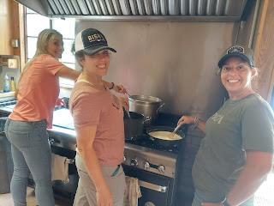

Janey helped cook up the 8 boxes of gluten-free rotini pasta in that huge pot. We learned from Emerson's mom that you have to cook it for HALF of the time that it says on the box. You want the texture to be somewhat crunchy still on the outside and tender in the middle. It keeps taking on moisture as it bakes in the casserole and you don't want it to turn to mush. Janey did an excellent job!

Alishia and Rebecca were my patient and dedicated roux whiskers. I added all the ingredients, one at a time, to their pans and they stood there whisking and whisking for a long time until it thickened and made a nice creamy and cheesy sauce for the mac & cheese casseroles.

Barb and her daughter, Abi, made the giant pan of cornbread, which turned out so delicious! Then we hauled everything up to camp in my car (2 trips) and set it all up for the food lines.

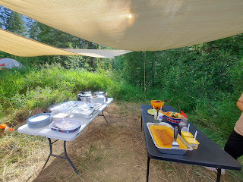

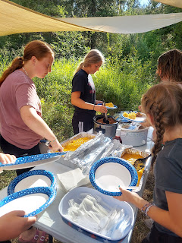

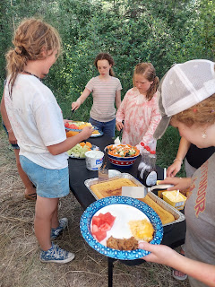

This was the one meal that I WAY OVERSHOT the amount that we needed for the pulled pork. The internet said you need 40% more raw pork than the serving size you want to end up with, since it loses some of its volume in the cooking process. We heated up those 30 lbs of pork in 3 crockpots all afternoon, but we didn't even finish off ONE crockpot of pork by the end of dinner!! We had a group of 45 for dinner, and most everyone got seconds, with a smaller group even heading back for thirds. We still had about 2 inches of pork left in the first crockpot, with the other two filled to the brim. What to do?

The bishop said not to worry. There is a stake young men's camp coming up in 2 weeks, and Doug Benson is going to be the camp cook for our ward (approx. 25 boys). Doug was up there with us for that last night of camp and so I talked it over with him. He was more than happy to use the remaining pounds of pork!! After dinner, I bagged it all up, refrigerating it first to cool it down, before moving it all into the freezer for the night. What a relief! It will all be put to good use! Who knew that I would be cooking for both girls camp and young men's camp!!??

After dinner was all cleaned up, we went down the hill to the front porch area of the lodge for some games with the bishopric. I missed the first one, but I was there for this one. Neal, a counselor in the bishopric, gave everyone a 10-12 inch length of stretchy tree tie material. (you know, the kind you see hanging on the trees on a trail so you know which way to go) He said that it represented each of us. He reminded us that Satan tries to break us, to ruin us, and damage our souls. He asked us to try to tear off a small section of our stretchy tie. It was pretty easy.

Then he had us buddy up with the person standing next to us and stack our two pieces together. It was harder to tear it in half when there was a double thickness, but it was doable.

Lastly, he had a couple of volunteers come to the center of our circle and he handed them a stack of 8 pieces of the stretchy tie all stacked together and asked them to try to pull them apart. Not so easy . . .

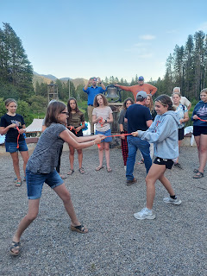

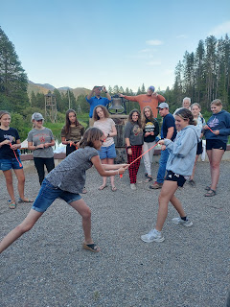

They got it stretched out into a thin and mangled piece of tie, but it didn't rip in half. Neal reminded us that if this represented our spirit, or us, then what conclusions could we find in looking at that beat-up remnant? The girls quickly noticed that even though "it" had been put through the wringer, it was still intact and unbroken. The point was then made that if we stick together and help and support each other, then we are so much stronger. Wow, what a powerful object lesson!

Next, we had ice cream sundaes and (far too many) warmed up Hostess fruit pies. I'm not a fan of the pies, but the bishopric (mostly Neal) thinks they're pretty great, so they brought them a second year in a row. The girls really enjoyed the ice cream sundaes with all the toppings that were served out of mason jars with a tulle bow on each jar. They felt really special.

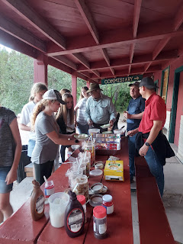

Our bishopric: Neal Cunningham, Bishop Aaron McCracken, and Nolan Anderson

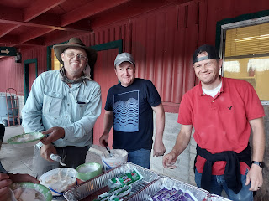

After our tummies were full yet again, we went on a Faith Walk. We were led on a path around the lake, silently, making stops along the way to hear a message about faith from each member of the young women presidency.

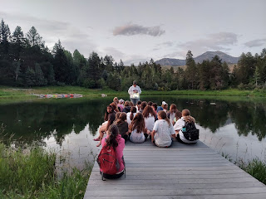

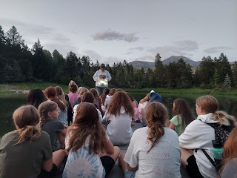

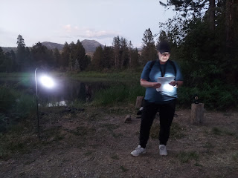

At one point on the trail, there was a flooded section that was unexpected. One of the youngest girls, Harmony, stepped into the muck and went to lift her foot up, only to discover that the suction of the mud had broken her flimsy flip flop and now she only had one functional flop. IMMEDIATELY, McKayla - who was right next to her - said, "Hop on my back." McKayla, one of the oldest girls in camp, carried Harmony through the mud, along the trail, and up a steep hill to our next stopping point. She didn't even hesitate! And not one single complaint was uttered either. I thought that was a very Christlike thing for her to do.

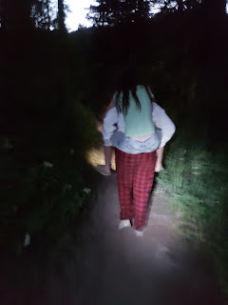

After our Faith Walk was complete (and it was beautiful and wonderful), we made it back to camp to start a fire and have a testimony meeting together. The bishop led us out by sharing a thought and his own testimony first. Several of the girls had something in their heart to share, although some were just content to think quietly to themselves and listen to the others.

The girls stayed up late into the night, as usual, and had a fun time together by laughing and telling stories in their tents. Girls Camp was a success.

The first night I got about 2.5 hours of sleep. The second night I got about 3-4 hours of sleep. But the last night, I got 4 hours of SOLID sleep and it was amazing!! I fell asleep around 2:00 a.m. and woke up at 6:00 a.m. because the wind sent a gust that made our rainfly on top of the tent rustle and flop around quite loudly. That's when I noticed that I was in the same exact position as when I went to sleep 4 hours earlier. Amazing. I slept like a true rock.

Saturday morning we got up early, I hauled up some muffins and milk, juices and yogurts for one last breakfast. We ate, packed up and cleaned up camp. Then we drove home. I was so filthy and sweaty and tired, but I was so happy at the same time. I love being in nature, I love being with the girls and the other women leaders. I love that the meals were a success! And I also love coming home.

If anyone is interested, you are welcome to check out the spreadsheet that I made to help me stay organized for all the camp meals. You'll see several tabs at the bottom for each day, as well as a few other categories. The grocery list was KEY, as it had the amounts of everything I bought, and the current pricing so we could see the running total at any given time.

https://docs.google.com/spreadsheets/d/1IMzzgw-USho_jWwdQwKIblhCc8xHuE0bmzWeQBnxoKM/edit?usp=sharing

And if you want even MORE photos and videos, you can check out this photo album that we made. Multiple people are still contributing to the album, including some of the older girls.

https://photos.app.goo.gl/gJCS6iyxTVNpUZfR6

Once I got home and got the remaining food unloaded from the trailer, I was able to take the most heavenly shower I've ever had. I got all squeaky clean and it felt fantastic! Later in the day, I also got the car washed, dusted and vacuumed. Hooray!

A little later in the afternoon, our nephew Caleb and his wife, Bethanne, and their little boy, Harrison, came to visit me. We hung out in the back yard for a bit before going up to Rigby for dinner with Scott's parents. Harrison is 2 years old and is such a little cutie! He wasn't shy at all in seeing me, even allowing me to hold his hand and take him downstairs to get some toys to bring back up. He can talk really well and likes to repeat some of what you say. "Do you want to go get some toys to play with?" Harrison: "Toys. Yes, toys."

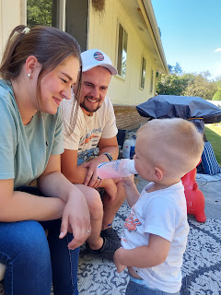

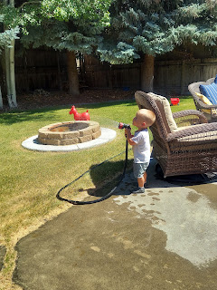

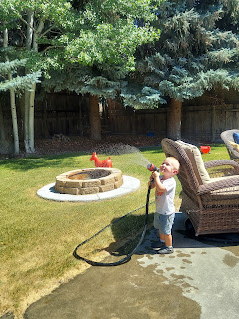

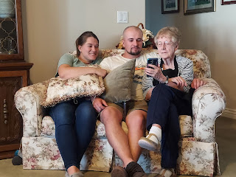

Phil, Coy, Caleb, Bethanne, and Harrison

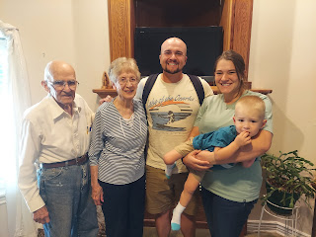

Sleepy boy . . . ready to go home on the plane . . .

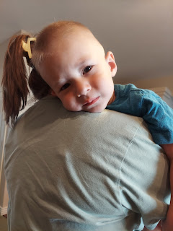

It was so good to see them again! It's been maybe a little over a year since we saw them in Arizona when Scott and I went to Payson on spring break.

After I dropped them off at the Idaho Falls Airport last night (Saturday), I came home and started getting ready for bed right away. I was soooo tired . . . I slept for a solid EIGHT hours, and while it felt amazing, I still woke up feeling like I could easily do another eight. But I needed to get ready for church.

I'm so relieved and grateful that girls camp was a success, but even more relieved and grateful that it's all over. I can have my life back. More importantly, I can have my BRAIN back, ha ha.

Time for Grandbabies . . .

Handsome Jack, ready for his modeling career

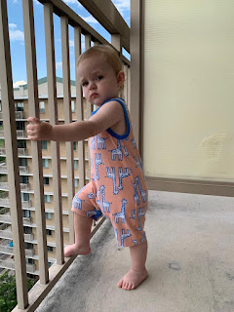

Video #1: Jack modeling his new sandals, even though he's clearly exhausted from all the hard work. (1 minute)
https://photos.app.goo.gl/PRyo9yKL4Jg6qHAWA

Video #2: Jack with his toothy little grin, doing his upper body workout for the week. (21 seconds)
https://photos.app.goo.gl/s8LaNVLMm48KZTtV7

Video #3: Jack contentedly feeling the pouring rain from the balcony. (19 seconds)
https://photos.app.goo.gl/x8sTdKyzeDfSRBuK8

Also, Jack was given a baby blessing this afternoon. Normally this is done when a baby is very little, as soon as the parents feel it's a good time to do so. (around 1-2 months old) It consists of a circle of priesthood holders gathering around the baby, each placing a hand on his head. Usually the father says the prayer, but sometimes it is a grandfather or close family friend. The purpose of the baby blessing is to recognize the birth on the records of the church, ask God for special blessings for the baby, and for the family to celebrate their new addition.

In Jacob and Hannah's case, though, they have had a lot going on this past year, including several moves. They kept putting it off and putting it off, perhaps thinking that they could do it in their next ward, etc. Well, today ended up being the day! It was kind of last minute, we only got a couple hours notice, receiving a Zoom link so we could participate from wherever we were.

I think the catalyst for the sudden invitation was something that happened as part of our family text conversation today. We were talking about baby names and Amber somehow remembered that we almost named her McKenzie. I didn't remember that at all, so I dug out her baby book and took a photo of the page where it asks how she got her name and if there was another name that was being considered.

As I was about to take the photo of just the top portion of the page with the answer to our question, the Spirit spoke to me in a tiny whisper, "Just take a photo of the whole page." So I did. On the bottom half of the page it mentioned Amber's baby blessing and who was in the circle of priesthood holders that had participated.

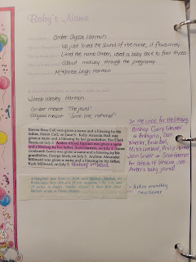

About 30 minutes after I shared that photo in our family group chat, Jacob sent out a Zoom link announcing that Jack would be receiving his baby blessing at 2:30 MST today. :)

I took a few pictures of Jack on my computer screen as we waited for everyong to log into the Zoom meeting. What a precious little boy he is!

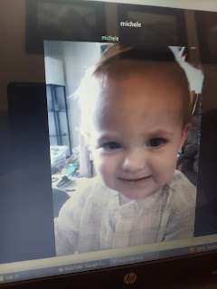

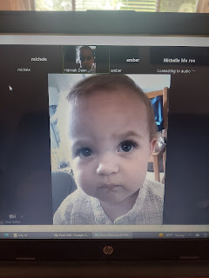

This was a half second before Jacob began speaking. It's usally considered irreverent to take photos during a blessing. I got it just in the nick of time! I also snuck a peak at Jack during the prayer. He was just happily eating whatever little snackies were in his cup the entire time.

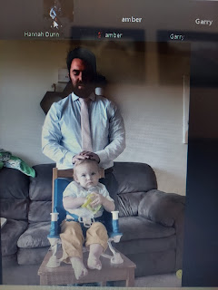

Some love from his papa after the blessing was done.

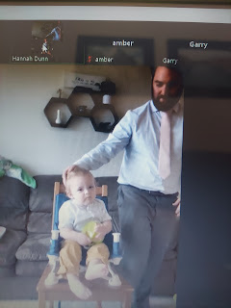

What a happy day for Jacob and Hannah! I'm so pleased to watch them as they lovingly raise their son, Jack. They are doing a wonderful job.

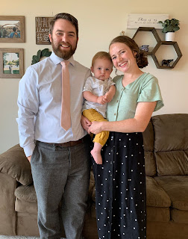

When Jacob shared the sweet family photo above, he also included this photo, with the caption: "Photo cred: @bluechairphotography".

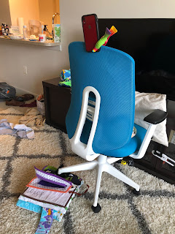

Gwennie has had a good week, too!

She has been teaching her kitten how to be reverent and fold his arms for prayer.

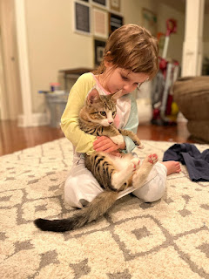

Below: I sent this photo for Amber to show Gwen, in response to the photo of her above.

My sister, Charmaine, and me, with our darling little fashionable kittens, wearing some doll clothes that we had put on them. This was when we lived in West Virginia, around 1975.

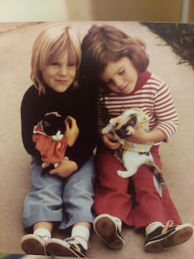

Amber is working hard to get the girls ready for school to start soon!

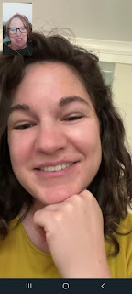

She and the girls will be here in my house by next weekend - I can hardly wait!! And as soon as they get home to Louisiana, the girls will immediately start school the next day. Gwen will be in Pre-K, I just learned. It's not the same thing as kindergarten. I'm not sure exactly how it differs, but I will learn all about it soon, I'm sure. Abby will be in 2nd grade this year.

I don't have any photos of Abby this week. Or of Avery either. But I still love them. :)

