Harmon Family Reunion: Part Two
Saturday, July 6th:
After I dropped Scott off at the airport to fly back to Italy, Benson and I drove over to Freeman Park in Idaho Falls to wait for the rest of the group (Amber, Weston, Abby, Gwen, Chelsea and Garret). They ended up waiting for an HOUR for our food to be ready at the best family-owned Mexican restaurant in town: Morenitas. It was worth the wait.

Benson and I sat at a picnic table under a large shelter and chatted about lots of things, which was so lovely. I never get enough one-on-one time with him. Meanwhile, Amber and Chelsea both told me later that even though it was tiring to wait so long for our food, they were so appreciative of the opportunity to talk and spend that time together as well.

Chelsea and Garret had driven all the way up from Denver to spend the weekend in Idaho Falls with our family. The last time we saw them was at their wedding in September 2021, so it had been a while . . . we keep in touch over the phone somewhat regularly, though. They seem very happy together and I love that they are both so positive and cheerful.

Here we all are at the park together . . .

Amber, Benson, Garret (forming the left back row)
Me and Chelsesa (in the center)
(And in the front) Gwen, Abby, and a tiny bit of Weston, who was holding the camera

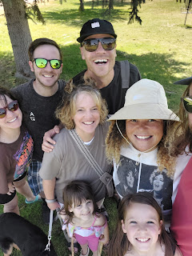

Another attempt, this time by Garret, who had a slightly larger wing-span . . . and now you can see Weston in the back behind Chelsea.

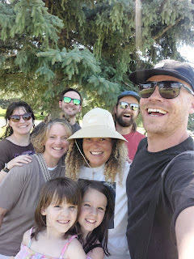

We followed the boys up the hill to the beginning basket of the frisbee golf course. I took Daisy's leash and kept her with me so Benson could play with Garret and Weston. Amber participated in a couple of "holes", until she hurt her shoulder from flinging the frisbee too hard, so then she came and hung out with Chelsea and me and the girls.

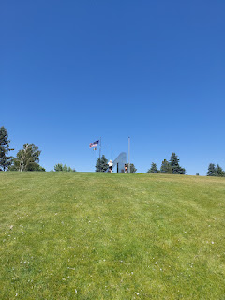

Weston, Chelsea, and Abby . . .

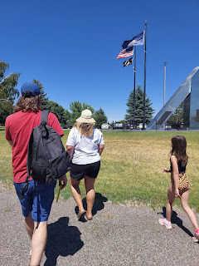

We found a comfortable place along the creek that runs through Freeman Park, where the girls could splash and explore, and Daisy could chew on some sticks. She mostly wanted to "shepherd" the girls, ha ha, because it's in her nature. She was anxious when I kept her next to me on the grassy bank, when what she really wanted to do was to be right next to the girls to make sure they were okay. She's just not quite old enough, nor trustworthy enough yet to allow her to be off-leash, though. I had to continuously reassure Daisy that the girls were fine and that she could just sit next to me and be petted and chew on a stick.

Garret and Gwen in the creek . . .

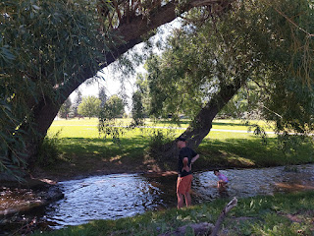

Abby found a whole colony of tiny snails in the creek . . . she wanted us all to come and see them.

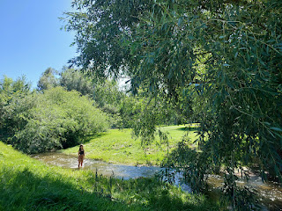

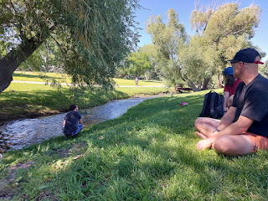

Video #1 of Daisy getting more brave in the water, putting her face underneath the surface so she could grab a rock: (9 seconds)
https://photos.app.goo.gl/ZyqMQFCtZ1eMnBhG7

Video #2 of Daisy grabbing another rock - with a better camera view this time: (10 seconds)
https://photos.app.goo.gl/WUqKGXweg5pd1iPXA

On our way back to the car, Daisy picked up the BEST STICK EVER, lol.

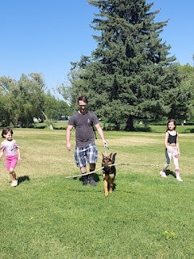

Amber and her family said goodbye to Chelsea and Garret as we prepared to leave the park. What a special time they had had together, bonding as sisters and learning more about each other.

Amber, Chelsea, and Abby

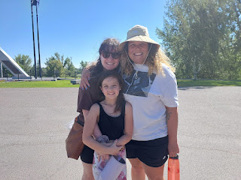

After Chelsea and Garret checked on their dog, Carol, at their AirBnB, they met me in downtown Idaho Falls at the Japanese Friendship Garden, which is always a great place to bring guests from out of town. We walked around for a bit, admiring the massive waterfall that spills over the man made hydro-electric dam across the street from the Japanese Friendship Garden. As a first-time visitor, Garret was quite impressed with the nature trails and beauty of the downtown area.

We ate dinner at a restaurant next to the waterfall, called Smokin' Fins. It's an upscale seafood restaurant and they do a very nice job. This was only my second time eating here, but I wanted to treat them to a nice dinner before we had to say goodbye for a while. I ordered the Lemon Caper Mahi Mahi, with fennel arugula slaw, goat cheese, lemon caper cream, cilantro lime rice, and chili oil. It was delicious!

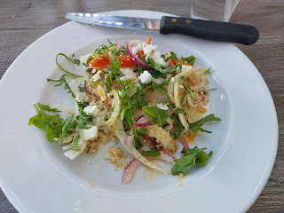

One of the things I really enjoyed during their whole visit was how Garret and Chelsea asked us all kinds of questions about our religious beliefs and commitments, including how and why we choose to abstain from alcohol and coffee. We discussed many topics over the couple of days we spent together, including why we send young men and women out into the world to serve a mission versus sending someone older and more seasoned. Garret asked how could an 18 or 19 year old boy possibly have something to offer the world, since he hasn't had much life experience yet. I told him that the most important person to convert to Jesus Christ is yourself, and when a young missionary spends 18 months or 2 years on a mission, ultimately they end up converting themselves in the process. I shared how Scott and I are excited to go out and serve a few missions in the not-too-distant future. We want to serve as military relations missionaries, helping to lend spiritual support to the soldiers and their families somewhere in the world.

I was grateful for an opportunity to share what I believe and why I believe what I believe. :)

It felt like it was way too soon to have to say goodbye, not knowing when we will get together again. Something we did discuss was hosting Chelsea and Garret next spring in Italy. We are all excited about the prospect of them coming over to visit and all the fun we can have over there.

Me and Chelsea . . . XOXO

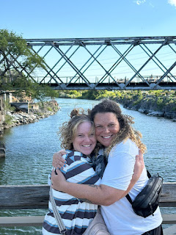

Chelsea, Garret, and me, saying our last goodbyes . . . what a wonderful visit we had!! I already miss them. They are so full of life and laughter and curiosity. Never a dull moment with those two, ha ha.

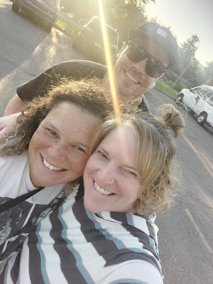

After the busy weekend with family, and as the crowd thinned out by Monday, I got a phone call from the Cemetery Board in Willits, CA. They had received the headstone that Scott and I had ordered several weeks ago for my 2nd great grandfather, James C. Baugh. The headstone was not in good condition, though. Dave, at the Cemetery Board, sent me this photo so I could see the shoddy workmanship. They didn't finish painting the black letters into the etchings before they shipped it out, so it was very difficult to read.

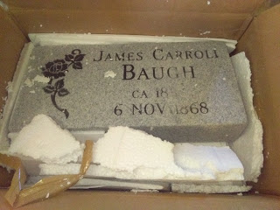

I couldn't believe that the company would send something out in this condition, so I emailed them to ask for a refund. I even offered to find a black paint kit that was weather-proof and told them that I could finish painting in the letters and numbers myself.

They responded to my email in just a couple of hours, apologizing for the condition of the headstone and admitting that it should never have left their facility like that. Since I had mentioned that there was a time crunch (I'm heading out to CA in just a couple of weeks), they said they would have a new one sent out by the end of the week and that we could just dispose of the first one.

We are still waiting for the replacement . . . and I even emailed them again a few days ago without any response so far. Hopefully, they will get it taken care of and quickly! I will call this week and see what I can discover about the process.

Look at this sweet face . . .

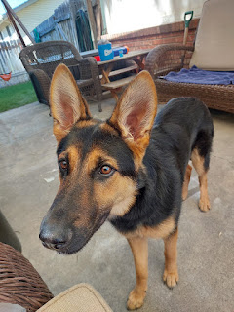

As the dust began to settle after all of the company we've had during two exciting weeks, Benson was the final departure. He stayed an extra day because he had some very serious pain in his shoulder blade that rendered him useless on Sunday (July 7th) and only 10% better on Monday. He finally felt well enough to travel on Tuesday, thank goodness, and made it safely back to Mountain Home AFB to report to work that evening.

Now it was just Amber and me, plus the girls . . . On Tuesday, we made a batch of my mom's famous "Noodle Doodles". There are only 4 ingredients, but they are oh-so-amazing.

Melt 6 oz chocolate chips + 6 oz butterscotch chips over hot water (double boiler).
Stir in 1 can of crunchy chow mein noodles + 1 cup of salted peanuts.
Drop by spoonsful on waxed paper and chill until set.

I substituted the salted peanuts for some coarsely chopped cashews. We were taking the dessert to a Ward Activity that evening, and I wasn't sure if anyone had a peanut allergy or not. Better to be safe than sorry. Sorry I didn't get a final photo, but it got a little crazy right before we left . . .

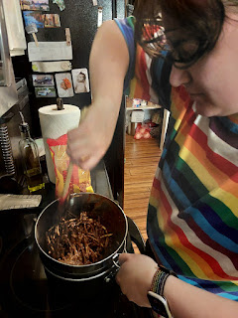

It was hot that evening, so the Noodle Doodles started getting a little melty partway into the activity. Amber overheard some teenage boys talking about how awesome the Noodle Doodles were and that they wanted to eat more, but they didn't want to get all covered in melted chocolate, ha ha. We'll take that as a compliment!

The theme of the party was to celebrate the upcoming Olympics, so the ward activities committee put together several races and games for the young and old alike. One of the activities was a triathalon, where the participants had to ride a bicycle course across the street in the church parking lot, then run around the trees at the hospital lawn (where the dinner was being served) and finally - to take on the massive slip & slide at the end. They handed out medals to the top 3 finishers of the primary aged kids, and to the top 3 teenagers in a separate race.

Then, they just let all the kids have fun on the slip & slide after the races were done.

Video of Abby and her friend, Ali, sliding down the plastic: (10 seconds)
https://photos.app.goo.gl/uPBfrqjG1L8aiHvT7

Abby, sliding to the finish line on her knees . . .

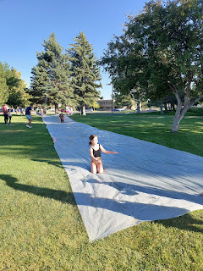

For the grownups, they had a "SPECIAL" activity. Mike Jorgensen, who has been a girls basketball coach for many years and has a very commanding voice, started trying to recruit husband/wife pairs to come sit in a chair for the final competition. There was no explanation whatsoever, other than you needed to sit in the chair. Nobody wanted to do it, so I stepped up and I said, "I'll do it. Whatever it is, I'll do it." Mike said, "Great!" and suggested that Amber be my partner, since Scott was gone.

Essentially, I was the one in the chair, and I held a mirror in front of me. I had to place a tall glass on my head.
Amber stood behind me, BLINDFOLDED, with a large pitcher of water.
Yeah, you're probably getting the picture . . .
I had to guide her, by using my mirror, and instruct her on where to poise the pitcher of water and then she had to fill up the glass on top of my HEAD. She could not touch the pitcher spout to the glass on my head. That was the only rule.

Our friends, the Quillings, recorded us: (37 seconds)
https://photos.app.goo.gl/smgMyUmj6c8MhAij9

It was a riot! I got a little wet, ha ha, but it felt pretty good considering how hot it was that day.

Video of our friends, Scott and Jen Anderson: (10 seconds) He didn't even get wet at all!!
https://photos.app.goo.gl/usJQZT2qcDkWobLr7

After several rounds of adults splashed their way through the game, they let anyone participate, including the kids who were quite eager to jump in. I got a video of Abby with her friend, Ali. It took three tries before they had success . . .

Video of Abby and Ali: (1 minute, 19 seconds) *That's Mike Jorgensen (the coach) in front of Abby.
https://photos.app.goo.gl/zv1CtQsddfW16EuM6

The following day, I drove up to Rigby to take my niece, Vanessa, to lunch. She is going through a very difficult time in her life right now, and is currently living in Phil & Coy's old house for an undetermined amount of time.

We decided to try this Mexican food truck - or bus. It was super cute on the inside and the food was tasty, too!

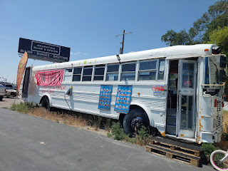

Here's what it looks like on the inside . . . tables and seating, with the ordering counter at the back, and the kitchen behind the cash register. How clever!! That's cute little Vanessa, carrying our bundle of deliciousness . . .

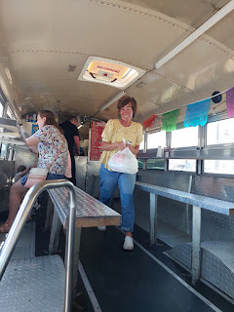

We drove over to the city park and talked and cried and talked and cried together, eating a few bites here and there. Bless her heart. She is the sunshine-iest, most positive and upbeat person on this entire planet, and yet she is going through something so painful and devastating and sad right now. The thing about Vanessa, though, is that no matter how bad things get, she always remembers to whom she can turn for comfort, peace and strength. (Our Savior, Jesus Christ) She takes her daughter, Taylor (16), to the temple every single week. They alternate going to the Rexburg Temple and then to the Idaho Falls Temple. They are powerful examples of what a Believer is and does.

The next day was a scorcher in Eastern Idaho. We rarely get triple digits, but it finally hit this summer. As I drove home from a couple errands, I saw the 100 on my dash . . . gross.

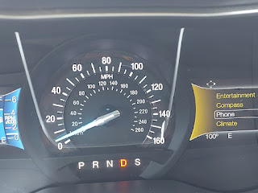

For dinner that night, we made a platter of light and no-stress fixings. We ate it on the back patio where the air was a little cooler than it was inside, and we listened to some Harry Potter together. We had lunchmeats, cheeses, sandwich fixings, fruit, and cookies, along with a refreshing kiddie pool to dip our feet into. Gwen wanted to follow along by reading in the Harry Potter book at the same time as we listened. What a great way to expand your brain!

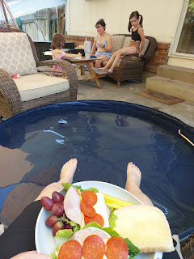

I recently went to the funeral for Darwin Richardson, who used to be a counselor at Ukiah High School, where I grew up. I have been close friends with his older boys, Josh, Sean, and Jason for many years. It was a wonderful service and I learned a lot about Darwin's background and his life growing up.

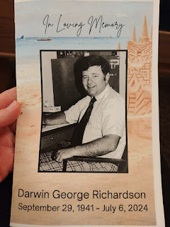

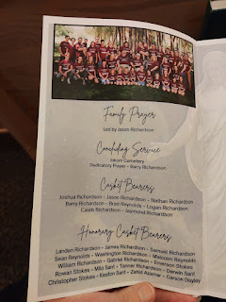

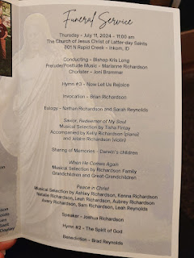

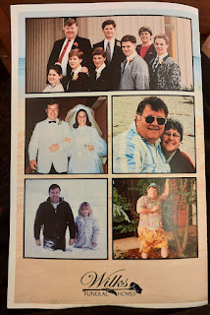

All of the kids stood together at one point in the program to share their favorite memory of their father. They are such a close-knit family and have influenced so many people for good in this world.

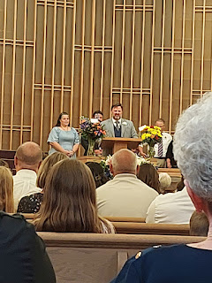

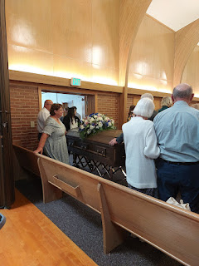

It was also a lovely reunion for those of us who grew up in Ukiah, CA and it was surprising to see how many of us live somewhat close together in Eastern Idaho or Northern Utah.

L to R: Lisa VanderStoep Morales (now in Idaho Falls), Dawnette McKell Engler (now in Smithfield, Utah near Logan), Me, and Julia Fawson Hathaway (now in Rexburg, Idaho).

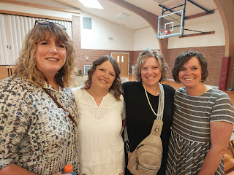

Jason Richardson, Me, and Josh Richardson . . .

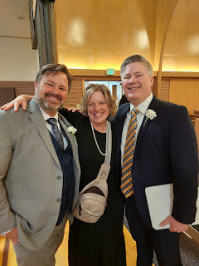

One of the stories that Josh shared was that his father, Darwin, was born and raised in Inkom, Idaho (near Pocatello). The land on which this church meetinghouse now stands used to belong to his great grandfather. The Church of Jesus Christ of Latter-day Saints bought this land from the great-grandfather so they could build this very church on it. Darwin's ancestors planted some apple trees on the property out in the back. Before I left the parking lot, I walked around to the hill behind the church to take a peek. I didn't see any apple trees, but I could visualize them.

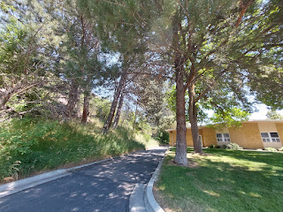

Later that evening, we had a "Spa Night" downstairs where we all painted our toenails and some of us painted our fingernails. I helped Gwen with her toes and fingers. She chose to do alternating colors for her fingernails.

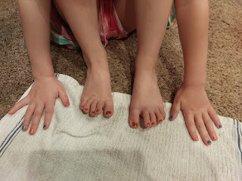

We listened to Harry Potter as we painted our nails and it was really fun.

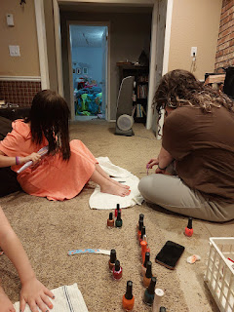

The girls got creative about drying their nails so they could move around more freely . . .

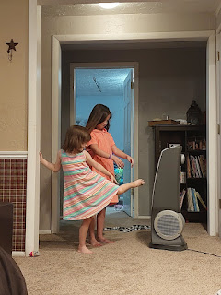

Amber and I met Vanessa at the Idaho Falls Temple on Friday morning (July 12th). We didn't get a picture with Vanessa afterwards because she had to dash off, but Amber and I paused to take a photo before we left. It was a wonderful and uplifting experience to be together in the temple, and especially to sit and feel the spirit in the Celestial Room for a while. None of us wanted to leave . . .

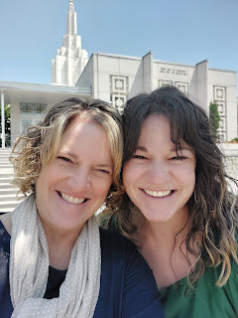

We got to have Avery over one more time on that Friday afternoon. She spent several hours with us and we had a great time!! Her favorite things are bubbles, water, and music. She could rotate between those 3 things for hours and be perfectly happy.

Amber, Avery, Abby, and Gwen . . .

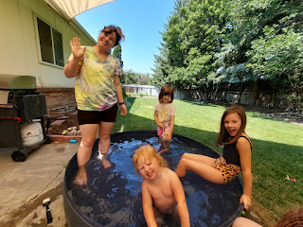

We put on a movie later (The Sword in the Stone), but Avery lost interest after just a few minutes. She liked the popcorn, though. :)

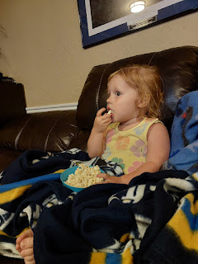

So we ended up in the back yard again to play with the water and more bubbles, ha ha.

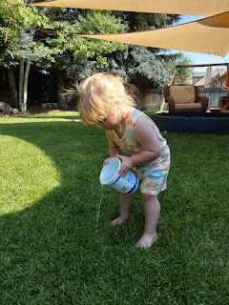

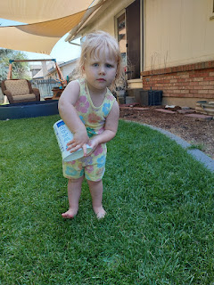

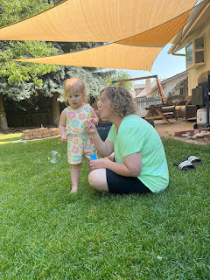

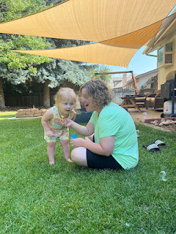

I think she was confused a couple times when she didn't see Benson in our house. She would start looking in each room, saying, "Go?" (as in, where did he go?) It broke my heart because deep down I knew it was her Daddy that she was looking for . . . but he was in Mountain Home.

I wish I had started this video a few seconds earlier, so you could hear her asking, "Go?" as she tiptoed down the hall and then over to the front door.

Avery video: (16 seconds)
https://photos.app.goo.gl/FVuzVvozvM2Rqnmr6

Below: Avery and Abby with similar stuffies that hang around your neck . . . this was on a different day and they're wearing different outfits, but I'm just inserting it here anyway. :)

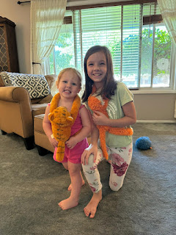

Avery tried to be interested in the Sword in the Stone movie again, laying down just like Abby was and eating some more popcorn (just like Abby was). Such a cutie!

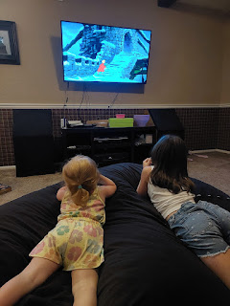

I spent some precious time with Avery swinging in the back yard. Because she loves music, I began singing a few primary songs to her from church. She loved it!

Video of me singing a portion of "I Wonder When He Comes Again" to Avery: (42 seconds)
https://photos.app.goo.gl/8KqbcxRm7TYPgZoe7

She would close her eyes and reverently soak it all in. It was really quite remarkable. I love the sweetness and innocence reflected in her eyes as she looked at me. XOXO

Video as I sang a portion of "I Am a Child of God" to her: (55 seconds)
https://photos.app.goo.gl/n7RNLixbsdLANL1y7

Abby came out and joined us, too . . .

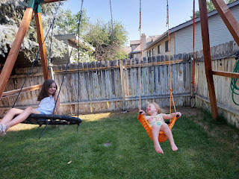

After feeding the kids crepes and fruit for dinner, we drove Avery up into the foothills to where Kylie has been staying with her Dad and step-mom, Nicole. Abby wanted to read some books to Avery the whole way (about 15 minutes), and Avery was a very good listener the entire time.

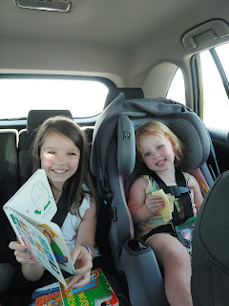

The following day, Saturday (July 13th), we all went to the movie theater to watch "Inside Out 2". It was really good, even if the script was quite a fast pace. There were some tender scenes that made me get a little teary, too. We took a selfie after the movie got out because Abdel was messaging me from Morocco and he sent us a photo of where he was, so we did the same.

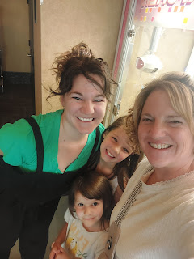

Monday of this past week (July 15th), I drove Kylie and Avery down to the Salt Lake City Airport so they could catch their flight to Chicago and then on to Venice. Their plan is to stay with Kylie's boyfriend, Miles, again until he gets a new duty station in January. They're hoping for Florida because he has lots of family there.

Kylie and I were pretty loaded down with all their luggage, but we somehow managed to haul everything from the 4th floor of the parking garage all the way to where she could check 3 suitcases in with American Airlines. She had two 50-lbs suitcases that I lugged with my mighty muscles (not really), and Kylie handled all the rest by herself: Avery's smaller suitcase, a car seat, a backpack, a duffel bag, and was somehow still able to steer the stroller with Avery in it!! We made quite a team.

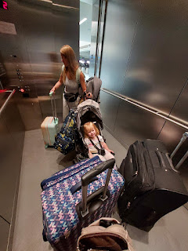

It was hard to say goodbye and watch them walk away to go through security, but I know we'll see Avery again soon in Italy. Kylie has already asked if we can watch Avery for a weekend in September.

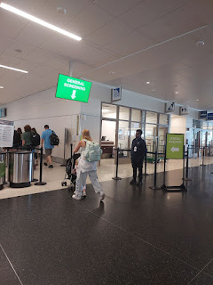

Our garbage dumpster has been so loaded down with all the garbage we've been generating from all the people visiting us, and every Tuesday we cheer loudly when the garbage man comes to empty it out for us. Some days, we wondered if it could hold one more bag of trash heaped up on top, ha ha. I tasked Abby with giving the poor dumpster a wash in the front yard after it was emptied out, earning her a nice $5.00. Gwen was a helpful assistant, too.

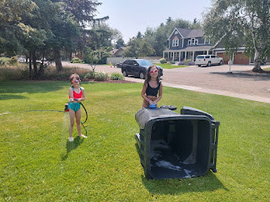

I've had a very quiet house this weekend, while Amber and the girls are up in Portland visiting Weston. I've cleaned the house a bit, caught up on the laundry, and even rented a carpet cleaner from Don Aslett's Cleaning Center. That thing was so heavy to haul around, up and down the stairs. Yes, the carpets are much cleaner now, but dang. I don't think I'll every do that rigorous job again.

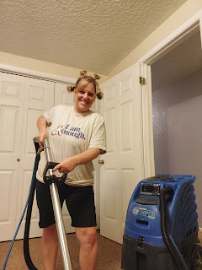

I was super sweaty and red in the face by the time I finished late Friday night . . .

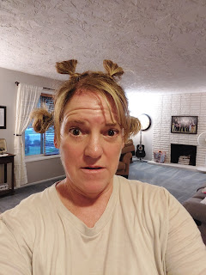

I rewarded myself with some thin-crust pizza from Marcos (my favorite) and a nice side salad . . .

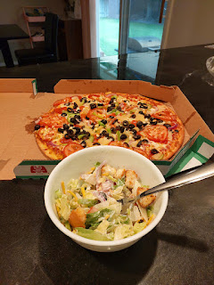

The next day, I did a little family history project that brought me a lot of joy. Abby has been noticing some cute little teacups and saucers in my craft room downstairs, and asked why they're just sitting on a shelf. Great question!! Well, now I finally have a place to tuck all those little treasures that I've had for such a long time: a china hutch that belonged to my mother-in-law Coy for many, many years. When Scott's dad passed away this spring, we inherited this special piece of furniture and now it has some new life, at least on the upper shelves. (The bottom cupboards are empty so far, but I'll add some things later on.)

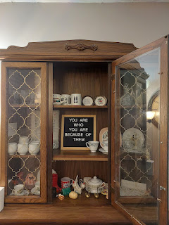

~ A cross-stitch sampler that was sewn by my great grandmother, Kate Lee Orr Rawles (circa 1900)
~ Teacups and saucers that were a wedding gift to my parents in 1967

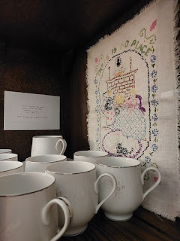

~ A red boot mug that was my Dad's when he was a young boy. Also, a checkered mug that says "Johnny", and a tin cup that has "John" engraved on the outside.
~ Clever little salt & pepper sets that belonged to my Grandma Zoe Rawles Snider, and her sugar bowl
~ Brass swans that belonged to Coy

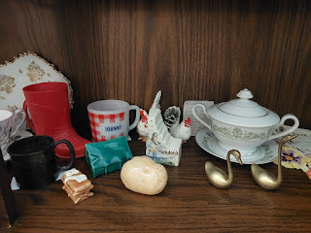

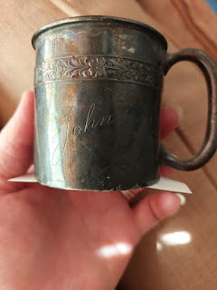

~ Corn cob dolls that were purchased by my parents when we lived in WV (early 1970's)
~ Teacups that belonged to Grandma Zoe, purchased in England by her younger sister, Mary

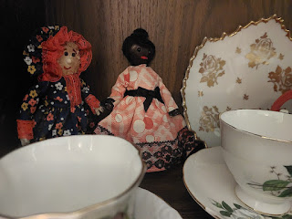

~ Misc. dessert dishes/saucers with whimsical paintings on them (click photo to enlarge and read the note that I wrote about them)

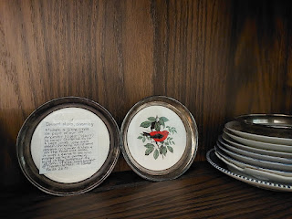

In fact, I wrote a note and taped it to the underside of each "set" or item to explain who it used to belong to and something interesting about it. When I shared the photos with my Snider family, my sister Charmaine said, "It's like a little family history museum!"

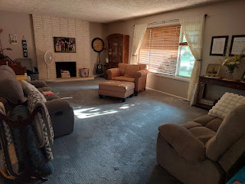

Our son, Jacob, was having some fun one day while Jack was in the bathtub. They were using some sort of photo filter on Jake's phone and these are some of the hilarious photos he shared with us . . .

Jake - as an old(er) man . . .

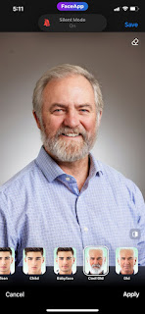

Jack - as the next Orphan Annie . . .

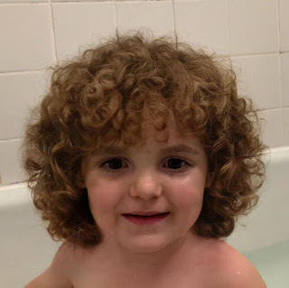

Scott - as a very distinguished old(er) man . . .

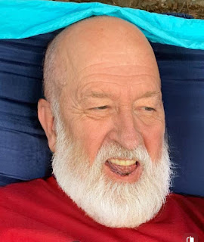

Benson - as . . . well . . . um . . . ???

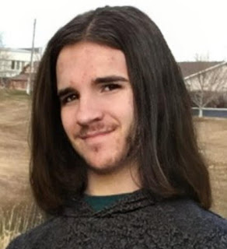

Amber and the girls have been having a wonderful time up in Portland, sending photos each day of some of their activities. They hiked to Bridal Veil Falls, they visited the Newport Aquarium on the coast, and Gwen lost another tooth!!

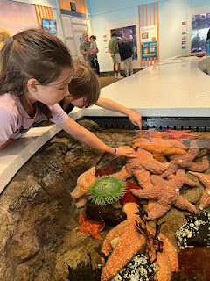

Gwen just beams with pride when she has another wiggly tooth, and even more so when it comes out!

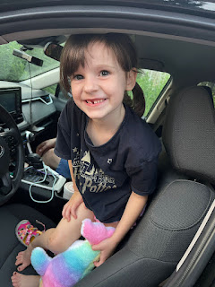

Last night, around 10:00 p.m., Abby told her parents that she wanted to call me to share something with me. She wanted to tell me about her new friend that she met at the Aquarium - her soft and cuddly pink otter named Ruby. How sweet that she couldn't wait to share it with me! :)

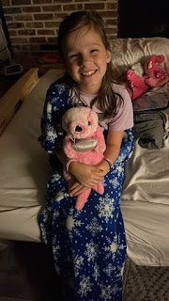

And lastly, Jake sent this funny quip yesterday:

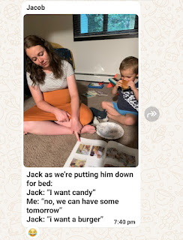

Next blog post:
I'll share all about my family history discoveries in Venice just before Scott and I flew back to Idaho. It was an incredible experience!

