I Can't Stop Walking
Walking. It's literally a habit now. I just crave going for a long walk to wherever, so I've been creating a reason to go for a walk almost every day this past week.
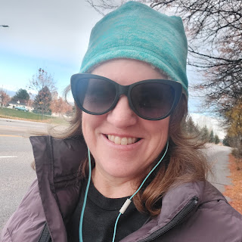
Monday:
After cleaning bathrooms, mopping floors, organizing my bedroom, and doing some laundry . . . I walked to Target and Albertson's. About 1.2 miles each way. I've been trying to come up with errands that I can do on foot. And since I live close to all the best shopping in Idaho Falls, it's pretty easy to get there and back.
Tuesday:
This is my standard lunch of choice lately. One slice of toasted bread, preferably sourdough, with cheese and lunchmeat, and a whole bunch of veggies with ranch dip on the side.

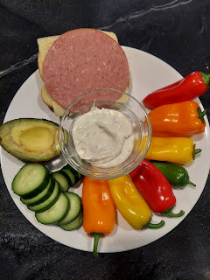

After my tasty lunch, I went for a walk to the neighborhood precinct to vote.
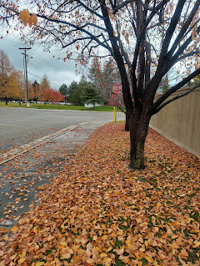

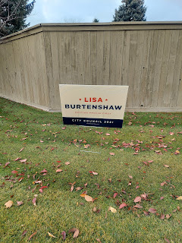

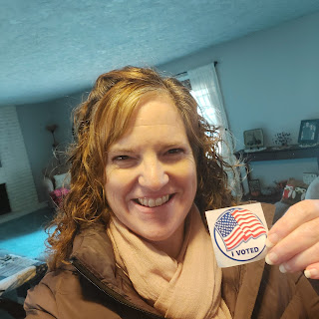

I saw my friends there, Del and Trudy Roberts. After we finished voting, we stepped outside to visit for a bit about their recent travels. They had just returned from visiting their daughter, Stephanie, who is the same age as my daughter, Amber. Stephanie lives with her husband and children down in New Mexico on one of the Air Force bases. They've had several hundred evacuees from Afghanistan arrive at the base there and were in need of assistance. Stephanie graduated some time ago with a degree in the ability to run a non-profit. She took that knowledge and expertise and used it to start a website for the base so that they could be more organized in everything they were trying to do! How amazing is that!

Del said that when the military personnel would feed the Afghan families on base, he noticed more than once that some of the Afghani men would balk when the women and children would be fed before them. They were told, "Welcome to the United States. This is how we do things here."

Most, if not all, of the Afghan evacuees had good-paying jobs in their native land (some of them were doctors, teachers, etc.) and it must have been devastating for them to leave, and to start over with nothing here in the United States. Scott and I have discussed multiple times how we might like to host or at least sponsor some refugees, or in this case, evacuees. We will see where the conversation leads . . .

Later that evening, I was able to go play Human Foosball at the church with the young men and young women. It was super fun!

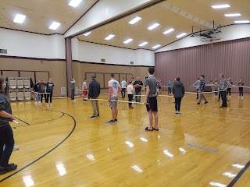

Click here to watch a little snippet of the fun: (28 seconds)
https://photos.app.goo.gl/BPWPgnpRQ9BNuqKbA

Some might call it cheating, but I just refer to it as a great assist . . . I was able to score the winning goal of the night! It was an epic goal and got rave reviews!! Let's just say the scorekeeper may or may not have moved the net a couple feet to the left . . .

This same day, my mom finally received the package that I sent from Germany weeks ago!! It was full of gifts for all my Ukiah family (it's nice when they all live in the same area). I sent dried apple slices from Ofterdingen, a calendar for Grandma Doris with photos from Mossingen, a German newspaper for Grandma Doris to peruse, and some chestnuts from the church grounds where our Muller and Schmid ancestors got married in 1846, among other things.

My niece, Ana, took her cue from the Italian apron that I sent them, and whipped up some tasty lasagna for dinner! What a great idea!!

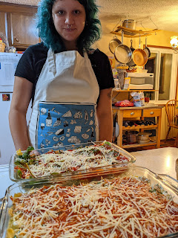

Wednesday:
After getting my dreaded annual exam the day before, I needed to get some blood work done. So I walked over to take care of that first thing in the morning, which took care of my craving for another long walk at the same time.

For the middle of the day, I spent hours working on both my family history and on my Christmas gift for Jack. Here are a few photos that are going into the project:

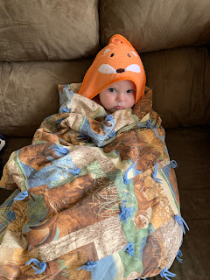





I've had steady contact with a young man over in Duntzenheim, France regarding our Schnepp and Dutt ancestors. He's only 24 years old, but has helped me tremendously with my family lines already! This was all in thanks to the people of Duntzenheim who took my friendly request seriously - that I'm looking for Schnepp descendants to connect with today. They posted my note on their community Facebook page and I've received emails from two people so far. It's been great!

One interesting thing that I learned in my research this week is that there were several generations of Dutts who worked as a shepherd in the neighboring villages to Duntzenheim. I began to wonder what that may have been like in the 1600s. So I did a Google search. It led me to this amazing story (mostly in photos) of a young man working as a current-day shepherd in the mountains of France, written in 2018.

This is the absolutely gorgeous article:
https://www.theguardian.com/environment/gallery/2018/nov/21/solitary-life-alpine-shepherd-in-pictures

I have had a fascination for years with sheep, lambies, and now I can add shepherds to the list. What an amazing profession! And if it's very difficult to be a shepherd in current-day times, just imagine how much harder it would have been back in the 1600's! They didn't have a solar-powered radio to listen to, or have any modern-day conveniences to cook and clean and take care of daily tasks. I have a profound appreciation for those hard-working shepherds in my family tree!

Eventually, I was able to peel myself up off the couch and head into the kitchen. I needed to work with the apples that I had picked up from my in-laws last weekend. I decided to make some applesauce with the jars that I had on hand, and see how far I got that evening.

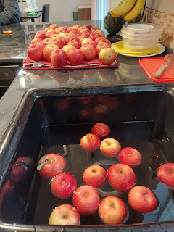

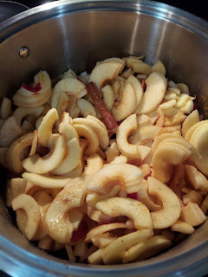

I made 4 quarts of applesauce Wednesday night, and another 2 more on Thursday. My house sure smelled amazing!!

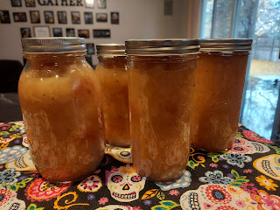

Thursday:
My Origami Paddler finally arrived!!! I've only been waiting for about a year for it to get here, ha ha! That's pretty normal though when you order something from Kickstarter. (Kickstarter is where someone has a brillliant idea but they need financial backing to make their dream come to life. You buy into the process and eventually get the product.) The Origami Paddler is both a paddle board and a sit-on-top kayak. It folds up to fit in your trunk so you can take it anywhere and get out on that water!!

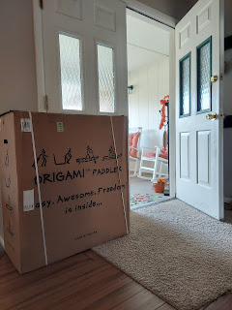

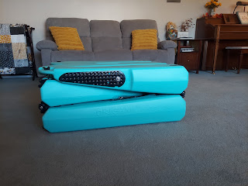

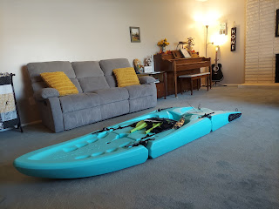

Brilliant idea, right?!! I'm so excited to use it . . . but I'm not sure when that will be since it's November and Idaho is pretty chilly right now. I'll probably have to wait until the spring . . .

Later that afternoon, I prepared the rest of the apples to go into the dehydrator. I sliced them up, put them briefly in some water with "fruit fresh" added in (to prevent browning), then arranged them on the dehydrator trays. I lightly sprinkled all the slices with a cinnamon-sugar mix, and then put them into the dehydrator in the garage for about 24 hours.

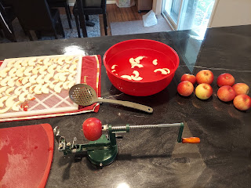

That evening, I went to a service project and dinner at the church for all the ladies in my ward. A lot of work and organization went into the service project ahead of when we arrived on the scene. A committee of ladies had worked with several local organizations to round up items for a Christmas gift bag to be given to each person coming to eat a hot meal at the Soup Kitchen.

The bags included: personal hygiene items, warm attire (homemade hats and scarves), gloves, socks, etc. We formed assembly lines in the church gym, and my job was to put a pair of gloves into each bag, and then pass it on to the next lady. We put together 150 gift bags in a matter of a few minutes!

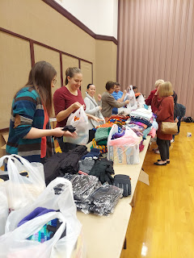

Then we got to walk over to the other half of the gym and sit down to a lovely meal with soup, salad, and rolls. After visiting for a bit, we were blessed to just sit back and listen to the guest speaker, Will Kazele, who pumped us up with positive messages of why we should take better care of our spirits and our mental health. He came from a deep place of firsthand experience in dealing with hard things, and he taught us through his own life lessons on how to make the most of adversity, fear, and loss of hope.

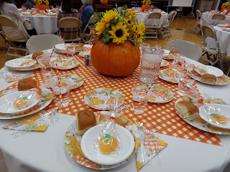

I was really glad I went. :)

Friday:
Not a whole lot to report for Friday. I did a lot of family history research, worked on Jack's Christmas gift, and talked to my friend Jenn in Ukiah for 2.5 hours, ha ha. It was GREAT!! We got caught up on everything!! :)

When Scott got home early from his army drill in Pocatello, he headed out back to round up all the leaves that were on the ground. It took me a while, but once I got off the phone (ha ha), I went outside to help him out. We had a fun time working together and chatting while we worked.

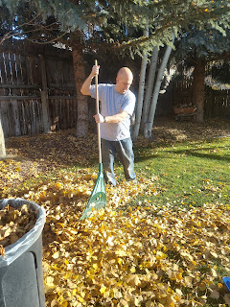

The dried apples were finally finished, too! Man, they are so tasty! I think we'll take some on our road trip to Louisiana for Christmas.

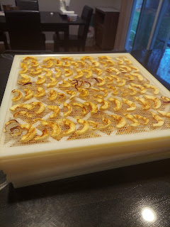

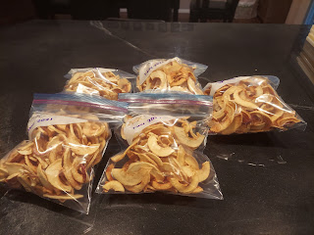

After the leaves were cleaned up, I pulled all the weeds out of the entire strawberry patch along the back of the house. That felt amazing! Now I have less anxiety about letting the plants go to bed for the winter, knowing that they are safer from the weeds.

We ate dinner together, and then Scott and I watched Clear and Present Danger with Harrison Ford as Jack Ryan. I haven't seen that in years, but it's always a good one.

Saturday:
Scott had army drill again, so I was on my own for the day. After I tinkered around for the morning, tidying up and putting laundry away, etc., I headed out on a nice long walk again. This time I walked to some area stores to look for some hand towels for the bathrooms, and to look at some of the Christmas decor. I had lunch by myself and brought home some leftovers for Scott.

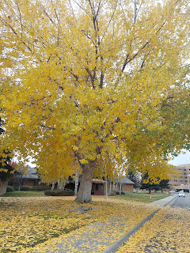

There was a whole area of a local parking lot devoted to families trying to sell their puppies and bunnies. I walked right by, only slowing to take a couple photos of the cutest puppies, but trying to not get caught up in all the puppy hype going on, ha ha.

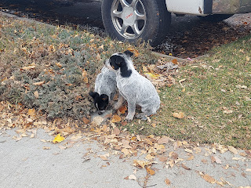

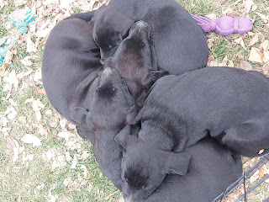

And I wished that I had the money to buy these darling (and giant) Christmas gnomes.

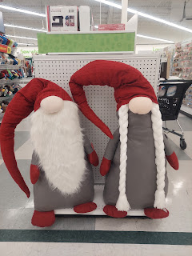

At some point during my walk, I started feeling quite lonely. I was having negative thoughts permeate and infiltrate my mind, and they were putting up quite a fight! I think it started when I saw everyone shopping with someone, and I was by myself. It wouldn't have been such a big deal, but when I had just come home from being alone for a month, I guess it had more of an impact on me than it should have.

I think I have had a taste of what old people in a nursing home must feel like. I have recently felt rejected, lonely, unloved, and just about every other horrible dark feeling that a person could feel. I found myself having to fight back the tears.

When Scott got home, I shared my thoughts with him and cried some more. Before he arrived and offered me some comfort, I found a bit of solace in the latest edition of Guideposts (magazine) that was sitting on my kitchen counter:

1. "If you knew what God thought about you, you would never have another insecure moment in your life." --Jimmy Evans, pastor

2. "How can we move forward from negativity in our past? Focus not on who you were but rather on the pursuit of who you can become. I know what it's like to feel stuck and insecure. I was a teen mom and wanted to give my son a life worthy of his existence. But I didn't know my own worth and value. When I examined my insecurities, I found I was living up to the negative words spoken by other people.

"If you're wondering if you have what it takes because you are still playing someone else's negative words in your head, ask yourself:
Will I allow this negativity to live in the garden of my soul? I can't help that it was planted there. But will I allow the hurtful things said about me to control how I show up in the world?
Then we have to do the work. Speak better words about ourselves. Create a defense plan for your mind. Practice confidence until you begin to grow stronger in it." --Sarah Jakes Roberts, best-selling author, pastor, and motivational speaker

These words hit me like a ton of bricks. I can sit endlessly in the midst of all the weeds in the garden of my soul - all the sadness I felt, the rejection that I felt, etc. - or I could start taking charge of that garden plot of mine. I can remove the negative thoughts and worries about how I was treated and whether or not I am loved by certain individuals. I can focus on more positive things that build up the garden of my soul. And like Scott suggested, "Go hang out with my parents more often. They love you a lot!"

It's hard to heal a broken heart. It's hard to shut down that green-eyed monster called jealousy when I entertain thoughts that I am potentially less loved than I would like to be. And it's hard to know how to move forward when my heart feels so raw at times that it takes my breath away and I feel the tears start to burn once again. It's also hard to admit that at 50 years old, I am still capable of feeling so insecure.

I want to make the world a better place. I want to help everyone to feel loved and appreciated, no matter who they are or what their life circumstances are. I don't like conflict; I am more of a peacemaker. But I also want to be treated in the same way that I try to treat everyone around me. I want to be loved and appreciated. I want to be respected and have my company sought after. I want to be wanted and I want to be needed. I hope that's not too much to ask.

On a brighter note . . .

Here are some fun tidbits from the world of my grandchildren.



Jack, looking so tired, and almost as if he's asking for permission to take a nap. :)

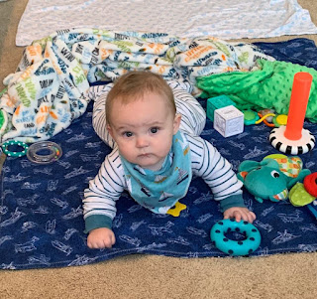

Just woke up from his longest nap to date: 4 hours, 6 minutes. Granted, he did get the flu shot and other immunizations the day before . . .

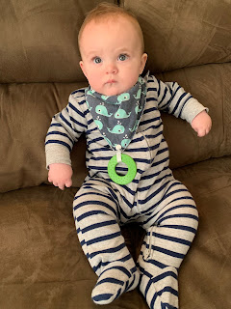

Video #1: (6 seconds) After getting his shots, he had a fever and wasn't feeling too great.
https://photos.app.goo.gl/cQveS6Ee6bTk6CPq9

Video #2: (17 seconds) Using the "swipe" technique to capture his Gerber Puffs.
https://photos.app.goo.gl/PTQieSo7nB4c7Zcw8

Video #3: (26 seconds) Spitting and chatting up a storm while doing the "Superman"
https://photos.app.goo.gl/mJM4ZFsqtkrj4TNy8

Video #4: (46 seconds) On a dare from his parents to roll off the couch . . . .
https://photos.app.goo.gl/87VfkrFj3WN8hZVM7

Video #5: (30 seconds) Happily nibbling on a "Rusk" cracker
https://photos.app.goo.gl/RfzSQGcxvz6gjCD56

A Gwen-ism from the week:

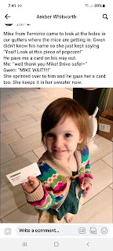

And this morning (Sunday) Abby said:

"My fork is Jesus and my macaroni is the people. He is bringing them up to heaven. Which is me. I'm heaven."

Amber is prepping her home for Christmas. They have a tradition to start early in November because of the beautiful feelings that the Christmas season brings. When they came home from the hospital the day that Jonny was stillborn (Nov. 10, 2016), decorating for Christmas is what helped bring some healing and peace into their hearts and their home. I think it's a wonderful tradition, especially knowing who the Source of peace and healing truly is.

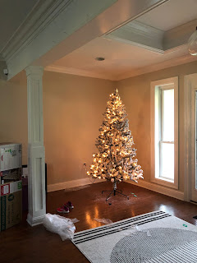

And one final thought on Family History: my love, my passion, and my joy.

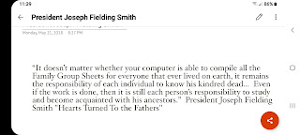

Amen. :)

