Making a House a Home
What makes a house a home? Is it the stuff that fills the space? Is it the smell of warm baked bread or chocolate brownies fresh out of the oven? Is it the people that you come home to? I'm sure there are a mixture of answers and opinions out there, but this has been a question I've been asking myself all week as I have sought to turn this empty space into one that is comfortable and sufficient, without overdoing or overspending.
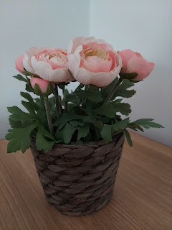

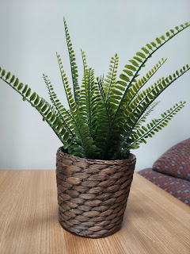

It's amazing to me how 2 small little fake plants could elevate this plain and simple space into something more "homey" and beautiful. Those two little items somehow really made me happy. Our walls are empty, but our hearts are not, and we are definitely feeling more settled in and content by the end of the week.

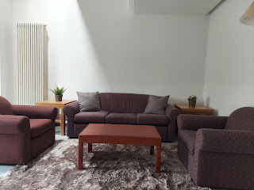

I have wrestled with how much to buy
vs.
when to restrain myself. I found a fabulous bargain on Thursday that I do not regret at all purchasing. I went to the thrift store on base to look for some children's books. It turned out that they were having a special "May the Fourth Be With You" sale and the books were all 3 for a dollar!! Whoopie and Hallelujah!

Somehow, in spite of all the stress and overwhelming decisions to make on what to buy for the house, how much to get, where to get it, etc., something that feels very easy for me to do is to build a room where my grandchildren can come and be happy.

I found all of these darling books, along with a Candyland game and a card game called "Monkey May I?".

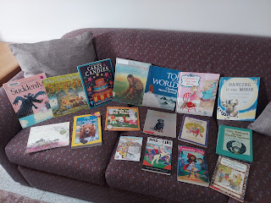

I cleaned them up a bit and then found the perfect spot on the bookshelves upstairs to place them. :)

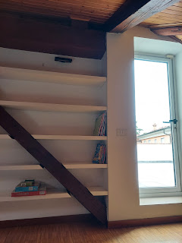

In a separate store, I found the Italian version of "Guess Who?" and I bought it!! The names are all in English so we'll be fine. I think it's just the name of the game and the instructions that are in Italian.

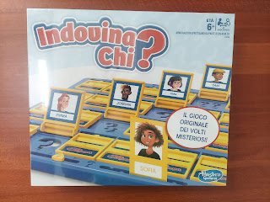

I don't have bedding yet for the Grandchildren Guest Room, but I'm working on it. I do have a couple of happy little rugs on the floor, though.

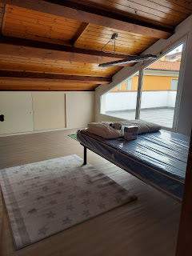

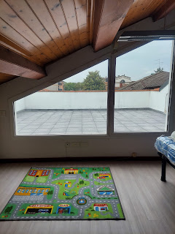

And I think this little sheepie mascot should be named Sherman. "Sherman the Sheep". Because why not. Next to him are some little glow in the dark stars or snowflakes that we will put on the ceiling at some point. It's fun making a space for the little ones. They're my favorites. Just don't tell their parents!

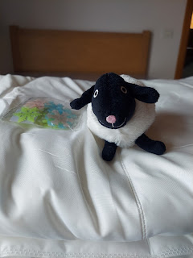

Another thing that makes a house a home is being organized enough so that you can relax, knowing that everything has its place and that the clutter is being managed to some degree. I found this hanging organizer at IKEA and it helped me to organize one of my bedroom wardrobes to be much more functional.

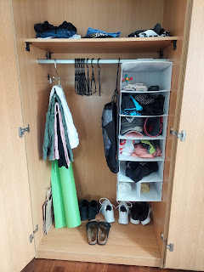

Another thing that makes a house a home is fixing the inevitable problems. If we were in Idaho, I guarantee something would need fixing at some point. Where Idaho has Home Depot and Lowes, Italy has Leroy Merlin. Scott is there at the moment getting a "cap" for the plumbing underneath the kitchen sink. I noticed that it was wet down there and when I saw all the bubbles coming out of this capless extension, it was obvious that this was the source of the problem, ha ha. I had just finished washing the dishes up above . . .

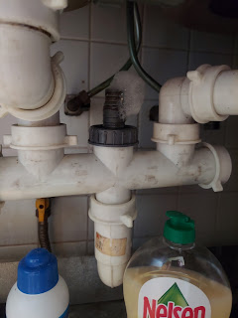

Something unpleasant about living here is that the kitchen has a stink to it. Well, really it's more of a STANK. I used my sniffer to narrow down the source and I think it's the kitchen sink, specifically the drains. There are no garbage disposals here and we have been very careful to not send things down the sink that ought not to go down. But who knows what the previous tenants may have left behind that has had plenty of time to rot and fester . . . I researched on Mr. Google on how to treat a stinky sink drain, and repeatedly the same advice was to use baking soda, white vinegar, and a pot of boiling water.

I had to walk over to the Commissary to find some baking soda, but I already had some vinegar on hand. I treated one drain at a time and it was very satisfying to create some volcano-like effects in each one.

Short video of my efforts: (22 seconds)
https://photos.app.goo.gl/D8UCKZNHsG1rYRMr7

Results: While it did not 100% eradicate the smell, it's a lesser stank than it was before. The Relief Society president told me that it's just normal for Italy and to not worry about it. How sad . . . I ended up ordering a diffuser with some lemon and orange essential oils. I'll be using it daily, probably, to mask the smell. Besides, who doesn't love the invigorating and cheery smell of lemon or orange?

Doing laundry is another thing that makes a house a home. Laundry day is actually something that I enjoy. Does that make me weird? I feel like it's something that connects me to all of my ancestors. Through the centuries of time, families have needed clean clothes and have found a variety of ways to get them clean. Fortunately, we live in a time where modern appliances make that process much more efficient, and I am very appreciative of this.

I am also grateful (yet again) for Google Translate. This time I needed to use it to understand what all the German labels meant on this Bosch dryer that the military provided for us. I am proud to say that I finally figured out which setting does the best job for our laundry, after an entire afternoon of sampling several of them without much success.

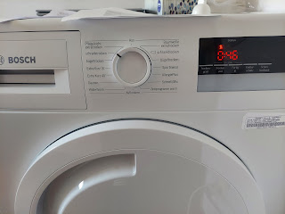

Enticing smells coming from the kitchen are another thing that make a house a home. I baked some brownies a few days ago, and we have been nibbling and enjoying them all week long.

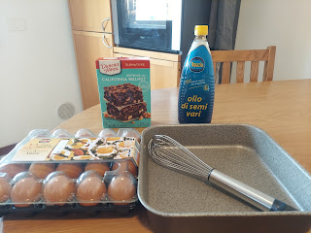

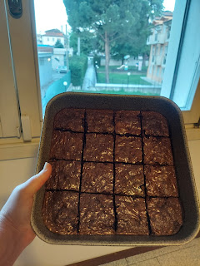

I would really like to bake some bread soon. I just need to find some loaf pans first. The bread here is a little weird. It doesn't have much flavor and I find it a bit disappointing. The thing I worry about is whether or not there is a shortage of flour in Europe yet because of the war going on. I haven't paid much attention to what's available, other than I saw some in the Conad grocery store last week.

I finally found some worthwhile containers with tight-fitting lids that I can use to store flour, sugar, etc. and I plan to get some baking ingredients today (Saturday). I didn't know if bugs might try to climb into the flour bag if I just left it up in the cupboard without putting it into a container . . . so I haven't bought any of those staple ingredients yet. But now that I have the containers, I can get the flour, yeast, sugar, etc. and hopefully find some loaf pans soon. Then we'll have that amazing smell of freshly baked bread emanating out the open windows. I bet we'll make some new friends by doing this . . .

Another important factor in making a house into a home is - does it feel safe? Is it a safe place to come home to land, to lay your head, to let your hair down, to be yourself and relax. One of the things Scott provided for us this week was to install mosquito nets in all of the windows so that we don't have to worry about being eaten alive while we open the windows to get some fresh air. I REALLY appreciate him for doing that. So far I've only gotten one bite. We found him (the rogue skeeter) the next day and squashed him up on the ceiling with our broom. That felt extraordinarily good.

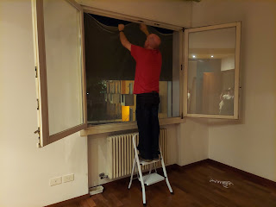

A functional part of making a house into a home is to have INTERNET. I know that people survived without it for centuries, but now that we have it, it's really hard to live without it. Lucky for us, Scott made a friend named Richard at the car dealership a few weeks ago. Richard is fluent in both Italian and English and has hooked us up with some very important services in Vicenza, including how to get the best internet. Most of the guys on base just go through the internet provider that the military provides. But it's a frustratingly long process, and many have reported that they waited a month or more to get mediocre internet service. Richard, however, told us about a local internet provider that came over within just a few days and installed a faster internet than what we have back in Idaho - for LESS than what we pay back home! Amazing.

I didn't take pictures of the two Italian guys doing the installation because I didn't want to creep them out, ha ha, but when they stepped away for a minute, this is part of what they were working on in the hallway by our bedroom. (The llama is a weighted door stop and he did a good job supervising)

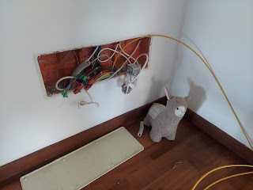

We are finally at a point where it feels like we have a good baseline for functioning in our new home now. It's been a stressful couple of weeks. I didn't want to complain too much before, because after all, we're in ITALY!! But it's certainly been stressful and hectic and busy. We haven't really done much in way of fun yet because there is always a long list of lists to work on every single day.

I am most grateful for who I get to share this space with. If it weren't for Scott and his military service, I wouldn't even be here right now. He is the best part of my day every day. We have remarked to each other several times this week that we make a good team. Scott
could
have moved into this house (or any other house) and gotten the things that were needed to cook, clean, sleep, sit, etc. but it would have been a lot harder to do by himself, especially while still working every day. And if he had gone to Germany, I
could
have done much of what we have accomplished these past 2 weeks by myself - but it would have been a great deal more stressful. I'm relieved and grateful that we have been able to do all of this together.

We are seeing the light at the end of the tunnel now and it sure feels wonderful! Now that we have a functioning house and a comfortable home - even though it's mostly bare - we can move on to other endeavors. Like having a little bit of fun maybe.

I didn't get to share some of what happened last weekend because we didn't have good internet at the time and the photos wouldn't load. We made an epic trip to the Iper Rosetto grocery store (Iper is pronounced like "eeper"). I say "epic" because everything about it was epic. That store is ginormous!!!

First we grabbed a cart and went up the conveyor belt ramp to the store above.

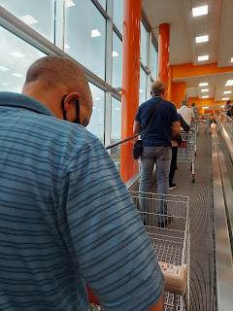

Each aisle has a massive selection of EVERYTHING. And these chicken legs and thighs - - the largest I've ever seen!

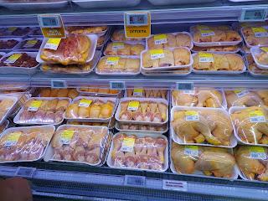

More varieties of parmesan cheese than I could fit into one photo. I'm literally in heaven here!

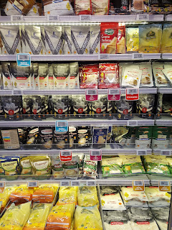

Dozens of varieties of FRESH butter - in huge slabs of course.

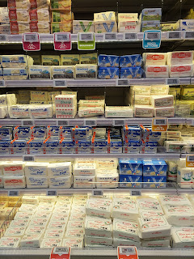

Some very interesting looking salmon crepes and zucchini crepes.

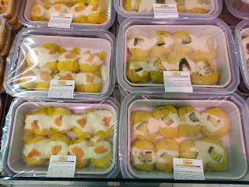

There were one and a half ginormous aisles full of just yogurts!!

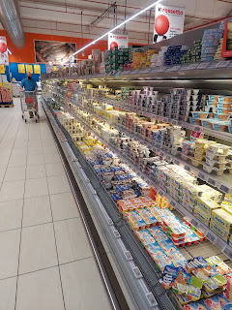

The produce is very high quality at the Rosetto. Take these massive heirloom tomatoes for example.

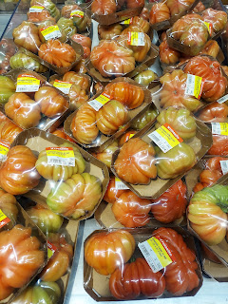

And I've never seen baby artichokes before. They are just so cute!

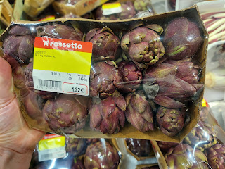

The parking area under the store is huge as well. But the nice thing about it is that when you pull in to find a parking spot, you can easily find one wherever the light is green above the spot. We went late in the evening, and were there until closing time, so we didn't have any trouble at all.

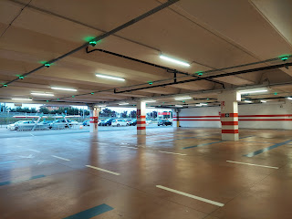

I had polled my children about what top 5 spices I should have on hand ahead of going to the store. Jacob gave me some good suggestions, and I ended up buying many of the ones he had mentioned. My first spices in Italy are: oregano, paprika, basil, garlic powder, and cinnamon. I also found some good quality olive oil. I couldn't believe how cheap it is here! I got this huge bottle for only $4.99. In Idaho it would have been maybe $15 or more for that same size.

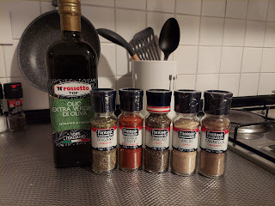

Earlier that evening, we went to the Piramidi Mall. Talk about a huge mall . . . it has THREE levels with several wings and it was a bit confusing to get our bearings.

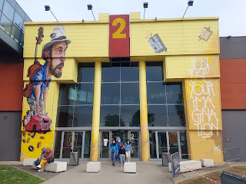

We were on the hunt for some bed sheets last Saturday and found a great store with great prices. It was called Smart Moda. Once we found what we came there for, we got some dinner at a Poke Bowl restaurant in the mall. If you're not familiar with what Poke Bowl is, picture something like Hawaiian Haystacks, but even better. First you choose a base: rice, noodles, or salad. Then you choose a few proteins: fresh salmon, fresh tuna, shrimp, etc. Next you can choose some sides: mango, avocado, edamame, spinach, etc. Then you choose a couple of "crunchies": like crushed chips, peanuts, sesame seeds, etc. And lastly, a sauce. I chose a teriyaki sauce for mine, while Scott chose an avocado drizzle of some sort.

While we waited for our food to be prepared, I had fun in the swing that was next to our table.

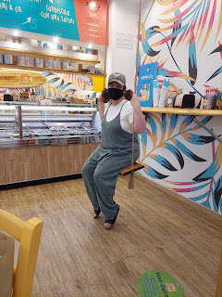

It was super delicious and I ate every single bite of mine!

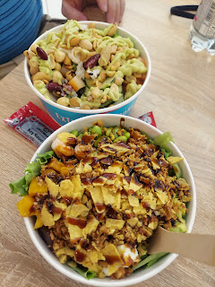

Also, I may have mentioned this last fall when I came to Europe then, but they use bamboo throw-away silverware everywhere instead of plastic. What a genius thing to do! I'm not a huge save-the-environment junkie, but when I see something as simple as that, it makes me think that we could do some baby steps of our own in the United States. Bamboo is fast growing and very sustainable. Plastic . . . not so much.

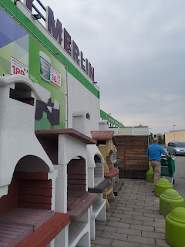

Having been to the Leroy Merlin store a few times in the span of one week, I have noticed something consistent about the clientele that frequent this store. They are all extremely well dressed!! When I think of the clientele coming into a Home Depot store, I picture people in their work-around-the-house (or yard) clothes, with paint splatters on their shirts, maybe even a little sweaty and in a rush to get the thing they need to get back home and back to work on whatever project they're in the middle of.

But here, the people are SO WELL DRESSED. They wander slowly and take their time. They are not in a hurry like we are in the States.

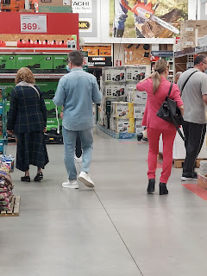

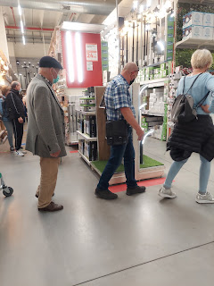

In the middle of a Saturday afternoon, couples come hand in hand, looking like they're on a fancy date together, with heels, leather jacket, and all.

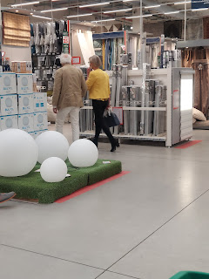

Orchids are very much in bloom right now in the stores and they look so pretty.

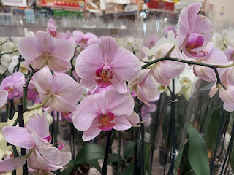

Last Sunday, we were invited to have dinner with the Delap family, who have a beautiful house and property just south of Vicenza. Daryl Delap is a JAG Officer for the US Army and has lived in a lot of really cool places in the world, including Japan and now Italy. He and his wife, Alison, are gentle giants, raising a family of 4 kids (I think) and doing a really good job. We enjoyed getting to know them a little better. They made a delicious feast of Mexican food, with homemade tortillas, homemade tostadas, and all the fixings to pile up on whatever you chose as the base.

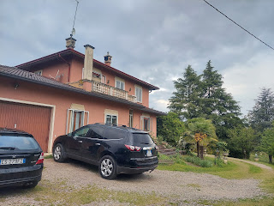

This is the view looking behind and to the side of their house.

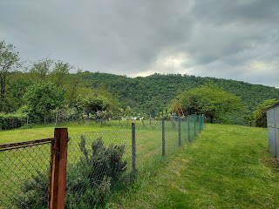

It was a very steep hill going up to their place, and a steep hill going back down toward civilization.

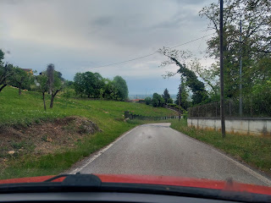

Some beautiful village charms on the way back to our house.

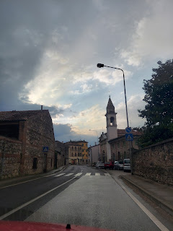

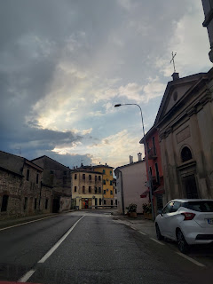

Also, last Sunday, we were asked to help serve in the nursery as we left the chapel after Sacrament meeting. Stacie, a delightful and cheerful lady in the ward (whose favorite color is also yellow), is the primary president and needed some last minute help. We were happy to pitch in. There were only 3 children, and that was plenty, ha ha. The older two are what the parents refer to as "frenemies" - it's either a love or a hate relationship between them. The youngest one was so darling and squishable, I wish I could adopt him.

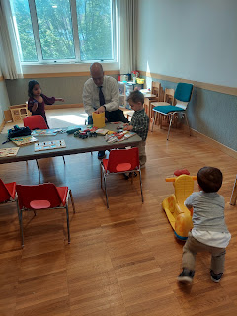

I rode the bus over to the Piramidi Mall on Tuesday so I could take my time and learn what was in all the different shops without boring my poor husband if he were with me . . . I found some foccaccia pizza for lunch and then walked over to the Leroy Merlin to slowly go through every inch of the store and learn what they have and where it is. I got some great homework accomplished and had a shopping bag full of items to haul back by the time I was done. (incuding that cute children's floor rug for our grandchildren guest room)

It's pretty easy to get over to that area by bus, a town called Torri di Quartesolo. But both times as I have tried to get back to where we live, it is a frustrating and loooooong process. The bus I need (#19) doesn't come around nearly often enough, and it doesn't stop over there in the late afternoon apparently. I had to walk quite a ways in the heat and across a giant roundabout with no pedestrian walkway in the middle of some very busy traffic, just to get to the bus stop that Google Maps was telling me to go to.

After I got to the specified bus stop, several scheduled pickup times came and went but no bus drove past. Almost an hour later, the bus finally came. I was hot and sweaty from standing out in the intense sun all that time.

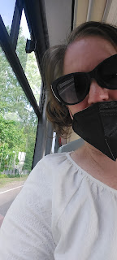

The mask mandate changed on May 1st to where we don't have to wear one in public places, like stores and restaurants (and church), but you still have to wear one on any public transportation. And it has to be an N95 mask. Blech. Not a fan of those hot masks when you're already hot and sweaty.

As I've walked around the area on several days this past week, I am always on the look-out for beautiful blooms. I found some really good ones. I added them to my "Flowers in Italy" photo album. If you are interested, you can find them here:

https://photos.app.goo.gl/i4RGiVYYiVicd4Ln6

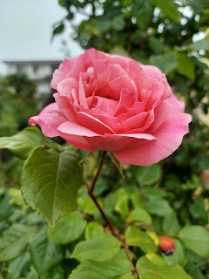

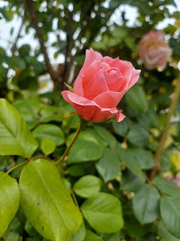

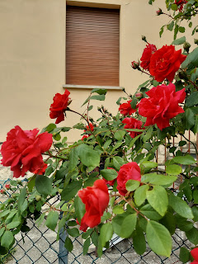

Scott wants to get a Kumquat tree when we are ready to get some plants for our rooftop terrace. I really want a lemon tree. When I went into the PX on base this week, I saw someone selling a kumquat tree! They wanted $48 for it, and that's a lot. We hope to find one for less at one of the local garden nurseries. But it's sure cute!

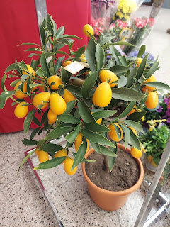

All the flowering wisteria trees are shedding and now the sidewalks are covered in beautiful blooms just outside the gate of Camp Ederle.

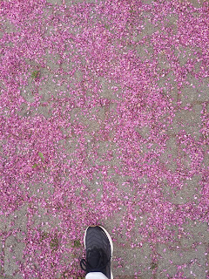

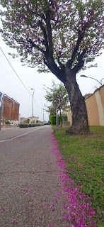

Speaking of blooms, I found some squash blossoms in the grocery store this week. I sent a picture to my sister, Charmaine, and she responded by saying that the new company she works for actually produces and sells them! It made me curious so I decided to look on the internet for recipes that use the blossoms. I found a good one: (it's more just a bunch of ideas on how you could use them)

https://www.tasteatlas.com/fiori-di-zucca-ripieni

A few other things and then I'll wrap this up . . .

We discovered YET ANOTHER fantastic grocery store within walking distance on Saturday. There are SO MANY grocery stores here!! It's called EuroSpin. It sounds like (and the sign even looks like) a laundromat, ha ha. They have a wonderful selection of produce, meats, and everything else.

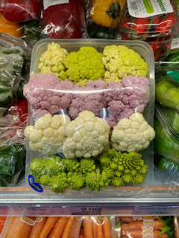

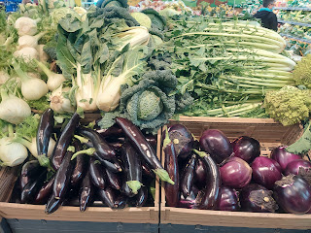

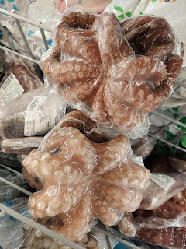

Remember earlier when I said I wanted to get all the ingredients to be able to bake some bread? Well, it took quite a bit of doing to find some of the items, like yeast. There are multiple types of yeast that I found at the EuroSpin and I had to use Google translate to find the correct one. It's called Lievito (yeast), but specifically I needed lievito secco (dry yeast). Not brewer's yeast, or any of the other kinds, ha ha.

In this photo, I lined up some of the more difficult things I finally found in the store, and invited my kids to try to identify them. See if you can figure them out as well. :)

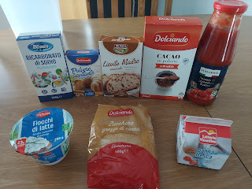

Using the passato (tall bottle in the back row), I made a really tasty dinner last night. It's called Pumpkin, Spinach and Ricotta Stuffed Shells.

Here is the recipe I used:

https://myfoodbook.com.au/recipes/show/pumpkin-spinach-and-ricotta-stuffed-shells

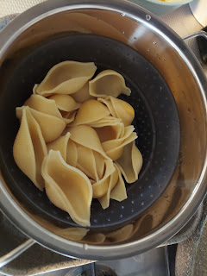

Cook the jumbo shells al dente. Cook the bacon (more like strips of fatty pork chop over here), add some roasted butternut squash bits, fresh spinach, and ricotta.

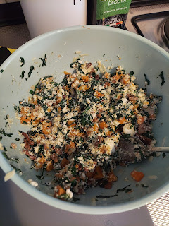

Stuff the shells and add them to the passata sauce.

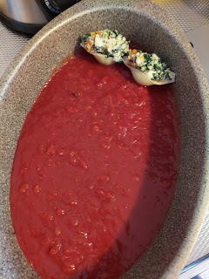

Halfway covered with cheese here - but trust me, plenty more cheese was added!!

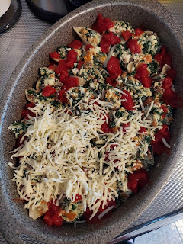

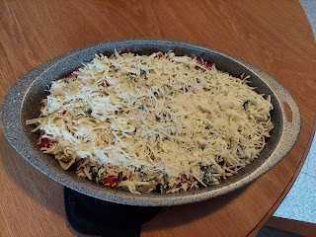

Absolutely delicious!!

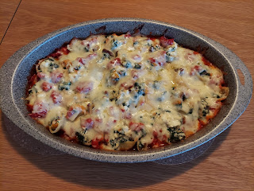

Now I can sit back and relax for dinner tonight on Mother's Day and just eat leftovers.

I made some goals a few days ago, both short-term and long-term. Some of my short-term goals are to do more family history, implement better menu planning, and work on some weed control outside. A long term goal is to build up a little bit of food storage and emergency preparedness for living in Italy. At home in Idaho, I feel ready for a disaster or emergency. But not so much in Italy.

As I tackled getting back into family history after a break, I decided to try out the new 1950 Census Indexing project. It was really cool!

Try this link and play with the options for yourself:
https://www.familysearch.org/getinvolved/1950

I chose to work on California and I chose the surname Snider. It let me choose from 3 types of projects within those peramters, and I chose to index a household. Basically, it had a head of household, along with several "Lodgers" that lived in the same apartment building. "A.I." (artificial intelligence) already did the preliminary work by looking at the census images and extracting names and other information. Our job now is to verify that the robots did everything correctly and make any adjustments if needed.

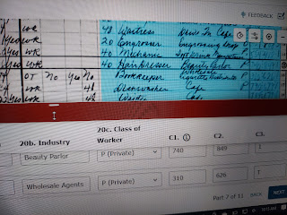

In the photo above, it showed in the blue highlighted area that Flora D. Snider worked as a bookkeeper for a Wholesale Cigarette Distributor. But the "A.I." extracted the info as "Wholesale Agents". I was able to correct that and then save it. Also, a lot of the numbers were incorrect, so I made a lot of corrections to those as well.

It felt really good to participate in this project, especially when, at the end, it says:
"Way to go! Thanks to you, the Opterbeck family (19 people) from California can now be found by their families." (Opterbeck was the head of household in which Flora D. Snider resided in 1950)

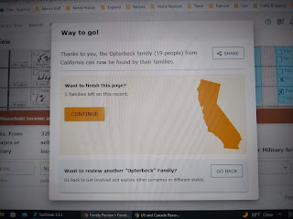

I will definitely be doing more on the 1950 Census project in the coming weeks! It was really fun!

Time for the Grandbabies . . .

Little Miss Avery - her hair looks strawberry blonde in this photo. I love it! And she's using the baby blanket that I made for her. Yay!

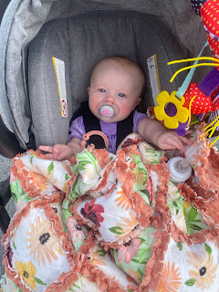

Kylie found a baby owl in one of her walls this week!! Whaatttt????

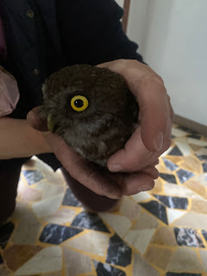

Amber found some baby kittens along with its feral mother on their property in the same week. She coordinated their care with Kylie in Italy, since Kylie has rescued MANY baby animals and has a lot of great knowledge and perspective to offer.

This one had a skunk-like stripe down its back and was promptly named Stinky, ha ha.

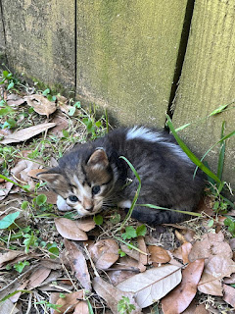

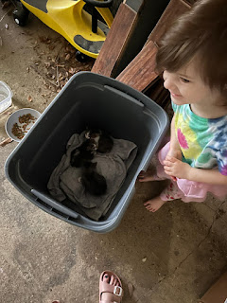

Gwen - applying her 40th layer of lip gloss . . .



Abby and Gwen watching TV. I was feeling all sentimental mid-week and asked my kids to please send me a picture of the grandchildren ASAP and this just happened to be what they were doing at the time.

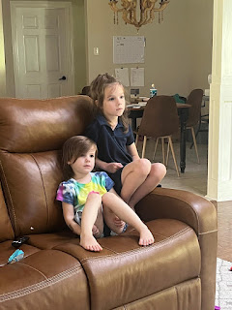

Jack Jack

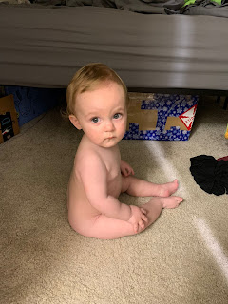

His daddy in the same exact pose about 25 years ago

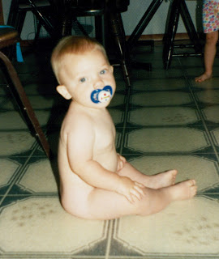

Jack is getting closer to walking on his own - I even saw him take a confident step from his walker to the couch in this video: (30 seconds)

https://photos.app.goo.gl/UYuFSdCCrqybH1649

And he called me again yesterday. I love it when he does that!





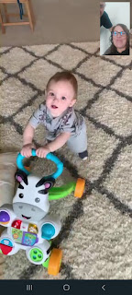

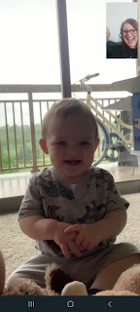

He climbed up and onto the laundry basket to reach something in the box that was stacked on top of it. He toppled over soon afterwards, but he was okay. :)

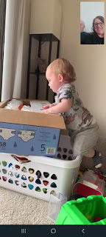

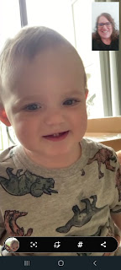



And he can climb up onto the couch all by himself now too! I watched the whole thing unfold . . .

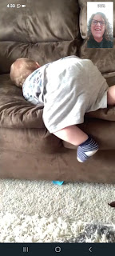

Good week everyone! Keep it up! Hang in there! You got this! :)

