Medieval Walls and Walks in Croatia & Slovenia
Places mentioned in this post:
Groznjan, Croatia
Plovanija, Croatia
Umag, Croatia
Piran, Slovenia

In the time it takes to drive from Idaho Falls to Salt Lake City, Utah, on this side of the world you can also drive from Vicenza, Italy to Grozjnan, Croatia. (roughly 3 hours)

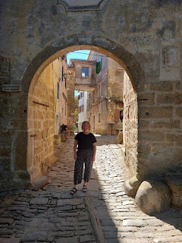

Day One:
Groznjan, Croatia / Plovanija, Croatia / Umag, Croatia

I can't even take 1% of the credit for researching and finding these places in Croatia. My sister, Charmaine, did all the legwork months in advance, scouring websites, YouTube, and building a spreadsheet of possibilities. All I did was drive us there, but I'm so glad I got to be a part of this scenic excursion!

Groznjan is up in the lush hilltops of Croatia, centrally located in the northern part of the country.

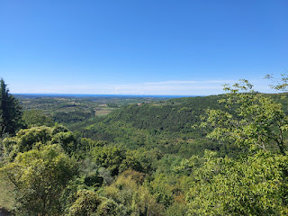

Fewer than 170 people call this village home. Interestingly, 39% of the municipality of Istria, which includes Groznjan, speak Italian as their primary language. This is because the area was under Venetian rule from 1358 until 1797 when the Republic of Venice fell. It is an area mixed with Austo-Hungarian and Italian influences, no doubt because they were ruled by each of these differing cultures.

Indeed, they were even ruled by Yugoslavia at one point, too! Per Wikipedia:
After the
Second World War
, Istria was divided into two parts, the Yugoslav one and the
Free Territory of Trieste
, which was divided into Zone A, controlled by the US Army, and Zone B, controlled by the
Yugoslav Army
. Grožnjan becomes a part of Zone B. On October 5, 1954, the
London Memorandum
was signed and Zone A was assigned to Italy, and Zone B to the
People's Federal Republic of Yugoslavia
. In 1975 the
Treaty of Osimo
divided the Free Territory of Trieste and Grožnjan became part of Yugoslavia.
The London Memorandum provided the population with the option of emigration to Italy. The new Yugoslavia's emergent communist system and its application, along with lingering hostilities between Italians and Yugoslavs (like the murder of priest
Francesco Bonifacio
), contributed to a large wave of emigration (part of the
Istrian–Dalmatian exodus
). By April 1956, 2/3 of the population emigrated from the area to Italy.
Although Groznjan has had a volatile history, it is a peaceful, quiet, and tranquil tiny town with endless charm and beauty everywhere. It is also known as the "City of Artists", with so many quaint shops and opportunities that abound around every corner. Artists from around the world have set up shops here, coming and going since the 1960's.

Here is a town map, along with a description of important local sites, that we found close to where we parked. (click photos to enlarge and read)

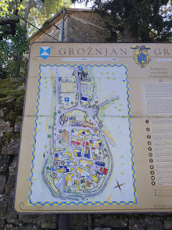

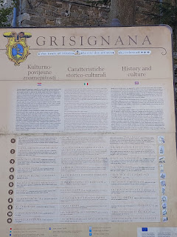

Even getting money from the ATM at the beginning of our visit was super cute on this "street" . . .

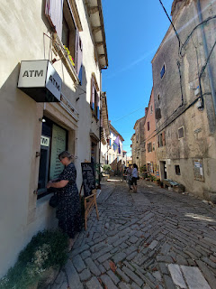

Local art shops offered everything from ceramics, jewelry, glass creations, paintings, resin art (on wood and other mediums), and much more.

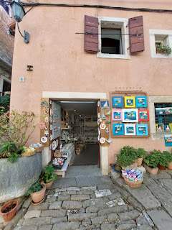

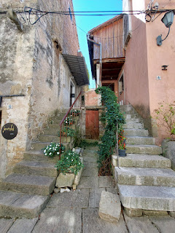

I found myself wanting to photograph every detail, every nook and cranny of this place.

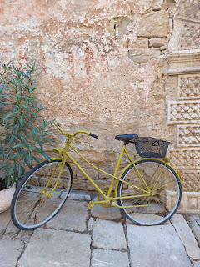

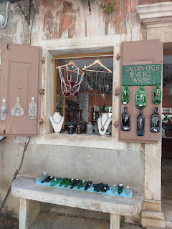

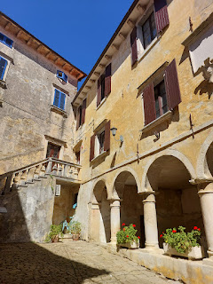

For lunch, we settled on this central restaurant with its plentiful outdoor seating on a raised patio in a sort of public square, although it felt tucked away in a neighborhood, as though it was "our little secret".

The menu listed their offerings in FOUR languages. Take note of the columns: far left (Croatian), 2nd from left (Italian), third from left (German), and finally English. Yay!

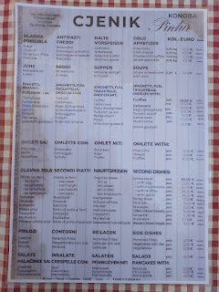

While we waited for our food, we took turns using the free bathroom inside the restaurant. When it was my turn, I noticed a local artist who was in the middle of painting a cute and oversized older man, just outside the entrance of the restaurant. As soon as I got back to our table on the upper patio, I zoomed in to capture the moment.

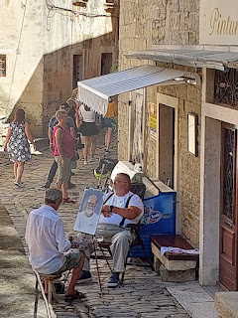

My lunch was simple and filling. It was a basic Istrian minestrone soup, the only soup offered on the menu. I am always in search of vegetables whenever I'm out and about, so this seemed like a good idea. It was okay, but the main thing I didn't like is that it tasted like the thick starchy liquid from a can of beans. For a minestrone soup, I guess I pictured more of a clear or tomato-y broth and lots of vegetables. This soup was mostly the starchy bean liquid that we would normally strain out of the can, along with a tiny bit of corn, plenty of beans, and maybe a stray tomato or two. Oh well. It was an "experience" and I'll take it.

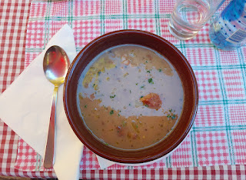

Near the end of our lunch, there was a little bit of excitement down below in the alley. I had a good vantage point to observe from our table . . . two worker guys showed up with a tiny little truck that was loaded to the gills with wooden chairs. First of all, it was a marvel to see a truck (or any vehicle) driving on those roads. The roads are super chunky, with rocks sticking out and jutting up every which-er-way, and I can only imagine how much havoc this wreaks on a vehicle's tires and undersides . . . After quietly observing for a few minutes, I deduced that they were about to deliver these chairs to a private residence behind the restaurant, getting permission first to traipse back there when signs clearly signified that this was not a place for tourists to come a-wandering.

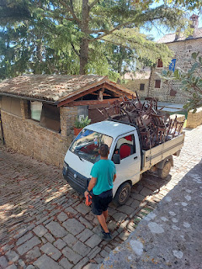

We noted that our waitress delivered some tall ice cream desserts nearby, so we motioned for her to come over to our table so we could copy-cat and order one to share as well. :) It was super yummy - pistachio ice cream with something else that I can't remember now. Maybe a chocolate with nuts, or something.

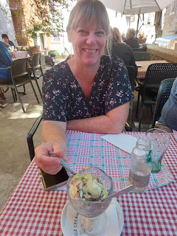

Just beyond where the workers were unloading the wooden chairs is a beautiful vista spot, with magnificent views of the hills and valleys that go on and on across Croatia. It reminded me of the Sierra Nevadas along the California border.

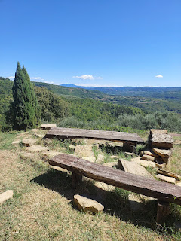

Now that our bellies were full, it was time to go for a walk. Wanna come along? This will be a photographic journey for the most part, and I hope you'll get a sense of how adorable this little village truly is.

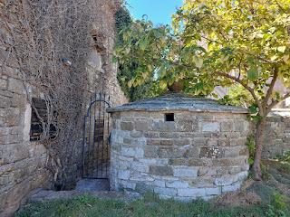

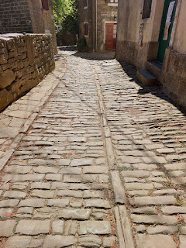

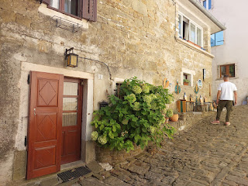

Charmaine, in her deep green and very flowy dress, was especially lovely, too.

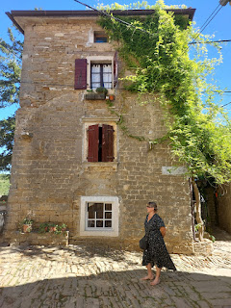

An artsy table with resin that overlays the wooden rounds and nature-y offerings underneath . . .

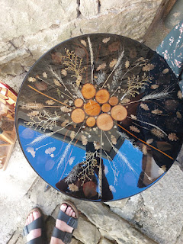

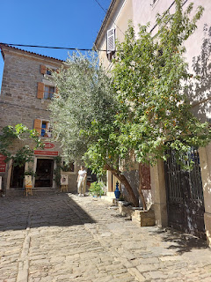

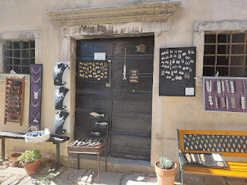

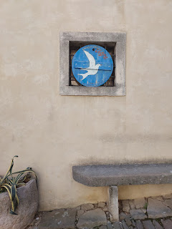

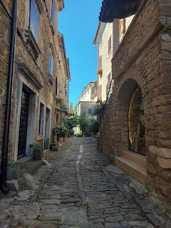

Below: Dried garlic in the windowsills . . . and while I'm not exactly sure what this is for, I found a hilarious blog post about strange things that Croatians both DO and DON'T DO . . .

https://www.royalcroatiantours.com/blog/25-quirky-things-croatians-do-and-would-never-do

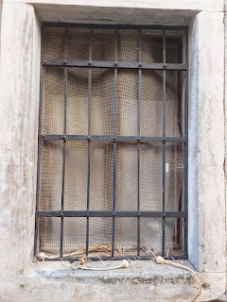

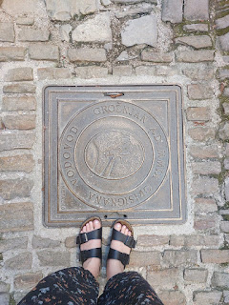

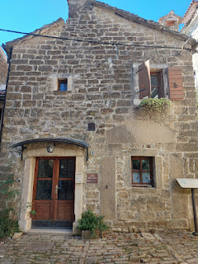

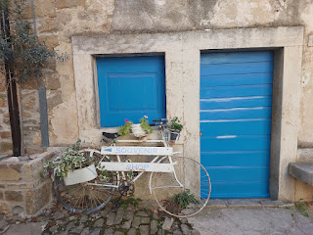

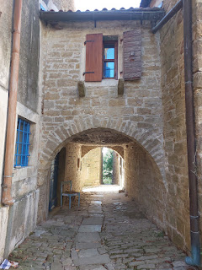

*Look closely at the chunky pathway that people use EVERY SINGLE DAY here. The rocks that stick up everywhere sure would make it difficult to navigate in the rain, and they would also ruin any bicycle tires really fast, too!

Video as I walked through the tunnel and turned down another alley: (16 seconds)

https://photos.app.goo.gl/NkyQ7tMNjLdXp1VF6

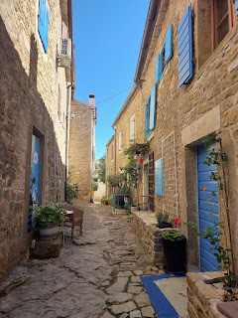

Video as I walked down another alleyway: (16 seconds)
https://photos.app.goo.gl/SWpj8bDwMWvu28VH7

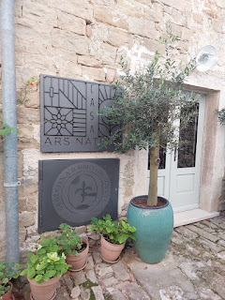

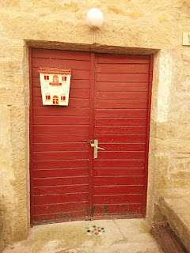

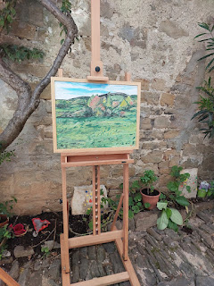

I thoroughly enjoyed my solo explore down so many connecting alleyways while Charmaine and Scott were sampling products in an olive oil and truffle shop. The paths all interconnected and I kept coming back at regular intervals to see if they were done yet, and also so they didn't think I was lost, ha ha.

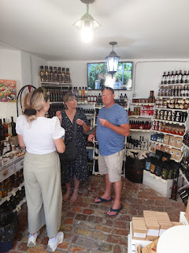

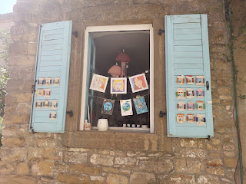

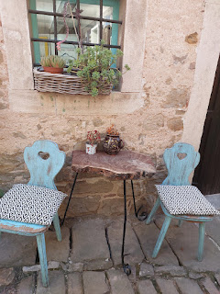

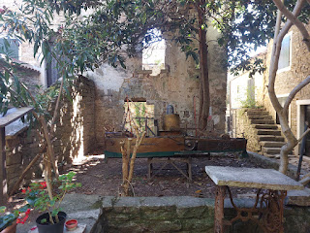

Above: Known as the Corner House, and was built on top of an older house back in 1567.

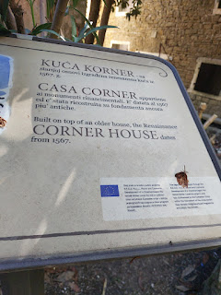

Even the public trash cans were cute and charming in Groznjan! This stylish trash receptacle was attached to the corner of a building.

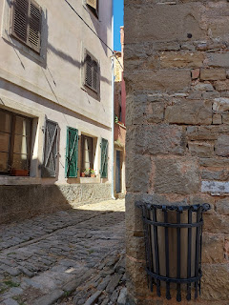

Everyone has a cushion to sit on, just like the article above mentioned. Because you can't sit on the concrete directly . . . lol

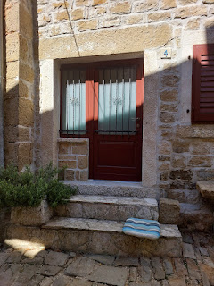

Framed art displayed on living art . . .

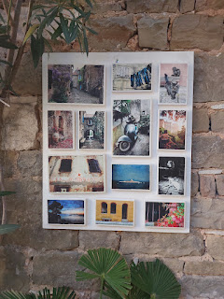

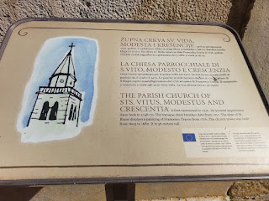

The Parish Church of Sts. Vitus, Modestus, and Crescentia, dating back a long way. As per the sign above: First mentioned in 1310. Its present appearance dates back to 1748-1770. There are baroque choir benches inside that date back to 1711. And the 36-meter tall tower was built from 1603-1682.

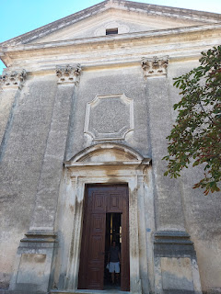

This was the only "peek" we got of the inside of the church. We were blocked by a glass partition from entering, but I was able to get a decent photo nonetheless.

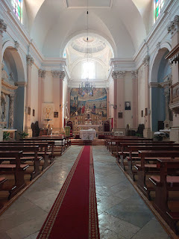

Charmaine had read about this next place ahead of time, and she was happy we found it before we left town.

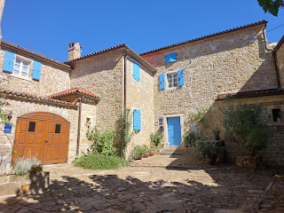

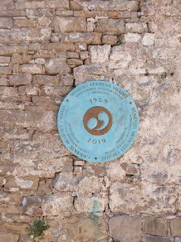

What used to be a castle, is now an International Cultural Center for Music. The sign below reads:
"The Castle - is first mentioned in 1102. It was the seat of various feudal lords until 1359, when it became the residence of Venetian captains and potestates. Traces of former partitions are visible on the southern side. Kastel's current appearance dates from the 19th century. It houses a concert hall and provides the headquarters for the International Cultural Centre of Jeunesses Musicales Croatia."

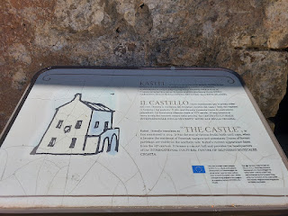

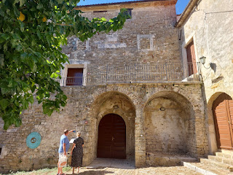

This tree in the courtyard was intriguing because the inside of the trunk appeared to be empty, and yet the leaves and growth still looked so lush and healthy . . .

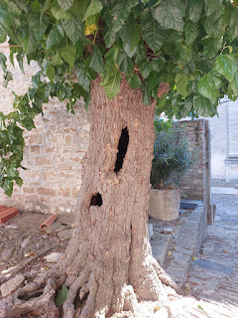

A caterer was setting up for a fancy luncheon in this beautiful and old veranda . . .

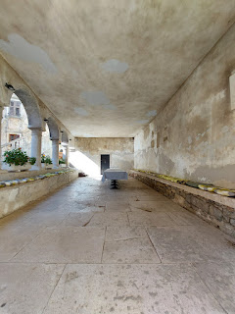

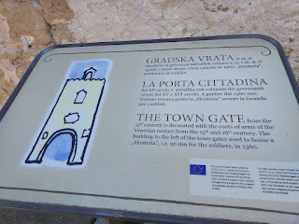

As per the sign above:
"The Town Gate from the 15th century is decorated with the coats of arms of the Venetian rectors from the 15th and 16th century. The building to the left of the town gates used to house a 'Hosteria', i.e. an inn for the soldiers, in 1360."

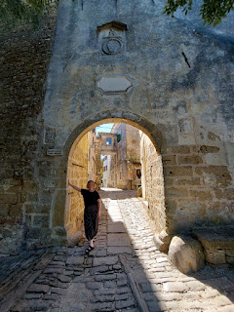

Before we left this delightful and charming town, Charmaine wanted a little photo shoot, so I did my best to make that happen. XOXO

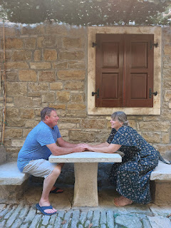

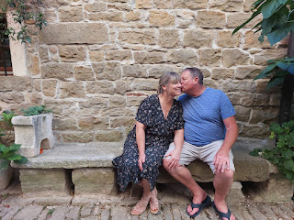

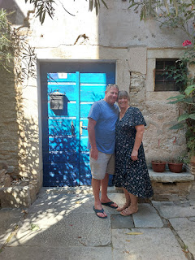

Our lodging for the night was a short distance north of Groznjan, in a town called Plovanija. We had an AirBnB all to ourselves, with very comfortable accommodations. I had this cute room, with 2 separate twin beds, while Charmaine and Scott had an adjoining room with 2 twin beds pushed together, as is the European custom, lol.

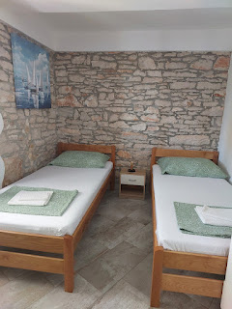

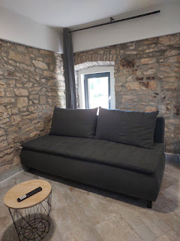

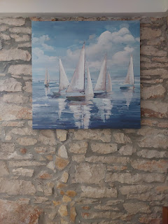

After a brief rest, Charmaine did all the legwork once again to find us a place for dinner. She is good at researching to find something interesting to the area, so I let her hop right to it. We called to make a reservation because a lot of places require them, plus we had already struck out earlier on a couple of other findings since they were already booked up for the night.

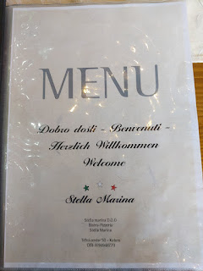

We drove about 15 minutes to get to Stella Marina, a restaurant in Umag, which is right next to the waters of the Adriatic Sea. The menu had some amazing options to choose from . . . (click photos to enlarge below)

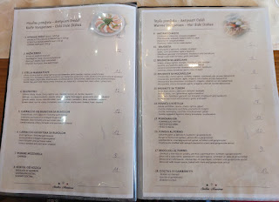

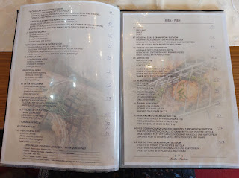

I ordered a starter plate for us (#3 in the cold side dishes section above). It was a lot of fun! Prosciutto and other meats, goat's milk cheese, green olives, tomatoes, rucola, and FIGS! So many flavors . . .

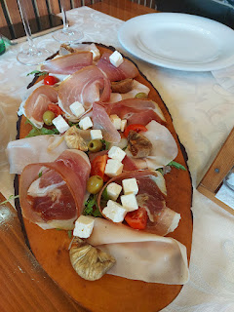

The spice grinders on our table needed some Google Translate: (on the left) Sea Salt - with chili and garlic, and (on the right) Pepper and Salt - together.

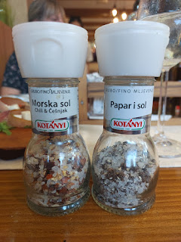

I tried to be super sneaky to get a photo of the family seated across from us. They seemed to be locals, due to the language they were speaking. I just wanted to share a glimpse of what Croatians look like.
Lots of families were out to dine together that night, with multiple generations present - grandparents, adult children, and even very young grandchildren.

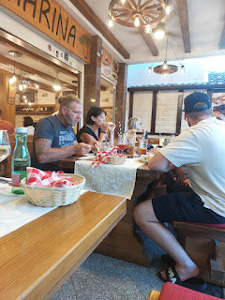

I ordered the mixed shellfish platter, with mussels, prawns, and other tasty morsels that I cannot remember now . . . It was messy but delicious.

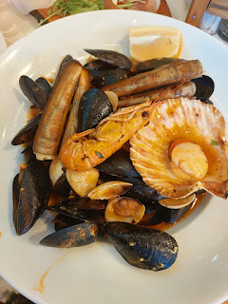

After dinner, we strolled over to see the almost finished sunset over the Adriatic . . . a 3 minute walk from the restaurant.

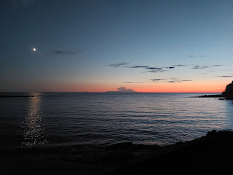

I chatted with my son, Benson, back in Idaho (I'm always so thrilled when he calls) and I sent him a few photos from where I stood in that moment.

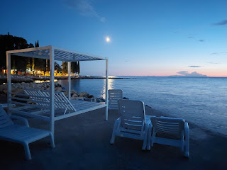

Day Two:
Piran, Slovenia

Approximately 20 minutes from our lodging in Plovanija, Croatia is the medieval fortress town of Piran, Slovenia. It juts out as a significant peninsula, almost exactly across from Venice.

Someone thoughtfully placed a giant map with sites of interest close to where we came up out of the parking garage. (click photos to enlarge)

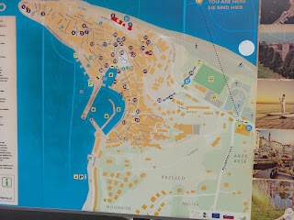

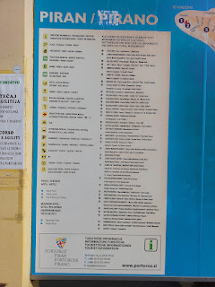

If you're interested in where we spent our time, we walked past or stopped to visit: 8, 9, 10, 15, 16, 17, 18, 19, 21, 22, 28, 29, 36, and 37. The parking garage is over on the far right of the map, where the bright blue "05" is shown.

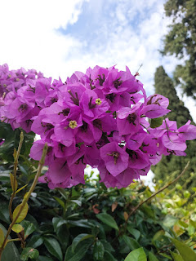

From the parking garage and the map, we walked west toward the historic city center. At the "end" of this stretch of road it turns into an older cobblestone road that slopes steeply downward.

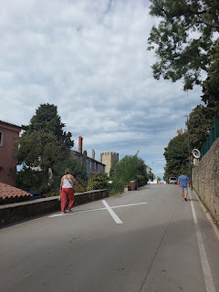

Our first stop was to visit the old town walls that overlook the town below. It was an impressive view of not only Piran, but the Adriatic Sea on all sides, as well.

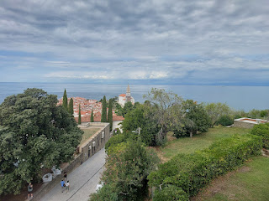

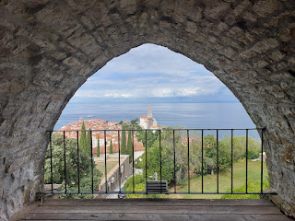

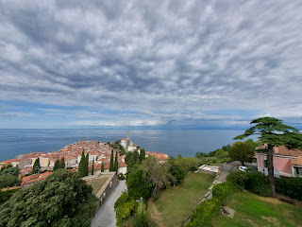

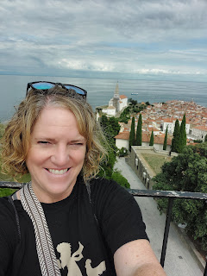

Video of the views after climbing a few steps: (12 seconds)
https://photos.app.goo.gl/xFtEDPmpKhME5BfcA

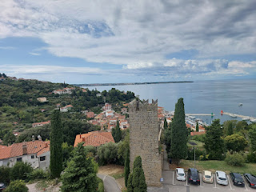

There was a nice-looking salmon pink house just below the medieval walls, and as I got closer to it, I noticed a handsome quilt hanging to dry on their upstairs balcony.

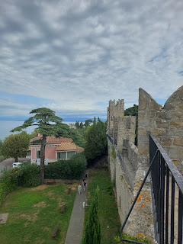

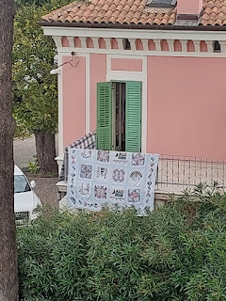

While the mother was watering the plants in their courtyard garden, her young son rode around on his scooter, chattering away to her. Their huge black dog (that looked as thick and bear-ish as it looked intimidating) trotted around, happily keeping up with the boy. Just a typical weekday morning for this Slovenian family . . .

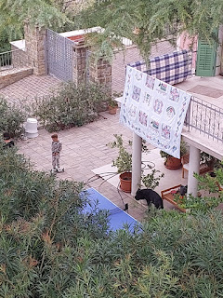

At the top of one of the many towers that you can climb up to (and we summited each one), there is a sort of compass. It was very helpful to note where other cities are - according to where you were currently standing. Below: my feet are pointed toward Venice . . .

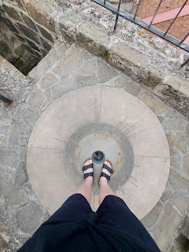

In the photo below, picture the scene as a clock face. Venice would be across the Adriatic Sea in the 9-10:00 position.

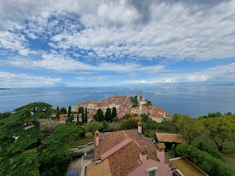

Looking north toward Trieste, Italy . . .

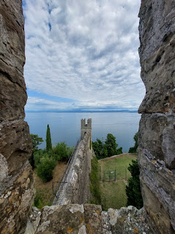

To the east of the tower walls is a huge sports complex, where several young people were doing soccer drills.

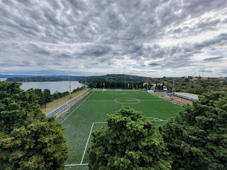

At the northernmost tip of the medieval wall, I paused to notice the huge property that belongs to that family in the salmon-pink house. They have a large grove of trees (fruit trees, nut trees, and olive trees) that ends where the cliffs begin, with a sheer drop-off into the waters below. Lest you worry, they do have a wall at the edge of their property, ha ha.

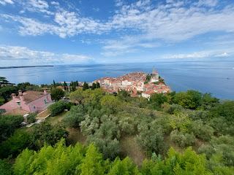

Video of the sweeping views that include the whole peninsula of Piran: (35 seconds)
https://photos.app.goo.gl/zUiv6HR65SDYReuP6

Video of one of the handful of swimmers down below: (10 seconds) *Note the many shades of the beautiful water.
https://photos.app.goo.gl/JwFaW45nzqByC7tt7

As we exited the tower walls, there was a trending sticker attack sign, where if you happen to have a funny or identifying sticker with you, this would be the place to slap it on. (click photo to enlarge) My favorite was the little baby chick that says, "I am not a nugget".

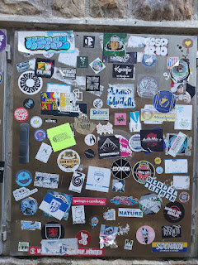

Next, we decided to make our way down to the main square so we could find some food. In one of the alleys that we walked down for quite a ways, we found ourselves having to squeeze through a huddle of young adults (maybe 17-19 years old). Several of them were smoking, and unfortunately they had zero awareness of how they were hogging the entire path. I gulped a last-ditch breath of "fresh" air before plowing through the smoke-filled zone. One of the boys blew out a big breath of cigarette smoke just as I was about to walk past him. I instinctively began waving my hand in front of my face to try to dispel some of it, which must have incited him. Next thing I knew, he made it a point to blow several breaths directly at me! I thought it was pretty rude and I was rattled for a bit afterwards. I've never encountered anyone that blatantly rude in any of the places I've traveled throughout Europe. He was just being a punk teenager at the time, and maybe he'll still grow up to become someone that is thoughtful and kind.

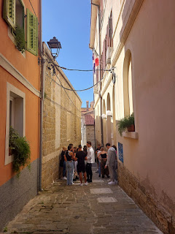

Shortly thereafter, we passed by an unexpected church in this same alleyway. It is called (in English), "The Church of Our Lady of the Snows". While you may click the photo below to read the translation of the sign outside the church entrance, it doesn't explain how it got its name. Online, I found a more succinct explanation: "This small church from the 15th century was built as a private chapel for a rich lady from Piran. Above the entrance, there is a painting of Our Lady of the Snows, which depicts the miraculous August snowfall in Rome, and thus gives the church its name."



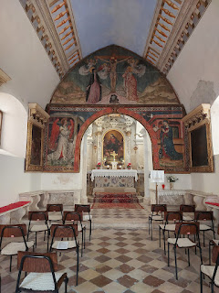

Almost there . . . after we passed through that arched tunnel in the photo below, we reached the shops that surround the large Tartini Square.

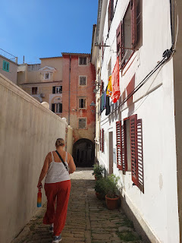

We found a great cafe to order some brunch. I ordered an omelet with grilled vegetables. It said on the menu that it comes with "bread", but oh my goodness, I didn't know the whole omelet would be stuffed into a ginormous hoagie roll, ha ha. I scooped all the innards out of the bread and then I focused on eating everything except for the bread. It was very satisfying.

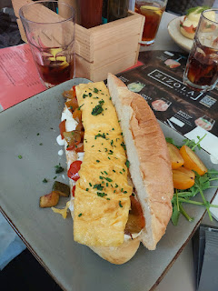

While this wasn't our menu, it had some interesting offerings and was one restaurant over from ours.
(click to enlarge and read)

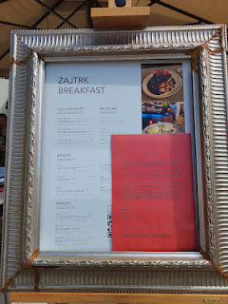

Tartini Square was named for the violinist and composer, Giuseppe Tartini, who was born in Piran in 1692. He traveled a lot and studied in Padova (Italy), before settling in Ancona (on the central eastern coast of Italy) for a time. (We'll be visiting Ancona in a few weeks while on a big loop that will include the Rome Temple.)

A fun fact that I learned on Wikipedia about Tartini:

"Tartini was the first known owner of a violin made by
Antonio Stradivari
in 1715, which Tartini bestowed upon his student Salvini, who in turn gave it to the
Polish
composer
and virtuoso
violinist
Karol Lipiński
upon hearing him perform: the instrument is thus known as the
Lipinski Stradivarius
. Tartini also owned and played the Antonio Stradivarius violin ex-Vogelweith from 1711."

He died of gangrene in 1770 while living in Padova (close to Vicenza).

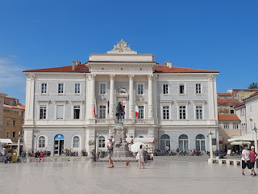

Here is the handsome statue of Giuseppe Tartini in Piran, Slovenia . . .

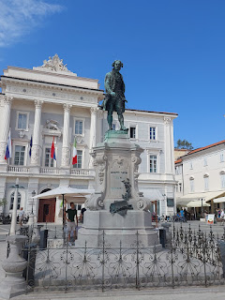

Charmaine and Scott in Tartini Square . . .

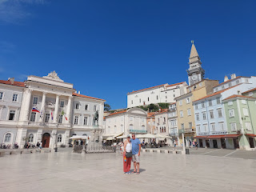

A handful of vendors were set up around the perimeter of the square, and I enjoyed investigating their offerings.

Short video of the square: (6 seconds)
https://photos.app.goo.gl/a15yK2z4myZhCfSV6

I ended up buying a few spices from this man.

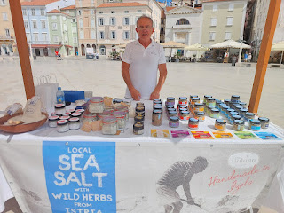

An interesting statue . . . what would you say the meaning is?

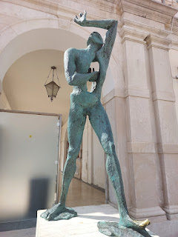

The Old Inner Harbor - as it once looked . . .

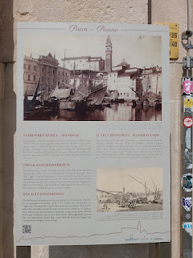

The history behind it is explained here . . .

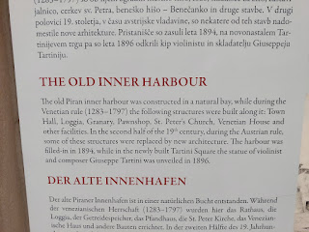

The harbour sits within view of Tartini Square, just a few steps away.

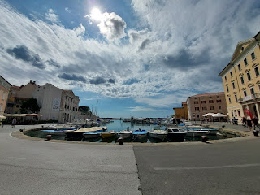

Charmaine, with the Old Harbour behind her . . .

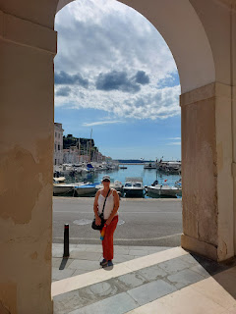

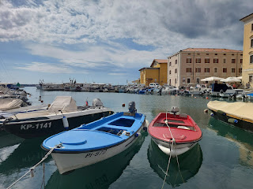

The cutest little car drove by, with a license plate that said "1 Love" - a nod to Bob Marley and his song, "One Love".

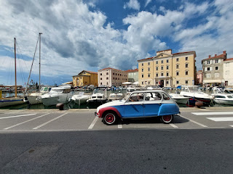

And this little tugboat reminded both Charmaine and me of a children's story we used to read when we were young, "Scuffy the Tugboat." I thought the boat was yellow and blue in my foggy memory of the book, but when I looked it up, the boat was RED and BLUE . . .??!! Oh well. It still made us think of Scuffy, bless his little heart.

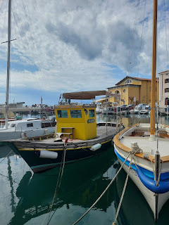

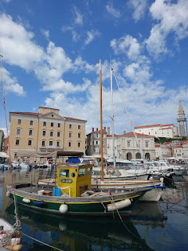

Our last big push in Piran was to get back up the steep path in order to see St. George's Church, which overlooks the old town below.

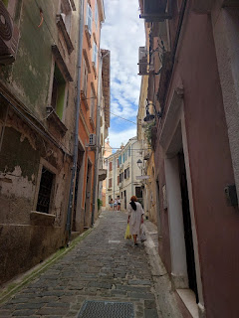

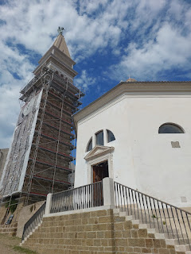

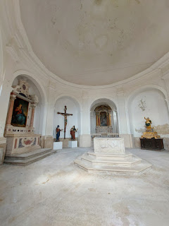

This is the church that we saw in the distance when we first got to Piran and climbed up onto those medieval walls. Check out that video here: (7 seconds)
https://photos.app.goo.gl/6WaxmD81AMnbVKiF8

A lady was just setting up her harp as we were about to walk by. We waited to hear her play, and then I gave her a couple of coins and thanked her. To my surprise, she spoke perfect English and thanked ME in return. It kind of sounded like she was American, but I couldn't engage her in conversation because she was a little busy, ha ha.

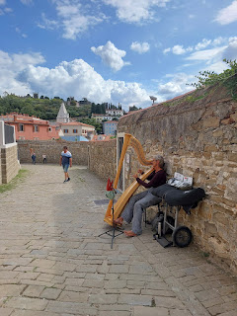

Video of her playing some lovely harp music: (17 seconds)
https://photos.app.goo.gl/1xbPjpKb9zquX3556

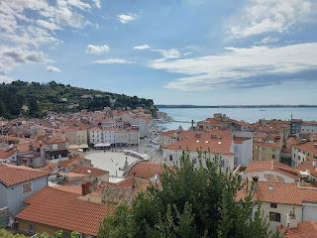

Views from St. George's Church . . .

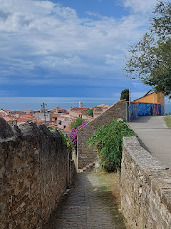

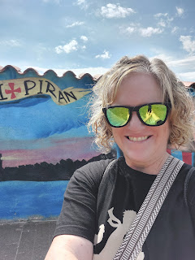

The locals make good use of anything that could become a makeshift beach, including limestone slabs, crumbly rocks, and what looks like a small parking lot. I had seen several people carrying long padded cushions that folded up for transport, and now I understood why. You can lay it out on just about any surface and voila - you can sunbathe in relative comfort.

This is one of those "beaches" down below the church and at the westernmost tip of the peninsula . . .

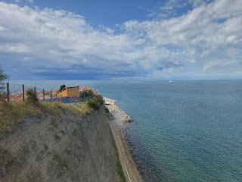

Gosh, the water was beautiful. So was the sky, with those wispy clouds that stretched on and on . . .

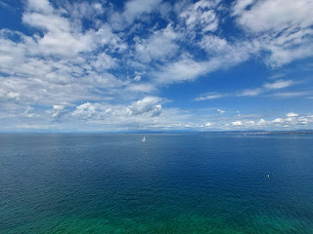

I definitely want to come back to see a little bit more of these places with Scott before we are done on this side of the world.

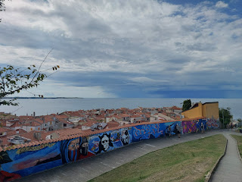

We weren't allowed to go inside St. George's Church, but we could stand in a little doorway to look.

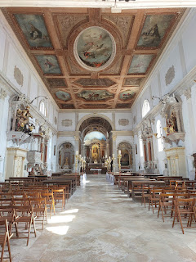

Yes, Piran has some beautiful offerings, along with a big basket full of history to explore and learn about. Cooler weather would be the best time of year to visit for all the walking you'll surely do. But also . . . warmer weather would be a nice compliment to the teal and turquoise waters that are calling out for you to jump on in . . .

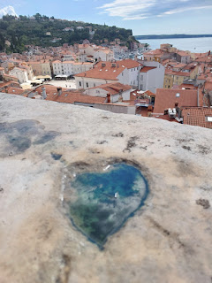

Goodbye for now, Piran . . . and I hope I'll be back again . . .

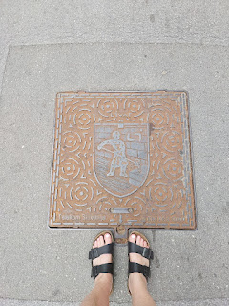

After almost 48 hours of being away from Scott, when we did get home later that evening and had eaten a light supper, he happily came on a walk with me down the street so I could get some gelato at my favorite place: Vaniglia. We walked and talked and I was able to share some of our adventures with him. XOXO

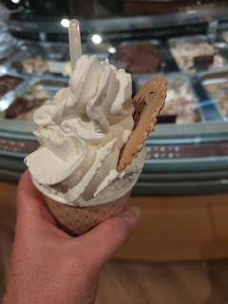

Meanwhile, he had gotten our white car all fixed up while the rest of us were playing in Croatia and Slovenia with the red car. We are looking forward to Round Two this weekend as we take our friends, Rich and Andrea, up into the Dolomites and try one more time to visit Cortina d'Ampezzo and the Cinque Torri hike.

The next post might be a little later than usual, but I'll do my best . . .

