Movers-R-Us & A New Year's Reset
Whether I was ready for it or not, 2023 came to a close and now we're jumping right into 2024. It has been busy these last few weeks, starting with the first few days after I landed in Idaho Falls on December 15th. I came home sick, and then the very day that I began to feel better is also when company started to arrive. We had 9 people here through Christmas and then all went quiet for a minute before another round of company came in.

Somewhere in the middle of it all, I was able to get Christmas all put away and also get the house sparkly clean. Benson came home to spend another week with me, and a friend from Vicenza spent 2 days with me until she got moved into her apartment for a new college semester that begins tomorrow (Monday).

I'll jump back a week in time and work my way up to "now".

Wednesday, Dec. 27th:
Amber and Weston left me in charge of Abby and Gwen while they drove down south to Lava Hot Springs for a 10th Anniversary getaway. Abby really wanted to eat at IHOP so we decided to walk there. It's about 6/10 of a mile from my house and I thought it would be good exercise. (Also, I was without a car because Benson had my car in Mountain Home again and A &W took their car to go on their special date.)

We left around 5:00 p.m. and the girls did great up until the last 1/10 of a mile or so. If we didn't have that brutal arctic breeze from the north, we would have been fine. Gwen was getting distressed because her face was so cold, even though she had a hat + earmuffs + her hood was up. Poor thing . . . I just kept encouraging her, pointing to the stoplight and intersection ahead of us, and reassuring her that IHOP was right up there next to the stoplight.

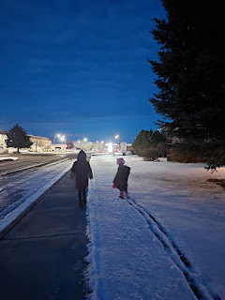

Thankfully, we made it to the restaurant all in one piece. They were very short-staffed, with only 2 visible chefs in the kitchen and one girl doing everything else (greeting, seating, taking orders, delivering orders, cleaning the tables, etc.) She gave Abby and Gwen some fun placemats with dot-to-dots, word searches, and other games. We had fun working on those while we waited. Abby even wrote and illustrated a short story! (click photo to enlarge)

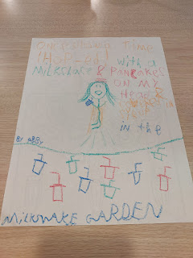

"Once upon a time, I-HOP'd! With a milkshake and pancakes on my head and covered in syrup in the milkshake garden." ~ Abby

Gwen ordered purple pancakes with sausage and a huge dollop of whipped cream that she ate as soon as she could grab a spoon to gobble it up.

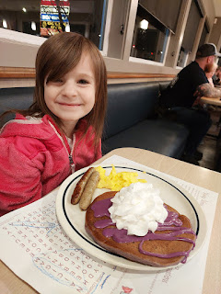

Abby ordered French Toast and fruit to dip into a little cup of chocolate syrup. She was in heaven, ha ha.

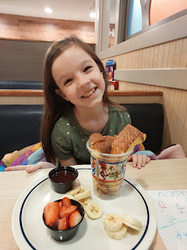

I ordered a yummy omelet with all the veggies and a few meats inside. We had a good time and we all enjoyed our dinner. I decided to reach out to Kim, my neighbor, to see if she could possibly pick us up after our meal was done. I had intended to take the girls across the street first, to the mall, so we could find some warmer socks for Gwen. But Kim insisted on picking us up at the restaurant and taking us to the mall so we didn't have to be out in the cold anymore. We didn't protest, ha ha.

We found some long, warm socks for Gwen - - - in the boys section. They didn't have any in her size in the girls section, so I had to convince her that it was okay to get some white/grey/black socks instead.

Once we got home, and after some play time, Gwen had a meltdown as she was helping to clean up the Lincoln Logs with Abby. I think it was a combination of the cold walk to eat our dinner, then a trip to the mall - plus settling for socks that weren't her first choice, plus just some general over-stimulation at the back end of the day. She is a little more sensitive in that department.

What I did to help her through her rage and tears was to first let her have a few minutes by herself to calm down. When she came back into the living room, I asked her how I could help. She agreed to let me hold her and snuggle with her. I chatted with her and tried to let her know that everything was okay. She mentioned that she wished her brother (Jonny) was there to help her. I explained that maybe he actually was there (in spirit). She looked at me with a confused expression, like how could that even be possible?

I shared with her that I have had many experiences where my deceased ancestors (mainly my Grandma Zoe) have come to comfort me at various times in my life. I told her that sometimes my Grandma Zoe just comes to "sit with me", not necessarily to comfort me, but to just hang out with me. This led to me telling her about a time when I was working on Abby & Gwen's second "Quiet Book", which included lots of needlework and intricate efforts. Early on a Saturday morning, as I sat at the kitchen table, quietly sewing words onto a page for the book, suddenly I felt like my Grandma Zoe came and sat down in the chair next to me. I felt of her calming presence and instinctively knew that she was pleased with what I was working on and that it made her happy to see me working on something for my granddaughters. She, herself, had made several dolls and other craftsy items for her grandchildren over many decades. She stayed with me for a long, long time, and it was very comforting - even though I didn't need to be comforted at that time.

This led to us getting out the treasure chest of dolls that I have previously shared with Abby, dolls that my Grandma Zoe made. They enjoyed seeing each doll as we gently lifted them out from the chest, one by one. Soon, Gwen was much more calm and ready to get into pajamas and go to bed. It was a remarkable experience, to go from a screaming and enraged Gwen, to a calm and more centered Gwen.

Thursday, Dec. 28th:
We worked on a craft project together for the morning, making homemade Christmas ornaments that they could take home with them.

Gwen was really excited when I showed her a picture of a Pikachu ornament that she could make. She showed me the correct shape of Pikachu's ears by using her finger, and then I drew the ears on some yellow craft foam. She then colored the tips of the ears with a black permanent marker.
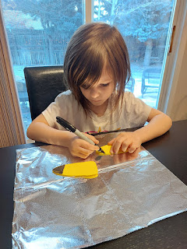

Next, we used a paint pen to add some eyes and a few other facial features.

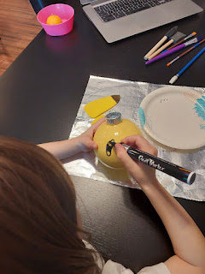

I forgot to get a picture of Gwen with her ornaments before they packed up to leave, so I had to wait until Amber could find them again in Louisiana once they got home a few days later. Gwen is holding her Pikachu ornament and an "I-Spy" ornament ball with a Pokemon Masterball symbol on the front (to distinguish hers from Abby's).

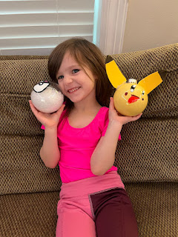

Abby wanted to do an "I-Spy" ornament ball, too. First, we experimented with a little bag of tiny foam balls, but that didn't work very well. They had too much static inside the ornament and we couldn't see any of the I-Spy items. So we dumped those out (which made a mess everywhere, ha ha) and used a little bag of decorative fake snow instead. This worked much better, with a lot less mess.

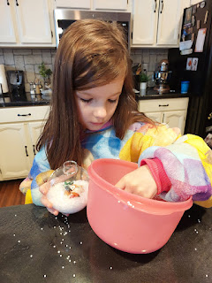

Once we got the fake snow inside each ball, the girls added some tiny little items that I had found in the dollhouse section of Hobby Lobby. Tiny little lollipops, fruits and veggies, a tiny little hairstyling set that included a teensy weensy comb, as well as a mirror and a hairdryer, and they also added in a few tiny little people, too.

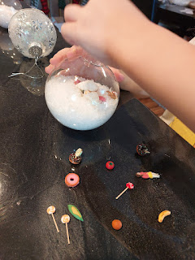

For Abby's second ornament ball, she decorated the outside with a variety of snowflake stickers that I also bought at Hobby Lobby, adding some finishing touches with long slender strips of silvery ribbon trimwork that had adhesive on the back. For the interior of the ball, we added maybe a tablespoon of Mop & Glo (a floor cleaner/polisher). It was extremely liquidy, something I didn't expect when I poured some in . . . I may or may not have poured a little too much . . . Anywho, next you pour in some glitter (we chose iridescent white) and swirl/gently shake it all around (with the ornament "cap" back on!) until it coats the inside. The extra liquid and glitter form a few clumps, which you can just dump out. It makes the inside of the ball really pretty!

Abby with her two ornaments . . .

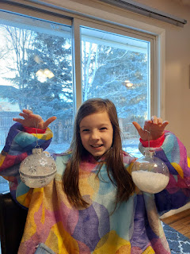

Later that afternoon, Amber and I took the girls sledding at the "Pit" around the corner from our house. Gwen didn't last very long, though. I think she was beginning to get a sense of what being truly prepared for the cold really means. We had both encouraged her to get waterproof gloves and snowpants on, but she didn't want to. Before Amber took her home, Gwen did have a little bit of fun first, though. :)

Gwen (on the left) and Abby . . .

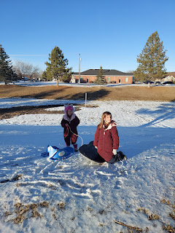

Video of Gwen going down the hill (with my boot giving her a shove, ha ha): (6 seconds)
https://photos.app.goo.gl/zogrG41GvBrNwUJJ7

Video of Abby going down the hill all by herself: (17 seconds)
https://photos.app.goo.gl/W3B9yzCcsbdkqQcW7

Video of Abby sledding in a new and steeper spot: (9 seconds)
https://photos.app.goo.gl/7EJme4HBrcKVoJMr6

Video of me going down the hill - with Abby as the videographer: (13 seconds)
https://photos.app.goo.gl/ZnTtCmV9CEgZfZEv7

Video of Abby in a new spot - "That was farther than anyone!" We were noting other sledders' tracks and if she passed their lines, we declared it a new record.
(14 seconds)
https://photos.app.goo.gl/7KTpGywhVWMc6zn3A

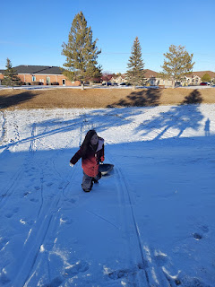

We had a really fun time, Abby and me. She would still be out there sledding today if I hadn't talked her into going home as the sun was setting . . .

We also had fun taking selfies together . . .

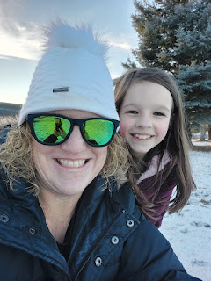

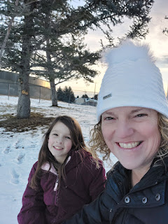

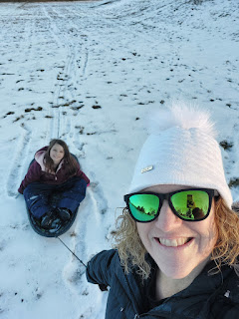

Friday, Dec. 29th:
We organized all their personal belongings scattered around the house, played some games, and then the Whitworths spent the last half of the day up in Rigby with Weston's family.

Saturday, Dec. 30th:
We all woke up pretty early so that Amber and her family could get out the door. They decided to drive back to Louisiana in TWO days instead of the usual THREE. Thankfully, Weston would be traveling with Amber this time, which meant that there would be two drivers to share the responsibilities.

My job was to wake the girls up and encourage them to eat a little something before they hit the road. Poor Abby was pretty sleepy at 6:30 a.m.
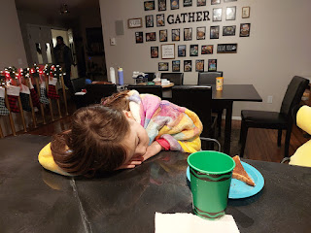

Gwen woke up in a very good mood and ate all her scrambled eggs.

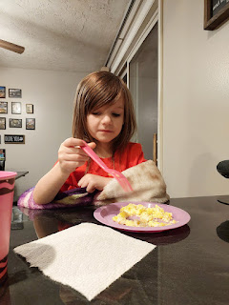

By 7:30 a.m. they were all loaded up and ready to go.

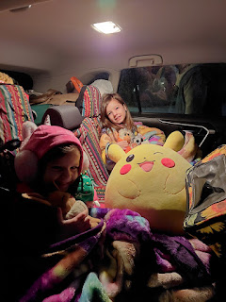

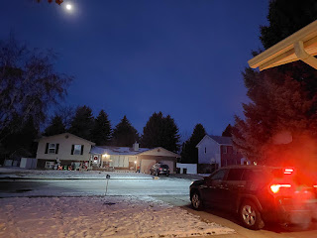

The sun wasn't even awake yet as they drove off . . . and the moon was still visible up in the sky. They drove 13 hours that day to Lamar, Colorado. Everyone did amazingly well. I'm sure it helped that the girls are older now, too. They drove 12 hours on Sunday to arrive safely home that evening.

Benson arrived later that same afternoon after working the past several days. He would end up spending an entire week with me, which I enjoyed to the fullest.

Benson and I tried a new dinner that night and we both loved it! It's basically burrito/taco fixings on top of an open-faced sweet potato. He loved it so much that he wants to put this in his rotation of favorite meals.

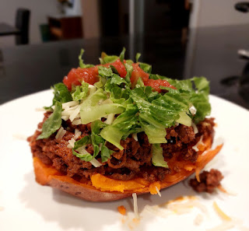

Sunday, Dec. 31st:
New Year's EVE!!! I went to church in the morning and my friend, Jen Anderson, invited us to dinner that evening. Benson and I enjoyed their company and after dinner, we played "Dead Grandma" (Amber was the illustrator for the card game) with all of the Andersons. We had a great time!!

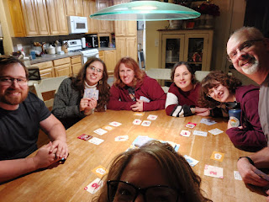

Scott's niece, Hunter Jackson Franco, posted a beautiful and wise quote around this same time, heading into the New Year. (Click to enlarge)



Monday, Jan. 1st:
Happy New Year!! I took down all of the Christmas decorations that had adorned my home since AUGUST. It felt really good to get everything clean and tidy and back in its place. It took me most of the day to get it all done.

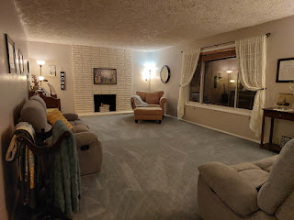

We tried another new dinner that night: Cheesy Ground Beef & Cauliflower Casserole.
https://www.eatingwell.com/recipe/7919044/cheesy-ground-beef-cauliflower-casserole/

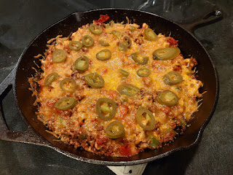

It was quite yummy. The recipe suggests to eat it with sour cream and tortilla chips, which we did.

Tuesday, Jan. 2nd:
I drove to the Hally's house to help them with some family history. Tom Hally has served on the Idaho Falls City Council for 20 years and will be retiring this next week. I thought it would only take me about an hour, but I ended up helping him and his wife, Judy, for about 2 hours. But it was time well spent!

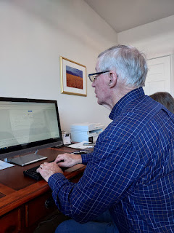

One of the resident squirrels in my back yard found a frozen croissant (where did it even come from?!?) and went to town on it. The neighborhood magpies were pretty jealous and made some attempts to scare him away, but none of their attempts worked.

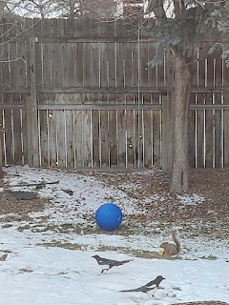

My friend back in Italy, Rachel McGovern, was interested in this foldout pamphlet that I've had for many years. It had come up in a recent conversation and I had promised to share it with her once I got home to Idaho and could locate it. I thought I would share it here, too, because it is VERY interesting.



It's essentially a chart with 10 Christian religions across the top, including The Church of Jesus Christ of Latter-day Saints (nicknamed "Mormons"). It also includes Methodist, Lutheran, Catholic, etc. Down the lefthand side are 23 religious topics. This is a helpful chart to show what each church believes and what their doctrines are, as stated in various curriculum materials and other sacred books that they have published.

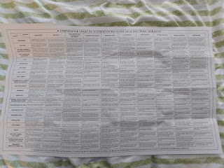

The chart above would be hard to read, even when zooming in, so I took 3 closer photos, which will enlarge much better for you, the reader. (click to enlarge)

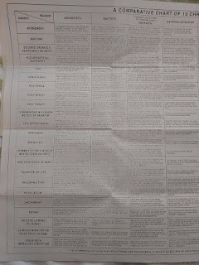





What I have enjoyed most about this chart is how it helps me to understand what other Christian viewpoints are and where the common ground is.

Benson spent his days off with getting caught up on sleep, hanging out with me, trying new foods with me, working on his car, and helping me with some manual labor. When my neighbor, Kim, mentioned that snow was on its way, Benson and I got some extra wood ready for future use in the wood stove downstairs. I wheelbarrowed the wood over to him, and then he did all the chopping. He also sharpened the axe for me. What a good boy. :)

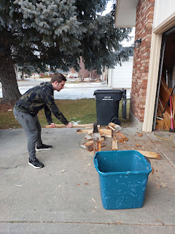

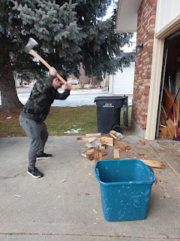

Wednesday, Jan. 3rd:
I put fresh bedding on all the beds downstairs (after all the partying through Christmas), cleaned 3 bathrooms, dusted, vacuumed, went to the grocery store, got some supplies at JoAnn Fabrics for a craftsy project coming up, got the oil changed in the car, and made a tasty soup for dinner.

Rachel McGovern's daughter, Emily, flew in around 9:00 p.m. that night (from Italy) to stay with me for a couple days before starting a new college semester at BYU-Idaho in Rexburg. I picked her up from the airport here in town and got her all settled in for a good night of sleep after her long travels.

Thursday, Jan. 4th:
I laid out my new felt, flannel and fleece supplies to get a feel as to how I will put this special project together in the coming weeks. I will be making a construction zone playmat for Jack's birthday in April. I'll post some updates as it begins to take shape soon . . .

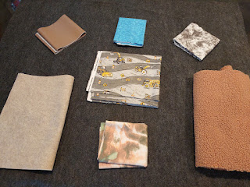

Emily is a very skilled musician. She plays the violin and the piano, and possibly other instruments, too. I was thrilled when she sat down at my piano to fill the house with beautiful music. I sneakily got a video of one of the many songs she played - it just happened to be during a vigorous part of the piece, but it had been building up to this point for a while with other peaceful sections, too.

Sneaky video: (20 seconds)
https://photos.app.goo.gl/uqRQ4VTPG72vEg1L6

I drove Emily up to Rexburg in the afternoon so she could get the keys to her apartment from the manager. One of her roommates was already there, a very chatty young lady named Dillon from the Boise area. Emily is a sophomore as far as school goes, but she will also be turning 21 this coming week. She spent the past 1.5 years working in Italy and spending time with her family, but also getting some medical conditions taken care of.

Dillon showed us a really clever beanbag idea that she put together. Apparently, she is an avid collector of squishmallows (squishy pillows that look like super cute stuffed animals, fruits, or other unique shapes). The idea that she shared is that she bought a beanbag cover from Amazon - hers was corduroy - and then she filled it up with all the squishmallows instead of styrofoam balls. Wow - what a genius idea!! I took a sneaky picture as she and Emily attempted to squish all the squishmallows back inside the corduroy cover.

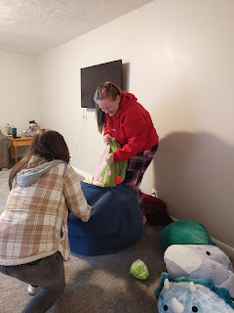

Friday, Jan. 5th:
Move-in day for Emily. I spent most of the day making runs up to Rexburg and getting her all situated. I was hoping that Benson could come with us, but he had some important things to take care of relating to his car. (more on that in a minute) He was good about helping us load things up, though. I took one carload up to Rexburg in the morning, which Emily and I carried up the THREE flights of stairs to her new apartment. When I realized that her remaining items (that have been in my basement since July) would be
at least
2 more carloads, I got permission to borrow my father-in-law's truck to be more efficient. So, on our way back from the first carload, we swapped out my car for his truck in Rigby and drove back to my house to load it up.

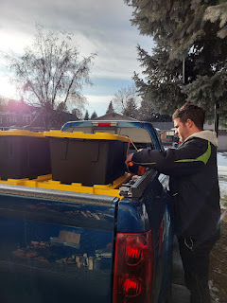

I didn't realize that this would be the beginning of a very physically exhausting weekend.

Emily and I teamed up very nicely, hauling up all those heavy totes to the third floor, one at a time. It was cold and icy, too, so we had to be careful in some areas. But we did it!!

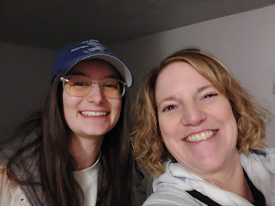

After we delivered all of her things, I took her to Walmart to get groceries and other essentials before we hugged goodbye for a few days. She is a sweet girl and is a real go-getter. The whole time she was at my house, she wanted to help in any way she could. (putting leftovers into tupperwares, loading up the dishwasher, shoveling snow with me, etc.)

I got home pretty late that evening, after stopping off in Rigby for a visit with Phil and Vernetta before driving my own car back home. Benson, meanwhile, had had a pretty rough afternoon.

He got the front bumper back on his car okay, and went to grab some food at Wendy's before getting his car insured and registered. He had put in a new battery the night before and was eager to take it for a spin. But while he was out getting his food, he noted that the car didn't sound good at all. He gently brought it home, about a mile from Wendy's to the house, and did some checking to see if his theory was correct. Unfortunately, he was right. Coolant had somehow made its way into the engine . . . I didn't know this at first, but it also means that the engine is now toast. He thinks a gasket blew, which then caused the mishap.

We talked about many options, which also included getting a different car. He has put so much into this car, and with the love that he has for cars in general, he is not quick to just give up and get rid of it. He researched the cost of a new engine and it will be about $2,000. Hopefully he will be able to take care of it once he gets his tax return.

The bigger problem was how to get him back to Mountain Home this weekend so he could go back to work. After much brainstorming, we pulled a Hail Mary. We decided to rent a U-haul truck and trailer to haul his car over to Mountain Home, along with a mattress and dining table that he needed, too.

I left several messages for Scott on Whatsapp before I went to bed, so he could be brought up to speed on what was going on. I definitely wanted his insights and opinions on such a big idea as this. Darn that 8-hour time difference, though! I checked my phone in the middle of the night when I got up to use the bathroom, and thankfully he had not only responded, but he also approved of our crazy idea.

By 7:30 a.m. Saturday morning, the plan was set and in motion.

Saturday, Jan. 6th:
Benson and I drove across town to pick up the truck & trailer by 8:30 a.m. I left my car there so I'd have a ride home at the end of the day. Benson drove us back to the house, which I was grateful for, knowing that he has some great automotive skills and could maneuver the trailer well, when needed.

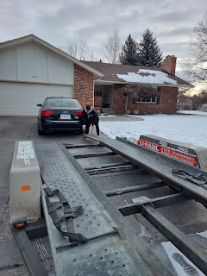

With me guiding him, he drove the car onto the towing trailer on the first try. He decided to back it on because he was worried about the low front bumper not fitting nicely if he had loaded it up facing the other way.

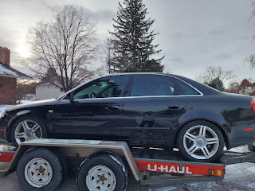

But then, because he had it facing backwards, he couldn't get out the driver's side door . . . LOL. He had to climb into the back seat to get out.

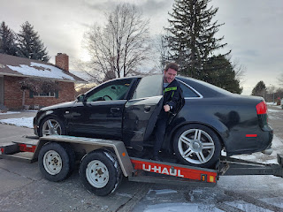

We filled up his car with all his clothes and other belongings, got the mattress and table into the truck bed, and then we were off.

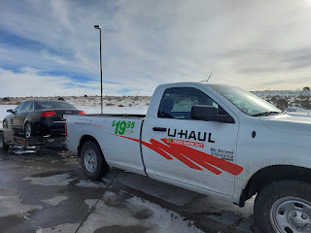

It was VERY windy during the first half of our drive. When we stopped for a potty break near American Falls, the icy wind was FRIGID!!! As we made our way back out to the truck, the wind was trying to blow us away . . .

Video of the nasty biting wind: (10 seconds)
https://photos.app.goo.gl/Sw1fMYd1X3J9B3n98

Video of some of the blowing and drifting snow on I-84: (4 seconds)
https://photos.app.goo.gl/naKuwxi1uWuYdymF6

We had fun on the drive, listening to music, eating snackies, and chatting about this or that.

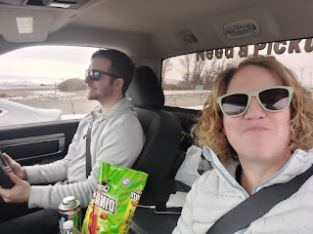

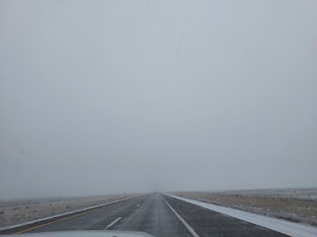

As we got closer to Mountain Home, the snow had begun. I was worried about getting home . . .

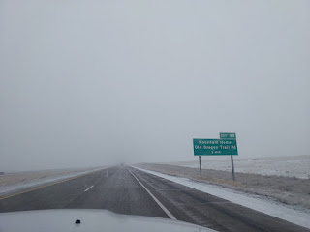

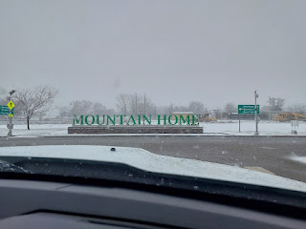

An F-15 jet in a spacious park on the Air Force Base near Benson's house.

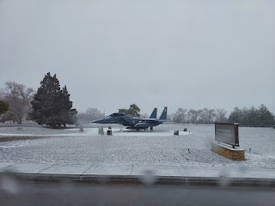

Benson's new home . . . in a very handsome neighborhood. I loved how clean and tidy everything was.

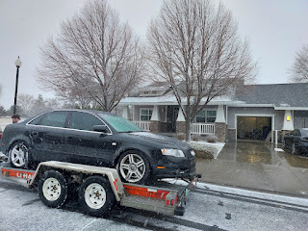

We got the mattress and dining table out of the snow and into the house very first thing after we arrived. We ate "linner" together and I got a tour of his place before we unloaded the car and got it into his driveway.

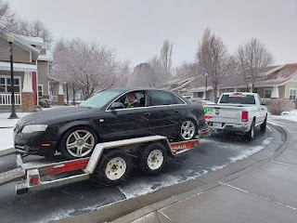

Now, it was time for me to drive 200 miles home by myself in a snowstorm, and pulling a trailer for the very first time. We had already said more than one prayer together, and I knew Scott was praying fervently for me, too. It was time to apply my faith.

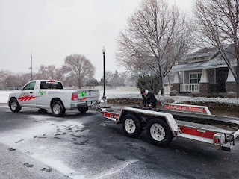

Well, the first hour of driving was pretty nasty. Ice, snow and slush covered the roads for a really long time. I was pretty nervous about all the what-ifs that could happen, which led to my having to do some deep and mindful breathing that whole time to avoid a panic attack. My chest hurt from the anxiety and my heart was beating vigorously and rapidly that whole time, too. But I breathed lots of deep breaths, which helped to keep me relatively calm (slowly in through the nose and slowly out through the mouth), and I also occasionally sang out loud to a few songs that came on the radio.

After that first hour, the roads began to change to just being wet with precipitation, which was much better than being coated with ice and snow. My anxiety began to let up and I could relax more and just enjoy the drive. Eventually, the roads became more dry as I got closer to home.

I only made one stop at a rest stop to use the bathroom and to get out and stretch a little before tackling the last 1 hour and 15 minutes. I arrived in good time at the U-haul rental facility, where I transfered all my winter gear and snacks back to my car and then I drove home. The entire front end of the truck was encased in solid ice. Even the side mirrors . . .

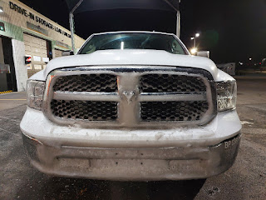

I felt so blessed to have made it home safely. It was such a last-minute plan that we put into motion, but it was a good plan. Benson told me more than once, "I am just so relieved that my car is here now. Thank you so much for helping me!" He has friends there that can help him get around if needed, and the Commissary (grocery store) is across the street from his subdivision on the base. He is within walking distance of the shop where he works, too, so that is super convenient.

I had been giving Scott updates throughout the day, even though I knew that he was 8 hours ahead and should have been sleeping after 1:00 p.m. Idaho time. He was worried about me and prayed many times for my safety. These are some of the texts he sent me throughout the whole experience:

~ Praying hard for you.
~ You are doing great and I am so proud of you.
~ Wow. You are awesome.
~ I love you guys.
~ Angels will watch over you.
~ Be safe.
~ You are my favorite.
~ You are a superstar.
~ I love you.
~ That was a miraculous trip. Nice work.

I love him so much. He supported our crazy and impulsive idea, funded it, and prayed for our safety and well-being. What a good man.

Sunday, Jan. 7th:
I woke up to a winter wonderland outside. I struggled to get out of bed to do the inevitable snow removal. I would have much prefered to just stay in bed for a while longer. However, I convinced myself to get up and do what needed to be done.

The snow was deep outside, about 3 inches, but was completely comprised of FLUFF, which made it difficult to achieve much success with a snow shovel. It just poofs off to the side of the shovel and you have to do a lot more work to clear one run. I was on the phone with Scott while I started shoveling (using ear buds so I could be hands free), and he suggested that I get the snow blower out and start it up while he was on the phone with me (in case I had any problems). So I did. I got it started and told him I would call him back later because it was so loud, ha ha.

I proceeded to clear all the snow for 3 houses: driveways, sidewalks, etc. It definitely went much faster with the snow blower, so I was glad that he had suggested it.



I showered, got ready for church (gotta love the significant volume my hair gets after I use the blowdryer), enjoyed the services at church, and came home to shovel another round of snow. This time it was only about 2 inches' worth. Ben Parkinson came over to help me finish up with Ellen's driveway next door.

Man. What a rigorous weekend!! Moving heavy boxes and items up 3 flights of stairs, about 15 loads in all. An intense 4-hour drive to Mountain Home and then 4 hours back all in one day. Then lots and lots of snow removal. I'm really looking forward to my massage appointment Monday morning . . .

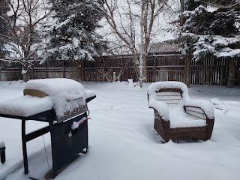

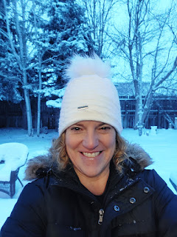

It truly WAS a miracle that we got Benson's car across the state safely on Saturday. I can't even imagine what it would be like if we had done it today, or even Monday, after all that snow. Wow.

A few more things to catch up on . . .

Scott
has been working on a few things recently. He's been making some instructional YouTube videos to teach some mathematical processes that are inside his brilliant brain. If you're curious about what he's working on, you can look him up on YouTube under the name K. Scott Harmon.

Here is a link to his YouTube page:
https://www.youtube.com/@MrHarmonk

He's also been getting acquainted with and learning to love the gift that my mother and I gave him for Christmas. It's a crazy new version of the Rubiks Cube. Here, see for yourself . . . he is usually playing with it whenever we have our daily video calls.

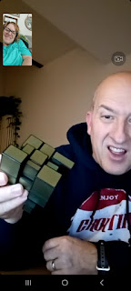



Some screenshots from recent conversations where he's explaining some brilliant, but foreign, ideas to me. These are programs that he builds in his spare time, people. Dang.

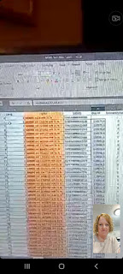

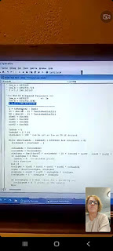

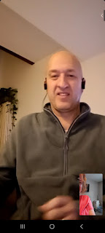

More Rubiks cube work . . .

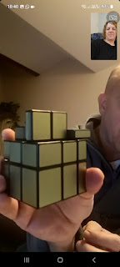

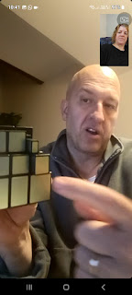

I love this guy so much.

Jack
has been having lots of fun, as usual, lately, too.

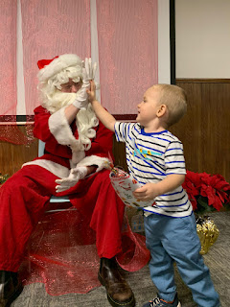

Back in Minneapolis . . .

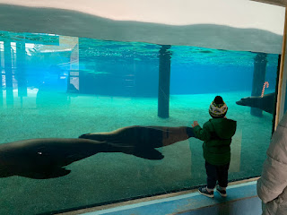

In Scipio, Utah, after Christmas, and enjoying the ranch where Hannah's mom and step-dad live.

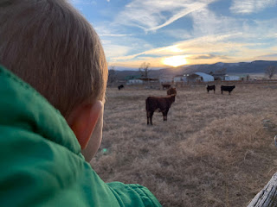

Here's a hilarious video that Jacob sent this weekend, where Jack is practicing his hockey skills.
"It went pretty far . . ." (25 seconds)
https://photos.app.goo.gl/3MXb45MreEAtunTNA

Abby and Gwen
were sad to leave the snowy north, but they were happy to be home, too.

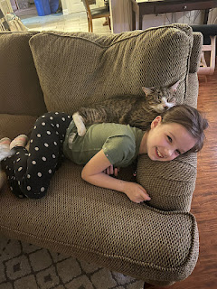

On a recent hike with friends - - Abby is in the center right, with Gwen front and center in hot pink. :)

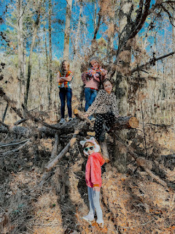

And Chelsea has been working on digitizing some childhood photos that her mom brought down from Nebraska during the holidays. She is excited to get them ready to share with me and her birth father, Doug, as soon as she can. She texted me one of the cute photos recently, and commented how her baby picture reminds her of Gwen. I can definitely see that, too! Amber and Chelsea looked so much alike as newborns, so it makes sense that Gwen would share some of the same DNA.

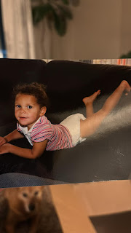

I can't wait to see the rest when they're ready! I missed watching her grow up, so this will be a special and memorable experience for me.

