Overcoming Obstacles and Fears
I got to meet Avery!!!! Hooray and Happy Day!!!! (More details below)
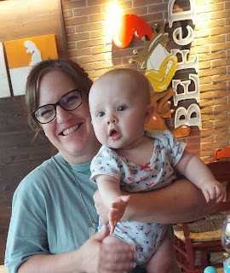

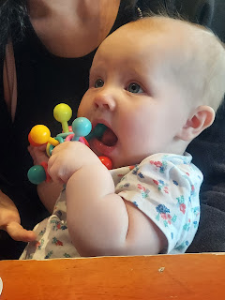

Even though she was tired and is going through the "stranger danger" phase, she let me hold her for about 4 minutes before she was done, ha ha. (I'll take it!!)

As for the title of the blog - - -
You might be thinking, how could Michele possibly have a fear of anything? Last fall, she went paragliding off the Italian Alps for goodness sake. But I realized mid-week that I had a real fear of driving in Italy and it was time to get brave.
Now that our second car is all fixed up, it is available for me to drive. But I've just been letting it sit in the courtyard outside, untouched ever since we drove it to church last Sunday. The mere thought of driving anywhere made me very anxious, and to be completely honest, I didn't like that it made me feel so anxious. I think that all those hours and hours I put into doing the Italy driving tests a few weeks ago really messed with my head (and my confidence), causing me to be ridiculously worried about making even the slightest mistake. So then what? What might happen? Would I wreck the car? Would I get injured? Would I hurt someone else? Would I get thrown in jail? Would Scott be reprimanded for my mistakes? It was just getting too big and too ridiculous in my mind.
After all, I got behind the wheel in England (2018) and started driving on the wrong side of the road with much less anxiety than I've been feeling here. I drove in France. I drove in Germany. No problem! I decided that I needed to be brave enough to get in the car and just go somewhere, it didn't have to be a long drive or a complicated drive, but I needed to do something to look that fear in the eyes and gain some confidence.

On Thursday, I decided to drive to the base and go to the thrift store and the Commissary. It wasn't far to go, and I didn't even need the GPS to get there or to get home afterward. The biggest hurdle for me was getting into the driver's seat and trying to visualize how I would get in and out of the courtyard and parked once my errands were done. It's a little tricky . . .

The alley is very narrow once you exit the courtyard. The gate to get out is also a little complicated. The ONE remote we have for the gate is on its last leg and is partially taken apart. Scott keeps it in his car and has a somewhat successful system of pushing two of the exposed buttons at the same time (and hope that it works). Once the gate is open, you have about 30 seconds until the gate starts to shut again. Sometimes there are other cars trying to squeeze past you in the alley, or bicyclists, or pedestrians, and you might end up waiting for a few minutes before you can actually pull out or back the car in.

When he is at work, he has that one remote in his car, so I can't use it. My plan is much different on how to get out or get back in. I just have to visualize everything before I leave, to be more confident about the success of the whole operation. The format is this: I have a tiny key that will manually open the gate, and then I have to place something in front of the sensor so it won't shut before I'm ready. I cautiously pull out of the courtyard to exit into the tiny alley street, and then I parallel park in front of our gate, hop out and move the object that's blocking the sensor so that the gate will shut. Then I'm ready to go somewhere!

Coming back is similar, but this time I have to back in, otherwise I will have one heck of a time getting out the next time. I parallel park slightly west of the gate - and partly up on the sidewalk so that other cars can squeeze past me if needed - then I hop out and use the tiny key to manually open the gate, prop something in front of the sensor to hold it open, and then wait for an opportunity to back up and into the courtyard without hitting anyone going by, and watch out for those narrow gate posts . . .

I think once I do it more often, it won't feel so complicated. At least, that's my hope.

I was just so proud of myself that I took that first step of driving independently in Italy, and that it was my choice to do so! The other 2 times that I drove the car were when we took the car into the shop and when we picked it up to bring it home. Both times, I felt the obligation to drive it out of necessity, but I also had Scott in front of me and could follow his lead to get where we were going. This was the first time I took the initiative and went somewhere of my own choosing, had some success, and gained some confidence for the next time.

Trying to overcome a fear is
real
. If you add in that I'm a perfectionist by nature, the anxiety level goes up exponentially. I wouldn't say that I have anxiety on a regular basis, and for that I'm grateful. But this was one of those unexpected times that anxiety was trying to get the best of me. Baby steps are important to be able to work through that fear and anxiety. For me, that meant going someplace nearby and not making it too complicated. If I had chosen to drive across town, or over to the IKEA in Padova for my first outing, that would have been too much. However, now that I've looked my fear of driving in the eye, I am less afraid to go on the next outing.

Time to Rewind . . .

Happy Belated Mother's Day! I chose to greatly minimize my time working on this blog and go have some fun with my husband last Sunday. That was my gift to myself. :)

I am infinitely grateful for the mothers and the motherly figures that bless my life so richly, and I am happy that they are all still living and are such an integral part of my life. The qualities of a good woman are endless: loving, nurturing, kindness, charity, a listening ear, healing, friendship, a gentle touch, the power to uplift and encourage, the list goes on and on. The women in my life (my mom, my mother-in-law, my step-mom, my grandmas, my sisters, my daughters, my friends) are such a blessing to me and I love them all so much! I hope everyone had a restful and uplifting mother's day.

I heard from each of my kids, with the kindest of words and compliments that really meant a lot. By late evening, I was able to connect with
almost
everyone that I had intended to . . . it's hard when I'm 8-9 hours ahead of the people I want to call, and then I also have to work around everyone's different church schedules. I ended up running out of hours in the day to connect with everyone, and for that I'm sorry. But I did send cards out to all the mommas - I hope you know that I love you!!

I got some really cute screenshots during my chat with Mom. We talked about a lot of things, and ended up being on the phone for almost an hour. :)

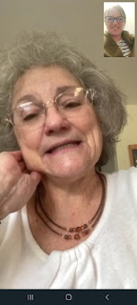

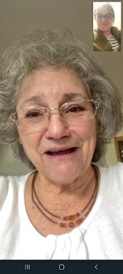

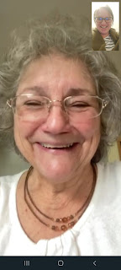

I was also able to chat with Amber after they got home from church in Louisiana. They are only 7 hours behind Italy. We have been trying to figure out a good time for their family to come for a visit to Italy, and I think we landed on a good time frame to work with. They just have so much going on this year, especially with a Whitworth family reunion and a separate Whitworth campout. They will probably just wait until next spring to come see the sights and eat all the pasta that Italy has to offer, ha ha.

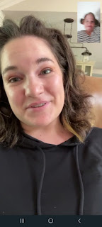

Abby and Gwen wanted to sing the Mother's Day song to me that they sang in church with all the primary children. It was so sweet to hear them sing it just for me. I just love them so much!!

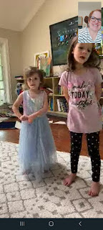

During the afternoon, Scott and I went on an adventure in downtown Vicenza. It was so fun and so beautiful! A friend in the ward had told me about Monte Bareco, a Catholic church that was built on top of a large hill in the center of town back in 1428. Legend has it that the "Blessed Virgin" (Mary) appeared to a peasant worker on that same hill on two separate occasions. The town had been suffering from a terrible plague for 2 years, and the Madonna promised him that if the citizens built a church on the top of the hill, she would rid them of the plague. The church was built in an astonishingly short 3 months!

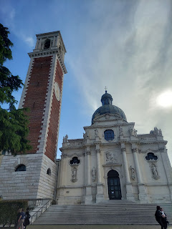

It's something of a landmark, which I will come back to later in this post, but it can literally be seen for miles from several points around the city.

We found a parking place not too far away from our starting point, with a lovely canal and arched bridges along the way.

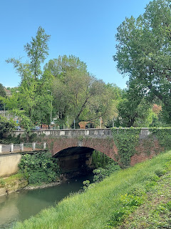

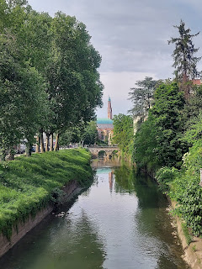

This is the beginning of the staircase heading up to the most magnificent view of the entire valley. If you've got a pair of good eyes, you might find Scott hiding in the picture below.

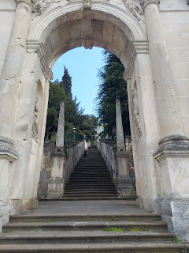

Le Scalette translates as "The ladders"

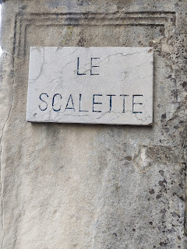

Looking back down from the top

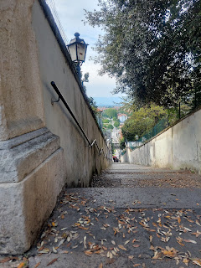

Not sure what this says, and I think it's in Latin. Anyone know Latin out there?

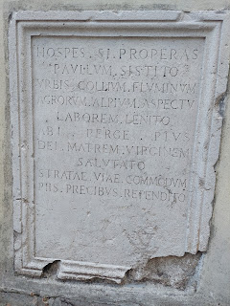

The view from the wall at the top of the stairs. You can see the Dolomites and several mountain ranges off in the distance. Wowza.

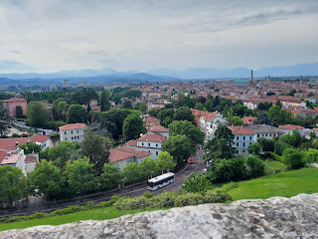

Church bells rang as we continued on up the hill further toward the church itself.
Video: (19 seconds)
https://photos.app.goo.gl/a2UHBTZn4Y4THX9w6

The world's tiniest car across the street from us . . .

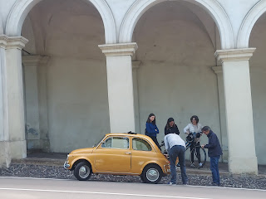

Map of Vicenza

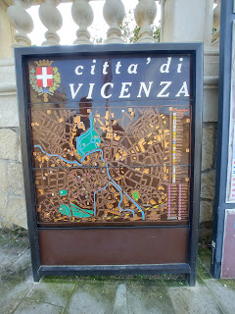

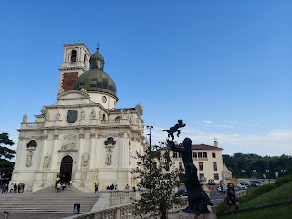

There's a large piazza, or courtyard or square, across from the ginormous church and tower. We had seen the tall Italian flag from below as we made our way up the hill, but didn't know if we would end up at its base or not. Luckily, we did.

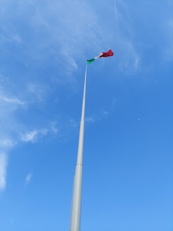

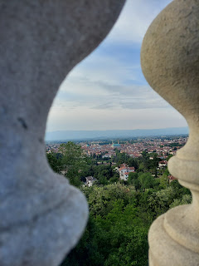

So many mountain ranges to learn about that can be seen from here. I've been to this one before . . .

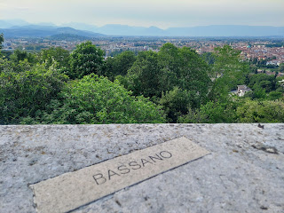

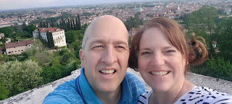

After seeing all that there was to see at the top, we began making our way back down the hill again. This long building has the most beautiful arches - I'm just not sure what the structure actually is.

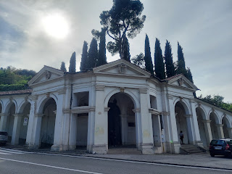

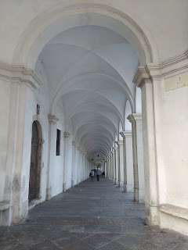

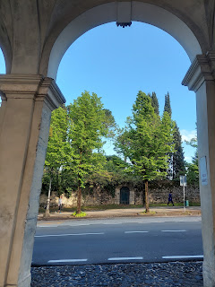

The size of that same car next to Scott . . . LOL

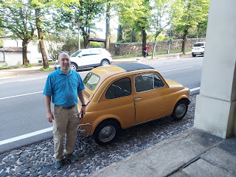

I'm always on the lookout for all the pretty flowers everywhere I go.

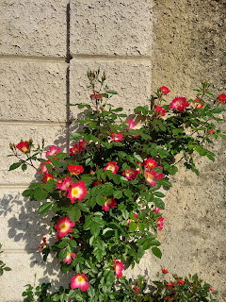

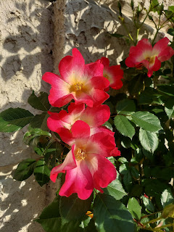

And charming old doors . . .

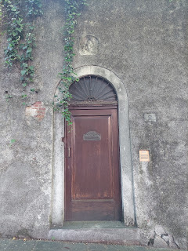

Soon, we were back on the street where we parked our car.

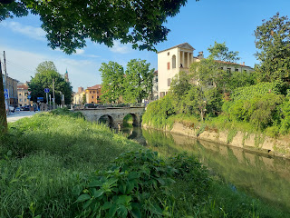

Mr. Lizard, sunning himself in quite a marvelous location. Does he even know how cool he is?

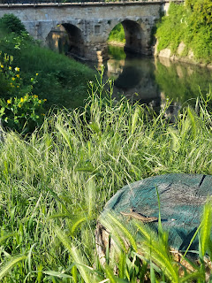

Yes, that afternoon adventure up to Monte Bareco with my sweetheart will be remembered for a long, long time. We got home in just enough time, too, before a storm rolled in with some serious rain, lightning and thunder! It was still a wonderful Mother's Day gift - one for the ages.

Monday:
Nothing really exciting happened, which was just fine. Scott had to work the night shift Monday evening, so his preparation ahead of time was to wake up really early on Monday morning, exercise, etc. and then take a nap for a few hours. While he slept, I put together 2 fans, which have been very helpful as the weather has gotten quite a bit toastier in the last few days.

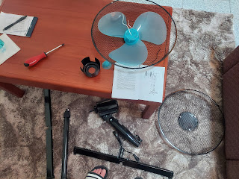

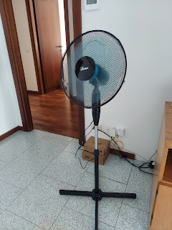

Tuesday:
Scott got home from working all night, and after eating breakfast, went right to bed.

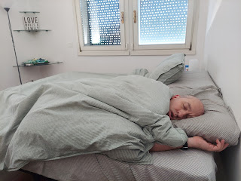

I entertained myself around the house and got some groceries across the street while he slept for half the day. Once he was awake enough later, we went to a different grocery store together. We were in awe of the size of the bell peppers there.

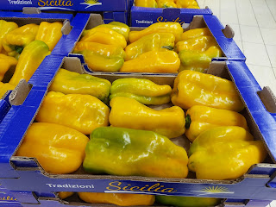

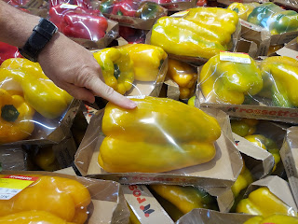

I also found ACTUAL brown sugar, unlike what I had bought previously, which was more like a raw cane sugar that happened to be brown. It's just not a common ingredient over here. In America, we are addicted to sugar, but in Italy, not so much.

The package on the left is the raw cane sugar, it is more crystallized and dissolves quickly. It's used more as a garnish. "Zucchero di canna" was the phrase I was looking for, using Google translate. But the KEY word that I didn't know at first was "integrale", or packed. The one (and only one) product that the store clerk directed me to just happens to be from PERU!! Wow, the things we take for granted. I just wanted the right ingredients to be able to make some chocolate chip cookies . . .

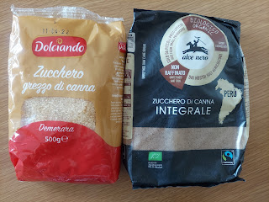

Wednesday:
I walked over to the base to meet my lady friends so we could walk and talk around the track, and found these beautiful calla lilies on the way.

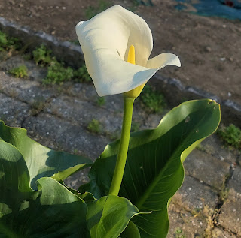

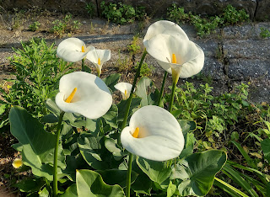

Turned out that I was the only one who showed up to exercise, but that's okay. I just headed back to the house and called that my walk. It takes 20 minutes to get there and 20 minutes to get back, so that's pretty good.

Scott had a normal day of work for Wednesday, and I didn't work myself too hard to be honest. I had a headache and I felt really tired, so I took it easy and even laid down for a rest in the afternoon. That helped quite a bit.

Our hammock arrived before dinner (we love Amazon Italy), and we waited until it cooled off a bit in the evening and then we set it up on the rooftop together.

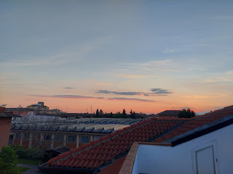

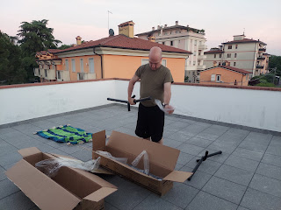

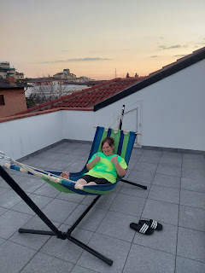

When I sent this photo to our kids, Amber wrote back: "Are you guys secretly just on an extended vacation? Is dad's deployment a sham?" ha ha

Thursday:
This is the day that I decided I would not let my fear of driving hold me back any longer. I drove that short distance over to the base and back, and found some great items at the thrift store again, including a few more children's books, and a fantastic (and large) stock pot.

I spent a good portion of the afternoon working on a meal for Linzi and her household. As I mentioned in a previous post, Linzi and her husband host Ukrainian families each week as they head to a more permanent place. On this particular day, Linzi was extremely grateful for the dinner that I put together so that she didn't have to cook for a night. She has a family of 6 of her own, plus she had about 7 extra houseguests staying with them.

I made spaghetti soup and Italian-style garlic bread, which was no small feat, especially when doubling the recipe. First, I had to find all the ingredients in a variety of Italian grocery stores, and I did great, except for one thing. I thought I had purchased beef bouillon, when in fact I had bought vegetable bouillon instead, which has an entirely different (and less enjoyable) flavor! I put in some additional spices and more salt, added some grated carrots and fresh spinach, and voila! It turned out great. The key word I was looking for when searching for lean ground beef in Italian, was "magra", which means slim, ha ha.

Spaghetti Soup with Garlic Bread (and plennnnty of my favorite Parmesan cheese)

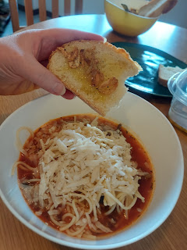

For the garlic bread, the Italian method is to slice up several cloves of garlic and sautee it very briefly in some olive oil before quickly removing it from the heat. You spread the oil and garlic onto whatever yummy Italian bread you've chosen, add some sea salt and freshly ground pepper and you are in heaven. Garlic heaven. :)

Linzi messaged me later in the evening after she had a chance to get the soup home to where they live south of town and feed the hungry crowd. She said they all had seconds and that it was heavenly to have such a delicious meal on a busy weekday evening. I was truly happy to help. She's the real hero here.

Friday:
Scott's schedule was all wonky again because he worked the night shift on Thursday night, so Friday was his recovery day. It's not a bad gig, all things considered. He even said so himself - "I only work 1 shift out of 2 days!" We got a little extra time together here and there, when he wasn't sleeping.

I walked over to the EuroSpin because I was looking for a hand mixer so I could make some chocolate chip cookies. That was the last thing that I needed. I didn't see one at the Lidl or the EuroSpin, which was surprising, since they have several other miscellaneous appliances and home goods mixed in with all the groceries. I decided to wait until Scott woke up to continue my search for a hand mixer, so that we could go on a practice drive with me behind the wheel.

As I walked back to our house, I decided to stop at the Pasticceria that I keep passing every time I walk by. It's a pastry shop, but they also serve breakfast and lunch items as well. I wanted to look more closely, so I stepped inside. I ended up choosing this pistachio cake and somehow had the self-discipline to only eat half of it, saving the other half for Scott.

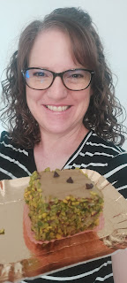

My friend, Erica, texted me around lunch time, asking if I'd like to go with her and her sister-in-law to the Bazaar on base at 4:00. It's a weekend-long event with several vendors from Italy and even a few from Germany. Sure! I had Scott drop me off after our errands (yes, we did find a good hand mixer) and I saw a handful of ladies from the ward that I could hang out with, including Erica.

Soon after I got there and had sampled a few pestos, cheeses, and other miscellaneous foods, my sister Charmaine called. She was 9 hours behind me and was just beginning her commute to work down in San Diego, CA. While we chatted, at first I tried to just wander and listen to what she was sharing, but there was so much to look at and it was too distracting, so I just found a chair to sit down so I could focus on our conversation better.

The vendors that I was most interested in were these:

Several items made from Italian olive wood . . .

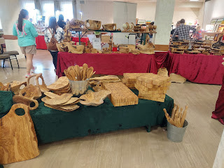

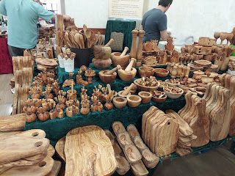

Pottery from Poland - they were SOOO beautiful and colorful, but way too expensive. Each of these gorgeous mugs were around $30 each. Yikes!! The plates and bowls were just as beautiful - but were even more expensive, around $80 for a large salad bowl.

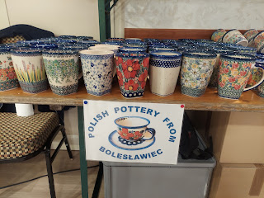

A variety of artwork from local artists - -

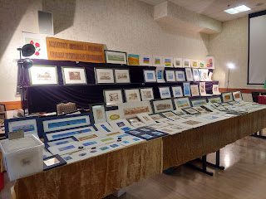

And the specialty chocolate table was something I was really interested in, but the line was so long that I didn't even try to get close, ha ha.

In the end, I purchased a couple of special items for Amber's upcoming birthday from the olive wood vendor, along with a mortar and pestle set for myself so I can try my hand at making pesto one day.

After Scott came back to pick me up, we made some nachos with all the fixings and took our plates up to the terrace to eat a late dinner together as the sun went down. He carried up 2 of our dining chairs and borrowed an end table from the living room to serve as our dining table.

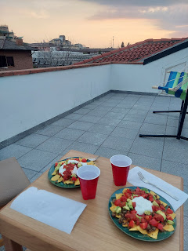

He is just the best. I love this man so much! He makes me so happy and is so kind and patient with me. Sometimes I just can't believe how much he loves ME. I've also been so impressed with his adventurous spirit here in Italy. Back home, he was mostly a homebody and didn't really want to go out and do much after work or on the weekends. But here - he's a whole different person! He's always ready to hop in the car and go somewhere, and he has no fear of the unknown. Usually he's the skeptical and reserved one and I'm the one pushing to get us out into the world and out of our comfort zone. But now he's right there with me, and I'm pleasantly surprised to see that side of him.

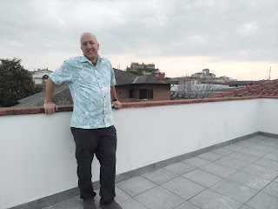

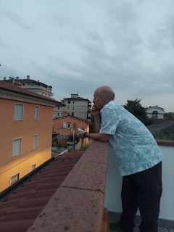

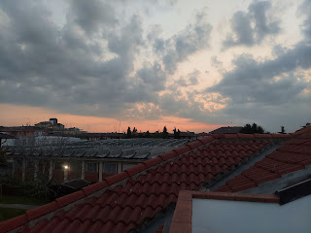

It took some tinkering with the oven temperatures to figure out how to bake the cookies for the first time. Everything is in celsius here, and the oven dial for the temperature settings is minimal at best. There's nothing between 150 and 200 degrees celsius on the dial, but 350 degrees F = 177 degrees C. It was hard to find the sweet spot to get the cookies to bake properly, but after a few burned ones, we did it! The new hand mixer works really well, and I found all the ingredients ahead of time, including that elusive brown sugar. I had to buy the chocolate chips at the Commissary because there are no such things in the Italian grocery stores.

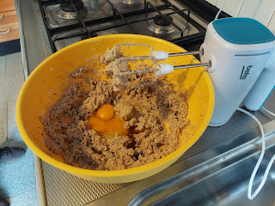

My cute little baking pans that can fit into my cute and tiny little oven.

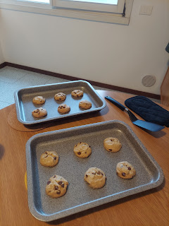

Saturday:
Scott had to go in to work for about half of the day. As he headed off to work, I went for a nice long walk. I went south of our house to an area we had seen by car recently, one that offers a beautiful wide trail for walkers and joggers and is more out in the countryside, even though it's a hop, skip and a jump from the busy streets of town.

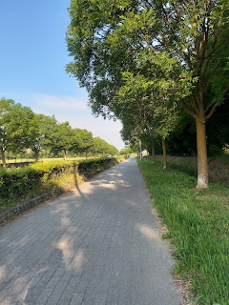

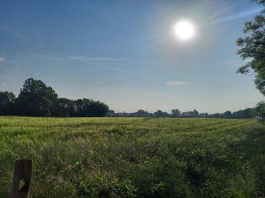

If you click on this next photo and zoom in, you can see the Monte Bareco church and tower off in the distance. It truly is a landmark from so many vantage points around Vicenza.

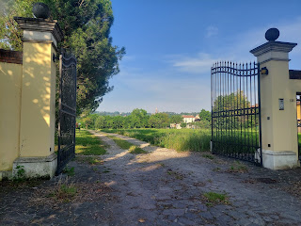

More beautiful roses on my walk.

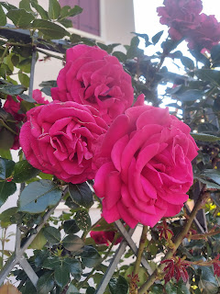

This is the pathway that goes from the countryside walking trail back into town. They've done a really nice job giving residents a beautiful place to recreate and exercise.

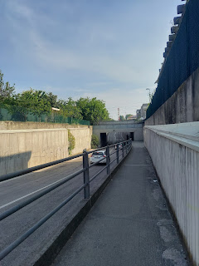

On the main street back to our house (it's only about a 5 minute walk once I come up from that tunnel path), there is a beautiful estate right in our busy section of town. The gates were open briefly and I paused to admire all the beautiful flowers inside that were in bloom, including dozens of purple irises. That's when I saw the huge white rabbit, nibbling at something in their front yard. I'm sure it was a pet bunny, and boy what a good life he has in Vicenza!

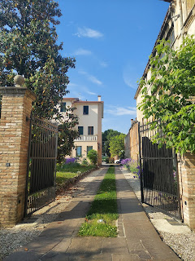

I walked for an hour total and arrived home covered in sweat, even though it was only 8:30 in the morning.

When Scott got home around lunchtime, we went to visit the other mall nearby for the first time, because it was highly recommended by several friends here. I wanted to find a new dress and we wanted to check out a store in the Palladio Mall called Emisfero. We were not disappointed!

While Scott went to explore the massive Emisfero store, I went in search of a dress. I found one for just $9.99 while he was sending me several pictures of what he was finding in the Emisfero. Emisfero is like a Super Walmart - on steroids. They have EVERYTHING there. Groceries, clothes, yard and patio furniture, dishes, . . . everything! And at such amazing prices!!

I found another dress there for just $12.99, and we found some sheets, some plates, a drying rack for our laundry, and some really comfy (and inexpensive) patio furniture that we plan to go back for later this week. Everything was priced so low, but the quality was still there. This might be our new favorite store.

From there, we hurried to drop off our stuff at home and then hit the road to go up to Aviano to see Benson, Kylie and Avery!! Yay!! It's about a 90 minute drive to get up there, with half of the drive on the Autostrasse (freeway) and the other half going through tiny and quaint towns. Most of the views were very rural and beautiful and reminded us of all the farm fields back in Idaho.

I always love to see the old churches as we go through the towns.

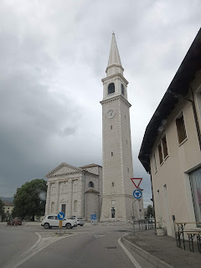

I had Scott pull over at one point so I could get some pictures of this beautiful field full of red poppies. The Dolomites (Italian Alps) are off in the distance, making for a breathtaking vista.

Video: (18 seconds)
https://photos.app.goo.gl/FwXJh4zqeVi9ZQdd6

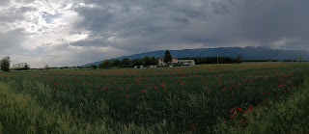

We arrived in Aviano about 30 minutes early, so we drove around town to see what we could see.

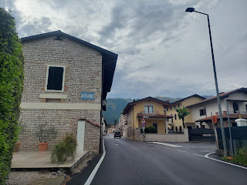

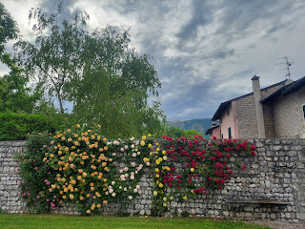

So. Many. Roses.

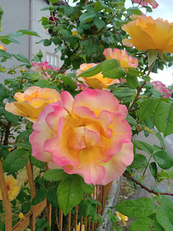

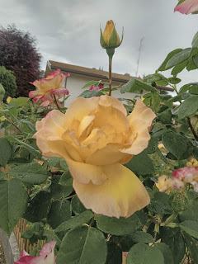

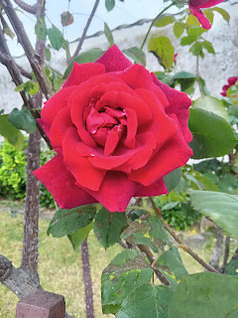

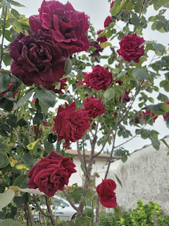

I keep updating my Flowers of Italy photo album - here is the link once again.

https://photos.app.goo.gl/i4RGiVYYiVicd4Ln6

Finally it was time to go to the restaurant - we let Benson and Kylie choose a favorite of theirs and they arrived soon after we did. It's called Befed - a chicken and burger joint. I think the Befed is most likely a conjunction of Be + Fed.

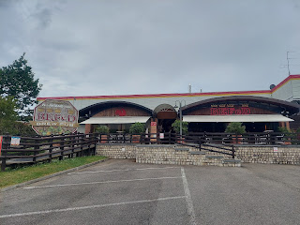

Avery is teething + she's in that "stranger danger" phase + she didn't get an afternoon nap, so she hung out with Mom for the most part.

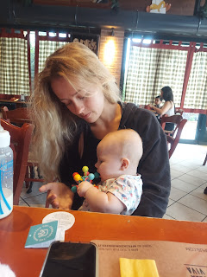

She loved the little toy that I brought all the way from NYC to Idaho to Italy for her. It seems to be perfect for the teething phase she's in right now. Just look at that sweet little face!

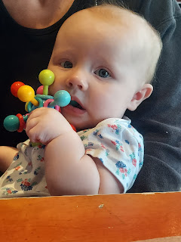

When Kylie needed a turn to work on her dinner with two hands, I offered to hold Avery, knowing that I was on thin ice, ha ha. As long as I held her facing away from me and looking at Mom and Dad across the table, she did pretty well for about 4-5 minutes. I was grateful for every single second. :)

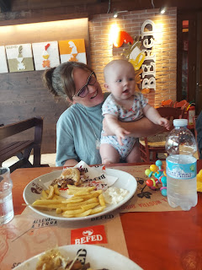

Benson and Scott had several entertaining military stories and details to swap, ones that I can't include in my blog, but they had a good chat. Benson is out of the field for now, but might potentially go back at some point. They are working on getting a visa for Avery so that Kylie can take her back home to visit her family sometime soon.

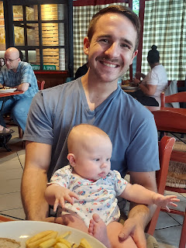

Dinner was short and sweet, and it was time to take Miss Avery home so she could go to bed, so we parted ways. (Not before I handed off several chocolate chip cookies that I had brought up for them) Benson suggested that Scott and I take a few extra minutes to go see Lake Barcis again (I went there with B & K last October), since we were so close. We decided to make a final push to see something spectacular before heading south, and we were glad we did.

On the way there . . .

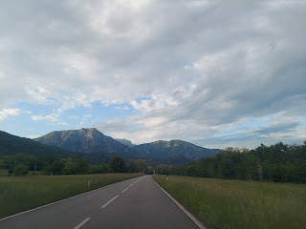

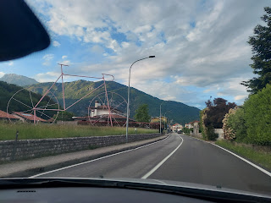

Driving through a few more tiny towns, with those infamous narrow streets, if you can even call them a street . . .

Video: (27 seconds)
https://photos.app.goo.gl/JhCWuaJYHKHrhvnJ9

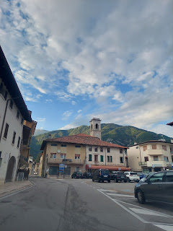

We passed through three tunnels on the way to Lake Barcis (pronounced Bar-chis) - one of which was 3 km long going through the mountain. It was wonderful to literally see the light at the end of the tunnel!!

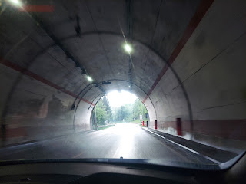

Several different views of Lake Barcis - from different spots around the lake. I LOVED seeing the mist hovering in certain areas of the mountains, like a blanket in the early evening and after a short rain.

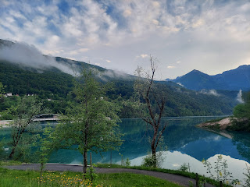

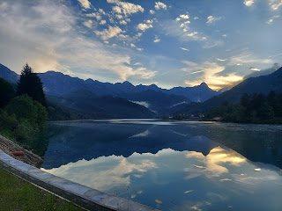

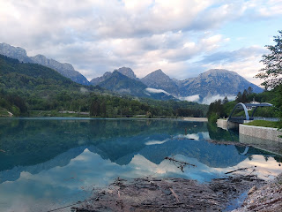

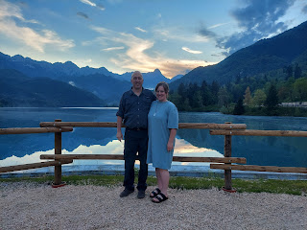

Yep. Worth the extra 25 minutes to get there, which then made the drive home 2 hours. Still worth it.

Another poppy field on the way home . . .

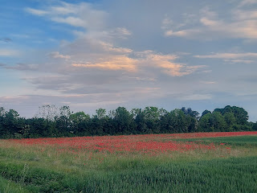

Once we arrived home just before 10:00 p.m., Scott saw that a text had come in from the stake executive secretary, asking if he could come meet with the Stake President at 9:10 a.m. before church started at 9:30 a.m. He cautiously agreed that yes, he could do that . . .

Sunday:
We got to church early so Scott could go to his brief meeting. The Stake President is Italian - his last name is Cicchio (pronounced Cheecheeo) and is quite young. He asked Scott if he would be willing to serve as the 2nd counselor in a new bishopric that would be sustained in just a few minutes. Scott said yes. :)

It was our ward conference, and everyone knew that Bishop Conner would be moving away very soon with a new military assignment to Cote d'Ivoire (the Ivory Coast of West Africa). What an amazing man he is!!! He spoke for the majority of the meeting, sharing several important and tender aspects of his years growing up in Georgia in the poorest of poor circumstances. He described that at one point his mother lived with her boyfriend in the main single wide trailer, while he and his younger brothers lived in a makeshift shanty that was sort of an "add-on" to the trailer, with blankets as a covering.

Somehow he had the will to live, and the will to survive. He started working in a factory at 15 years old to help contribute to the wellbeing of the family and to help buy clothes for himself and his younger brothers. It was when he was 14 years old that he wanted to know what his purpose in life was and if God was really there and were the scriptures really true. They had only gone to church sporadically up until this point, but he wanted more. He wanted more understanding for one thing. So he decided to pray and ask God if the things he was learning at church were really true. He received a wonderful answer to his young heart and mind, and decided then and there that he would always choose to serve God over anything else.

He went on to graduate high school with just shy of a 4.0 GPA, with a full scholarship to the Univ. of GA for his expert swimming skills, had multiple jobs being offered to him left and right, and basically had the world at his fingertips. He decided to put all of those things on hold in order to serve a mission for the Church of Jesus Christ of Latter-day Saints, much to the astonishment and disappointment of everyone around him. They all literally thought he was crazy to just walk away from all of those amazing opportunities. But he knew better. He said that this was the single most pivotal thing he's chosen to do in his entire life. He loved God and understood that he was loved in return. He knew that if he served a mission, his life from that point forward would be a blessed one, and it has been.

There were so many more details, miracles, and inspirational parts to his story, but just know that he is truly a wonderful man, one who is pure and genuine, one who is humble and recognizes where all good gifts come from. I am sad to see him and his family go, but I know that wherever they end up, they will be okay because they put God first in their life.

The new bishopric: (L to R) Kevin Parker, Bishop Horner, and Scott

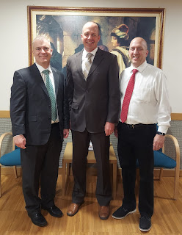

The new bishop is Bishop Jonathan Horner. I don't know a whole lot about him yet, but I do see a man who is gentle and kind, without guile, and someone who exudes love - like the Savior Himself would convey. His whole family seems to be the same way - I think they have 5 kids - from the upper teens down to maybe a 9 or 10 year old daughter.

The first counselor is Kevin Parker - he is from Rexburg, Idaho and is here on military assignment as well. Their family is a lot of fun - we've gotten to know them a bit already. They have a great sense of humor and are very musically talented.

And now Scott will be the second counselor. He was a little nervous going into Sacrament meeting, as the weight of the calling began to sink in. He served in a bishopric somewhat recently - until he left for Saudi Arabia in 2019 - so he knows the amount of time that it requires outside of a full-time job and family obligations. I tried to whisper words of comfort to him throughout Sacrament meeting, but I actually think it was listening to Bishop Conner's talk - along with his priesthood blessing by the Stake President after church - that helped him feel more confident and at peace with serving in this big capacity for the next couple of years.

Already, just since we got home from church today (after 2 hours of meetings afterwards where I sat and patiently waited for him since we had come with just one car), there are several big things on the horizon that need immediate attention, planning and implementing.

Starting this week, he needs to attend mutual with the young women and young men every Tuesday night. There is a ward dinner this Friday night. I've been asked to speak in church next Sunday. And the biggest one of all: in 2 weeks it will be Memorial Day weekend, so for the military community it will be a 4-day weekend. Scott and I already made plans to go somewhere for the weekend, thinking that it might be the only time we could get away and celebrate our 30th anniversary since he will be in Morocco for most of June. But Bishop Horner and Brother Parker also made plans with their families for the same 4-day weekend . . . well, since they have children still at home and we don't, we will sacrifice a portion of our weekend in order to be here for church. Scott will need to attend as the only member of the bishopric that day, and together the two of us are in charge of teaching all the youth for their class after Sacrament meeting.

For that Memorial Day weekend, we have reservations for an AirBnB over in Lake Garda (about 90 minutes west of here), but we think it will work out okay to come back in time for church on Sunday morning and then go back to Lake Garda once Scott's responsibilities are done after church. We still have Monday to continue our little getaway, so all will be well. :)

Anyway, there is a lot to stay on top of, but we know that we will be blessed for his service to all the good people of the ward, and ultimately for his service to our loving Father and His Son Jesus Christ. I am grateful to be married to a man who recognizes where blessings flow from, and who is also willing to roll up his sleeves and get to work. He will do great things here in Vicenza. Of that I am certain.

And we will definitely be taking 2 cars to church from now on as well . . .

