Retirement, Projects, and Easter
There's a LOT of stuff to cover in this post, so BUCKLE UP. :)

I'll start with Scott's retirement ceremony, because it was pretty special. The flag he received for his 37+ years of service sits proudly in the front entryway of our home.

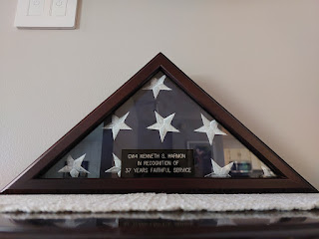

The last day he laced up those military-issued boots . . .

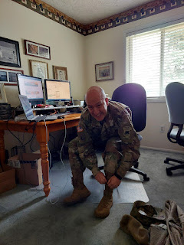

Obliging my need for photos before we drove over to the National Guard Armory . . .

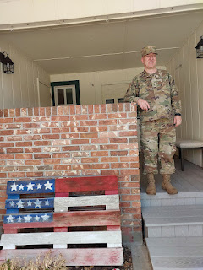

I found myself getting emotional as we drove . . . every single American flag flying at local businesses and homes caused fresh tears to spring to my eyes. Home Depot's flag was the first one to set me off . . .

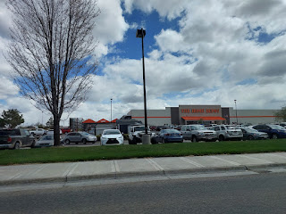

The sky was absolutely gorgeous that day . . .



In front of the National Guard Armory in Idaho Falls . . .

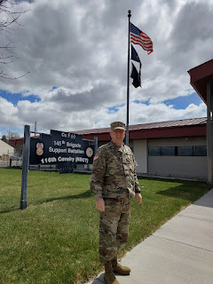

Benson drove all the way from Mountain Home Air Force Base that morning to be there with us. He had a slowdown on the freeway just south of Idaho Falls, which meant we had to leave the house without seeing him. We needed a few extra minutes to pick up my niece, Mari, and Benson needed a few extra minutes to get his dog, Daisy, settled in the back yard. So we just ended up meeting at the armory.

Scott's sister, Bev, had fully intended to come - but at the last minute she had to go down to Salt Lake City and wasn't able to join us. She felt terrible, but we reassured her that it was okay.

Our dear friends, the Hoffenbackers, came though. As soon as Kim arrived, we hugged and I melted into tears on her shoulder. She summed it up so perfectly when she announced that we have been "Battle Buddies" for 21 years. Our husbands left for Iraq back in 2004 when we really had no idea if they would even return. We leaned heavily on each other for moral support during the 17 months of that first deployment without our sweethearts.

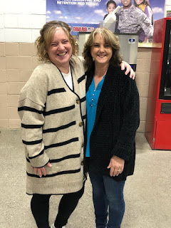

We "buddied up" again in 2010 when our husbands left for Iraq the second time. This time I had teenage boys, which was not an easy time for me. She provided a listening ear and a voice of reason and humor when I needed it, and she was always good for a hug. Hugs mean so much when you don't get them very often. During that time, my teenage boys did not want to hug their MOTHER (ewww), although Amber was always so sweet and affectionate. Whenever Kim gave me a hug, it meant the world to me.

Benson and Mari were also there in attendance. It was so nice for Mari to be able to take part with us. She commented afterwards how special it was and how glad she was that she could come.

There was a small group of soldiers in attendance. They gathered into a formation to prepare for the ceremony.

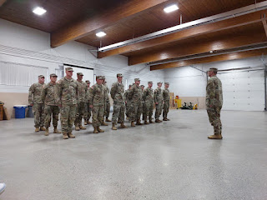

Sgt. Webster read a program (included below) that gave everyone a thorough background into Scott's many years of service in the military.

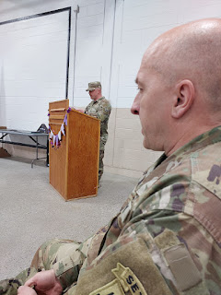

Salutes were given . . .

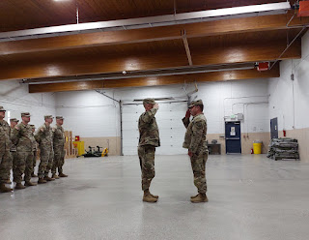

Video of Sgt Webster reading Scott's accomplishments while Colonel Batt pinned on the medal:
(48 seconds)
https://photos.app.goo.gl/socZTtjCxMfcUh2C6

**Note: I am not really sure of the ranks for Webster and Batt. I'll have to doublecheck them with Scott.

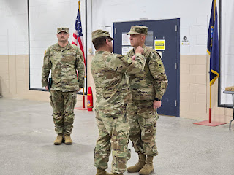

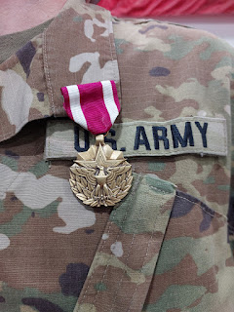

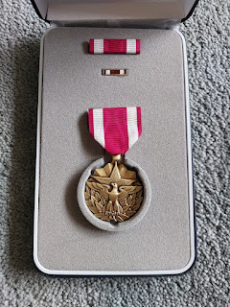

In total, there were about 30-35 people in attendance.

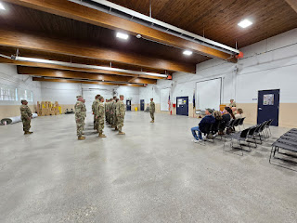

Scott knew exactly what to do with each gift he was given. He would pause while holding the flag, the awards, the certificates, etc. and face the girl tasked with taking all the photos to document the occasion. She shared the photos with me afterwards. I was grateful because she had a much better angle than I did. I was seated to Scott's side and could hardly see his face, but she had a perfect vantage point.

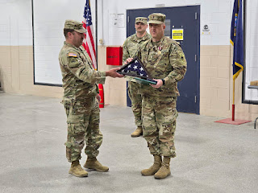

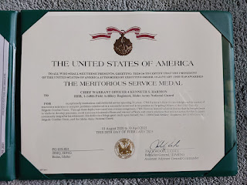

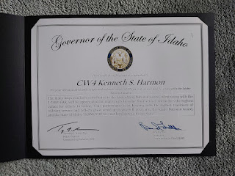

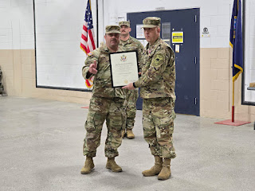

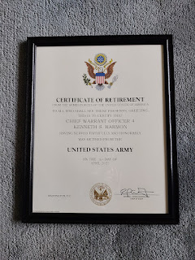

I was surprised when they asked me to join him in front of everyone . . .

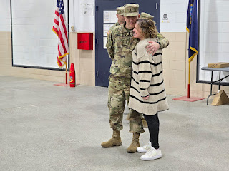

But they had a special gift for me, too! It was a certificate of appreciation for all the years I supported Scott so that he could faithfully serve our nation. Wow! What an honor!!

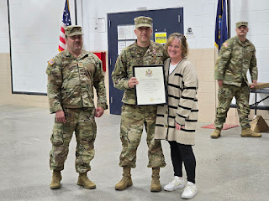

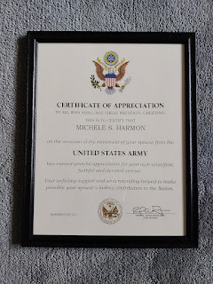

Video of Colonel Batt sharing some stories about Scott: (2 minutes, 42 seconds)
https://photos.app.goo.gl/sjTSeaDvmcRMHV3j8
*Turn your volume up, it's a little hard to hear.

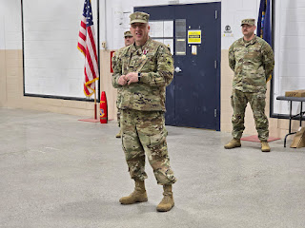

Below is a video of Scott's short speech about how he joined the military back in 1986 and his career choices up until he became a warrant officer. It was so sweet at the end because he got choked up when he said that this was his last day of putting on his uniform . . .

Also: the beginning of the story was cut off in the video, but he mentioned how when he first joined the Army Reserves in Rexburg, Idaho, he started off as a mechanic. He did that for about 8 years before he saw a better opportunity to do something more math-related.

(1 minute, 15 seconds)
https://photos.app.goo.gl/4YWsEZzA4rCBEgDi7

Video of Sgt. Taylor telling a short story of how Scott was his professor down at ISU and how he (Scott) saved the students over $200 on the cost of their course books. (39 seconds)
https://photos.app.goo.gl/rn5JJMVa5Mvn2KgW9
Here is the script that Sgt. Webster read for the program. (Click photos to enlarge)

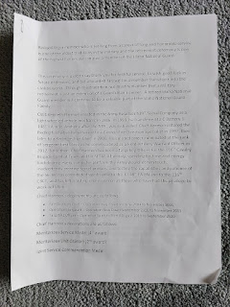

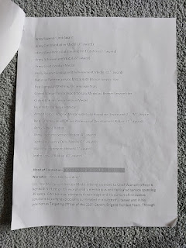

Family and friend photos after the 20 minute ceremony - it was so short and sweet!

Me, Scott, Benson, and Mari . . .

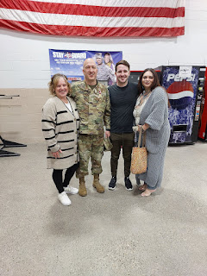

Me, Scott, and Benson . . .

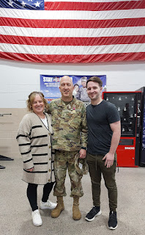

Our two military men: Scott and Benson . . . XOXO

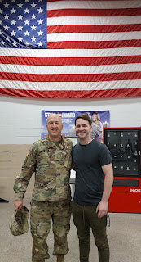

Scott and Bob Hoffenbacker . . . we mostly call him "Hoffy," but we also call him Bob.

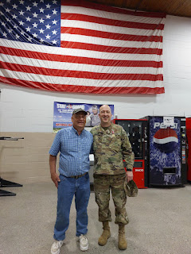

Hoffy is who told Scott about the option to sign up for Tours of Duty - essentially a deployment that you CHOOSE to do. That's how Scott ended up in Saudi Arabia in 2019-2020. Bob told him that a lot of times your spouse can go with you, depending on where you go. When Scott saw that there was an option to serve in North Carolina, he jumped into action. We both got really excited. But later in the process we learned that the NC Brigade was heading to Kuwait and then to Saudi Arabia. Darn it. I wasn't able to go with him . . . Instead, I quit my job and headed out to CA to spend 4 months with my Mom and my Grandma Doris (who was 98), and then I spent a month down in San Antonio with my daughter and her family. From there I traveled up the east coast doing family history for a month before Covid shut the whole country down. This was how my blog first started in August of 2019 - to keep my friends and family in the loop as I traveled all over the United States.

Scott ended up in Italy because of this same program - "Tour of Duty". He applied for the job in Vicenza and was accepted in 2022. Italy is where he spent the last 3 years of his military career and they have been some pretty great years. :)

Scott and some of his buddies who spent time together in Iraq, and who also came to the retirement ceremony . . .

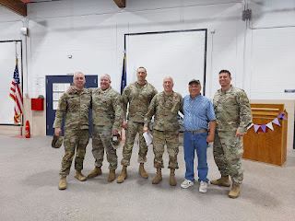

I had to share this oldie but goodie. In the months leading up to when Scott first deployed to Iraq in 2004, Grandma Helen Harmon didn't want him to go. She was worried about him and kept praying that he wouldn't have to go. As it turned out, she was the one who passed away while he was on the other side of the world. She was 97 years old. When Scott couldn't come home for the funeral, Jacob stood in for him as a pall bearer with all of his uncles and Grandpa Phil. Jacob was just 8 years old at the time.

This was the last photo of the two of them together . . .

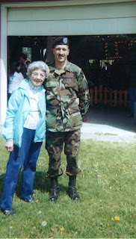

After the ceremony was over, we all went to get some Mexican food at Morenitas (always a favorite) and then we came home to rest. Scott had started getting sick the night before, with a scratchy throat and a cough. I'm just glad he made it through his speech!

Daisy was happy to hang out with us, too.

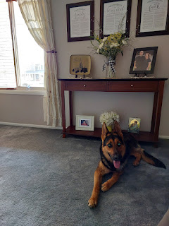

Video of Daisy's secret hiding spot that she created behind the couch: (12 seconds)
https://photos.app.goo.gl/f86zbxePzKbJwGYW7

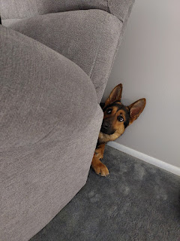

The following day (April 19th), Benson and I went for a little drive up into the hills east of Idaho Falls so we could let Daisy have an off-leash explore. We found a place to park adjacent to a massive farm and then we went for a walk across the fields. There were several windmills off in the distance, and views of the snow-capped mountains of Jackson Hole. It was a windy day but we didn't care.

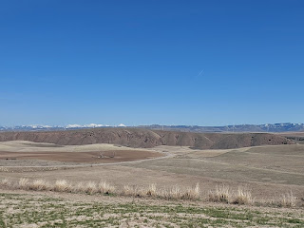

Benson's buddies at the Air Force Base pooled together to get him a really nice DSLR camera for his birthday. ($1500 worth!!) He was excited to try it out, taking a variety of photos of the sagebrush, the windmills, and Daisy of course!

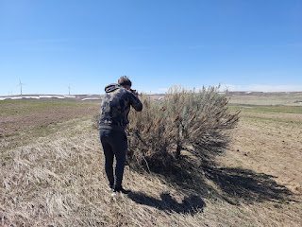

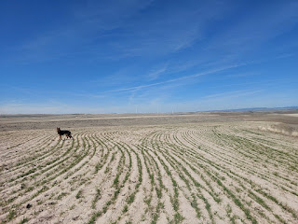

I finished baking the carrot cake for our Easter lunch and frosted it with a cream cheese frosting. It ended up being TO DIE FOR. Literally.

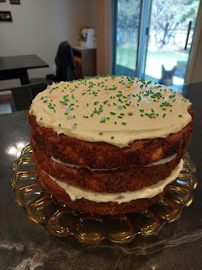

I had two recipes to work from - the one my mom has made many times over the years, and one that I found at my Grandma Lillian's home a few years ago. They turned out to be the EXACT SAME recipes!!

This is the link to the printed recipe that Grandma had - it's easier to read than my teenage handwriting on the recipe card that my Mom has.

https://photos.app.goo.gl/hYzEk6rVxTT4si356

I didn't use the Buttermilk Glaze recipe on the above recipe page, but instead I used this one for the cream cheese frosting:

https://photos.app.goo.gl/ySfQr38vsY9Hopv27

We had a cute little video chat with Jake and Maisie that afternoon. They were at one of the many playgrounds in their apartment complex.

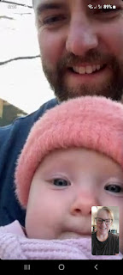

Jake helped Jack across the monkey bars . . .

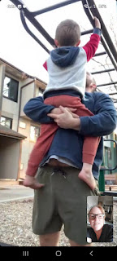

And Jake even did a hilarious monkey trick of his own: while Jack hugged his papa around the front, Jake flipped upside down and started carrying the both of them across the monkey bars . . . !!

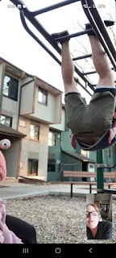

After church on Easter morning, we called Kylie in Italy to wish them a Happy Easter. It's been about a month (or slightly more) since we last spoke to Avery, so it seemed like a good reason to reach out.

Avery was so cute - she showed us her little bunny . . .

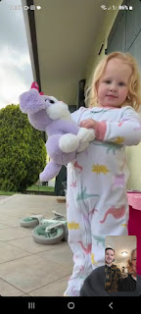

She said, "Gramma, you come here to my house?" And when we tried to explain that I needed to get on a plane soon in order to come see her, she immediately pointed to the sky, thinking that I was coming right now!

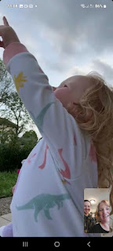

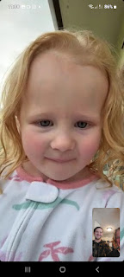

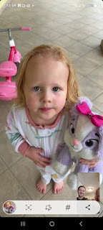

We got to see her new tricycle, and after she gave it a go, she asked her mommy (Kylie) to hop on so she could help her mommy ride it, too.

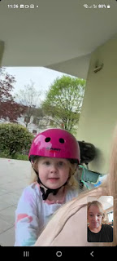

It was Grand Central Station at our house that morning, with people stopping by to see Scott and to see Benson. But Benson managed to steal a few minutes privately with his daughter, Avery, as he took my phone outside onto the back patio to visit with her there.

Eventually, we needed to say goodbye - so Avery did her best to make a little heart for her Daddy with her sweet little 3 1/2 year old hands. It was the most precious thing EVER.



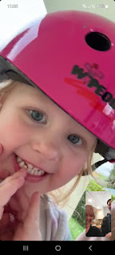

What a cutie!! Capital Q + Capital T.

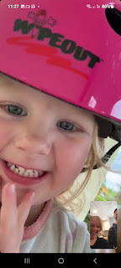

Our Easter lunch turned out really well. Scott picked Mari up and brought her over to join us, and she contributed the most delicious fruit salad. She added lemon juice, honey, and mint leaves to all the sumptuous fruits, and it was absolutely heavenly.

I followed my sister Charmaine's lead in using ham steaks instead of a giant ham that we wouldn't be around long enough to eat. I had never heard of ham steaks before, but apparently they're a common grocery item! They're large flat slices of ham - fully cooked - and they're in the meat section of your grocery store. Each "slice" is individually packaged, and can provide 4 decent sized servings. There is a tiny piece of bone in the middle (as you can see in the photo below), but it didn't interfere with how we prepared the main dish.

The ham turned out SO DELICIOUS!! It was super easy and required very minimal effort.
This is the recipe I used:
https://healthyrecipesblogs.com/ham-steak/

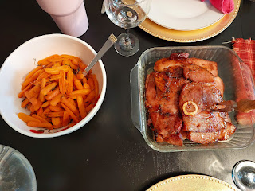

We also served roasted glazed carrots, and a mashed potato casserole that was SO GOOD!! (Also shared by my sister Charmaine)
Recipe here:
https://www.delish.com/cooking/recipe-ideas/a41867974/mashed-potato-casserole-recipe/

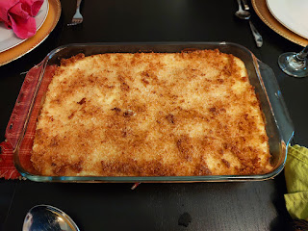

The peas turned out just "okay" (I had to change the recipe significantly and it just didn't work unfortunately). But look at that beautiful fruit salad!! And the carrot cake . . .

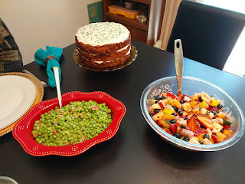

I have a little crystal that sits on the windowsill in my living room, and one afternoon it made the prettiest rainbow that really amplified my Easter decorations by the front entry . . .



Scott and I squeezed in a couple trips to the temple, knowing that soon we wouldn't be close to one at all.

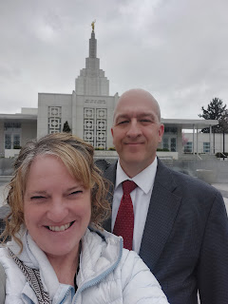

The tulips and other spring bulbs were a colorful reminder that our Heavenly Father loves us.

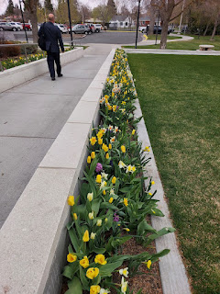

When we got home from the temple, our little apricot tree was blooming out, too, in splendid fashion. :)

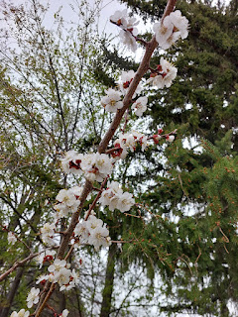



It has a wonky branch on the left side, ha ha, and may not produce anything, but the right side looks good and seems to be happy.

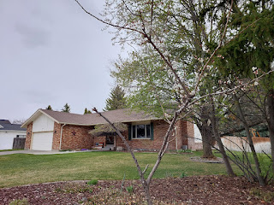

I took a bunch of pictures to share with our landlord, Daniele, back in Italy - and his father Bruno, who lives downstairs from us.

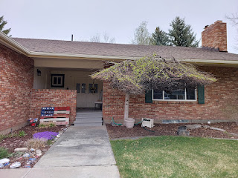



Scott worked on some big projects while he was home for a couple weeks after our recent 2-week trip. I have been asking for a new banister and railing upstairs for several years, and I'm happy to report that we can check that off the list now! The space between the railings was NOT up to code . . . whoever built it originally did not think about how babies, toddlers, and even 10 year old children can fit their whole head in between the poles!! We've had to be creative over the years in order to keep our grandchildren (and tiny visitors) safe.

Plus, I have hated the brass ever since we moved in almost 20 years ago . . .

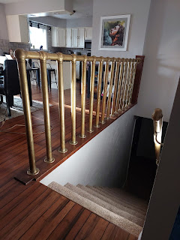

It only took a few minutes for Scott to remove the whole thing . . .

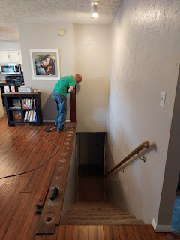

And over the next 1-2 days, he quickly moved through the rest of the project . . .

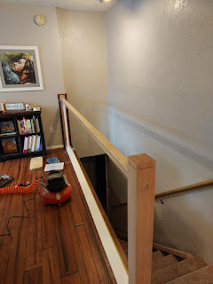

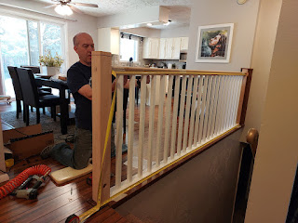

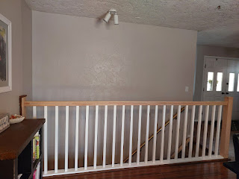

I absolutely LOVE the new look. He did such a great job!! When I come back later in the summer, I will stain the oak to match the bamboo flooring.

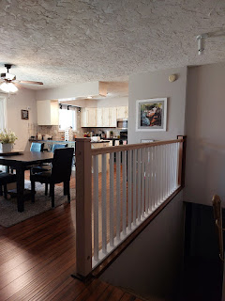

Our dear friend, Ben Lemons and his new wife Liz stopped by for a visit before Scott left for Italy a few days later. They used to teach next door to each other at Bonneville High School 30 years ago!! Ben is one of those super dynamic teachers - and now he's an elementary school principal - that strives to know every single student's name and finds ways to connect with them every single day. He is amazing. Ben and Liz want to come see us in Italy sometime soon. They will be lots of fun when they do! Ben is such a hoot.

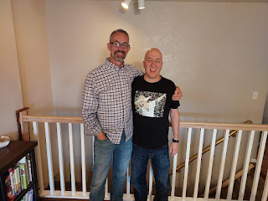

Scott watched a few YouTube videos and did some research before figuring out a good way to make a new handrail going down the stairs. He brought home the long piece of oak first, ordered the end caps separately, and then pieced them together. Next, he sanded the area where they joined up so they would be smooth and seamless.

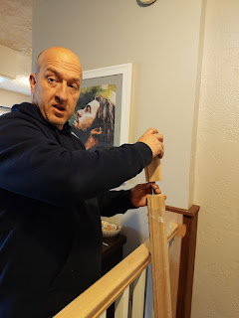

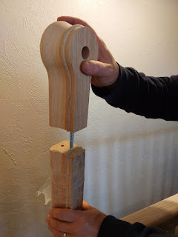

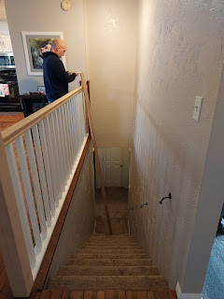

This is the finished project - for now. At least until I can put some stain on the wood this summer . . .

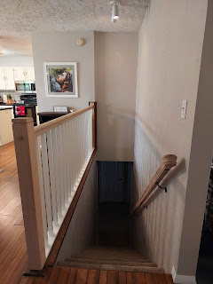

He also chopped up the old stump from when he pushed a dead birch tree down recently. It slowly cooked down to ashes over the next 24 hours . . .

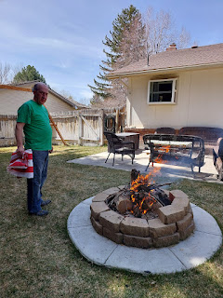

We took the opportunity to properly burn a worn and tattered US flag at the same time . . .

Video of our flag burning up in the firepit: (13 seconds)
https://photos.app.goo.gl/79s2Zjumexuwun5u9

Our wonderful neighbors, Don and Helma Blatter, loaned us their old pickup truck to take care of some errands. We first borrowed it so we could bring home the new handrail and banister pieces from Lowe's.

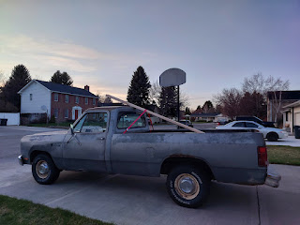

Don told Scott that they've had this same pickup since they were first married . . . and while I'm not sure how many years they've been married, the biggest clue to their age is that Don retired about 2 years ago. He's gotta be in his upper 60's by now.

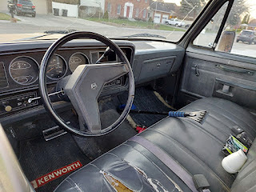

On another occasion, Scott borrowed the same truck to haul some things to the dump. I had tasked him with cleaning out the garage while he was home. I know, I know, I'm a slave driver. But I didn't know what was important
vs
what could be tossed in "his" section of the garage, so I figured this was a great time for him to make those decisions when he's actually home long enough to do it.

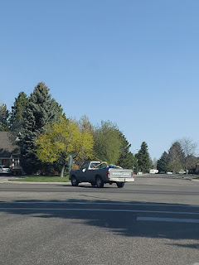

On another day, Scott noticed a large broken branch high up in our May Tree in the front yard. He shimmied up like it was nothing, and with the help of our neighbor Brent's extending saw-pole-thing, he got it down in no time.

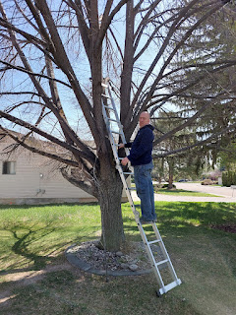

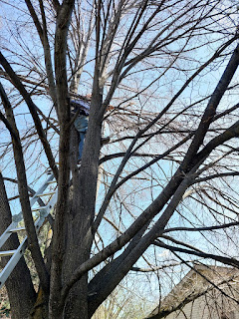

On another day, while Mari was over at our house doing some laundry, I asked Scott if he could help me dig up all the raspberry plants in the back yard. For the past two summers, I've harvested maybe 10 raspberries each season, but the amount of time and energy it takes to climb in and around those thorny branches to keep the weeds at bay far surpasses the delight in eating those 10-ish raspberries.

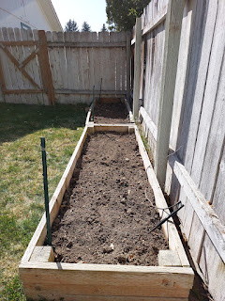

Now, at least, we can just pay the landscaping company to spray some roundup on anything that tries to sneakily grow back in those raised beds.

On another day, we picked up our friends, Scott and Jen Anderson, so we could go for a walk around the greenbelt in downtown Idaho Falls. It was a bit windy and therefore on the edge of crisp as far as temperatures go, but we walked and talked for about 90 minutes and had a great time.



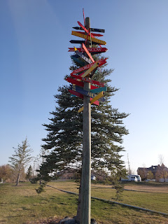

I had not seen this here before . . . a cute and very tall pole with arrows pointing to cities all around the world from Idaho Falls. In the above photo, it even mentions Rome - a mere 5606 miles away.

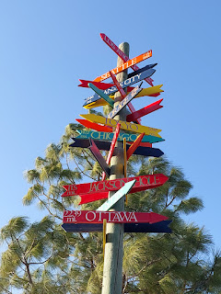

Me, Scott, Scott, and Jen . . .

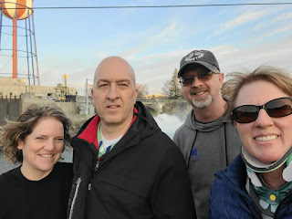

The more time we spend in Idaho Falls, the more we realize how much we love it here.

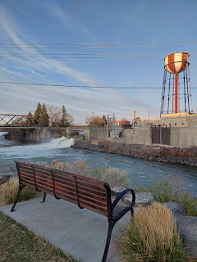

Down the road, we will probably still hang on to our house here and just add on a condo somewhere that's close to our kids. We could split our time in Idaho (when the weather is great) and wherever else when it's nicer there.

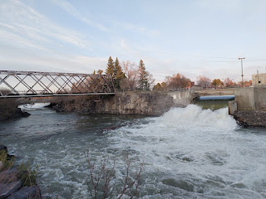

I got my annual mammogram, and this time another bone density screening. Yes, I still have osteopenia, but the good news is that there was no significant decrease in bone density since the last test a couple years ago. Yay! I think that doing regular resistance exercises and going to the gym is helping with that.

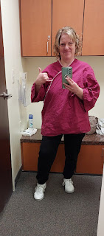

Last visit to the temple . . . for a while anyway. :)

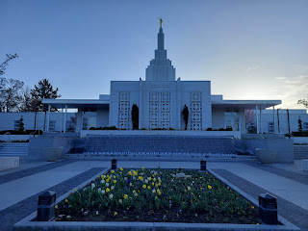

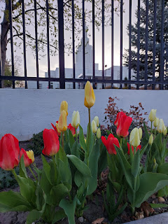

The moving company came to haul our stuff away on the same day that Scott left for Italy.

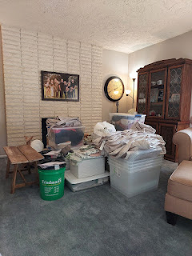

We sent several totes full of clothes, sewing supplies, dishes/pantry items, and some family history to work on.

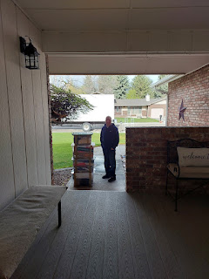

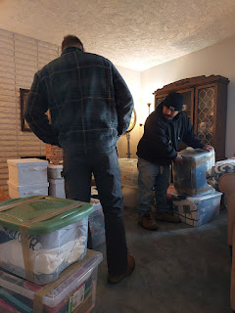

Plus, we sent our two upstairs couches . . .

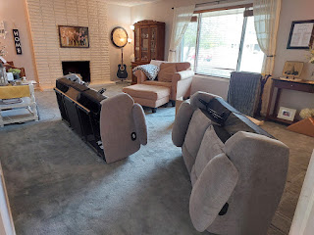

Good thing we have those double doors. It makes carrying large items in and out much easier.

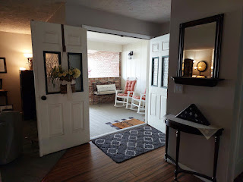

Our very empty living room now . . .

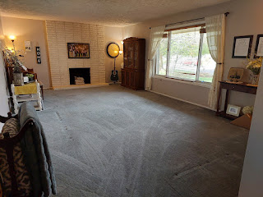

We moved the mustard yellow oversized chair down to the family room and it looks like it was made for that room. It goes perfectly with the rest of the decor.

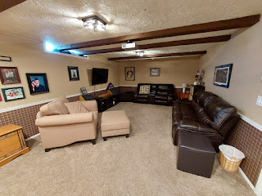

In the coming days, our new couch set and coordinating chair will be delivered after I'm already gone. My neighbor Kim will let the people inside and she'll show them where to put everything.

Scott flew back to Italy a week ago and made it just fine. He officially started his new job the following day (last Friday), even though he had already been working the job for several weeks earlier this spring. He loves it so far, and his workday is from 8:00-4:00. He can wear CASUAL CLOTHES, too. Whaaat??

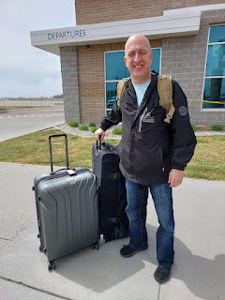

I sorted through all of Grandma Lillian's jewelry and took some of them over to Fred Meyer Jewelers to have them assessed for any value.

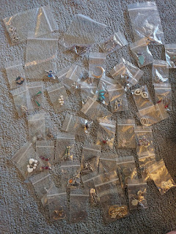

If this little testing wand that they use detects any diamonds, it starts beeping. Well, Grandma had some seriously good taste, because when all was said and done, I came home with about $10,000 worth of jewelry!! (rings, mostly)

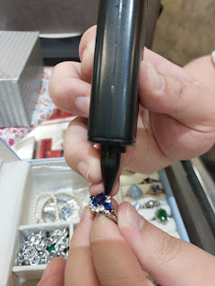

I wrote a really good review for Fred Meyer, because they spent about 2.5 hours helping me - for FREE.

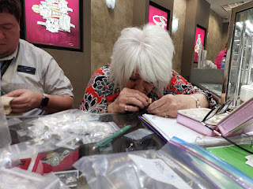

A few days later, I sorted all of the costume jewelry into white sachet bags to take to the celebration of life. The valuable pieces were hauled up to Oregon and are being given back to Mike and Suzy, Grandma Lillian's oldest son and wife. They are the executors to her estate and will add them into her personal assets.

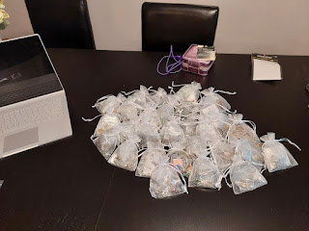

A win-win took place just before I traveled up to Portland for a quick weekend trip. I wanted to offload some pantry items that needed a good home, and I was paired up with a lady named Lori (in my ward) who was in need. She was so chatty and fun - we visited for over an hour when I took all the bags of groceries over to her apartment. I'm guessing she is in her late 50's or possibly early 60's. She has so many amazing life stories and I was uplifted by hearing her ability to overcome adversity and tragedy over and over again.

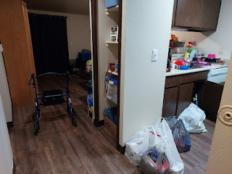

A significant story that Lori shared with me was that she was run over by a van at the local Walmart in February. The driver didn't even see her as he was backing out of a space in the parking lot!! She is still using a walker and has several residual issues, but she likes to crack jokes and be optimistic. She was baptized two years ago on May 18th, and she looks for, sees, and hears the voice of God in her life every day. She is always trying to learn whatever He is trying to teach her. Talk about humble . . . I was in awe that of all the people I could have brought some food to, it ended up being her.

The last thing I want to share is that I finally finished writing a poem about the porch swing from my childhood. I started it a year ago, but life got busy and I kept forgetting to get back to work on it.

This is the swing at Grandma Lillian and Grandpa Linton's ranch in Ukiah, CA.

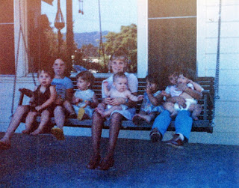

From L to R: Justin Moore (on my lap), me, my sister Melanie, my sister Charmaine - holding our brother Ryan, Christy Moore, Terri Moore - holding her sister Erin Moore. The Moores are my cousins through Grandma Lillian and her first husband, Dean Moore.

Here is the link to the poem I wrote:
https://docs.google.com/document/d/1w8JvOv8rDb22AbFT2inF0TcukifmkpSqaotW4A63sDg/edit?usp=sharing

I am currently sitting at the Idaho Falls Airport, getting ready to fly to Denver, then Munich, Germany, and on to Venice by tomorrow. Scott will be picking me up tomorrow afternoon, and we should be back to our new house by dinnertime.

I'll share more about Grandma's Celebration of Life in my next blog post. XOXO

