Road Trip to Oregon
I can't help but think of the Lego song, with the lyrics: "Everything is Awesome!! Everything is cool when you're part of a team!! Everything is awesome when we're living our dream!!"

Life IS awesome when you get to see your children and grandchildren, and to know that they're all okay. :)

Day One:
Scott and I left our home first thing in the morning (Tuesday, March 25th) and began a 7.5 hour drive for the day.

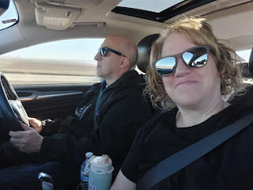

Three and a half hours later, we arrived on Mountain Home AFB to see our youngest son, Benson.

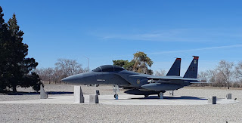

Scott and Benson hadn't seen each other in almost a year . . .

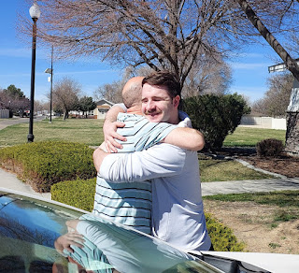

It was a beautiful moment for them to hug and then do the typical man-slaps on the back . . .

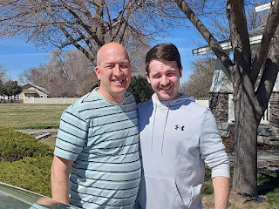

We ate some lunch that Scott and I had picked up from Rolberto's, a locally owned Mexican food joint - and Benson's favorite - in the city of Mountain Home (about 25 minutes north from the base and next to the interstate). After we filled up, we went for an hour+ walk all around the neighborhoods. It was sunny and pushing 80 degrees. It felt absolutely amazing.

Benson and his "puppy" Daisy . . . (she's a little over a year old now)

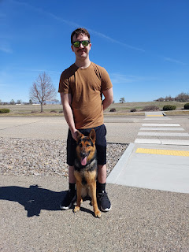

We eventually circled around to see the huge park that showcases several jets and planes that the Air Force has worked on over the decades. The B-1 Bomber is massive.

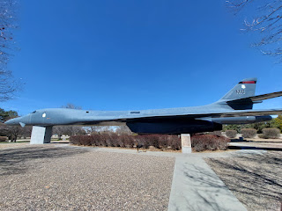

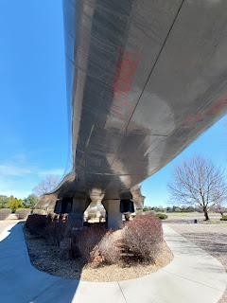

The F-15 is the main jet that is being used on the base here . . .

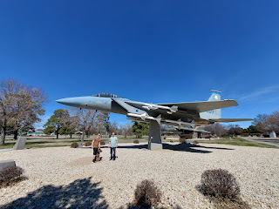

Some "stats" about the F-15, also known as the "Eagle" . . .

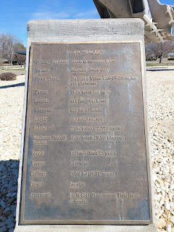

Once we were all a little sweaty and a brighter shade of pink from the glorious sun exposure, it was time to part ways. Benson needed to get ready for work and we needed to drive another (almost) 4 hours to get to our hotel in Pendleton, Oregon. We absolutely LOVE spending time with Benson. He is such a good guy. He is so pleasant to hang around because he's so relaxed all the time. He is content and happy for the most part with his circumstances, and what he isn't happy with - he is still okay with. He knows that these things are not permanent and so he is just biding his time until things CAN change. He would like to get out of Mountain Home someday, for example. Baby steps is the name of the game though, because nothing is quick when you're dealing with the military.

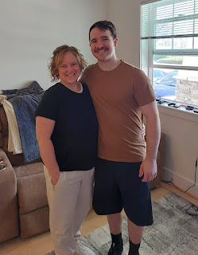

Driving over the mountains of Eastern Oregon in late March, with these sunny blue skies, was sure the opposite of the last time I drove through here! When I drove up in December to spend a couple weeks with my daughter and her family through Christmas, I dealt with rain, slush, snow, hydroplaning, icy roads, and a whole lot of stress (and a panic attack) while driving in the dark. But this time, it was quite pleasant. And it was also nice that someone else was driving so that I could take in the surroundings.

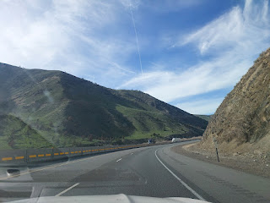

We stayed at the Holiday Inn Express in Pendleton, which was at the end of a street and on the edge of a steep hillside that led down into several farmfields that went on for miles. It was quite pretty at the end of the day.

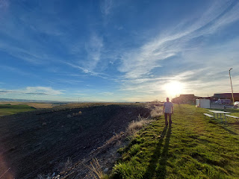

We ate dinner at my new favorite place, the Great Pacific, in downtown Pendleton. I ordered the tuna melt and their tomato bisque soup. Scott ordered a giant sandwich and the same soup. We sat right in front of the stage, but there was no live music that night, sadly.

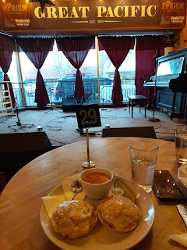

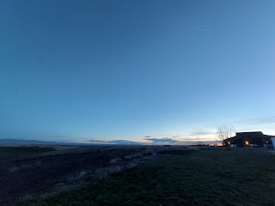

Day Two:
With only 3 hours and 20 minutes to drive that day, we left with happy hearts and full tummies from the hotel in Pendleton. I pulled out my "zippy" bag with a page from Maisie's Quiet Book that my sister Melanie helped me get started. This scene will be a cute little kitchen, with a cookie sheet full of cookies that can go in the oven. Each cookie will have 1-9 chocolate chips on it, with corresponding numbers velcroed underneath. I stitched on the handles for the oven door and the cupboard doors as we drove.

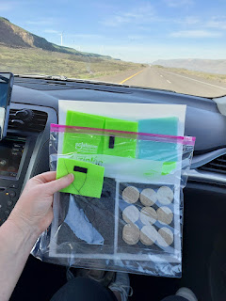

This is the original idea that I found on Pinterest. While I'm copying several features, I will aim to be original in a few aspects.

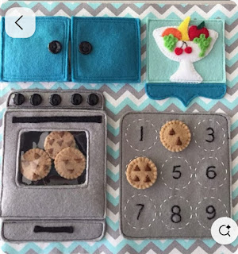

Somewhere along the Columbia River, we got pulled over for speeding in a construction zone. Scott thought the construction zone was done, but I guess it wasn't . . . The officer was very nice and ended up letting us go without issuing a ticket. Yay!

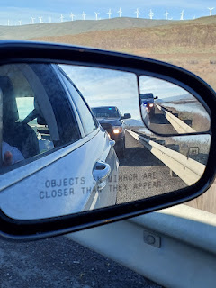

Mt. Hood was especially beautiful in the distance, with all the white snow covering it . . .

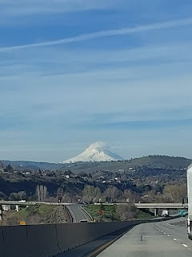

I convinced Scott to stop briefly so we could see Multnomah Falls. He didn't realize at first that it was right next to the freeway AND that the waterfall cascades down a whopping 620 feet. He ended up being quite impressed and was glad that we stopped to see it. Plus it was really nice to get out of the car for a few minutes. We hiked up to "Benson Bridge" and back to the car in about 25 minutes. (This also included a potty stop and lots of pictures)

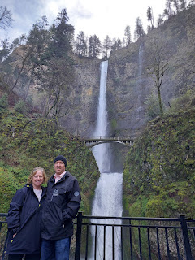

Video of the falls before we went up the trail: (8 seconds)
https://photos.app.goo.gl/ZxtW9uNDvrztmekZ9

Video of the falls from the bridge: (4 seconds)
https://photos.app.goo.gl/UorqZiL7M5sduHuc7

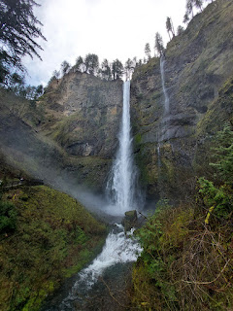

A short time later, we arrived at Amber and Weston's home in Lake Oswego. It was too early in the day to check into our hotel down the street, so we left our luggage inside their apartment while we all went on a little adventure to see the cherry blossoms in full bloom. The girls wanted to ride in our car, of course, so we cleared out the back seat for them. :)

Amber and Weston drove separately, but we all eventually found some parking down by the Willamette River and the Riverfront Park. Gwen and Scott had fun zipping all around on the scooters, while Abby and I held hands and just walked a more leisurely pace. We chatted about all kinds of things as we went along, and from time to time, Scott and Gwen would circle back to check on us.

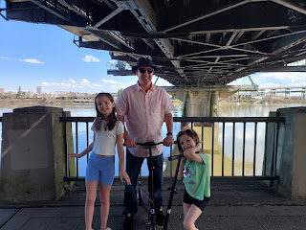

Abby, next to the Willamette River . . .

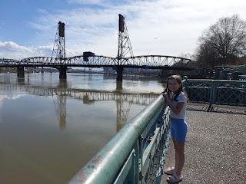

We paused at one point to watch a couple of worker guys in their cherry picker "crane" that was angled UNDERNEATH one of the bridges.

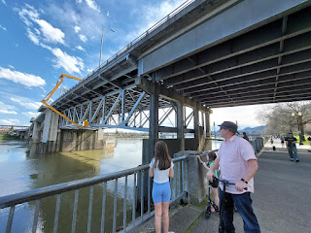

The afternoon started off very beautiful, with blue skies and upper 70's in temperature. But Amber had also been staying on top of the weather forecast, and she had warned us that a storm was due to roll in at some point.



All the blossoming trees were SO PRETTY!! Everyone else must have thought so, too, because the greenbelt along the river was packed with people from all different walks of life.



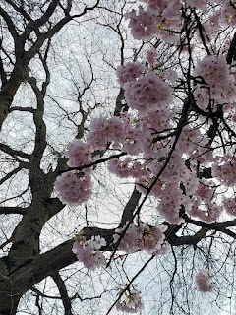

Abby, Gwen, and me . . .



Scott took this photo of Abby and me . . . such a sweet moment . . .

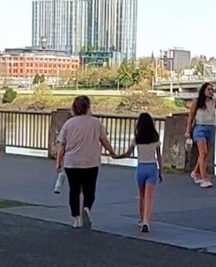

Amber's family has a favorite restaurant called McMenamins. They have several branches all over Oregon. They also have a "passport" that you can have stamped as you visit the various locations, which then leads to rewards (like a free appetizer). Weston chose a McMenamins near the Riverfront Park for us to have an early dinner together. It turned out to be the smallest one he'd ever been in - about the size of a small pub. But the food was great!

Several plants hung below a large skylight window, soaking up what sunshine that they could. They seemed to be very happy up there!

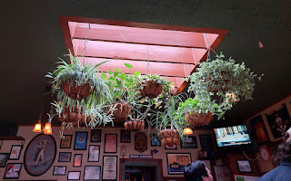

I ordered the Portland sandwich - with turkey, swiss cheese, mushrooms, etc., along with an au-jus dipping sauce and a side salad. It was AMAZING.

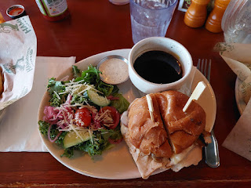

Scott, Abby, and Amber . . .

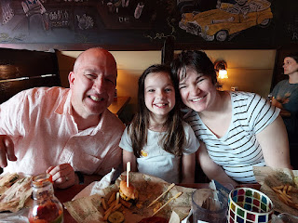

Weston, me, and Gwen . . .

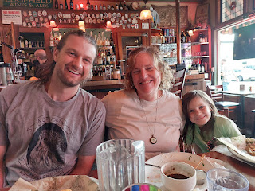

The rains did come eventually, but not the golf-ball sized hail that had been predicted. We were grateful, especially since our car was parked outside the hotel without any protection.

Day 3:
Scott had not been to a temple since last October when we drove down to the Rome Temple during a 4-day weekend. Our hotel was just 5 minutes (or less) from the Portland Temple, so we went first thing the following morning. (Thursday, March 27th)

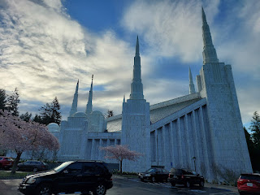

The trees and flowers in bloom were - - - gorgeous, edifying, awe-inspiring, jawdropping, exquisite, and every other possible descriptive word that means BEAUTIFUL.

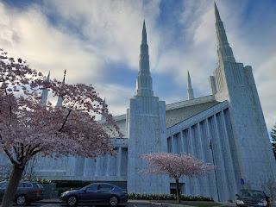

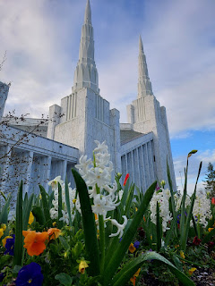

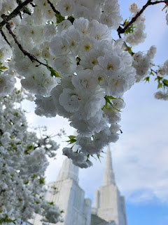

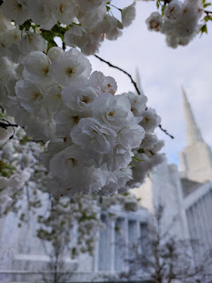

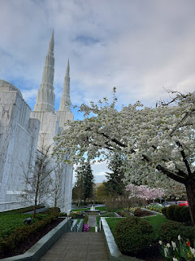

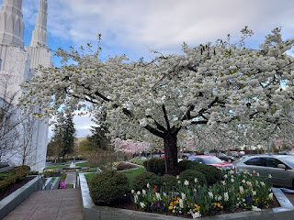

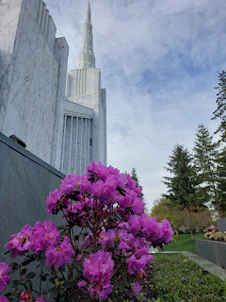

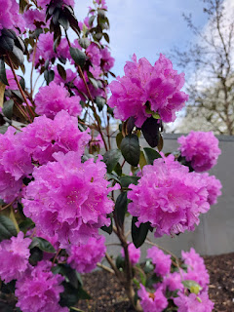

I had a really special experience in the temple this time. I had gone with a little bit of a heavy heart because I had seen something really disturbing on the greenbelt the day before, and it still continued to haunt me. Plus, I had another matter that was weighing on my mind. I said a prayer before we left the hotel, with the hopes of receiving some peace and wisdom and reassurances.

I haven't cried that much in a long time, but I had a good cry that morning in the temple. I felt many reassurances from my loving Father in Heaven during the temple session, and I felt like my burdens had been lifted and lightened by the time we left.

God's plan for us is very simple, but it's WE who make it more complicated. Being reminded of the simple nature of His perfect plan - for our learning, our growth, our eventual exaltation and neverending joy - was very helpful to me in the temple that morning. Sometimes the details of everyday life crowd or even drown out the beautiful and simple plan that is truly intended for us. We are all children of God, and each is divine with exceptional potential. He loves each of us with all the fervor of a kind and generous Father, no matter who we are, no matter what we're doing or not doing, with all of our flaws and sins, and no matter what we look like or how much money we have in our bank account.

The cherry blossom trees gave our car a nice layer of blossoms that made me feel like we were heading off on a honeymoon, ha ha.

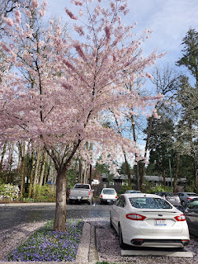

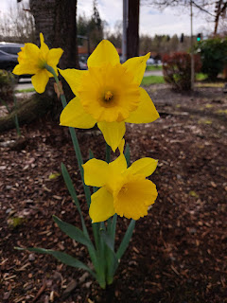

We met up with Amber and the girls and drove down to Salem in one car together. There were a few items to pick up from my Uncle Mike and Aunt Suzy, so we set up a time to visit at their home. When Suzy invited Gwen to come sit on her lap, she wasn't shy at all! Suzy pulled out some containers of soft clay in bright colors that Gwen could play with while the grown-ups talked.

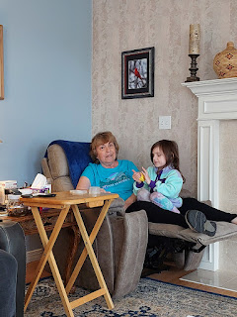

A little later, Suzy began showing us Grandma Lillian's jewelry. She and my Uncle Mike had recently asked me if I would be willing to find a way to notify all of the grandchildren and to let everyone have a chance to choose something. Suzy had already sorted everything out in a very organized fashion, including the placement of each pair of earrings into individual clear plastic jewelry bags. I had no idea Grandma had so many pairs of earrings!!

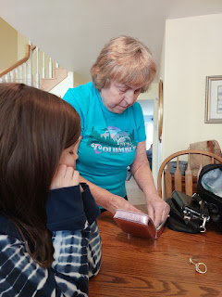

I instantly recognized this necklace piece because I remembered seeing Grandma wear it many times over the years . . .

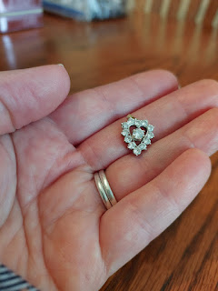

Abby enjoyed trying a few rings on with us . . .

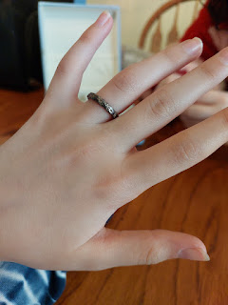

Mike, me, and Suzy . . .

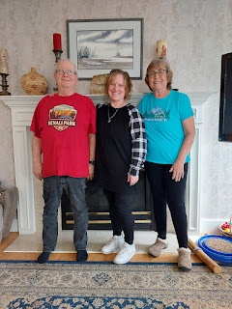

Suzy joined us for lunch at one of Grandma Lillian's favorite sushi restaurants in Salem, called Momiji.

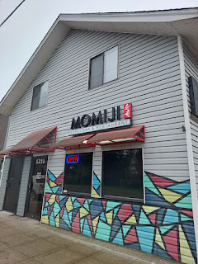

The girls ordered some shrimp nigiri with either edamame or rice, while Amber and I ordered some sushi rolls. Scott's not much of a lunch eater (he eats a big breakfast + a big dinner), but Suzy ordered a teriyaki chicken bento box.

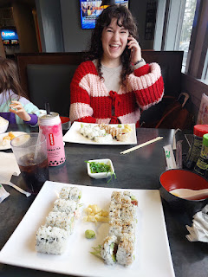

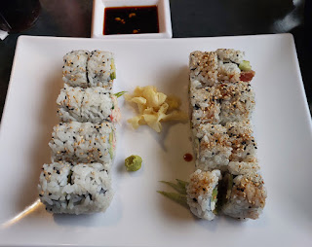

Per Suzy's suggestion, we took the girls to the Old Fashioned Carousel at Salem's Riverfront Park after lunch. Amber bought them tokens for 2 rides each and they had a great time.

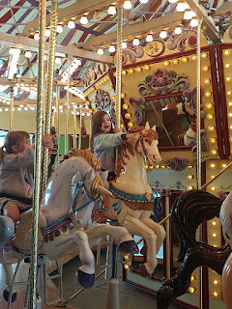

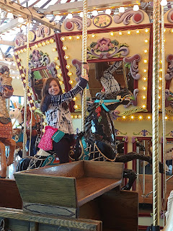

A "forced" hug-your-sister-so-I-can-take-a-photo moment, ha ha . . .

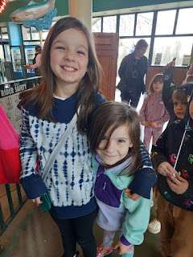

The detail work on the horses and other animals were quite impressive. A lady named Hazel Patton helped bring all of this to fruition.

"The carousel was inspired by community activist Hazel Patton. As the story goes, she was visiting family in 1996 in Missoula, Montana, which built a carousel on its riverfront. She was struck not only by the ornate beauty of the carousel but by how it had united the community, and she believed the citizens of Salem could create the same magic. Her vision sparked the imagination and creativity of the community, and a team “was formed to organize the effort, get approval from the city, and raise $2.1 million. Volunteers began carving horses in 1997 in a space on the second floor of Liberty Plaza. Salem Peace Pony was the first to be carved." (From the Statesman Journal -
https://www.statesmanjournal.com/story/news/2017/09/23/six-things-know-salems-riverfront-carousel-dream-team-oregon/693498001/
)

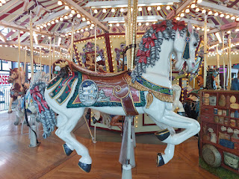

Next, we visited the State Capitol Building of Oregon. There was a lot of construction going on outside, along with a fair amount of rain coming steadily down. We took a quick picture and then moved on to the gardens across the street.

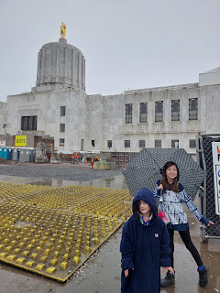

Every bit as beautiful as the cherry blossom trees up in Portland, the pathway around the gardens in Salem had an additional festive feature of several hanging ornamental lanterns.

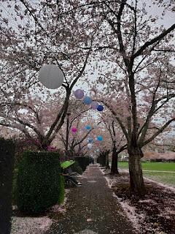

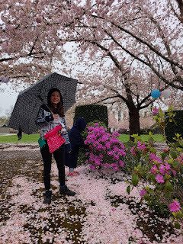

Scott, meanwhile, had gone off in search of a gas station while we tromped around in the rain. When we were done splashing around, we sent him a "pin" to our current location, and in a few minutes he arrived to scoop us up. The girls were good sports about walking around in the rain the whole time - - maybe living in Portland has made them more patient with inclement weather.

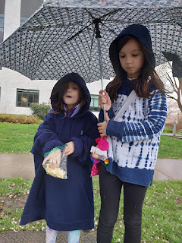

Last stop of the day - - an antique store in Canby, Oregon.

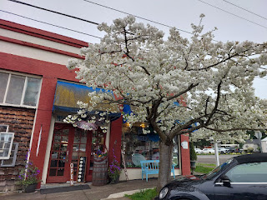

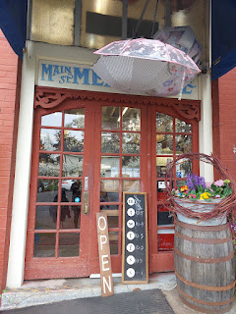

Many years ago, when Grandma Lillian lived in her little RV trailer in Aurora (which is very close to Canby), she took me "antiquing" in Canby. She drove us on the back roads to get there, which are always so beautiful and foresty, and I learned how to look for certain things in the stores under her unassuming tutelage. She showed me how to look on the underside of china sets in order to learn where they were made, and therefore discern their potential value. She helped me choose a set of teeny-tiny serving forks that day, and they have been a massive hit in our family ever since.

In fact, when my granddaughter, Gwen, was 5 years old and her family was living with us at the time, she loved using those tiny forks for just about everything. She'd use them to eat her sliced hot dogs, cut-up strawberries, diced avocados, you name it. One day, she said to me: "Mimi - - do you have some tiny forks in Italy, because I want to use them when we come visit you." I immediately went in search of another set of tiny forks so that I'd have some in Italy for her. XOXO

This is the kind of photo that I love to send to the kids in our family group chat. It's usually so weird and disturbing, that it tends to spark some hilarious reactions.

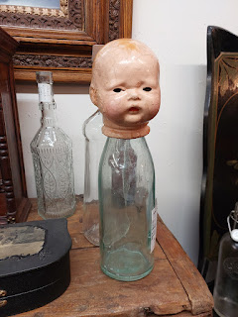

Because we arrived just 30 minutes before the store closed, Amber and I decided to split up with the two girls, while Scott had some quiet time in the car across the street. She took Gwen with her, and I had Abby with me. We had the best time wandering around and looking for something that "spoke" to us. Abby found her item almost immediately. (see below)

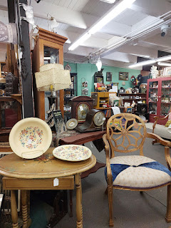

Abby put this cute little hat on and we found a nearby mirror for her to see how she looked. Adorable. That's how she looked.

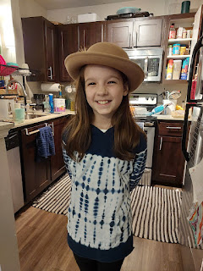

It took me much longer to find something that I liked enough to want to buy it. Eventually I came across a beautiful lap-sized quilt with a muted medium-green trim that framed 9 smaller squares with Holly Hobbie dolls in each one. It felt like something Grandma would have picked out if she had been there. I remember how she used to make my sister Charmaine and me doll clothes for us to play with. I used to go with her to quilt shops regularly in Oregon, too, where we'd ooh and aah over the pretty quilts on display. I remember she was working on a Sudoku quilt for one of her boys (Tim, maybe?) and we went to several places before she found someone who could put the finishing touches on it for her. She also kept calling it "Soduko" instead of Sudoku.

Amber made some lemon chicken and roasted potatoes for dinner that evening, and then we celebrated Abby's birthday a few days early. Her parents gave her a Polaroid camera. Technically, it is very similar to a Polaroid, but it prints on less expensive photo paper inside. She's already gotten really good at taking pictures.

I gave her (on behalf of both Scott and me) a scrapbook supply kit: a scrapbook binder with several sheet protector pages already loaded with colorful and bright paper; a huge variety of stickers to decorate with; some scalloped-edge scissors; and a few stamps with about 6-7 colors of stamp pads. I fit everything into a cute tote box so it can all be contained in one place. She was over the moon with the two coordinating gifts of a camera and a way to scrapbook her photos. I'm so happy that she was so happy!

While Amber was making dinner earlier, I picked up everyone's favorite donuts at a place called Sesame Donuts. We used Abby's as a substitute for cake. (They all left the day after we did to head down to a Whitworth Family Reunion where Weston's parents are running a girls camp near Cloverdale, CA - and they didn't want a bunch of leftover or wasted cake.)

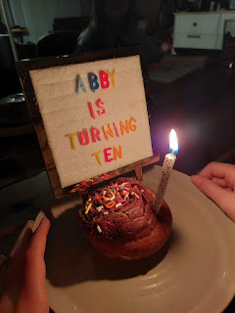

The look on this sweet girl's face . . .

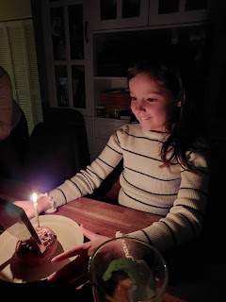

The very first photo she took with her new camera was of Scott and me sitting on the couch next to her. She then promptly added it into her new scrapbook, choosing the world map page to lovingly place us. What a perfect spot!

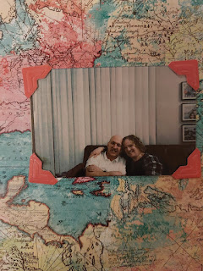

In my next post, I'll share more about our experience at the Italian Consulate today. Tonight, it's time to get ready for bed because we fly out to Minneapolis tomorrow to visit Jack and Maisie!! Yay!!

