Sardinia: Part One
Sardinia!! We spent a little over 3 days on the island over Valentine's weekend, gobsmacked by how beautiful everything was. We certainly "earned" our weekend getaway, after all the countless hours that we put in to get us moved over to the new house.

At the end of my last post, Scott was building us a sturdy new dining table. Now it sits elegantly in our new dining area, surrounded by several newly assembled chairs. With extensions for each end of the table (in "secret" compartments that are tucked underneath), we can comfortably fit 8 people, with the potential for 10 or more. Yep, that's an invitation for you to come on over to see us in Italy!

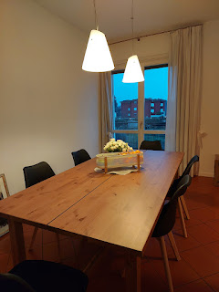

I did 99% of the cleaning over at the old place, with the exception of this gross task . . . We have used mesh screens over the shower drain hole in the master bathroom for the past 3 years, occasionally swapping it out for a new one. They helped to prevent hair buildup in the drain (I'm sure it was mainly for Scott, with all of his long locks), but it left some gummy adhesive mess behind. Scott worked on that disgusting residue with a razor blade, scraping it all off so that the shower would be more presentable for the next tenants.

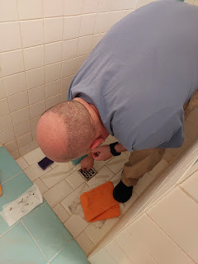

Meanwhile, I vacuumed the entire house with our new vacuum (it's much faster in cleaning up the dust bunnies!), I mopped everywhere, dusted, wiped everything down with Clorox wipes, cleaned all the bathrooms and showers, sanitized the kitchen - leaving it way more sparkly clean than when we first moved in originally, and gathered up all the last-of-the-last miscellaneous items that never seemed to end.

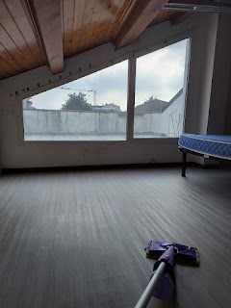

CFMO (the military furniture guys) came to pick up all the loaner furniture yesterday (Wednesday). Up until then, most everything was just pushed into the corner of the living room . . .

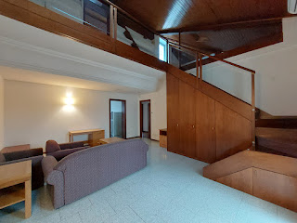

I also thoroughly cleaned out the fridge and the oven. The fridge and the dining table/chairs also belonged to the Army, so those were cleared out, too. We had also borrowed a desk for Scott, a washer & dryer, nightstands, and wardrobes for me. The bed in the upstairs guest room belonged to the Army, too.

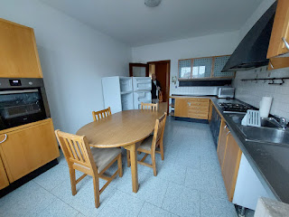

Every time I'd drive over to the new house, I found it to be such a peaceful and joyful place to come home to. I have really enjoyed watching the large flock of egrets that forage in the field behind our house. We also saw a HUGE bunny rabbit hopping through the field one day, too, although I haven't seen him since.

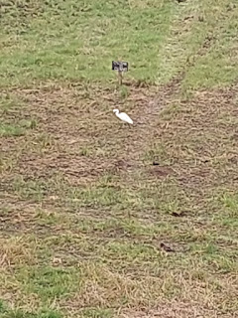

Video of the egrets: (12 seconds)
https://photos.app.goo.gl/ooFPdEgxzZTVyCWV6

I haven't made this soup in quite a while, but man was it good to make it again. It's made primarily of "riced" cauliflower, with some onion and garlic, bacon bits, broth, and some shredded cheese and green onions on top. As I was licking my bowl clean, I commented to Scott that I wished I had two stomachs so I could eat another bowlful . . .

Here is the recipe link:
https://iowagirleats.com/bacon-cheddar-cauliflower-chowder-a-low-carb-alternative-to-baked-potato-soup/

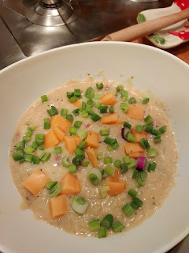

After the old house was 100% cleaned out, we made preparations to leave town the following day. I met up with my friend, Kelly Campbell for a little visit that morning before I flew back to the U.S. a few days later. Her husband, Trevin, is a licensed therapist for military personnel and their family members. Kelly is super fun - and is an excellent (and very thrifty) shopper. If I ever need to find something, she's one of my go-to people to ask for recommendations on where to go. We met at the Caffe Amoro for some cioccolata calda ("chockolotta kahlda" - or hot chocolate). This time, the waitress delivered the whipped cream in a separate dish instead of piled on top. Italian hot chocolate is thick, almost like pudding. It's seriously SO GOOD.

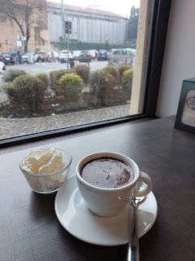

Kelly and me . . .

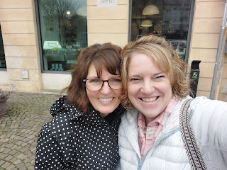

Scott slipped out of work a little early, around 2:00 p.m., so we could start our drive to the Milan Airport, which is about 2.5 hours to the west. We had found a good deal on a nonstop flight to Olbia, Sardinia and it meant we needed to fly in and out of Milan. We arrived with plenty of time to enjoy the sunset as we walked up to the terminal.

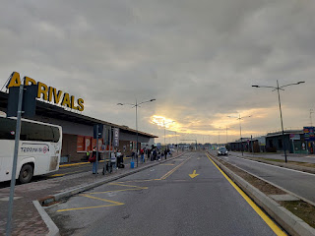

We arrived in Olbia around 9:30 p.m. on February 13th, after a short one-hour flight. There is a large island between mainland Italy and Sardinia, called Corse (or Corsica). It's owned by France! We got a better view of it when we flew home on Monday during the daytime.

I was surprised to see that when we booked a rental car - and we selected a Fiat Panda - this ended up being the exact car that we got! Ours was the grey car next to this bright and snazzy periwinkle car.

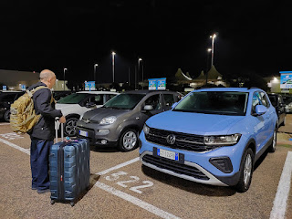

It was only a 4 minute drive from the airport to our lodging for the night: the Jazz Hotel. Scott was happy to see that it was right across the street from a large Lidl grocery store.

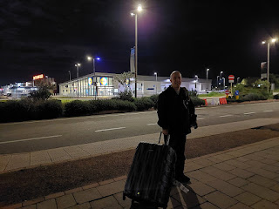

Day One:
(First full day) (Also Valentine's Day)

After doing a great deal of research on where to go and what to see in Sardinia, I quickly learned that it would be best to stick to one main area - either the north or the south. Since we were flying into Olbia, which is up on the NE side of Sardinia, it made good sense to look for things to do in the north. It takes roughly 3 hours to get from Olbia down to Cagliari, but we didn't want to spend that much time driving when we only had a short weekend there.

I found this local tour guide's website to be extremely helpful:
https://goaskalocal.com/blog/sardinia-travel-guide

He breaks down the four main regions of the large island and makes it much easier to choose where to go and what to do. We decided to spend most of our time over in the NW portion, in Porto Torres and the surrounding areas. Therefore, we only spent a morning at the front end and an evening at the back end in the Olbia area, to be closer to the airport.

We visited a beach called Spiaggia de Bahas . . .

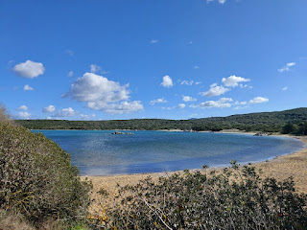

We encountered a small section of flooded road on the way: (13 seconds)
https://photos.app.goo.gl/2Jwtq7qSZiCSjUKc9

Originally, we had set out to drive to the Spiaggia ("spee-AW-juh") di Cala Sabina, but part of the road was closed off for the season. So we parked the car and walked along a dirt path to get to the Spiaggia de Bahas instead.

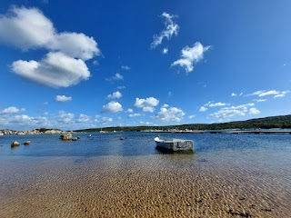

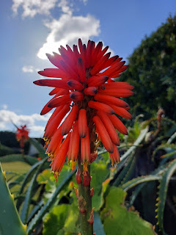

There was a long dock with only a couple of boats tied up, and a seasonal restaurant on the shore (closed for now though).

Video of the small bay: (16 seconds)
https://photos.app.goo.gl/5y8c9ZmF747Sae118

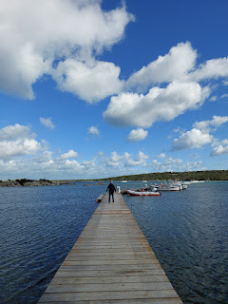

The weather report had warned us of an extremely windy day, but my oh my, you had to really brace yourself on the dock so you wouldn't go careening off . . .

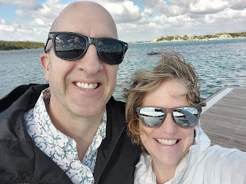

Scott had been holding my tall metal water bottle while I was busy taking photos, and when he set it down on the dock for a moment, the wind sent it sprawling. Luckily, we were pretty quick, too, and we saved it before it rolled into the sea.

The colors of the Tyrrhenian Sea were exquisite! Sardinia offers a smattering of aquas, teals, navy blues, and everything in between.

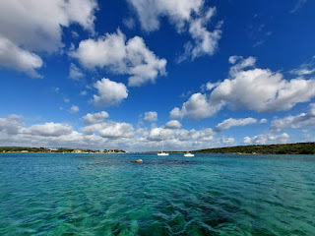

The photo above and the photo below were all part of the same bay.

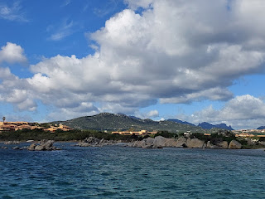

Another view of the same bay while out on the dock: (7 seconds)
https://photos.app.goo.gl/HkL695Q4SfRxz72p8

I've never seen a succulent/cactus relation like this before, with such a dark maroon bloom . . .

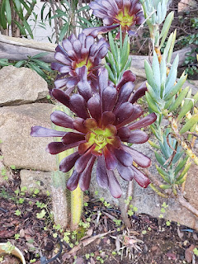

With yellow consistently being one of my top two favorite colors my entire life, I was quick to admire these delicate little flowers. (I love the portrait mode on my cellphone camera, too.)

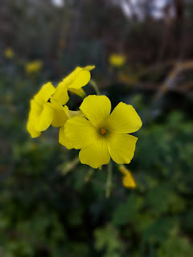

We didn't spend a whole lot of time on this beach, mainly because of the wind. It was kind of ridiculous, ha ha. On our way across to Porto Torres on the northwest, we passed through a variety of scenery. It reminded us quite a bit of Cyprus, to be honest.

*Speaking of which: there was a little issue with my Cyprus post being seen when I tried to publish it a few months ago. Scott had accidentally published it before we were supposed to go "public" with the fact that he was there, so when I WAS finally ready to share it, unfortunately it just slipped back into the same month of when it was originally published (Valentine's Day 2024). If you want to read it, you'll have to scroll back through the list of weekly posts for the past year until you get to it.

As I was saying, on our drive across the top of Sardinia, we saw a landscape buffet: ocean views, curvy back roads over the mountains, groves of trees (including the cork tree), and boulders that reminded me of the Sierra Nevadas.

Someone even built their house upon a rock . . .

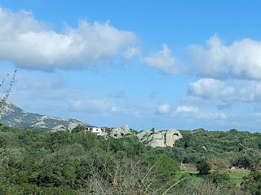

On a portion of the windy and curvy mountainous road, we passed these cows quietly grazing next to the road. Scott dutifully found a place to safely pull over so I could walk back and talk to them. :)

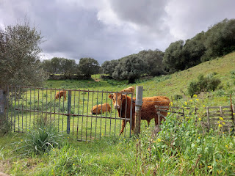

Our conversation went something like this:

Me: Buongiorno! Comestai?
Mr. Bull: (startled upward jerk of his head from the grassy lunch he was in the middle of) (*no comment*... just a blank stare, as if to say, "How in the heck did you find us clear out here?)

Video of Mr. Bull and his buddies: (10 seconds) As you will see, he wasn't in the mood for conversation.
https://photos.app.goo.gl/4VLS9SaHbov9b8qe7

At one point, I really needed to go to the bathroom. Lucky for Scott, he's a male. He found two places between the windy bay that we had visited earlier and Mr. Bull's meadow, where he "took a walk" into the trees. However, I 100% prefer an actual toilet. So I looked for a restaurant nearby where we could grab a bite to eat AND use their toilet for free. As it turned out, we were less than 5 minutes from a lovely restaurant that was rated 4.7 out of 5 stars. Voila!

The name of the place is Lu Maestrali, located just outside the tiny town of Viddalba. Scott ordered a saucy pasta dish with beans and sausage. He shared a bite with me and it was really yummy.

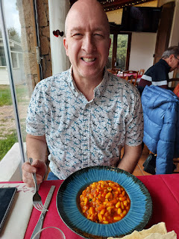

I ordered what I thought was going to be more of a soup . . . but it turned out to be something more like a mac & cheese casserole with breading, along with a nicely browned top crust. It was actually incredibly delicious, even if it was loaded with more carbs than I had anticipated, ha ha.

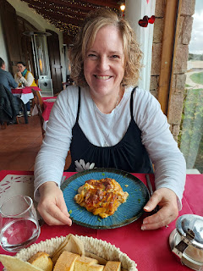

While we waited for our food, we enjoyed looking out the sunny window next to our table, where I noticed a black and white cat cleaning itself and relaxing.

Video of the cat: (10 seconds)
https://photos.app.goo.gl/jzd4ou9fFfESQco76

Our waiter was a young man with a delightful exuberance and enthusiasm for life. He spoke somewhat comfortably in English, even though it was choppy at times. Certainly it was more than I could say for my Italian capabilities!! Picture lots of gesturing and expressiveness as he would animatedly say to more than one of the lunch guests, "Relax . . . it's Sardinia!" He told us it was his biggest dream to go to America. When I asked where he wanted to go in the U.S., he promptly replied with gusto, "Detroit!!" Um, okay . . . that wouldn't be my first choice (or my 43rd choice). I wondered what got him so excited about Detroit, but he had trouble trying to explain himself in English, so I guess we'll just have to keep wondering what is so special about Detroit . . .

To break up our drive to Porto Torres, we veered off the beaten path a little bit in order to visit an unusual site. It sprinkled and drizzled on our way, but occasionally some blue skies would peek out briefly, even though it was still super windy.

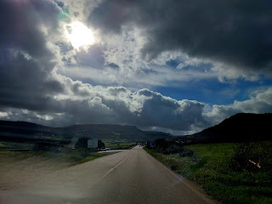

We passed a shepherd who was rounding up his sheep and sending them off and beyond the big house, perhaps into the pasture on the other side.

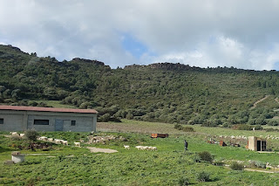

This unusual and unique rock formation is called, "Roccia dell'Elefante". Can you guess why?

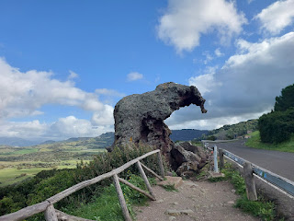

There were a few holes and a cavern deep inside the Elephant . . .

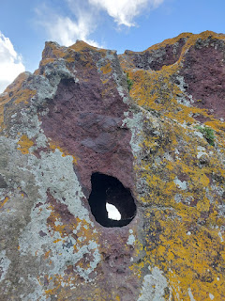

He was super cute. Don't let those blue skies fool you though . . . the winds were about 35 mph (steadily) and the temperatures felt extremely cold because of it all. Scott practically ran back to the car for cover, lol.

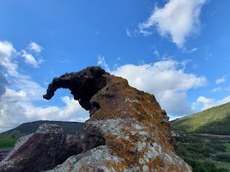

From there, we drove along the northern coastline for about 30-40 minutes.

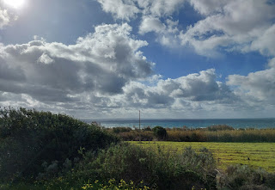

We passed through a cork tree forest or two as well.

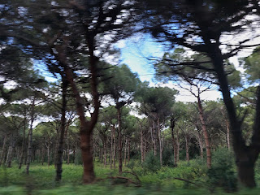

Per AI: In Sardinia, cork trees are used
to make many items, including wine stoppers, flooring, furniture, and clothing
.
Cork is the outer bark of the Quercus Suber tree, which is common in the Mediterranean.
Uses
Wine stoppers
:
Cork is the primary purpose of cork trees, and is used to seal wine bottles
Flooring
:
Cork is used to make floors and walls
Furniture
:
Cork is used to make stools, benches, and other furniture
Clothing
:
Cork is used to make clothing, including skirts, shawls, dresses, jackets, and accessories
Containers
:
Cork is used to make containers for food and beverages, such as trays and ladles
Insulation
:
Cork is used to insulate roofs and walls
Fishing
:
Cork is used to make floaters and line holders
Nativity scenes
:
Cork is used to make nativity scenes
Sardinia is the leading producer of cork in Italy, producing about 80% of the country's cork.
Cork has been used in Sardinia since the Nuragic era.

We paused briefly to hop out and stand on one of the many beaches along the northern coast.

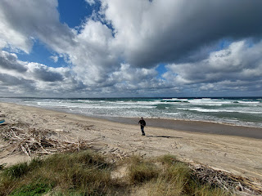

Other than the unique colors of the sea, it reminded me a little of Fort Bragg, CA and all the times we've been over to that beautiful and rugged coastline.

Video here: (12 seconds)
https://photos.app.goo.gl/NGzteHmZwHCguocx6

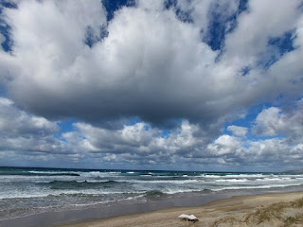

A few minutes later, we arrived at our AirBnB for the next 2 days in Porto Torres. It was located right on the most northern "point" of a small jutty-outy peninsula in an area known as Balai in Porto Torres.

This is the listing for the property on AirBnB:
https://www.airbnb.com/rooms/848391851292018699?source_impression_id=p3_1740067982_P396sqpGFKgGGfU8

It was absolutely perfectly located. Ocean views, a paved walking trail across the street, close to shops and restaurants, etc. And it was only $70/night! We had a full kitchen, too, where we cooked our own dinners each night. (We ate out for lunches though.)

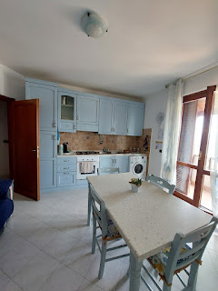

Views off the balcony . . .

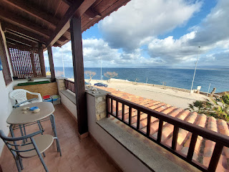

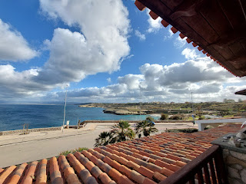

This beautiful statuette was sitting on the bedroom dresser . . .

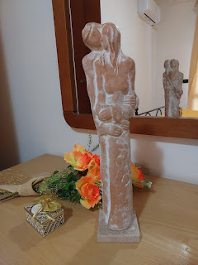

The nearby cove that we could see from the balcony is called Spiaggia di Balai. It was only a 3 minute walk to get there, so we ventured over before the sun went down.

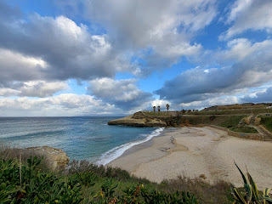

It was still very cold and windy, but the cove offered some protection from the stiff breeze.

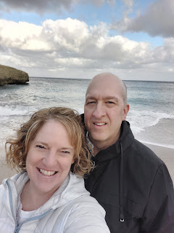

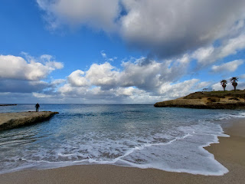

I found an abandoned shell that I hauled back to Vicenza in my suitcase . . .

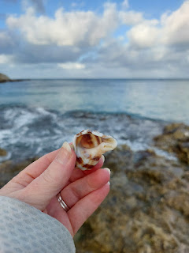

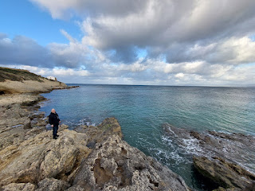

Video of the cove: (15 seconds) *Note that you can see the church on the far right in the video.
https://photos.app.goo.gl/39c9y7zjkvvq86PY7

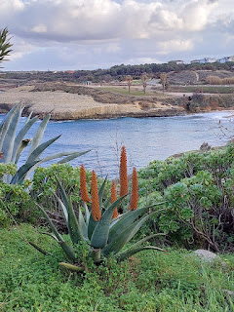

On our way back to the AirBnB, we took a peek at this old abandoned church, known as Chiesa di San Gavino al Mare. It sits on the edge of a small cliff and is right across the street from where we stayed.

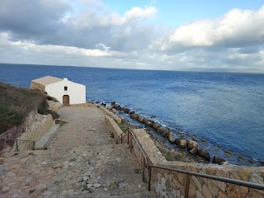

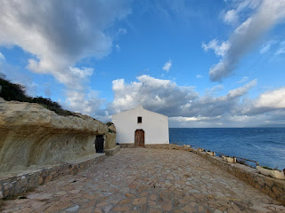

This church was built in 1850 and was done so primarily to commemorate the place where 3 Christian martyrs were buried:
Gavino
: A soldier who was martyred in 304 AD because he refused to sacrifice to the Gods. Also known as Gavin and Gavinus, he was the commander for the Roman garrison at Porto Torres and was converted to Christianity by 2 priests (Protus and Januarius).
Protus
: A Christian priest and bishop.
Januarius
: The deacon for Protus.
Apparently, Gavino was tasked with arresting Protus and Januarius and was supposed to haul them off to jail. Instead, he was so impressed with their courage, that he asked for their prayers and then he allowed them to escape. The next day, Gavino was arrested for failing to to produce his prisoners. He declared himself a Christian and was subsequently beheaded on the shore.
After Protus and Januarius learned that Gavino had been martyred, they returned to the city, were arrested themselves, and then also beheaded. Sheesh.
Next to the church are some very old caves, believed to have been connected to multiple churches during the 5th - 7th centuries. Hundreds of graves have been discovered here, and there are some remnants of ancient carvings on the walls. The church is typically closed all year, except for during the month of May. This is when visitors and locals can walk through and participate in a remembrance of the three Christian martyrs.

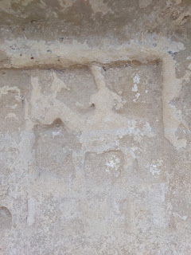

When we shared the photo of Scott and me with our family, from earlier when we were down in the cove of Spiaggia di Balai, our son Jacob asked for the latitude and longitude of our location, ha ha. It was easy to send the info to him because Google photos saves the details when you take a picture, as long as you have your location mode turned on when you are taking said photos.

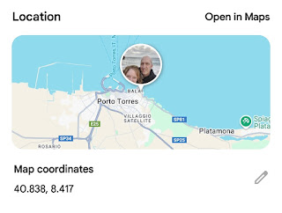

We stopped at the Lidl grocery store for some dinner supplies. Scott wanted to build a hearty meat-topped salad, while I wanted some soup and sardines, ha ha. I figured that I should probably eat some sardines while I was in Sardinia. They had a few flavors to choose from, and I ended up choosing this one.

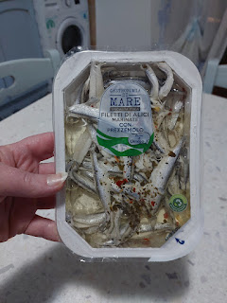

It was in a vinegar-y marinade, with parsley and a few other spices. I was nervous to try the first one, but once I ate him and realized it wasn't half bad, I munched on several more. I had to stop eating them, though, because historically if I eat too much of something with vinegar or lemon juice or a high amount of acidity, then I am more likely to end up with a cold sore on my lip. So I stopped. But they were actually reasonably tasty. Would I eat them regularly? Probably not. But I didn't hate them either.

Also, we found two comfortable jackets at the Lidl. They always have a section in the center of their stores with all kinds of random things. Everything from clothes, to bedding, to dishes and appliances, to tools, and seasonal gifts for the next holiday. Scott had only brought a thin windbreaker jacket to Sardinia (plus he had only packed short sleeved shirts), so he needed another layer to combat the cold. He found a nice fleece jacket to wear under his windbreaker and then he was much happier. We also found me a super nice windbreaker with some warmth on the inside. Scott's jacket was $14 and mine was $17. Way to go, Lidl!

I'll share more about our relaxing weekend in Sardinia next week. I am still working through some lack of sleep issues from flying back to Idaho Falls on Tuesday. I added up the miniscule amount of sleeping hours that I got between Sunday, Monday, and Tuesday of this week, and I came up with just over 10 hours for 3 days. Gross. I did really well yesterday (Wednesday) but today (Thursday) I've had a constant headache the whole day. Right above my right eyebrow . . .

I'll end with a few photos of the grandchildren.
Prepare yourself for a Maisie Fest
. XOXO

Jacob recently sent us this photo of Maisie, explaining that in a matter of seconds she went from Point A (the pink stick figure) to Point B (her current location).

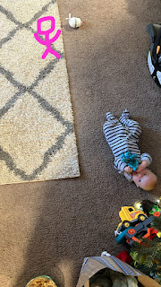

When Scott and I asked if she had rolled or scooted, he sent this as a follow-up . . .

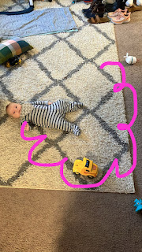

She is such a little red-head! And she likes to sit up with some support these days.

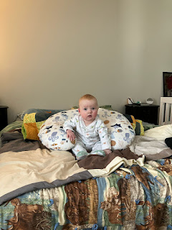

Jack and Maisie hanging out together . . . Jack is drinking his milk while Maisie appears to be eating her bib, although I'm sure she'd much rather be eating the crinkly package of baby wipes that she's holding!

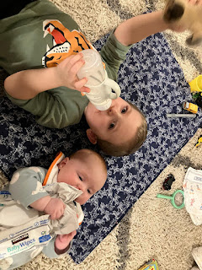

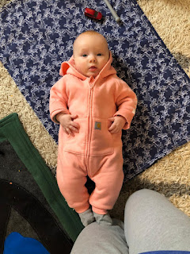

Jacob sent us this photo of Maisie along with a comment that she may have outgrown this sleep sack outfit . . .

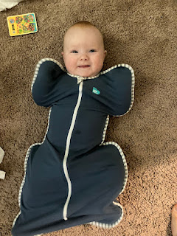

Jack and Maisie - in the restaurant area of their local IKEA store . . . the Swedish meatballs were the giveaway, ha ha.

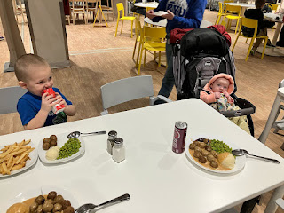

Video of Maisie trying her darndest to drink out of her mom's water glass: (10 seconds)
https://photos.app.goo.gl/RYMz5rBvEi8LfXCe8

Video of Maisie "eating" something that's very bright green (possibly peas?):
(18 seconds)
https://photos.app.goo.gl/1a4WvdZTCgrHGuxMA

Her little smug look, LOL. She is having so much fun trying new foods these days. What a cutie.

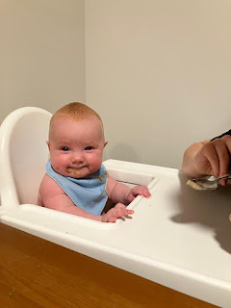

Meanwhile, up north in Portland, Amber's family got quite a bit of snow!! Abby was thrilled to run outside and make some snowballs. She has never shied away from the cold as long as she can play in the snow!! (I can't believe she's almost 10 years old...)

