Snowtastic? Or a Snowtastrophe?
I was stuck at home for 2 days (Friday and Saturday) because I would have inevitably gotten stuck as soon as I backed out of my driveway and onto the street . . . I waited for the snow plows to come through for more than 48 hours. My wish finally came true when I checked out the window on Sunday morning. Hallelujah and can I get an Amen?!!

Friday morning, I woke up to a solid 3 inches of fresh snow on the ground. That was just Round One. I fired up the snowblower and cleared my driveway, the front sidewalk and Ellen's driveway and her sidewalk next door. I used up all the fuel in the snowblower and then went and helped Ben Parkinson across the street with my shovel.

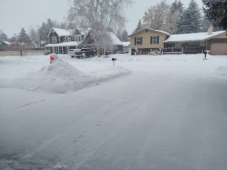

The snow just kept coming down though. Once again, you couldn't even tell that I had done anything.

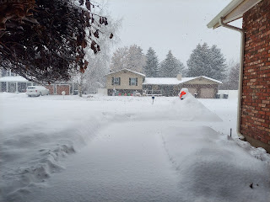

My back patio hasn't been shoveled once this winter and this is what it looks like currently.

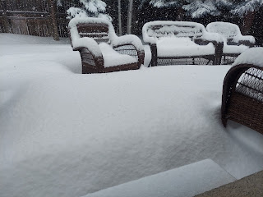

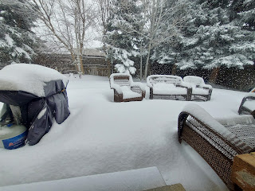

Ha ha, pretty soon all my patio furniture will be buried and invisible!!

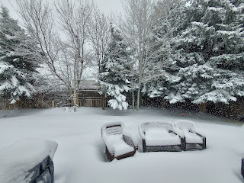

The snow came down constantly until 3:00 p.m. and that's when all the neighbors came outside to get to work.

I fired up that snowblower again, with a full tank of fuel. I cleared my property first.

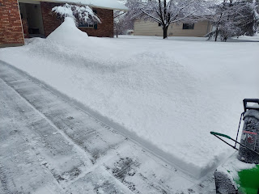

It was apparent that another 3 inches of snow had fallen. That makes a Grand Total of 6 inches of snow in a matter of hours!!

Once I cleared my driveway and front walks again, I went next door to the north. A single mom lives there with her two kids (11 and 9). I don't know if they even own a snow shovel, because I have not ever seen one leaning up in front of their house, nor have I ever seen any of them outside shoveling. The mom is a nurse and works during the day, and I'm sure she is tired when she gets home and then has to prepare dinner and help her kids with homework, etc.

Well, thank goodness for a snowblower, because otherwise I would have died trying to clear 6 inches of snow covering her double driveway and sidewalk!!

After I got done at their house, I went over to Ellen's (south side of my property) and got her all cleared out for a second time. Then, I noticed that all 3 vehicles at the Parkinsons across the street were gone. And their driveway was loaded with snow all over again from that second round. I figured that this was a perfect time to clear some snow before one of them returned home. I got about 85% of their triple driveway cleared before I ran out of fuel. And around that same time is when their daughter, Mady, pulled in from school. She parked carefully, so as not to run over the small areas that weren't cleared yet, while I ran across the street to get my fuel can.

However, when I filled up the tank and attempted to start up the snowblower again, it would not start. I think it was telling me that it was tired and that it just needed a little rest . . .

I hauled it home across the deep snow in the road, dragging it with all my might to park it in the garage for a rest. He was definitely the hero of the day!!

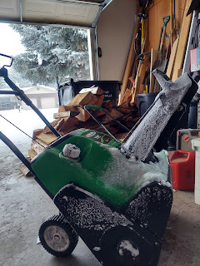

Mr. McGillicutty, who has slowly been declining in recent days, is now in hiding until spring arrives.

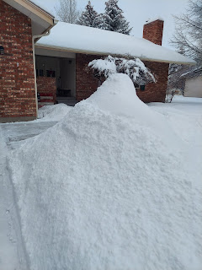

There are still some indications that he's in there somewhere . . .

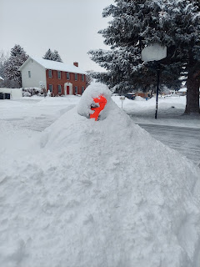

And the trees in the back yard . . . my goodness. They are so loaded down with snow that the big, heavy branches of the spruce trees are practically touching the ground . . . The song, "Do Your Ears Hang Low" comes to mind.

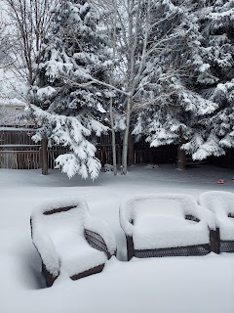

When all was said and done on Friday, my forearms were quite sore, especially my right arm. My snowblower is not self-propelled. I have to push it to make it move forward. It was most difficult to maneuver at the house next door (single mom) because I was attacking the whole day's worth of snow in one shot. But I'm glad I did what I did. The next day, I chose to do the bare minimum around the house so as to rest my arms as much as possible. And ibuprofen is a good friend, too.

Snowing in the front: (17 seconds)
https://photos.app.goo.gl/fh7Td3goAkeWjjqV8

Snowing in the back: (21 seconds)
https://photos.app.goo.gl/VSV5t1Kuu7mirvYi7

After the winter storm dumped all that fresh snow, the wind changed direction and we have the Canadian Arctic Freeze blowing down and making things more interesting.

This morning, getting ready for church, the app on my phone said it was 2 degrees, with 14 mph winds from the north, which equaled a wind-chill factor of -19 degrees. BRRR!!

Before I DROVE around the corner to church (because I certainly was not going to WALK), I had a little situation . . .

You see, my garage door has been acting up lately. (Have I already mentioned this?) It won't open from the button in my car, so I have to get out, unlock the front door with a key, walk through the house to the garage, and then push the button IN the garage to get the garage door to open. Then I can pull the car in. Every single time I run an errand, this is what I end up doing.

As I was cleaning out a section of my bedroom during my 48 hours of being stuck at home, I found what looked like another front door key. So, before I left for church today, I decided to try it out and see if it worked.

It did.

But when I tried to lock the front door again (don't worry, I was inside and out of the cold), the deadbolt lever on the door got stuck halfway. It would not budge. It was halfway deadbolted and I couldn't make it fully lock and I couldn't make it fully UNLOCK either. I knew it had to be because of the COLD.

I retrieved an extension cord from the garage, grabbed my hair dryer, and proceeded to HEAT up the deadbolt lock to see if that would fix it.

It did.

Amazing. I decided to leave the deadbolt UN-locked so that it wouldn't freeze while I was at church and then I'd be locked out . . .

I was so grateful that I had been prompted to try that key BEFORE church. Because if I hadn't, then guess what. I would have been out on that freezing cold front porch, trying to get into my house, and I would be stuck.

I'm going to call a garage door specialist tomorrow and set an appointment for them to come fix whatever is going wrong with my garage door not opening from the car. My mother-in-law, Coy, said they had a similar problem with their garage door recently, and it needed a new sensor. They haven't had any problems since.

After church, I got into the house just fine, thankfully. I shoveled a light layer of snow off the driveway, ate some lunch, and then headed up to Rigby to share Coy's birthday book that I had been waiting so eagerly for her to see.

This is how much snow is on my street after the snow plows came through last night.

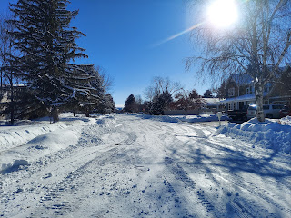

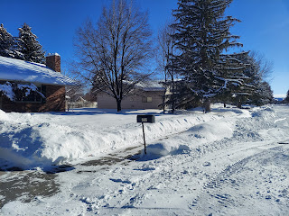

Just as we imagined, Coy loved her birthday gift. She oohed and aahed over all the pages, then began reading the pages in earnest.

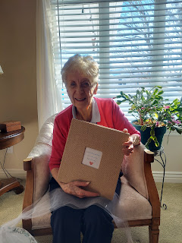

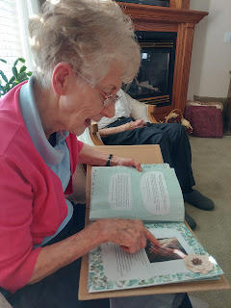

Some letters made her cry, others made her laugh, while some brought up memories from long ago that she had forgotten. Approximately 26 family members sent her a note or a full-page letter with their favorite memories of their mother, mother-in-law, and grandmother. What a beautiful thing for us all to pull together for. :)

Here is the link to the Google photo album with pictures of the book and videos of her enjoying it:

https://photos.app.goo.gl/wbMyHrh5bEm6JavW8

Her daughter, Bev, sent the most beautiful peach/coral roses to her as well. They were simply gorgeous!!





I hope that when I'm 90 years old, people will have a third of the amount of good things to say about me as they do about Coy. She has been an amazing mother-in-law, and the most wonderful grandmother to all of her many grandchildren. She has set the bar high, and I hope I can keep up with her purposeful and loving footsteps.

As for the rest of the week . . .

I made some jerky for Benson so that he will remember me and know how much I love him. This was always his favorite jerky in the whole world. More than once, he'd steal a bag of homemade jerky and eat over a POUND of it in a matter of a couple hours!!

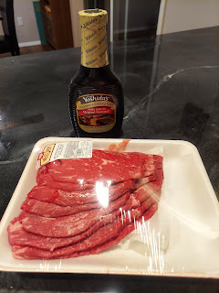

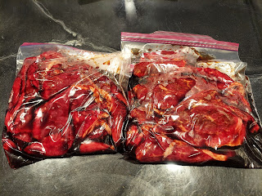

Benson's favorite jerky is also the most simple to make. Get some carne asada meat. I bought 4 lbs. this time. Put them in ziploc bags and divide a bottle of Yoshida teriyaki sauce/marinade into the 2 gallon-sized bags. Let it all marinate in the fridge for 24 hours, then place them on food dehydrator trays. Cook according to the temperature on the dehydrator, but in this case, it took about 18 hours to fully cook.

I don't trim any of the fat until after it's done drying. I take the large slabs of jerky and trim them into more manageable strips with my kitchen shears, snipping off any excess fat at the same time. Then I bag them up into quart freezer bags and hope that Benson won't eat them all in one sitting. ha ha

I forgot to get more photos of the rest of the process . . . whoops. Next time.

I mailed them out on Thursday, so he should get the motherload of jerky in about 2 weeks. :)

On Wednesday, it was a busy day. I had a mammogram and a bone density scan in the morning. So fun.



At 12:45 p.m., just 15 minutes before my scheduled haircut (that I've been waiting weeks for), Tessa texted me to say that a pipe burst in their building and the water had been shut off! She offered to still do my haircut, but she would only be able to use a spray bottle to wet down my hair.

I ended up hopping in the shower lickety-split to wash my hair before dashing over, since she had no way to wash my hair either. She did a fantastic job with the haircut, fixing a couple of problems that had occurred during my last haircut in Italy. I have some layers again (hooray) and she did a lot of texturizing and thinning in the bushiest areas.



I also made a big pot of soup for the sister missionaries that came over for dinner Wednesday night. They were shy at first when I asked them if there was something they were craving, but finally they asked if I could make Zuppa Toscana Soup, a favorite of theirs. You betcha!



When they first walked in, they immediately noticed the huge family tree that Amber painted on my wall a few years ago. They spent several minutes admiring each photo, turning them over to read about each person on the back. I think we spent about 25-30 minutes just talking about Scott's and my ancestors. How precious is that!??

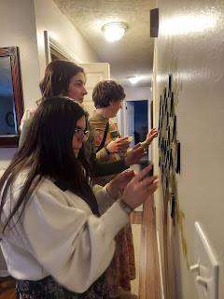

We had a lovely dinner together and enjoyed each other's company very much. They are lovely girls, with sweet and fun personalities. They are from Utah, Illinois, and Arizona. (I think I got that right . . .)

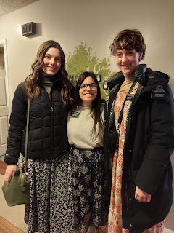

They invited me to make a social media post about something that means a lot to me in the Gospel. I chose to post some of my thoughts about family history. One thing I didn't add, though, is that we are ALL part of God's family and that we are ALL connected. I've mentioned that before in a previous post, so I chose to do this other focus instead: (click photo below to enlarge the words)

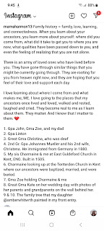

Family history brings a lot of healing to our hearts and our minds. I have seen that and felt that for myself, too many times to count.

Time for Grandbabies . . .

I miss that spunky little redheaded girl in Italy. I can't wait to get back over there and make some arrangements to "borrow" her for a few days again.

Video of Avery checking herself out on Kylie's phone: (31 seconds)
https://photos.app.goo.gl/b8cM2ueJjaMaPnKM9

That giggle of hers! And she says the word "no" now, ha ha.

Jack has been hard at work in Virginia this week.

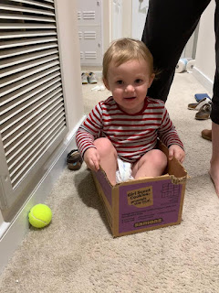

Video of him painting the floor: (9 seconds)
https://photos.app.goo.gl/F61TrUjV1BnRwpaL7

Video of Jack sweeping the gymnasium floor at church: (9 seconds)
https://photos.app.goo.gl/LEXkKfRWS2p9BLZJ9

Video of Jack thinking of new ideas for a sequel to "The Birds": (32 seconds)
https://photos.app.goo.gl/nyDRb9dWDAUfwRZS9



If Jack hears a helicopter, a flock of birds, the garbage man, a school bus, or an emergency responder, he wants to go out on the balcony
immediately
to check out the scene.

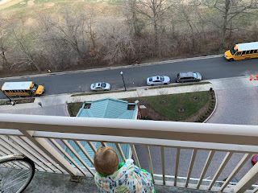

He has also become very helpful in pushing the elevator buttons. He's finally tall enough to reach this one now. Better watch out . . . he's a sneaky one . . . ha ha

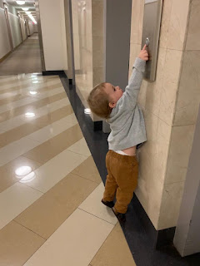

Meanwhile, Gwen is about as fast as I am on roller skates now! Check this out . . .

Video of Gwen racing around her living room: (12 seconds)
https://photos.app.goo.gl/xLRaV3Lj5BnDKm8x9

And Amber sent us this hilarious video of Gwen just chowing down on some chopped up cilantro. Gwen has always enjoyed "unique" foods, foods that not many children her age would even touch with a 10-foot pole.

I'd say that Gwen gives a pretty convincing testimonial here: (be sure to watch to the end)
(27 seconds)
https://photos.app.goo.gl/N5gZH6oiGZC4QvvY8

And that's a wrap.

Oh, and here's the forecast for Idaho Falls over the next few days.

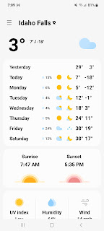

When I go to Oregon to visit my Grandma Lillian this week, the mid-40's will feel like sunbathing weather . . . XOXO

