The Oregon Trail
I had the loveliest time visiting my Grandma Lillian over a long weekend. We talked and talked and laughed and laughed. We ate our habitual sushi together, talked about the good old days, and explored her family tree on Ancestry.com. It was just lovely.
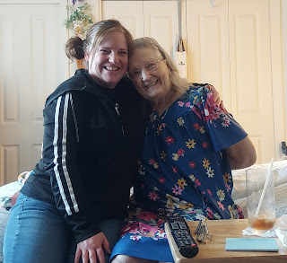
Monday:
Scott traversed the streets of Italy as he explored the base where he's been staying. He wanted to find where everything was in proximity to his hotel, and most especially where the housing office was.
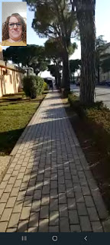

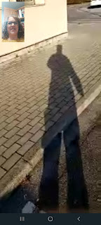

Meanwhile, back in Idaho, Sophie and I went out to lunch together. Well, not exactly . . . she came in the car with me to get some lunch through the drive-through at Costa Vida. I had to tell her more than once, "Sophie, don't be weird." Ha ha, she kept licking things like the car door or the arm rest . . .

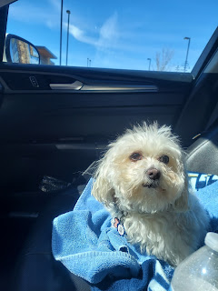

She patiently waited for me most of the day as I cleaned out the craft room downstairs, only coming downstairs once or twice to check on me and to look at me with those eyes that said, "When are you ever going to be done so we can go on a walk?!!"

I did finally take a break late in the afternoon so we could go on a nice long walk together around the neighborhood. That made her very happy. So happy in fact, that when we got home, she fell promptly asleep and didn't even lift her head up when I moved around doing things. Usually she's right there at my feet, wondering what I'm doing and where I'm going.

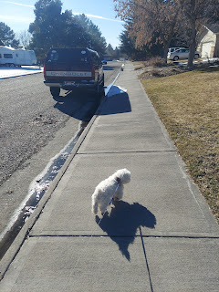

As for the craft room, it went from this - (and you can't even see 2/3 of the mess everywhere)
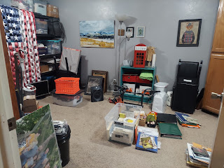

To this -

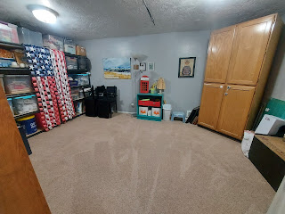

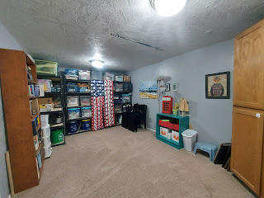

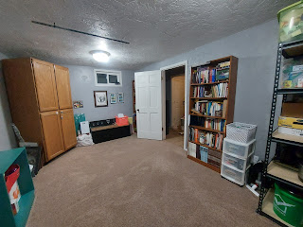

I got rid of about 50% of all my fabric, fleece, and flannel. They just haven't been used in years and I don't have any plans to use any of them so I figured it should all be donated to somewhere that would use it more efficiently.

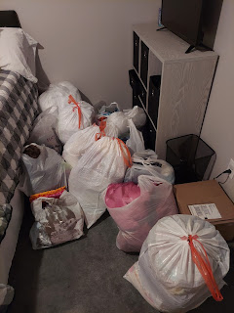

I also cleared out a lot of items that are serving no purpose or are just not wanted anymore. By clearing all of these bigger items out, I freed up quite a bit of space on our storage shelving. I was able to place all of our 72-hour buckets (filled with misc. items for emergencies) in the lower shelves for the first time, which looks pretty great if you ask me.

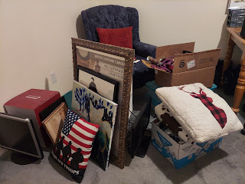

Amber also did a huge painting lesson with the young women in her ward, plus their moms, and even a couple of dads! She taught them step by step how to paint this beautiful watercolor of the Savior. I lost count of how many people were at her house, based on all the photos of the participants, but it looked like she taught somewhere between 20-30 people!!

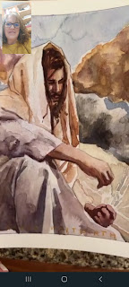

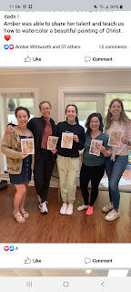

Tuesday:
Sophie moved on to her cousin's house for the rest of the week, while her owners are vacationing in Florida for spring break. I wasn't able to watch her for the whole time because I was getting ready for a trip of my own!

I loaded up the trunk with all the fabric to be delivered to the Humanitarian Center. I say "loaded", but what I really mean was that I
stuffed
the trunk full . . .

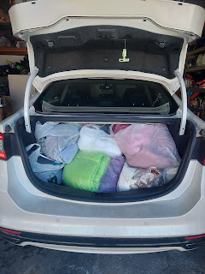

After that errand was done, I came home and loaded up the trunk all over again, this time to take all those miscellaneous items to the D.I. (a thrift store). It spilled over into the back seat as well, filling that area up, too. It always feels good to get rid of stuff, especially knowing that it's going to a good place, such as Deseret Industries.

In between cleaning, packing, and running errands, I put together these cute little Easter egg goodies. I wanted something to be able to give to the children I'd be staying with on my trip to Oregon and Northern Idaho, such as our niece's 5 children and my brother Michael's two little boys. I stuffed the eggs with a bunny marshmallow "peep" and some sweet-tarts in the shape of bunnies and chicks, plus a few jelly beans for good measure. (I ate all the black ones)

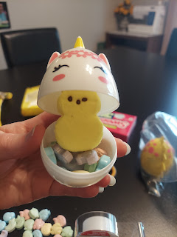

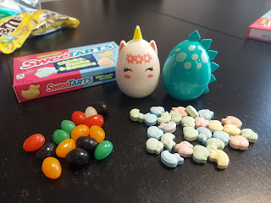

That night, while I fixed a torn area on my favorite black rain jacket, I watched "The Monuments Men" on Amazon Prime. It's a true story about a team of art experts who were tasked with recovering stolen (and priceless) art during WWII. Hitler had organized teams all over Europe to steal and plunder centuries-old paintings, sculptures and other artifacts, and then he tucked them all away somewhere secret. This team of art experts had to go to basic training in order to navigate safely during dangerous war zones in France, Belgium, and Germany. You'll have to watch it for yourself to see what they were able to recover! Quite amazing, actually.

Wednesday:
After my monthly massage in the morning, I headed out just after 12:30 pm to drive to Meridian, Idaho (near Boise).

I made it safely to Scott's sister Carol's house in about 4 hours. We ordered in for dinner and in between lots of visiting, we watched a fun show on BBC, showcasing some of Wales' oldest cathedrals. Carol is always working on a crocheting project after a long day at work, and has made far too many blankets and other gifts to count. It's always fun to visit them and I wish we could see them more often.

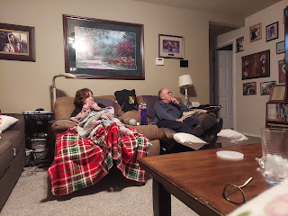

Apparently it was also National Proposal Day . . . so Amber posted this cute picture of the day she and Weston got engaged.

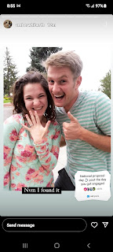
Thursday:
I had 8 hours of driving to accomplish, not including any stops. So I got up early and headed out by 7:45 a.m. just as the sun was thinking about coming up.
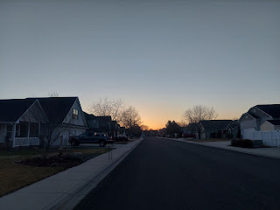

Goodbye Mike and Carol! Thanks for a fun night!

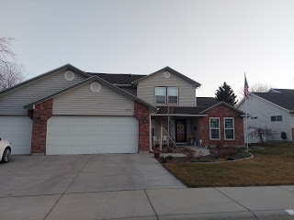

I used to think that Eastern Oregon was ugly and uninteresting. But it was pleasantly interesting this time. Maybe because it was spring time and the hills and mountains were green with occasional snowy caps. Eventually I made it to the Columbia River, which is always spectacular. The mountains and rocky cliffs along the gorge are just breathtaking. If I weren't driving solo in the car, I would have taken a lot more photos. I stopped at a rest area just to get a couple pictures in.

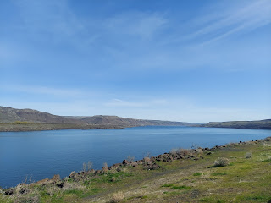

At long last, I was able to cross the river and head a few miles north to Goldendale, Washington, the land where my 2nd great grandmother lived until she passed away.

Video while crossing the bridge over the Columbia River: (37 seconds)
https://photos.app.goo.gl/uVKGfpRM9odMqUvs8

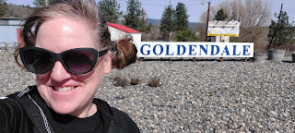

Fun story:
I intended to visit the grave of Ellen Lambert Baugh Pollan, my great-great grandmother. I had found it after much hunting when I last visited the cemetery in 2019. This time, I had an idea of where to park, remembering the general section of the cemetery where she was buried. I looked on Find-A-Grave and found a photo of the headstone. It was a close-up of the wording on the monument, but it looked like the headstone was white, medium-sized, and rectangular shaped. So that's what I wandered around looking for. But I never found her.

I needed to go to the bathroom, and my tummy was hungry, so I decided to head back into town for lunch and then make a stop at the Klickitat Historical Society for help. After a quick bite to eat, I arrived at the Presby Mansion & Museum just as the worker was getting into her car to leave! She invited me inside and we tried without success for 30 minutes to find a cemetery index that would give me the block and/or lot number where Ellen was buried.

Finally, I had some inspiration from the Holy Ghost. He reminded me that when I DID find the headstone back in 2019, I had taken some pictures. So I opened up Google Photos on my phone and went back to August 2019 to find the photos. Lo and behold, it wasn't a short rectangular headstone that I needed to look for! It was tall and chimney-like . . . plus it had a distinctive open book on the top. I also noted that there were houses and buildings, even the perimeter fence, in the background - all clues that could help me find the right spot!

This was the 2019 photo that I took.

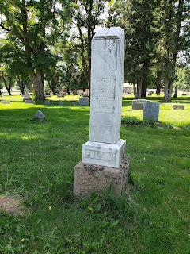

And here is the photo from Thursday. Interestingly, I parked right by this headstone when I arrived the first time before lunch. But I was looking for the wrong shape of headstone! Instinctively I was right about the area, though.

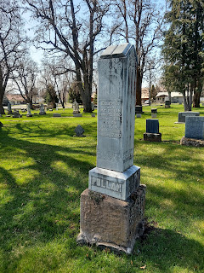

I took care of two important additional tasks while I was there. First, I added the GPS location to her memorial marker by using the Find-A-Grave app on my phone. All you have to do is make one click to add the location. (You do need to have your location turned on your phone as well)

*Note the photo that was in the background below on the Find-A-Grave page. That's why I struggled to find the marker! The photo was not accurate in representing the overall appearance of the memorial itself.

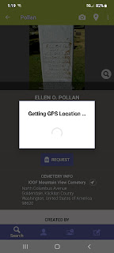

Note at the bottom of this next photo where it shows the GPS coordinates. If you wanted to find her but had no idea where to find her in the cemetery, you can just click on the little icon next to the latitude/longitude numbers.

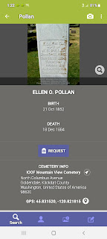

Next it will ask you if you want to open up Google Maps, which I did. And then you can walk directly to the headstone using the map app. How fantastic is that!!!

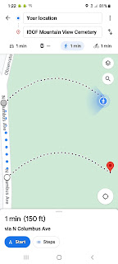

Now, I will never get lost again finding her headstone.

Before I left, I took a couple more photos to give more context for what the headstone actually looks like, and I added those to her memorial on Find-A-Grave, using the app itself. You can add more photos while you have the app open to her page.

That felt amazing! I was a Fixer. I fixed the problem for anyone who wants to come find her in the future. That was really satisfying. :)

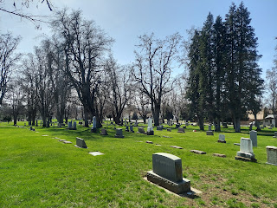

A little bit about Ellen:
She married at the age of 12/13 to James Baugh. Soon after, she gave birth to my great-grandmother, Sarah Jane Baugh, who was premature and so tiny they would put her in a bread loaf pan on the warm open door of the oven! Not too long after Sarah was born, Ellen gave birth to a little boy that they named Addison. Unfortunately, her husband James was murdered in 1868, so Ellen was now a widow with two small children at the age of 16. Shortly thereafter, she married William Carl Pollan and went on to have 7 more children before she passed away at the way-too-young age of 30. She had lived a lifetime in those short years.

On my way back down to the Columbia River, I passed this beautiful prairie scene, with Mt. Hood in the distance, all covered in crisp white snow.

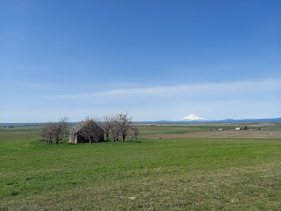

Here is a short video as I headed down the last hill to the bridge that would take me from Washington back to Oregon. (32 seconds) (*And I promise I was watching the road!!)
https://photos.app.goo.gl/cKyu8V93LziPPCZR7

If it hadn't taken so long in Goldendale, I could have stopped at Multnomah Falls again. It's always so beautiful and it's even right next to the freeway! I held my camera up and told it "capture!" a few times, hoping to get something that actually looked good. Here's what I ended up getting . . .

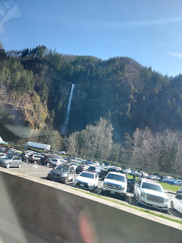

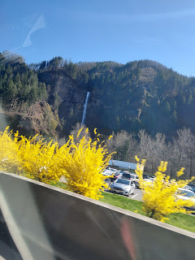

After dealing with some early rush-hour traffic around Portland, I finally made it to West Salem by 4:30 p.m.

Grandma's caregiver, Barbara, was still there and I got to meet her. She's very nice and does a lot to help out during her Monday-Friday shifts. Grandma and I ordered some sushi takeout, which I went to pick up, and then we just visited for the rest of the evening.

I took some photos around her apartment, of several nostalgic mementos that I remembered from their ranch in Ukiah, CA when I was growing up. I'm glad she's kept these things all these years.

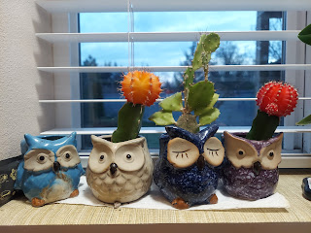

This was the cute old owl cookie jar that was always full of delicious cookies whenever we came to visit. I remember it being filled with oatmeal cookies mostly, and when I asked Grandma if that were true, she said she often made oatmeal crispies.

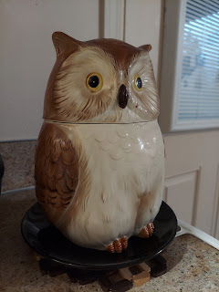

Here's the recipe for the cookies:

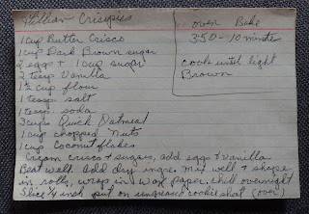

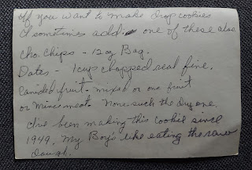

And this clock used to sit on the mantel above the fireplace at their Ukiah Ranch.

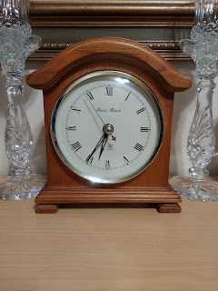

I definitely remember this cute little sign that used to hang out on the porch to welcome visitors.

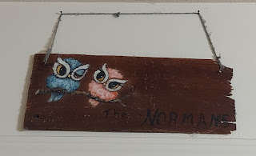

Grandma Lillian was born in Texas, and so was I. As we were commenting that we were the only Texans in the family, I remembered that Gwen was born in Texas, too! So that makes 3 of us. :)

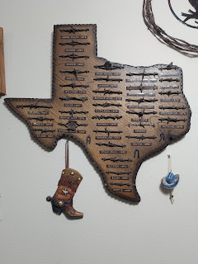

Her son, Tim, was another talented artist in the family. He painted this beautiful and majestic tiger.

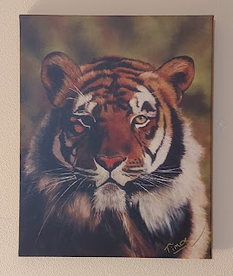

Grandma Lillian painted this peaceful swan.

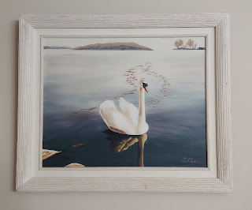

I love sitting with Grandma and hearing old stories. She is a wealth of knowledge and remembers everything so clearly, like it was yesterday. Here are some of the stories she shared about my Grandpa Linton.

Story #1: Grandpa Linton really liked things to be neat, tidy and clean. He even enjoyed washing the dishes. One night, (during a time when Grandpa was really struggling with Alzheimers), he was trying to clean a plate that had some dried up syrup on it. It took him a long, long time to clean it, but he stuck with it. Grandma quickly figured that if she needed him to stay out of trouble, she could just pour a little bit of syrup on a plate and let it dry overnight. Then, the next day she'd say to him, "Honey, could you do me a favor? Could you please wash the dishes?" And he would happily do it. For however long it would take.

Story #2: One night she gave him a sleeping pill and thought all was well. (Later, after he passed away she found a large stash of all the pills he spit out and hid underneath the bed over the years) Well, he didn't actually swallow the sleeping pill this particular night either . . . The next morning he was so proud of himself - he had moved the entire wood pile from the garage and stacked it neatly and perfectly in the middle of the living room! Grandma thought for a minute, and then said, "Well you sure did a great job stacking that wood so nicely!" And then she invited him into the kitchen for some breakfast. After they ate, she asked him if he could help her with another favor. He was happy to do anything to help her. She asked if he could please move that woodpile out to the garage and stack it all neatly out there. He excitedly got right to work. :)

Friday:
I went on a nice long walk in the morning while I chatted with Scott in Italy. It was delightful to see all the trees in bloom everywhere. The daffodils are so welcoming and bright in Oregon, but at home in Eastern Idaho, my tulips and daffodils have not even begun to poke up through the ground . . .

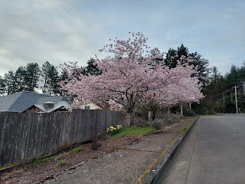

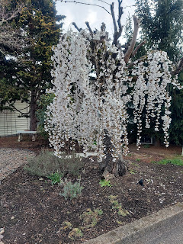

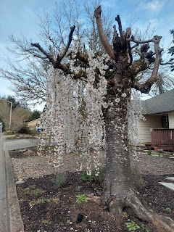

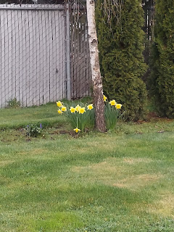

Grandma and I chatted for hours, getting all caught up on all the grandchildren and great-grandchildren. For dinner, I went to the nearest grocery store, Roth's, a very upscale market. They had a huge selection of specialty mushrooms, since after all, we are in the Pacific Northwest . . .





I found a photo enhancing app to see if I could improve upon this cherished photo for my Grandma. This was a photo of Grandma with her first husband, Dean Moore, and the father of her 5 boys. It was a paper copy that had been placed into a frame, but was slightly blurred and pixelated. With the app, I was able to clarify her face, but not so much Dean's. It was certainly fun to try!

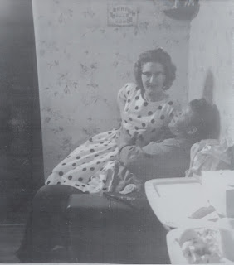

Another interesting story about my Grandpa Linton: Shortly before he passed away, a local youth group came over to help them clean up the backyard in Newburg, OR. He was intended to be the recipient of the service project, but very soon after the group got to work, Grandpa had come outside to join them! He got right to work in the cleanup project alongside everyone else. :)

This was Grandpa on that very occasion.

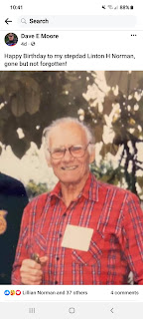

Saturday:
Scott found us a house in Italy!! He met with a realtor named Silvia and went to see several places before finding this one.

https://www.immobiliare.it/annunci/76366028/

It is very close to the main military base, has a shuttle over to the other base where he will be working, and there are plenty of shops around, including a grocery store right across the street. It has 3 bedrooms, 2.5 bathrooms, a loft with a smaller bedroom that will probably be used as an office, and even has a rooftop terrace!

Scott took a very speedy video, going quite quickly from room to room. You might get dizzy in watching this, but it does provide a few more details than the listing itself.

https://photos.app.goo.gl/LsAYsFwJXL3D61vGA
(1 minute, 32 seconds)

Silvia, the real estate agent, will be reaching out to the housing office on Monday to begin getting all the paperwork started. We are very excited to find something so nice and also so close to the area that he wanted!! :)

I went for an even longer walk this time, talking to Scott the entire time! I walked 4.1 miles in 90 minutes, up and down several steep hills in the neighborhoods nearby. While I chatted away, and tried to catch my breath at times, Scott was quietly taking the Italian driving permit test with 200 questions!! At one point I asked him why he was so quiet and that's when I learned what he was REALLY doing, ha ha.

Some of the sights on my walk . . .

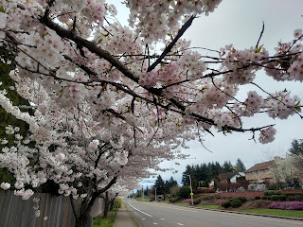

A pink magnolia tree

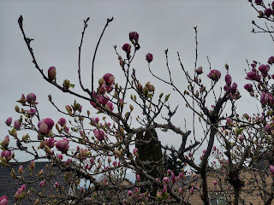

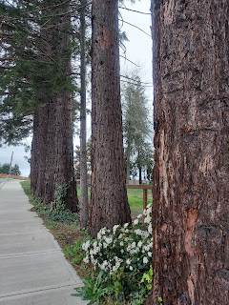

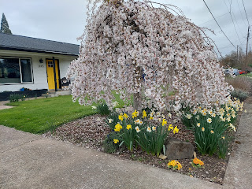

I also got a couple of early morning photos from our kids on the East Coast. Hannah participated in a 5k run in Washington DC with a couple of their friends, Adam Stratton and his wife (I don't know her name). Adam's mom was there visiting and snapped a couple of fantastic photos. Adam is from Idaho Falls and went to high school with Jacob. I know his mom, Michelle, pretty well, too. I was so grateful to get these photos from her!

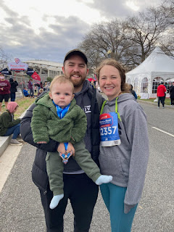

Sweet and handsome little Jack Jack

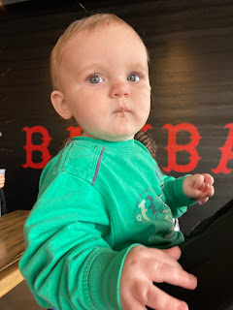

In the middle of the day, the missionaries stopped by to visit Grandma, having made an appointment with her the day before. Over juice and cookies, they checked on her to see what her feelings are toward our church (The Church of Jesus Christ of Latter-day Saints). She has read the Book of Mormon twice and has studied our church for several years. She definitely recognizes the truths of the gospel and has warm feelings toward the church. She is just not in any hurry to be baptized at her age (88) and in her condition. It was a lovely visit and we appreciated having the missionaries here in her home.

I asked Grandma late Friday night if she might like them to give her a priesthood blessing when they came, since she was in quite a bit of pain at bedtime. She agreed, and so we asked the young men to do just that.

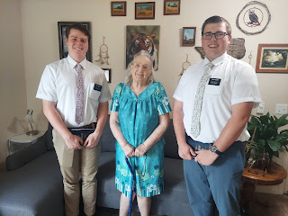

The younger missionary, Elder Linderman (on the left), had not given very many priesthood blessings yet, so he needed to confer with his companion, Elder Weaver, on what to do. Elder Linderman applied the consecrated oil and then Elder Weaver gave the actual blessing. Grandma said that even though Elder Linderman was clearly a beginner with such things, when he laid his hands on her head, she felt the warmest feeling come over her and filled her from head to toe. She was grateful for the blessing that Elder Weaver gave her and felt comforted by it.

They were both so sweet and kind, and Elder Weaver had a cute sense of humor but was also very sincere in his testimony. We truly loved having them here, and I hope they come again soon to check on Grandma. Unfortunately, it's hard for her to set any concrete appointments because she never knows if her chronic back pain will allow her to follow through . . .

After the missionaries left, we started sorting through several bags and boxes of her sewing supplies. I sat on the floor and pulled everything out, one item at a time, while she indicated what she wanted to do with it (throw it away, keep it, or donate it). She's given me a large selection of her buttons to take home, which I am excited about. I love buttons!

Here she is, sorting through a smaller tin of buttons, picking out just a small handful to keep for herself, and giving me all the rest.

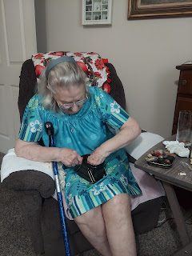

We ordered some fancy nachos for dinner, which I went and picked up. Over dinner, we watched some episodes of UK Antiques Roadshow. :) A great way to end our last full day together.

Sunday:
It was a lazier-than-usual morning where I didn't want to get out of bed, and I ended up just calling Scott from my sofa couch and chatted with him for about 40 minutes. I finally got some gumption to get up and get myself dressed so Grandma and I could watch church from the Zoom link that the missionaries gave her yesterday.

Scott was able to navigate perfectly to church this morning in Vicenza and he enjoyed the services there. He caught a bus that took him to a stop right by the church meetinghouse.

Here's the route to church. Look for the white path that winds around Vicenza on the map below.

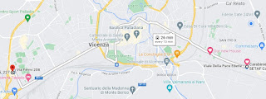

It's not a typical meetinghouse though. There was a sign on the outside of a building that looked like an Italian merchant's shop, but the sign said Church of Jesus Christ of Latter-day Saints (in Italian). He went up to either the 2nd or 3rd floor where they had classrooms, a chapel, a bishop's office, etc.

There were only about 40 people in attendance, but someone said that there are usually a lot more people there when there's not a 4-day weekend for the military personnel. There were families and children, which is great. After sacrament meeting, he went to his Elder's Quorum class. Everyone went around and said their name, where they are from, when they arrived, and when they expect to leave. Scott said, "I just got here and I'll be here for a long time!" There was a soldier in his EQ class who is from Pocatello, Idaho. Small world.

After church was done, he caught the bus back to the base and was comfortably hanging out in his hotel room when I called. He thought he was just 7 hours ahead of Idaho, but in fact he is 8 hours ahead.

Grandma and I watched her local sacrament meeting via Zoom together. It was "fast and testimony" Sunday. (Members fast - or go without eating or drinking for up to 24 hours - and then share their testimony) Several people got up to share their testimony of some part of the Gospel that has touched their life. The people here in West Salem are going through hard things (as are most people in this world), but they are full of faith and they are being blessed in spite of their difficulties. I felt encouraged and inspired even thought I'm not currently going through anything that I would consider extreme or difficult. I have worries and concerns about my husband and his safety, and some worries and concerns about my children and their children. But I know the Lord is mindful of all of us and will be there with us through whatever we need to go through in this life

Time for Grandbabies . . .

Benson holding little Avery on his shoulders. Soon we'll get to meet that little cutie!

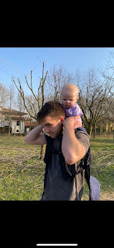

Jack - having fun with the screened in porch on their recent vacation

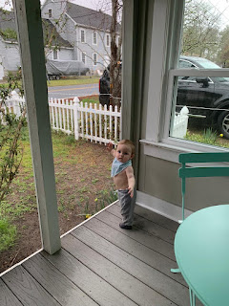

Video of Jack out on the porch: (21 seconds) He's moving around pretty good!
https://photos.app.goo.gl/DVqwfFQSfuMzD9Jm6

All tuckered out

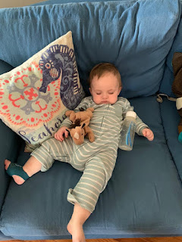

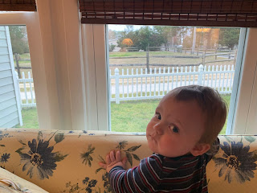

Assateague and Chincoteague Islands

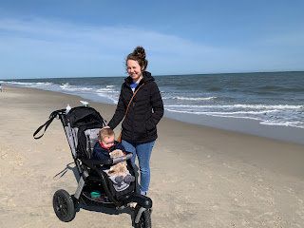

Now they're back home

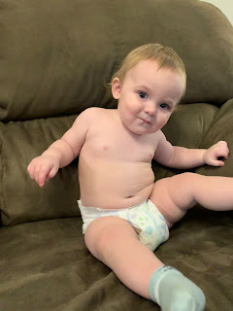

One last video of Jack. He has figured out how to drink some water and then spit some out, ha ha.
https://photos.app.goo.gl/wxvwVEhnwwFkaMKr7
(13 seconds)

Gwen is really loving having the trampoline to herself while Abby is at school every day. Obviously . . .

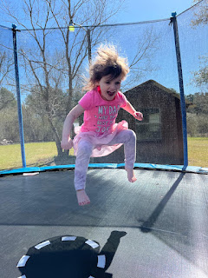

Amber had a bit of a chore to do early one morning this week. The rains caused some flooding into their carport because the ditch that runs around their property couldn't keep up. This was the same day that all the tornadoes were sweeping through Texas and Louisiana and up into the north.

When she went out to wait for the bus with Abby, she noticed the ditch was all clogged up. So she grabbed a rake and started working to clear it out.

Working on the problem: (14 seconds)
https://photos.app.goo.gl/oxE2z3cpEtAoDWQM8

Problem is solved: (11 seconds)
https://photos.app.goo.gl/qoDgPxzDwvAQrVyEA

I'm glad they were protected from those crazy tornadoes and that all is well.

