Whitworths in Italy: Part One
After our fun little trip up into the mountains to visit Asiago, we began a very fun week of adventures together with Amber, Abby and Gwen.

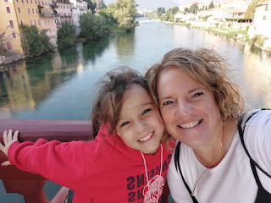

Monday, October 2nd:
We moved Gwen downstairs to sleep for Sunday night, since the girls were partying so late on the two previous nights, ha ha. We set her up on a foam mattress topper down in the living room, and this is what we woke up to Monday morning . . .

Bits of torn foam all over the place . . . LOL

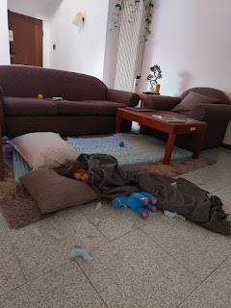

Mid-morning, we went on a little explore on foot. We walked to a park down the street, and then a little further to a cute little Pasticceria named Pastri Bolzani Georgio. A friend told me it was the best one in all of Vicenza. A pasticceria is basically a bakery, with pastries and treats, as well as a few lunch items such as sandwiches or croissants, etc.

We picked up one little dainty treat per person and sat outside near the fountain to eat them.

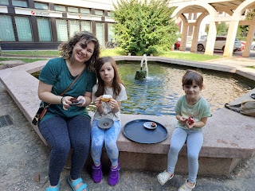

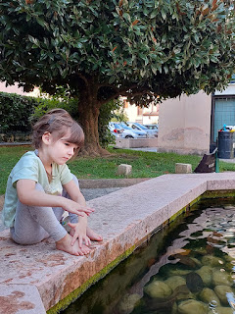

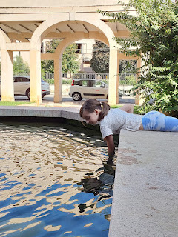

Later in the afternoon, the craft store was open, so we tottered off to pick up a couple things. The girls were completely in heaven with the beads and baubles section.

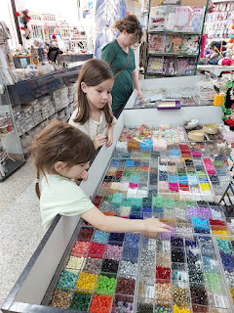

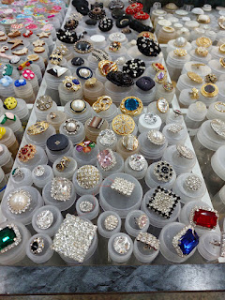

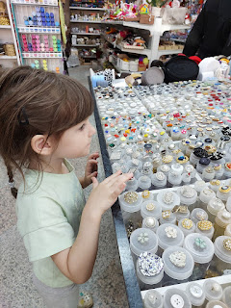

We picked up a few random buttons and beads that they could make into necklaces over the next few days. Amber found some extremely soft alpaca yarn to make into some mittens for her girls, along with a couple of crochet hooks. And then we walked to the Vaniglia gelateria two doors down for an afternoon gelato pick-me-up. :)

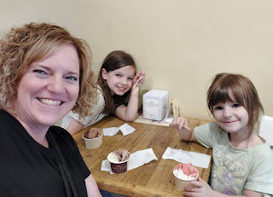

Gwen ate every last bite of her gelato and then was bouncing around when she saw all the large fancy desserts in the glass cases next to us . . .

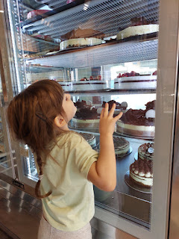

We may have overloaded on sugar that day, because I had also planned to bake some oven pancakes with cinnamon-sugar apple bits for dinner. Oops, ha ha. Amber squeezed in a little time to fill out her absentee ballot that she had requested to be sent to Italy, since that's where she knew she would be when the ballots were due to be mailed out. What a diligent voter!

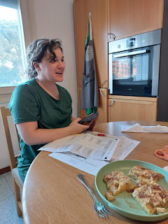

Scott was in a panic that we needed to hurry to the Bunny Park before it closed at 7 p.m. We got there at 6:35, thinking that we would have 25 minutes before we needed to exit. (The Italian police are very strict about closing the gates at the designated time.)

We spent less than 10 minutes in the park before the policeman came by, yelling at everyone to get out. It wasn't even close to 7 p.m., but we later learned that they close the parks at sunset, not necessarily at 7 p.m.

We brought some carrot sticks and carrot slices with us, and Gwen had just had some success with feeding a little black bunny before we had to exit.

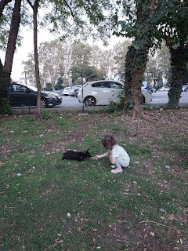

She was set on feeding a white bunny next, who was nearby. But then we got scolded by the policeman, which led to the girls bursting into tears because we had just gotten there and now we had to leave. The policeman didn't even soften his stance 1%. He didn't care that he made two little girls cry . . .

We left the park and drove a short distance to drop off Nell's cake pan back to her. What should have been a quick errand turned into a fun evening walkabout in downtown Vicenza that was lovely and informative. Nell is like a walking encyclopedia and always has some interesting nuggets of local history to share with us. We walked all over the downtown area, and the girls were good sports to keep up with our longer legs.

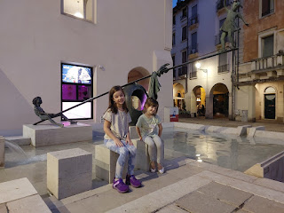

Video of the girls enjoying this "teeter-totter fountain" and noting the pigeon on top of the statue's head: (12 seconds)
https://photos.app.goo.gl/kQcKrcbsafSv4eYCA

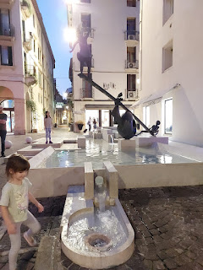

When we finally did get home, we hurried to get the girls ready for bed. We all went up on the roof to read scriptures together, taking turns reading one verse at a time. The girls especially enjoyed seeing the stars above as we read and said bedtime prayers together.

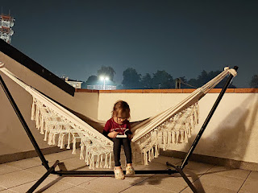

Amber and I had fun calling my mom in Northern CA to sing "Happy Birthday" to her before we went to bed. I think we surprised her because she didn't know that Amber had made it to Italy yet, but having us both singing together over the phone made her very happy. :)

Tuesday, October 3rd:
We got up and ready extra early because we had a very fun day ahead. We had a train to catch at 8:14 a.m. to take us to Bassano del Grappa. Scott dropped us off at the train station on his way to work, which is always so helpful. The girls were super happy to ride an actual train for the first time, different from the times they have ridden on a subway train in a few U.S. cities.

It was a special opportunity to finally share the land of our Bassano ancestors with my daughter and her daughters. As we walked past the statue of Jacopo da Ponte, I made a mental note to myself to do a little more research again to see if I can find the link between the "da Ponte" family and my Bassanos. I feel like deep down there IS a link, I just need to find it. He was a famous painter, while my Bassanos were musicians. I have seen the names Da Ponte and Bassano interchangeable within an article a couple of times, but no explanation for it so far.

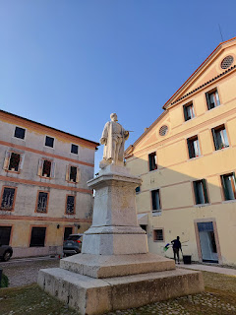

Abby and Gwen jumping for joy . . .

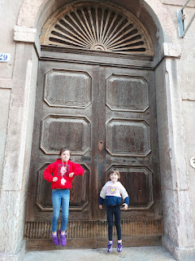

Roaming the streets on our way to the river . . .

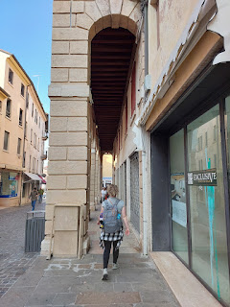

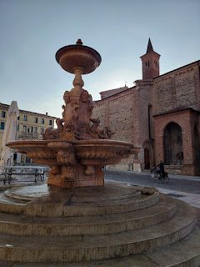

The girls had a good time playing around this fountain, while Amber and I took some photos of nearby buildings and artwork in the plaza.

Video of the girls: (19 seconds)
https://photos.app.goo.gl/n3jEwUKTynSPiVqy7

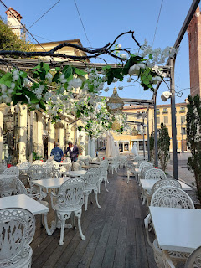

Sadly, the things I wanted to show them in Bassano were all closed on a TUESDAY. Most places in Italy, if they're going to close for a day, shut down on a Monday. But apparently, Bassano del Grappa chose Tuesday as their day. Darn it. The Museum was closed and also a cool exhibit near the Brenta River was closed, known as "King Kong Rhino".

Here is a blog post, written about the extraordinary Rhino:
https://assoyuanfen.wordpress.com/2019/05/20/king-kong-rhino-e-il-rinoceronte-di-durer-quando-il-destino-abbatte-le-distanze-di-luogo-e-tempo/

We could see it through the locked gate, but could not get very close to it this time. We hope to squeeze in one more trip to Bassano before Amber and her family leaves Italy in a few weeks, and we will definitely go on a different day other than a Tuesday!

We moved on and made it to the famous Ponte Vecchio Bridge, designed by Andrea Palladio in the 1500's. The views from the bridge are just postcard pretty . . .

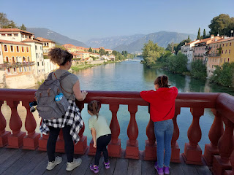

Amber . . .

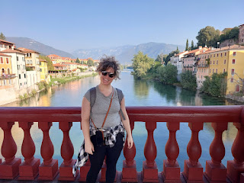

Abby and me . . . who knew that we looked so much alike until I took this selfie of us!?!

We walked along a nature path on the west side of the River Brenta, which opened up to several spots for us to stop and enjoy the peaceful scene for a while.

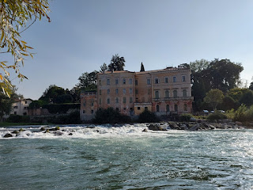

Amber and the girls wanted to touch the water and see if it was cold . . . it was cool, but comfortable. Not swimming water at this time of year, but refreshing.

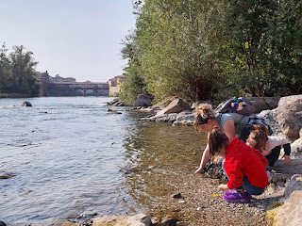

These two models were great to work with . . .

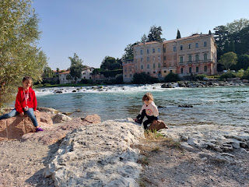

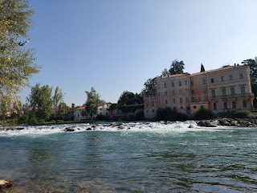

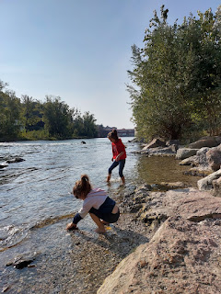

Video of the girls giggling and having a great time: (23 seconds)
https://photos.app.goo.gl/yUCWbBc82hTTGpvs6

Another video of the scene: (30 seconds)
https://photos.app.goo.gl/u3unGHmLvNCp62ZD8

A little further up from our peaceful spot was a place we could climb and jump across some rocks to get closer to the cascades.

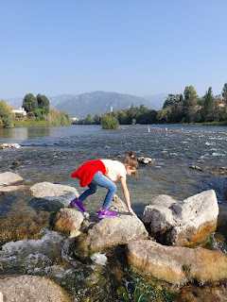

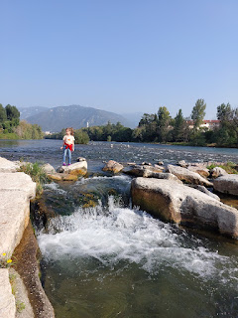

Abby, Amber, and Gwen, with the Italian Alps behind them . . .

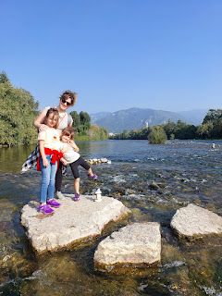

I always marvel at this ivy-covered house next to the river, each time I've walked past it. It's so beautiful.

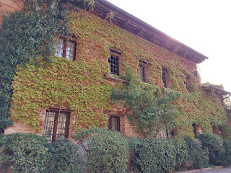

Video of Gwen skipping ahead, and then hiding behind a post when other walkers approach:
(14 seconds)
https://photos.app.goo.gl/u9qRNW6Hjb1FhKDd6

When our tummies started getting hungry, we headed back into town. Unfortunately, lunch isn't generally served in Italy until noon or 12:30, so we had to wait for a place to open their kitchen. There was a lovely spot to sit on a bench next to the Ponte Vecchio Bridge, and Amber pulled out her sketching supplies to crank out a hasty masterpiece.

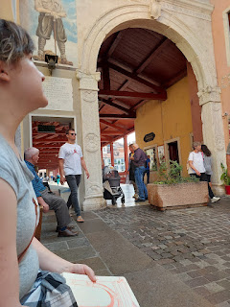

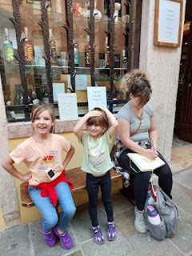

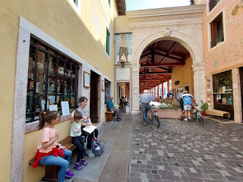

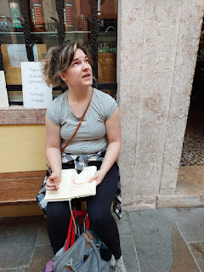

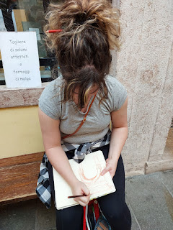

When the restaurant next door opened up, we ordered lunch and let the kids color on their placemats until the food arrived. I flipped my placemat over and did some coloring as well. Tee hee.

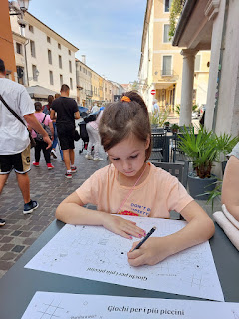

I ordered a pistachio-encrusted red tuna fillet, over what looked like some thinly sliced spirals of jicama. It was delicious!!

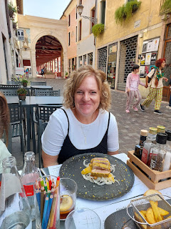

On our way back to the train station, we passed by the same landmarks again. Familiar and also beautiful.

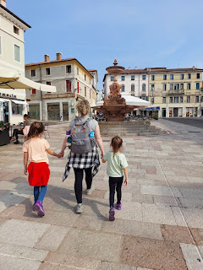

Gwen kicked back for the train ride home . . .

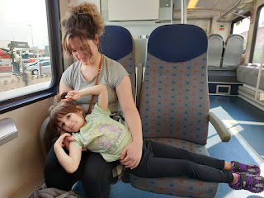

That evening, we went back to the Bunny Park again with Scott. We ate an early dinner so we could get over there with enough time to feed the bunnies and wander around before the security guard started yelling at everyone to get out, ha ha.

Gwen had one goal: to feed a white bunny. She was very patient and tried to entice a few white bunnies, before she finally had success.

Video of Gwen feeding the white bunny: (21 seconds)
https://photos.app.goo.gl/nMytVaFfWDP35fdd9

On the other hand, Abby just wanted to feed a bunny. ANY bunny. She was patient and gentle with each attempt, but for some reason the bunnies were a little more shy this time. She was disappointed as a whole, but she still enjoyed a few other adventures in the park.

Video #1 of Abby trying to feed a bunny: (28 seconds)
https://photos.app.goo.gl/vun4LWkb59QgtFjB8

Video #2 of Abby trying to feed a bunny: (9 seconds) Our technique oftentimes was to try to coax the bunny to come closer by tossing a piece of carrot out, and then toss another one closer to us, etc.
https://photos.app.goo.gl/W3ELbxMsn65jbVG39

The moat around the island within the park was FULL of turtles . . .

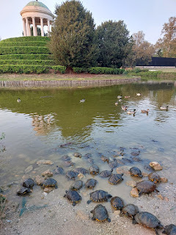

And the nutrias were large and in charge, as usual, too. A nutria is like a muskrat. Scott refers to them as giant rats, but that just sounds gross to me.

Video of the turtles and a nutria: (26 seconds)
https://photos.app.goo.gl/6xZzjvyy47PGJZu37

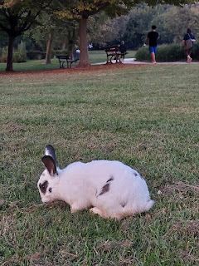

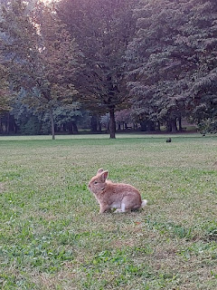

Trees to climb . . .

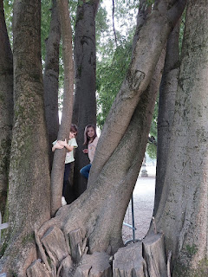

More bunnies to try to share our carrots with . . .

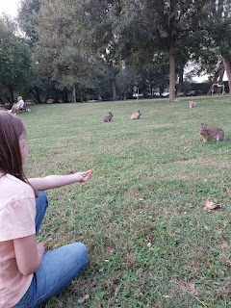

Beautiful statues and wide open spaces . . . all in Parco Querini. (a.k.a. the bunny park)

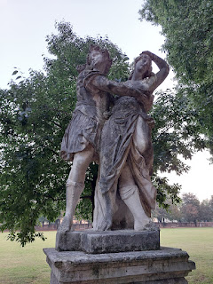

And here's a cute photo of Avery to make your day. It sure made mine!!

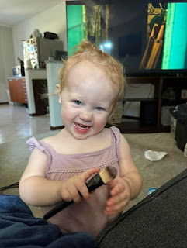

Wednesday, October 4th:
I brought Amber and the girls to one of my Wednesday in Italy activities. This is a group of ladies that we go on weekly field trips with. Marnie Parker knows a lady who has a glass-blowing shop in her garage near Cittadella and was willing to give us a demonstration. Her name is Sonia and she knows the same process of glass-blowing that has been done for centuries out on the island of Murano (next to Venice). She and her husband and their daughter work together to make beautiful things to sell.

There were about 16 of us in our group, but not very much space in the garage to safely fit us away from the heat of the oven, so we split up into two groups. The other group could peruse items for purchase outside, and then we switched after each demonstration.

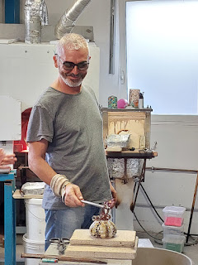

Pumpkins for autumn were the focus of the demonstration. I mostly took a series of short video clips this time, because Amber has been teaching me how to make reels on Instagram and Facebook. But I did take a few longer videos that I can share below.

Video #1: Sonia's husband spinning and finishing up a vase in the oven before he began a pumpkin for us. (16 seconds)
https://photos.app.goo.gl/EHa8MQonpHXFk8HA8

Video #2: Rolling the hot goo (for lack of a better term) in a tray with glass crystals of varying colors and composition, then back into the hot oven. (9 seconds)
https://photos.app.goo.gl/nStTvL9TxDkq9GQz6

Video #3: Sonia explaining that the silver or gold leafing that they sometimes use needs to be pure and of a specific composition, so it doesn't ruin the process. (23 seconds)
https://photos.app.goo.gl/SUAY9dwTvmSLbjnB8

It was interesting to watch the pumpkin take shape. First, he had a small and long shape, like a hot dog. It slowly got longer and thicker as he added crystals and leafing to it. Later, he gently tapped the long shape on its end, which gave it more of a roundish and squatty shape. Eventually, it looked more like an actual pumpkin.

Video #4: This was my favorite part. He made the little curlique stem for the pumpkin. He made it look so easy!! (16 seconds)
https://photos.app.goo.gl/h8bQ7h1Ypdxphe1C7

Video #5: Clipping off the excess stem of the pumpkin after some firing process. (15 seconds)
https://photos.app.goo.gl/rfrPTXJ38GM4fHGVA

Video #6: As he finished firing the pumpkin, Sonia explained that it needed to now sit for 24 hours to cure. (12 seconds)
https://photos.app.goo.gl/6Yn6WLs856MZxRMU8

There are so many cool analogies to pull from this demonstration.
We think we know the end from the beginning. But when we see a hot dog shape forming (i.e. ourselves) and we know it (we) should be a pumpkin, we may lose our faith or form some mistrust in the process (of our life). When really, what is happening, is that there is a Master who definitely knows what He is doing. We need to allow Him to shape and mold us into what we are truly meant to be.
There are many "colorful" pieces and components that will be placed in our path of life. They are meant to enhance our journey and add some "spice" and "color" to our overall experience.
We all need to go through a firing process in order to become glorified and brilliant. Some of us may need a little more firing in order to fully refine us, but it is not meant to hurt us. Instead, it is meant to help us become more perfect in the end, just as the Master lovingly intended.
Here are some of the GORGEOUS finished products that were on display for us to choose from, if we wanted to make a purchase.

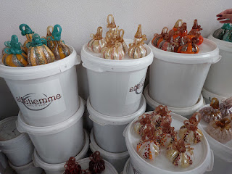

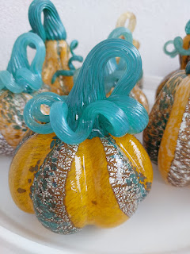

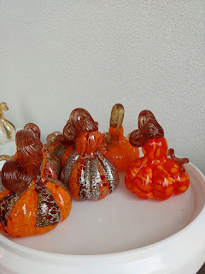

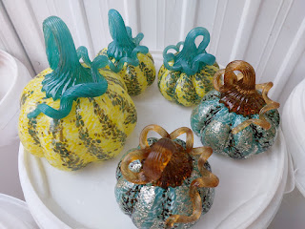

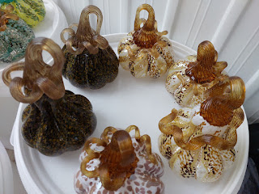

I chose a cute little orange pumpkin, and Amber chose two beautiful coordinating cream and "greige" pumpkins. We will ship them carefully home for her before she leaves Italy.

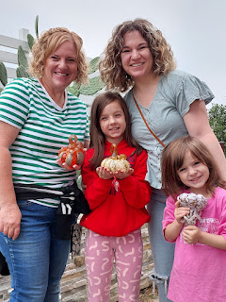

When Scott was done at work, he met us over at the base. I had an appointment to get Amber and the girls a 30 day pass to come on base, so we got that all taken care of. We took the girls to the library, where they hung out with their mama while Scott and I went to give a priesthood blessing to my friend, Christine. The missionary couple serving here, Elder and Sister Haines, met us there. It was a beautiful experience.

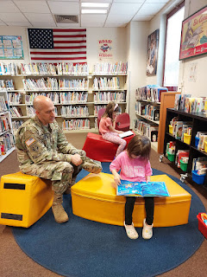

After dinner, the girls worked on a fun puzzle that I had bought recently. If you haven't heard of the show, "Bluey", you are missing out. It is a cute children's show that is just as entertaining for the adults as it is for the kids! I found a 4-pack of Bluey puzzles and I bought it so the girls could have something to do. What I didn't realize is that if you flip each puzzle over, there is another puzzle on the back for you to COLOR!! How fun! The girls remarked, "Wow...I've never been allowed to color on a puzzle before...!"

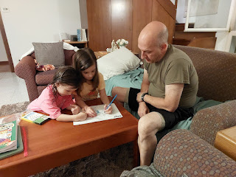

Thursday, October 5th:
We drove 5 hours north to Salzburg, Austria!! Stay tuned for the next blog post in a few days with all the details . . . I will be a little bit behind during the month of October. (nervous laugh)

In the meantime, let this darling video of Jack keep you fully entertained . . .

Jack - in the early days of his upcoming Master Chef career: (51 seconds)
https://photos.app.goo.gl/Ci2CyGrXV1wWe1WY8

