Zaanse Schans & The Netherlands (Part 2)
Places mentioned in this post:
Zaandam, Netherlands
Zaanse Schans, Netherlands
Amsterdam, Netherlands

Tuesday, April 23rd:
Picking up where I left off in the last post, we left Keukenhof Tulip Gardens right after lunch and headed by bus and train up north to Zaanse Schans. This town is the cutest and possibly THE MOST darling of anywhere I've ever traveled before. It was approximately a 10-15 minute train ride from our hotel in Zaandam.

*
Warning:
You will be seeing the word "cute" used multiple times and in a smattering of ways throughout this blog. Prepare for a cuteness overload!! :)

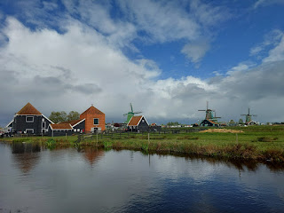

The sidewalk leading from the train station into town has cute little mosaics placed lovingly at your feet. Every so often, you'll pass over another "batch".

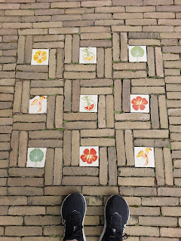

At a few stategic intersections, you will find a helpful map of Zaanse Schans to find your way around. If you click on the photo to enlarge it, you will see the train station at the bottom of the map, and a red, dotted path showing the way into town and to the rest of the windmills. This is the path we followed.

As we got into town, we could smell the distinctive scent of chocolate in the air . . . how delightful!! We learned right away that there is a chocolate factory in Zaanse Schans where cacao powder is processed.

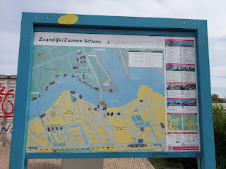

Our first windmill up close . . . and on the map above, it's right where the large red dot is, indicating "you are here".

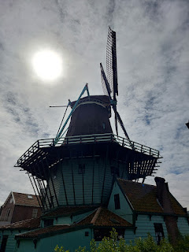

We crossed over the main bridge to get to the rest of the windmills, with the Zaan River below that felt wide enought to be a large harbor.

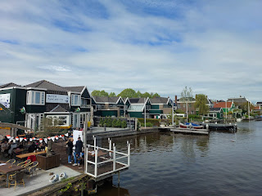

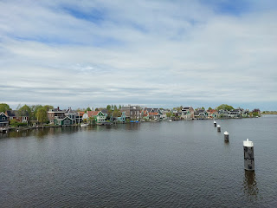

Video from the middle of the bridge: (14 seconds)
https://photos.app.goo.gl/UFjR3RiJfwdWyFaUA

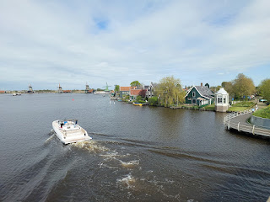

Right after I took those last few photos, a siren started blaring on the bridge, a red light began flashing (similar to a RR crossing), and an announcement in English told us to move away from the center of the bridge and get behind the indicated lines.

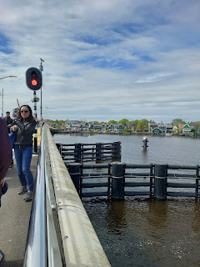

The drawbridge was about to go up!! I've never been ON a bridge when the drawbridge needed to go up at the same time. How exciting!

Video #1 of the drawbridge going up: (13 seconds)
https://photos.app.goo.gl/ioLVCrUe2n97C8hh7

Video #2 of the drawbridge going up: (14 seconds)
https://photos.app.goo.gl/jxAT3sv3duEFs4WM7

Video #3 of the CACAO boat that needed to pass through from the mill to the factory: (16 seconds)
https://photos.app.goo.gl/UdJSv7tCkVoNgh3t6

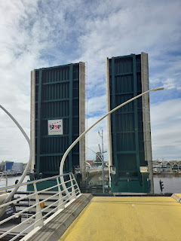

Just over the bridge we arrived in the magical area of the windmills and several quaint shops.

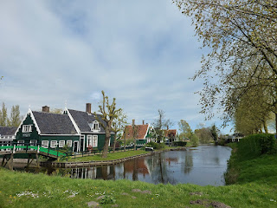

Video as we entered this VERY cute and historic district: (7 seconds)
https://photos.app.goo.gl/bY8BegnmibAitJAn9

The first little shop on the left (below) pays homage to Albert Heijn, who started his first grocery store in 1887 in Zaanse Schans, which eventually grew into a huge supermarket chain all over Holland, and later expanded into additional chains in the U.S. - "Stop & Shop" and "Giant" (along the East Coast).

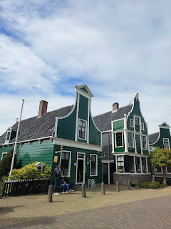

Per Wikipedia:
"In the first store, Albert took care of 'repacking' purchased items into barrels, boxes and open containers. Brandy, gin, vinegar, oils, bluing, sanding sand, flour, legumes, coffee, tea, herbs, medicines are examples of items. Currants and legumes were 'read', and flours were sifted. Tea and coffee were mixed, sugar was grated. At the time, customers brought their own jar, bottle or jug ​​​​for most items. Bags were initially glued by Albert and Neeltje [his wife] themselves, but this was soon outsourced. Initially to orphanages and prisons, and later to the Zaanse bag industry. In the 1997 interview with grandson Ab Heijn, he explains why packaging in the grocery store was a craft and a lot of work.
[5]
"Only sweets were in the window. The stock was in the store as well as the desk where Albert kept the administration.
"
The service
required the most time
. The store was open from six in the morning to ten at night. Albert was a wholesaler for about 30 pseudo-shops owned by widows in the area. He also had a modest delivery service, which later grew to such an extent that in 1893 he hired a servant specifically to take care of orders. Albert Heijn had its own imports and in 1894 had the designation: 'Colonial Goods and Distilled' added to its invoices. He started with the novelty of the time: handbills."
The store front we stood in was as charming as it could be, staged to look as it did over a century ago, with products galore to purchase, such as chocolates, postcards, soaps, wooden kitchen tools, and an entire back shop devoted to coffee and its local processes.
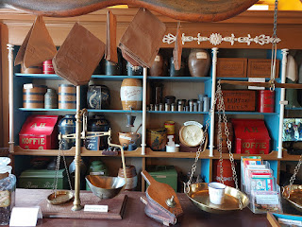

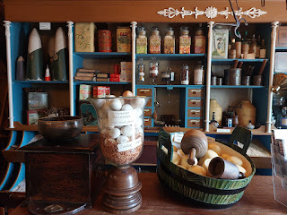

Today, the 1887 shop is mostly a museum and is run by volunteers. We had a lengthy and lovely chat with the lady running the front store, but she didn't think her hair looked good enough for a photo with us. :)

Across the street from the Albert Heijn shop, I found my retirement home. I fell madly in love with this house, surrounded by narrow canals and a footbridge to welcome you to the cutest home EVER.

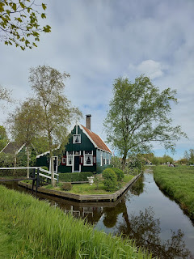

Video of my future dream home: (10 seconds)
https://photos.app.goo.gl/ifvYUyKbSrwKbo6N9

Another view of the same house on the following morning, when I saw the cute little wooden yellow clogs hanging on the far left, and a dock area also on the left side. Perfect for a little row boat. How CUTE!!

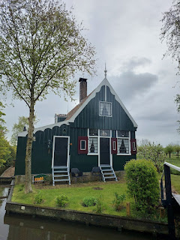

I found a very helpful blog with information about all of the Dutch windmills and their individual purposes. This blog is what helped us to understand the area the best.
Here is the link:
https://www.hiddenholland.com/zaanse-schans-windmills/

For example, I used to think that the windmills were solely for energy or farming purposes. But I was mistaken.

In the blog (linked above), Gerrit explains: "
Back then, there were
more than 1,000
of them! Used for producing food, but also things like paper.
There are 13 left today, and about six are
open to visit
.
The Zaanse offers
more than windmills
, though. It’s a collection of authentic Dutch houses painted with the typical green paint local to this area. It’s called “Zaans Groen” (Zaans Green).
This color makes the
Zaanse Schans
so distinct and easy to recognize
."

I learned from him first (as you'll read in his blog) about some of the windmills' distinct purposes. Zaanse Schans has a spice mill, a paint mill, a wood sawmill, and an oil mill, just to name a few.

We stopped in the spice mill next . . . I took a couple of photos at first, and then I got caught up in all the spices for sale and forgot to take any additional pictures. I was surprised to see some packets of freshly ground mace, something I could not find anywhere in Vicenza last fall when I was making homemade applesauce. You better believe I bought some mace here! I also bought some ground mustard, some AH-MAZINGLY delicious cinnamon candies, and a magnet for my fridge.

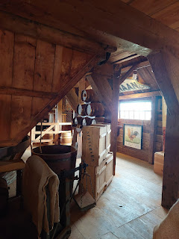

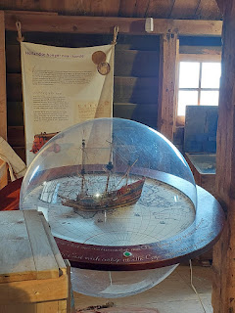

When I saw this sign at a nearby shop called "Blik Op Cacao", I was hooked. The weather was quite chilly at this point, and when you smell chocolate everywhere you go, it feels like it's just constantly calling to you to buy something chocolatey . . .

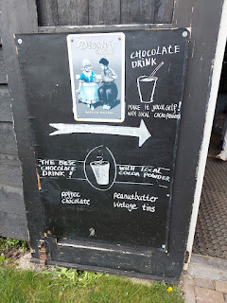

Someone pointed the way for me to the back of the shop where I could make my own hot chocolate. Miraculously, I was able to get a video of the area without any crowds whatsoever!

Video of the hot chocolate station: (29 seconds)
https://photos.app.goo.gl/FDhyjaFmsC9Lvwmx9

~First, you have to decide if you want a small or a large cup. The small is 4 euros; the large is 6 euros.
~(I chose a small)
~Second, follow the arrows and instructions painted on the table.
~One scoop of cacao powder for the small cup, two scoops for the large.
~Third, add some brown raw cane sugar. One spoonful for the small cup, two for the large.
~Fourth, add a shot-glass amount of cold water.
~Stir briskly with the wooden stick provided for a solid 60 seconds.
~Fifth, go up to the cashier and have them add the hot water and optional cream. Is cream *really* ~optional? In my world, it is always mandatory.
~I added a sprinkle of cinnamon on top to garnish it. And Voila!

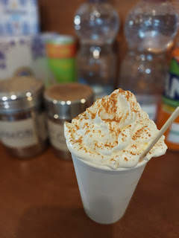

That singular experience literally changed my whole world regarding hot chocolate. I learned a few key things:
The quality of the cacao powder makes a crucial difference. Darker cocoa powder adds more overall flavor, which then means you don't need to add powdered milk or loads of sugar to it. (*Cough* - Carnation) Also, the fact that it was fresh and locally sourced made for a more robust flavor.
The use of brown raw cane sugar, and how little was needed, surprised me. A couple people have told me that raw cane sugar is healthier than regular granulated sugar, but in my initial research on the world wide web, I could not find anything to back that theory up. The thing that surprised me in my hot chocolate, though, is that the sugar spoon was small and yet it yielded plenty of sweetener.
I liked the fact that milk was not needed, neither fresh milk nor powdered milk. Just hot water.
And lastly, a high quality whipped cream on top was the icing on the "cake".
It felt like the carb count was lower than what I would have gotten with a traditional hot chocolate packet mix. The cacao powder was the key ingredient, for sure. Yay - it feels like I finally have an option for hot chocolate during the long winters back in Idaho!

The next mill we toured was the one that makes paint. The whole experience here was really fascinating!

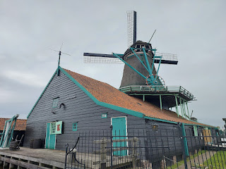

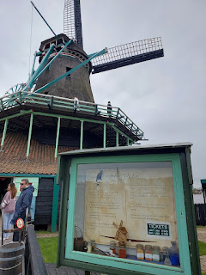

This sign says: Verfmolen De Kat - since 1782.

"Have you ever asked yourself how Rembrandt came by his paint? Here played the paint mills a major role.

"The mills process all kinds of minerals and earths, to which the artist added oils like linseed oil to make his paints.

"Verfmolen De Kat is the last remaining wind-powered paintmill in the world that grinds pigments and dyestuffs.
(bold type added)

"Come in and see our true craft skills in action. Or set yourself to work with our wide range."

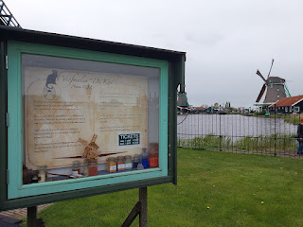

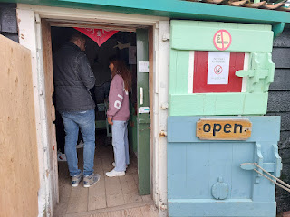

The sign below gives an overview of how they make paint pigment powder and chalk for football fields.
(click photo to enlarge)

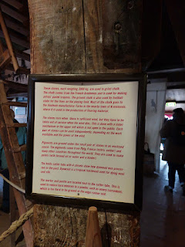

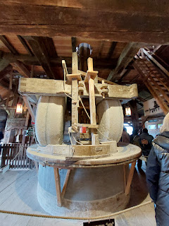

I got really excited when I saw these next displays in a glass case because they explained how and where the colors come from to make the paint and/or chalks. Feel free to click on each photo to read the little explanations.

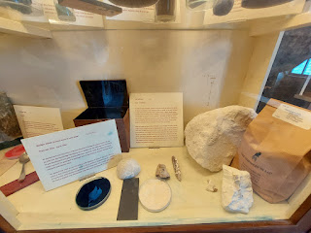

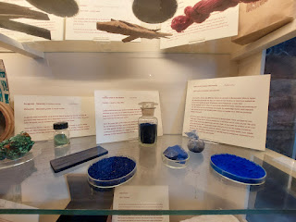

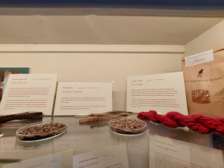

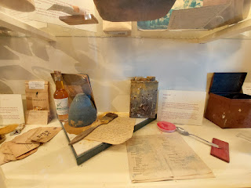

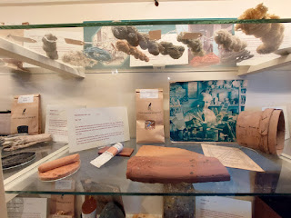

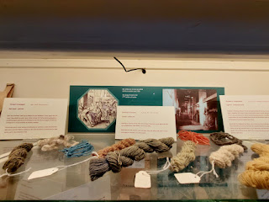

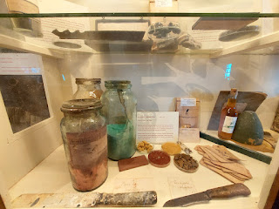

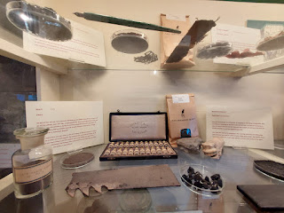

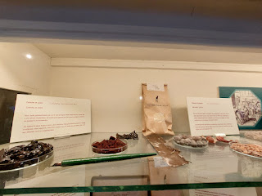

I was especially excited to document a tour of
this
mill because my daughter, Amber, is an artist. :)

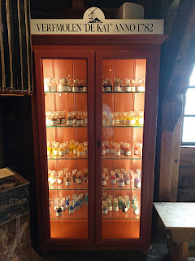

The "pulverizers" . . .

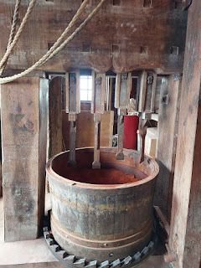

The mortar and pestle area . . .

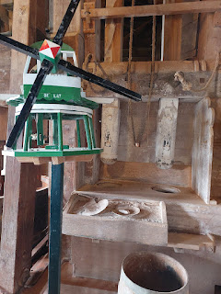

Barrels of powdered pigments . . .

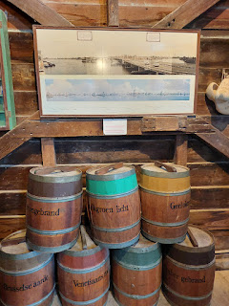

So beautifully arranged . . .

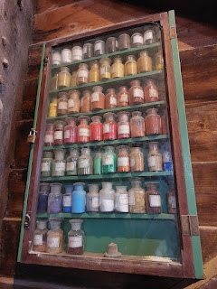

Video of the stairs where you can "take it to the next level": (6 seconds)
https://photos.app.goo.gl/ie81Kxb9X3DjKCj89

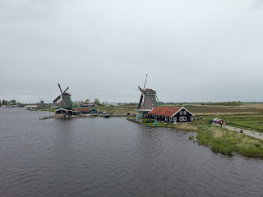

Video of the views from the upper deck: (8 seconds)
https://photos.app.goo.gl/24n3iCLDegjnjj2VA

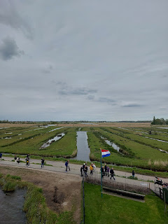

'Twas quite breezy outside by this point . . .

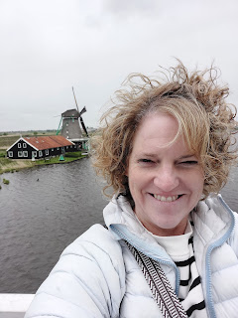

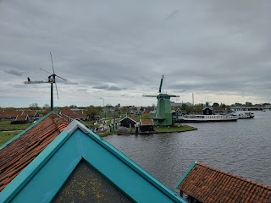

This stalwart guy was up at the tippy-top of the paint mill - painting, of course!!

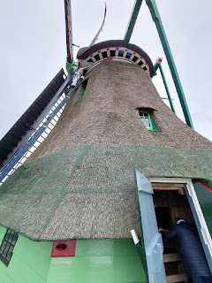

Lots of people were terrified to go back down, because it was literally STRAIGHT DOWN. While they were trying to talk themselves into being brave enough to take the first step, I jumped ahead and started the long shimmy down. These sorts of things don't really bother me . . . Scott is a whole different story, though!!

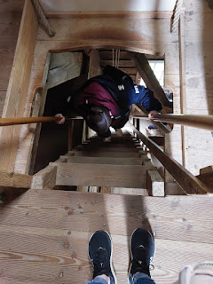

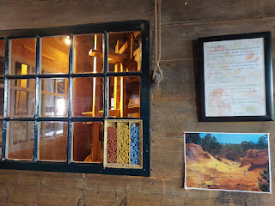

In the other half of the room downstairs (where we began our tour), they had a video playing that demonstrated the whole process of making a tube of paint. It was SO COOL!!!

You can watch it here: (1 minute, 2 seconds)
https://photos.app.goo.gl/sN3FjdSJfKyQUVQg8

I bought Amber a VERY special birthday gift before we left the paint mill. And don't worry about the possible surprise being ruined . . . she's been so busy packing for their move to Portland that I'm pretty sure she's too preoccupied to be reading this. She turns 30 on May 18th and I know this will be a treasured gift for years to come.

As we exited the mill, the rain had started up again outside. It was blustery and very cold. We decided to get some food and go back to our hotel for the evening. On our way back through town, we stopped at the "Dutch Pancake Co." It was a great location and sounded yummy.

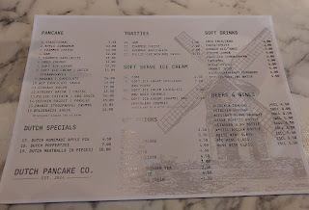

I asked for the ham and cheese "toastie" (basically a grilled cheese sandwich), and Emily ordered the Dutch poffertjes (tiny and spongy mini-pancakes w/ powdered sugar on top). We shared our smallish meal. The food was good, even though they didn't cook up a HAM and cheese toastie for me, I just got a simple cheese toastie.

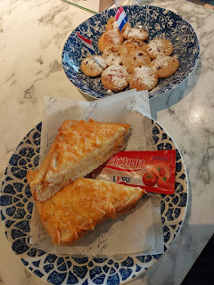

We also had to wait over 30 additional minutes for the chef to make up another batch of hot chocolate. They fill a large barrel with the hot mixture and the guy at the front bar ladles it out into a mug for each customer. I guess it takes an eternity to get another barrel's worth of hot chocolate . . .

It was good, but not quite as epic as the one I had made earlier in the Blik Op Cacao shop.

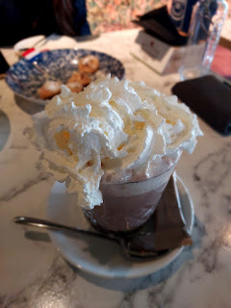

Wednesday, April 24th:
(Benson's birthday!) We woke up the next morning all excited because we were going back to Zaanse Schans again!! We had unfinished business there, and more to explore. Even though the weather had turned pretty foul the day before, the following morning was quite mild and made for some lovely photography.

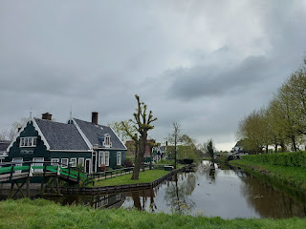

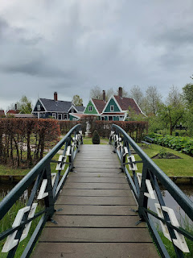

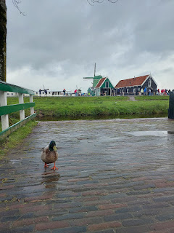

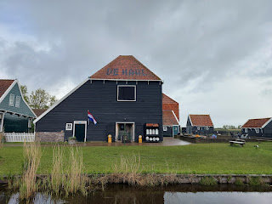

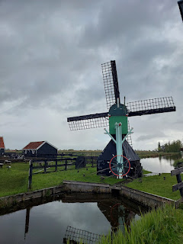

Our primary goal was to visit the clog shop, and it ended up being a lot cuter than we ever anticipated!!

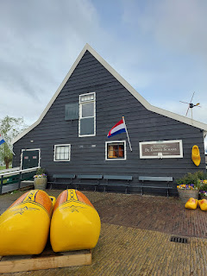

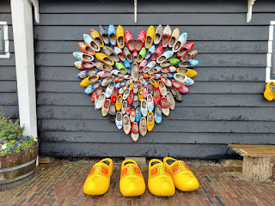

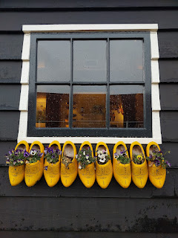

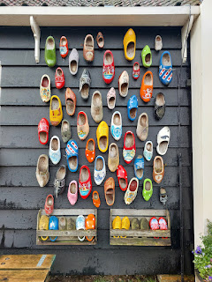

Me and Emily . . .

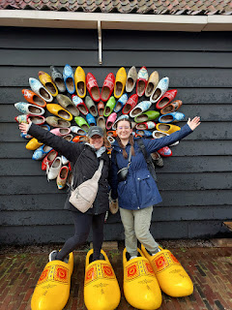

Inside, we first entered a long hallway that was pretty much a clog museum, teaching us about the history of clogs and all of their many uses. (Click on each photo to read more) For example, the first photo below says that each region in the Netherlands had its own style of shoe. Anyone could tell where you were from, based on the clogs you wore.

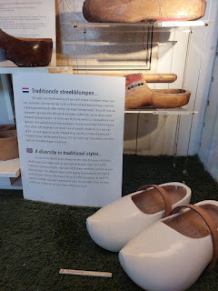

This next photo has a map of the Netherlands with traditional clogs from each region . . .

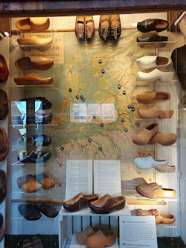

The photo below has a more readable "key" for each clog and its region on the map . . .

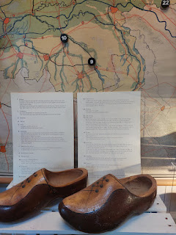

A sampling of work clogs through the ages . . .

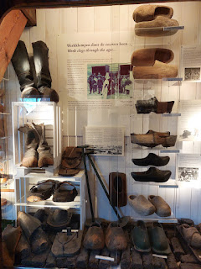

Sunday clogs . . .

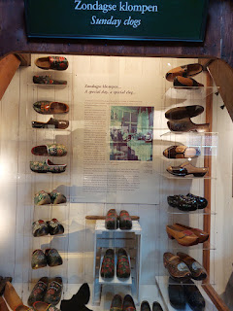

This next one is harder to read the explanation, so I will try to help with that. There is a terrible glare, too, on the glass (sorry!). There is a photo in the center that mentions a 300 year old pair of shoes. On the upper right, the interesting pair of pointy clogs has a fascinating story behind them. They are known as Pyrenees clogs due to their connection to the Pyrenees Valley in France. They are authentic betrothal clogs that have been traditional for hundreds of years. The groom would present a pair of the long pointed wooden shoes to his bride-to-be on Christmas Eve. They would be covered with leather and richly decorated with ornamental studs and carved patterns. The shoes would express the passions of husband for wife; the longer the point, the more fervent the love . . . !!

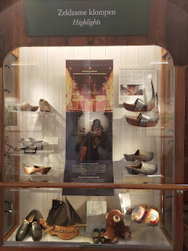

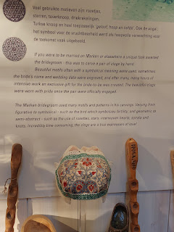

The photo above describes the intricacy of the clogs below . . .

It says: "If you were to be married, a unique task awaited the bridegroom. This was to carve a pair of clogs by hand. Beautiful motifs, often with a symbolical meaning were used. Sometimes the bride's name and wedding date were engraved, and after many, many hours of intensive work, an exclusive gift for the bride-to-be was created. The beautiful clogs were worn with pride once the pair were officially engaged.

"The Marken bridegroom used many motifs and patterns in his carvings. Varying from figurative to symbolical - such as the bird which symbolizes fertility; and geometric to semi-abstract - such as the use of rosettes, stars, interwoven hearts, spirals, and knots. Incredibly time-consuming, the clogs are a true expression of love!"

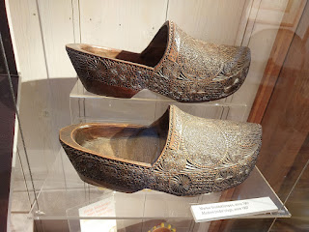

The translation for the clogs below says, "Children's shoes from France."

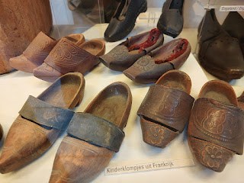

A pair of clogging skates?!! I would love to give those a whirl . . .

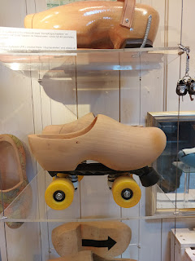

A few other interesting pairs . . .

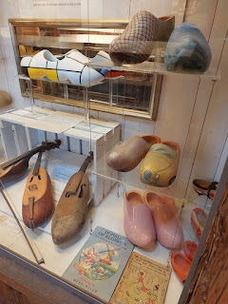

While we waited for a tour group to arrive for the next clog-making demonstration, I took a video of the quiet workspace that would soon be packed: (54 seconds)
https://photos.app.goo.gl/bwUT3WdmqUpFRttr8
Emily and I wandered around the gift shop area before any other tourists arrived. I had fun looking through all the million pairs of clogs, ha ha.

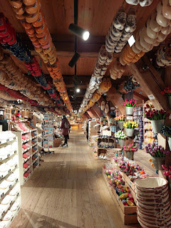

Video of the clog choices: (10 seconds)
https://photos.app.goo.gl/72qWRXDkB8yFbrTc9

I should have gotten a photo of how much larger the clogs actually are on the outside, compared to the smaller insides where your feet fit comfortably. My shoe size is usually 6.5 in the U.S., which meant my Dutch size, or UK size, would be roughly a 36 or 37.

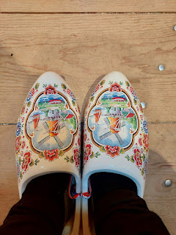

I decided to buy a pair that would probably get more use back home, so I chose this pretty colored pair of leather clogs instead . . . they're like a greyish-sage green.

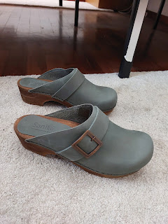

So many clogs . . . and all of them were so cute!

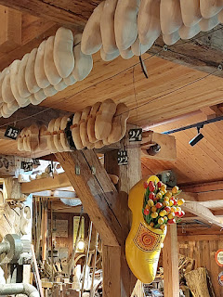

Time to learn how clogs are made! The instructor was ready to cater to both an Italian tour group and some of us English speakers, so he switched back and forth between both languages during his demonstration.

Video #1 of the clog-making demonstration: (1 minute, 8 seconds) He first shows us how a shoe would be made by hand. He tells us that it takes about 2-3 hours by hand, OR about 5 minutes by machine.
https://photos.app.goo.gl/Rbi9K9jD8BTzCBjQ8

Video #2 of the demonstration: (19 seconds) Scott noted that as the machine is spinning the large block of wood on the left, it's also mimicking the already-formed clog "shell" that is spinning just to its right.
https://photos.app.goo.gl/Yr5u4hxKvnqoMXtC8

Video #3 of the demonstration: (1 minute, 34 seconds) The instructor transfers the clog to a different machine to bore out the inner core. He uses some sweet hip/leg action during the skillful process.
https://photos.app.goo.gl/9AHYQFYukCGdoX16A

Video #4 of the demonstration: (54 seconds) The instructor trims off the tip of the shoe and explains that it now needs to dry for 4 weeks. This clog will also fit a size 4 child's foot, he adds.
https://photos.app.goo.gl/Hd5FuhLjcstfQQVM8

Outside of the videos, he told us that these shoes, once treated, are waterproof, keeping the feet warm and dry.

After the lively demonstration, we left the clog shop and walked around for a bit.

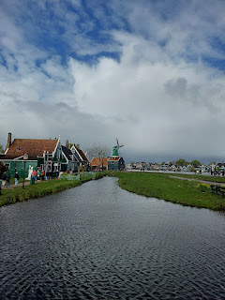

We enjoyed petting a goat through the fence . . .

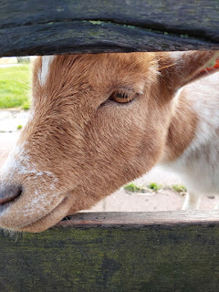

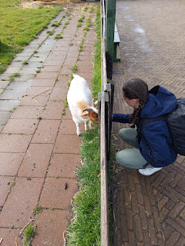

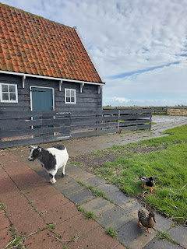

And we got a mini-stroopwaffel for 1 euro. It was nice and warm and quite divine.

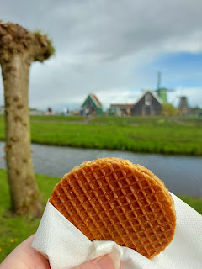

We had to wait a few minutes outside The Tiny Chocolate Factory for them to open up for the day. It turned out that it was just one guy running the whole shop, running the register, making coffees and other hot drinks, etc. He is from Madagascar, we learned, and most of his chocolate-y items are imported from there.

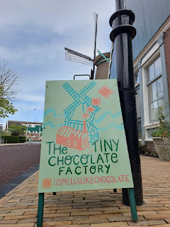

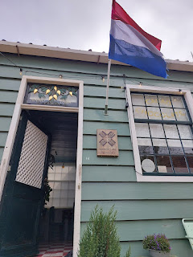

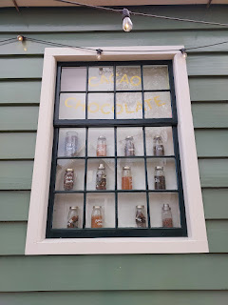

It was still a very cute shop, even if it didn't have many offerings with locally made chocolate. I saw this display, though, that said you can choose a "tin" and then have it filled with
local cacao powder
. Yes, please!!

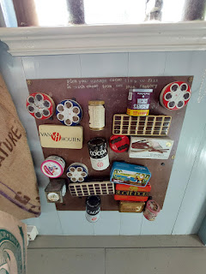

He also offered some little chocolate goodies, but we did not buy any of them. Instead, I bought a book about how they go from the cacao bean in Madagascar to various forms of chocolate in the stores.

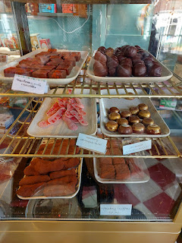

A cozy fireplace is inside the shop for those EXTRA cold days . . . but this was just a "medium" cold day.

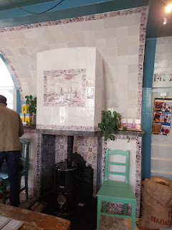

Cacao beans . . .

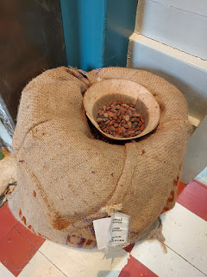

The tin I chose . . .

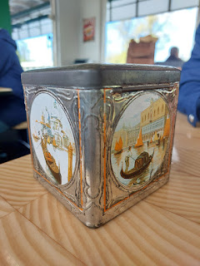

And tucked inside was some cacao powder from Zaanse Schans . . . XOXO

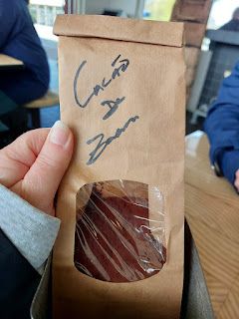

We rode the train back to our hotel where we could reset and solidify our next round of plans. After lunch in Zaandam, we hopped on the train again, heading into Amsterdam to visit the Rijksmuseum.

Rijksmuseum:
Designed by Pierre Cuypers and with its doors officially opened in 1885, it is a massive museum with art collections that include Rembrandt, Vermeer, and Van Gogh, to name a few. Emily was also excited to see the Cuypers Library that is housed inside. More on that in a minute . . .

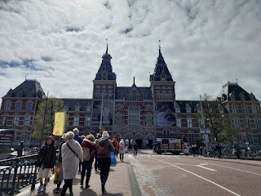

The National Museum of the Netherlands was founded in 1798 in The Hague, and moved to Amsterdam in 1808. Something I didn't know before, was that Napoleon Bonaparte established the Kingdom of Holland in 1806!

Knowing my tendency to want to photograph all of the art in a museum that "speaks to me", but also recognizing that I had already taken a TON of photos all over Amsterdam, I made a silent pact to myself: I will limit my photos to the Top 20 paintings that I like the most. If I ended up with more than 20, then it either needed to be justifiable, or I would need to dump one of the other 20 to free up a slot for the higher priority one.

I told Emily of my plan so that I had a little more accountability, ha ha. She liked my plan and supported my efforts. :) Keep in mind that in order to document and connect the artwork with its master, I also had to take a photo of the description plaques. For you math nerds out there, that would make 40 in total.

I will just share a few here, with a link down below for further exploration.

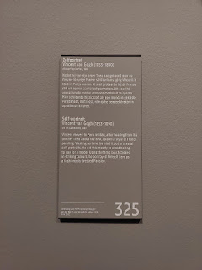

Self-portrait of Vincent Van Gogh, 1887.

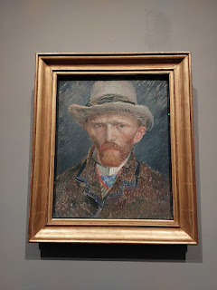

Not only did I like the composition of this next painting, but I appreciated the description of it. It basically represents how being an artist doesn't always pay the bills. There might be periods of time where you are sustained by simple bread and water, until better times eventually come.

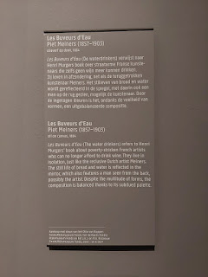

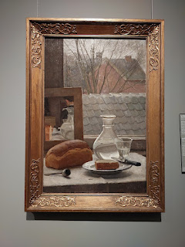

I loved the reflection of the windmill in this 1889 painting . . .

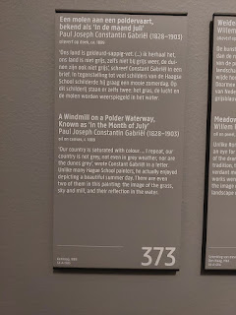

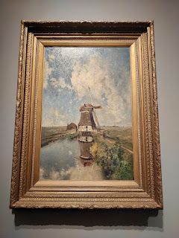

It took a bit of elbowing to get up close to a couple of Rembrandt's paintings, and I sometimes had to wait several minutes to get close enough to actually enjoy seeing it and to take a photo or two. It was worth it in the end, though. Where else would I get to see an original like these?

For some of the special works, there was also a laminated and double-sided "closer look" 11x14 poster. They pointed out some interesting features in the painting that might have gone unnoticed otherwise. I really enjoyed this additional tutorial. If I were a trained artist, I might notice those hidden features a little better. But, since I'm not, it's like having an "Art for Dummies" book on hand.

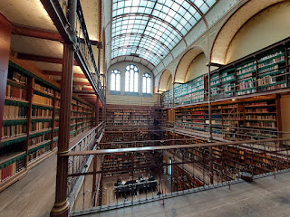

This next sign explains about the history and design of the Cuypers Library, but it's a little blurry. Some highlights are: It is the largest of its kind in the Netherlands; it was completed in 1881; use of the library is intended for art students or researchers; and this upper portion contains one kilometer of books and materials, with 5 more km of books and materials in the basement of the museum.

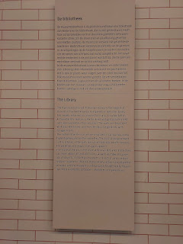

Video of the library as seen from the balcony: (12 seconds)
https://photos.app.goo.gl/v1gxjdifH68vuiZ67

Rembrandt's "Night Watch" (1642) is probably the most popular piece in the entire Rijksmuseum. It is his largest work, and even though it's hard to get context from the photo below, it fills the space from floor to ceiling.

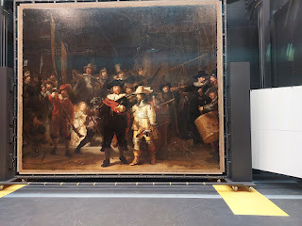

These are some of the detailed explanations and interesting features that the laminated posters share:

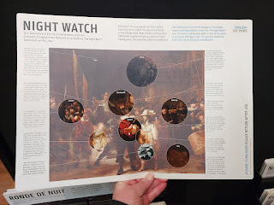

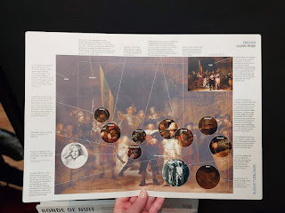

For a complete rundown of my Top 20, and a few extra items that weren't technically "paintings" (and therefore didn't count towards my Top 20), click here:
https://photos.app.goo.gl/ftcRp8YpxK3VKDqR8

Outside the museum entrance, street performers often fill short slots of time before swapping out with the next "act". As we entered earlier, this young man was playing his accordion: (10 seconds)
https://photos.app.goo.gl/Tb4E4XZkw1sR9aVMA

And as we left a couple hours later, these two were playing some intense accordions in the same spot:
(36 seconds)
https://photos.app.goo.gl/uhKQ9zmGKz3AJP8J8

When we exited the museum with our brains filled to capacity, Emily and I decided that a canal cruise would be most appropriate. Luckily for us, there was one right across the street. We bought our tickets and only had to wait a few minutes for the next boat to arrive.

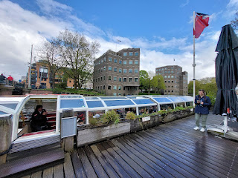

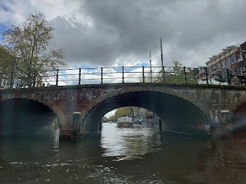

Video with the narrator describing how Dutch apartment buildings are too narrow for hauling furniture up the steep stairs, so most buildings have a hoist at the top to heft items up instead: (16 seconds)
https://photos.app.goo.gl/KY9WJzLAMEEkw1639

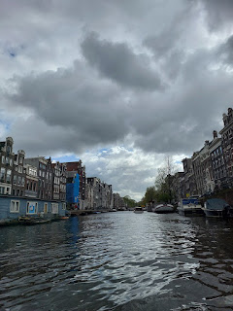

Video portion where the narrator describes how some buildings tend to lean a little over time, because of the lack of a sturdy foundation: (22 seconds)
https://photos.app.goo.gl/dFXYsoXRn7TXsz7T9

This is a famous block of leaning buildings . . .

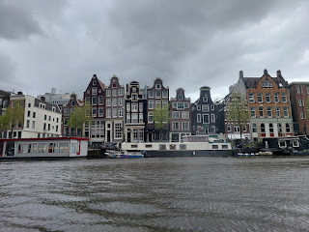

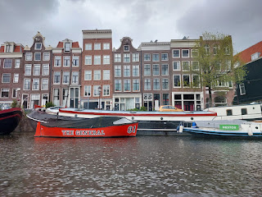

We saw many historic sites during the cruise, including the opera house, government buildings, the fanciest hotel (where celebrities stay), and this old fortification tower (built in 1512).

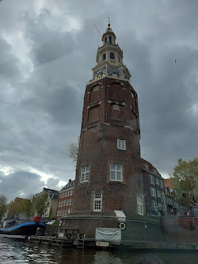

As we prepared to sail underneath Amsterdam's most famous bridge, our tour guide explained the need to kiss as we passed under it, ha ha. He was a comedic guy and made us laugh several times. In this next video, he is counting down to when we were supposed to kiss (or high-five if kissing wasn't an option)
Video: (26 seconds)
https://photos.app.goo.gl/DFBe5rwHxq5H6aV47

The bridge is called Magere Brug, or "Skinny Bridge" and also happens to be a drawbridge. It's been rebuilt a few times over the past 300 years and has also drawn famous movie sets to its location, including James Bond with his 1971 hit, "Diamonds Are Forever". At night, there are 1,200 lights lining the length of the bridge. It is said that this is the most romantic bridge in all of Amsterdam and that it's a place for many proposals and lovers' strolls. Legend also says that if you kiss while standing on it (or while floating under it), then whoever you kiss will love you forever!

Click here to see the bridge with its 1,200 lights at night:
https://www.iamsterdam.com/en/see-and-do/attractions-and-sights/bridges-of-amsterdam

Video of us chugging along, past a few houseboats: (26 seconds)
https://photos.app.goo.gl/MUP4arwBsiS6xgJs8

Some houseboats were very plain and very close together: (18 seconds)
https://photos.app.goo.gl/QqcicVGJzxgf7oRV6

Other houseboats were exceptionally well-kept, with lush potted gardens, inviting decks with sitting areas and a BBQ grill. Overall, the canal cruise was VERY relaxing and allowed us a chance to rest our legs and just kick back and enjoy the views from the Amstel River. I would highly recommend it!

Something I would NOT recommend is trying to find a restaurant when you are super hungry . . . Actually, we had a restaurant picked out before we even started our canal cruise. It was nearby and offered traditional Dutch cuisine. But, because it was a smallish restaurant, if you didn't have a reservation in advance, then you were out of luck. We desperately looked around the area, seeing a few other Dutch cuisine restaurants, but they, too, required a reservation. It was a popular area, so we knew there HAD to be something . . .

We found this nearby Spanish cuisine joint instead, called Granada, and hallelujah - they had space for us and we didn't need a reservation! Unfortunately, the food was just "meh", plus it was overpriced. Out of curiosity near the end of our meal, we looked on Google to see what this place was rated: a mere 3.5 out of 5 stars. How disappointing on our part, but we learned an important lesson. Do your research in advance, and plan as much as you can in advance - especially to know if reservations are needed.

Prawns - that I spent a good while taking apart to then have only 6 tiny shrimp left to eat, fries that needed salting, and a minimalist salad. Also, when you ask for water with your meal, the tiny bottles of water in Amsterdam (we're talking maybe 8 ounces) cost between 3-6 euros. No free water like what we get in America.

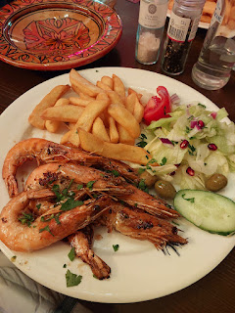

After dinner, we walked about 15 minutes to get to a super cute stroopwafel place. On the way, we passed this old building with an identifier above the door, stating that its orgins were in the year 1581. Today, it is a nutrition store, next door to a tattoo shop.

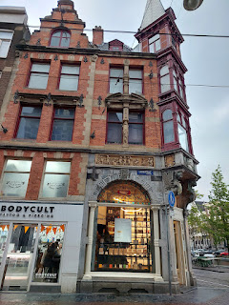

The walk through the rain was totally worth it when we saw how cute this place was!! It smelled so amazing and we actually got to see how the waffles are made. The shop is called "Hans Egstorf" and was established in 1898.

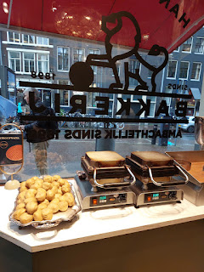

Video of how a stroopwafel is made: (44 seconds)
https://photos.app.goo.gl/g2jKmUQceJVyxZZ47

I think the dough ball splits somehow in the cooking process, because it ends up with a top layer and a bottom layer. The girl gently separated the two layers to place a scoop of carmelized gooey syrup in between, before pressing it down all together. Then they serve it to you nice and warm. Yummm.

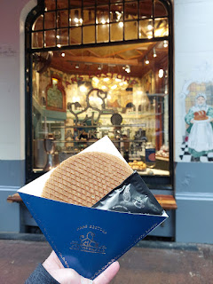

Here is a helpful YouTube video on how to make a stroopwafel: (1 minute, 34 seconds)
https://youtu.be/k6eSmGci1pM?si=QTgZADGX2maJ5xNb

I thought of my grandkids and my nephew, Blake, when I saw this magical lego store in typical Dutch style - with a giant windmill and a lego lady holding a wheel of cheese for you, ha ha.
Video here: (15 seconds)
https://photos.app.goo.gl/x6myU63SFJiqfCRN6

Before we went to sleep that night, I was finally able to connect with Benson (after 6 weeks of radio silence). He has a slightly different schedule lately, which makes it even more difficult to reach him when he's actually awake, taking into account the 8-hour time difference, too. We chatted for about 35 minutes and I was able to wish him a happy birthday. Yay!!

He sent me a picture of a recent award he received for helping to save that man's life back in February, when the roads were so icy on the interstate near Mountain Home AFB. I'm so proud of him!

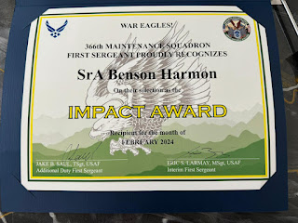

Thursday, April 25th:
Our last day . . . or partial day, I should say. We decided against squeezing one more thing in, and instead, we had a nice leisurely morning. We packed and organized all our stuff, including all the souvenirs and goodies to haul home, and then we went back one last time to our favorite nearby restaurant, Lagom Cafe.

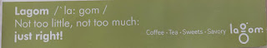

While we waited for our food, I noted the outfit this guy had on and thought to myself how nice Scott would look in something like that. I've been trying to talk him into some jogger pants for a while now.

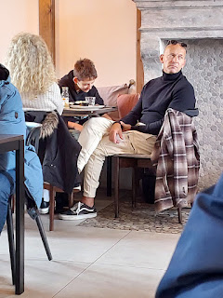

I showed the picture to him when I got home and surprisingly he liked what he saw! Now we're on the hunt for a comfy pair of jogger pants in that same "stone" color.

I ordered the traditional Lagom breakfast, but only minimally touched the breads. It was all very delicious! The yogurt parfait on the left was fruity and yummy, and the cheeses and cream cheese were great, too. I slathered some cream cheese on half of the croissant and immediately decided this was a new favorite thing for me. Also, in Europe (and Morocco and Cyprus), you peel your own boiled eggs. :)

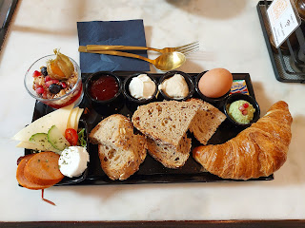

I had a headache that wouldn't quit, so I broke my "don't drink Coke-Zeros all the time" pact, to order one. They brought me a locally-made equivalent, called "Frittz-kola", which was just as good! Emily ordered one more hot chocolate from the Netherlands - for good luck.

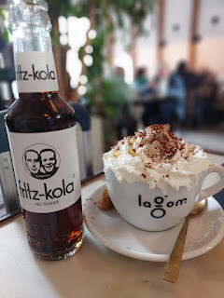

And then we caught a train back to the Schiphol Airport and flew back to Italy. The End.

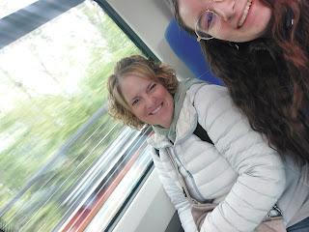

Just kidding . . . I will quickly summarize our 3.5 days by saying:

It was wonderful, amazing, enlightening, and delicious. I can't wait to go back.

In the next blog post, I will catch up on some other happenings in our family, with pictures of the grandchildren, and I'll share a couple of day trips that Scott and I have been on recently (Soave Castle and more Bassano ancestral sites).

