Hey Look Ma I Made It!!
Driving into California yesterday was a real treat. As soon as I got close enough to the ocean, I opened up the sunroof so I could hear and smell EVERYTHING!! I did about 6 hours of driving in all, making a few stops to break it up and enjoy along the way.

Starting the day in Grants Pass, Oregon, my first stop heading south was in Crescent City. I stopped just to get out and actually BE at the ocean. It's not the most beautiful beach I've ever seen, but it was still beautiful. As I walked over to take some pictures, there was an older gentleman sitting on the rock wall so we started visiting. He was heading back up north to Alaska, and once I learned he had served in the Air Force, we visited much longer than I first anticipated, ha ha. It was a pleasure to get to know him and his lovely wife. He even complimented me on my beautiful new top!

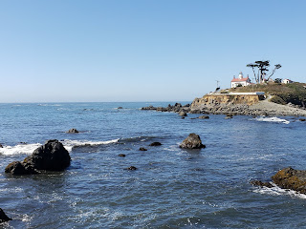

Second stop was in Trinidad, CA. I absolutely love this little beach harbor town!! The population is only about 500 but it's sooo charming!!! I got a smoked salmon grilled sandwich and had a scoop of chocolate ice cream on my way down to the beach. There's a set of driftwood steps going down to the water, with maybe 300 steps? It's virtually straight down. And then deep down you know that what goes down must also get back up!! I just tried not to think about that.

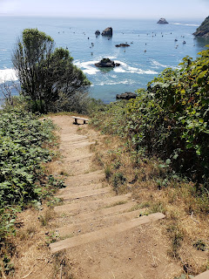

After taking lots of pictures and dipping my toes in the water and walking for a bit, I started heading back to the stairs. My rescue came in the form of a Marco Polo video from Amber and Abby. For some amazing reason, I had perfect reception down by the water but had zero anything back up in the restaurant!! So I spent a few more minutes doing videos with them. Long story short, I made it up the stairs. **wheez cough cough**

Hopping back into the car, I only had to drive a short distance before I arrived in Arcata. The thing I love about Arcata is their Community Forest. (
https://www.visitredwoods.com/listing/arcata-community-forest/489/
) It's always a great place to park and hop out of the car and immediately be immersed in the quiet solitude of a beautiful redwood forest.

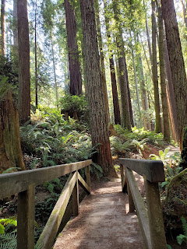

I also took the exit for the "Avenue of the Giants" further south, which is a slower road that winds through some redwoods close to US Highway 101. I propped my phone up on the dash and did a video of just driving along through there. You can see it here - as well as the other photos from the day.

https://photos.app.goo.gl/gWa7NL269wKEFTdE6

My dad and I set up a plan that as soon as I drove through Laytonville I would call him and give him a heads up. That way, we could meet at a designated spot down the road near his mailbox and visit for a bit. He lives about 45 minutes north of my mother, but it's off the main highway down a series of dirt roads out in the boonies, so to meet by his mailbox on the highway was a great spot!! We visited for about 30 minutes and took a selfie before back into the car again for the final leg down the mountain to Mom's house.

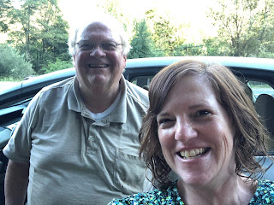

I just want to say how fabulous it is to be in CA, where my roots, my ancestors, my homeland is. This is where family is. This is where my ancestors settled almost 200 years ago. This is such a blessing and an opportunity to spend time with my loved ones for a few months. I am so grateful!!

News from Scott:

He called me Sunday evening and he is doing very well. He's been going to briefings and getting medical testing done - checking all the boxes that he's healthy to be sent overseas. He will still be in Fort Bliss, TX until roughly mid-October. Cell phone reception is spotty, but he has good service if he steps outside his barracks. He can get a text if you care to send him one, but he will only occasionally be able to get it as his schedule allows. :)

Lastly:

Last night I took my first night shift with my 98 year old Grandma Doris. She is in the bedroom just down the hall from my room, and I have a baby monitor to help me hear her if she needs anything. It took me forever to get to sleep because I was worried I wouldn't hear her if she called out. It was 102 degrees here yesterday, so we had ALL the fans on throughout the house, including a loud one in my room. So I worried. And laid awake. But around 1:30 a.m. I heard her on the monitor asking if I could please turn off the ceiling fan in her room. I was grateful that it all worked and that I didn't need to lay awake worrying anymore. I got up with her 3 more times in the night. So I'm a bit tired today, but I am grateful to be here to serve my sweet grandma and to help ease the burdens my mother has as well.

