Service is a Blessing
I've been out here in Ukiah, CA for one week now. I have come to appreciate some things and have learned some things these past few days.

I have been thinking a lot about Jesus Christ as my personal Savior and Example of selfless service. I am learning how to serve, how to serve continuously, and how to serve more joyfully. As a mother of three children, you'd think I would have already learned these things. I would say that I have - but in a different way. There is service in that which you choose to invest in, such as parenting. And then there is service in that which you are needed for, but it's not necessarily something you would have chosen to do in the first place. The service I am learning about right now is the second example. I am learning to follow Jesus' example in giving service to those who are in need, even when it can be exhausting and when I feel like I might prefer to do something else on occasion.

When I first realized that I had an opportunity to travel (once it became apparent that Scott was heading overseas for a year), I knew that my first stop needed to be here with my mother. And all summer long, I wished I could come faster so that I could help her sooner. Now that I am here, I am realizing just how weighed down she is with many burdens. I really feel for her. She lost her sweet companion, Frank, just before Mother's Day this year. And within a week of his passing, Mom invited her then 97 year old mother to move in. The thought behind that was for them to have joy and companionship together, to save money, and to keep an eye on Grandma under the same roof instead of driving across town all the time. While she was helping Grandma downsize and move in, and she was trying to work through her grief as a widow, it became apparent that she would also need hand surgery. The joint at the base of her right thumb is bone-on-bone right now and hurts to do every day tasks. I was grateful to come out here to be of assistance with all of these things. Her surgery is scheduled for Monday, Sept. 9th.

It has been a privilege to spend time with Grandma Doris (now 98 years old): to read with her, fix her meals, learn how to make a nice cup of coffee for her each morning, draw her eyebrows on each day, help her go to the bathroom - even in the middle of the night, sit with her on the back patio swing and talk about everything under the sun, and most of all - to say prayers with her each night. She is what you would call "plucky". She has endured a lot of hard things in her lifetime, but she is still able to be happy and laughs easily. She can also get frustrated when she can't do simple things, and the other night at the dinner table she dropped some pasta in her lap while trying to feed herself. I heard her mutter under her breath, "son of a -----". But her prayers are the most simple, honest, heartfelt and genuine of any prayer I've ever heard. Especially because she is not of any particular faith. She has her own quiet sort of faith. A trusting faith.

Last night, I also had some inspiration that would help Grandma feel more useful. I decided that each day we should find a job or a task that she can do that is also safe for her to do. So I invited her to put the silverware away as I unloaded the dishwasher and she really enjoyed that! She was so energized that she asked what else she could do, ha ha. So later I had her fold a load of towels out of the laundry. Pretty soon, she even got a little saucy and started indicating that she didn't even need us and that she could do things just fine on her own! I think we're working on finding a happy middle now, ha ha.

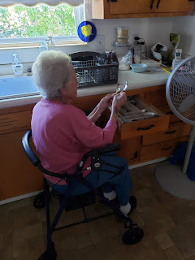

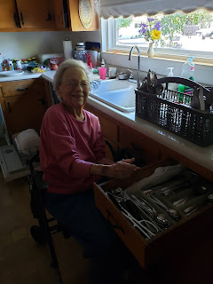

Today she wanted to tinker on the piano, so I taught her how to play Row, Row, Row Your Boat and some basic finger exercises. She is having fun over there as I'm typing this blog right now. :)

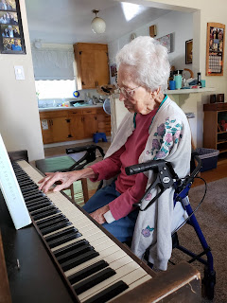

My existence right now consists of trying to get enough sleep at night since the nights that I'm helping Grandma Doris = minimal sleep; learn where my Mom keeps everything - such as cleaning supplies - so that I can take over and help after her surgery; eat as much fresh produce as possible out of the garden so it doesn't spoil; keep Grandma entertained during the day; and run any errands that need run - such as to Walmart or the grocery store. I keep encouraging my mom and Grandma to start getting ready for bed earlier in the evenings. It takes forever to get Grandma all situated so if we could just begin at 9:00 pm that would be FANTASTIC! But that's not the case. Usually they begin around 9:45 pm and that is just way too late for me. I would rather go to bed early and get up early, but they prefer to go to bed late and sleep in the next morning.

60% of the cherry tomatoes on one bush that I picked this morning:

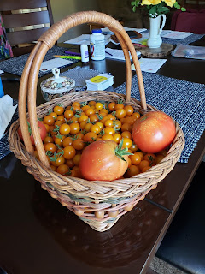

News from Scott:

He's doing great down in Fort Bliss. He's very happy and is looking forward to his future assignment overseas. He calls me most every evening, which blesses my life immensely. He can't tell me much about what he's doing, but is always asking about everyone here. We are even doing video calls, which is awesome. I'm so thankful for modern technology!!

That's about all for now. I'll catch up again in a few days.

Love to you all.

