Coy Michie Harmon 1933 - 2023
My amazing and wonderful mother-in-law, Coy Harmon, passed away last Monday, May 8th at 6:20 p.m.
She was blessed with 90 years of love and legacy that she left behind.
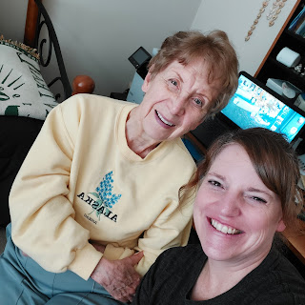
Link to the audio recording of her funeral:
https://drive.google.com/drive/u/2/folders/1_bgcEkd4E8Wt9xhpE1F_4p_aq2zPi1zG
She had been having some health issues in recent months, especially with her heart, and went in on April 20th to get a CT scan. The results showed that her entire liver was engulfed in tumors, and there were signs that tumors were elsewhere, too. She was sent to the cancer specialist the very next morning to discuss what to do.
The diagnosis was late-stage liver cancer, and the prognosis was bleak. There would be no surgery to remove the tumors, because they would have to remove the entire liver and get a transplant. Not something viable for a 90 year old woman . . . There would be no chemotherapy, either. Instead, she was told to line up some hospice care and that when the time came, the doctors would prescribe morphine to help make her more comfortable.

L to R: Dad (Phil), Coy, Pam Harmon (holding Mom's hand), Bev Harmon Vian (down in front), Melodi Arnold Calvert (Sharon's daughter), and Emily Vian Dever (Bev's daughter).

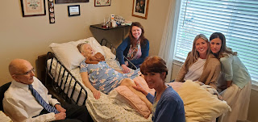

Scott and I were in Italy when the call came with the devastating news. His brother Gordon, and sister-in-law Pam, were with us as well. We were all set to celebrate Scott's birthday (April 20th) when we received the news. We didn't feel like celebrating much after that.

The following day, we were with Benson at the BeFed Restaurant up in Aviano when the call came regarding the official diagnosis and letting us know that nothing could be done. It was hard to eat our dinner after that. In fact, it was very difficult to sort out all of our feelings for the next several days. But it was good to be together to process the news and make lots of phone calls to Idaho and to pray for Mom as a group.

A couple of days later, another call took place that was very hard to process. Scott's sister, Bev, called to let us know what Mom wanted everyone to do and how to take part in her upcoming funeral. We had just left Aquagardens and were driving back to our house in Vicenza, when Bev called. We pulled over so that we could just focus on the phone call. When Bev told Gordon that Mom wanted him to sing "It Is Well With My Soul" at the funeral, everyone in the car burst into tears. I don't remember much after that. Somehow we made it home and limped through the rest of the evening.

I haven't been able to talk about any of this until now, because there were a couple of tricky family situations going on and not everyone had been notified of Mom's diagnosis. But now I am free to share a few details of the past 3 weeks.

Right away, Bev's two daughters, Vanessa and Emily, made plans to drive up to Idaho from Arizona to help tend to their Grandma. Sharon's daughter, Melodi, and son-in-law, Lance, also flew out from Georgia to stay for a while. Vanessa and Emily reached out to me and we made arrangements for them to stay at my house, while they lovingly cared for Coy in her final days. They drove back and forth from Idaho Falls to Rigby every single day. They (along with Lance and Melodi) held her hand, read to her, laid quietly next to her while she slept, cleaned her house, cooked for her and Grandpa, ran errands, and kept her company. As she declined rapidly, those loving acts of service became more tender, as they dressed her, carried her, showered her, massaged her legs when they were in pain, etc. They sang to her, read poems and scriptures to her. They read text messages to her from family members who couldn't be there, and they even slept on the floor next to her once she moved into the hospital-issued bed down the hall.

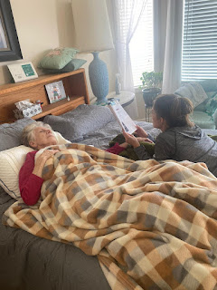

Vanessa and Emily began sending us daily updates so we could still be included in what was going on. Emily sent me this message on
May 1st:
"We've been rubbing her legs to keep her circulation going and helping her in and out of bed and in and out of chairs, up stairs, to the bathroom, etc. We've been helping her with her medication and getting dressed and getting chores done. Last night she was sick during the night and Vanessa helped her through that panicky episode. We got the flower beds cleaned out some and grandma's new flowers planted today. She of course wanted to be in the middle of it. She got too dizzy outside and she toppled over onto the soft grass. Luckily Vanessa and I were right there. We held her like a little child until she felt better and then we got her back into the house. She recouped pretty well and we got to be silly with her before bedtime. She is so sweet and so grateful and tender."

On May 6th,
Vanessa sent me this message: "Thinking about you this morning! I'm sure Amber is in close touch, but she made grandma so happy when Amber's bright and pretty face came through the door. And Grandma had been so uncomfortable yesterday morning, and then finally slipped into a deep and unresponsive sleep for so many hours. Lance and Melodi and Grandpa and we had taken turns sitting by her and reading her poetry or scriptures or just being still. Right before Amber arrived, Grandma's sleepy eyes came open and she wanted to be moved to her burgundy chair - not knowing another special guest was on her way . . . When Amber walked in, Grandma was ready to receive her."

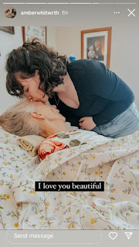

That same night, Amber wrote us: "She's declined sharply over the past week, from bustling around the house like normal, to barely able to move. We help her adjust herself so she's in the least amount of pain, and we help her use the bathroom, though tonight she could not. She seems to want to avoid the morphine as long as possible so she can be lucid and be involved and aware, but her pain is getting bad, so we are having to remind her that we will still be here even after it kicks in. Today she took a huge long nap most of the day and they were worried she was drastically declining, but then just 20 minutes before I arrived, she woke up and was sitting in the living room. She was lucid for a couple hours (Emily said she was amazed at how lucid she was) and I was able to talk to her about many things. She was so happy to see me. I had the most wonderful evening there. We got her tucked into bed after the morphine kicked in, and Grandpa put his metal pan by her face (he insisted a couple nights ago that she bang on the pan if she needed him in the night). After he left, Grandma said, "Take this ridiculous thing away" and then in the morning, Grandpa was like, "Where's the pan?" and we all sang some hymns for her as she fell asleep."

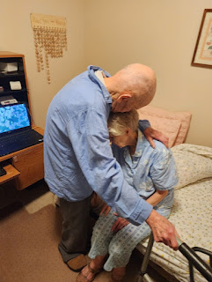

May 7th, from Amber:
"We think Grandma will pass tonight. Grandpa sent everyone home except Carol (who arrived this afternoon) and Vernetta. They will both take turns with Grandma tonight. Her pulse is slowing and becoming erratic. But this evening, she perked up and said a few words. Let me try to remember - - - Gordon said something like 'yeah, I know I'm the favorite' and Grandma broke into a huge smile. Then Bev came to say goodnight and said, 'I'm sorry Mama, I have to go' and Grandma responded with 'That's okay baby'. Then Bev kissed her on the head and Grandma said, 'Hello baby'. They called Grandpa in while Grandma was perky and she began to try to say something to him. She was making noise with her throat and moving her lips but couldn't get any words out. Grandpa said, 'I know, honey. I understand. I know we're in love. Wherever you're going, I'm going too.'

Same day, May 7th:
Emily recorded on an index card the conversation from Grandpa to Grandma: "I love you Darlin. I always have. That's an eternal promise. And wherever you're going, I'm going too." As she tried to speak: (he added) "I understand Darlin. Don't worry about it. I know we're in love."

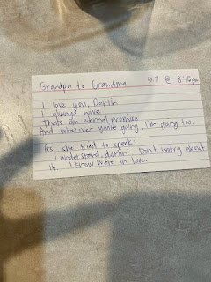

May 8th, from Amber:
"Grandma passed away peacefully with all of us around her at 6:20 p.m. Grandpa is doing alright. He's very at peace. Carol was amazingly strong, caring for her through and past the moment of death."

Dad said to his bride of 67 years, immediately after her passing, "Good job, honey. You did great!"

Amber also called us in the middle of the night while we were sleeping in Italy. I remember looking at the clock and saw that it was roughly 2:30 a.m. Scott talked to her briefly, thanking her for being there and for letting us know, and then we laid there in bed side by side, hugging each other for a little while before going back to sleep. We both commented in the morning that we each felt a strong feeling of peace for a long, long time after Amber's phone call. For me, it was a warm feeling in my heart, that seemed to envelop my entire body. The feeling stayed with me for several minutes, and I felt comforted by it. I felt like it was Coy, reassuring us that all was well. I felt of her love and knew that she was happy and in a peaceful place. It was a beautiful experience.

Amber posted on social media . . . (click on photo to enlarge if needed)

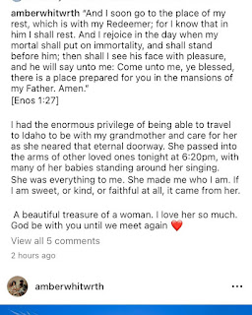

A couple days prior, Bev had called to gently implore us to come as soon as possible. She explained that everyone was there (except for us) - or would be arriving in the next day or so - and that when the time came (which was expected to be very soon) for Mom to pass, they could put together a funeral very quickly while everyone was still there. They just needed us to be there, too. So Scott and I hurried to put some plans in place, which ended up being for Thursday. (May 11th)

Scott arranged his flight through the Red Cross and the Army. The Army paid for his ticket, which was so nice. It was around $900. We paid for my flight separately, just a one-way ticket though, for now. It was $1500 because it was only a few days away . . .

While the family back in Idaho were mixing and mingling, cleaning and organizing things around Mom's house, etc., we finished up the last few days of our visit with Jacob, Hannah, and Jack. I arranged for the three of them (plus myself) to ride the shuttle bus from the base in Vicenza to the Venice Airport early Thursday morning. I had to get passes for them to come on the base, which we took care of on Monday afternoon. There were MANY details that Scott and I were handling, all while trying to enjoy our precious company. Somehow, through it all, we were being infinitely blessed.

Thursday, May 11
: Scott flew to the United States via Amsterdam and into Salt Lake City, where his brother Gordon picked him and drove him north to Idaho Falls. He picked up our car and then drove up to Rigby to be with all of his family there. It was a bittersweet reunion, but thankfully there were many loved ones there to give him lots of hugs.

My travel was not as straightforward as his, but I will share that story in a separate post.

Friday, May 12th:
I had no further difficulties in my travels, and arrived in Idaho Falls a little before 12:30 p.m. Weston flew in just 5 minutes before me, so we waited together out front for Scott and Amber to come pick us up.

Scott and I quickly put together a grocery list and had just finished getting groceries, when I received a text from Gordon's wife, Pam. She let me know that I was invited to come help dress Mom at the funeral home prior to the family viewing. I had to hurry home, put the groceries away, and then race up to Rigby to participate in that tender service.

Pam met me outside and hugged me sweetly before we went inside. My heart was racing because I was about to see my mother-in-law for the first time since she had passed. I walked into the back room at the funeral home, where Carol and Bev (Scott's older sisters) and Vernetta were waiting for me.

It is difficult to describe how it felt to see Coy for the first time in this state. I melted into tears right away as all kinds of emotions were chaotically filling my body. I felt guilt and regret that I hadn't been there in person to say goodbye. I felt guilt and regret that I hadn't been there to help, either. Yet, at the same time, I felt a sweetness and peace envelop me once again, reassuring me that all was well.

Bev quickly began coaching me about what we were going to do, since we had limited time. She wanted me to understand that as we dressed Mom, we would inevitably be touching her hands, her arms, her legs, and that they were cold to the touch. She invited me to touch Coy's hands, which caused more tears to instantly roll down my cheeks.

Then, we began to dress her. She was already in her undergarments, with her hands gently overlapping each other on her abdomen, in a peaceful, yet permanent position. The ladies all seemed to have plenty of confidence as they proceeded to dress Mom in her white temple skirt. I tried to keep up, even while I was a bit in shock. After all, they had already been there for a few days before Mom passed, and they were all there when she did finally pass. But I wasn't there for any of that.

We gently took turns rolling her onto one side, while the others gently tugged and pulled to get her skirt on from the other side. Then repeat the process from the opposite side. When it came time to put her white temple top on, it was long sleeved and buttoned up in the front. We got her first arm in the sleeve, and brought the rest of the blouse around her back, but it was obvious right away that it would be impossible to get her second arm into the other sleeve. Someone had been wise to bring a pair of scissors, and we cut the back of her blouse all the way up to the top collar, almost cutting the fabric into two separate pieces. That allowed for a much easier process to get her other arm into the second sleeve. If you were to bend or lift that frozen arm of hers too much, it would literally break. So we tried to be as gentle as possible.

What struck me throughout this entire process, was how these sisters spoke so lovingly and consistently as we dressed her. "Sorry, Momma, we just need to move you a little bit here." "Sorry, Momma, we're almost done." "Wow, Momma, you look so pretty." "You're doing great, Momma." "We love you so much."

I worked minimally, as I was either crying or in a little bit of shock. At one point, Pam gently invited me to help with a specific task: "Shellie, we need to put Mom's stockings on. Here, would you like to put this one on? And I'll put this one on." As I tenderly placed a white knee-high stocking over Mom's foot and pulled it up to her knee, I began weeping silently.

Next, Pam had the difficult task of styling Mom's hair for the family viewing in just a few minutes. She didn't want to do it, but everyone knew she was the most qualified since she was a hairdresser. She lovingly combed thorugh Mom's hair one final time, while tears flowed down her face. She spritzed some hair spray here and there to hold things in place. And then we stepped back to appreciate and admire what we had just done.

Vernetta and Pam, as Pam was styling Mom's hair . . .

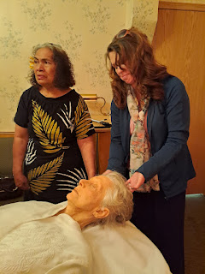

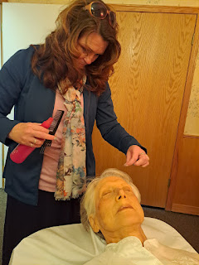

The funeral worker came in at that point and offered to take our photo. And then he took Mom away on the gurney so that their team could transfer her to the casket for the viewing before everyone arrived.

L to R: Me, Pam, Carol, Bev, and Vernetta

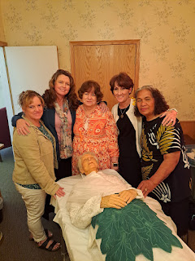

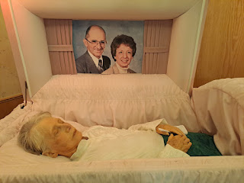

Within moments, family began arriving for the family viewing. Coy did not want a public viewing, so it was just for family only.

Weston and Amber . . .

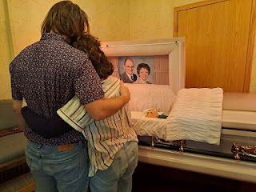

Gordon hugging his sister, Sharon, who had just arrived with her husband, Shawn

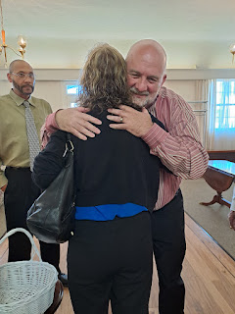

After some mingling, hugging, and visiting, Dad gathered us all together for some instructions for the following day, along with a precious and uplifting pep talk for everyone.

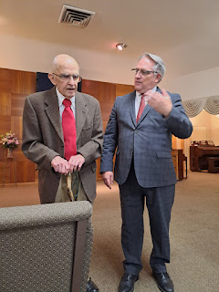

Video #1 of Dad: (1 minute, 17 seconds)
https://photos.app.goo.gl/qZjSwuGxkvz48o3U8

Video #2 of Dad - pep talk: (1 minute, 36 seconds)
https://photos.app.goo.gl/ssv8eZ6Jug9z3pAN9

After Dad's stirring message, Sharon was able to walk over with her older sister, Carol, to see Mom in the casket. This was Sharon's first time seeing her mother since she had passed.

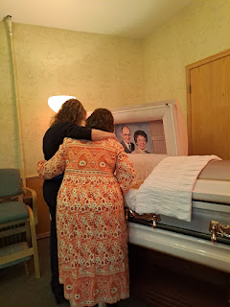

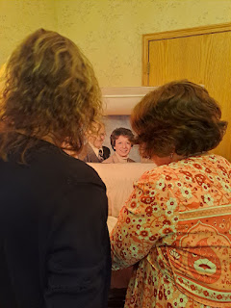

Carol quietly spoke to Sharon, just as Bev had done with me earlier, explaining that Mom would be cold to the touch, but to go ahead and reach out . . .

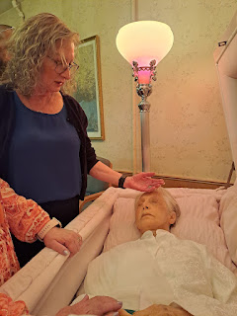

Sharon, Carol, and Dad looking on . . .

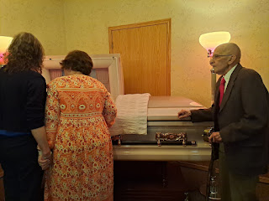

There had been some tension in recent months between Sharon and the rest of the family, but it seemed to melt away as we all gathered together at the funeral home as a Harmon family and as loved ones. Scott always has a lot of love in his heart to share, and he spent some lovely moments with his older sister here.

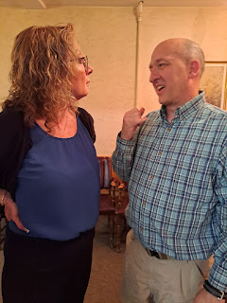

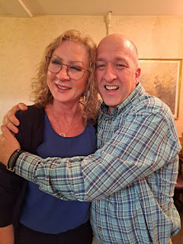

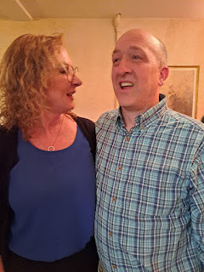

When it came time to finish our gathering and viewing hour, we drove two blocks over to the church where the funeral would take place the following morning. We commenced with a family choir practice to work on the song that Coy had asked all of us to sing, one of her favorites: The King of Love, My Shepherd Is.

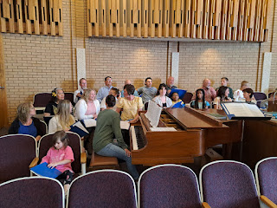

Once we worked out the most tricky measures of the song, we did one final rehearsal all the way through. I asked Gwen to hold my phone and slowly pan back and forth to record it. She did a great job, even though I had to tell her to slow down a couple times, ha ha. She also dropped the phone once, and had fun holding her hand in front of the lens near the end. LOL

But I am so grateful that she patiently stood there recording for almost FIVE minutes!! What a special gift that was.

Gwen's video of our song practice: (4 minutes, 47 seconds)
https://photos.app.goo.gl/iTbWB2ifAwyAwc8e6

I added a short clip of the men practicing a tricky section: (37 seconds)
https://photos.app.goo.gl/4vnPnDC84XgQ5t257

Gordon had been asked to sing "It Is Well With My Soul", something he was very nervous about. He worried that he would just be a mess of tears, instead of projecting the beautiful tenor voice that he has been blessed with. After the singing practice had all finished, he asked some of his brothers to give him a priesthood blessing so that he could perform in a pleasing manner for his mother at the funeral.

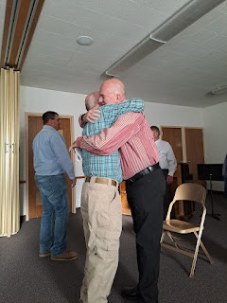

Video of a portion of Gordon practicing his song: (1 minute, 26 seconds)
https://photos.app.goo.gl/JVB4Ju47tHT5HkVM8

Saturday, May 13th:
We arrived at the church in Rigby at 8:30 a.m. so that family could gather in the Relief Society room and have a family prayer before we formed a procession into the chapel behind the casket. Mom's casket truly was so beautiful.

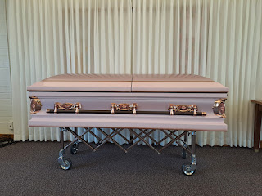

As I looked at the funeral program, I noticed a couple of important details. One: the honorary pallbearers included both my boys, Jacob and Benson, who were not able to attend, and also little Jack, my 2 year old grandson. What a sweet way to include all the grandsons and great-grandsons!

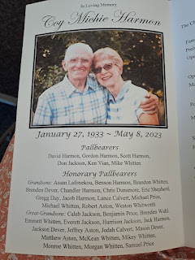

And second: My name was on the program!! What a surprise!! I had not been notified that I would be participating . . . oopsies . . . so I scrambled to ask family members where was this poem I am supposed to read. I received multiple apologies that I had not been notified ahead of time, to which I quickly reassured them that it was okay, and that I'm sure there was so much going on to where this detail was understandably overlooked. Someone quickly dashed back over to Dad's house in Rigby to retrieve the poem that was sitting on a table downstairs.

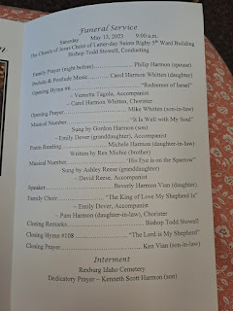

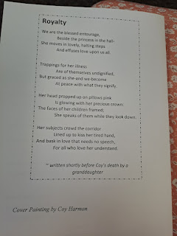

Here is the poem. Rex Michie, Coy's younger brother, wrote this when he was also diagnosed with cancer. He died back in 2006.

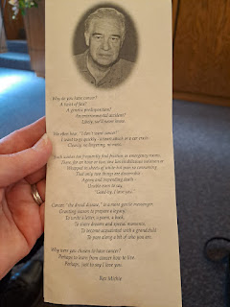

Link to the audio recording of her funeral:
https://drive.google.com/drive/u/2/folders/1_bgcEkd4E8Wt9xhpE1F_4p_aq2zPi1zG

During the family procession into the chapel, we passed by all the photos, Coy's paintings and various poems that were on display in the foyer, which caused another round of fresh tears to tumble down my face.

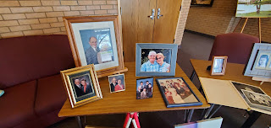

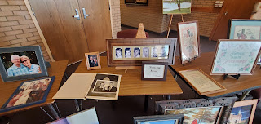

Bev was the only speaker, besides me reading the poem. (Although the Bishop did offer a few remarks at the end) Bev did a phenomenal job. She told us earlier that she wrote her talk when Mom was still lucid and before she declined so rapidly in those final days. Bev shared the talk with her and Mom gave her overwhelming approval. Mom wanted Bev to share her testimony of the gospel and NOT give a life sketch.

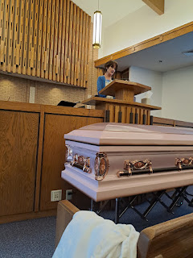

The music was SO powerful during the entire service. Gordon blew everyone away with his gorgeous rendition of the song he had practiced so hard on. As soon as he finished and walked over to his seat, he collapsed into sobs, while Carol, who was sitting behind him instantly reached out to hug him for a long time. That's when I was supposed to read the poem . . . not an easy thing to follow.

Ashley's song, "His Eye is on the Sparrow," was incredible. Her husband David accompanied her on the piano. At some point we will have a thumb drive of the audio recording of the funeral in its entirety. I will add that in as a link once we have it. The music will no doubt blow you away and stir your soul with emotion.

Link to the audio recording of the funeral:
https://drive.google.com/drive/u/2/folders/1_bgcEkd4E8Wt9xhpE1F_4p_aq2zPi1zG

Vernetta's son, Philip, was thoughtful to video our family choir from the back of the chapel.
Video of our song: (4 minutes, 18 seconds)
https://photos.app.goo.gl/UajLibL6ypHYyVws5

After the service, we followed the casket containing our loving family matriarch out to the hearse, and then on to the Rexburg Cemetery.

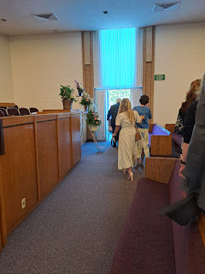

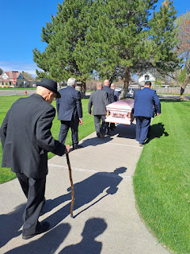

Dad (Phil), Sharon, and Shawn

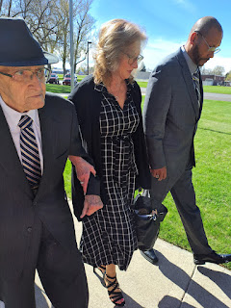

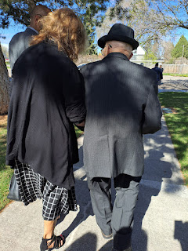

The pallbearers arriving at the back of the hearse . . .

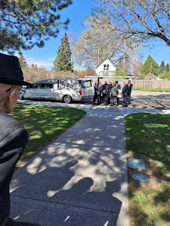

Dad got a special opportunity to ride in the hearse with Mom. (Gordon had presented this idea as a wiser alternative to Dad driving himself behind the hearse. Dad still likes to drive, even though the entire family cringes at the thought . . .)

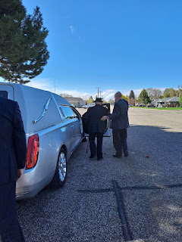

Scott and I were the 4th car behind the hearse. We had Abby and Gwen with us as well.

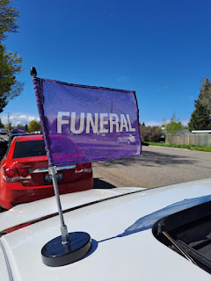

Weston and Dad chatted quietly in front of Jonny's headstone (Weston and Amber's baby boy), which was next to where Coy would be buried.

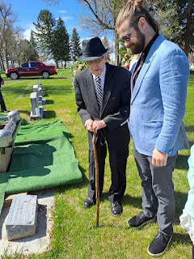

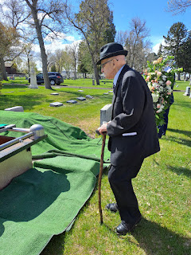

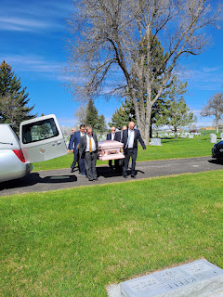

L to R: Scott (you can only see the top of his head), Don Jackson (Vanessa's husband), Ken Vian (Bev's husband), David Harmon (a distant relative who also happens to live across the street from Dad in Rigby), and Gordon Harmon. Not seen in this photo is Mike Whitten - behind David Harmon. He is Carol's husband.

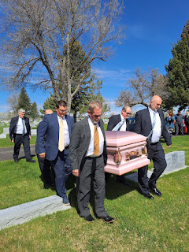

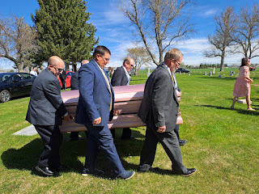

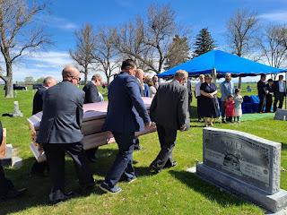

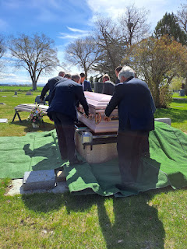

This next photo shows the covering that would be placed on the burial plot after the casket would eventually be lowered into the ground.

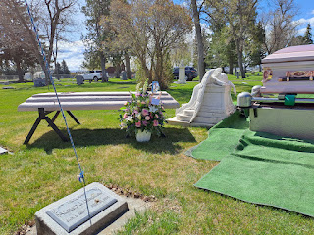

Philip Wesley Harmon was Coy's oldest boy, who died from suicide many years ago. In this family plot at the Rexburg Cemetery, Philip is next to Jonny (Harmon) Whitworth, and now Coy. There is a space reserved for Phil next to Coy, and Phil's parents Wesley L. Harmon and Helen Gordon Harmon are buried on the other side to the right.

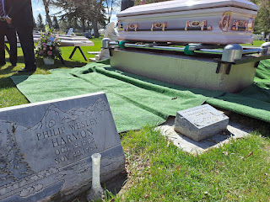

Scott's assignment at his mother's request, was to dedicate the grave. This is a priesthood blessing and a prayer given to protect and consecrate the gravesite until Resurrection Day after Jesus Christ's Second Coming. He gave a beautiful and emotional prayer. I was so proud of him. :)

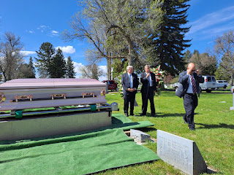

L to R: Anna Price (Carol's granddaughter), Phil, and Amber, after the dedicatory prayer.

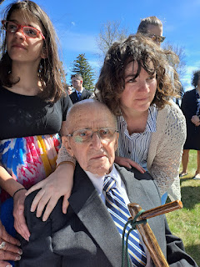

Below: Weston, Amber, Abby and Gwen, kneeling next to Jonny and Grandma Coy. One of the things that gave Amber great comfort when Jonny was stillborn and she was dealing with all the funeral details, was knowing that he would be buried next to family and therefore he wouldn't be "all alone". XOXO

I also had the thought come to me the morning after Coy passed away, that she would be the first to be reunited with Jonny in heaven. What a beautiful and joyful thought!

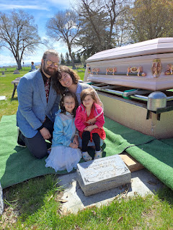

Scott and Me . . .

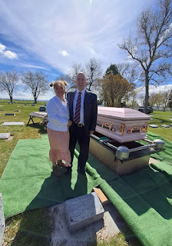

L to R: Vernetta Tagaloa (unofficially adopted into the family from Mom and Dad's years in Samoa when they taught at the College of Western Samoa), Bev Harmon Vian, Gordon Harmon, Sharon Harmon, Phil Harmon, Scott Harmon, Carol Harmon Whitten, and Gerald Love (also unofficially adopted into the family from when Mom and Dad served a mission in Milwaukee, Wisconsin back in the late 1990's.)

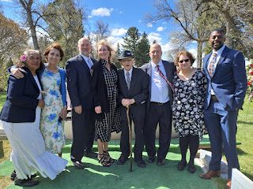

Ashley Harmon Reese and her family, gathered around Ashley's father Philip's grave. He died just a few days before she was born, so she never knew him in this life. L to R: Mia, Edmund, David, Ashley, and June Reese.

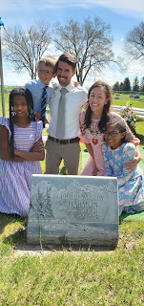

Scott and Gordon kneeling next to their older brother Philip's headstone, with Mom behind them.

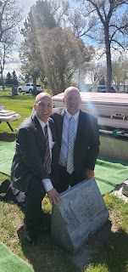

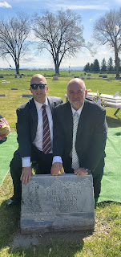

Photo below has all the family gathered under the canopy, shortly before Scott dedicated the grave. I'll do my best here to identify everyone in the photo.

Front row L to R: Scott, Gordon, Ashley, Bev, Sharon, Carol, Me (holding Gwen on my lap), Dad (Phil), and Amber leaning down talking to Grandpa Phil. On the ground in front are Edmund Reese on the left, and June Reese with Abby on the right.

Second row L to R: Gerald Love (almost hidden on the far left), David Reese, Emily and her daughter Sydney Dever, Ken Vian, Lora Whitten Shepard wrapped in the blanket, Vernetta, Anna Price, and Weston (behind Amber).

The last row is hard to distinguish, but they are a mixture of Whittens and Whitten posterity, as well as Vernetta's posterity.

Standing to the right of Abby are Carolyn and Mick Michie, Coy's nephew (and his wife) through Coy's younger brother Mark Michie.

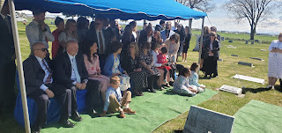

Vernetta and many of her children were also able to come to the funeral.
L to R: Joseph (?) Cline with his father Eddie Cline, Philip Cline and his wife (?), Nancy Cline, (?) Cline, Vernetta in the center, Gordon Cline, Diana Cline, Luka Cline, Kenneth Cline, and Koki Cline.

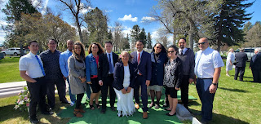

We spent a little while at the cemetery, allowing all who desired a chance to say a final goodbye to Coy. I walked over to her casket while everyone else was occupied in little pockets of conversation, so that I could say a few quiet words to her in private. Tearfully, I whispered to her how sorry I was that I wasn't there to take care of her at the end of her life. I told her how much I missed her and how I loved her so much. I told her that I would miss her love and support and that I would continue to carry on the great work of family history, something we bonded deeply over the last 30+ years. After a brief pause with my hand on her casket, I felt at peace in my heart, knowing that I had the closure that I needed in order to walk away.

Soon after, we all drove back to the church where the Rigby 5th Ward had prepared a beautiful luncheon for the family. As I walked around taking photos before we sat down to eat, I felt connected to Coy because if she were there, that's exactly what she would have been doing, too. She and I were of the same mind when it comes to documenting family history. :) The meal consisted of ham, funeral potatoes, green beans, salad, rolls, and a variety of desserts.

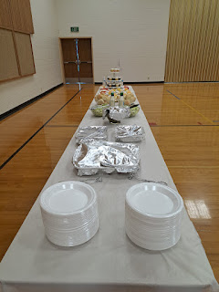

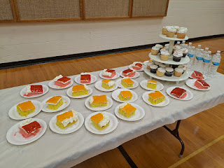

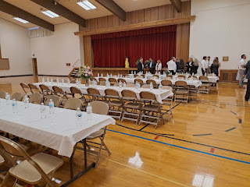

I was so enamored with this gorgeous vase of flowers, that I placed my personal belongings on a chair and gathered Abby and Gwen to come sit at this table with me so we could be near the flowers. Later, during the lunch conversation at our table, I commented to Dodee Harmon (David's wife) that I chose this table because of the flowers. Later, during the cleanup, Dodee came and found me so she could hand that same vase of flowers to me to take home. My lucky day!!

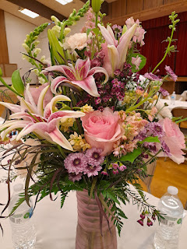

Amber, when she was helping at Grandma's house while I was still in Italy, had been sorting through Coy's art supplies. Everyone wanted Amber to have dibs on anything relating to Grandma's oils, pastels, and paintings. She came across a decent collection of watercolor paintings that Coy had made over the years, mostly of birds and flowers. Amber brought them all to the luncheon and made an announcement to everyone that she wanted them to thumb through the paintings and choose one to take home as a memento. (Amber had already photographed each one earlier that morning, per my suggestion.) The granddaughters were so thrilled to be able to take home a little piece of Grandma. :)

Group photos were taken before all the families started leaving.

L to R: (all the grandchildren & their spouses who were in attendance) Kaylene & Michael Whitten Jr. in the back left, Kim Whitten Price in front of them, Lora Whitten Shepard, Heather Whitten Aston, David and Ashley Harmon Reese, Weston and Amber Harmon Whitworth, Emily Dever and her sister Vanessa Jackson (Bev's younger daughters).

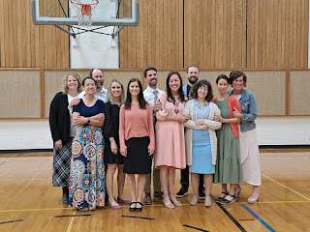

Below: All the grandchildren and great-grandchildren who were able to come.
Family groupings will be in similar form to the photo above. I don't know the names of all the Whitten grandchildren (Carol's posterity) that are on the left. Ashley Harmon Reese and her family are in the center. Then Amber and her family . . .

I do want to point out Emily and Vanessa and their children on the far right, especially because they were so instrumental in Grandma's tender loving care for so many days. Behind Amber is Emily Dever with her beautiful daughter Sydney to Amber's left. Vanessa is peeking over Sydney's head in the back row. Next to Vanessa is Taylor, her youngest daughter, then Hunter and her brother Caleb Jackson, holding his son Harrison.

Sydney and Taylor were part of the crew of heroes that took such good care of Coy in those final days.

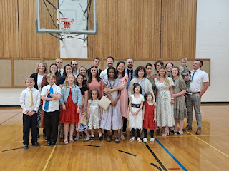

Here is a beautiful story that emerged over the weekend. While most of the family was already there with Coy in her final two days, word got out to the Rigby 5th Ward that Coy was likely going to die soon. The primary leaders sent out a message to gather as many primary children as possible to come and sing to Coy through the window where she lay in her hospital bed.

Video of them singing: (1 minute, 39 seconds) You can see Carol next to Mom in her bed, as well as Dad and Vernetta near the window. Bev is who provided the recording.
https://photos.app.goo.gl/8jAP1AFaUY3kjMHP6

They also brought Coy a blanket that they made for her, with an assortment of colored flowers on it. When she died, she still had that precious blanket laying over the top of her.

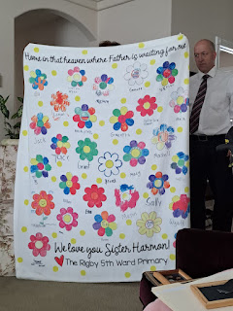

There are so many miraculous and tender stories that will hopefully be recorded by Vanessa, Emily, Melodi, Amber, Bev, Carol, Gordon, Pam, and so many others. Coy's legacy needs to live on forever.

Sunday, May 14th:
The day after the funeral and also Mother's Day, Scott and I accompanied his father to church in Rigby. As soon as we began singing the opening hymn, Scott and I melted into tears all over again. Scott thanked me later, saying, "Thank you for being willing to cry with me."

I snuck a couple of sweet photos of all of us sitting together . . .
L to R: Me, Scott, Ken Vian, Dad (Phil), and Don Jackson (Vanessa's husband)

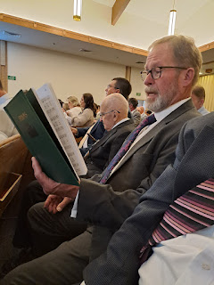

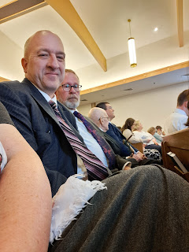

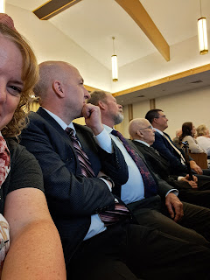

In Relief Society, one of the ladies mentioned that she was part of the group who came to sing to Coy with the primary children and teachers. She said that even though everyone was sad that Coy was so sick, Don Jackson (Vanessa's husband) brought out a huge package of ladybugs that needed to be distributed around the yard, something that Coy always did each year. They responded joyfully and had a wonderful time placing ladybugs on flowers and shrubs to help eat any aphids that might appear in the coming weeks. She said that it turned a sad situation into a joyful one . . . an analogy of life. I mentioned this in a recent blog post already, but this is exactly what I was trying to convey! We can still have joy in spite of sadness and difficulties. We can have joy in addition to sadness. And we can have joy at the same time as sadness.

After church, and when we returned to Dad's house to hang out, I felt compelled to take some quiet photos around the house of some things that represented Coy, or things that I just felt prompted to photograph.

The view outside the window where Coy died, but also the place where the children sang to her.



Her favorite apron . . .

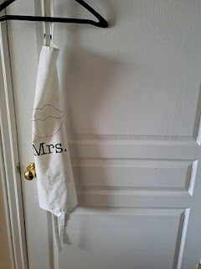

Her china hutch, where she served so many family meals over so many decades . . .

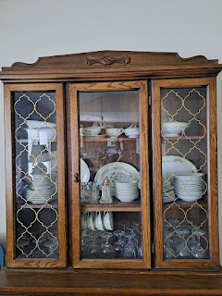

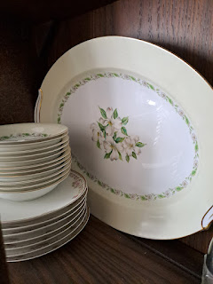

Her front entry . . .

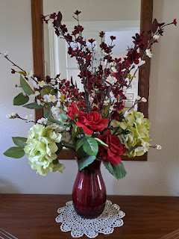

She and Phil chose this family motto, which she then cross-stitched and framed for the upstairs hallway.

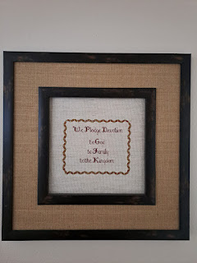

The Harmon family tree, with all of her posterity that she diligently updated through the years. This latest version was just completed last year.

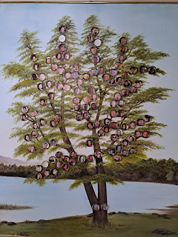

Her office for the past 20 years, which was also the room in which she died. (Family members had rearranged the furniture so that they could have plenty of room to gather on all sides of the hospital bed.) She spent many, MANY hours at her computer in this room working on family history and other related projects.

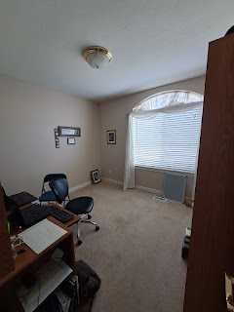

Photos of her children that hung at the head of her hospital bed, with the cross-stitch "For this child I prayed" (made by Carol several years ago). Amber said it took on a whole new meaning because it all flipped.
Coy
became the child (of God) for whom they all prayed over these past 3 weeks.

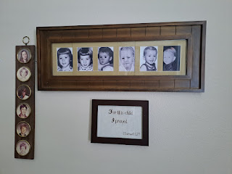

A collection of her projects and favorite books in her office . . .

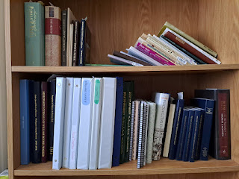

So many treasured memories of Coy reading stories to her grandchildren . . .

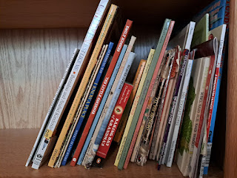

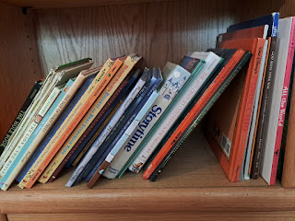

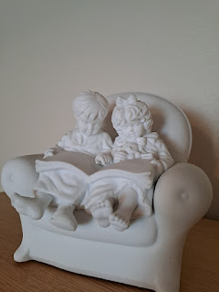

Coy and Phil have diligently exercised in the early morning hours every day for decades. They were a true example of taking good care of your body throughout your mortal life.

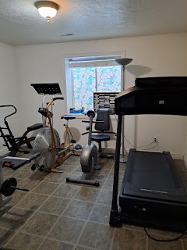

Phil bought Coy an organ for her birthday a few years ago. She loved to come downstairs, slip off her shoes, and play the organ in her socks. A few times a year, such as during Christmas, she and I especially enjoyed playing duets, with her on the organ and me on the piano, while other family members sang along.

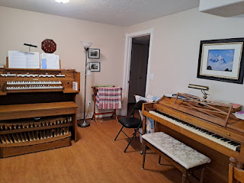

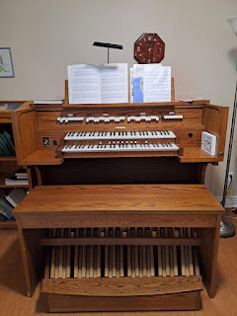

Many family gatherings were held in the family room downstairs . . .

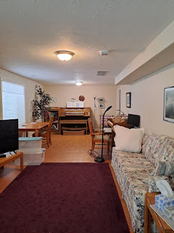

Some of her (and her granddaughters') favorite movies . . .

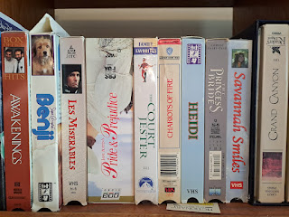

A framed needlework that hung downstairs for many years . . .

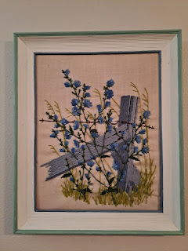

She hand-painted the downstairs family room windows to look like stained glass behind the blinds . . .

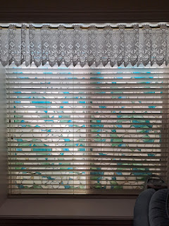

Some kitchen drawers and cupboards, reminding me of all the many meals and cookies she made for family over the years . . .

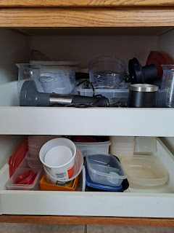

She was an EXCELLENT bread maker. She taught me how to bake bread many years ago. She continued to bake homemade bread weekly, even during 2023 in her 90th year.

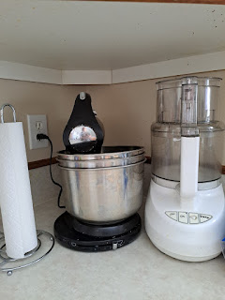

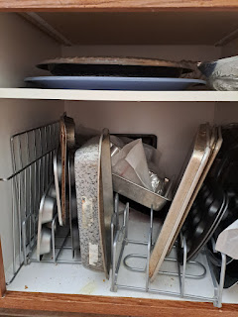

Her outdoor space and gardens meant so much to her . . .

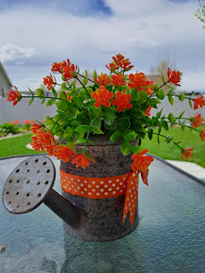

She hand-painted this birdhouse for a pair of King Fisher birds that frequented here for many years, adding to their family each spring.

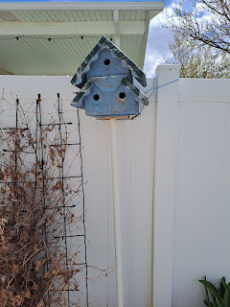





I always loved how she organized her perennials, paying close attention to which ones thrived in the shade versus in the sun.

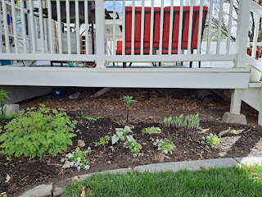



I gave her some strawberry starts from my own garden a couple summers ago. They are thriving, but so are some weeds in the same area. I will work on that in the coming days . . .

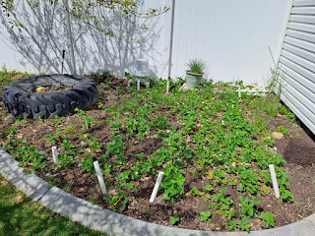

Her pear tree produces the best pears that I've ever tasted. I never liked pears until I tried some of hers.

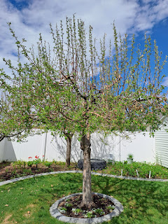

She gave me a section of her rhubarb several years ago, and I still have it and enjoy it to this day.

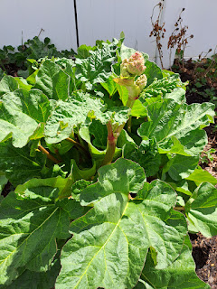

Her gardening gloves . . .

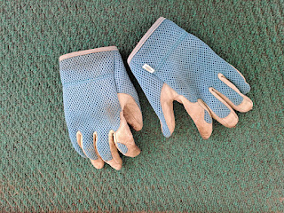

Her son, Philip, gave her a Christmas Cactus plant shortly before he died in 1984, which she has kept alive all these years. It was recently gifted to Ashley, Philip's daughter that he hasn't met yet. She made sure to snip a few "starts" for other family members so they can keep the beloved plant alive in multiple homes scattered around the country.

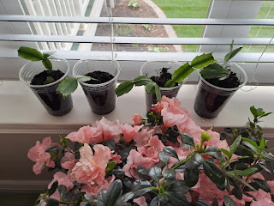

I'm not sure who gave this beautiful azalea to Coy recently, it might have been Karen, Ashley's mom.

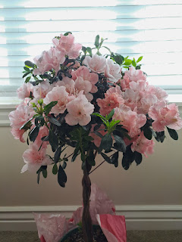

Quintesssential living room layout with an open invitation to all who stop by . . .

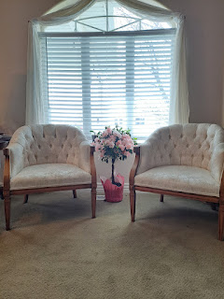

It has been such an honor and privilege to have Coy as my mother-in-law, to learn so many things from her, and to have her support, love, and care for the past 30 years. I will miss her dearly, but I know I will see her again. I am also sure that she will be close by as I navigate through the rest of my life here upon the earth. She and I shared such a love of family history and documenting treasured family moments, as well as sharing these stories and photos with each other.

I can feel her close by even as I am typing this blog post . . .

Her next door neighbor has the most incredible and majestic tree in bloom right now. To me, it represents the Tree of Life. In other words, it is symbolic of the Love of God. All those who come unto Him, and follow His Son Jesus Christ, will feel of that love forever and ever.









I love you Coy Harmon. I can't wait to hug you in Heaven someday.

