Yak Ancestry & 31 Years of Marriage
Happy 31 years of marriage to Scott and me!!! What a wonderful ride it has been. Even though we only got to talk on the phone for about 5 minutes on Tuesday, we still sent a few nice texts to each other. I sent him a Top 10 List of Things I Love About Him.

Here are the Top 10:

1. Your hugs. The big wrap-your-arms-around-me-and-squeeze-me-tight kind.
2. Your thoughtful wisdom when making important decisions.
3. Your sense of humor. I've always loved how you make me laugh.
4. Your diligent and devoted testimony of the Gospel.
5. The way you can look into my eyes and make me cry because of how much you love me.
6. How generous you are with your money, and how you are so kind to share some of it with my family members over the years.
7. Your wonderful talents with home renovation projects and the beautiful rooms you have built in our home.
8. You are a good listener and a devoted friend to me.
9. You're always down to go on a walk with me.
10. You never speak unkindly to me, but instead you always try to build me up.



13 June 1992 - The Best Day of My Life





Scott has finished up in Morocco and made his way back up to Italy this weekend. At the same time, Benson, Kylie and Avery all made their way to Idaho Falls!! And at the same time, Scott's sister, Bev, is in the middle of her drive across the country to come live with Dad in Rigby. Also at the same time, Amber and her family down in Louisiana have had a series of storms pass through the South, causing them to take shelter in their bathroom in the middle of the night because there was a serious threat of a tornado in their area. They have been without power since Friday morning . . .what a weekend!! (update below)

Weston also added that power is out at his optometry office in Shreveport and that the estimate for getting power restored again isn't until June 23rd!! My goodness. Amber is supposed to start her drive across the country on Monday, so we'll see how that goes. Hopefully there won't be any threats of tornadoes in her path . . . She has been researching alternate routes just in case. We will be praying for their safe arrival for sure!

This week has been a good week. It's been a mixture of doing some hard things and also doing some restorative things - in other words, things that help me to relax and recharge.

Monday:
I started the morning by getting on some grubby clothes and donning some disposable gloves and an N95 mask. I said a prayer that I could be brave . . . and then I went downstairs to clear out and clean out the utility room underneath the stairs. Blech.

First, I had already found a dead mouse under my kitchen sink that same morning. That was pretty disturbing. I opened up the door to get the dishwasher detergent and decided to move a couple things to check behind them (just in case), and sure enough, there was a dead mouse attached to a deployed trap. I screamed and jumped a bit before composing myself and taking care of the situation. Disgusting.

I prepared myself for the worst downstairs . . . and I purposely chose my "Discover the Hero Within" t-shirt from Girls Camp back in 2021.



I cleared out all the suitcases, storage totes, and boxes of misc. stuff. I sorted them in the hallway, deciding between "disinfect and keep" versus "disinfect and sell at my future garage sale this summer" versus "throw it away".

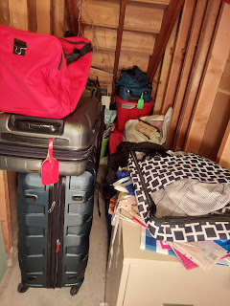

It didn't take me too long to do all of that and then vacuum everywhere.

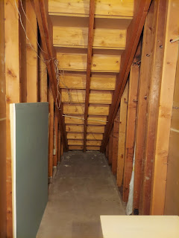

I found one dead mouse behind the water heater and had to get creative on how to get him out. I used a small garden hoe in combination with something to push him onto the hoe so I could dispose of him . . . blech.

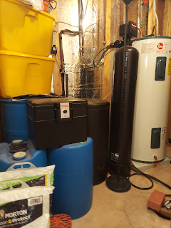

I told Scott that once I was done vacuuming up anything having to do with mice poops, I would be throwing that nasty vacuum away and getting myself a whole new vacuum. At first, he gently protested, asking if we could just clean it really well. I said, Nope. Not gonna do it. I told him that this was my reward for doing the grunt work. He conceded and consented . . .

I knew we were at the tail end of having a mice infestation, because the pest control company has been so confident and reassuring these past couple of weeks. I was grateful for their expertise and for the bait stations, but it also felt good to clean out the rest of my basement this week. Now I know that everything is clean and sterile because I did it myself.

I went up to Rigby for a portion of the afternoon. We were supposed to get the internet switched to a new provider that day, after weeks of coordinating back and forth and making too many phone calls to count. But the stars and planets were NOT aligned for us that day. The new provider had an unexpected power outage that blanketed across Rigby and Ririe, so we ended up having to reschedule for a week later. Sheesh. It's been a month in the process since Scott tried to set it all up for the switch while he was here in person. The whole reason we are switching is because Dad's internet is pretty archaic, and Scott found a provider that has 20x better internet for just $5 more a month. This will be important for when Bev arrives, since she'll be working remotely and will need good internet to support her laptop while Dad watches Adam 12. :)

Later that afternoon, there was quite a rainstorm back in Idaho Falls. I took a video of the massive amount of rain out the back door. There was a small river flowing next to the house, thankfully AWAY from the foundation, and the rain gutters were completely overflowing overhead.

Video of the rain and the floods on the back patio: (25 seconds)
https://photos.app.goo.gl/V7soCaEDCmqudruu6

This went on for a couple hours!! I kept running downstairs to make sure that none of the bedrooms were getting flooded from the ground-level window wells. Thankfully, everything was okay each time I checked.

Tuesday:
Anniversary Day. XOXO

I spoke with Jack and Jacob mid-morning. Poor Jack had a decent fever and felt sleepy and sluggish all morning. But he was still willing to smile and be cheerful on the video chat, even though each time after he gave a huge smile, you could tell he was just exhausted.

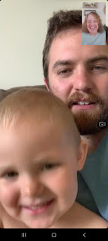

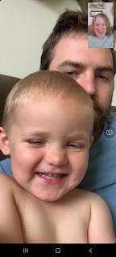

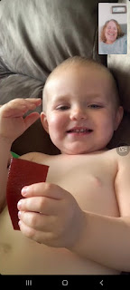

His parents were trying to keep him awake for just a little bit longer so he could take a huge mid-day nap. As it turned out, it was just a weird 24-hour bug. His only symptom was the fever. He didn't eat quite as much as he normally would, but at least he still ate. In the photo above, he was holding a fruit leather for a long time, with very sleepy eyes, and an occasional smile for me. I convinced him to lick it, hoping that it would entice him to want to take a bite. I'm not sure if he ever ate it though, since we said goodbye soon after I took that last photo. Jacob said that whenever Jack is sick, he just sleeps a lot more. Some babies sleep LESS because they don't feel well, but not Jack. He sleeps a lot more. They are so lucky!!

Scott went out with some Army buddies for a nice dinner down in Morocco, and I went and got my hair done. It's a 3 hour appointment because Tessa had to update my highlights and hair color, since I am still trying to hide the grey that tries to take over around my face.



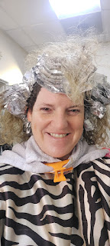

She used a blowdryer after the color and cut was done, which always makes my hair get so HUGE. So once I got home, I pulled it back with a clip to control it a bit . . .



I picked up a nice dinner for myself, too, since I couldn't go out WITH Scott for our anniversary. I ordered some salmon with creamy garlicky mashed potatoes and steamed broccoli. It was just perfect!



Wednesday:
I picked up my friend, Lasina, to run some errands together, since she is still without a car. We went to Hobby Lobby first, which is where I discovered the darling family history of a particular yak.

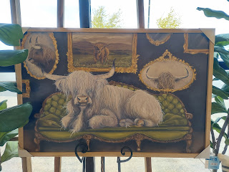

I had plans to make a wreath for the front door in Rigby, more for Coy than for Dad, to be honest. Lasina decided she wanted to make a wreath for her new front door, too, so we had fun picking out flowers together. When we got to the wreath aisle, Lasina pointed out a cute hanging basket that could be fun, and I got really excited. It would be much easier to place seasonal flower arrangements in the basket, instead of hot-gluing flowers permanently to ONE wreath for ONE season. With the basket, you can just swap out the flowers whenever you want! Brilliant.

I got home just in time to meet Vernetta and Dad, who were just pulling up.

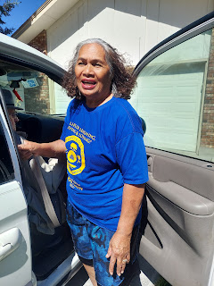

We had arranged ahead of time for me to take Dad to his appointment with the cardiologist, while Vernetta went to the temple. Afterwards, she would go see the chiropractor, while I fed Dad his supper at my house and let him take as many naps as he wanted to. :)

I had to scramble and snarf a little bit of lunch, as Dad impatiently kept looking at his pocketwatch and wanted to drive over to the Idaho Heart Institute, even though we were 30 minutes early and it only takes 2 minutes to drive there from my house . . . It felt like I was shoving food into my mouth, just to swallow it down and not enjoy any of it, all while he stood there, watching me and anxiously waiting. So I decided to put the rest into the fridge until we got back, when I could enjoy it a little more, ha ha.

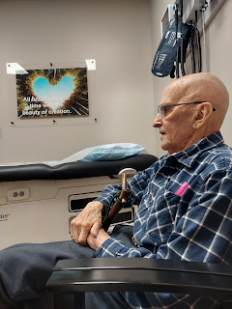

Dr. Gorman suggested that Dad schedule a cardioversion, a procedure done at the hospital where they give you a light sedative and then shock your heart. It stops beating and then it's supposed to start up again, with the goal being a heart rate that is appropriate, instead of too fast or too erratic. Dad has a "flutter", which is slightly better than what Mom had most of the time (A-fib - a consistently high heart rate that was exhausting for her). His heart rate jumps up for a bit, then settles down again. The Dr. hoped that with a cardioversion, they could force it to get into a better rhythm.

The problem that I could see as the Dr. was talking to us, is that it all sounded "experimental". I didn't get the sense that there was any sort of promise or guarantee that this would even work. And even if it did work, what kind of improvement would it actually be? For a man of Phil's age, it wouldn't be an astronomical improvement, so why go through all the trouble (and risk) to do the procedure??

When we got home, Dad was exhausted so he laid right down for a long nap. Meanwhile, I called Scott's two sisters, Bev and Carol, to let them know what the doctor was recommending.

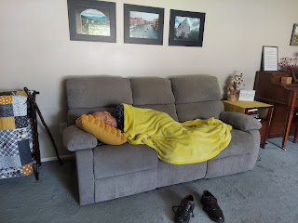

I was also able to catch Scott before he was asleep in Morocco, too. We all discussed the pros and cons, and decided that it was a bad idea to proceed with the cardioversion. Carol, who is an RN, was adamant that there were too many risks for someone Dad's age (91). When they shock your heart, she said, they wait for it to start up again. Well, Dad has had multiple heart attacks over several decades, and had subsequent damage because of them. What if his heart doesn't start back up? Dad also has a DNR in place (Do Not Resuscitate). So then we've got a real problem. Or what if Dad somehow thinks that this could be his ticket out of this life and that he will get to be reunited with his sweetheart . . . and then what if his heart DOES start ticking again and then he is sad and disappointed that he didn't die . . . She also mentioned that his heart could start up again, but it might be worse off than it was before, and then what?

Once Dad finished his nap an hour later, and I had fed him a nice lunch, I asked him how he felt about what the doctor had suggested. He didn't want to do it either, something I was grateful to hear. After I got his input, I decided to share what all of us had chatted about on the phone. I told him that all four of us (Scott, me, Bev, and Carol) didn't want him to do it either. He was relieved that his kids felt the same as he did. So then it was settled.

While he napped, I also started working on the floral arrangement for his front door so that they could take it home when Vernetta got back. Here's how it turned out . . .

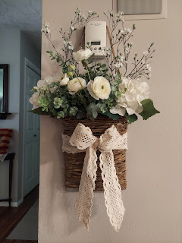

And here it is now, hanging on the door in Rigby . . .

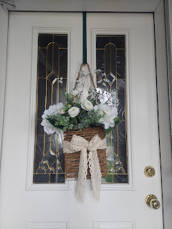

I made one for my front door, too, but I wasn't too sure about the ribbons I first tied around the basket. I didn't like it 100%, but I was fresh out of the other creamy lace ribbon . . .

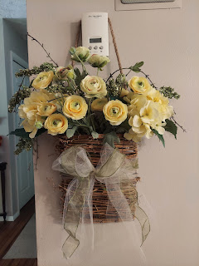

Later that evening, I decided to walk over to JoAnn Fabrics to get some creamy lace fabric ribbon. That sealed the deal and made me much happier with the final result.

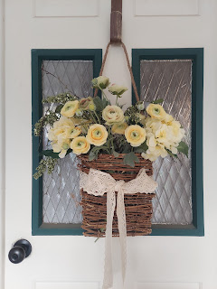

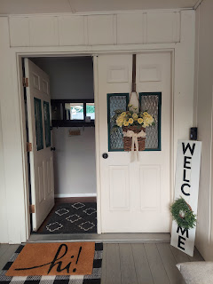

Lasina put hers together as well, and sent me a photo of her front door. It turned out beautiful!!

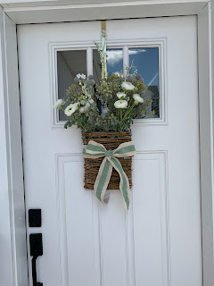

Although, as an afterthought, she decided she needed a few more white flowers to fill it out a little more, so I took her back to the store the following day. I don't have an updated photo, though . . .

Thursday:
I went to a much-needed massage and did some cleaning downstairs, putting all the things away under the stairs again.

Friday:
I went to the temple in the morning and I was so grateful that I was able to do so. It had been a few weeks and I needed the extra blessings from attending. :)

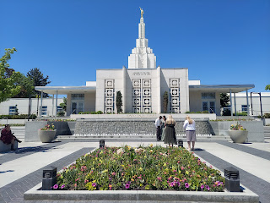

The rest of the day I cleaned the entire downstairs. Well, except for the grandchildren guest room . . . I'll be doing that over the next couple of days before Abby and Gwen arrive. I bought myself a new vacuum from Kohl's, the same kind I've had for the last few years and I really like this particular model (Shark Rotator). It was cheaper to buy it from Kohl's with their sale, plus my 30% off coupon, plus a $5 Kohl's reward. What I meant about it being cheaper is that it was cheaper than what Amazon could offer for the same exact model.

I dusted, cloroxed, and vacuumed the guest room, my craft room, the family room, and even the stairs.

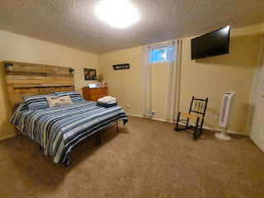

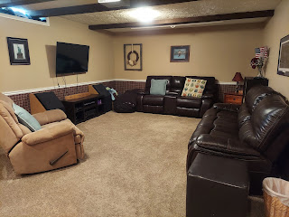

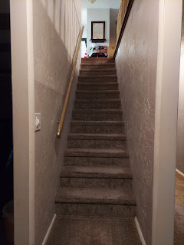

I deep-cleaned the downstairs bathroom . . .

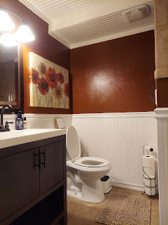

And with my neighbor, Kim's help, I put together a place for Benson to sleep in once he arrived. I had recently loaned everything from his room to our friends Chris and Lasina, who came over from Italy, so now Benson had nothing . . . but the Parkinsons had a twin bed and a little table with a lamp that they hauled across the street for us. What good neighbors!!

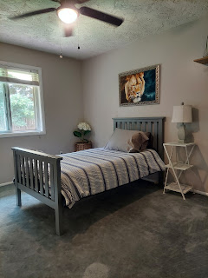

I also put together another floral arrangement in a little white tin box that I got on clearance at Hobby Lobby for $4.00 a couple days prior. I love the patriotic theme.

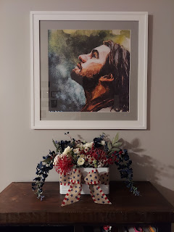

And at the end of a VERY busy day, Scott's oldest sister, Carol, and her husband Mike, arrived from Boise to spend the weekend with me. We chatted until WAY too late, ha ha, and I went to bed around midnight.

Saturday:
After I did several loads of laundry in the morning, I went with Mike, Carol, Vernetta, and Dad to Perkins for an early Father's Day dinner at 3:00 in the afternoon. (Because that's when Dad likes to eat.)

From the left: Dad, Mike, Carol, Vernetta, and me.

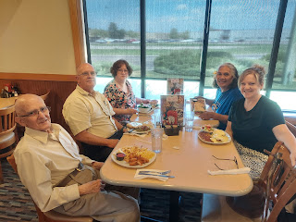

I ordered a poached egg platter with hollandaise sauce, sun-dried tomatoes and a sliced avocado on English muffins. It was really good!! It also came with hash browns and fresh fruit on the side.



Just a short while later, around 5:30 p.m., Benson, Kylie and Avery arrived at the Idaho Falls Airport. They were thoroughly exhausted since Avery didn't sleep AT ALL on any of their flights. In fact, they told us that she screamed during each take-off and landing for several minutes each time . . . Kylie tried to give her Benadryl at one point, but it had the opposite effect from what she hoped for. Benson later told me that the only time Avery slept was when they got to Denver and Kylie put her in the front carrier while they went through customs and found the next gate. Those poor parents . . .

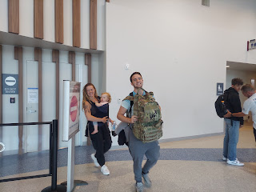

Kylie's step-mom, Nicole, hasn't seen Avery (in person) since Avery was a week old. They have visited on the phone every day during a video chat this whole time, but to actually see Avery in person after so many long months, it made Nicole burst into tears. It was so precious, the whole scene, because Avery recognized her right away and wanted out of that carrier so she could be scooped up by Nicole.

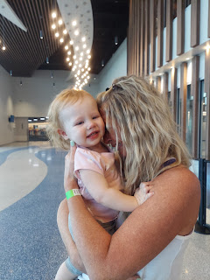

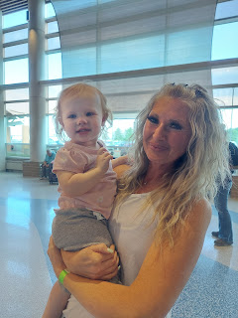

Soon, though, Avery lit up because she noticed me, too, and wanted me to hold her. I loved how she reached out with both hands, making little squeezy scrunchy fists to indicate that she wanted me. We had fun passing her back and forth, from one grandma to another. XOXO

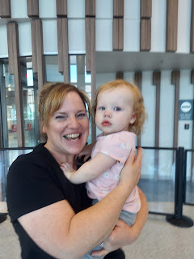

After we got everyone's luggage, Kylie and Avery headed home with her family, and I brought Benson home with me. We made two stops before going home: to get some flowers for visiting the cemetery on Sunday, and then to pick up some Mexican food for Benson's dinner, something he has been craving for months.

Benson, in Mexican Burrito Heaven . . .

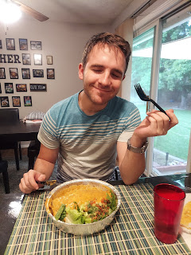

Mike and Carol got back from Rigby a little while later, and we enjoyed some fun banter and laughter until Benson couldn't keep his eyes open any longer. He showered and went to bed around 8:00 or 8:30 and slept until maybe noon the following morning. Bless his little heart. LOL

Sunday:
I enjoyed church very much, especially Peter Vance's Sunday School lesson. We spoke at length about the symbolism of the Savior being the True Vine and a few other symbols found in chapter 15 of John.

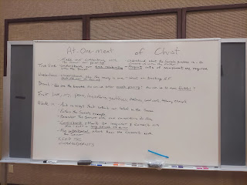

Something that struck me, as we were discussing the verse that talks about God having a house where He has prepared many mansions, is that the word "house" could be interpreted as a verb instead of a noun. Peter said that it was confusing to him that God would say He has a house, which in Peter's mind seemed smaller than all the mansions . . . But I suggested that if the word house is used as a verb, it could mean that God's LOVE
houses
all of us. There is a place for ALL of us therein, and then within that, there also exists a mansion for each of us. He liked that idea a lot.

At the end of church, strawberry shortcake was being served for all the fathers and young men who will be someday be a father as well. I picked up a plate to take home to Benson, and then the ladies serving the treat encouraged me to take one home for myself as well, since they had an abundance. I responded with, "Well, maybe I'll take an extra plate home for Scott, and I'll call him and eat it in front of him. I'll tell him how delicious it is and how he would absolutely love it if he were here." LOL

When I got home, Benson was just waking up. He had slept really well and woke up happy. We spoke briefly to Jacob and then we called Scott to wish him a happy father's day. He enjoyed watching me eat his strawberry shortcake. :)



We drove up to Rigby to put some flowers on the family graves while Mike and Carol were in town. Benson got to see Grandpa Phil for the first time in two years. They had a nice long hug before we walked over to the family plot.

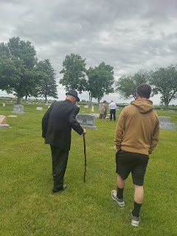

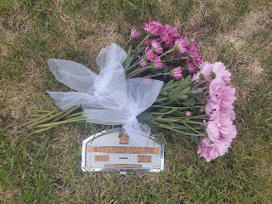

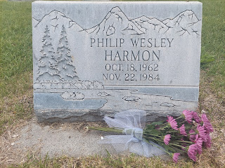

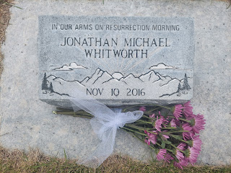

We had fun taking a selfie over Mom's grave. Benson did a great job taking the picture for us.

L to R: Me, Vernetta (behind me), Dad, Mike, Carol, and Benson

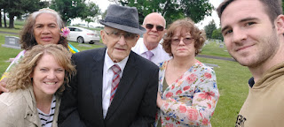

Carol helped Vernetta put some pinwheels in the ground along with their flower arrangements.

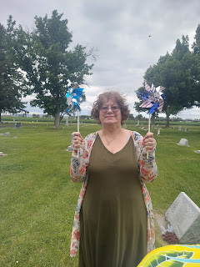

Three wonderful fathers: Benson, Phil, and Mike.

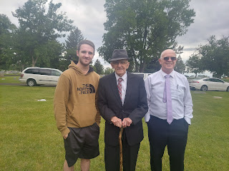

It was pretty cold and drizzly, so we didn't stay too long. Dad wanted to have a family prayer around Mom's grave, so we did. He gave a beautiful prayer. And then we drove back to the house in Rigby for dinner.

Vernetta had made meatloaf, some Samoan sweet rolls with coconut milk, as well as a potato casserole. Carol made some succotash (I didn't know what it was, but apparently it's corn, beans and green beans), and I brought the dessert. It was all very yummy!!

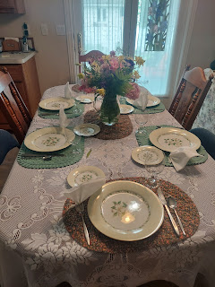

L to R: Vernetta serving the Samoan rolls, Mike, Dad, Carol, and Benson.

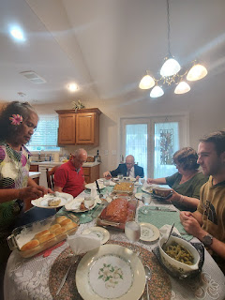

After we stuffed ourselves, Benson helped Mike carry Mom's old sewing machine from the basement bedroom all the way up the stairs and out to their truck. Carol is an amazing seamstress, so the sewing machine will be in a very good home. Carol used to make Amber little dresses when she was little, including some matching dresses for Amber and me, too.

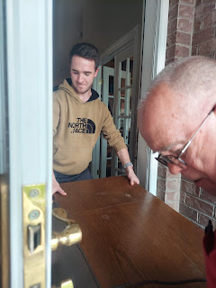

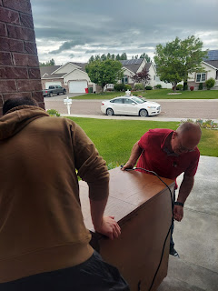

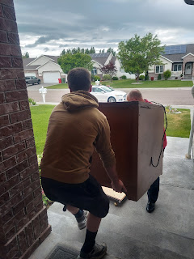

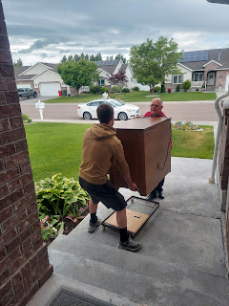

We visited for a good long while, and it was fun to hear entertaining stories back and forth between Mike, who served for 40 years in the military (retiring as an E-8 in the Army), and Benson, who is in the Air Force. We were laughing and having a good old time.

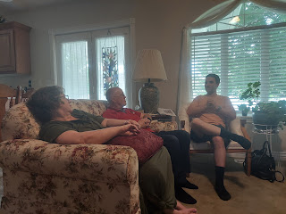

Poor Dad kept falling asleep while sitting up as we talked and talked and talked . . .

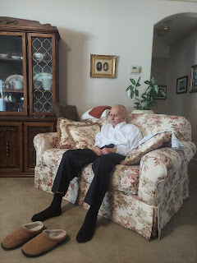

I would like to wish a Happy Father's Day to all the fathers in my life, including my own wonderful father, as well as all of my brothers and brothers-in-law who are wonderful fathers to their children. I'm grateful, too, for a Loving Father in Heaven, who is the Perfect Father of us all.

My boys are also good fathers and I love them so much.

I sent my dad this very fashionable apron for Father's Day and he, in turn, shared a delightful photo of him wearing it.

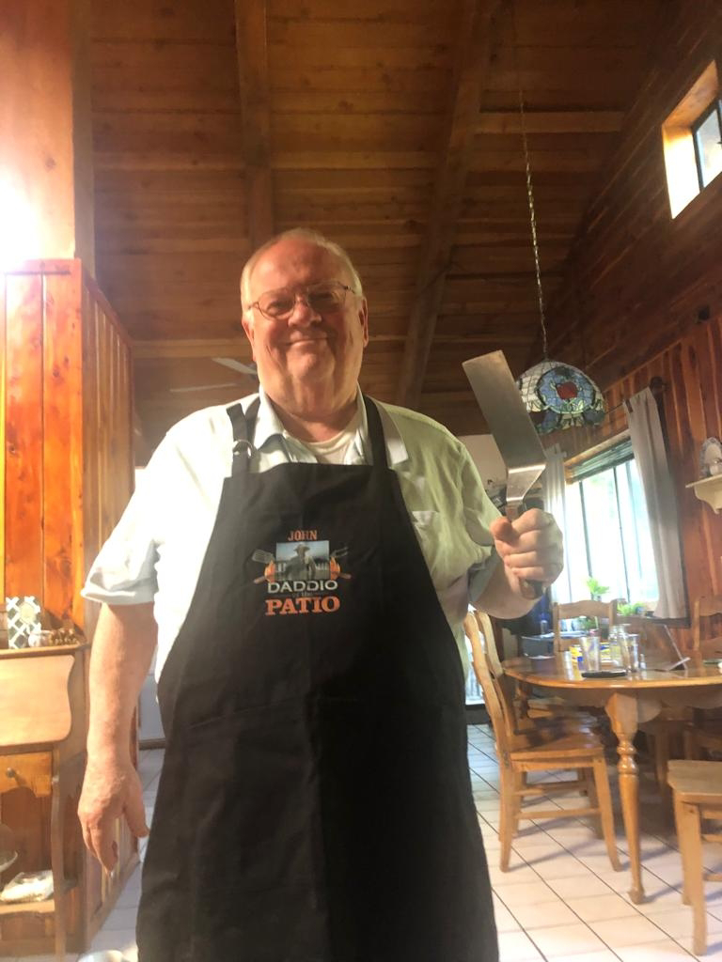

Jacob also sent us a couple of cute pictures this week. They sold their car in anticipation of moving soon to Minneapolis, therefore they have been resigned to using public transportation in the DC area. Jack is more than happy to ride a bus, and in the photo below he also has a toy bus in each hand!!

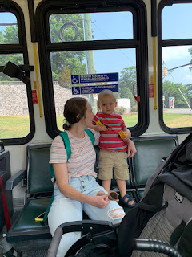

To get to church on Sunday, they rode their bikes . . . I also see that Jack has his beloved Foxy along for the ride, too.

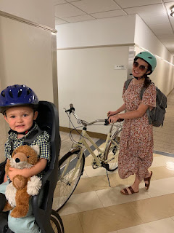

Amber and Weston have had a rough weekend down in the South, with all the aftermath from the storms, tornadoes, and power outages. Thursday night heading into Friday, they got an alert in the middle of the night (1:30 a.m.) to take cover because there was a serious tornado threat in their area. They grabbed the girls and some blankets and then everyone camped out in the bathroom tub for a while before the "all clear" alert was given. Abby had a hard time going back to sleep, and was very worried until around 3:30 a.m., poor thing.

Their power has been out clear until Sunday evening!! It was exceptionally miserable because they were having record heat these past several days, but then they had NO A/C!! Amber reported that their house got up to about 90 degrees INSIDE. Thankfully, Saturday evening, their new neighbors brought over a small A/C unit that they could hook up to the new generator that Weston had just bought on Friday. They had a family sleepover in Ma and Pa's room, finally falling asleep once the temperature got down below 80 degrees.

Here is the new model of generator that Weston bought: (6 seconds)
https://photos.app.goo.gl/32V1ootXW8YagKSSA

I'm grateful that their power is back on tonight, and I'm grateful that their neighbors were so kind to share some air conditioning with my children and grandchildren. Amber is still planning to start her drive across the country Monday . . . I'll be praying for them the whole way!!

